Suppl. 36 Identification of Randaiol (Cas 87562-14-9, C₁₅H₁₄O₃, M.W. 242.27)
Standard
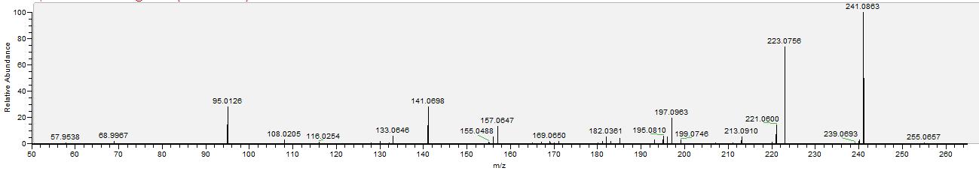

Sample
