Suppl. 26 Identification of Astragalin (Cas 480-10-4, C₂₁H₂₀O₁₁, M.W. 448.38)
Standard
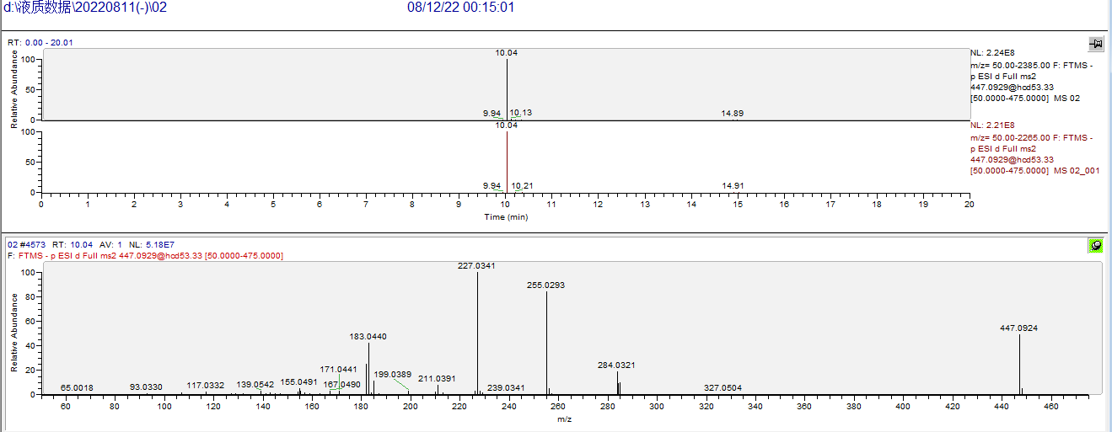

Sample
