Suppl. 2 Identification of Quinic acid (Cas 77-95-2, C₇H₁₂O₆, M.W. 192.17)

Standard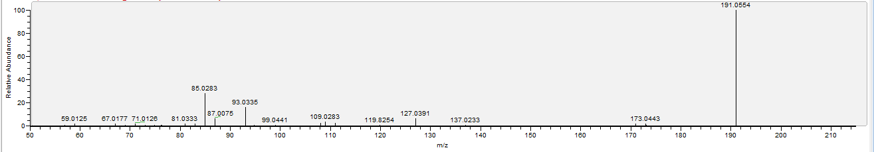

Sample
