Suppl. 45 Identification of 18β-glycyrrhetinic acid and exclusion of 18α- glycyrrhetinic acid

Standard 18α- glycyrrhetinic acid
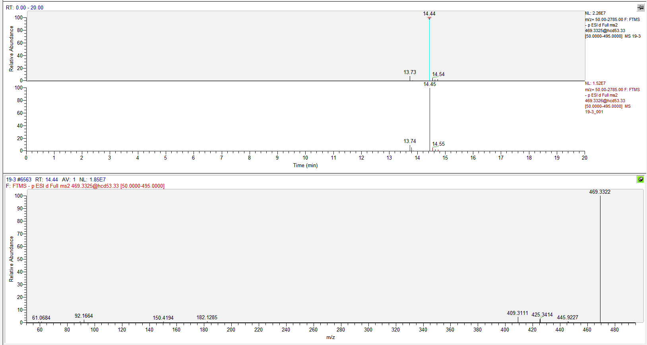
Fig. S1 18α-Glycyrrhetinic acid Standard UHPLC-Q-Orbitrap (R.T. = 14.44 min; m/z: 469, 425, 409)

Standard 18β- glycyrrhetinic acid
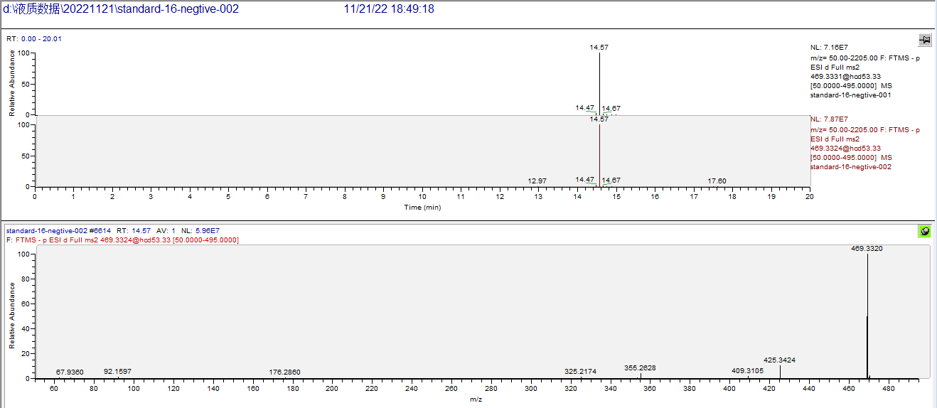
Fig. S2 18β-Glycyrrhetinic acid standard的UHPLC-Q-Orbitrap (R.T. = 14.57 min; m/z: 469, 425, 409, 355)

Sample
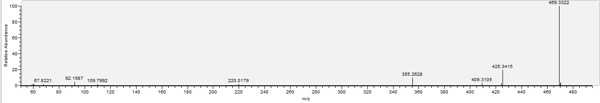
Fig. S3 UHPLC-Q-Orbitrap of sample

The chromatographic conditions are manily based on the literature ^{[1]}.

Reference
[1] Tsai, T.H.; Chen, C.F. High-performance liquid chromatographic determination of 18 alpha-glycyrrhetinic acid and 18 beta-glycyrrhetinic acid in rat plasma: application to pharmacokinetic study. J Chromatogr. 1991, 567, 405-414.
