Suppl. 28 Identification of Saikosaponin A (Cas 20736-09-8, C₄₂H₆₈O₁₃, M.W. 780.982)

Standard
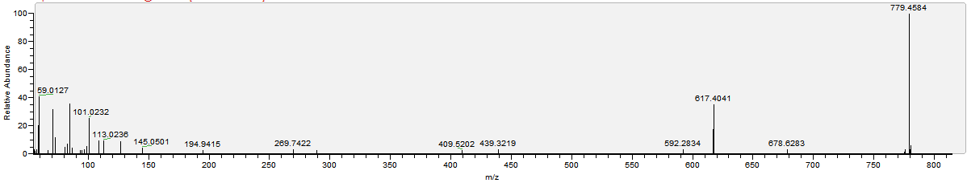

Sample
