Suppl. 51 Identification of Hypericin (Cas 548-04-9, C₃₀H₁₆O₈, M.W. 504.45)

Standard
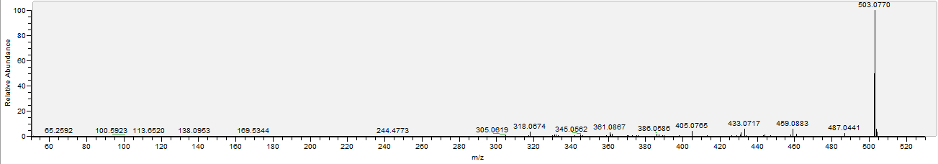

Sample
