Suppl. 14 Identification of Acteoside (Cas 61276-17-3, C₂₉H₃₆O₁₅, M.W. 624.59)

Standard
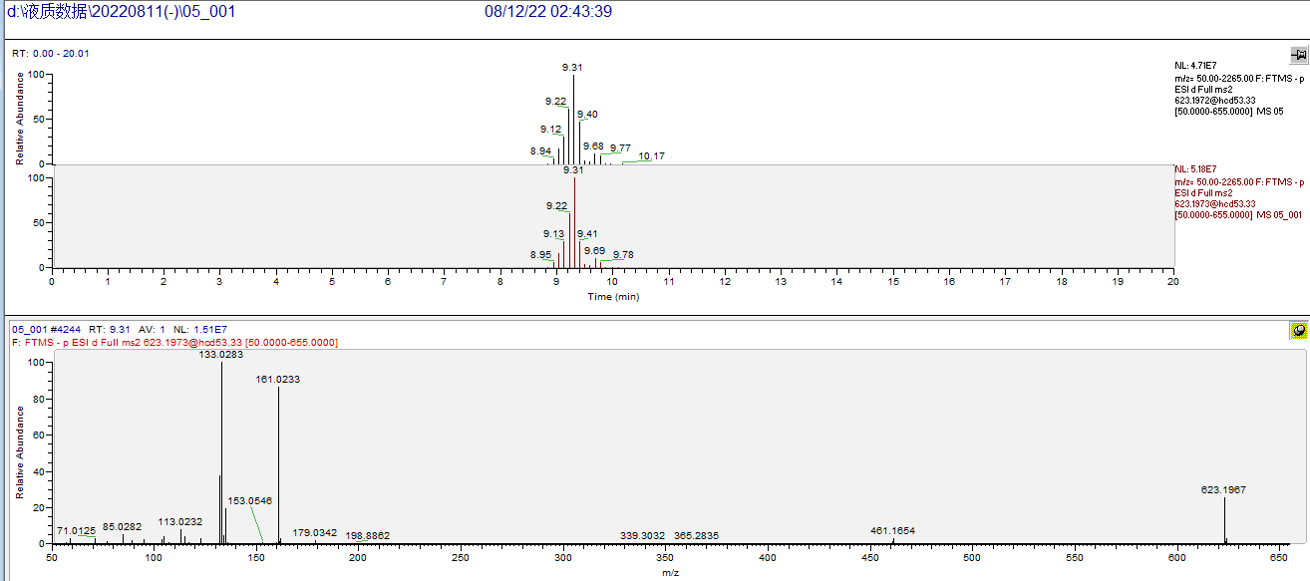

Sample
