Suppl. 7 Identification of Caffeine (Cas 58-08-2,C₈H₁₀N₄O₂, M.W.194.191)

Standard
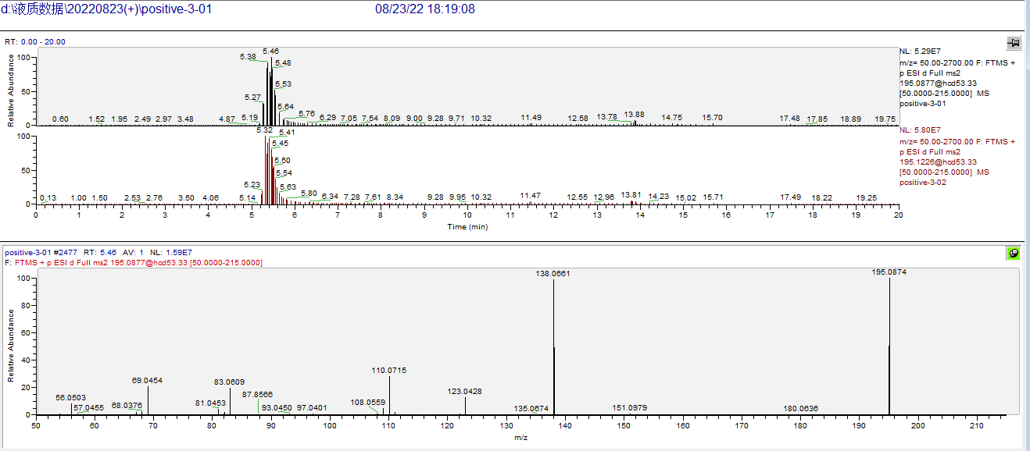

Sample
