Suppl. 24 Identification of Isochlorogenic acid A (Cas 2450-53-5, C₂₅H₂₄O₁₂, M.W.516.45)

Standard
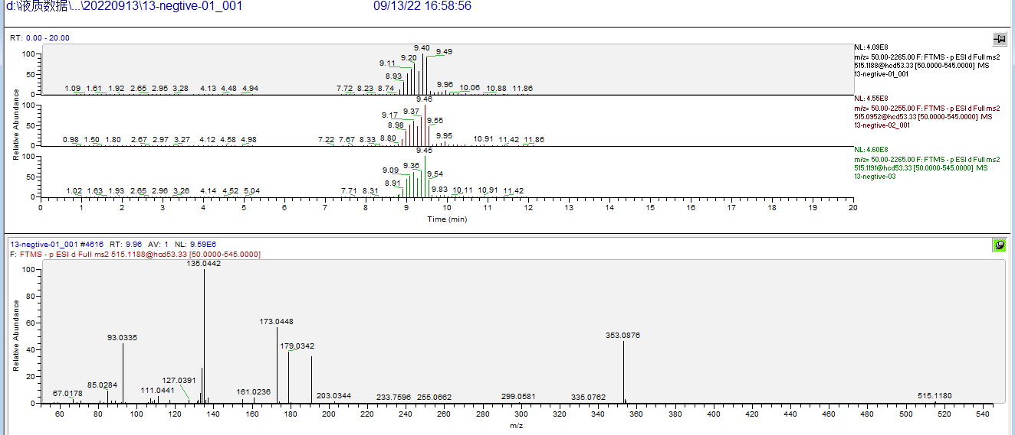

Sample
