Suppl. 46 Identification of linoleic acid (Cas 60-33-3, C₁₈H₃₂O₂, M.W. 280.4)

Standard
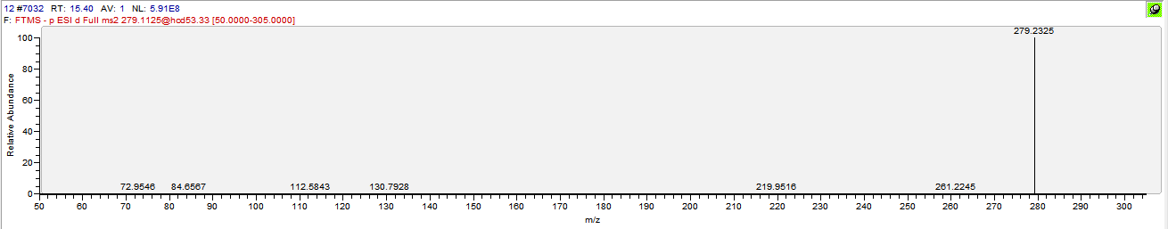

Sample
