Suppl. 44 Identification of Magnolol (Cas 528-43-8, C₁₈H₁₈O₂, M.W. 266.32)

Standard
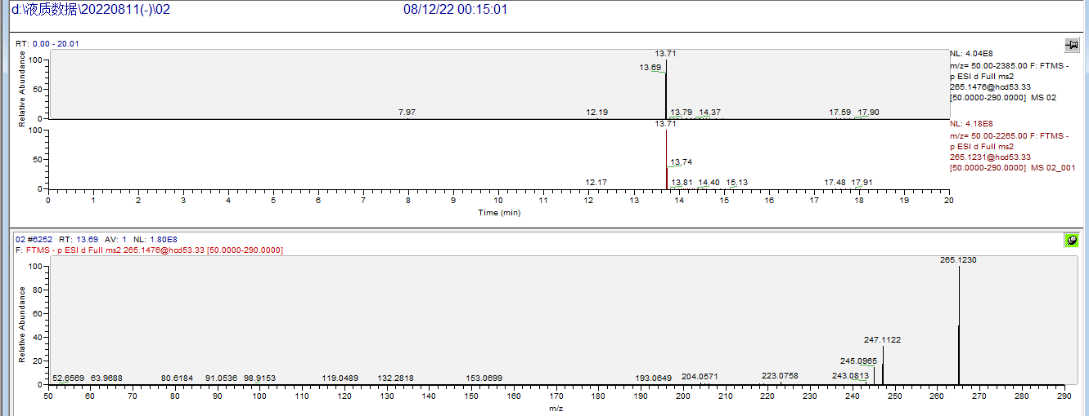

Sample
