Suppl. 37 Identification of Isoliquiritigenin (Cas 961-29-5, C₁₅H₁₂O₄, M.W. 256.257)

Standard
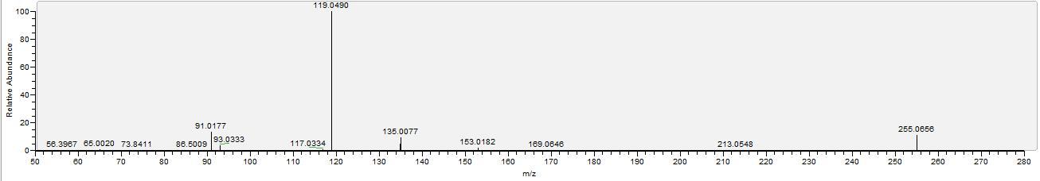

Sample
