Suppl. 9 Identification of Vicenin-2 (Cas 23666-13-9, C₂₇H₃₀O₁₅, M.W. 594.52)

Standard
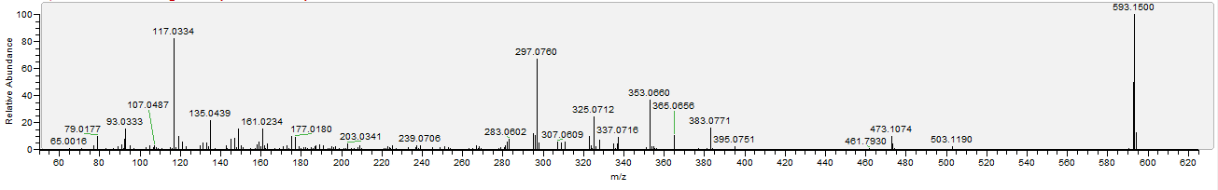

Sample
