Supplementary Materials for

Nano-Clustering in Water-Lean Solvents Establishes Novel CO₂ Chemistry

Julien Leclaire,*¹ David J. Heldebrant,*^{2,3}Katarzyna Grubel,² Jean Septavaux,¹ Marc Hennenbelle,¹ Eric Walter,² Ying Chen,² Jose Leobardo Bañuelos⁴ Difan Zhang,² Manh-Thuong Nguyen,² Debmalya Ray,² Sarah Allec,² Deepika Malhotra,² Jaelynne King.²

¹Univ Lyon, Univ Lyon 1, CNRS, INSA, CPE, ICBMS, F-69622 Lyon, France.
²Pacific Northwest National Laboratory; Richland, WA 99352, United States of America
³Washington State University, Pullman, WA 99164, United States of America
⁴University of Texas El Paso; El Paso, TX 79968, United States of America
*Corresponding authors. Email: julien.leclaire@univ-lyon1.fr; david.heldebrant@pnnl.gov

Table of content
Materials and Methods 3
Materials 3
Instruments 3
Synthetic Procedures and characterization 5
Analytical procedures 8
PVT Measurements 8
Polarity measurement 9
Loading assessment and EEMPA-CO2 covalent adduct detection/quantification 10
Matlab data Analysis 12
Computational procedures 14
DFT Calculations of the stability of the different clusters 14
Static DFT calculations of the rotamer energy landscape on E(2)R species 14
AIMD modelling of Tetrameric Structures as a function of time at 25% CO₂ loading 14
Supplementary figures 16
pKa determination 16
Gaz-liquid partition 17
Polarity measurements 20
Binding isotherms 21
NMR speciation 23
¹³C-NMR spectra of the carbamic acid E(1) 29
Fitted NMR data 33
Speciation models 37
FT-IR data 39
DFT-computed clustering and absorption energies 43
Structural data from DFT calculations 46
AIMD data for Tetrameric Structures as a function of time at 25% CO₂ loading 47
¹³C NMR monitoring of E(2) decay 51
DFT analysis of CO₂ absorption mechanisms from 50% loading state 54
NMR and MS data of in situ and ex situ E(2)R formation 56
DFT-computed conformational energies on E(2)R derivatives 66
Supplementary tables 67
Abbreviations and schematic representations 67
Binding isotherms and speciation data 69
WAXS parameters 71
References 73

Materials and Methods
Materials
Trimethylsilyldiazomethane in hexanes was purchased from Thermo Fisher and used without further purification. Liquid state NMR were recorded on either 500 MHz Varian, or 500 MHz Bruker NOE spectrometers. ¹³CO₂ (99%) was purchased from Cambridge isotopes. Boc₂O and DMAP were purchased from Sigma-Aldrich and used without purification.
Instruments
Mass Spectrometry analysis was performed using an Q Exactive Plus mass spectrometer (Thermo Scientific, San Jose, CA) outfitted with a Heated ESI source. The source temperature, ion transfer tube temperature and spray voltage were 110ºC, 300ºC and 3.9 kV, respectively. Data weas collected for 2.5 min, with data acquisition being initiated immediately a stable signal is observed. FT-MS spectra was acquired from 50 to 650 m/z at a resolution of 140k (AGC target 3e6).

Negative mode Cryo ToF-SIMS analysis was performed on ToF-SIMS 5 (IONTOF, Műnster, Germany) using 10 kHz 100 µs cycle time and flood gun of 2.10 Å. Temperature of the experiment was set to -128 °C and raised to -115 °C and then to -80 °C. Time of the experiment was 30 min for the first raise and 45 min. for the second temperature raise. During first step, a 2 mm spacer was used in the cell, the during second step no spacer was inserted. Prior to analysis, sample was frozen in liquid nitrogen and mounted on a cooling stage.

High and low pressure IR spectra were collected on Nicolet iS10 Thermo Scientific instrument using high pressure demountable transmission liquid Harrick cell, and OMNIC 9 software.

Regular liquid state NMR spectra were recorded on 500 MHz Varian iNOVA spectrometer, or 500 Bruker Avance NEO spectrometer using standard pulse sequences. Where deuterated solvent was used, obtained spectra were referenced to residual solvent signal. Where no solvent was used and reaction was recorded in “neat” conditions, ¹³C NMR spectra were referenced to methyl signal of 2-EEMPA set to 16.1 ppm.

High-pressure liquid state NMR. All spectra were recorded on 500 MHz Varian iNOVA spectrometer, using in-house manufactured PEEK NMR tubes connected to commercial Parr reactor and Teledyne ISCO pump. All experiments were recorded using standard pulse sequences with delay time d₁ = 5 or 10 seconds. Spectra were recorded without use of additional solvent and referenced to acetonitrile as an external reference

Solid-state NMR ¹³C MAS-NMR spectra were collected on a 600 MHz Bruker Avance III spectrometer using 5 mm zirconia rotors spinning at 3–5 kHz. We utilized a home-built custom HX probe as described previously where the design is compatible with our in-house-developed WHiMS rotor system, additionally, (1)magnetic susceptibility matched wire for the RF coil further enhances the spectral resolution of the mixed-phase samples. The 90° pulse width calibrated for the probe was 5 µs for both ¹H and ¹³C, and the relaxation delay was optimized for full relaxation before each scan. 1H and 13C spin-lattice relaxation time (T₁) measurements utilized the inversion-recovery (180° - t_{delay} - 90° - acquisition) sequence. ¹H-¹H and ¹³C-¹³C exchange spectroscopy (EXSY) experiments using a standard pulse sequence were carried out with several mixing times (5, 50, and 100 ms).

WAXS Measurements. Wide-angle x-ray scattering experiments were carried out on a Xenocs Xeuss 2.0 SAXS/WAXS system employing a monochromated Cu $K_{α}$ ($λ_{avg}$= 1.54189 Å) source and an effective Q range of 0.1- 2.3 Å⁻¹. The sample pressure was controlled using a manual piston pump and in-house high pressure tubing manifold connected to a 1 mm inner diameter polyimide tubing.

Potentiometric Titration was performed using a Mettler Toledo T5 instrument with a DGi102-Mini glass electrode calibrated with standard calibration solution at pH = 4.01; 7.01 and 9.00 purchased from Mettler Toledo.

Solvatochromatic Analysis. Solvatochromic measurements were performed using Nile red (Sigma-Aldrich). Nile red dye was dissolved in the solvent to produce a concentration of 10⁻⁴ M. Absorbance was measured with an Agilent Cary 60 UV-Vis spectrophotometer at room temperature.

EPR analyses. All EPR measurements were performed on a Bruker ELEXSYS E580 spectrometer equipped with an SHQE resonator. A quartz capillary, ID 0.8 mm and OD 1 mm, was used to hold the solution in the EPR cavity with both ends sealed by Critoseal. Instrument settings used to record the spectra were microwave frequency = 9.32 GHz, sweep width = 50 G, sweep time = 42s, microwave power = 2 mW, field modulation amplitude = 0.1 G, with four scans averaged. Spin Hamiltonian parameters for the spectra were obtained by fitting with EasySpin.¹

Synthetic Procedures and characterization

EEMPA E₀
Synthesis. N-(2-ethoxyethyl)-3-morpholinopropan-1-amine (2-EEMPA, E) was synthesized using the synthetic methodology developed in our previous work² and was successfully characterized using proton ¹H and ¹³C carbon NMR spectroscopy. The reaction was carried out under nitrogen atmosphere. All the reagents were purchased from Sigma Aldrich, TCI and Fisher scientific and were used without purification.

Assessment of Water content in EEMPA. Coulometric Karl Fischer titrator C30S was used to measure the water content in synthetic batches of 2-EEMPA. Each batch had water content analysis performed in triplicate, with contents of all batches ranging between 309 ppm to 580 ppm H₂O.

pKa Measurement by potentiometric titration. A 0.37 M solution of EEMPA was prepared by diluting 1,47 g of EEMPA in 20 mL of triply distilled water. A 0.5 M HCl solution was freshly prepared by dilution of 37% HCl solution with triply distilled water. 10 mL of the 0.37 M EEMPA sample was added into a 50 mL glass-jacketed titration cell containing a Teflon-coated stirrer. Aliquots (0.2 mL) of 0.5 M HCl solution were then added to the sample and the pH was monitored. The [H⁺] of the solutions was determined by the measurement of the electromotive force of the cell, E=E₀ +Q log[H⁺]. The term pH is defined as -log[H⁺]. E₀ and Q were determined by calibration of the electrode using a solution of known hydrogen-ion concentration at pH= 4.00; 7.01 and 9.00. Two equivalent points were detected during the titration (Fig S1a) of E(0) by HCl, corresponding to the sequential formation of E(0)⁺and E(0)²⁺ (Scheme S1).

Scheme S1. sequential protonation reactions on EEMPA.

The Bjerrum function ( $n̄$ ) detailed in (eq 1) was used for accurate pK_{a} determination. This function quantifies the average protonation state per unit of analyte concentration ³, as :
$n̄ = \frac{Total bound proton}{Total analyte}= \frac{c_{H+} -[ H^{+}]}{c_{t}}$ (1)
Where c_{H+} and c_{t} are the total concentrations of the proton and analyte, respectively. The difference between the total and free hydrogen ion concentration corresponds to the concentration in bound hydrogen ions, and it can be obtained by measuring the pH of the solution and computing the total hydrogen ion concentration. pK_{a} values were extracted from the inflexion points on the corresponding curve (Fig. S1b).

pK_{a}(E(0)/E(0)⁺) = 9.25 and pK_{a}(E(0)⁺/ E(0)²⁺) = 6.01

In situ Synthesis of E(2)Me.

10 mL of ~0.6 M trimethylsilyldiazomethane in hexanes (corresponding to 0.685 g, 6∙10⁻³ mol) was transferred into an Ace pressure tube with a plunger and a front seal and put under vacuum until more than 90% of hexanes has been removed (at this point, TMS-diazomethane started to evaporate as well, as evidenced by yellow color of the condensate in the trap). Next, 1.3 g (6∙10⁻³ mol) of 2-EEMPA and 0.24 mL (0.192 g, 6∙10⁻³ mol) of MeOH were added. This mixture freeze-pump-thawed twice to remove any residual air. Next, ¹³CO₂ was introduced to the mixture, which was briefly cooled down to condense as much ¹³CO₂ as possible. Reaction was left stirring overnight. After this time, reaction was concentrated and purified on column eluting with Hex:AcOEt 1:1 and then 4:1. Obtained 456 mg (23.7 % yield) liquid of 99.5% purity (vide NMR). All of the following spectra were recorded on 500 MHz Bruker equipped with PI HR-500-S2-BBF/H/D-5.0-Z SP probe and at 298 K. Spectrum in Fig. S41 and S42 were collected neat, while spectra in Fig. S43-46 were collected using CDCl₃ and referenced to residual solvent signal (CHCl₃ at 7.26 for ¹H and 77.16 ppm for ¹³ C NMR).

¹H NMR (CDCl₃, 298 K, 500 MHz): δ 3.67 (t, J = 4.9 Hz, 4H); 3.64 (t, J=3.5 Hz 3H); 3.52-3.48 (br, 2H); 3.44 (dd, J = 6.5 Hz, J = 7.0 Hz, 2H); 3.40-3.32 (br, 2H); 3.29 (br, 2H); 2.39 (br, 4H); 2.29 (br, 2H); 1.14 (t, 3 J = 7.0 Hz, 3H). ¹³C NMR (CDCl₃, 298 K, 125 MHz): δ 157.5 (1C, NC(O)O); 156.8 (1C, OC(O)O); 69.0 (1C, COCH₂CH₃); 67.0 (2C, OCH₂ morpholine); 66.5 (1C, OCH₂CH₃); 56.1 (1C, N_{morpholine}CH₂); 53.7 (2C, NCH₂ morpholine); 52.5 (OCH₃); 47.5 (1C, NCH₂CH₂OCH₃); 46.7 (1C, N_{morpholine}CH₂CH₂CH₂); 25.4 (1C, N_{morpholine}CH₂CH₂); 15.2 (1C, OCH₂CH₃). BR-SIMS m/z calcd for C₁₄H₂₄N₂O₆ [M-H]- 317.2, found 317.2
ESI-FTMS m/z calcd for C₁₄H₂₆N₂O₆ [M+H]+ 319.1869, found 319.1840

Ex situ Synthesis of reference compound E(2)tBu

The procedure followed was adapted from previous report.⁴ In an ice bath cooled round bottom flask under argon atmosphere, Boc₂O (2 equiv) was dissolved in 3 mL of MeCN, and DMAP (0.5 equiv) was added. After 5 min, a solution of EEMPA (0.5 mmol) in 2 mL of MeCN was added slowly during 2 min, and after an additional 1-5 min, chloroform (10 mL) was added and the solution was washed immediately with water (2 × 50 mL), dried with MgSO4, and evaporated to give a colorless oil.

¹H NMR (CD₃CN, 298 K, 500 MHz): δ 3.55 (t, br, 4H); 3.42-3.37 (m, 4H); 3.29 (br, 2H); 3.21 (t, 3J = 6.5 Hz, 2H); 2.31 (br, 4H); 2.23 (t, 3J = 6.75 Hz, 2H); 1.66 (m, br, 2H); 1.38 (s, 9H); 1.10 (t, 3 J = 7 Hz, 3H). ¹³C NMR (CD₃CN, 298 K, 125 MHz): δ 155.7 (1C, NC(O)O); 141.2 (1C, OC(O)O); 78.3 (1C, OC(CH₃)₃); 69.2 (1C, OCH₂CH₂); 66.6 (2C, OCH₂ morpholine); 65.8 (1C, N_{morpholine}CH₂); 55.8 (1C, OCH₂CH₃); 53.7 (2C, CH₂N_{morpholine}); 47.3 (1C, OCH₂CH₂); 46.1 (1C, NCH₂CH₂CH₂); 28.2 (3C, OC(CH₃)₃); 25.3 (1C, NCH₂CH₂CH₂); 15.1 (1C, OCH₂CH₃). ESI-FTMS m/z calcd for C₁₇H₃₂N₂O₆ [M+H]+ 361.2333, found 361.2336.

Analytical procedures
PVT Measurements
To support and complement the NMR-based speciation, CO₂-binding isotherm was measured using a custom “Pressure Volume Temperature (PVT) cell.” This apparatus was designed for simultaneous measurement of vapor liquid equilibrium, sorption kinetics and solvent viscosity ⁵ (Scheme S2) as described in our previous published work on EEMPA ⁶. Vapor-Liquid Equilibrium measurements on CO₂ sorption were collected on the static synthetic method ⁷ which known amounts of CO₂ are injected into the cell of known volume and allowed to come to equilibrium pressure at a fixed temperature. The PVT apparatus provides direct measurement of total pressure in the cell, however the equilibrium partial pressure of CO₂ (P*) is calculated by subtracting the vapor pressure of EEMPA from the total pressure equilibrated at a given temperature of the measurement. EEMPA’s vapor pressure is ~1 mbar at 25 ˚C, resulting in the total equilibrium pressure P_{f} to be equivalent to P_{f}* of CO₂ (Fig. S2).

Scheme. S2.
Schematic of the PVT apparatus used for isotherm measurements.

Polarity measurement
Solvatochromic Measurements and Analysis. Kamlet-Taft polarity parameters provide insight into a solvent’s hydrogen bond donating ability or acidity (α), hydrogen bond accepting or basicity (β) and polarity-polarizability (π*), based on the absorbance maximum exhibited by the solvatochromic dye. The polarity-polarizability scale of π* is an indicator of a solvent’s ability to stabilize charge or dipole moment ⁸. Linear relationships between the dielectric constant with π* include a contribution from the refractive index ^{8,9} which introduces an inherent difficulty to calculate the dielectric constant of an unknown solvent from π* when the refractive index is also unknown. Similar attempts to correlate the Reichardt’s parameter, E_{T}(30), with the solvent dielectric constant have also been proposed with contradicting results ¹⁰. More importantly, Reichardt’s dye bleaches in amine solvents, limiting the ability to apply the E_{T}(30) scale to CO₂ capture solvents like EEMPA. Alternatively, Nile Red dye was used to determine the polarity of the EEMPA solvent based on the λ_{max­}. Nile red dye was dissolved to produce a concentration of 10⁻⁴ M.

EPR Measurements and Spectroscopy. TEMPOL (4-Hydroxy-TEMPO, Sigma-Aldrich) was dissolved in all solvents to produce stock solutions of 10 mM which were subsequently diluted to produce 100 μM solutions. The samples were purged with helium to remove dissolved oxygen. All EPR measurements were performed on a Bruker ELEXSYS E580 spectrometer equipped with an SHQE resonator. A quartz capillary, ID 0.8 mm and OD 1 mm, was used to hold the solution in the EPR cavity with both ends sealed by Critoseal. Instrument settings used to record the spectra were microwave frequency = 9.32 GHz, sweep width = 50 G, sweep time = 42s, microwave power = 2 mW, field modulation amplitude = 0.1 G, with four scans averaged. Spin Hamiltonian parameters for the spectra were obtained by fitting with EasySpin ¹.

Loading assessment and EEMPA-CO2 covalent adduct detection/quantification

NMR samples preparation at 1 atm for EEMPA-CO₂ isotherms and speciation (Fig. S2, S6-S12)
All spectra were run neat and referenced to external capillary (¹H Proton to C₃H₃(CF₃)₃ at 8.5 ppm and ¹³C Carbon to CD₃CN at 118.26 ppm). EEMPA samples containing varying EEMPA/ CO2 ratios x₀ were obtained as previously described in the literature ^{11,12} , by combining pressure and gravimetric monitoring on tubes containing a known amount of EEMPA. The following parameters were used for spectra recording : D1 = 75 sec; # scans 512 except for free 2-EEMPA, which was 128.

NMR sample preparation above 1 atm for EEMPA-CO₂ isotherms and speciation (Fig S2, S6-S12.). The general methodology followed correspond to procedures validated in the literature. ¹² For pressurized experiments, rotors of the WHiMS design were used ¹³ . This material allows for gas to be added via a one way check valve. The liquid portion of the sample was pipetted into a tared rotor which was then sealed with the o-ring containing bushing. After this reference mass was recorded, the rotor was placed in a pressure vessel. After removal of the surrounding air with a vacuum pump, the vessel (and therefore the rotor) was pressurized with CO₂ using an Isco syringe pump. After equilibration (~15 minutes), the rotor was removed and the new mass recorded. We utilized a home-built custom HX probe as described previously ¹⁴ where the design is compatible with our in-house-developed WHiMS rotor system, additionally, magnetic susceptibility matched wire for the RF coil further enhances the spectral resolution of the mixed-phase samples. The 90° pulse width calibrated for the probe was 5 µs for both ¹H and ¹³C, and the relaxation delay was optimized for full relaxation before each scan. 1H and 13C spin-lattice relaxation time (T₁) measurements utilized the inversion-recovery (180° - t_{delay} - 90° - acquisition) sequence. ¹H-¹H and ¹³C-¹³C exchange spectroscopy (EXSY) experiments using a standard pulse sequence were carried out with several mixing times (5, 50, and 100 ms).

Qualitative monitoring of the equilibrium between dissolved CO₂ and EEMPA-bound CO₂ (E(1)⁽⁻⁾) by MAS ¹³C NMR. EEMPA was sparged with CO₂ gas at ambient pressure for 3 minutes and then pressurized for 1 minute around 20 bars (corresponding to an initial CO₂/EEMPA stoichiometry x₀ of 0.99). The sample was subjected to static and MAS ¹³C and ¹H NMR (Fig. S16). At low loading (α = 0.47), mixing of CO₂ and EEMPA happens quickly, so the spinning of the rotor simply offers higher resolution for the spectra. At higher loading (α = 0.75), the complete mixing and reaction of CO₂ and EEMPA takes more than 30 minutes, therefore the rotor spinning provides a fast complete mixing between CO₂ and EEMPA, as seen in the sudden conversion of E(1)⁻ (carbamate) into E(1) (carbamic acid) corresponding to the shielding of the ¹³C CO signal by more than 1 ppm (see also Fig. S11)

Qualitative monitoring of the anhydride E₂⁻ conversion into carbamic acid pairs E₁-E₁ (Fig. S33-35) 3 mL of 2-EEMPA was put in a 25 mL Parr reactor, which was closed and evacuated. Next, Parr reactor overhead stirrer was switched on and 2-EEMPA was pressurized with P*₀ = 20 bars (x₀ = 0.99) of CO₂ delivered by high pressure Teledyne ISCO pump and kept at constant pressure by continuous CO₂ delivery. During pressurization, temperature increased from ambient to ~49 °C as CO₂ was being consumed. After temperature decreased back down and stabilized at 26 °C, stirring was switched off and the mixture was pushed with P*₀ = 35 bars of CO₂ (x₀ = 1.6) through the PEEK tube into the PEEK NMR cell without opening it to air. Spectra were recorded immediately over a period of 19h.

Direct observation of E(2)⁻ and of its capping by TMCHN₂ by ¹³C NMR (Fig S41-42)
2.6 g (0.011 mol) of 2-EEMPA was mixed with 10 mL of ~0.6 M trimethylsilyldiazomethane in hexanes. This mixture was placed in an Ace pressure tube with a plunger and a front seal and put under vacuum until more than 90% of hexanes has been removed (this amount is just an estimate, but, at this point, TMS-diazomethane started to be evaporated as well, as evidenced by yellow color of the condensate in the trap). Next, ¹³CO₂ was added to the mixture, which was briefly cooled down to condense as much ¹³CO₂ as possible. Reaction was left stirring for 2 h. Upon warming up of the solution, it bubbles and releases excess of condensed ¹³CO₂. At this stage, the pressure flask was opened, an aliquot was drawn and analyzed by ¹³C NMR, confirming initial formation of the carbamate. Small doublet of doublets assigned to E(2)Me starts to be already visible as well (Fig. S41). After the NMR spectra were collected, the faint yellow solution of moderate viscosity (due to the presence of hexanes) was put back in the reaction vessel, which was briefly evacuated to remove headspace gas. The vessel was then back-filled with CO₂ and allowed to stand overnight. ¹³C NMR analysis confirmed full disappearance of signal @ 161.2 ppm, which was attributed to the carbamate species. This disappearance is concurrent with growth of doublet of doublets, which we attribute to the E(2)Me species

Pressurized Sample preparation and FT-IR spectra acquisition. A Nicolet is10 FT-IR equipped with a DTGS KBr detector coupled with a high-pressure demountable liquid cell was used to record transmission spectra. The spectrum of the empty transmission cell was used as background to remove residual signals of atmospheric water and CO₂. EEMPA was loaded into the transmission cell using a syringe to create a thin layer on the KBr windows. The cell was connected to a Parr reactor that was pressurized with CO₂. The transmission cell was initially evacuated before a two-way valve was opened pressurize the cell to 1328 psi. Pressure was monitored using a pressure transducer provided by a Parr reactor controller that was connected to the Parr reactor. The pressure was held constant for 20 minutes before the pressure was released by opening a two-way valve to a second Parr reactor that was under vacuum. Spectra were recorded throughout the isobaric process and during the stepwise decrease in pressure. All spectra were recorded using 32 scans at a resolution of 4 cm⁻¹. Initial pressure P₀ to stoichiometry x₀ to loading α conversions were conducted using reference curves displayed at Fig S2.

Matlab data Analysis

Dimeric EEPMA model

$xE_{0.5}^{2}= K_{0.5}^{2}∙{xE}_{0}^{2}∙xCO2$ (1)
$xE_{1}^{2}= K_{1}^{2}{∙xE}_{0.5}^{2}∙xCO2$ (2)
$xE_{0}^{2}+ {xE}_{0.5}^{2}+xE_{1}^{2}=1$ (3)
$xCO2=x_{0}-α^{2}$ (4)

With $xCO2$ being the molar fraction of unbound CO₂ (in the headspace and as a dissolved gas) and x$E_{i}^{2}$ the molar fraction of i-loaded dimer (i = 0, unloaded, i = 0.5 half-loaded, i= 1, fully loaded).

The chemical loading α of the sample can be expressed as :
$α^{2}=0,5 {xE}_{0.5}^{2}+xE_{1}^{2}$ (5)

Tetramolecular EEPMA system:

$xE_{0.25}^{4}= K_{0.25}^{4}∙{xE}_{0}^{4}∙xCO2$ (6)
$xE_{0.5}^{4}= K_{0.5}^{4}∙{xE}_{0.25}^{4}∙xCO2$ (7)
$xE_{0.75}^{4}= K_{0.75}^{4}∙{xE}_{0.5}^{4}∙xCO2$ (8)
$xE_{1}^{4}= K_{1}^{4}∙{xE}_{0.75}^{4}∙xCO2$ (9)
${xE}_{0}^{4}+{xE}_{0.25}^{4}+{xE}_{0.5}^{4}+{xE}_{0.75}^{4} {+ xE}_{1}^{4}=1$ (10)
$xCO2=X_{0}-α^{4}$ (11)

With $xCO2$ the amount of unbound CO₂ and
$α^{4}=0,25 {xE}_{0.25}^{4}+0,5 {xE}_{0.5}^{4}+0,75 {xE}_{0.75}^{4} {+ xE}_{1}^{4}$ (12)

Equilibrium constant determination by parametric fitting.
The association constants for both dimeric and tetrameric EEMPA clusters are calculated through the concomitant fitting of the speciation (molar fraction of E(0)⁽⁺⁾ and E(1)⁽⁻⁾ species quantified by q¹³C NMR as a function of $X_{0}$ ) using a MATLAB script with:
The CO₂ loading $α$, determined by q¹³C NMR or PVT (2 x 49 dataset),
And,
The CO₂ loading $α$, determined by q¹³C NMR and the chemical shift variation of each of the 18 ¹³C nucleus observed, with respect to its value at $X_{0}=0$ (20 x 14 dataset),
For any given set of equilibrium constants, the molar fraction of each species of the system is determined by solving the system of equation composed of the CO₂ absorption equations and CO₂ / EEMPA mass balances (equations (1) to (5) for the dimeric system or equations (6) to (12) for the tetrameric system). During the fitting process, the predicted molar fractions are determined for any set of association constants and total quantity of CO₂ $X_{0}$ using MATLAB’s build-in fsolve function with Levenberg-Marquart algorithm.
The predicted CO₂ loading $α$ is obtained through the equation (5) or (12).
When appropriate, for each ¹³C nucleus, the predicted chemical shift perturbation ${∆δ}_{i}^{n}$ of nucleus $i$ in the n-mer model is obtained through the equations (13) or (14), after parameter adjustments of the chemical shift perturbations ${dδ}_{l}^{n}$ through curve fitting with chemical shift variation data, using MATLAB’s build-in lsqcurvefit function with trust region reflective algorithm.
${∆δ}_{i}^{2}={dδ}_{0.5,i}^{2}∙{xE}_{0.5}^{2} {+ {dδ}_{1,i}^{2}∙xE}_{1}^{2}$ (13)
${∆δ}_{i}^{4}={dδ}_{0.25,i}^{4}∙{xE}_{0.25}^{4}+{dδ}_{0.5,i}^{4}∙{xE}_{0.5}^{4}+{dδ}_{0.75,i}^{4}∙{xE}_{0.75}^{4} {+ {dδ}_{1,i}^{4}∙xE}_{1}^{4}$ (14)
Comparison between predicted and observed data permits the parameter adjustment of the association constants using the lsqcurvefit function with trust region reflective algorithm. The fittings are performed on non-normalized datasets. CO₂ loading data receives a higher ponderation than chemical shift variation during the fitting to account for their higher reliability (coherent q¹³C NMR and PVT data) and lower variability. The ponderation of $α$ data was set at 10 against 1 for each ¹³C nucleus chemical shift variation. To avoid local optimums, initial constant values are randomly generated within the design space over multiple attempts (>30) and fittings displaying the lower residual are conserved.
Scheme. S3.
Schematic representation of the algorithm used for the determination of association constants (here for fitting over CO₂ loading α and chemical shift variations, with the tetramolecular EEMPA system).

Computational procedures

DFT Calculations of the stability of the different clusters
Static DFT calculations were performed using ORCA software package^{15,16} using B3LYP^{17,18} functional and Grimme-D3 dispersion correction.¹⁹ Def2-TZVP basis sets were used for all the atoms and SMD implicit solvent model²⁰ with DMF, t-butanol and 1-propanol solvents were used for structural optimizations. Numerical frequencies were computed in order to confirm the local minimum structure of these structures and to assess the entropy effects (including translational, rotational and vibrational contribution). The energy landscapes of rotamers for the anhydride forms with different capping agents were also evaluated using these setups. Acetonitrile and Methanol was used as implicit solvent for the modeling of the rotamer landscape.

Static DFT calculations of the rotamer energy landscape on E(2)R species
The DFT calculations were carried out on E(2)R (R = H, Li, Me, ^{t}Bu) using SMD implicit solvent model. Therefore, both intramolecular interactions and intermolecular interactions between E(2)R rotamer and the implicit medium contribute to the overall rotational barrier. No explicit inter-molecular interaction is considered in this solvent modeling, which might be a significant factor that affects the rotational energy barrier in the real experimental system.

AIMD modelling of Tetrameric Structures as a function of time at 25% CO₂ loading
AIMD simulations were performed using CP2K software package²¹ using PBE functional S13²² and Grimme-D3 dispersion correction.¹⁹ The simulation box (19.9115 $×$ 19.9115 $×$ 19.9115 Å³) included 20 EEMPA molecules. Out of these 20 EEMPA molecules, 5 of them were loaded with CO₂ (i.e. 25% loading, see fig 2). Canonical NVT Ensemble simulations were performed at 298 K. Norm conserving pseudopotentials were used for core electrons²³ and DZVP quality Gaussian type basis sets were used for all atoms. An auxiliary plane-wave basis set²⁴ with 450 Ry cutoff criteria was used for calculating electrostatic terms.

WAXS monitoring of the clustering process
WAXS methods measurements and data acquisition at STP. The equilibration of EEMPA samples upon CO2 exposure at each pressure was monitored using WAXS for duration ranging from 1 to 4 hr, the highest initial pressures/stoichiometries requiring the longest equilibration times. Sample scattering data was corrected for sample container background and sample geometry, and normalized by time, transmission coefficient, and the intensity scaled to absolute units of differential scattering cross section per unit volume.

WAXS data processing methodology and fitting. The WAXS curves were fit (SASview version 5.0.4, http://www.sasview.org/) over the measured range using a Teubner-Strey model^{25,26} for the low-Q region of the spectra and three Gaussian peaks for the higher angle high-intensity peak that consists of various short nearest molecular neighbor correlations. The Teubner-Strey (TS) model applied at low Q describes the periodicity and correlation length due to regions of alternating electron density distribution induced by CO₂ absorption.

The full two-phase Teubner-Strey model with three Gaussian peaks (TS+3G) is presented below:
$$I\left(q\right)=\frac{8πφ_{a}\left(1-φ_{a}\right){\left(∆ρ\right)}^{2}c_{2}/ξ}{a_{2}+c_{1}q^{2}+c_{2}q^{4}}+\sum_{i=1}^{3}{A_{i}e^{-\frac{1}{2}{\left(q-q_{0,i}\right)}^{2}/σ_{i}^{2}}}+bgd$$
In this model, $φ_{a}$ is volume fraction of phase a, $ξ$ is the correlation length, and $∆ρ$ is the x-ray scattering length density difference between the two phases. Because the term $\left(1-φ_{a}\right){\left(∆ρ\right)}^{2}$ depends on precise knowledge of the density of electron rich core in comparison to its surroundings, this term was held constant and a single scaling parameter. Instead, A_scale represents the growth of the CO₂-dependent core phase, presented in Table S1 below. The parameters a₂, c₁, c₂ are related to the periodicity d and correlation length $ξ$ as follows:
Periodicity d is given by: $d=2π{\left[\frac{1}{2}{\left(\frac{a_{2}}{c_{2}}\right)}^{1/2}-\frac{1}{4}\frac{c_{1}}{c_{2}}\right]}^{-1/2}$
And the correlation length is given by: $ξ={\left[\frac{1}{2}{\left(\frac{a_{2}}{c_{2}}\right)}^{1/2}+\frac{1}{4}\frac{c_{1}}{c_{2}}\right]}^{-1/2}$.
The three Gaussian peaks are used to fit the primary broad peak signal between 1.32 and 1.40 Å⁻¹, which is due to a number of nearest neighbor intermolecular correlations. The list of obtained fitting parameters for the TS+3G model are presented in Tables S8-S11.

The amphiphilicity factor, $f_{a}$, is useful in describing the phase stability of the system and is related to the Teubner-Strey model parameters as: $f_{a}=\frac{c_{1}}{{\left(4a_{2}c_{2}\right)}^{1/2}}$ . The original definition of the amphiphilicity factor is in relation to the water-water structure function. Table S8 describes the physical properties corresponding to different values of $f_{a}$ (adapted from reference²⁷ The α dependence of the amphiphilicity factor for EEMPA is shown in Fig S27.

Supplementary figures

pKa determination

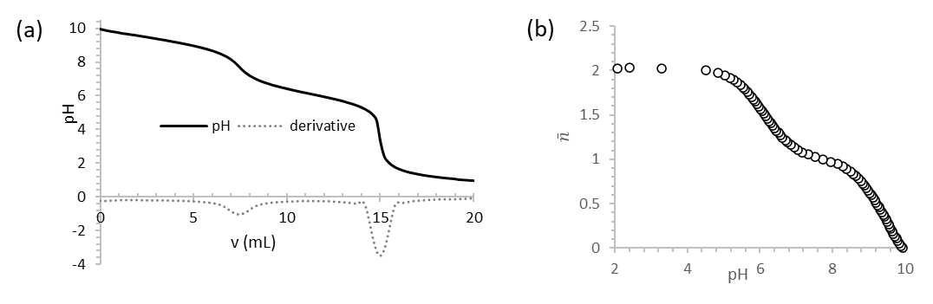
Fig. S1.
Titration curve of aqueous EEMPA 0.37 M with aqueous HCl 0,5 M (a) and plot the protonation state of E(0) vs pH in aqueous medium (Inflection points correspond to) the pK_{a} value (b).

Gaz-liquid partition
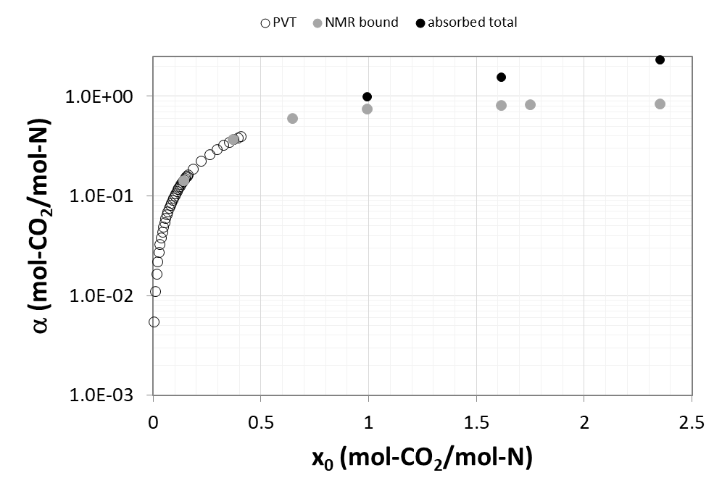
Fig. S2.
EEMPA CO₂ binding isotherm. Plot of the chemical loading α vs initial CO₂/EEMPA stoichiometry x₀. Empty circles : PVT measurements. Full dots : q¹³C NMR data (black : including dissolved CO₂; grey : without dissolved CO₂). Perfect match between PVT (white dots) and q¹³C NMR measurements (grey dots) cross-validates both quantification methods.

According to IUPAC recommendations, the binding isotherms is defined by the relation, at constant temperature, between α, the fraction of ligand (herein CO₂) bound to a receptor (herein EEMPA) vs the amount of unabsorbed ligand (herein free CO₂ in the headspace) noted x(unbound). In most set-ups (in particular those devoted to adsorption of CO₂ on solid material), the gas is supplied in large excess so that the amount bound can be neglected with respect to the global reservoir. This lead most authors to approximate the amount of unbound gas to the total amount of gas introduced, i.e. the equilibrium partial pressure P*_{f} and the initial partial pressure P*₀. Equilibrium pressure measurements confirmed the linear relationship in our set up between x(unbound) and x₀ (Fig. S3). This validates our systematic use of x₀ as the x-axis of binding isotherms.

Fig. S3.
Gas/liquid CO₂ partition upon EEMPA loading. molar fraction of CO₂ in the headspace x(headspace) derived from pressure measurements vs initial CO₂ to EEMPA molar fraction x₀.

P*_{f} can extrapolated from x_{unbound}, the molar fraction of CO₂ which was neither dissolved in EEMPA (physically captured) nor reacted with EEMPA (chemically bound). This fraction was calculated by subtracting the total amount of CO₂ initially introduced measured by gravimetry to the molar amount CO₂ bound into the liquid phase measured by q¹³C NMR. P*₀ can be measured independently (see PVT measurement section) and was found to correlate with x₀ through the perfect gas law within less than 2% deviation. Therefore, the same law could reasonably be applied to evaluate P_{f} from n_{f}.

Fig. S4.
Relationship between initial partial pressure in CO₂ P₀* and equilibrium/final partial P_{f}* pressure in CO₂ in our setup monitored experimentally.

Polarity measurements
Fig. S5. Polarity measurement on neat EEMPA samples upon gradual CO₂ loading. (a) Nitrogen isotropic hyperfine coupling constant a_{N} as a function of dielectric constant for solutions of Tempol in various polar non-hydroxylic solvents including EEMPA at α = 0, 25 and 36 mol% CO₂ loading. (b) Comparison of the Nile Red dye λ_{max} and the dielectric constant calculated through EPR as a function of CO₂ loading.

Free EEMPA has a polarity like PPG-1200 with an absorption maximum of 526 nm. CO₂ loaded EEMPA exhibited a red shift in the absorbance spectrum. At 25 mol% CO₂ and 36 mol % CO₂ loading, the absorbance maximum are located at 530 and 533 nm, respectively, which indicates an increase in polarity of the medium. Based on the nile red λ_{max} values, the EEMPA solvent polarity shifts from a nile red similar to PPG-1200 to t-butanol (5.0 Mpa CO₂, 25 °C) in the loading range mentioned above.

The nitrogen isotropic hyperfine coupling constant, a_{N}, was measured for EEMPA, 25 mol % CO₂-loaded EEMPA, and 36 mol % CO₂-loaded EEMPA. As the CO₂ loading increased, a_{N} increased from an initial value of 15.46 to 15.54 and 15.60 for 25 mol% and 36 mol% CO₂ respectively. The increase of a_{N} with CO₂ loading was expected from Nile Red experiments as a_{N} is known to increase with increasing solvent polarity due to the stabilization of the nitroxide radical. a_{N} was found to linearly correlate with the various solvent polarity parameters: Wertheim parameter (μρ ln ε/MW), dielectric constant (ε) and the Dimroth-Reichardt parameter (E_{T­}30) ²⁸. The dielectric constant of EEMPA, 25 mol % CO₂-loaded EEMPA and 36 mol % CO₂-loaded EEMPA was extrapolated from the linear relationship between the dielectric constant of polar non-hydroxylic solvents that include ethyl acetate, acetonitrile and dimethyl sulfoxide (DMSO) and a_{N} shown in Fig. S5a. The linear regression presented in literature gave a better fitting with r = 0.963 with an intercept of 15.45 and a slope of 0.0062 ²⁸. The dielectric constant of EEMPA increases from 1.92 to 15.47 and 24.2 with 25 mol% and 36 mol% CO₂ loading, respectively, due to the formation of charged species.

Comparison of the dielectric constant calculated through the EPR technique to the solvatochromic technique using Nile red dye show the same trend with increasing CO₂ loading, shown in Fig. S5b. The trend confirms the increasing polarity of EEMPA as CO₂ loading increased.
Binding isotherms

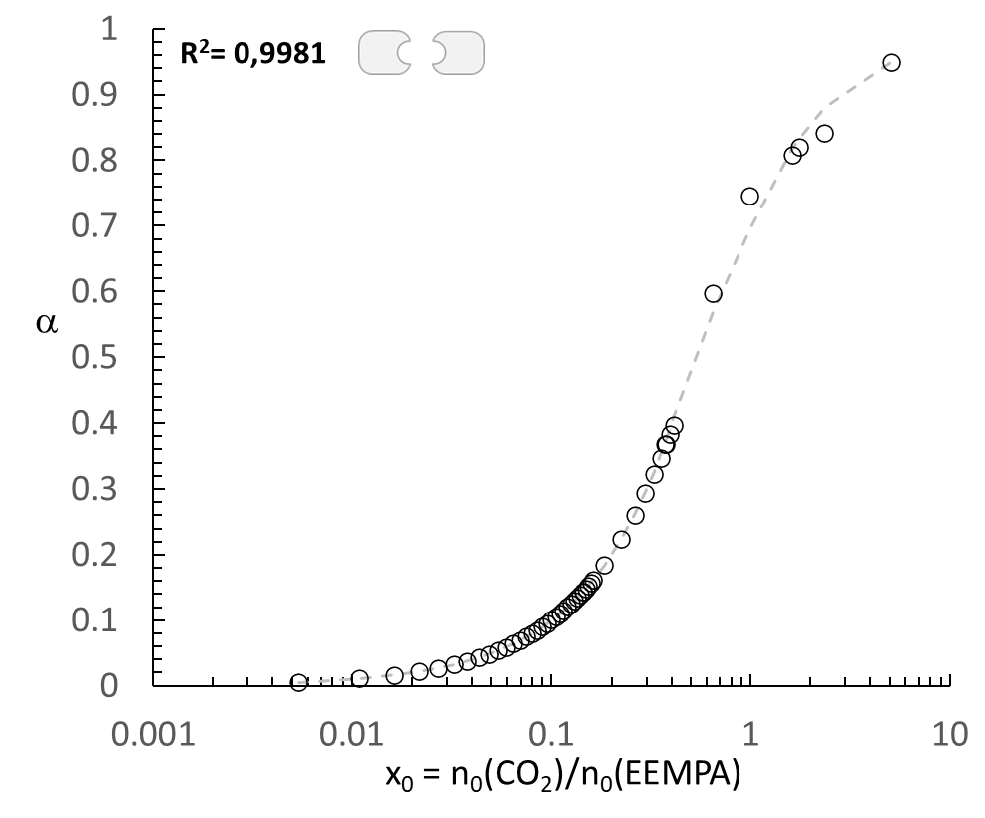
Fig. S6. Fitting of the experimental chemical loading α values (circles) with increasing CO₂/EEMPA stoichiometries x₀ with the dimeric model and resulting RMSD value.

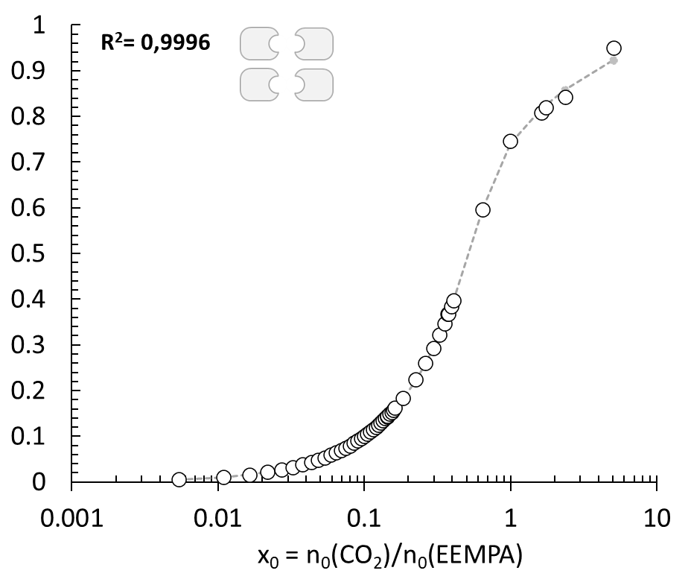
Fig. S7. Fitting of the experimental chemical loading α values (circles) with increasing CO₂/EEMPA stoichiometries x₀ with the tetrameric model and resulting RMSD value.

NMR speciation

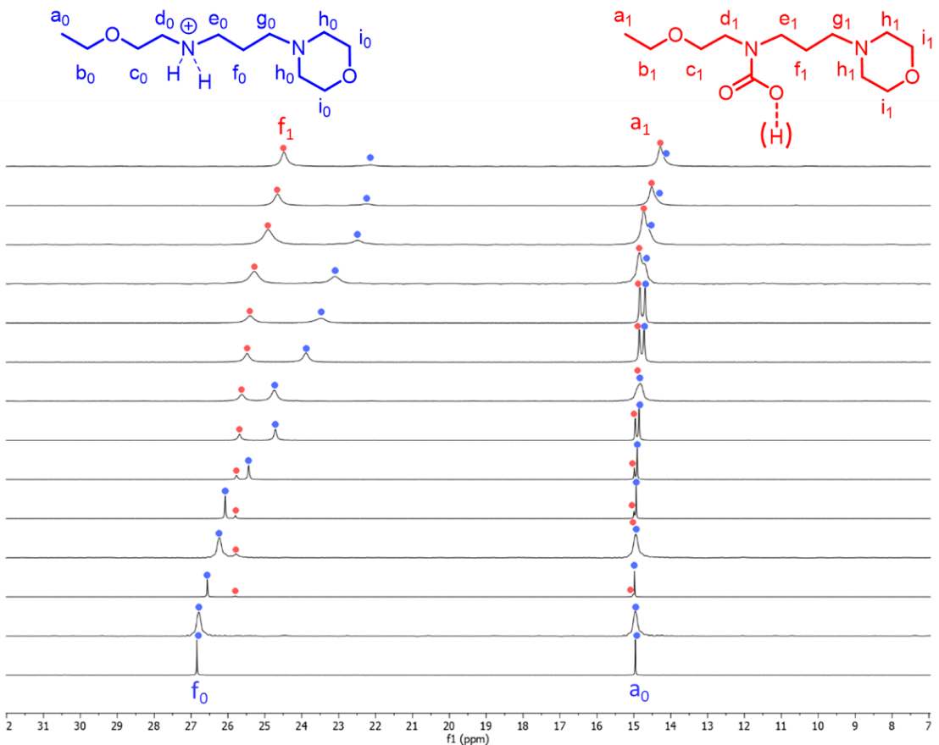
Fig. S8. q¹³C NMR stacked spectra of EEMPA upon gradual loading with CO₂ (bottom to top, see table S6 for values) focused on nuclei C_{a} and C_{f}. Blue : E(0)⁽⁺⁾, Red : E(1)⁽⁻⁾

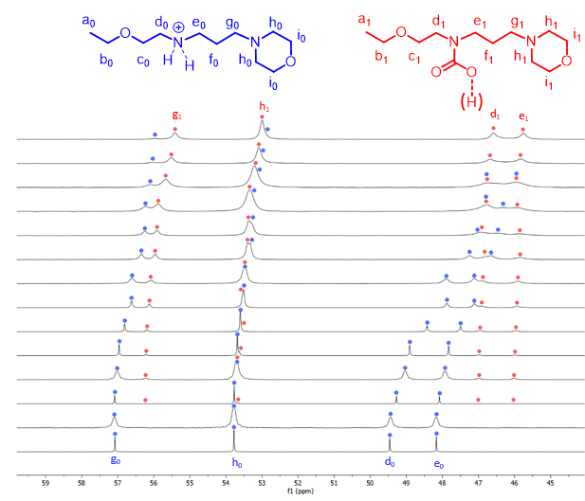
Fig. S9. q¹³C NMR stacked spectra of EEMPA upon gradual loading with CO₂ (bottom to top, see table S6 for values) focused on nuclei C_{d}, C_{d}, C_{g} and C_{h}. Blue : E(0)⁽⁺⁾, Red : E(1)⁽⁻⁾
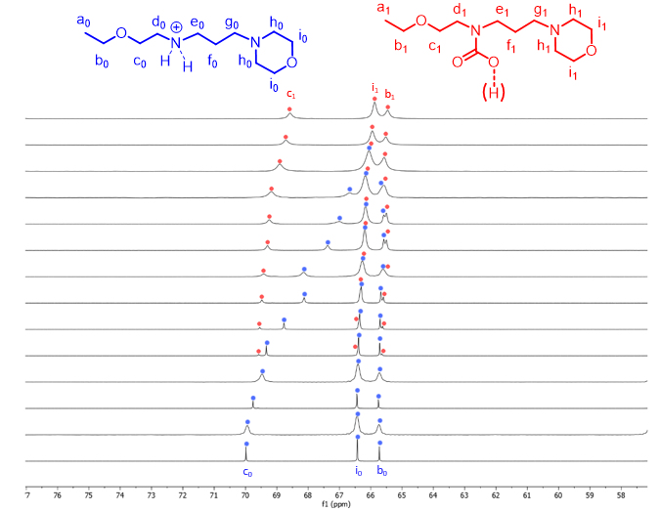
Fig. S10. q¹³C NMR stacked spectra of EEMPA upon gradual loading with CO₂ (bottom to top, see table S6 for values) focused on nuclei C_{b}, C_{c} and C_{i}. Blue : E(0)⁽⁺⁾, Red : E(1)⁽⁻⁾

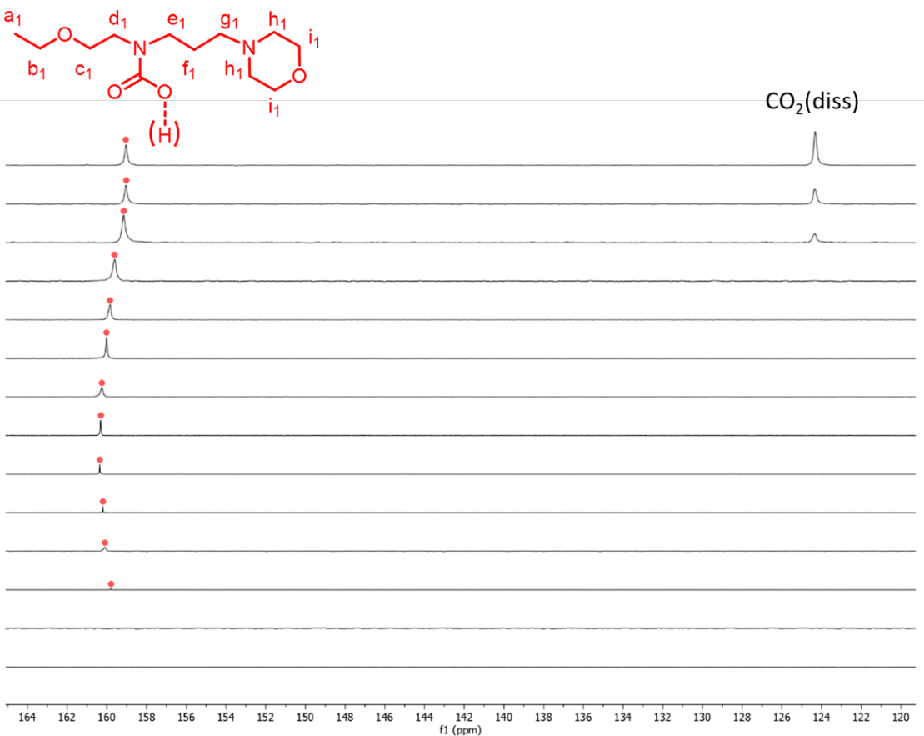
Fig. S11. q¹³C NMR stacked spectra of EEMPA upon gradual loading with CO₂ (bottom to top, see table S6 for values) focused on carbonyl and dissolved CO₂ signals. Blue : E(0)⁽⁺⁾, Red : E(1)⁽⁻⁾

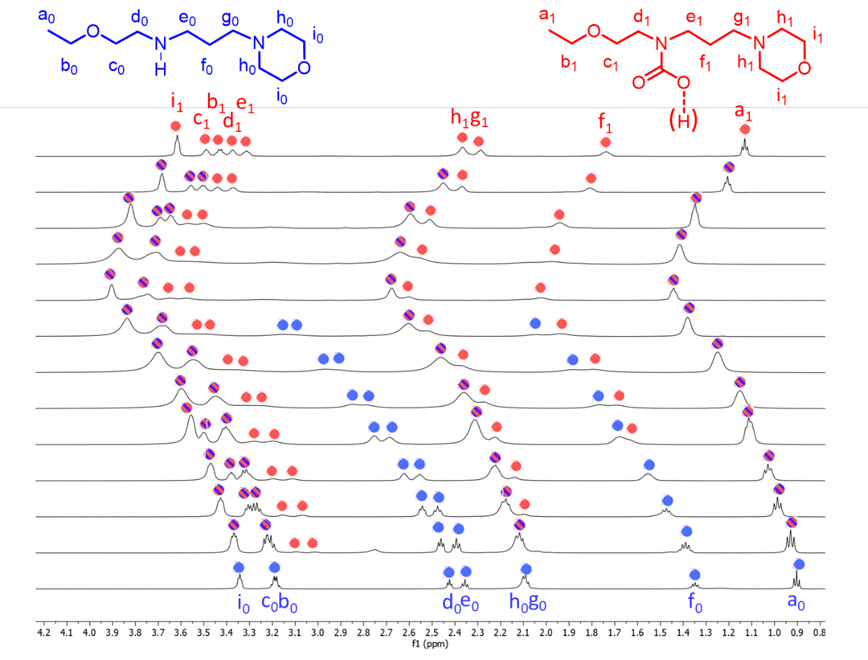
Fig. S12. q¹H NMR stacked spectra of EEMPA upon gradual loading with CO₂ (bottom to top, see table S6 for values) focused on CH signals (0.8 – 4.2 ppm).

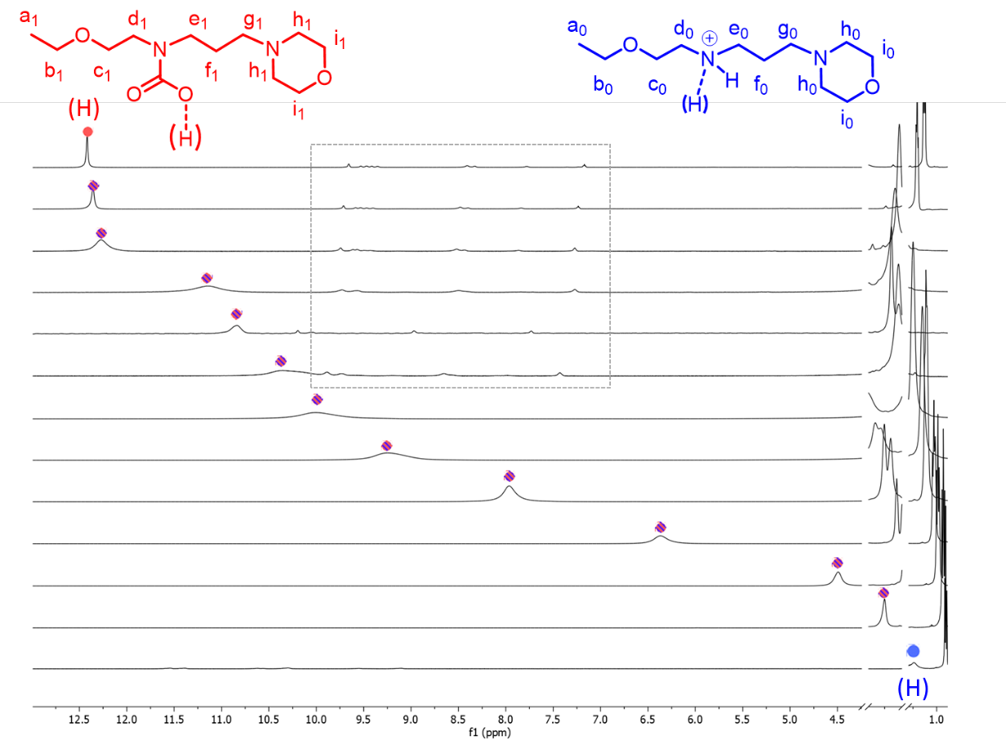
Fig. S13. q¹H NMR stacked spectra of EEMPA upon gradual loading with CO₂ (bottom to top, see table S6 for values) focused on XH signals (X = N, O; 2.5 – 13 ppm).

¹³C-NMR spectra of the carbamic acid E(1)

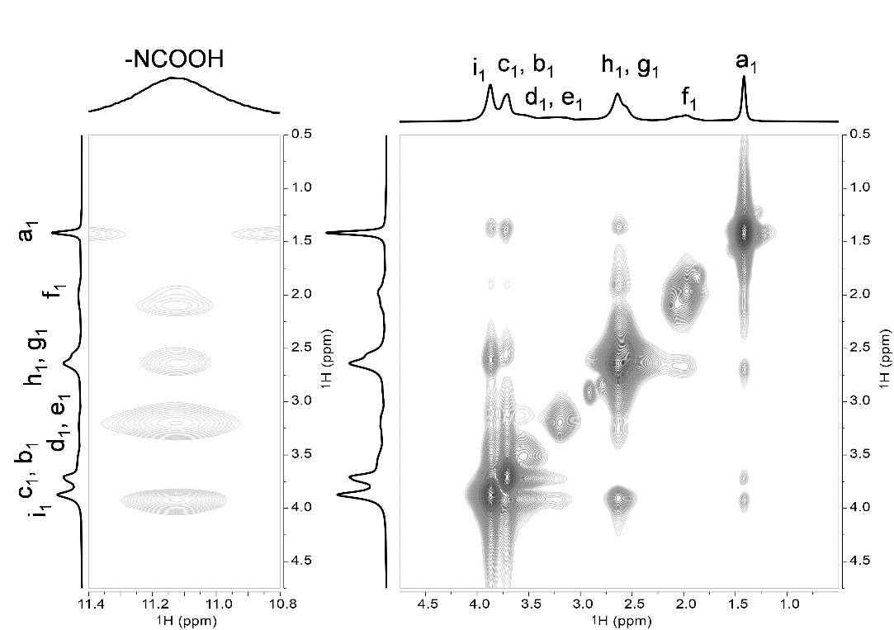
Fig. S14. ¹H-¹H NOESY NMR spectra of EEMPA and CO₂ (α =0.95) at a mixing time of 10 ms.

This experiment reveals that the carbamic acid proton is closer to a morpholine ring (the correlation between NCOOH and f, e, g, h, i, j, k, as well as the lack of correlation between NCOOH and a, b, c, d). These correlations between a and j, k are consistent with the tetrameric clustering into reverse micelles-like architectures.
Fig. S15. ¹³C-¹³C 2D EXSY spectra of CO₂-EEMPA (α = 0.95) at a mixing time of 50 ms. cross-peak correlation indicate an equilibrium process between carbamic acid E(1) (159 ppm) and dissolved CO₂ (125.2 ppm) but not between carbamic acid E(1) and CO₂ gas (124.8 ppm).
Fig S16. Effect of spinning on the carbamate E(1)⁻ + dissolved CO₂ to carbamic acid E(1) conversion. ¹³C of EEMPA and ¹³C-enriched CO₂, at P*₀ = 1 bar (x₀ = α = 0.47) in static (a) and MAS conditions (b) and at P*₀ = 20 bars (x₀ = 0.99, α = 0.75) in static (c) and MAS conditions (d).
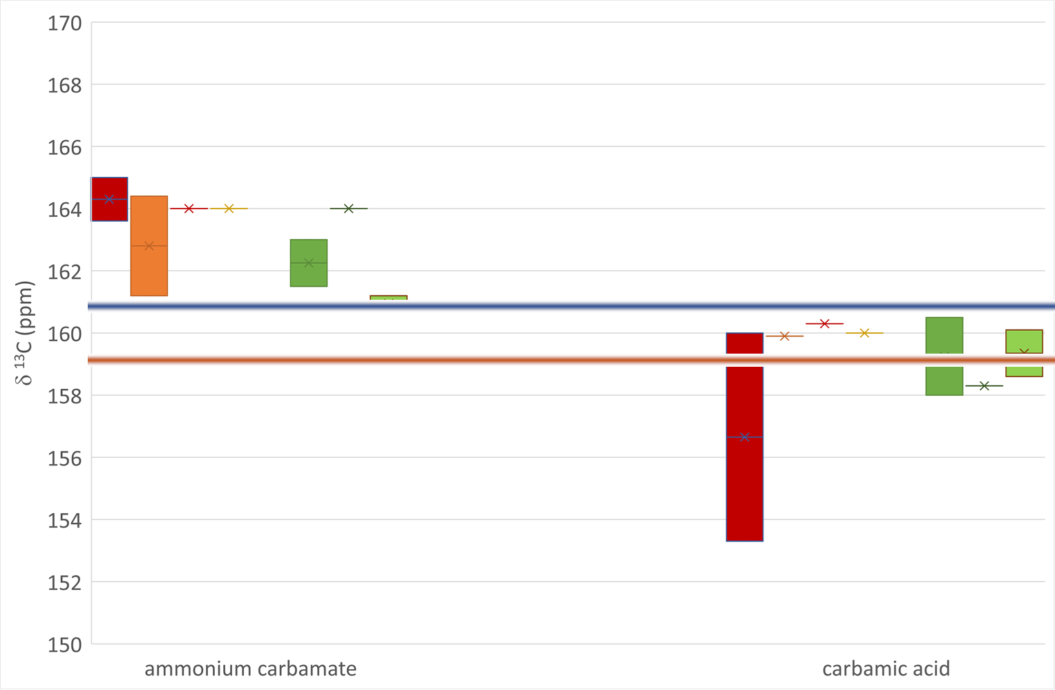
Fig S17. Literature survey (histogram) of ¹³C NMR shift of CO signals of amine-CO₂ adducts in porous solids²⁹ (red-orange) and organic solutions^{30,31} (green) by category of adduct : ammonium carbamate (left) and carbamic acid (right) and comparison with measured values in the present study (horizontal lines : values obtained in this work ; blue : ammonium carbamate; red : carbamic acid; size of the bar reflect the dispersity of the reported values).

Fitted NMR data
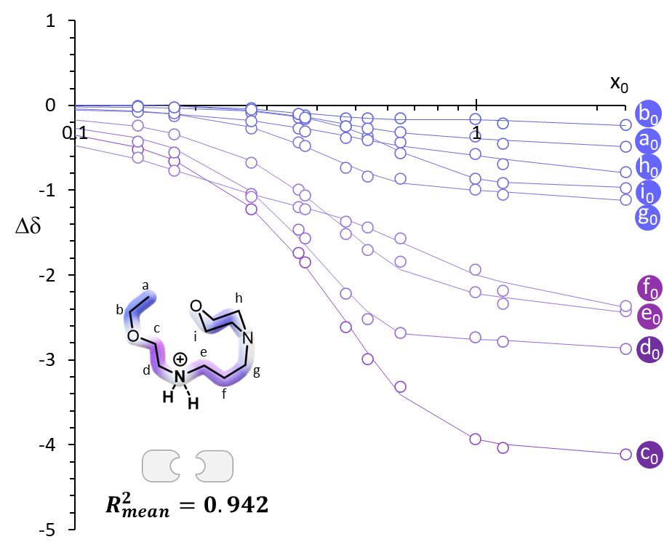
Fig. S18. Plot of the Chemical shift perturbation (CSP) Δδ(i) of the ¹³C nuclei of unloaded E(0)⁽⁺⁾ upon loading with increasing CO₂/EEMPA stoichiometries x₀. Color code reflects the amplitude of perturbation. Dots : experimental data. Line : thermodynamic dimer model from Matlab fitting. R²mean = 0.942 is calculated as the average standard deviation of the full fit series displayed in Fig. S18+S19.
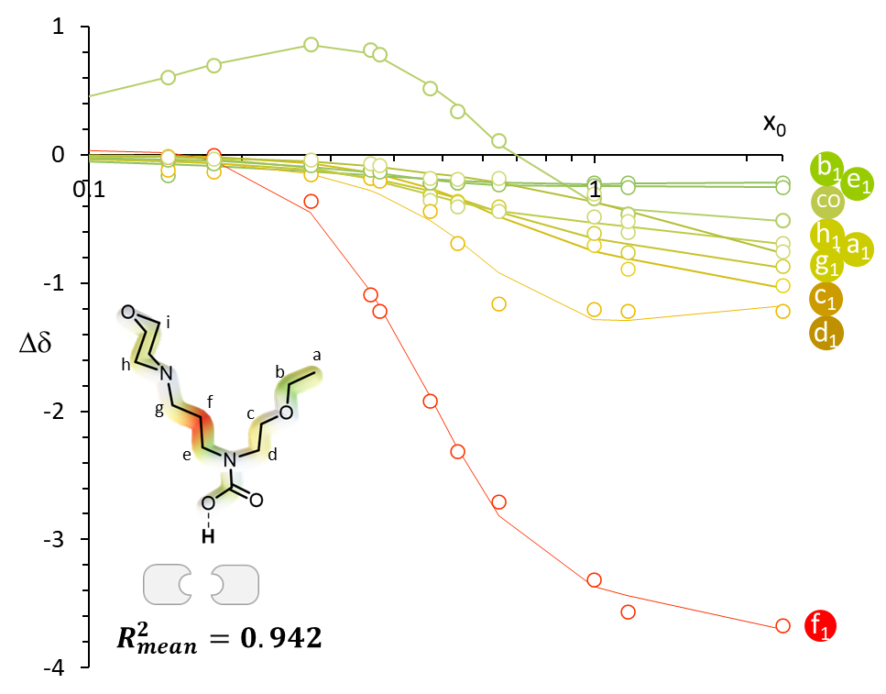
Fig. S19. Plot of the Chemical shift perturbation (CSP) Δδ(i) of the ¹³C nuclei of loaded EEMPA E(1)⁽⁻⁾ upon loading with increasing CO₂/EEMPA stoichiometries x₀. Color code reflects the amplitude of perturbation. Dots : experimental data. Line : thermodynamic dimer model from Matlab fitting. R²mean = 0.942 is calculated as the average standard deviation of the full fit series displayed in Fig S18+S19.

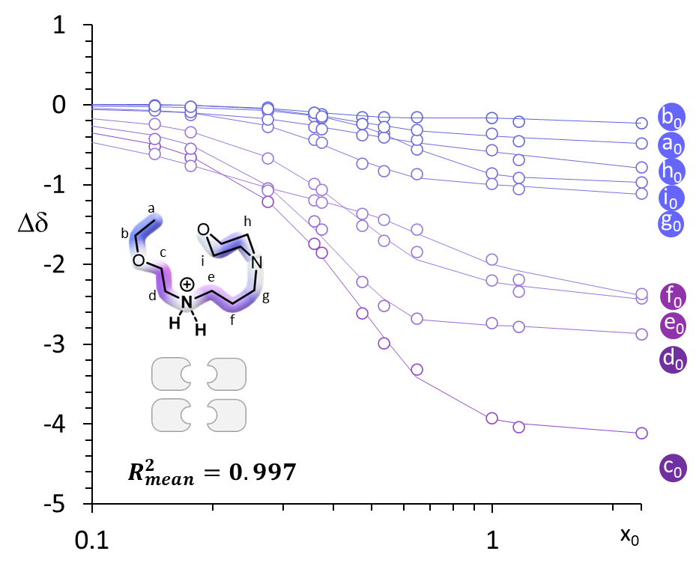
Fig. S20. Plot of the Chemical shift perturbation (CSP) Δδ(i) of the ¹³C nuclei of unloaded E(0)⁽⁺⁾ upon loading with increasing CO₂/EEMPA stoichiometries x₀. Color code reflects the amplitude of perturbation. Dots : experimental data. Line : thermodynamic tetramer model from Matlab fitting. R²mean = 0.997 is calculated as the average standard deviation of the full fit series displayed in Fig S20+S21.
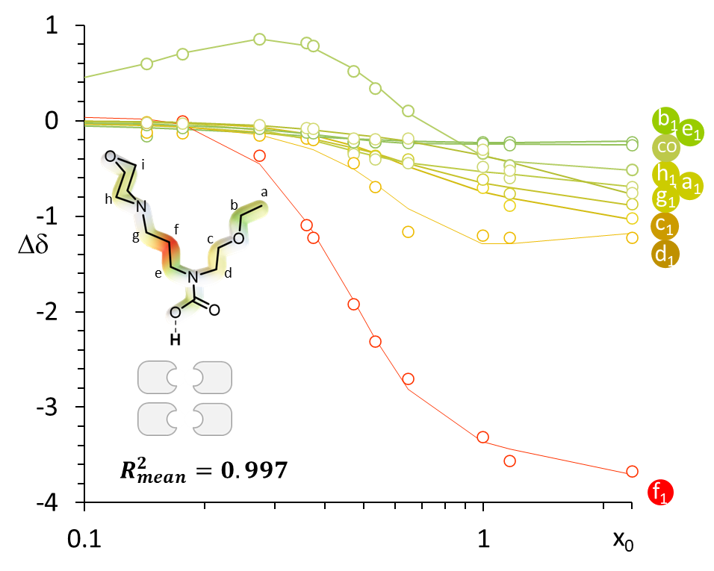
Fig. S21. Plot of the Chemical shift perturbation (CSP) Δδ(i) of the ¹³C nuclei of loaded EEMPA E(1)⁽⁻⁾ upon loading with increasing CO₂/EEMPA stoichiometries x₀. Color code reflects the amplitude of perturbation. Dots : experimental data. Line : thermodynamic tetrameric model from Matlab fitting. R²mean = 0.997 is calculated as the average standard deviation of the full fit series displayed in Fig. S18+S19.

Speciation models
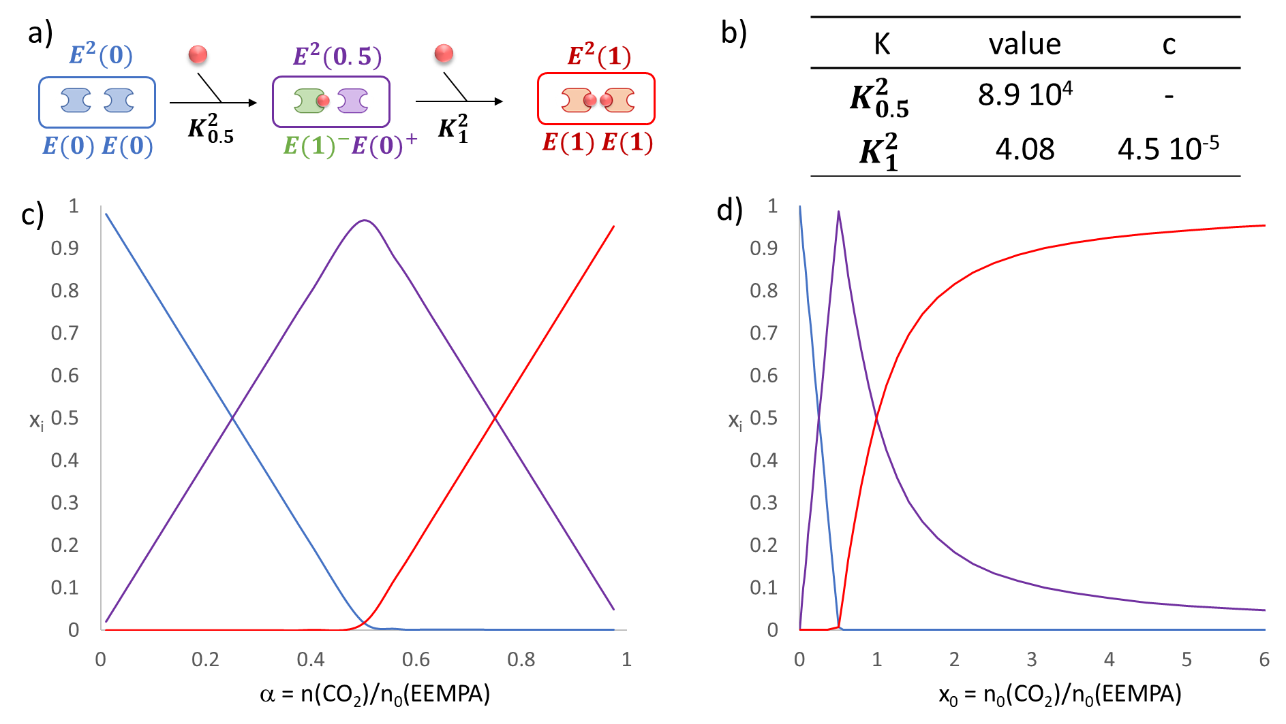
Fig. S22. Dimeric model used to fit the NMR data displayed at Fig. S18 and S19 (a) and equilibrium constant obtained (b) (c indicates the cooperativity factor, see ³² and speciation resulting from the model plotted as a function of the chemical loading α (c) or initial stoichiometry x₀ (d). This model predicts that the carbamic acid E(1) is only present from α = 0.5.

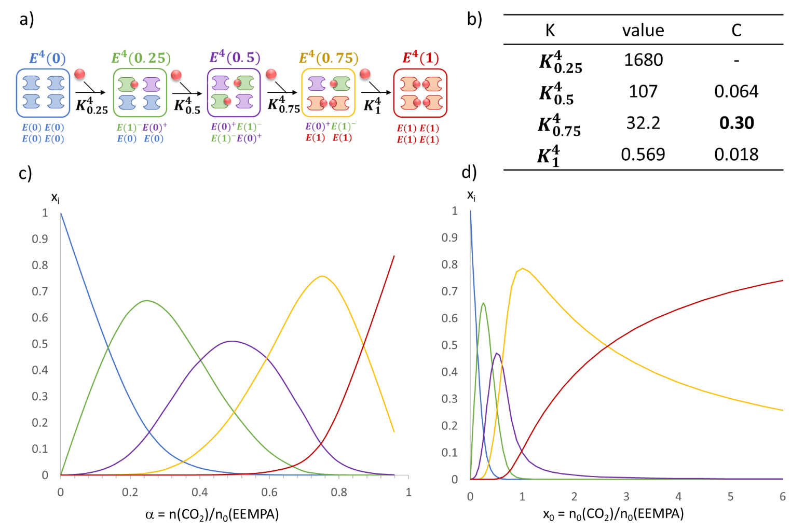
Fig. S23. Tetrameric model used to fit the NMR data displayed at Fig. S20 and S21 (a) and equilibrium constant obtained (b) (c indicates the cooperativity factor, see ref) and speciation resulting from the model plotted as a function of the chemical loading α or initial stoichiometry x₀. This model predicts that the carbamic acid E(1) is present from α = 0.2.

FT-IR data
Fig. S24. FT-IR spectra of EEMPA during pressurized loading CO₂ and depressurization. Absorbance spectra of EEMPA during increasing CO₂ loading (green : 0.27, purple : 0.58, yellow: 0.89 and red : 0.92; colour code correspond to speciation displayed at Fig S23). (b) Absorbance spectra of EEMPA during depressurization from a CO₂ loading of 0.92 (red) to 0.27 upon progressive depressurization

The pattern of signals obtained in FT-IR with EEMPA at low CO₂ loading is constituted of two overlaying peaks in the carbonyl region (around 1655 cm⁻¹ and 1682, for α = 027, wherein the singly occupied (green) tetramer E⁴(0.25) is the main species). This band becomes narrower as the CO₂ pressure in the Parr reactor and the loading increased (up to a = 0.92, from green to red, Fig. S24a). Depressurization of the Parr reactor (Fig S24b) to release CO₂ causes the band at 1682 cm⁻¹ to reform as the band at 1655 cm⁻¹ to decrease until it fully disappears. Interpretation of this phenomenon is proposed at Fig S25.
Fig. S25. Reported carbonyl stretching frequency in FT-IR spectroscopy for carboxylic species (grey) ³³ and carbamates as isolated^{34,35} or herein paired species? X+ is the counter-ion which accompanies the carbamate/carbamate. Unusual decrease of the CO stretching frequency for EEMPA between α = 0.3 – 0.9 is attributed to E⁴(0.5) + CO₂ -> E⁴(0.75) which corresponds to the conversion of two (ammonium) carbamates into (ammonium) carbamate – carbamic acid pair. Symmetrical and unsymmetrical modes have radically different intensities and only the first one is detected

WAXS data

Fig. S26. WAXS data comparison of unloaded and CO₂-loaded EEMPA at STP, against pressure-induced CO₂ loading (α) structural data.
Medium range ordering (MRO) with periodicity of ~12 Å begins to appear at low Q for α from 0.58 - 0.72. The MRO becomes better defined at higher pressures for α from 0.58 – 0.86. The I(Q=0) value, which is proportional to isothermal compressibility, initially increases as unbound CO₂ expands cavities within the solvent yet drops once the new high-pressure tetramer binds locally available CO₂. The curves α: 0.03-0.86 are vertically offset by 0.01 cm⁻¹ on the plot for clarity. The CO₂-loaded EEMPA at STP is offset by 0.062 to align with the α=0.36 curve.

Fig. S27. Amphiphilicity factor dependence on CO₂ concentration in EEMPA.
During initial CO₂ incorporation, the interface becomes less defined up to α = 0.36, when the structure contains similar quantities of the different CO₂-bound species and as well as gas phase CO₂. Increased pressure drives the system to the primary CO₂-loaded tetramer state and the interfaces demarcating the regions of unique binding chemistry are better defined with f_{a} ~ -0.8.

DFT-computed clustering and absorption energies
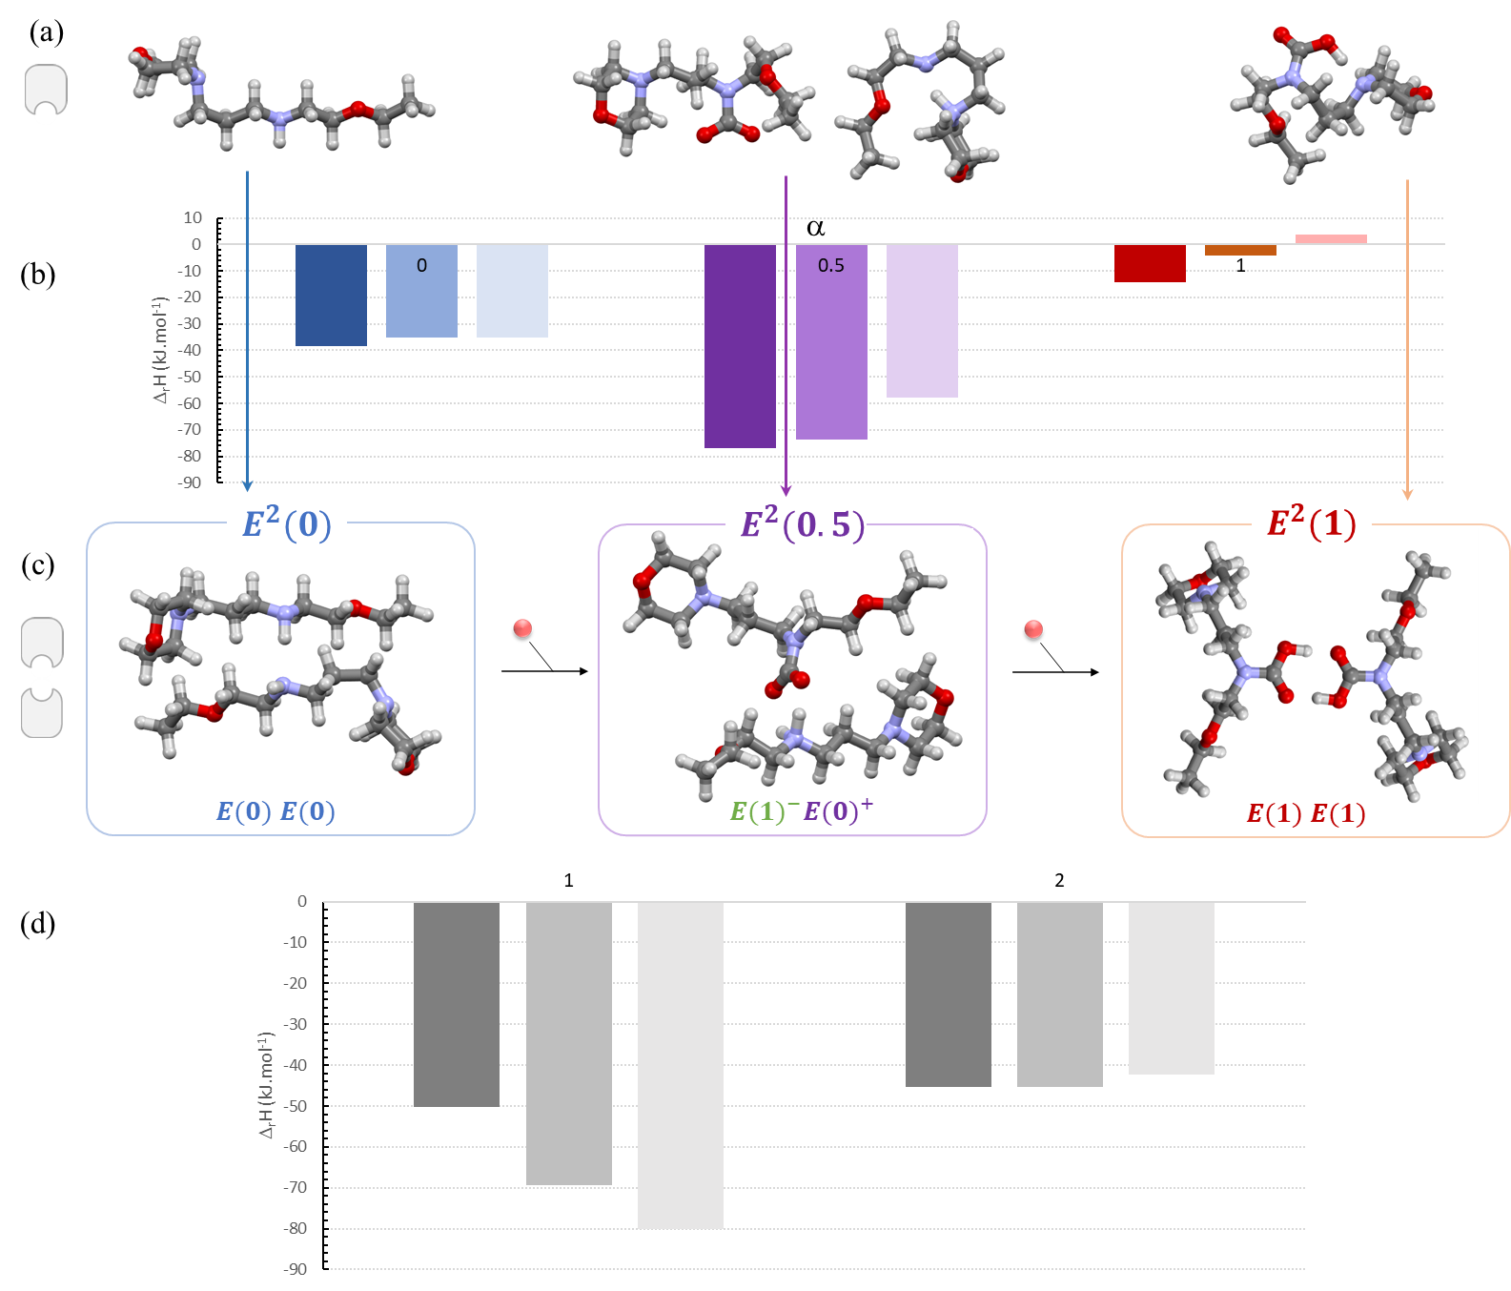
Fig. S28. DFT modelling of EEMPA-CO₂ adducts and absorption enthalpies: (a) optimized structures of monomeric constituents (in DMF) and their dimerization enthalpy (b) into corresponding optimized structures (c, in DMF) and successive enthalpies of CO₂ absorption (d) (Atom color code : C (black), H (white), O (red), N (blue); histogram implicit solvent code : DMF (light), t-butanol (medium), propanol (dark). Although all structures were minimized in the three solvents, the choice was made to display minimized structures in the most dissociative one (DMF).

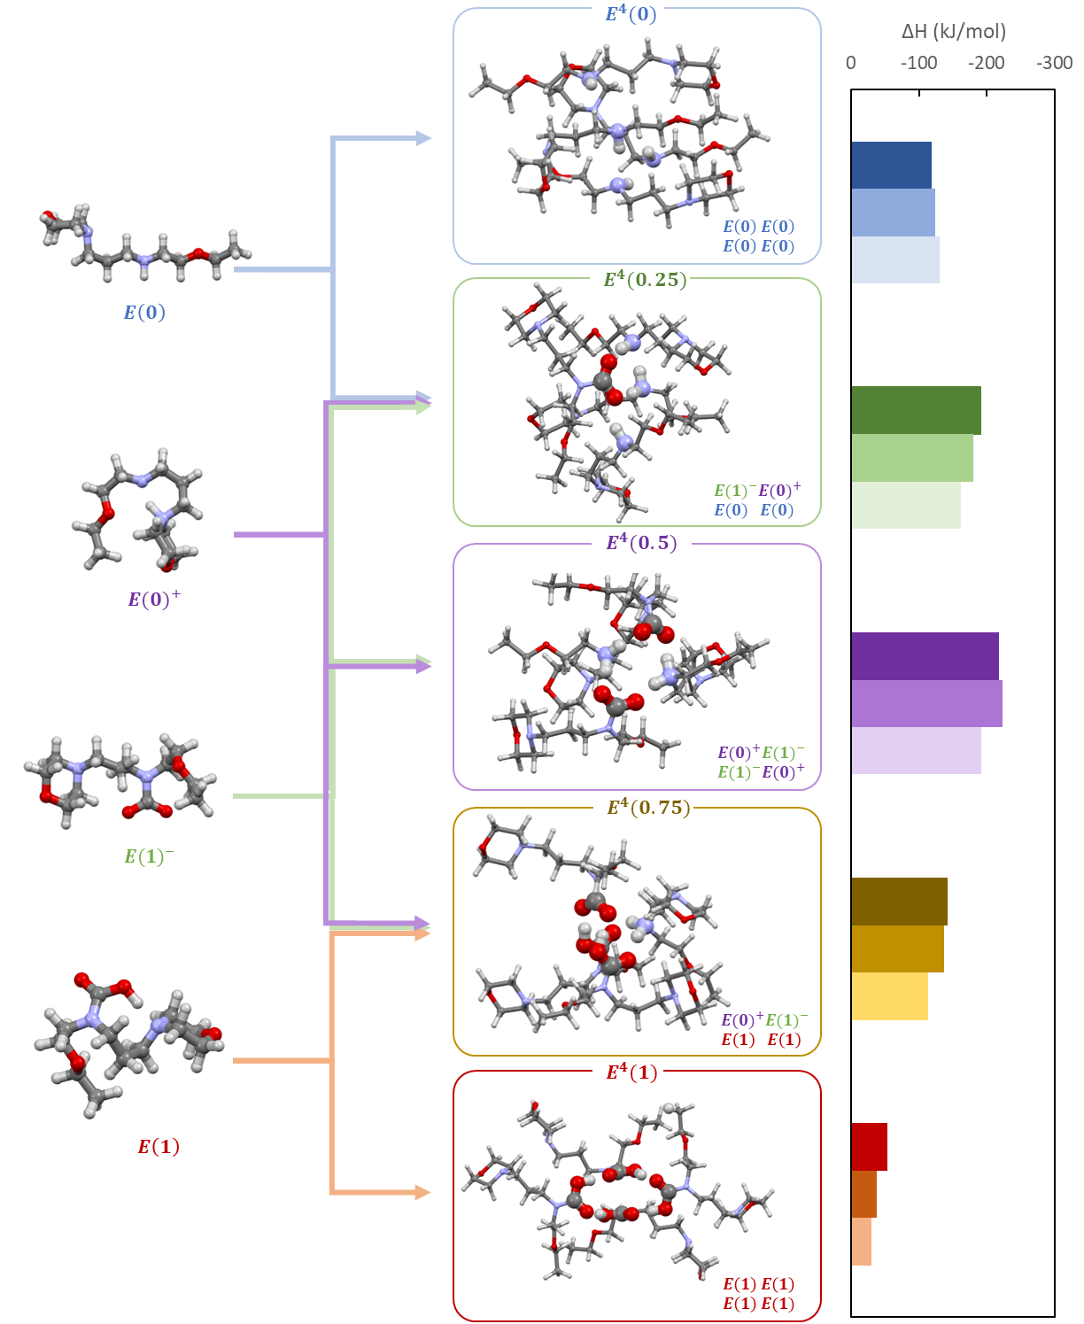
Fig. S29. DFT modelling of EEMPA-CO₂ adducts and self-assembling enthalpies. Optimized structures of monomeric constituents (in DMF, left) and their tetramerization enthalpy (right) into corresponding optimized structures (in DMF, middle) (Atom color code : C (black), H (white), O (red), N (blue); histogram implicit solvent code : DMF (light), t-butanol (medium), propanol (dark). Although all structures were minimized in the three solvents, the choice was made to display minimized structures in the most dissociative one (DMF).

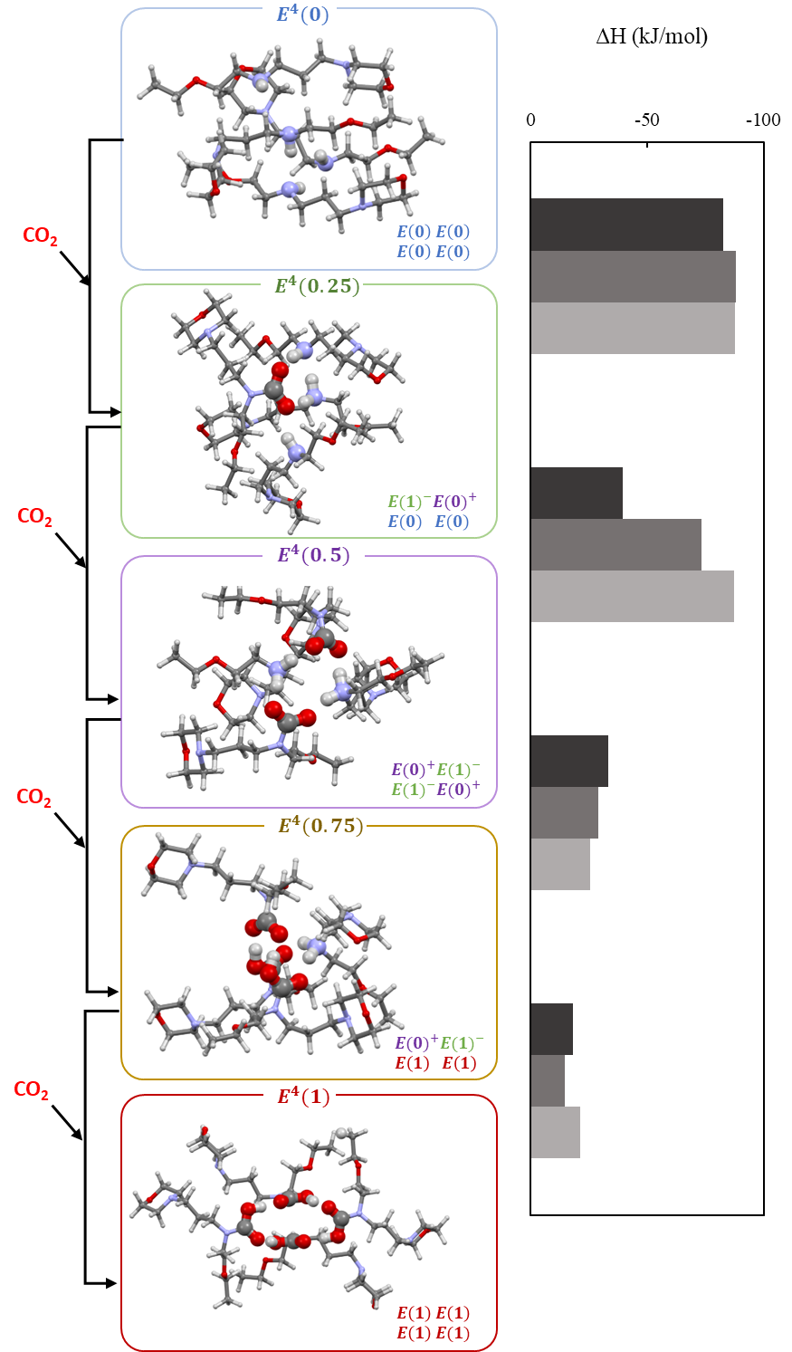
Fig. S30. DFT modelling of CO₂ absorption by self-assembled tetramers. Optimized structures of monomeric constituents (in DMF, left) and their CO₂ absorption enthalpy (right) (Atom color code : C (black), H (white), O (red), N (blue); histogram implicit solvent code : DMF (light), t-butanol (medium), propanol (dark). Although all structures were minimized in the three solvents, the choice was made to display minimized structures in the most dissociative one (DMF).
Structural data from DFT calculations
Fig. S31. DFT modelling of self-assembled tetramers in DMF and quantification of their morphological features. Minimized structures of E⁴(0.5) (a), E⁴(1) (b) and of their internal reactive sites (c) and (d). These dimension as well as the computed sizes of tetramer clusters (left bars) and their cavities (right bars) quantified by gyradius (e) match experimental values obtained by WAXS (see Fig.3). (atom color code : blue : nitrogen, red : oxygen; black : carbon; white : hydrogen).

AIMD data for Tetrameric Structures as a function of time at 25% CO₂ loading

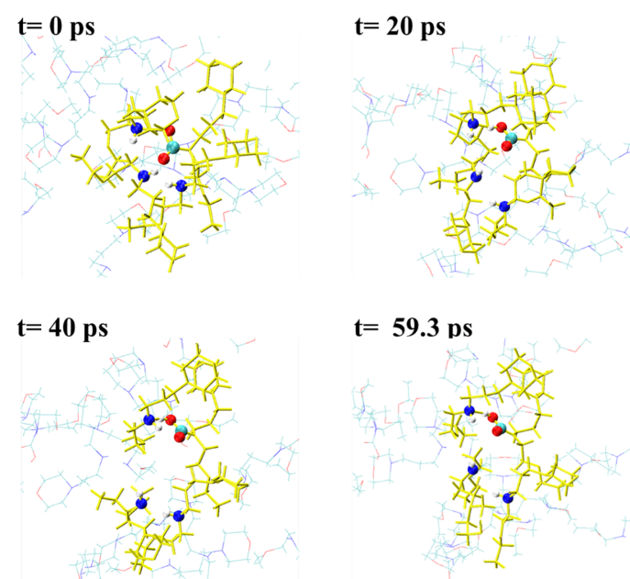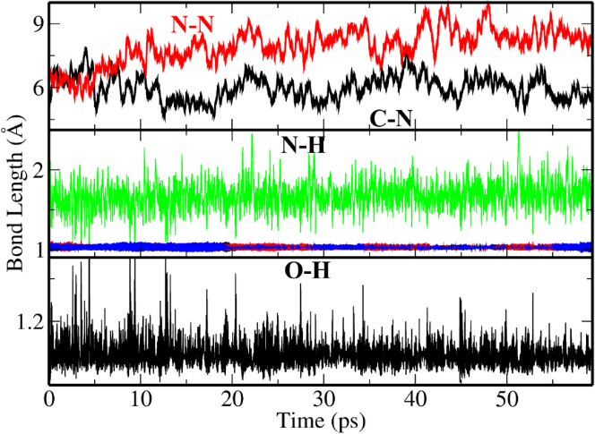
Figure S32. (top) Snapshots of AIMD simulations of E₄(0.25) at different time. (bottom) The dynamics of bond lengths for atoms in the pocket highlighted in the top panel. The tetramer involving one CO₂-loaded EEMPA is stable over ~59 ps in full agreement with the NMR model. The C-N bond length is ~6 Å whereas N-N distances are around 8 Å.

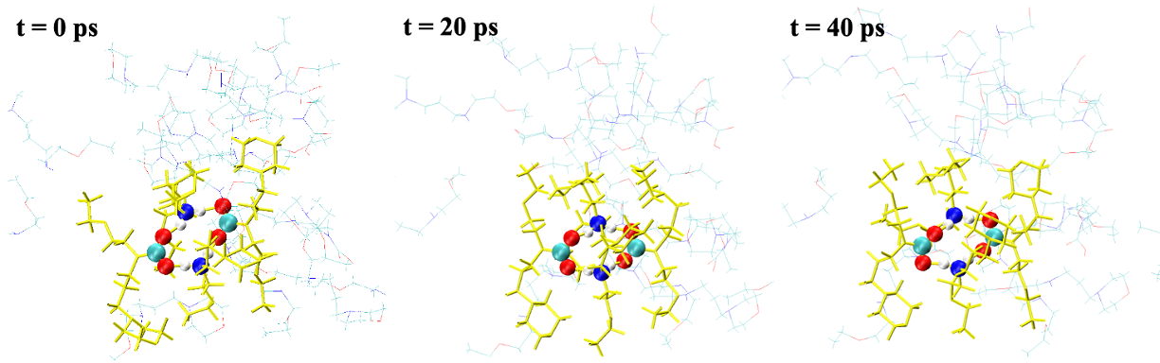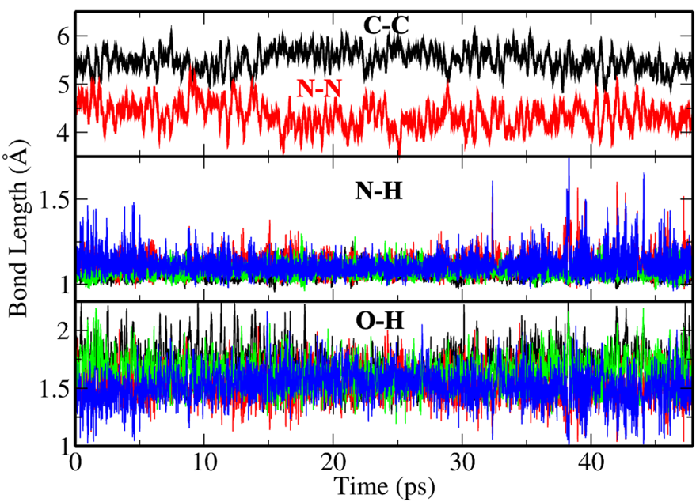
Figure S33. (top) Snapshots of AIMD simulations of E⁴(0.5). at different time. (bottom) The dynamics of bond lengths for atoms in the pocket highlighted in the top panel. The tetramer involving two CO₂-loaded EEMPA is quite stable over a timescale of ~48 ps (Figure 12). The C-C and N-N bond lengths are shown in Figure 13. We further analyzed the N-H and O-H bonds present in the tetramer. The N-H bonds are in the range 1.0-1.25 Å whereas the O-H bonds are in the range 1.4-2.1Å. This suggests that the core of the tetramer involving two CO₂ loaded EEMPA involves two salt bridges and 4 strong hydrogen bonds.

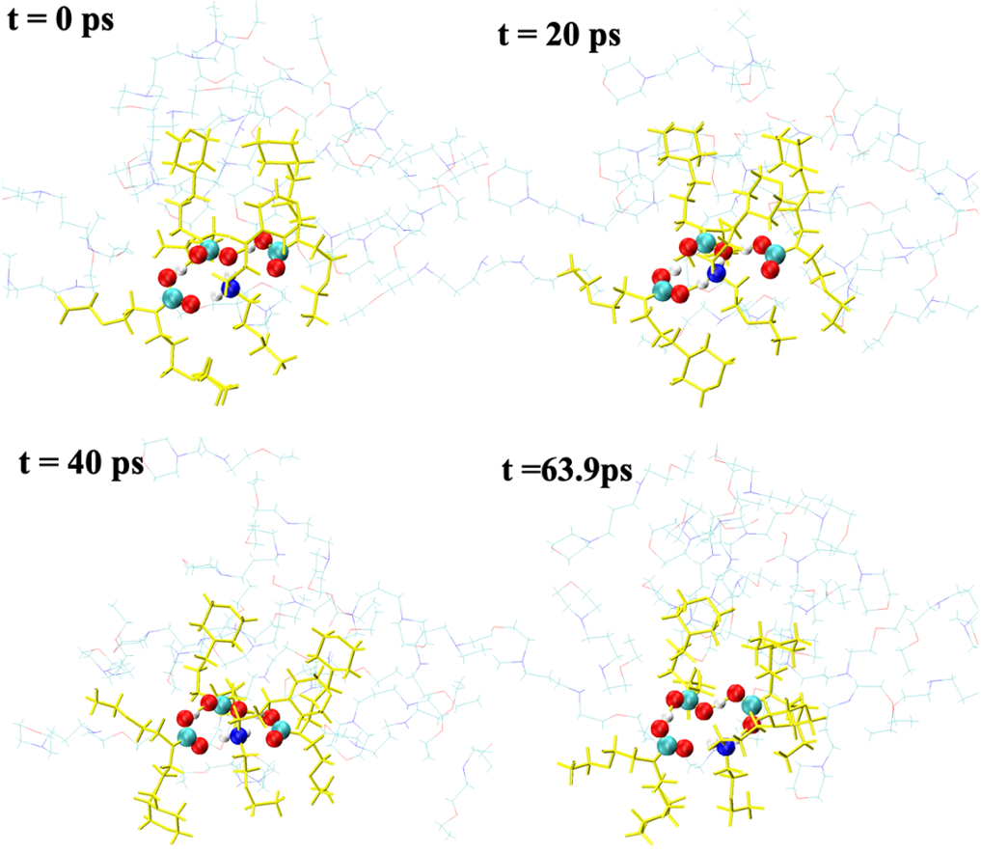
Figure S34. Snapshots of AIMD simulations of E⁴(0.75) at different times. Atoms in the tetramer pocket are highlighted. The tetramer involving 3 CO₂-loaded EEMPA constituents is quite dynamic at 25% CO₂-loading. It varies between a trimer like structure to a tetramer like structure at 298 K and low CO₂ loading. Thus, at low CO₂ loading, this tetramer will moderately favored. This agrees with the NMR-based speciation. E⁴(0.75) has one zwitterionic interaction and 4 hydrogen bonding interactions present.

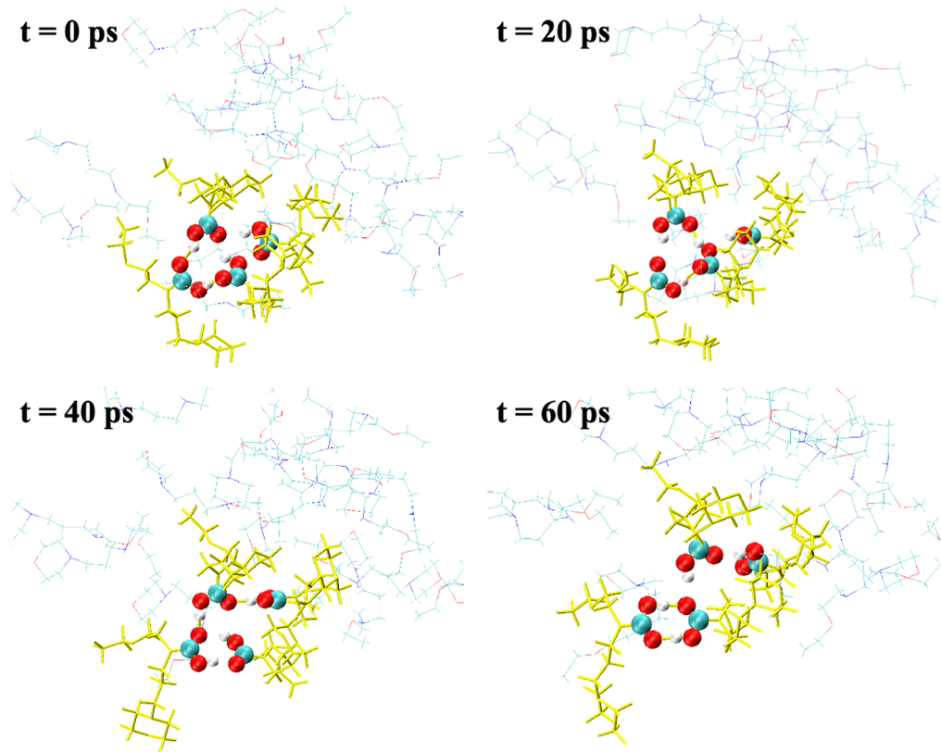
Figure S35. Snapshots of AIMD simulations in E⁴(1.0) of different times. Atoms in the tetramer pocket are highlighted. The tetramer involving four CO₂-loaded EEMPA constituents is unstable at 25% CO₂ loading. As shown in Fig. S35 the tetramer falls apart during the AIMD trajectory. This is consistent with experimental observation as well as cluster DFT calculations where we also see that the E⁴ (1.0) is unfavored at low CO₂ loading, and with the model obtained from NMR speciation.

¹³C NMR monitoring of E(2) decay
Fig S36. Extension of the 46-72 ppm region of the spectra during decay over time of the free anhydride from a = 0.96 (bottom spectrum) to a = 0.56 (top spectrum) as measured by relative f1 vs f0 integration. (Bottom spectrum : immediately after transfer, then every 10 min for the next six spectra; the last one was recorded 19h after transfer and correspond to equilibrium state at α = 0.56).

Fig. S37.Extension of the 15-28 ppm region of the spectra during decay over time of the free anhydride from a = 0.96 (bottom spectrum) to a = 0.56 (top spectrum) as measured by relative f₁ vs f₀ integration. (Bottom spectrum : immediately after transfer, then every 10 min for the next six spectra; the last one was recorded 19h after transfer and correspond to equilibrium state at α = 0.56).
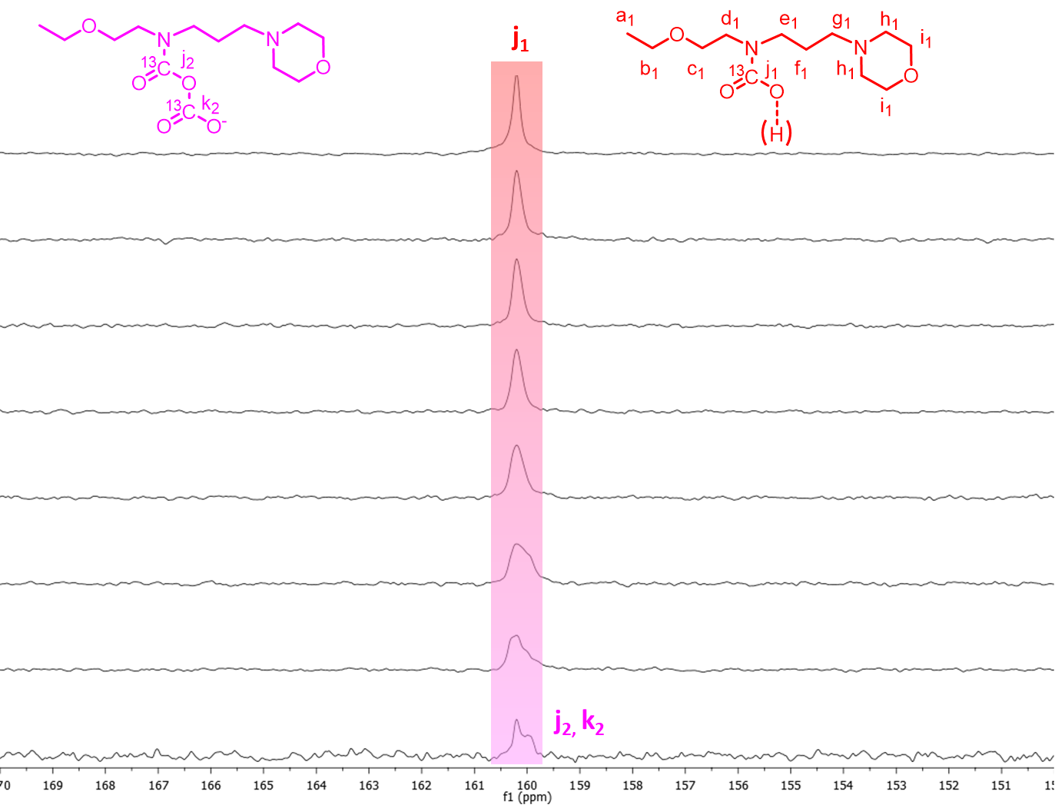
Fig. S38. Extension of the 15-28 ppm region of the spectra during decay over time of the free anhydride from a = 0.96 (bottom spectrum) to a = 0.56 (top spectrum) as measured by relative f₁ vs f₀ integration. (Bottom spectrum : immediately after transfer, then every 10 min for the next six spectra; the last one was recorded 19h after transfer and correspond to equilibrium state at α = 0.56).

DFT analysis of CO₂ absorption mechanisms from 50% loading state

Figure S39. DFT computed anhydride-based CO₂ absorption mechanisms by EEMPA (a) dimeric pathway, (b) tetrameric pathway. Three implicit solvent environments were considered. Structures displayed correspond to DMF as an implicit solvent.
Figure S40. DFT computed zwitterionic mechanisms of E⁴(0.5) + CO₂ -> E⁴(1) absorption step E⁴(0.5) + CO₂ -> E⁴(0.75) absorption step via the zwitterion intermediate E⁴(0.75)^{z} (a) and E⁴(0.75) + CO₂ -> E⁴(1) absorption step via the zwitterion intermediate E⁴(1)^{z}. Three implicit solvent environments were considered.

NMR and MS data of in situ and ex situ E(2)R formation
Fig. S41. ¹³C NMR spectra of crude mixture obtained from E, TMSCHN₂ and ¹³CO₂. See Fig. S42 for assignment of the signals below 80 ppm.
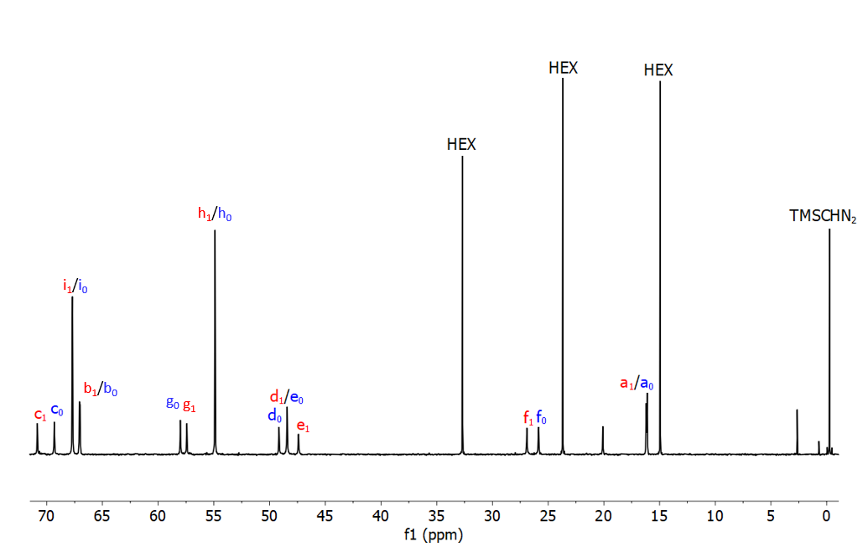Fig. S42. Extension of the aliphatic region with assignments of known signals (E(1)⁽⁺⁾ and E(0)⁽⁻⁾ are the major compounds). Unlabeled signals are postulated to belong to E-TMS, main side-product of the reaction when conducted in the absence of MeOH.

Fig. S43.¹H NMR of purified E(2)Me. For details about the assignment see Fig. S45.

Fig. S44. ¹³C NMR of purified (E(2)Me), including numbering scheme. Insert is the expansion of the carbonyl region in dark orange.

Fig. S45. Extension of the relevant region of the HSQC NMR of purified (E(2)Me). Numbers relate to protons/carbons as outlined in previous spectra. HSQC was recorded to establish short-range proton-carbon coupling (¹JCH) and assign ¹H signal displayed at Fig. S41.

Fig. S46. Extension of relevant region of HMBC NMR of purified (E(2)Me). Capital letters refer to carbon (C_{x}) nuclei, while lower case letters relate to protons (H_{x}). HMBC was recorded to establish long-range proton-carbon coupling (^{n}JCH) within ethylenic moieties (see double arrows). No conclusive correlation involving carbon j₂ and k₂ could be obtained.

Fig. S47. (-)-LR-TOF SIMS spectrum of purified E(2)Me. Found for [E(2)Me-H] (Calcd 317.2).

Fig. S48. (+)-HR-ESI/MS spectrum of purified E(2)Me. Found for E(2)MeH⁺ : 319.1840 (Calcd 319.1869) and E(2)Me₂⁺ : 333.1996 (calcd : 333.2026).

Fig. S49. 140-160 ppm region of the ¹³C NMR of E(2)^{t}Bu (orange) containing traces of E(1)^{t}Bu (red).

Fig. S50. 60-90 ppm region of the ¹³C NMR of E(2)^{t}Bu (orange) containing traces of E(1)^{t}Bu (red).

Fig. S51. 40-70 ppm region of the ¹³C NMR of E(2)^{t}Bu (orange) containing traces of E(1)^{t}Bu (red).

Figure S52. 10-40 ppm region of the ¹³C NMR of E(2)^{t}Bu (orange) containing traces of E(1)^{t}Bu (red). * and # respectively mark traces of AcOEt and tBuOH.

Figure S53. (+) HR-ESI MS spectrum of purified E(2)^{t}Bu (a) and comparison between experimental and theoretical pattern (b).

DFT-computed conformational energies on E(2)R derivatives
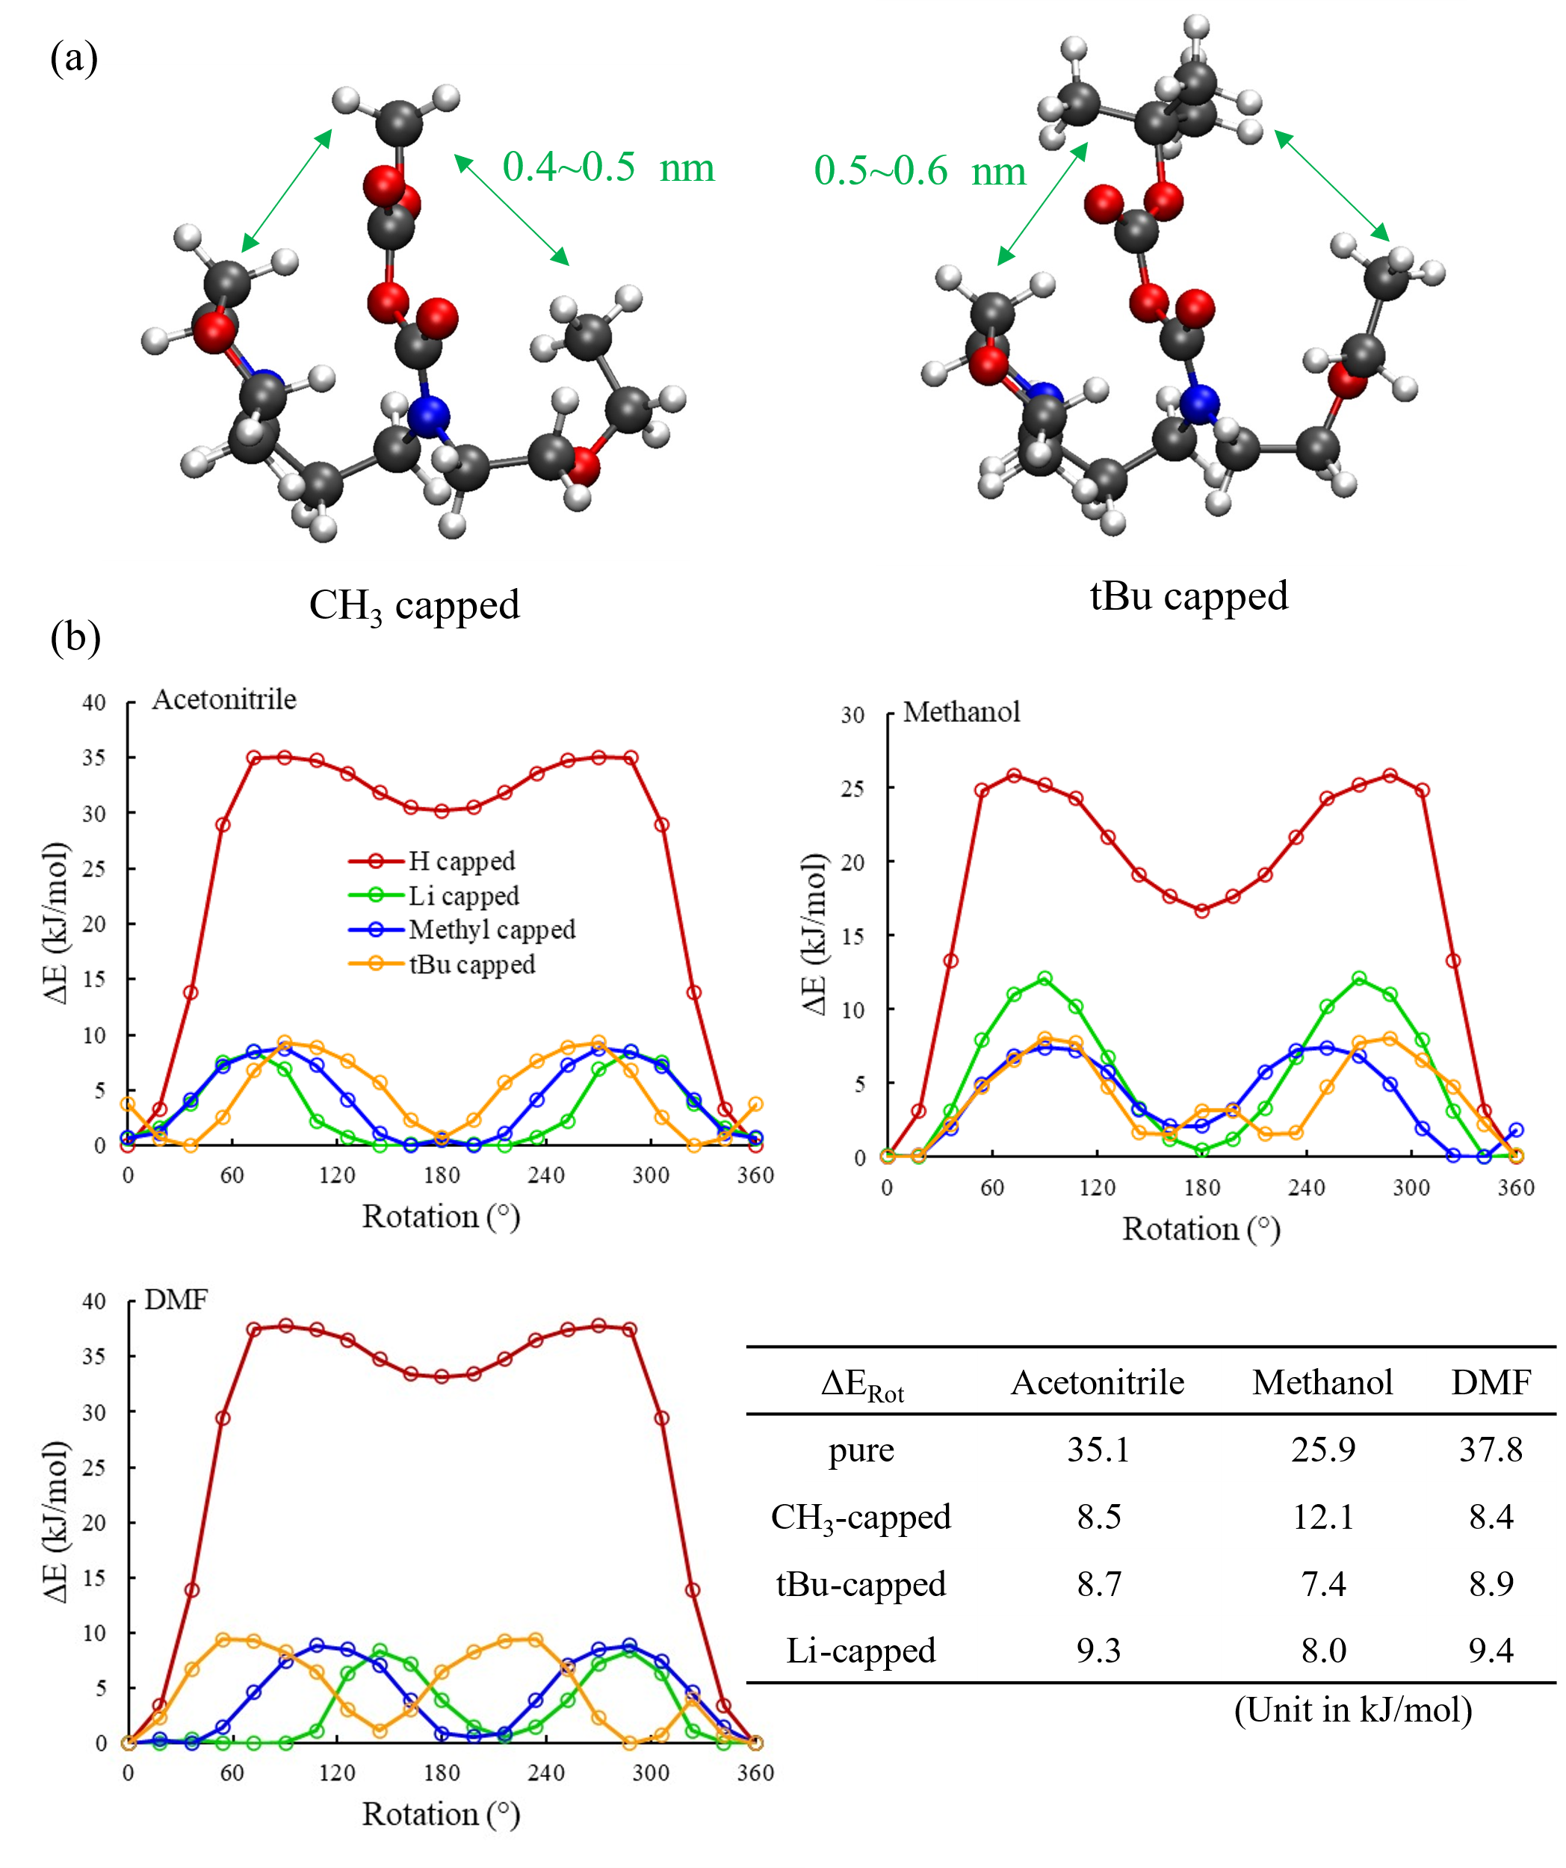
Fig. S54. (a) Snapshot of minimized structure of E(2)Me and E(2)^{t}Bu obtained by DFT calculations. (b) Rotamer landscape for EEMPA anhydrides E(2)R with different capping agents (R = Li, H, Me, tBu). The inset table shows the energy barrier of different rotamers.

Our calculations above (Fig S54) have shown that different implicit solvents have limited impact on stabilities of the intermediates and products of CO₂ capture by EEMPA. Furthermore, even though the tetra-butyl cap has a significantly larger size than the other groups, the rotational barrier is not affected much by intra-molecular interaction due to the large space for the rotation of the capping group. On the other hand, the intra-molecular hydrogen bonding in the H capped anhydride results in higher rotational barrier.

Supplementary tables

Abbreviations and schematic representations

Table S1.
Building blocks involved in CO₂ capture / Constituents of dynamic covalent system.
Constituent/building block | Formula | Symbol
E |  | 
CO₂ | CO₂

Table S2.
Adducts from capture / resulting from reversible covalent linkage between constituents. Components for non-covalent clustering into dimers/tetramers.
Component/adduct |  | Formula | Symbol
E(0)⁽⁺⁾ | E(0)
E(0)⁽⁺⁾ | E(0)⁺ |  | 
E(1)⁽⁻⁾ | E(1)⁻ |  | 
E(1)⁽⁻⁾ | E(1) |  | 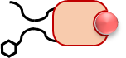

Table S3.
Adducts from capture / resulting from reversible covalent linkage between constituents. Components for non-covalent clustering into dimers/tetramers.
(trapped) Intermediate | Formula | Symbol
E(2)⁻ |  | 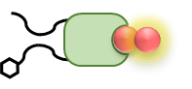
E(1)^{Z} |  | 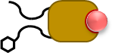
E(2)Me |  | N/A
E(2)^{t}Bu |  | N/A

Table S4.
Dimeric clusters resulting from non-covalent assembling of components/capture adducts
Dimer/cluster |  | Formula | Symbol
E² | E²(0) | E(0)E(0) | 
E² | E²(0.5) | E(1)⁻E(0)⁺ | 
E² | E²(1)* | E(2)⁻E(0)⁺ | 
E² | E²(1) | E(1)E(1) | 

Table S5.
Tetrameric clusters resulting from non-covalent assembling of components/capture adducts
Tetramer/cluster |  | Formula | Symbol
E⁴ | E⁴(0) | E(0) E(0) E(0) E(0) | 
E⁴ | E⁴(0.25) | E(1)⁻E(0)⁺E(0) E(0) | 
E⁴ | E⁴(0.5) | E(1)⁻E(0)⁺E(1)⁻E(0)⁺ | 
E⁴ | E⁴(0.5)^{N} | E(1)⁻E(0)⁺ E(1)E(0)
E⁴ | E⁴(0.75)^{N} | E(1) E(0) E(1) E(1)
E⁴ | E⁴(0.75)^{Z} | E(1)⁻E(0)⁺ E(1)E(1)^{z}
E⁴ | E⁴(0.75)* | E(2)⁻E(0)⁺ E(1)⁻E(0)⁺
E⁴ | E⁴(0.75) | E(1)⁻E(0)⁺E(1)E(1) | 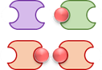
E⁴ | E⁴(1)^{Z} | E(1)E(1)^{Z}E(1)E(1)
E⁴ | E⁴(1) | E(1)E(1)E(1)E(1) | 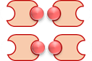

Binding isotherms and speciation data

Table S6.
EEMPA/CO₂ samples analyzed by q¹³C NMR (Fig. S8-S16). Correspondence between initial stoichiometry x₀ and chemical loading α.

x₀ | α
0.000 | 0.000
0.077 | 0.077
0.143 | 0.143
0.176 | 0.176
0.274 | 0.272
0.359 | 0.356
0.374 | 0.371
0.472 | 0.467
0.534 | 0.520
0.646 | 0.597
0.993 | 0.746
1.616 | 0.809
2.352 | 0.842
5.054 | 0.950

Table S7. RMSD values of the fit of experimental ¹³C chemical shifts and loading values vs x₀ with the dimeric (left) and tetrameric model. (Right) (Averaged RMSD : bold font, RMSD values below an arbitrary 0.95 cutoff : red).
 | R²(E²) | R²(E⁴)
alpha | 0.9931 | 0.9996
CO | 0.6181 | 0.997
c' | 0.9745 | 0.9914
c | 0.9809 | 0.9991
i,i’ | 0.9626 | 0.9986
b,b’ | 0.9118 | 0.9618
g | 0.9618 | 0.9959
g' | 0.9829 | 0.9895
h | 0.9869 | 0.9895
h' | 0.951 | 0.9825
d | 0.9783 | 0.9979
e | 0.9808 | 0.9979
d' | 0.8848 | 0.9652
e' | 0.9727 | 0.9825
f | 0.969 | 0.9963
f' | 0.935 | 0.9982
a' | 0.9368 | 0.9759
a | 0.9427 | 0.9883
 | 0.9370 | 0.993

WAXS parameters

Table S8. WAXS TS+3G model, Teubner Strey Parameters.
α | A_scale (cm⁻¹) | A_scale (Err) | A_d (Å) | A_d (Err) | A_xi (Å) | A_xi (Err)
0.03 | 0.0035 | 0.0045 | 21.96 | 1.16 | 7.96 | 4.82
0.08 | 0.0036 | 0.0097 | 20.34 | 2.24 | 6.10 | 6.76
0.20 | 0.0047 | 0.0071 | 20.58 | 1.31 | 6.71 | 4.46
0.36 | 0.0086 | 0.0220 | 20.82 | 2.72 | 4.53 | 3.69
0.58 | 0.1932 | 0.0161 | 11.93 | 0.08 | 4.20 | 0.16
0.72 | 0.3782 | 0.0083 | 11.90 | 0.02 | 5.92 | 0.08
0.79 | 0.4228 | 0.0097 | 11.85 | 0.02 | 5.65 | 0.08
0.84 | 0.4245 | 0.0091 | 11.85 | 0.02 | 5.71 | 0.07
0.86 | 0.4244 | 0.0088 | 11.81 | 0.02 | 5.81 | 0.07

Table S9. WAXS TS+3G model, Gauss Peak 1 parameters.
α | B_scale (cm⁻¹) | B_scale (Err) | B_peak_pos  (Å⁻¹) | B_peak_pos (Err) | B_sigma (Å⁻¹) | B_sigma (Err)
0.03 | 0.1319 | 0.0024 | 1.326 | 0.0008 | 0.216 | 0.0026
0.08 | 0.1309 | 0.0028 | 1.326 | 0.0009 | 0.213 | 0.0029
0.20 | 0.1315 | 0.0024 | 1.328 | 0.0008 | 0.211 | 0.0026
0.36 | 0.1354 | 0.0035 | 1.328 | 0.0010 | 0.212 | 0.0035
0.58 | 0.1274 | 0.0018 | 1.325 | 0.0009 | 0.207 | 0.0028
0.72 | 0.1277 | 0.0021 | 1.322 | 0.0006 | 0.174 | 0.0019
0.79 | 0.1239 | 0.0031 | 1.321 | 0.0007 | 0.177 | 0.0026
0.84 | 0.1277 | 0.0024 | 1.322 | 0.0006 | 0.175 | 0.0022
0.86 | 0.1307 | 0.0020 | 1.322 | 0.0006 | 0.173 | 0.0018

Table S10. WAXS TS+3G model, Gauss Peak 2 parameters.
α | C_scale (cm⁻¹) | C_scale (Err) | C_peak_pos  (Å⁻¹) | C_peak_pos (Err) | C_sigma (Å⁻¹) | C_sigma (Err)
0.03 | 0.0341 | 0.0020 | 1.378 | 0.0018 | 0.115 | 0.0026
0.08 | 0.0332 | 0.0022 | 1.377 | 0.0021 | 0.116 | 0.0029
0.20 | 0.0304 | 0.0021 | 1.377 | 0.0020 | 0.112 | 0.0030
0.36 | 0.0302 | 0.0023 | 1.374 | 0.0020 | 0.110 | 0.0031
0.58 | 0.0342 | 0.0024 | 1.356 | 0.0013 | 0.109 | 0.0026
0.72 | 0.0208 | 0.0025 | 1.344 | 0.0021 | 0.090 | 0.0044
0.79 | 0.0283 | 0.0037 | 1.337 | 0.0018 | 0.098 | 0.0044
0.84 | 0.0242 | 0.0030 | 1.336 | 0.0018 | 0.092 | 0.0043
0.86 | 0.0234 | 0.0025 | 1.340 | 0.0018 | 0.088 | 0.0039

Table S11. WAXS TS+3G model, Gauss Peak 3 parameters.
α | D_scale  (cm⁻¹) | D_scale (Err) | D_peak_pos (Å⁻¹) | D_peak_pos (Err) | D_sigma (Å⁻¹) | D_sigma (Err)
0.03 | 0.0613 | 0.0021 | 1.339 | 0.0018 | 0.526 | 0.0330
0.08 | 0.0631 | 0.0029 | 1.338 | 0.0021 | 0.503 | 0.0373
0.20 | 0.0656 | 0.0024 | 1.333 | 0.0016 | 0.501 | 0.0302
0.36 | 0.0609 | 0.0050 | 1.334 | 0.0040 | 0.518 | 0.0721
0.58 | 0.0669 | 0.0019 | 1.374 | 0.0042 | 0.484 | 0.0107
0.72 | 0.1032 | 0.0011 | 1.394 | 0.0016 | 0.497 | 0.0046
0.79 | 0.1065 | 0.0012 | 1.402 | 0.0020 | 0.517 | 0.0054
0.84 | 0.1079 | 0.0011 | 1.401 | 0.0018 | 0.512 | 0.0050
0.86 | 0.1087 | 0.0010 | 1.402 | 0.0017 | 0.512 | 0.0046

References
1. Stoll, S. & Schweiger, A. EasySpin, a comprehensive software package for spectral simulation and analysis in EPR. Journal of Magnetic Resonance 178, 42–55 (2006).
2. Cantu, D. C. et al. Molecular-Level Overhaul of γ-Aminopropyl Aminosilicone/Triethylene Glycol Post-Combustion CO2-Capture Solvents. ChemSusChem 13, 3429–3438 (2020).
3. Subirats, X., Fuguet, E., Rosés, M., Bosch, E. & Ràfols, C. Methods for pKa Determination (I): Potentiometry, Spectrophotometry, and Capillary Electrophoresis. in Reference Module in Chemistry, Molecular Sciences and Chemical Engineering 1–10 (Elsevier, 2015). doi:10.1016/B978-0-12-409547-2.11559-8.
4. Basel, Y. & Hassner, A. Di- tert -butyl Dicarbonate and 4-(Dimethylamino)pyridine Revisited. Their Reactions with Amines and Alcohols. J Org Chem 65, 6368–6380 (2000).
5. Jiang, Y. et al. Techno-economic comparison of various process configurations for post-combustion carbon capture using a single-component water-lean solvent. International Journal of Greenhouse Gas Control 106, 103279 (2021).
6. Zheng, R. F. et al. A single-component water-lean post-combustion CO2capture solvent with exceptionally low operational heat and total costs of capture-comprehensive experimental and theoretical evaluation. Energy Environ Sci 13, 4106–4113 (2020).
7. Gibbs, R. E. & Van Ness, H. C. Vapor—Liquid Equilibria from Total-Pressure Measurements. A New Apparatus. Industrial and Engineering Chemistry Fundamentals 11, 410–4130 (1972).
8. Kamlet, M. J., Abboud, J.-L. M., Abraham, M. H. & Taft, R. W. Solvent Effects in Organic Chemistry. J. J. Am. Chem. Soc 48, 23 (1983).
9. Brady, J. E. & Carr, P. W. An Analysis of Dielectric Models of Solvatochromism. J. Phys. Chem 89, 5759–5766 (1985).
10. Teo, W. et al. Nile Red fluorescence spectroscopy reports early physicochemical changes in myelin with high sensitivity. Proc Natl Acad Sci U S A 118, e2016897118 (2021).
11. Septavaux, J. et al. Simultaneous CO2 capture and metal purification from waste streams using triple-level dynamic combinatorial chemistry. Nat Chem 12, 202–212 (2020).
12. Pugh, S. M. & Forse, A. C. Nuclear magnetic resonance studies of carbon dioxide capture. Journal of Magnetic Resonance 346, 107343 (2023).
13. Walter, E. D. et al. Operando MAS NMR Reaction Studies at High Temperatures and Pressures. Journal of Physical Chemistry C 122, 8209–8215 (2018).
14. Mehta, H. S. et al. A novel high-temperature MAS probe with optimized temperature gradient across sample rotor for in-situ monitoring of high-temperature high-pressure chemical reactions. Solid State Nucl Magn Reson 102, 31–35 (2019).
15. Neese, F. The ORCA program system. Wiley Interdiscip Rev Comput Mol Sci 2, 73–78 (2012).
16. Neese, F., Wennmohs, F., Becker, U. & Riplinger, C. The ORCA quantum chemistry program package. Journal of Chemical Physics 152, (2020).
17. Becke, A. D. Density-functional exchange-energy approximation with correct asymptotic behavior. Phys Rev A (Coll Park) 38, 3098–3100 (1988).
18. Lee, C., Yang, eitao & Parr, R. G. Development of the Colic-Salvetti correlation-energy formula into a functional of the electron density. Phys Rev B 37, 785–789 (1988).
19. Grimme, S. Semiempirical GGA-type density functional constructed with a long-range dispersion correction. J Comput Chem 27, 1787–1799 (2006).
20. Marenich, A. V., Cramer, C. J. & Truhlar, D. G. Universal solvation model based on solute electron density and on a continuum model of the solvent defined by the bulk dielectric constant and atomic surface tensions. Journal of Physical Chemistry B 113, 6378–6396 (2009).
21. Vandevondele, J. et al. QUICKSTEP: Fast and accurate density functional calculations using a mixed Gaussian and plane waves approach. Comput Phys Commun 167, 103–128 (2005).
22. Perdew, J. P., Burke, K. & Ernzerhof, M. Generalized gradient approximation made simple. Phys Rev Lett 77, 3865 (1996).
23. Goedecker, S., Teter, M. & Hutter, J. Separable dual-space Gaussian pseudopotentials. Phys Rev B 54, 1703–1710 (1996).
24. Lippert, G., Hutter, J. & Parrinello, M. A hybrid Gaussian and plane wave density functional scheme. Mol Phys 92, 477–488 (1997).
25. Teubner, M. & Strey, R. Origin of the scattering peak in microemulsions. J Chem Phys 87, 3195 (1987).
26. Schubert, K. V., Strey, R., Kline, S. R. & Kaler, E. W. Small angle neutron scattering near Lifshitz lines: Transition from weakly structured mixtures to microemulsions. J Chem Phys 101, 5343–5355 (1994).
27. Morkved, T. L., Stepanek, P., Krishnan, K., Bates, F. S. & Lodge, T. P. Static and dynamic scattering from ternary polymer blends: Bicontinuous microemulsions, Lifshitz lines, and amphiphilicity. Journal of Chemical Physics 114, 7247 (2001).
28. Ottaviani, M. F., Martini, G. & Nuti, L. Nitrogen Hyperfine Splitting Constant of Nitroxide Solutions: Differently Structured and Charged Nitroxides as Probes of Environmental Properties. Magnetic Resonance in Chemistry 25, 897–904 (1987).
29. Forse, A. C. et al. Elucidating CO 2 Chemisorption in Diamine-Appended Metal− Organic Frameworks. J Am Chem Soc 140, 18016–18031 (2018).
30. Kortunov, P. V., Siskin, M., Baugh, L. S. & Calabro, D. C. In Situ Nuclear Magnetic Resonance Mechanistic Studies of Carbon Dioxide Reactions with Liquid Amines in Non-aqueous Systems: Evidence for the Formation of Carbamic Acids and Zwitterionic Species. Energy and Fuels 29, 5940–5966 (2015).
31. Masuda, K., Ito, Y., Horiguchi, M. & Fujita, H. Studies on the solvent dependence of the carbamic acid formation from ω-(1-naphthyl)alkylamines and carbon dioxide. Tetrahedron 61, 213–229 (2005).
32. Hunter, C. A. & Anderson, H. L. What is cooperativity? Angewandte Chemie - International Edition 48, 7488–7499 (2009).
33. Masuda, K., Ito, Y., Horiguchi, M. & Fujita, H. Studies on the solvent dependence of the carbamic acid formation from u-(1-naphthyl)alkylamines and carbon dioxide. Tetrahedron 61, 213–229 (2004).
34. Switzer, J. R. et al. Reversible Ionic Liquid Stabilized Carbamic Acids: A Pathway Toward Enhanced CO 2 Capture. Ind Eng Chem Res 52, 13159–13163 (2013).
35. Didas, S. A., Sakwa-Novak, M. A., Foo, G. S., Sievers, C. & Jones, C. W. Effect of Amine Surface Coverage on the Co-Adsorption of CO 2 and Water: Spectral Deconvolution of Adsorbed Species. J Phys Chem Lett 5, 4194–4200 (2014).

