Additional file 1
Supplementation of green-synthesized nickel oxide nanoparticles enhances biohydrogen production of Klebsilla sp. using lignocellulosic hydrolysate and elucidation of the regulatory mechanism
Qin Zhang¹, Siyuan Xu¹, Yanbin Li^{1,2*}, Pengfei Ding¹, Yonggui Zhang¹, Pei Zhao¹
¹College of Biological and Food engineering, Anhui Polytechnic University, Wuhu, Anhui, 241000, China
²Anhui Engineering Laboratory for Industrial Microbiology Molecular Breeding, Anhui Polytechnic University, Wuhu, Anhui, 241000, China
* Corresponding author
Prof Qin Zhang
Email: jhtabszq@163.com; zhangqin@ahpu.edu.cn

Prof Yanbin Li

Email: ydhant@163.com

Table S1 Green synthesis of nanoparticles using aqueous extracts of Eichhornia crassipes.
Types of NPs | Size | Morphology | Application | References
FeNPs | – | Rod | Antibacterial activity | [27]
FeNPs | 20.0 – 80.0 nm | Spherical | Removal of Cr(VI) | [68]
FeNPs | 40.0- 60.0 nm | Spherical | Wastewater remediation | [69]
Fe₃O₄NPs | 10.0 ± 4.0 nm | Spherical | Antibiofilm activity | [70]
Fe⁰, FeO, Fe₂O₃ and Fe₃O₄ | 50.0 – 80.0 nm | – | Removal of Cr(VI) | [71]
Pt-NPs | 3.7 nm | Spherical | – | [29]
Ag-NPs | 12.5 ± 3.4 nm | Spherical | Integrated medicinal application | [31]
Ag-NPs | 2.2 ± 0.4 nm | Lattice fringe | – | [67]
CuO NPs | 28.0 ± 4.0 nm | Spherical | Antifungal activity | [30]
ZnO NPs | 32.0 ± 4.0 nm | Spherical | – | [28]
NiONPs | 9.1±2.6 nm | Spherical | Enhancing biohydrogen production | This study

Table S2 Details of the primers used in the RT-qPCR assays.
Gene name | Primers | Primer sequence (5’-3’) | Product size (bp) | Source
Internal control (16S rDNA) gene | 16Sf | TATTGCACAATGGGCGCAAG | 150 | This study
Internal control (16S rDNA) gene | 16Sr | GGAGTTAGCCGGTGCTTCTT | 150 | This study
Hydrogenase maturation factor hypD | HPDf | CAGCCGGACAACAGTATCGAC | 203 | This study
Hydrogenase maturation factor hypD | HPDr | CGGTACTGATTTTCCACATCGC | 203 | This study
Hydrogenase small subunit | HYGf | AATTCATGCCCGTCTGCC | 137 | This study
Hydrogenase small subunit | HYGr | CAATCTGCCGTCCATAGCG | 137 | This study
Hydrogenase expression hypA | HPAf | AACTGCATATCGCCGAACAAC | 111 | This study
Hydrogenase expression hypA | HPAr | GCTGGTCGTTATTGCAGTGCG | 111 | This study
Hydrogenase large subunit | HYLf | AAAACAACGTGGTGCCGATT | 140 | This study
Hydrogenase large subunit | HYLr | CGCCAGCTTTTCCATTCCG | 140 | This study
Formate-hydrogen lyase transcriptional activator | FLAf | CATACCTTCGCGCAGATCGTC | 177 | This study
Formate-hydrogen lyase transcriptional activator | FLAr | TTTCGCCACCTCGCTGACC | 177 | This study
Formate-hydrogen lyase subunit 4 | FHFf | CATATCAGCGCCATCACCGA | 102 | This study
Formate-hydrogen lyase subunit 4 | FHFr | TTTGCCCATCTCGATAAAGGT | 102 | This study
Formate-hydrogen lyase subunit 6 | FHSf | CTCAAGCATAACGGCGATACCC | 111 | This study
Formate-hydrogen lyase subunit 6 | FHSr | AATACGATCGGACGGCACCA | 111 | This study

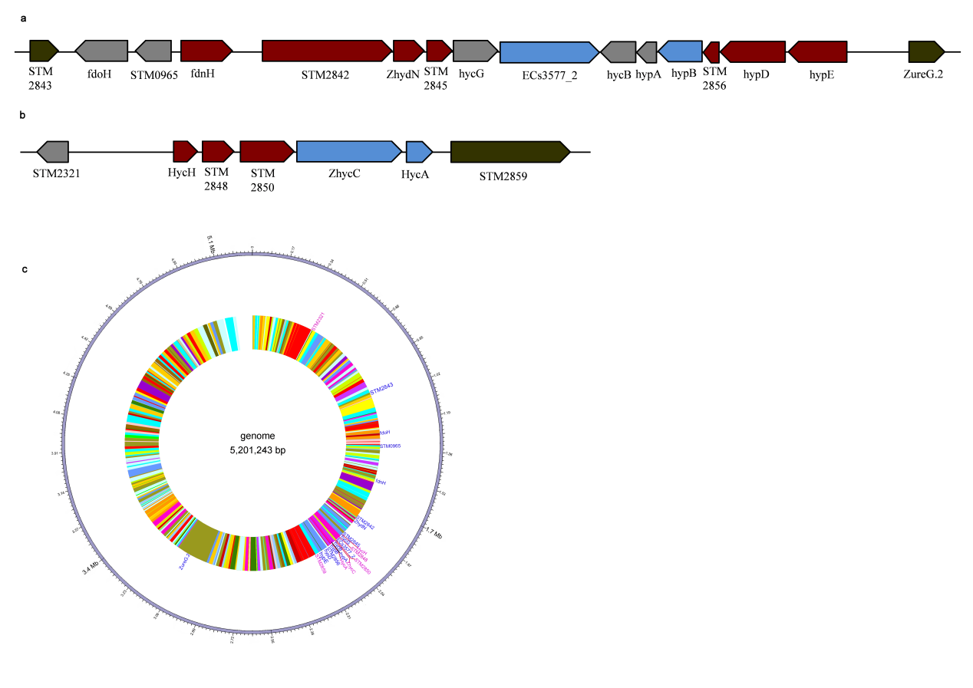

Fig. S1 Hydrogenase- and formate-hydrogen lyase-related genes in the genome of Klebsiella sp. WL1316. a The direction and relative position of hydrogenase-related gene cluster; b The direction and relative position of formate-hydrogen lyase-related gene cluster; c The distributions of gene clusters of hydrogenase and formate-hydrogen lyase in the genome.

* Correspondence E-mail: jhtabszq@163.com; zhangqin@ahpu.edu.cn (Q. Zhang); ydhant@163.com (Y. Li)

