Supplementary Material
Metabolic predictors of COVID-19 mortality and severity: A Survival Analysis

Abdallah Musa Abdallah1*, Asmma Doudin2, Theeb Sulaiman3, Omar Jamil4, Rida Arif5, Fatima Al Saada2, Hadi Yassine2, Mohamed A. Elrayess1,2, Abdel-Naser Elzouki1,3, Mohamed M. Emara1, Nagendra Babu Thillaiappan1, Farhan S. Cyprian1*

¹College of Medicine, QU Health, Qatar University, Doha, Qatar; ²Biomedical Research Center (BRC), Qatar University, Doha, Qatar; ³Internal Medicine Department, Hamad General Hospital, Hamad Medical Corporation, Doha, Qatar; ⁴Department of Radiology, Hamad General Hospital, Hamad Medical Corporation, Doha, Qatar; ⁵Emergency Medicine Department, Hamad General Hospital, Hamad Medical Corporation, Doha, Qatar.

Correspondence*: Abdallah Musa Abdallah & Farhan S. Cyprian
Abdallah.musa@qu.edu.qa
fcyprian@qu.edu.qa

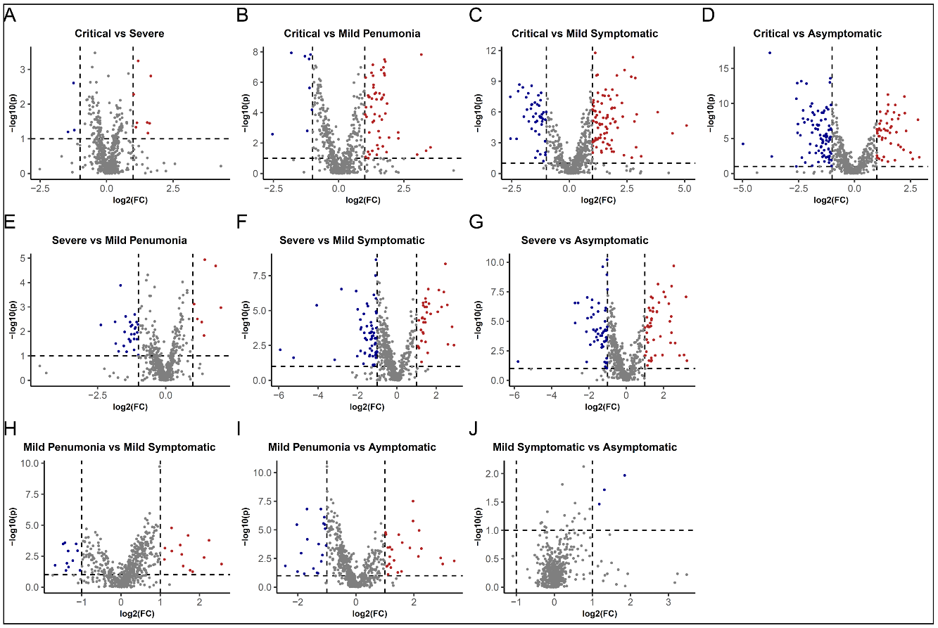

Supplementary Figure 1. Fold change volcano plots of metabolites associated with disease severity in COVID-19 patients. The x-axis represents the log2 fold change in metabolite levels between the two respective severity groups and the y-axis represents the -log10 p-value. Metabolites that are significantly associated with disease severity (p-value < 0.05 and fold change > 2) are represented by red dots. The dots in the base of the volcano represent the metabolites that were not found to be differentially expressed. The color code represents the direction of the fold change, red for upregulation and blue for downregulation.

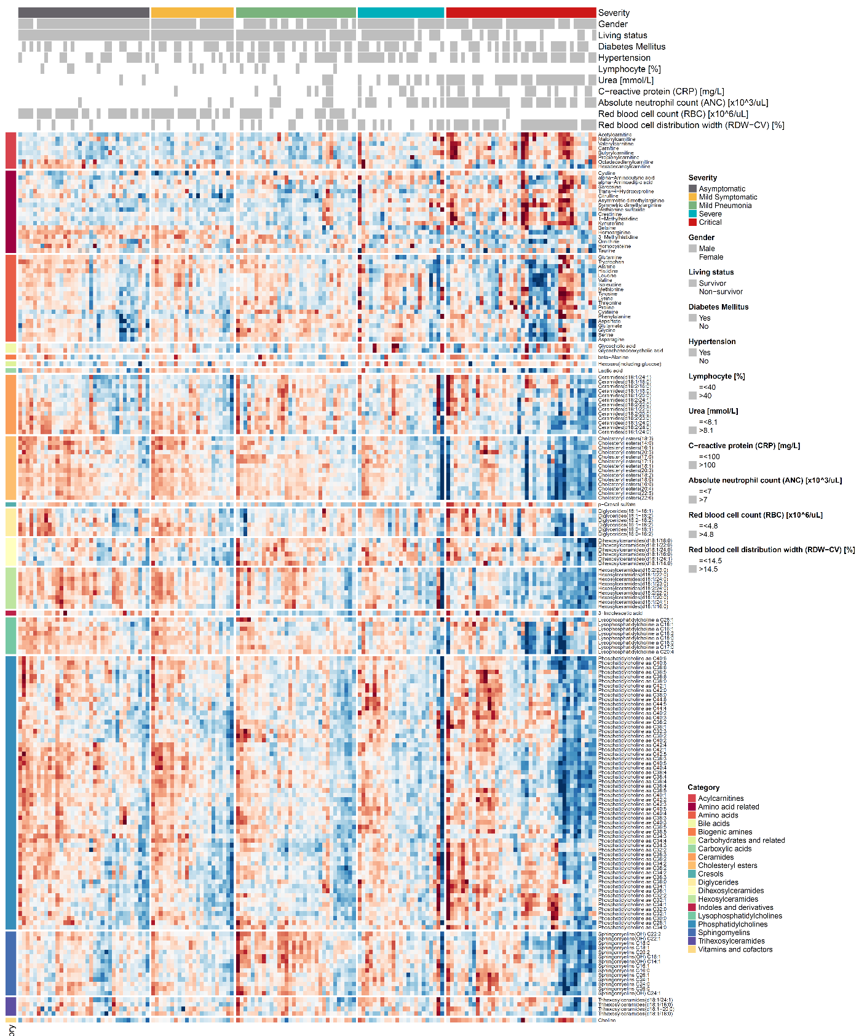
Supplementary Figure 2. Heatmap of several metabolite categories and clinical parameters associated with disease severity in COVID-19 patients. These categories includes lipids and related such as acylcarnitines, cholesteryl esters, diglycerides, dihexosylceramides, hexosylceramides, lysophosphatidylcholines, phosphatidylcholines, sphingomyelins, trihexosylceramides. Second, organic acids such as bile acids, carboxylic acids, and cresols. Third, amino acids and related: amino acid related, amino acids, biogenic amines, indoles and derivatives. Fourth, carbohydrates and vitamins such as carbohydrates and related, ceramides, vitamins and cofactors.
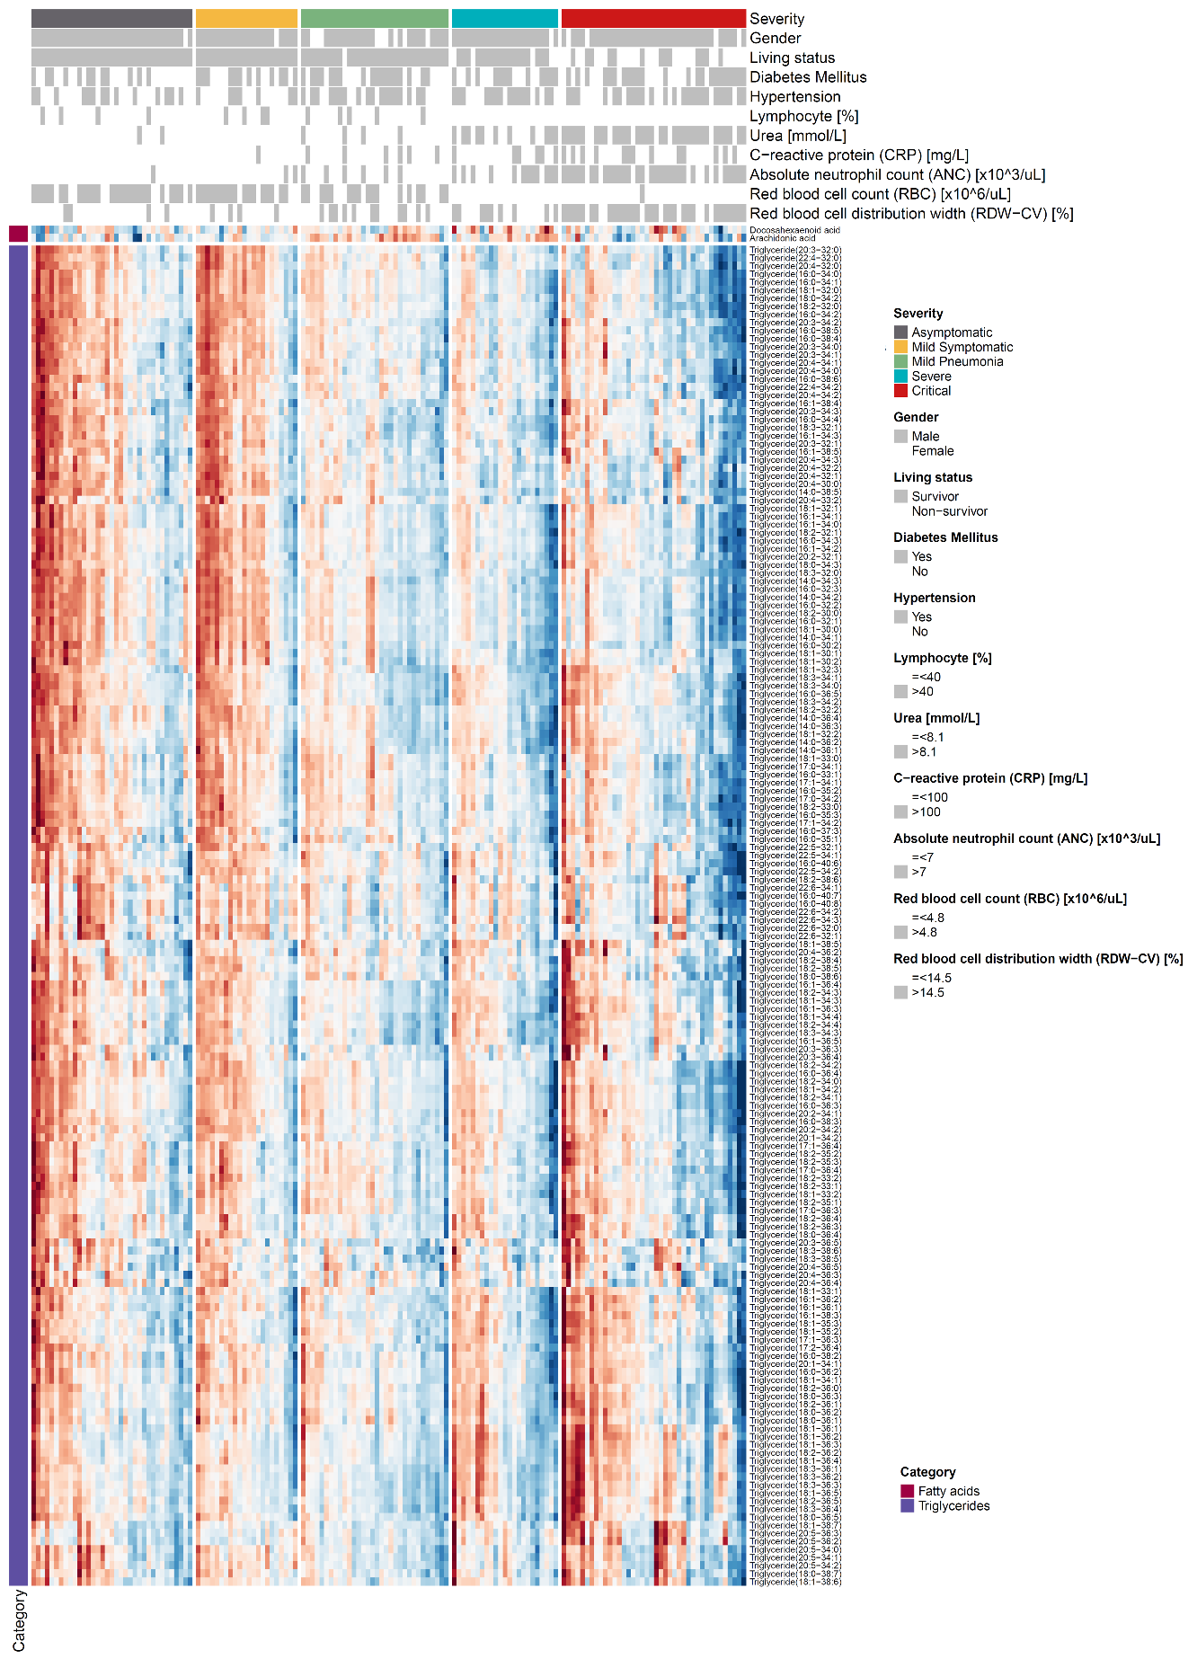
Supplementary Figure 3. Heatmap of fatty acids and triglycerides with clinical parameters data in COVID-19 patients with varying disease severity.

