Electronic Supplementary Material

Long-term exposure to polystyrene microplastics promotes HFD-induced obesity in mice through exacerbating microbiota dysbiosis

Zhian Zhai ¹, Ying Yang ¹, Zhenlong Wu^{1,} ^{2, *}

¹State Key Laboratory of Animal Nutrition, Department of Companion Animal Science, China Agricultural University, Beijing 100193, China;
² Beijing Advanced Innovation Center for Food Nutrition and Human Health, China Agricultural University, Beijing 100193, China.

*To whom correspondence should be addressed:
Zhenlong Wu, Ph.D.
Department of Companion Science
China Agricultural University
Beijing 100193, China
E-mail: bio2046@hotmail.com
Tel: +86-10-6273-1003

Fax: +86-10-6273-1003

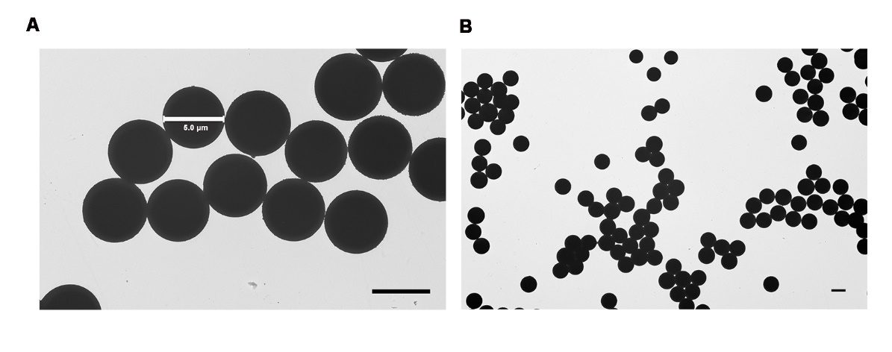
Fig. S1. Characterization of PS. (A and B) TEM images of PS used in this study. Scale bar, 5 μm .

Fig. S2. Effects of PS on microbiota composition in ND and HFD-fed mice by drinking water for 8 weeks. (A) Observed species. (B) Shannon diversity analysis. Microbiota composition analysis using 16S rRNA sequencing, relative abundance of bacteria is shown grouped by phylum (C), family (D) and genus (E). Data are represented as mean ± SD (n = 5). * P < 0.05, *** P <0.001, **** P <0.0001.
Fig. S3 PS-induced microbiota changes caused inflammation in colon and adipose tissues. (A–B) IL-17A and TNF-α mRNA expression levels in colon. (C) IL-17A mRNA expression levels in inguinal adipose tissue. Data are represented as mean ± SD (n = 5). * P < 0.05, ** P < 0.01.
Fig. S4. ABX treatment eliminated gut microbiota in mice fed ND or HFD. (A) Operational Taxonomic Unit (OTU) number and (B) Shannon index of feces from ND and ND +PS groups with or without ABX treatment. (C) Operational Taxonomic Unit (OTU) number and (D) Shannon index of feces from from HFD and HFD +PS groups with or without ABX treatment. All values are represented as mean ± SD in scatter plots (n = 5). **** P <0.0001.

Table S1. Primers used for quantitative real-time PCR.
Gene | Forward primer (5' to 3') | Reverse primer (5' to 3')
TNF-α | TGAGGTCAATCTGCCCAAGT | GGGGTCAGAGTAAAGGGGTC
IL-17A | GAAGGCCCTCAGACTACCTC | CTTTCCCTCCGCATTGACAC
IL-6 | CTGCAAGAGACTTCCATCCAG | AGTGGTATAGACAGGTCTGTT
IL-1β | AGCCGAGGTCTGCATTACATT | TGGCAGTCTGGATAACTGATGA
Muc2 | ATGCCCACCTCCTCAAAGAC | GTAGTTTCCGTTGGAACAGTGAA
ZO-1 | CTCCAGGTGCTTCTCTTGCT | TATCTTCGGGTGGCTTCACT
Occludin | TGAAAGTCCACCTCCTTACAGA | CCGGATAAAAAGAGTACGCTGG
Claudin-3 | ACCAACTGCGTACAAGACGAG | CGGGCACCAACGGGTTATAG
GAPDH | AAGCCCATCACCATCTTCCA | CACCAGTAGACTCCACGACA

