Supplementary information to
Well-managed urbanization could halve nitrogen pollution in China
Contents
S1. Supplementary Methods 2
S1.1 Urban expansion modeling. 2
S1.2 Rural land reclamation modeling. 2
S1.3 The potential modeling of large-scale farming potential. 3
S1.4 Crop-livestock coupled production modeling 3
S1.5 Nitrogen budget modeling. 4
S1.6 High spatial resolution N loss inventory building. 5
S1.7 Air PM_{2.5} estimation and validation 6
S1.8 Estimation of Nr output to sea and its imitation 6
S1.9 Geo-distribution of social benefit 7
S2. Comparison of different water quality model 8
Table S1 Land use change flow matrices from 2017 to 2050 (million ha). 10
Table S2 Pig unit conversion factor and the total livestock. 11
Table S3 Key parameters adjusting in the human relating subsystems in CHANS. 13
Table S4 Key parameter adjusting in agricultural relating subsystems in CHANS. 15
Table S5 Proxy variable and land use raster for high spatial resolution Nr loss inventory. 16
Table S6 GAINS mitigation unit cost (US$ kg N⁻¹) by provinces in 2017. 17
Table S7 N_{r} loss-related social benefit through urbanization in China 18
Table S8 Cost-benefit analysis of China’s regional divisions. 19
Table S9 Investment cost of sewage/garbage projects from Public-Private Partnership Service Platform of China. 20
Table S10 Investment cost of rural reclamation, cropland consolidation and livestock relocation 21
Fig. S1 | Comparison of observed and modeled monthly mean PM_{2.5} concentrations. 23

S1. Supplementary Methods
The High Resolution Remote Sensing Monitoring of Chinease Land Cover 2018 (HRRSM-CLC2018, 30 m), county-level population census and multi-source livestock database (FAOSTAT and APSCC2017) were combined to stimulate the urbanization processes in ArcGIS platform (version 10.6), including process of population migration, land use geo-distribution change, agricultural management change, and industrial upgrading. Then, the varying forms of Nr loss from the > 2,800 countries were calculated in 2017 and 2050 by the Coupled Human And Natural Systems (CHANS) model in China. Meanwhile, changes on air and water quality based on Nr loss reduction were simulated by the Weather Research and Forecasting model coupled with Chemistry (WRF-Chem) and the Water Nitrogen Retention and Removing model (WNRR), respectively. Finally, the policy feasible and cost-benefit of the urbanization pathway were analyzed. The framework of the method is shown in Extended data Fig. 10.

S1.1 Urban expansion modeling.
Since urban expansion occurs preferentially in the peri-urban grids, these grids have higher urban expansion priority (UEP_{i})¹. Focus Statistics Tool in ArcGIS was used to simulate UP_{i} with a value of 1 to the urban grid pixels and 0 to the other grids by the 100 by 100 grid rectangle.
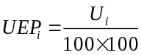 (1)
where U_{i} refers to the number of urban grids in the surrounding 100 by 100 grids centred on the ith grid. We ranked the UEP_{i} for all grids in descending order, and eliminate grids that are objectively unlikely to develop into cities (including current urban areas and water). If multiple girds have equal UEP_{i} , they are ranked according to GDP from largest to smallest, and by default regions with higher GDP are more likely to develop into cities. Based on the following linear plan, urban expansion grids are filtered out.
maxmize r
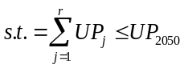 (2)
where j is the serial number ranked by UEP_{i} and GDP, and UP_{j} is the urban population in the jth grid, UP₂₀₅₀ is the national urban population in 2050 as projected by United Nations' World Urbanization.

S1.2 Rural land reclamation modeling.
Assuming that non-agricultural land would be reclaimed to cropland more preferentially in grids with a higher proportion of surrounding cropland, a proxy of reclamation priority (REP_{i}) was defined and calculated. Statistics Tool in ArcGIS was used to simulate RP_{i} with a value of 1 and 100 to the cropland and rural built-up land grids, respectively, by the 300 by 300 grid rectangle.
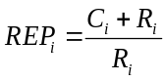 (3)
where C_{i} and R_{i} denote the number of grids of cropland and rural land in 300 × 300 grids, respectively. We ranked all the rural grids in descending order of REP_{i} and eliminated the grids which were unsuitable for reclamation (slope > 25 degrees or elevation > 3000 m). Finally, based on the following linear programming, reclamation grids in 2050 were filtered out.
maxmize r
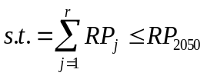 (4)
where j is the raster number ranked by RP_{i}, and RP_{j} is the rural population in the jth grid, RP₂₀₅₀ is the national rural population in 2050 as projected by United Nations' World Urbanization.

S1.3 The potential modeling of large-scale farming potential.
The high-resolution cropland raster data (30×30m) in 2050 was derived from the land reclamation modeling results. It is assumed that if there are no other features (e.g., rivers, roads, etc.) spatially separating the cropland grids within the county, they can be connected into larger croplands. We first split the raster data using county boundaries, then we used a raster data set to obtain polygon features of every cropland plot through Analysis Toolbox on ArcGIS version 10.6. Then, the plots were divided into five categories (<0.64, 0.64-2.56, 2.56-16, 16-100, and >100 ha) according to the size of the field plots, and we analyzed the total number of plots and total area of each category. In particular, a grid of points with an interval of 1 km was produced. At each point, the k-nearest neighbour method was applied to the given point, and we set k=5 as suggested to obtain the value of the unknown point. The data analysis was done in R environment. The following R packages were used: raster (https://CRAN. R-project.org/package=raster); RANN (https://CRAN.R-project.org/package=RANN); and sp (https://CRAN.R- project.org/package=sp). Finally, the plot number and total area of five categories in the sub-counties were extracted, and the average field size in the sub-counties was estimated. More details can be found in Duan., 2021².

S1.4 Crop-livestock coupled production modeling
The current distribution of livestock manure and manure carrying capacity of large scale cropland was estimated in the grid scale. Based on FAOSTAT2017 and NBSC2017 database, numbers and manure N of 17 livestock and poultry species were collated (Table S2). Around 2.3 billion livestock were allocated in equal proportions according to APSCC2017 (5 livestock species, equaling 1.2 billion pig units in total). APSCC2017 covers more than 20,000 farm households and belongs to the Chinese Ministry of Agriculture and Rural Affairs³. Coefficients of Nr cycling in livestock systems, i.g. emission factor of NH₃ volatilization, ratio of manure return to the field, etc., also refer to the result of the APSCC2017³. The maximum livestock carrying capacity per hectare of cropland is around 30 pig units, equivalent to 117 kg N, referring to the Ministry of Agriculture's recommendation for manure carrying capacity in cropland⁴. If the manure N produced by livestock in the county is larger than the manure N carrying capacity of cropland, the livestock needs to be moved outside the county or province. Here, LRPi was used to quantify this process. LRPi is less than 0 means that the livestock carrying capacity of the grid is overload and the livestock need to be removed. While, it is greater than 0 means that the grid can still carry more livestock and can be moved into the livestock. Then, the provincial livestock relocation capacity (PLRP_{r}) and relocation amount (PRA_{r}) were calculated. If PLRP>PRA, which represent the provincial livestock manure N can be carried by cropland, livestock relocation would be conducted inner province.

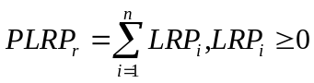 (5)
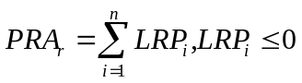 (6)

S1.5 Nitrogen budget modeling.
The Couple Human and Natural System (CHANS) model was applied to calculated the nitrogen budget among 14 ecosystems with urbanization (Fig. S2). Nitrogen mass balance is used to calculate and quantify N inputs and outputs, and then to determine if the system is an N source (input < output) or a sink (output < input) . The N balance calculations of the whole system, and for each subsystem follow the basic principle:

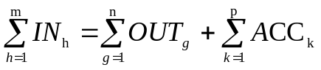 (7)
where IN_{h} and OUT_{g} represent N inputs and outputs, respectively, and ACC_{k} represents the different N accumulation terms. Most N input cycles into different subsystems, for example NO_{x} emission from fossil fuel combustion further deposits onto three major landscapes, natural land (i.e., forest, grassland), water bodies and cropland. The nitrogen cycling processes within and between different subsystems are described in detail in past studies^{5,6}. In this study, to make the human system more responsive to urbanization, the original human system was divided into urban and rural subsystems (Extended Fig. S3). At the same time, nitrogen cycling processes were constructed for the urban and rural systems (Equations 8-11), and activity data and parameters were collected (see Table S11 for details).
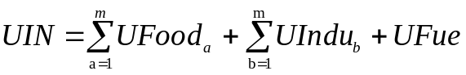 (8)
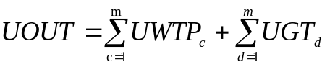 (9)
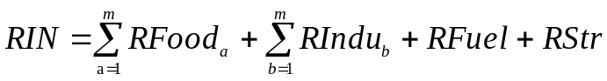 (10)
 (11)
Where UIN and RIN represent the input of nitrogen into urban and rural subsystems, respectively. UOUT and ROUT represent the output of nitrogen from urban and rural subsystems, respectively. UFood_{a} and RFood_{a} refer to the consumption of human food in urban and rural, including crop, livestock product (meat and milk) and aquaculture product (fish and others), respectively. UIndu_{b} and RIndu_{b} represent the consumption of industrial product in urban and rural, respectively. UFue and RFuel represent the the consumption of fossil fuels in urban and rural, respectively. RStr refer to the straw input in rural. UWTP_{c} and RWTP_{c} refer to the domestic wastewater collected from urban and rural and treated by wastewater treatment plant, respectively. UGT_{d} and RGT_{d} are domestic garbage collected by urban and rural and disposed of by sound waste treatment methods (i.e., landfill, incineration and other), respectively. NOx_{e} refers to NO_{x} emission from fuel and straw consumption. OUT_{com} refers to the nitrogen content of compost from rural domestic garbage, while OUT_{runoff} refers to the nitrogen that leaches into waters from direct wastewater discharge and discarded garbage.

S1.6 High spatial resolution N loss inventory building.
Annual N emissions, including NH₃, NO_{x}, N₂O, and NO₃⁻, derived from each subsystem of the CHANS model were assigned to counties by proxy parameters. Among them, the results of Wang et al. 2021^{7,8} were used for the inventory of ammonia emissions from cropland because of the large emissions and complex influencing factors. The geo-distribution of NH₃ emission from livestock was from APSCC2017. Then, emissions from each subsystem were assigned to the corresponding land-use raster on a county basis, plotted as a set of high-resolution emission inventory. For example, ammonia emission from chemical and organic fertilizers is assigned to agricultural land, and ammonia emission from industry and urban is assigned to urban. The proxy parameters and allocation raster for the spatial inventory of Nr emissions are shown in Supplementary Table S5.

S1.7 Air PM_{2.5} estimation and validation
We used the WRF-Chem model to assess surface concentrations of PM_{2.5} in 2017 and 2050. The model covers China and its surrounding area with a horizontal resolution of 27 km and 37 vertical layers extending from a 40 m thick surface layer to 50 mbar (mb)⁹. We drive the model with initial and boundary conditions from the 2017 atmospheric chemistry. Meteorological initial and lateral boundary conditions were provided by the National Centers for Environmental Prediction Final Global Run Analysis data at a resolution of 1º× 1º. Chemical initial and boundary conditions are archived from the Community Atmospheric Model with Chemistry(CAM-Chem). We simulated January, April, July, and October for 2017 and 2050, and assumed annual average concentrations as the average of these four months. We restarted WRF-Chem every 48 hours to prevent the drift effect of the simulated meteorological field. We assessed simulated 2017 surface PM_{2.5} concentrations against ground-based observations from the Ministry of Ecology and Environment (MEE). Monitoring sites with monthly data missing rate less than 5% of monitoring site data were selected for model validation. Fig.S2 shows that the model well simulates the monthly variation and spatial pattern of surface PM_{2.5} concentrations in mainland China.

S1.8 Estimation of Nr output to sea and its imitation
With the inventory of Nr loss to surface water as the primary data source, we estimated national Nr output to sea based on a water network-based framework (WNF)¹⁰, which incorporates topology structure, hydrological and biogeochemical processes. It assumes that the Nr entering the surface water body, through a combination of linear water bodies (LW) and isolated areal water bodies (AW), eventually enters the ocean. Loading of Nr in ith grid to sea (NtoS_{i}) were estimated as follow:
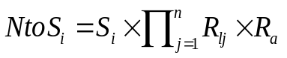 (12)
where S_{i} refers Nr output to inland water in ith grid calculating by CHANS. R_{l} and R_{a} were the released factor of Nr during linear water bodies and areal water bodies, respectively. j refers the different Strahler Order for different linear water bodies. We calculate the released factor of Nr during water transport (R_{l} and R_{a}) by letting each unit of travel time (t) have a dynamic removal rate (k) of the Nr it receives¹¹.
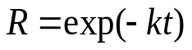 (13)

The calculation of k includes the importance of water size, location, and water type as described in Xia and Yan (2020)¹² and Alexander et al (2000)¹³. And, t represent the travel time of Nr from a given grid i to sea. The travel times of linear water bodies (t_{l}) are assumed to increase as the length l_{i} the hydraulic path increases and as the square root of the average slope of the hydraulic path decreases (Ferro and Porto,2000). The travel times of areal water bodies (t_{a}) depends on the total area of the water (A_{a}) through which the Nr pass¹¹.
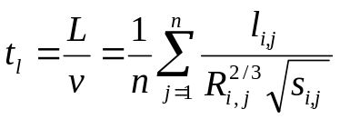 (14)

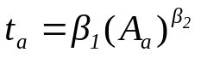 (15)

in which l_{i,j} R_{i,j} and s_{i,j} are the length, hydraulic radius, and average slope of ith source during jth type of hydraulic path, respectively. β1 = 1.50, β2= 0.23 are the coefficients derived from a meta-analysis of different areal waters across the wold¹¹.

This framework is simple and computationally efficient, and can describe the influence of the topological structure of surface water on nutrient transport and retention. It can be applied to any available water structure, land use, and DEM map, without limitation on the size of the water body. Although this framework has been used and validated in the Yangtze River Basin¹⁰, there are still some limitations in using it for nitrogen input estimation at the scale of China. For example, this framework does not consider the influence of water flow velocity on nutrient retention. In addition, it does not take into account the contribution of groundwater runoff to the ocean, and cannot evaluate the lagged benefits resulting from changes in nitrogen input to rivers. Therefore, it may underestimate the nitrogen output to the ocean in 2050.

S1.9 Geo-distribution of social benefit
The total health benefits of the China are allocated to counties based on changes in air and water pollution (Fig. 5). The health benefit would be affected by the Value of Statistical Life (VSL) and county population density. For example, higher VSL and population density increase the health benefit10.5s per reduction of unit Nr loss, such as Beijing-Tianjin region. Therefore, the counties’ health benefits (HB_{t}) are corrected using VSL and population density in 2050 with the following equation:

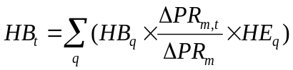 (16)

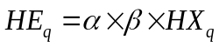 (17)

where t represents >2800 counties. q represents the forms of Nr, i.e. NH₃, NO_{x} and NO₃⁻. HB_{q} is the total health benefit on the reduction of the qth forms of Nr. m represents air or water pollution, denoted by PM_{2.5} and river N loading, respectively. ΔPR_{m} is the total reduction of PM_{2.5} or river N loading. HX_{q} represent the correction coefficients of health benefit. α, β represent the correction coefficient of VSL and population density, respectively, and are equal to the county value divided by the national average value.

As health benefits, ecosystem and climate benefits also are allocated at the county scale based on changes of Nr loss reduction. Considering that the county distribution of ecosystem benefit (EB_{t}) is influenced by the local economic status and environmental pollution status, while climate benefit (CB_{t}) is only influenced by the local economic status. GDP per capita and Nr loss in 2017 in county scale are used to make corrections for EB_{t} . The specific calculation formula are as follows:

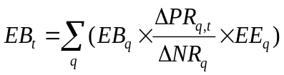 (18)
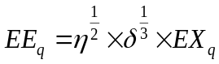 (19)

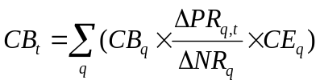 (20)
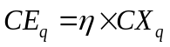 (21)
where ΔNR_{q} is the reduction of qth Nr through urbanization in China. EXq and CXq are the correction coefficients of ecosystem benefit and climate benefit, respectively. η, δ are the correction coefficient of GDP per captal and Nr emission in 2017, respectively.

S2. Comparison of different water quality model
In this study, we compared our findings with those of previous studies. We estimated 15.6 Tg of Nr entering water bodies by CHANS, of which 10.5 Tg was from surface runoff in river basins such as the Yellow River Basin, Hai River Basin, Liao River Basin, Pearl River Basin, Yangtze River Basin, Huai River Basin, and Southeast China River Basin. Our findings were similar to the estimations of the IMAGE-GNM (15.4 Tg)¹⁴ and DNDC model (14.5 Tg)¹⁵. In addition, our estimation of Nr output to sea based on WNF was 6.8 Tg, which was smaller than the IMAGE-GNM model's estimate of 11.7 Tg¹⁴ but larger than the MARINA model's estimate of 0.83-1.18 Tg¹⁶ and China's official announcement of 2.3 Tg¹⁷. We consider the estimation results of this study to be within acceptable limits, although there is a uncertainty of Nr to seas. This uncertainty was common in other studies, as it is difficult to obtain long time and multi-point river cross-section data to model and validate the national-scale model.

The primary research objective of this study is to evaluate the impact of well-managed urbanization on nitrogen (N) influx to rivers and seas, rather than to estimate national-scale N loss. Coupling CHANS and WNF ensures that nitrogen transport processes are simulated in complete agreement and that N inputs to rivers and seas are influenced solely by changes in emission sources due to well-managed urbanization.

Table S1 Land use change flow matrices from 2017 to 2050 (million ha).
2017-2050 | Grassland | Urban | Cropland | Ocean | Forest | Rural | Water | Other | Areas in 2017
Grassland | 219.2 | 0.1 |  |  |  |  |  |  | 219.3
Urban |  | 5.5 |  |  |  |  |  |  | 5.5
Cropland |  | 1.3 | 133.6 |  |  |  |  |  | 134.9
Ocean |  |  |  | 0.0 |  |  |  |  | 0.0
Forest |  | 0.4 |  |  | 252.5 |  |  |  | 252.8
Rural |  | 0.3 | 6.9 |  |  | 6.2 |  |  | 13.4
Water |  |  |  |  |  |  | 35.5 |  | 35.5
Other |  | 0.2 |  |  |  |  |  | 58.3 | 58.5
Areas in 2050 | 219.2 | 7.8 | 140.5 | 0.0 | 252.5 | 6.2 | 35.5 | 58.3 | 719.9

Table S2 Pig unit conversion factor and the total livestock.
No. | Species | Pig unit conversion factor | FAOSTAT and NBSC |  |  | APSCC2017
No. | Species | Pig unit conversion factor | (million head) | (million pig unit) |  | (million head) | (million pig unit)
1 | Chickens, broilers | 0.02 | 10298 | 165 |  | 8925 | 143
2 | Chickens, layers | 0.07 | 737 | 49 |  | 1906 | 126
3 | Duck, brolilers | 0.01 | 2404 | 22
4 | Duck,laying | 0.08 | 737 | 62
5 | Groose | 0.09 | 651 | 59
6 | Rrabbit | 0.10 | 320 | 33
7 | Swine, market | 1.00 | 712 | 712 |  | 674 | 674
8 | Swine, breeding | 0.57 | 447 | 254
9 | Dairy cattle | 10.00 | 62 | 620 |  | 8 | 84
10 | Other cattle | 5.00 | 39 | 196 |  | 37 | 184
11 | Buffalo | 10.09 | 4 | 44
12 | Goat/Sheep | 0.33 | 302 | 100 |  | 302 | 100
14 | Horse | 9.09 | 3 | 31
15 | Ass | 4.95 | 3 | 13
16 | Mule | 4.95 | 1 | 4
17 | Camel | 8.27 | 0 | 3
SUM |  |  | 16720 | 2365 |  | 11853 | 1311
Note: This table shows the total nation livestock from three database, based on pig unit conversions. Pig unit conversion factors of 6 species of livestock collected in APSCC2017 were used in this study. Conversion factors for other animals were defined as the ratio of livestock excretion factor to swine excretion factor, calculated from FAOSTAT and NBSC.

Table S3 Key parameters adjusting in the human relating subsystems in CHANS.
Subsystem | Parameters | 2017 | 2050 | Method and parameters in 2050
Urban | Population (million person) | 8.1 | 10.9 | Population in 2050 is projected by The United Nations’ World Urbanization Prospects
 | Urban excretion (Tg N) | 5.0 | 6.5 | The volume of garbage production changes in proportion to the population between 2017 and 2050.
 | # Disposal | 4.1 | 6.3 | The urban excretion disposal rates in 2050 are constant with the 14th Five-Year plan.
 | # Leakage | 0.4 | 0.0
 | Urban garbage production (Tg) | 21521 | 28696 | In 2050, the amount of urban garbage will be determined by multiplying the per capita urban garbage production rate by the urban population. Historical data shows that the per capita urban garbage production rate is 0.72 kg per person. Additionally, the latest (2021) National Statistical Yearbook of Urban Construction indicates the rate of environmentally sound disposal.
 | #Landfill | 12038 | 10044
 | #Incineration | 8463 | 18653
 | #Other treatment | 533 | -
 | #Composting | - | -
 | #Discard | 487 | -
Rural | Population (million person) | 5.80 | 2.70 | Population in 2050 is projected by The United Nations’ World Urbanization Prospects
 | Rural excretion (Tg N) | 3.1 | 1.4 | The volume of rural excretion changes in proportion to the population between 2017 and 2050.
 | #Disposal | 0.3 | 0.3 | The rural excretion disposal rates in 2050 are referenced in the 14th Five-Year plan. The rates of untreated and returned to cropland wastewater in 2050 were determined based on their respective shares in the remaining parts in 2017.
 | #Return to cropland | 1.0 | 0.4
 | #Untreated | 1.0 | 0.4
 | #Leakage | 0.3 | 0.1
 | Rural garbage production (Tg) | 19994 | 9449 | The calculation of waste generation in rural areas follows the same method as in urban areas, with the per capita waste generation rate in rural areas being 0.8 kg per person, according to data from the National Ministry of Health survey. Meanwhile, the rate of environmentally sound disposal in 2050 is consistent to 2017.
 | #Landfill | 3514 | 767
 | #Incineration | 2470 | 2653
 | #Other treatment | 78 | 119
 | #Composting | 2178 | 1029
 | #Discard | 7319 | 2823
 | #Kitchen garbage feed | 4357 | 2059
Wastewater | Domestic sewage discharge (billion m3) | 59 | 86 | The quantity of domestic wastewater has increased by 1.3 times compared to that in 2017, primarily due to changes within the Urban and Rural subsystems domain.
Urban greenland | Greenland area (million ha) | 2.9 | 4.3 | Areas increase by 48% in proportion to urban expansion rate.
Note: Data for 2017 for both urban and rural areas are from the 2018 National Year of Urban Construction Statistics

Table S4 Key parameter adjusting in agricultural relating subsystems in CHANS.
Subsystem | Parameters | 2017 | 2050 | Method and reference for parameters in 2050
Cropland | N fertilizer (Tg) | 28.9 | 10.1 | Nitrogen fertilizer input changes through three steps. First, it would increase by 4% in corporation with cropland areas. Second, it would decrease by 38% due to large-scale farming. Finally, it would decrease by 46% due to more manure returned to the cropland.
 | NH3 emission factor | 11% | 9% | NH3 emission factor decreased by 17% due to large-scale farming8.
 | Straw N (Tg N) | 5.9 | 6.1
 | #Recycle to cropland | 3.5 | 3.5 | By 2030, 57% of cropland is projected to be converted into high-standard farmland, with a 100% straw recycling rate. This means 57% of straw will be recycled and used in cropland. Additionally, as a result of crop-livestock coupling, any remaining straw will be used as feed for livestock.
 | #Livestock feed | 1.1 | 2.2
 | #Domestic straw fuel | 0.9 | 0.0
 | #Industrial materials | 0.4 | 0.4
 | #Burning in field | 0.0 | 0.0
Livestock | Manure applied to cropland | 5.5 | 10.1 | Whole manure would return to cropland after crop-live stock coupled

Table S5 Proxy variable and land use raster for high spatial resolution Nr loss inventory.
Subsystem in CHANS | Proxy Variable | Land use raster
Cropland | Wang et al., 2021^{7,8} | Cropland
Livestock | Zhu et al., 2022³ | Cropland, Rural
Grassland | Grassland area | Grassland
Aquaculture | Water area | Water
Urban greenland | Urban area | Urban
Human-urban | Population of urban | Urban
Human-rural | Population of rural | Rural
Industry | Industrial output | Urban
Wastewater | Population | Urban, Rural
Solid waste | Population | Urban, Rural
Forest | Forest area | Forest
Note: The portion of livestock manure returned to cropland is allocated to cropland, while the rest of manure is allocated to rural.

Table S6 GAINS mitigation unit cost (US$ kg N⁻¹) by provinces in 2017.
Province | Abbreviation | Mitigation unit cost of industrial upgrading |  |  | Province | Abbreviation | Mitigation unit cost of industrial upgrading
Province | Abbreviation | NH₃ | NO_{x} |  | Province | Abbreviation | NH₃ | NO_{x}
Beijing | BJ | 2.30 | 25.56 |  | Hubei | HB | 1.65 | 10.30
Tianjin | TJ | 2.11 | 33.10 |  | Hunan | HN | 2.03 | 11.43
Hebei | HB | 1.53 | 20.48 |  | Guangdong | GD | 1.13 | 4.27
Shanxi | SX | 2.76 | 15.01 |  | Guangxi | GX | 2.08 | 8.77
Inner Mongolia | NMG | 2.18 | 17.85 |  | Hainan | HN | 1.99 | 2.06
Liaoning | LN | 2.33 | 22.91 |  | Chongqing | CQ | 2.38 | 5.77
Jilin | JL | 1.72 | 16.47 |  | Sichuan | SC | 2.49 | 6.09
Heilongjiang | HLJ | 2.27 | 16.80 |  | Guizhou | GZ | 2.41 | 11.04
Shanghai | SH | 2.40 | 4.99 |  | Yunnan | YN | 2.23 | 5.83
Jiangsu | JS | 1.06 | 4.92 |  | Tibet | XZ | 2.05 | 0.46
Zhejiang | ZJ | 1.32 | 5.62 |  | Shannxi | SX | 4.11 | 15.12
Anhui | AH | 1.61 | 12.04 |  | Gansu | GS | 3.25 | 23.55
Fujian | FJ | 2.18 | 5.94 |  | Qinghai | QH | 4.01 | 8.19
Jiangxi | JX | 2.39 | 11.89 |  | Ningxia | NX | 3.96 | 18.07
Shandong | SD | 1.95 | 9.99 |  | Xinjiang | XJ | 3.21 | 13.26
Henan | HN | 1.37 | 13.76
Note: original cost data are derived from Zhu et al. (2022)³ and Zhang et al. (2020)¹⁸

Table S7 N_{r} loss-related social benefit through urbanization in China
Unit benefit (US$ kg N⁻¹) |  |  |  |  | Total benefit (US$ billion)
 | Human health | Ecosystem | Climate |  | Human health | Ecosystem | Climate
NH₃ | 4.2 | 6.3 | -1.5 |  | -26.3 | -39.4 | 9.4
NO_{x} | 18.7 | 8.1 | -3.6 |  | -33.1 | -14.3 | 6.4
N₂O | 1.1 | 1.1 | 11.9 |  | -0.6 | -0.6 | -6.3
NO₃⁻ | 2.0 | 13.2 | 0.0 |  | -15.0 | -101.4 | 0.0
SUM |  |  |  |  | -74.9 | -155.7 | 9.5
Note: original unit cost data are derived from Zhu et al. (2022)³

Table S8 Cost-benefit analysis of China’s regional divisions.
Region code | Explanation | Contains province
IR | Inflow region | Beijing, Tianjin, Shanghai, Jiangsu, Zhejiang, Fujian, Guangdong, Chongqing
DOR | Developed outflow region | Hebei, Shanxi, liaoning, Anhui, Jiangxi, Shandong, Henan, Hubei, Hunan, Guangxi, Hainan, Sichuan, Guizhou, Shannxi
LOR | Less developed outflow region | Inner Mongolia, Jilin, Heilongjiang, Yunnan, Tibet, Gansu, Qinghai, Ningxia, Xinjiang
Note: The region division is based on population change during urbanization and GDP per capta of each provinces.

Table S9 Investment cost of sewage/garbage projects from Public-Private Partnership Service Platform of China.
Region code | Investment projects for sewage treatment |  |  |  | Investment projects for garbage landfill |  |  |  | Investment projects for garbage incineration
Region code | No. of projects | Mean (US$ m⁻³) | Range (US$ m⁻³) |  | No. of projects | Mean (million US$ t⁻¹) | Range (million US$ t⁻¹) |  | No. of projects | Mean (million US$ t⁻¹) | Range (million US$ t⁻¹)
IR | 26 | 1875 | 403 - 6977 |  | 1 | 0.06 | 0.06-0.06 |  | 5 | 0.09 | 0.06-0.11
DOR | 93 | 1955 | 262 - 26833 |  | 15 | 0.09 | 0.02-0.34 |  | 25 | 0.14 | 0.02-1.77
LOR | 29 | 1222 | 522 - 4186 |  | 12 | 0.10 | 0.03-0.16 |  | 6 | 0.10 | 0.00-0.23

Table S10 Investment cost of rural reclamation, cropland consolidation and livestock relocation
Region code | Rural reclamation |  |  |  | Cropland consolidation
Region code | Number of projects | Rang  (US$ ha⁻¹) | Mean  (US$ ha⁻¹) |  | Number of projects | Rang  (US$ ha⁻¹) | Mean  (US$ ha⁻¹)
IR | 7 | 36225-979054 | 337731 |  | 46 | 2275-12516 | 5196
DOR | 20 | 2-323023 | 54481 |  | 116 | 1725-11796 | 4528
LOR | 2 | 13-22007 | 21654 |  | 39 | 1243-6604 | 3546
Region code | Livestock facilities dismantling |  |  |  | Subsidy of livestock
Region code | Number of projects | Rang  (US$ ha⁻¹) | Mean  (US$ ha⁻¹) |  | Number of projects | Rang  (US$ pig⁻¹) | Mean  (US$ pig⁻¹)
IR | 5 | 6.4-69.7 | 29.2 |  | 10 | 9.7-51.5 | 35.4
DOR | 7 | 3.2-56.4 | 24.9 |  | 7 | 6.4-32.2 | 16.8
LOR | NA | - | 26.7 |  | NA | - | 27.8
Note: Cost data of homestead reclamation and cropland consolidation were collected from more than 200 implemented projects in China Land Consolidation and Rehabilitation (CLCR, http://www.lcrc.org.cn). Subsidy of livestock relocation were collected from 35 local compensation programs by local governments.

Table S11 Constraint zone for livestock breeding and livestock volume through crop-livestock coupled
Province | Abbreviation | Zones for livestock production | Livestock (million pig unit) |  |  | Province | Abbreviation | Zones for livestock production | Livestock (million pig unit)
Province | Abbreviation | Zones for livestock production | 2017 | After coupled |  | Province | Abbreviation | Zones for livestock production | 2017 | After coupled
Beijing | BJ | Constraint zone | 8 | 8 |  | Hubei | HB | Constraint zone | 142 | 142
Tianjin | TJ | Constraint zone | 17 | 15 |  | Hunan | HN | Constraint zone | 173 | 117
Hebei | HB |  | 184 | 186 |  | Guangdong | GD | Constraint zone | 126 | 76
Shanxi | SX |  | 81 | 92 |  | Guangxi | GX |  | 128 | 96
Inner Mongolia | NMG |  | 96 | 168 |  | Hainan | HN |  | 20 | 17
Liaoning | LN |  | 132 | 144 |  | Chongqing | CQ |  | 54 | 60
Jilin | JL |  | 67 | 91 |  | Sichuan | SC |  | 179 | 198
Heilongjiang | HLJ |  | 89 | 89 |  | Guizhou | GZ |  | 73 | 67
Shanghai | SH | Constraint zone | 3 | 3 |  | Yunnan | YN |  | 185 | 108
Jiangsu | JS | Constraint zone | 108 | 108 |  | Tibet | XZ |  | 14 | 4
Zhejiang | ZJ | Constraint zone | 32 | 32 |  | Shannxi | SX |  | 60 | 104
Anhui | AH | Constraint zone | 109 | 109 |  | Gansu | GS |  | 60 | 66
Fujian | FJ | Constraint zone | 57 | 32 |  | Qinghai | QH |  | 17 | 12
Jiangxi | JX | Constraint zone | 90 | 85 |  | Ningxia | NX |  | 31 | 16
Shandong | SD |  | 227 | 235 |  | Xinjiang | XJ |  | 82 | 121
Henan | HN |  | 202 | 247

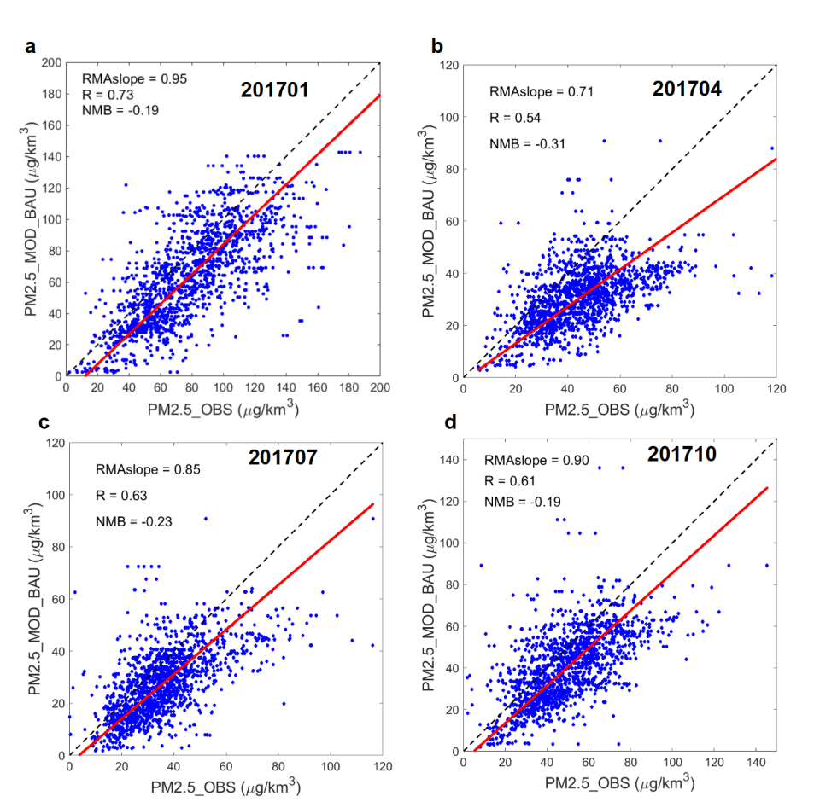

Fig. S1 | Comparison of observed and modeled monthly mean PM_{2.5} concentrations.

References:
¹ Wang, S. et al.. Urbanization can benefit agricultural production with large-scale farming in China. Nature Food 2 183-191 (2021).
² Duan, J. et al.. Consolidation of agricultural land can contribute to agricultural sustainability in China. Nature Food 2 1014-1022 (2021).
³ Zhu, Z. et al.. Integrated livestock sector nitrogen pollution abatement measures could generate net benefits for human and ecosystem health in China. Nature Food 3 161-168 (2022).
⁴ Technical Guide for Measuring the Land Carrying Capacity of Livestock and Poultry Manure. (Ministry of Agriculture and Rural Affairs, PRC, 2018) http://www.xmsyj.moa.gov.cn/zcjd/201904/t20190429_6287183.htm
⁵ Gu, B., Ju, X., Chang, J., Ge, Y. & Vitousek, P. M. Integrated reactive nitrogen budgets and future trends in China. Proc. Natl. Acad. Sci. U.S.A. 112 8792-8797 (2015).
⁶ Gu, B. et al.. Toward a Generic Analytical Framework for Sustainable Nitrogen Management: Application for China. Environ Sci Technol 53 1109-1118 (2019).
⁷ Wang, C. et al.. An empirical model to estimate ammonia emission from cropland fertilization in China. Environ Pollut 288 117982 (2021).
⁸ Wang, C. et al.. Ammonia Emissions from Croplands Decrease with Farm Size in China. Environ Sci Technol (2022).
⁹ Zhou, M. et al.. Environmental benefits and household costs of clean heating options in northern China. Nature Sustainability 5 329-338 (2022).
¹⁰ Xia, Y. et al.. A new framework to model the distributed transfer and retention of nutrients by incorporating topology structure of small water bodies. Water Res 238 119991 (2023).
¹¹ Cheng, F. Y. & Basu, N. B. Biogeochemical hotspots: Role of small water bodies in landscape nutrient processing. Water Resour Res 53 5038-5056 (2017).
¹² Xia, Y. & Yan, X. How Variations in Constructed Wetlands Geography Affect Nutrient Discharge. Journal of Geophysical Research: Biogeosciences 125 (2020).
¹³ Alexander, R. B., Smith, R. A. & Schwarz, G. E. Effect of stream channel size on the delivery of nitrogen to the Gulf of Mexico. Nature 403 758-761 (2000).
¹⁴ Wang, J. et al.. Spatially Explicit Inventory of Sources of Nitrogen Inputs to the Yellow Sea, East China Sea, and South China Sea for the Period 1970–2010. Earth's Future 8 (2020).
¹⁵ Yu, C. et al.. Managing nitrogen to restore water quality in China. Nature 567 516-520 (2019).
¹⁶ Strokal, M., Kroeze, C., Wang, M., Bai, Z. & Ma, L. The MARINA model (Model to Assess River Inputs of Nutrients to seAs): Model description and results for China. Sci Total Environ 562 869-888 (2016).
¹⁷ Bulletion of China marine ecological environment status 2017. (State Oceanic Administration, PRC, 2017) http://gc.mnr.gov.cn/201806/t20180619_1797652.html
¹⁸ Zhang, X. et al.. Societal benefits of halving agricultural ammonia emissions in China far exceed the abatement costs. Nat. Commun. 11 (2020).

