Supporting information

Dual pH- and Temperature-Responsive Poly(dimethylaminoethyl methacrylate)-Coated Mesoporous Silica Nanoparticles as a Smart Drug Delivery System
Sina Ramezanian^{1,2}, Jafarsadegh Moghaddas^{1,2, *}, Hossein Roghani-Mamaqani^{3,4}, Azim Rezamand^{5,6}
1. Chemical Engineering Faculty, Sahand University of Technology, P. O. Box 51335-1996, Tabriz, Iran
2. Transport Phenomena Research Center, Chemical Engineering Faculty, Sahand University of Technology, P.O. Box 51335/1996, Tabriz, Iran
3. Faculty of Polymer Engineering, Sahand University of Technology, P.O. Box 51335-1996, Tabriz, Iran
4. Institute of Polymeric Materials, Sahand University of Technology, P.O. Box 51335-1996, Tabriz, Iran
5. Pediatric Health Research Center, Tabriz University of Medical Sciences, Tabriz, Iran
6. Department of Pediatrics, Faculty of Medicine, Tabriz University of Medical Sciences, Tabriz, Iran
Author to whom all correspondence should be addressed. E-mail: jafar.moghaddas@sut.ac.ir (J. Moghaddas), Tel: (+98-41-33459155).

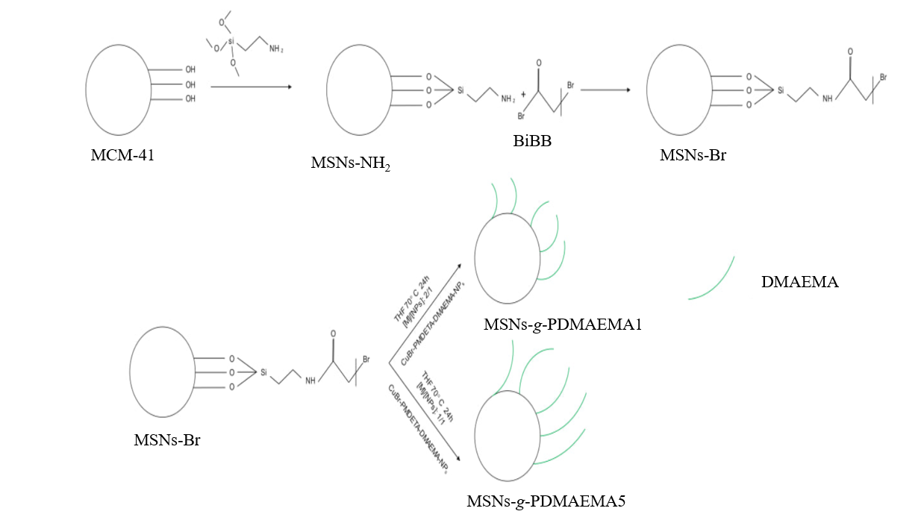
Figure S1: Synthesis of MSNs-g-PDMAEMA
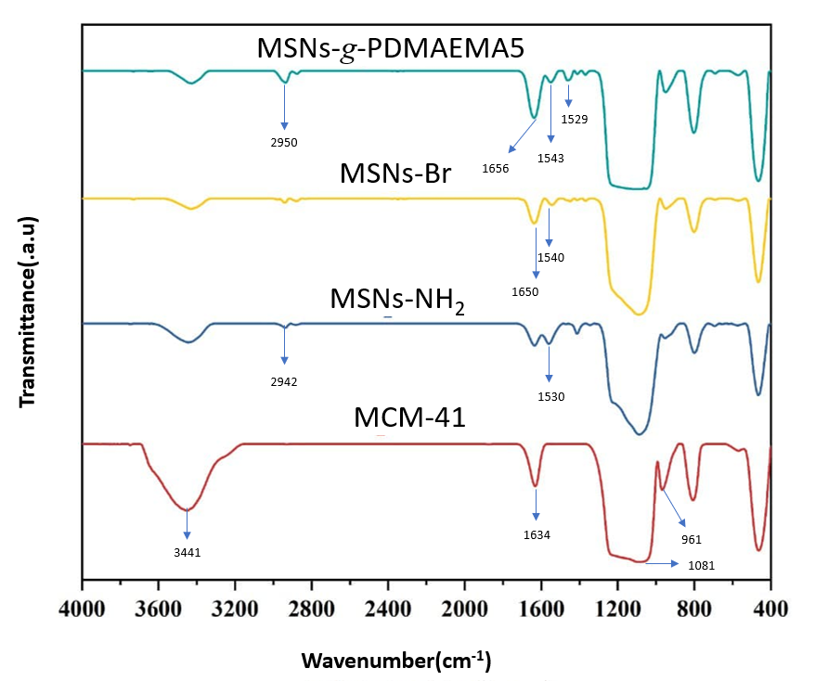
Figure S2. FT-IR spectra of (a) MCM-41, (b) MSNs-NH₂, (c) MSNs-Br, and (d) MSNs-g-PDMAEMA5
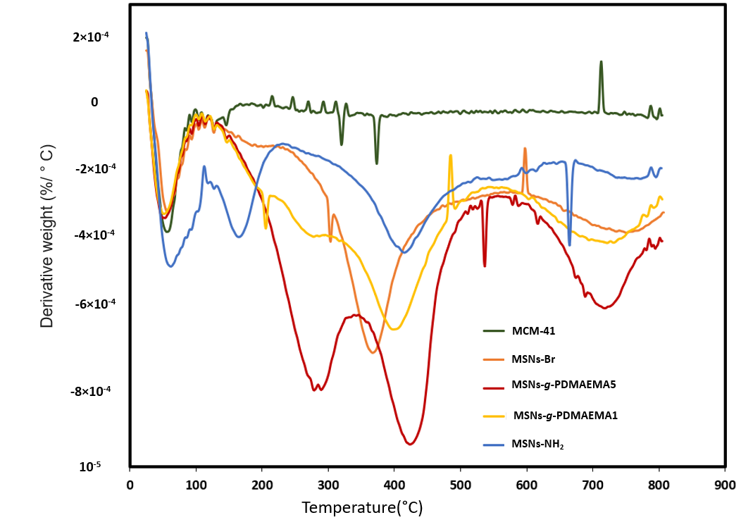
Figure S3. DTG results for the pure and functionalized MSNs
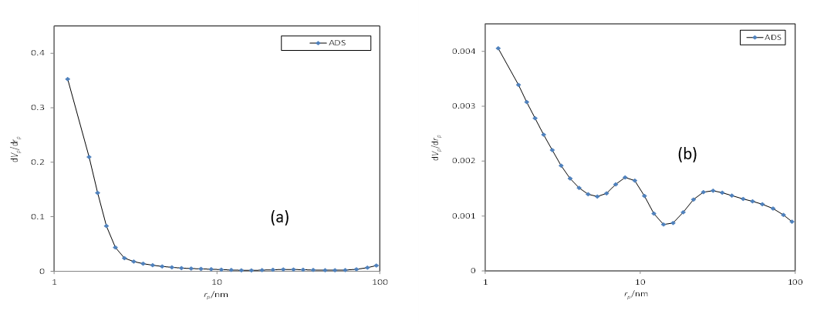
Figure S4. Pore size distribution diagram related to BJH method for (a) MCM-41 and (b) MSNs-g-PDMAEMA5

