Supplementary Material

Monitoring of air pollutants using plants and co-located soil - Egypt: characteristics, pollution, and toxicity impact

W. M. Badawy^{1,5} , Yasmin Sarhan², Octavian G Duliu^{3,5}, Junbeum Kim^{4,7}, Nikita Yushin⁵, H. El Samman², A. Hussein², Marina V. Frontasyeva⁵, Alexey I. Shcheglov⁶

¹Radiation Protection & Civil Defense Department, Nuclear Research Center, Egyptian Atomic Energy Authority (EAEA), 13759 Abu Zaabal, Egypt.
²Menoufia University, Faculty of Science, Department of Physics, Shibin El-koom, Egypt
³University of Bucharest, Faculty of Physics, Department of Atomic and Nuclear Physics, 405, Atomistilor str 077125 Magurele, Romania
⁴CREIDD Research Centre on Environmental Studies & Sustainability, Department of Humanity, Environment & Information Technology, the University of Technology of Troyes, France.
⁵Frank Laboratory of Neutron Physics, Joint Institute for Nuclear Research, str. Joliot-Curie, 6, 141980 Dubna, Moscow Region, Russian Federation
⁶ Faculty of Soil Science, Moscow State University, Moscow 119991, Russia
⁷Division for Geology of School of Earth Sciences and Engineering, National Research Tomsk Polytechnic University, Russia

Table 1SM: Distribution of collecting points

Sample # | Administra-tive division | Collection place | Sample |  | Longitude | Latitude
11 | GC | Atati (el-Haram) | F. benjamina | soil | 31.15943 | 30.01287
02 | GC | Ramsis | F benjamina | soil | 31.24722 | 30.06453
03 | GC | Tahrir | F benjamina | soil | 31.23308 | 30.05194
04 | GC | el-Sayyeda Zainab | F benjamina | soil | 31.23719 | 30.02735
05 | GC | el-Sahel | F benjamina | soil | 31.23473 | 30.09000
13 | GC | Kafr Nassar (Giza) | F benjamina | soil | 31.13547 | 29.98996
07 | GC | Shubra el-Kheima (power station) | F benjamina | soil | 31.23836 | 30.12400
15 | GC | al-Amireyya | F benjamina | soil | 31.30143 | 30.10564
16 | GC | el-Qawmeyya el-Arabeya (Imbaba) | F benjamina | soil | 31.20411 | 30.09482
19 | GC | al-Azhar park | F benjamina | soil | 31.26592 | 30.04097
06 | GC | el-Sharabeya | E globulus | soil | 31.25593 | 30.08889
01 | GC | Shubra el-Kheima (Crystal Asfour) | E globulus | soil | 31.25673 | 30.12455
12 | GC | el-Haram (Nazlet el-Batran) | E globulus | soil | 31.15051 | 29.98846
14 | GC | Nasr City | E globulus | soil | 31.31054 | 30.05917
08 | GC | El-Maadi | E globulus | soil | 31.24991 | 29.96207
09 | GC | Mustrod | E globulus | soil | 31.29481 | 30.14599
10 | GC | Basus | E globulus | soil | 31.21564 | 30.14100
17 | GC | el-Basateen | E globulus | soil | 31.26815 | 29.98891
18 | GC | el-Darb el-Ahmar | E globulus | soil | 31.26603 | 30.03616
20 | GC | (el-Qanater el-Khaireya) | E globulus | soil | 31.12720 | 30.18943
23 | MG | Sadat City | F benjamina | soil | 30.57352 | 30.39367
24 | MG | Ashmoun | F benjamina | soil | 30.97858 | 30.29995
27 | MG | al-Shuhadaa | F benjamina | soil | 30.89752 | 30.59032
28 | MG | al-Bagour | F benjamina | soil | 31.02430 | 30.47317
29 | MG | Hit-Menoufia | F benjamina | soil | 30.97611 | 30.37415
21 | MG | Menouf | E globulus | soil | 30.90021 | 30.46382
22 | MG | Sirs el-layyan | E globulus | soil | 30.97241 | 30.43531
25 | MG | Berket el-Sab | E globulus | soil | 31.07351 | 30.65218
26 | MG | Shebin el-Kom | E globulus | soil | 31.01808 | 30.59271
30 | MG | Hit-Menoufia | E Globulus | soil | 30.97629 | 30.37411
GC= Great Cairo
MG=Menoufia Governorate

Table 2SM: Enrichment factor EF and the category of enrichment.

EF Value | Category
EF < 1 | No enrichment
1 < EF < 3 | Minor enrichment
3 < EF < 5 | Moderate enrichment
5 < EF < 10 | Moderate to strong enrichment
10 < EF < 25 | Strong enrichment
25 < EF < 50 | Very strong enrichment
EF > 50 | Extremely strong enrichment

Table 3SM: Potential ecological risk PER and Risk Index RI and their interpretation categories (Hakanson, 1980; Karuppasamy et al., 2017)

PER value | RI value | Category
PER < 40 | RI < 150 | low potential ecological risk
40 ≤ PER < 80 | 150 ≤ RI < 300 | moderate potential ecological risk
80 ≤ PER < 160 | 300 ≤ RI < 600 | considerable potential ecological risk
160 ≤ PER > 320 | RI ≥ 600 | high potential ecological risk
PER ≥ 320 | RI < 150 | very high ecological risk

List of figures

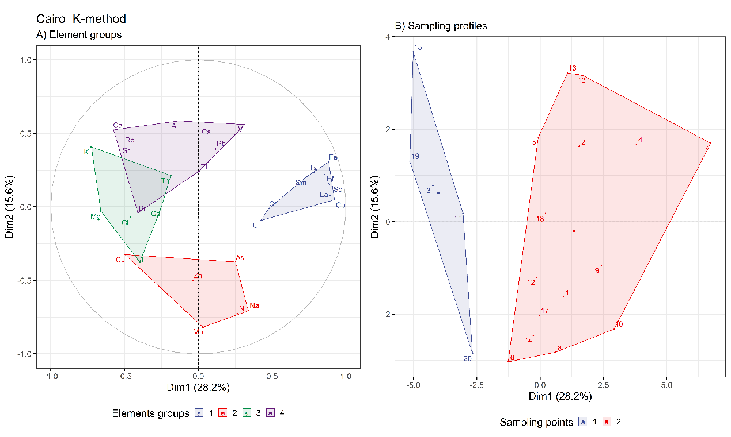
Fig. 1SM: PCA for tree leaves results illustrating the existence of significant clusters of determined elements A) and investigated collecting points B) by implementing K-method in GC.
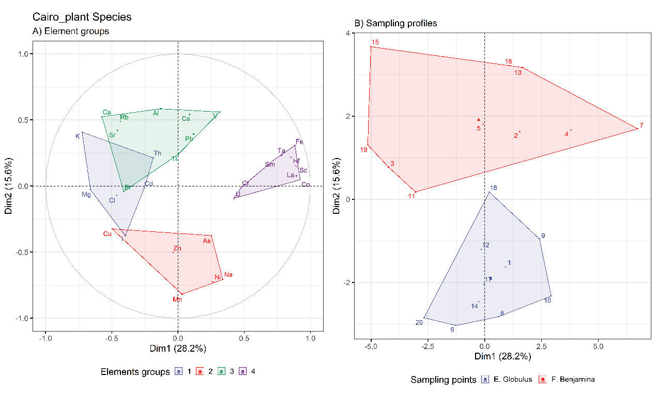
Fig. 2 SM: PCA for tree leaves results illustrating the existence of significant clusters of determined elements A) and investigated collecting points B) by implementing plant species in GC.

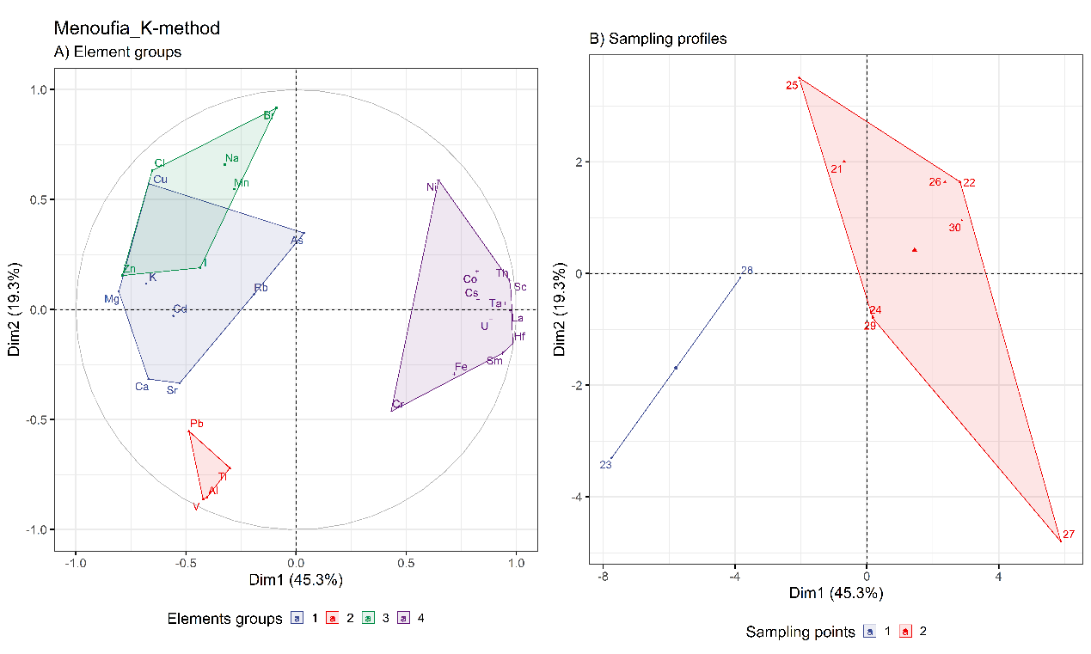
Fig. 3SM: PCA for tree leaves results illustrating the existence of significant clusters of determined elements A) and investigated collecting points B) by implementing K-method in MG.
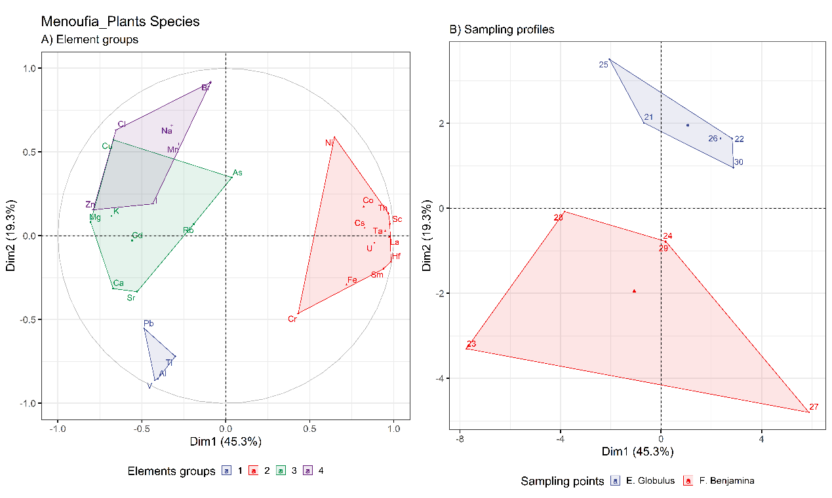
Fig. 4SM: PCA for tree leaves results illustrating the existence of significant clusters of determined elements A) and investigated collecting points B) by implementing K-method in MG.

Fig. 5SM: Human and Terrestrial ecotoxicity information maps of each element

Corresponding author: wael@jinr.ru

