Supplementary file 1
Supplementary Figure 1 - Western Blot (WB) images of HF sEV and LF sEV confirming the presence of sEV WB markers CD81, TSG101, CD9, Flot-1 and minimal exposure of non-sEV markers GAPDH and BSA.
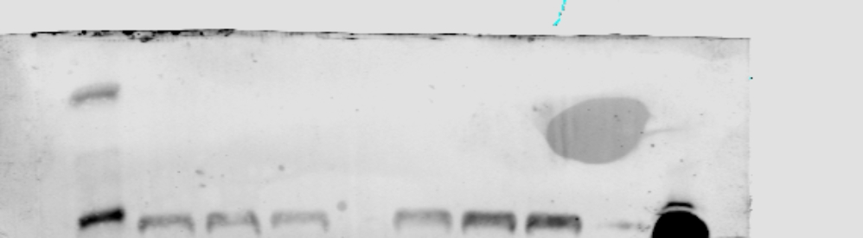
Anti-CD81
1/500
Plasma HF HF HF LF LF LF L

L EV HF HF HF LF LF LF GM L

Anti-TSG101
1/1000

Anti-CD9
1/1000

L JEG HF HF HF LF LF LF GM L

Anti-FLOT-1
1/1000

Anti-GAPDH
1/5000

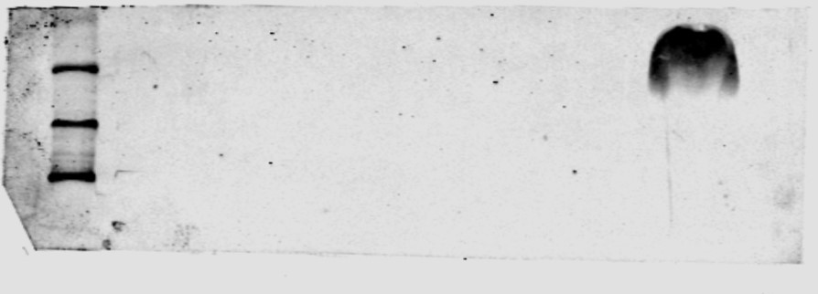
Plasma HF HF HF LF LF LF L
Anti-BSA
1/5000

Supplementary Figure 2 – Transmission electron micrography (TEM) images
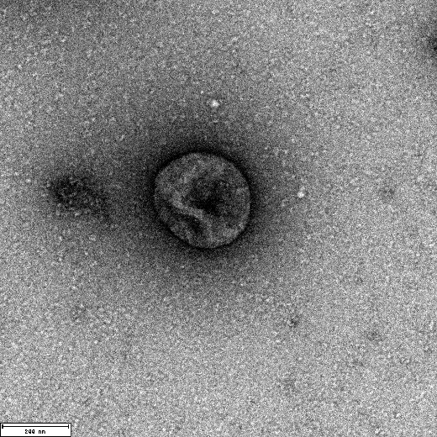
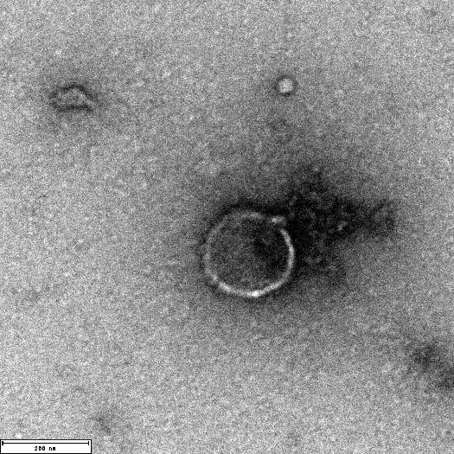
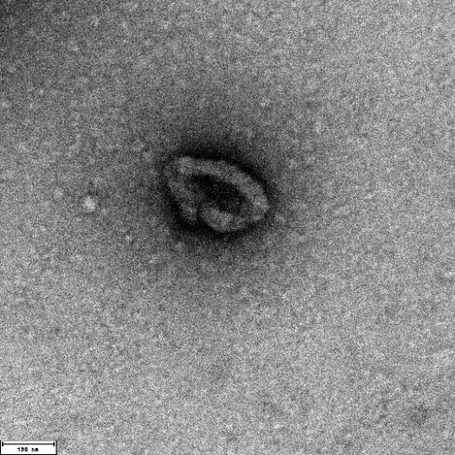
Supplementary Figure 2a – TEM images from HF sEV confirm the presence of sEV particles with defined shape and size in the samples.
200nm
200nm
100nm

Supplementary Figure 2a – TEM images from LF sEV confirm the presence of sEV particles with defined shape and size in the samples.
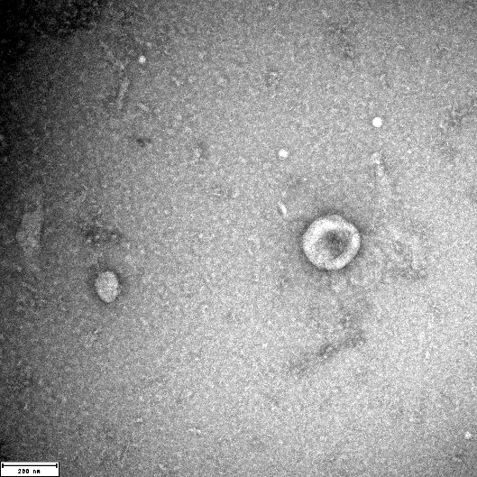
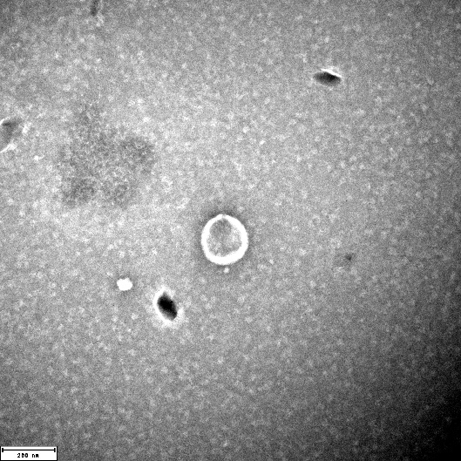
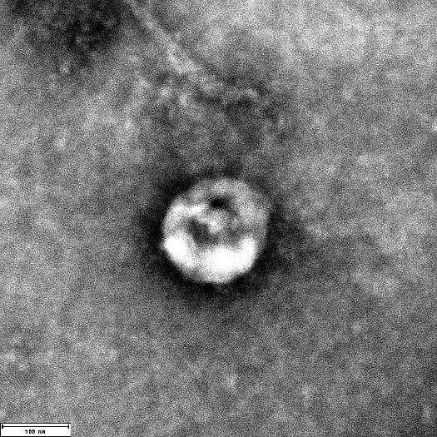
200nm
200nm
100nm

Supplementary Figure 3 – Nano particle tracking analysis (NTA) confirms the sizes of the particles isolated are within desired size range of 30-150nm. However, LF sEV indicates more particles.
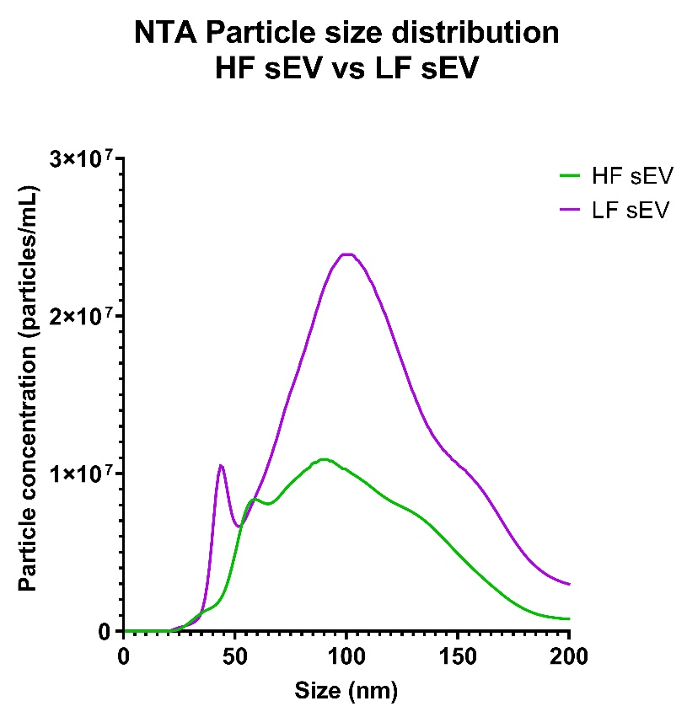

Supplementary Figure 4 – Particle purity estimate
