Supplementary material
Supplementary Figures
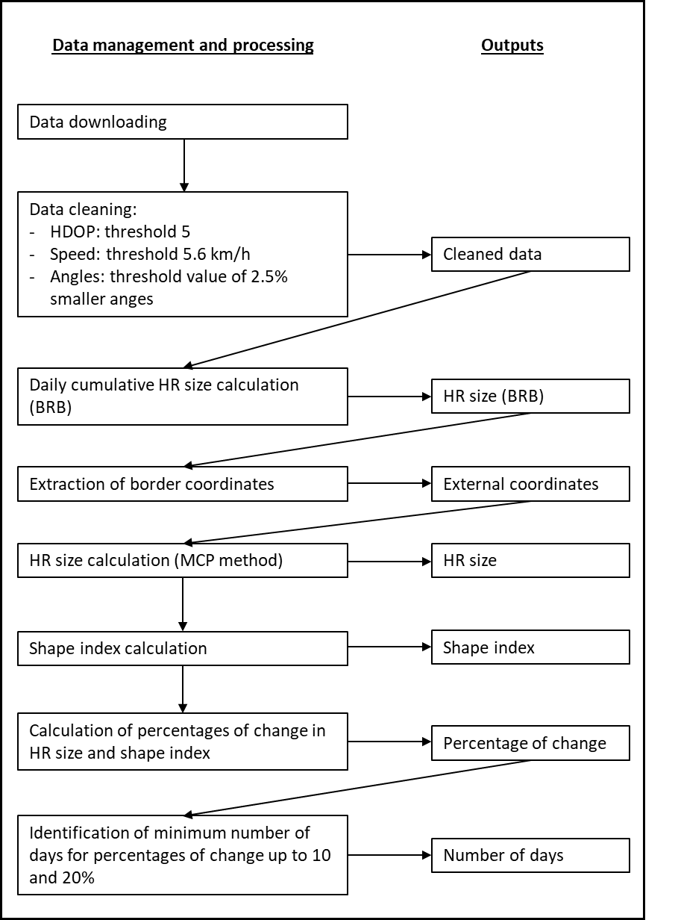
Data cleaning:
- HDOP: threshold 5
- Speed: threshold 5.7 km/h
- Angles: threshold value of 2.5% smaller angles
Supplementary Figure S1: Flow chart of data cleaning and management and of the analysis carried on in this study.
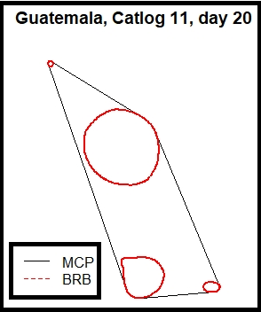
Supplementary Figure S2: Shape of the 95% isopleth for dog D011 from Guatemala, with 20 days of observation. The red lines represent the limits of the 95% BRB isopleth. The isopleth is constituted by four polygons that sum up to an area of 11.7ha. The black line is the MCP that includes the limits of the 95% isopleth and has a size of 35.3 ha. The shape index in this example is 11.7 ha/ 35.3 ha = 0.331.

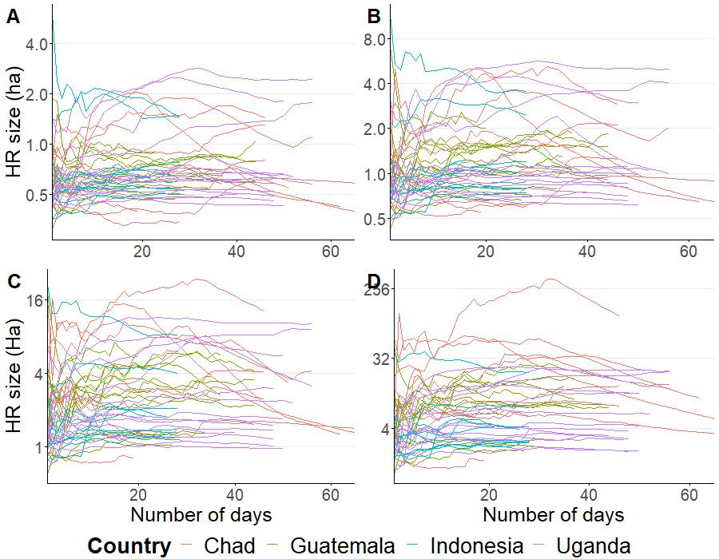
Supplementary Figure S3: Estimated daily HR size values for all the dogs during the study period, for the isopleths 60% (A), 70% (B), 80% (C) and 90% (D) for Chad, Guatemala, Indonesia and Uganda. Y-axis is presented in a logarithmic scale.
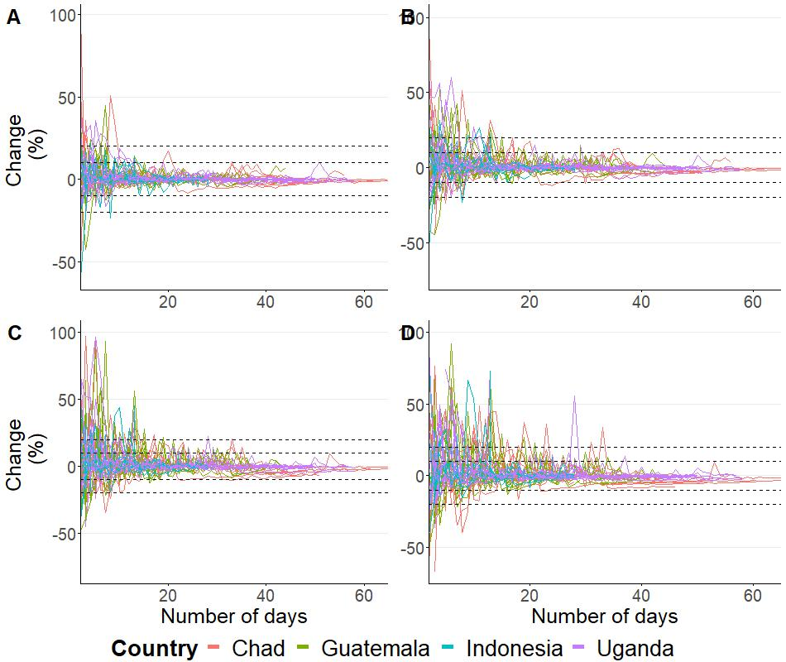
Supplementary Figure S4: Daily percentage of change in the estimated HR size values for the isopleths 60% (A), 70% (B), 80% (C) and 90% (D). The dashed lines indicate the 10% and 20% limits of percentage of change. All dogs from the same country have the same color. The y-axis is limited to +/-100, which excluded some outliers in Figures B, C and D.

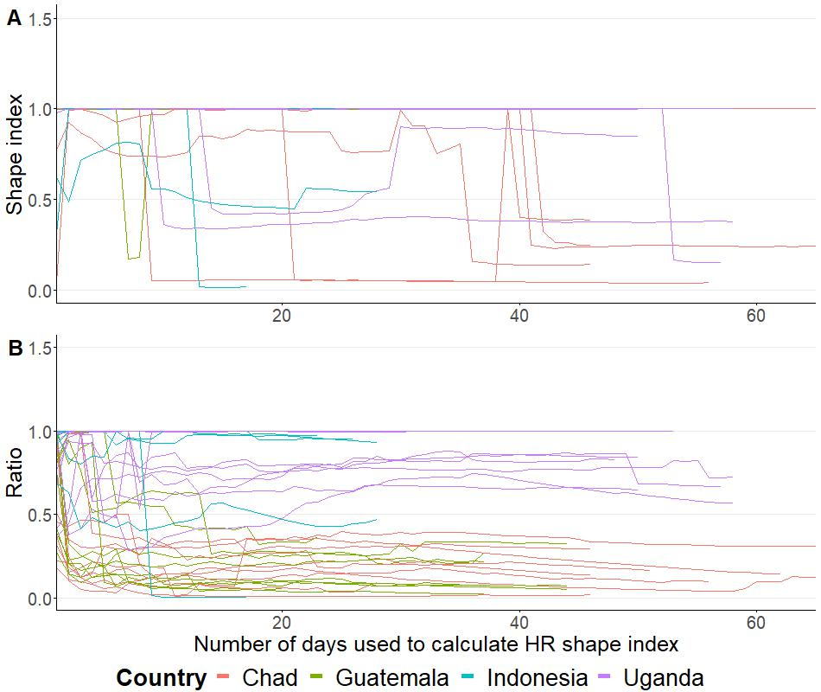
Supplementary Figure S4: HR shape index over the observation period, for the core (A) and the extended HR (B), for dogs from Chad, Guatemala, Indonesia and Uganda. Each line represents the shape index of one dog and each color represents a country.

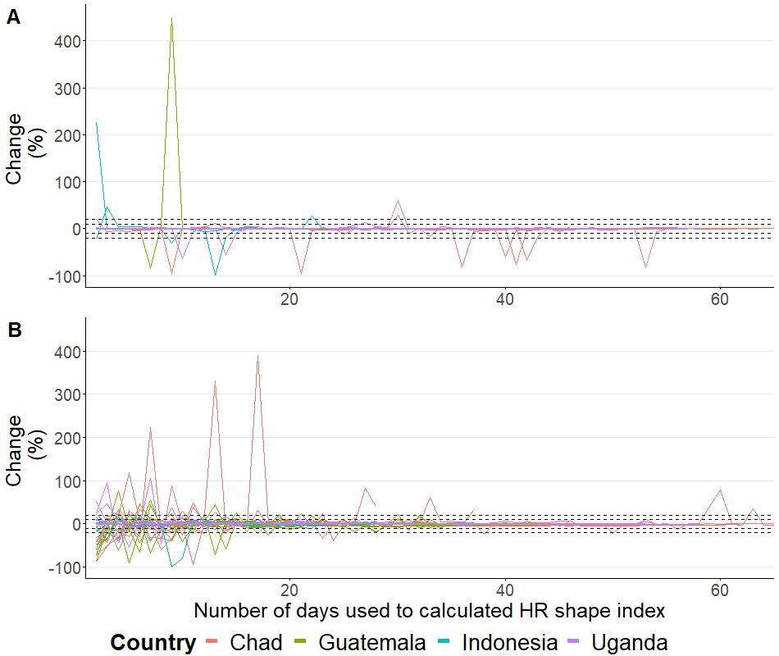
Supplementary Figure S5: Daily percentage of change in shape index values for the core (A) and extended (B) HR. The dashed lines indicate the 10% and 20% thresholds of percentage of change. Each line represents the shape index of one dog and each color represents a country.

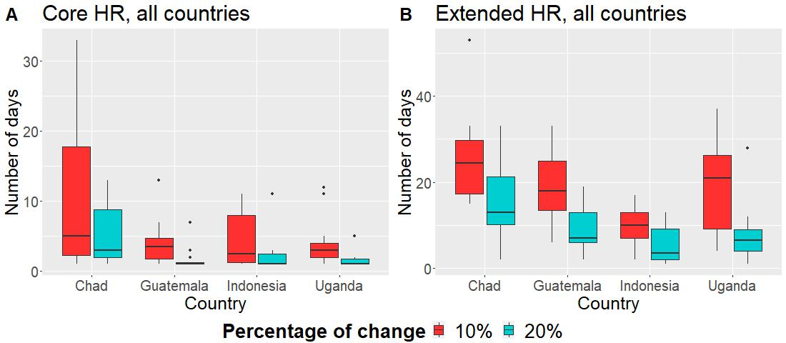Supplementary Figure S6: Comparison between countries and the number of days required per dog to reach a daily percentage of change in the HR value equal or below 10% (red) and 20% (turquoise) for the core (A) and extended (B) HR sizes. Dogs that never reached the thresholds were excluded.

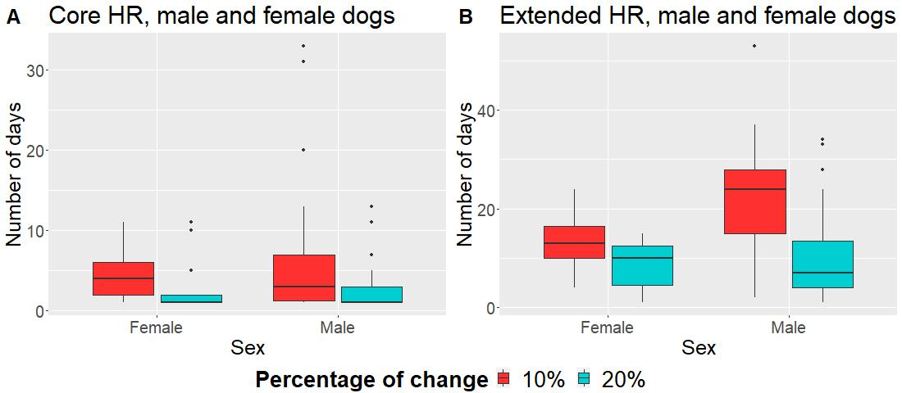
Supplementary Figure S7: Comparison between males and females and the number of days required per dog to reach a daily percentage of change in the HR value equal or below 10% (red) and 20% (turquoise) for the core (A) and extended (B) HR sizes. Dogs that never reached the thresholds were excluded.
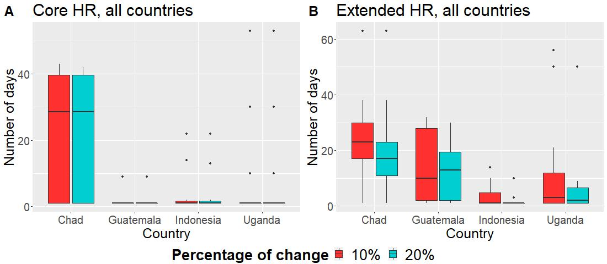
Supplementary Figure S8: Comparison between countries and the number of days required per dog to reach a daily percentage of change in the shape index equal or below 10% (red) and 20% (turquoise) change for the core (A) and extended (B) HR. Dogs that never reached the thresholds were excluded.

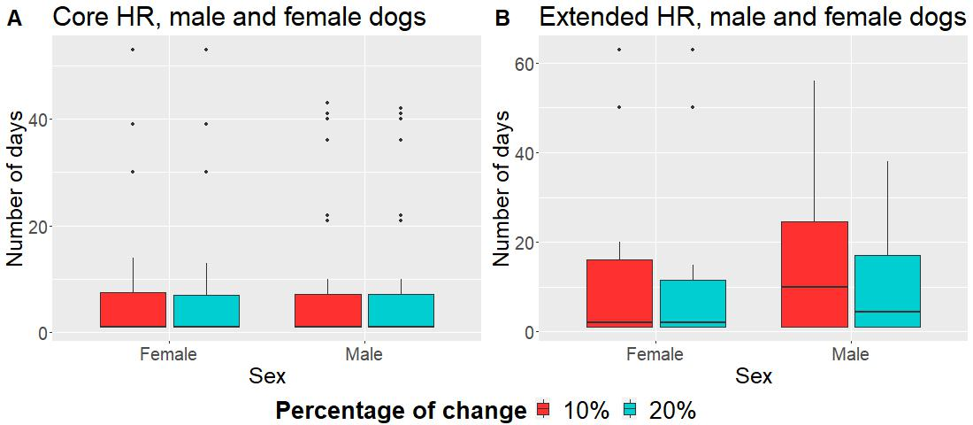
Supplementary Figure S9: Comparison between males and females and the number of days required per dog to reach a daily percentage of change in the shape index equal or below 10% (red) and 20% (turquoise) for the core (A) and extended (B) HR sizes. Dogs that never reached the thresholds were excluded.

Supplementary Tables
Supplementary Table S1: Description of the study sites from where dogs were collared with GPS devices.

Country | Nature of study site | Name of town or village | Expected dogs density | Study period | Coordinates | Admininstrative information
Chad | Rural | NDakonon | Low | Jan-March 2018 | 8.7475733, 18.53374 | Province: Moyen-Chari Department: Grande Sido  District: Danamadji
Chad | Rural | Sinetaye | Low | Jan-March 2018 | 13.2638383 17.721605 | Province: Batha  Department: Lake Fitri District: Yao
Guatemala | Rural | La Romana | Low | May-June 2018 | 16.408846,  -89.587039 | Department: Petén Municipality: Poptún
Guatemala | Rural | Sabaneta | Medium | May-June 2018 | 16.324934,  -89.324777 | Department: Petén Municipality: Poptún
Guatemala | Urban | Poptún | High | May-June 2018 | 16.34494,  -89.4249067 | Department: Petén Municipality: Poptún
Indonesia | Rural | Pogon | Low | July-September 2018 | -8.681464, 122.341900 | Province: East Nusa Tenggara Island: Flores Regency: Sikka
Indonesia | Rural | Hepang | Medium | July-September 2018 | -8.713159, 122.150506 | Province: East Nusa Tenggara Island: Flores Regency: Sikka
Indonesia | Semi-urban | Habi | High | July-September 2018 | -8.6349867, 122.2547617 | Province: East Nusa Tenggara Island: Flores Regency: Sikka
Uganda | Rural | Kamuda (I) | Low | Jan-March 2019 | 1.750024, 33.533461 | Region: Eastern Uganda District: Soroti
Uganda | Rural | Kamuda (II) | Low | Jan-March 2019 | 1.703531, 33.556220 | Region: Eastern Uganda District: Soroti
Uganda | Semi-urban | Soroti municipality | High | Jan-March 2019 | 1.7084433, 33.6320767 | Region: Eastern Uganda District: Soroti

Supplementary Table S2: Number of observation days required to reach a constant value of percentage of change in HR size equal or below 10% and 20% for the 60%, 70%, 80% and 90% isopleths. Numbers presented here indicate the minimum (Min) and maximum (Max), median, percentile 25 (Per. 25), percentile 75 (Per. 75) and mean of the minimum number of days required amongst all dogs.
Isopleth | Change (%) | Number of days
Isopleth | Change (%) | Min | Max | Median | Per. 25 | Per. 75 | Mean
60% | 10 | 1.0 | 51.0 | 4.5 | 2.0 | 9.5 | 7.7
60% | 20 | 1.0 | 9.0 | 1.0 | 1.0 | 3.0 | 2.4
70% | 10 | 1.0 | 36.0 | 7.0 | 4.0 | 16.75 | 11.5
70% | 20 | 1.0 | 15.0 | 2.0 | 1.0 | 6.5 | 4.3
80% | 10 | 1.0 | 35.0 | 12.0 | 6.0 | 23.0 | 15.2
80% | 20 | 1.0 | 33.0 | 7.0 | 2.0 | 11.75 | 8.0
90% | 10 | 2.0 | 37.0 | 16.0 | 8.0 | 24.0 | 16.9
90% | 20 | 1.0 | 33.0 | 7.5 | 4.0 | 12.75 | 9.5

