Supplementary materials

Uncertainty
Each process has a Pedigree Matrix assessment within the Ecoinvent database, where the majority of secondary data was sourced. This qualitative method is derived originally from post-normal science (Funtowicz, 1990), where it measures “the level of ignorance”. Whilst there is work on converting pedigree matrices into log-normal distributions, such as within (Ciroth, Muller, Weidema, & Lesage, 2016), work from other projects the authors are active in, currently unpublished, shows this can lead to errors in decision-making between processes.
Pedigree matrices are included within all results possible to give an illustrative impression of the reliability of the results and the underlying data.
The measures analysed within the Ecoinvent Pedigree Matrices are provided in Table 6.
Table 6: Pedigree Matrix as given on the Ecoinvent website (Ecoinvent).
 | Reliability | Completeness | Temporal correlation | Geographical correlation | Further technological correlation
1 | Verified data based on measurements | Representative data from all sites relevant to the market considered over an adequate period to even out normal fluctuations | Less than three years of difference to the time period of the data set | Data from the area under study | Data from enterprises, processes and materials under study
2 | Verified data partly based on assumptions or non-verified data based on measurements | Representative data from > 50% of the sites relevant for the market considered over an adequate period to even out normal fluctuations | Less than six years of difference to the time period of the data set | Average data from a larger area in which the area under study is included | Data from processes and materials under study (i.e. identical technology) but from different enterprises
3 | Non-verified data partly based on qualified estimates | Representative data from only some sites (<< 50%) relevant for the market considered or > 50% of sites but from shorter periods | Less than ten years of difference to the time period of the data set | Data from an area with similar production conditions | Data from processes and materials under study but from different technology
4 | Qualified estimate (e.g. by an industrial expert) | Representative data from only one site relevant for the market considered or some sites but from shorter periods | Less than 15 years of difference to the time period of the data set | Data from an area with slightly similar production conditions | Data on related processes or materials
5 | Non-qualified estimates | Representativeness unknown or data from a small number of sites and from shorter periods | Age of data unknown or more than 15 years of difference to the time period of the data set | Data from an unknown or distinctly different area (North America instead of the Middle East, OECD-Europe instead of Russia) | Data on related processes on a laboratory scale or from different technology

The five headings within Pedigree Matrices are as described below;
Reliability
The ‘reliability indicator’ relates to the sources, acquisition methods and verification procedures used to obtain the data. The indicator is independent of the data quality goals: a decision made under the goal definition does not change the reliability of the data, and the score would be identical if the data were used in another study.
Completeness
The ‘completeness indicator’ relates to the statistical properties of the data: how representative the sample is, whether the sample includes a sufficient number of data and whether the period is adequate to even out normal fluctuations. As for the ‘reliability indicator’, the ‘completeness indicator’ relates to the properties of the sample itself and is independent of the data quality goals of the particular study. Finally, the next three indicators all relate to the correlation between the data and the data quality goals concerning the technology or production conditions in a broad sense:
Temporal differences
The ‘temporal indicator’ represents the time correlation between the year of study (as stated in the data quality goals) and the year of the obtained data. As technology develops very quickly in certain industries, ten years difference between the year of study and the year of the data might cause the emissions and the production efficiency to be changed. Hence, the ‘temporal indicator’ is closely related to the data quality goals under the goal definition.
Geographical differences
The ‘geographical indicator’ illustrates the geographical correlation between the defined area (as stated in data quality goals) and the obtained data. The production methods and the production conditions can be very different in Norway (e.g. small-scale agriculture), the USA (large-scale productions, modem technology) and East-European countries (older technology).
Further technological differences
The ‘technological indicator’ concerns all other aspects of correlation than the temporal and geographical considerations. Although data may be of the desired age and representative of the desired geographical area, it may not be representative of the specific enterprises, processes or materials under study. Thus, it can be necessary to use data from related processes or materials, sometimes preferable to older data or data from a different geographical area.
It is important to see the five indicators as characterising independent aspects of data quality. For example, data from a ‘wrong’ area may imply a different technology is used. Nevertheless, this aspect is described under ‘geographical correlation’. The indicator ‘further technological correlation’ relates only to further differences occurring despite the data being of the same age and from the same geographical area.

Life Cycle Inventory
The Life Cycle Inventory is based on data from Brilliant Planet (and partners), the Ecoinvent Database, scientific literature, and sensible scientific calculations and assumptions.
The data used within the model is presented between Table 8 to Table 45.
Electricity is very often the, or greatest, source of impacts. Initial analysis of the Brilliant Planet data also showed this as the case for Brilliant Planet. Therefore, three sources of electricity were analysed, the data of which fed into the previously mentioned scenarios. These were;
- Average Moroccan grid electricity mix
- Solar Farm
- Wind turbines
These made up the three primary scenarios. In total, there were six scenarios, as detailed in Table 7. For the “a” scenarios, the system was “as is” but with only the electricity supply changed, and for the “b” scenarios, where additional changes were made.
The low carbon measures within the “b” scenarios were as follows; two options were made for nitric acid, the standard product produced internationally (“market for nitric acid, without water, in 50% solution state | nitric acid, without water, in 50% solution state | Cutoff, U – RoW”), and an option of nitric acid produced with renewable energy as the source of electricity (green nitric acid)(Table 10). Other low-carbon measures considered were replacing the HDPE within the intake pipe with a lower-carbon version (Table 36) and replacing the GFRP of the ponds(Table 11).
Table 7: Scenarios
Electricity Source | Additional carbon-saving measures
Electricity Source | No | Yes
Moroccan electricity grid | Scenario 1a | Scenario 1b
Solar Farm | Scenario 2a | Scenario 2b
Wind Farm | Scenario 3a | Scenario 3b

Renewable energy options

Moroccan Electricity Grid
For the grid scenario, the existing Ecoinvent 3.7 market process was used, named “market for electricity, low voltage | electricity, low voltage | Cutoff, U”. This model uses data from 2018 for the grid mix of Morocco, so it is slightly out of date. Ecoinvent calculated the generation mix and grid loses from the 2018 IEA World Energy Statistics and Balances (DOI: 10.1787/enestats-data-en). As the data is old, this is represented in the model’s pedigree matrix. As shown in the results, the temporal element of the Pedigree Matrices often shows outdated data within Ecoinvent.

Solar Farm
The solar model required a significantly different model to the existing Ecoinvent model; this is because, from Decerna’s experience in the solar industry, we have seen there are significant differences between the manufacturing techniques described within Ecoinvent and standard industrial practices; one example is the use of ozone-depleting chemicals in older photovoltaic manufacturing, which are no longer used.
To avoid these issues, a different data source was used, specifically (Müller et al., 2021), which we found to be an excellent article on LCA of photovoltaics. Therefore, the Life Cycle Inventory from (Müller et al., 2021)was used to create a model of a solar cell and photovoltaic modules (colloquially, a solar panel). Using this, the existing Ecoinvent mounting system model was used, measured in terms of m2/kWp, so the factor from (Müller et al., 2021)of 5.052 m2/kWp was used.
To understand the real output of a solar farm in Akhfennir, a model was constructed using PVSyst, a standard piece of solar farm design software, with weather data from the Meteonorm database. This showed for a 5MW solar farm; there would be an output of 8,370,000 kWh. A size of 5MW was chosen as a reasonable size for the 30-hectare site.
Using the above, an LCA model was constructed. The “market for inverter, 500kW | inverter, 500kW | Cutoff, U – GLO” model from Ecoinvent was used.
Photovoltaic modules degrade over time, meaning that after 20 years, a solar array may only generate 90% of what it did in Year 1. Therefore, to calculate the electricity generated over the lifetime of the solar array, we used Equation 1.

$$Total lifetime power output=-1*(\frac{(1-D)^{T}-1}{D})$$ | Equation 1
$$Y1=Year 1 power output$$
$$D=Degradation$$
$$T=Liftime of solar farm$$

In this case, the total lifetime power generation was calculated as 2.1×10⁸. From this, the impacts over the lifetime of the solar array could be calculated. This showed the electricity climate change impact is 0.02475 kgCO2e.

Wind Turbines
In terms of the wind model, a model from Ecoinvent was taken, electricity production, wind, 1-3MW turbine, offshore, this is for a 2MW wind turbine based in Portugal. The wind regime is slightly different in Morocco at the Akhfennir Wind Farm. According to the operator, Navara, the wind farm is rated at 100.23MW and generates 405.0GWh annually. This equates to 4.04GWh/MW installed. The Ecoinvent Portugal model has a generation of 5.26GWh for a 2MW system, hence an output of 2.63GWh/year. The Portuguese data assume a capacity factor of approx. ~30%, which is to be expected from onshore wind. The Akhfennir wind data suggests a capacity factor of 46%, usually associated with onshore wind. Within this work, we have taken a conservative approach and stayed with a capacity factor in the region of 30%, and thus used the Portuguese wind data. However, if further work confirms the high capacity factors of the Akhfennir wind farm, then the models will be modified accordingly, reducing the impacts of Brilliant Planet even further.
The wind turbine mode (electricity production, wind, 1-3MW turbine, offshore, cutoff, U - PT), along with the step-down voltage models (electricity voltage transformation from high to medium voltage | electricity, medium voltage | Cutoff, U - MA) and (electricity voltage transformation from medium to low voltage | electricity, low voltage | Cutoff, U - MA) and given in Table 46, Table 47 and Table 48 of the Appendix.

Further Results Tables
Here we present the full ReCiPe Hierarchist Midpoint outputs of the model. It is important to note that this study would not be a true LCA without considering a sensible range of impacts.
Figure 2: Impacts Scenario 1a
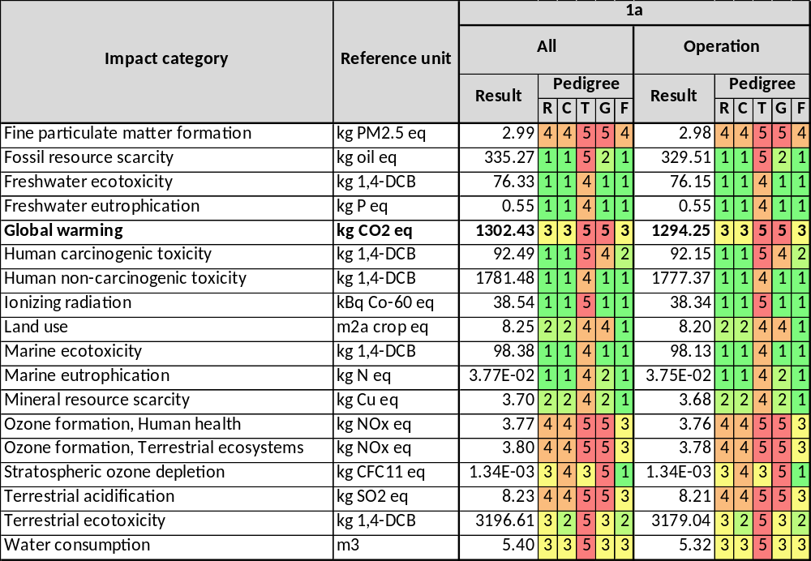
Figure 3:Impacts Scenario 1b
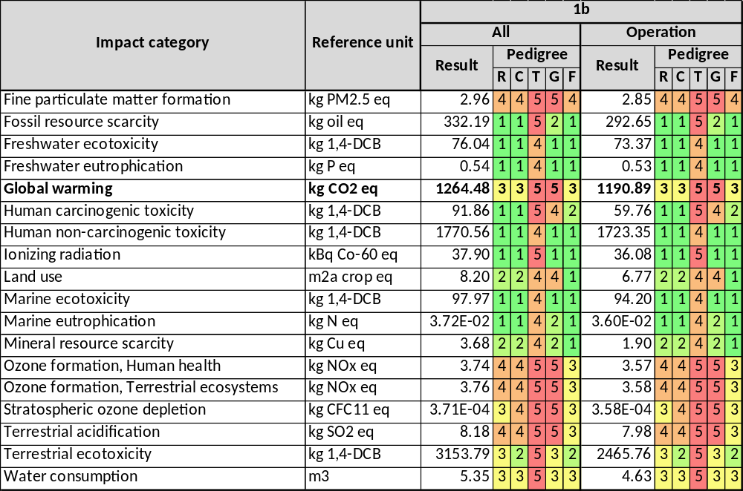
Figure 4:Impacts Scenario 2a
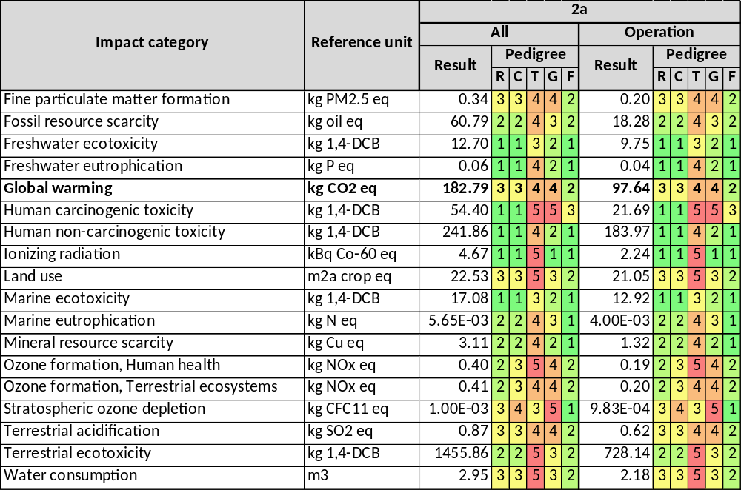
Figure 5:Impacts Scenario 2b
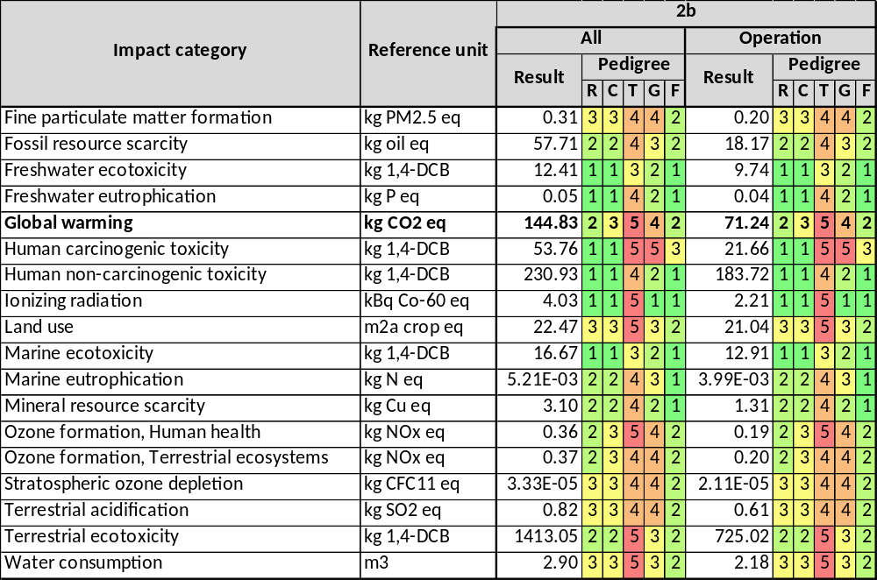
Figure 6:Impacts Scenario 3a
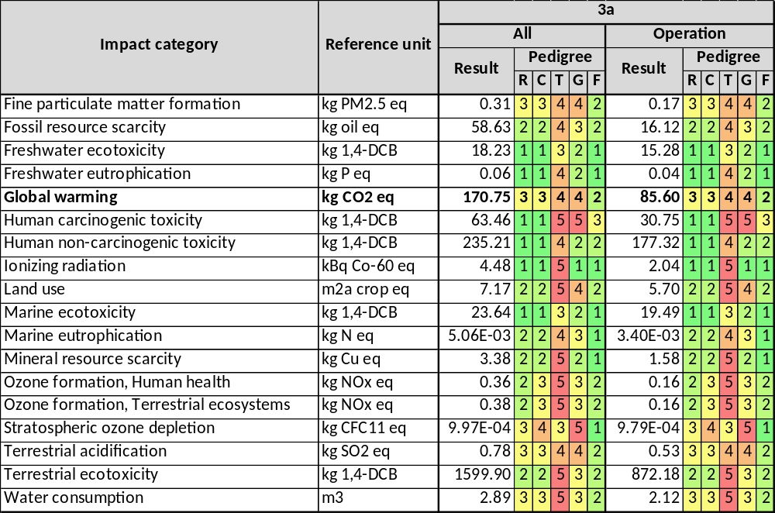
Figure 7:Impacts Scenario 3b
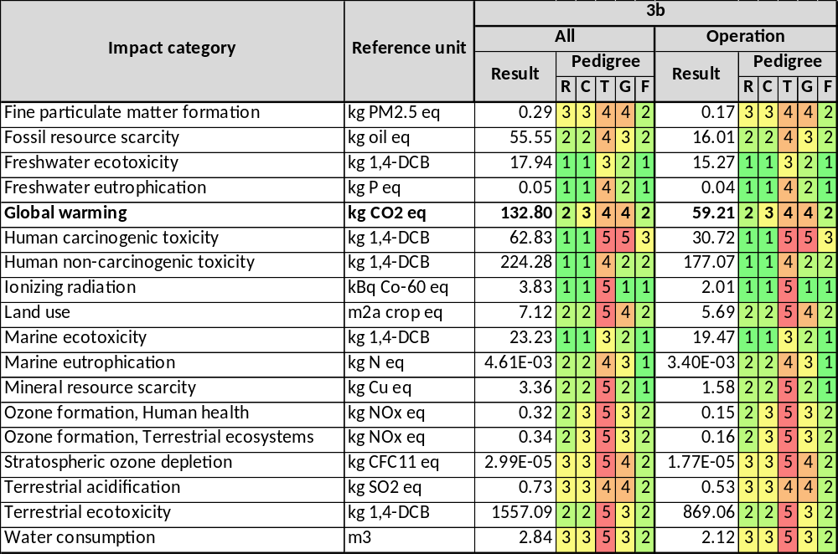

Tables

Phase 1 (Biomass Cultivation)
Table 8: Inputs for Seawater intake system
Input | Value | Unit | Comments | Provider
Electricity medium voltage | 7066.84 | kWh | As stated in the Brilliant Planet data | Dummy Electricity
Seawater | 192000.0 | m³ | As stated in the Brilliant Planet data | Seawater
Output | Value | Unit | Comments | Provider
Seawater (In-System) | 192000.0 | m³ | - | -

Table 9: Inputs for Biomass cultivation system
Input | Value | Unit | Comments | Provider
Electricity low voltage | 235.12 | kWh | As stated in the Brilliant Planet data | Dummy Electricity
Seawater | 192000.0 | m³ | As stated in the Brilliant Planet data | Seawater
Nitric acid/Green nitric acid | 222.0 | kg | Brilliant Planet value given in ml per m3 of sea water so value was converted into kg using density of nitric acid. | Green nitric acid/market for nitric acid, without water, in 50% solution state | nitric acid, without water, in 50% solution state | Cutoff, U - RoW
Phosphoric acid | 123.0 | kg | Brilliant Planet value given in ml per m3 of sea water so value was converted into kg using density of Phosphoric acid. | market for phosphoric acid, industrial grade, without water, in 85% solution state | phosphoric acid, industrial grade, without water, in 85% solution state | Cutoff, U - GLO
Phase 1 construction | 1.0 E-4 | Item | As calculated utilising the life span of the system allocating impacts for a single day of the facility. Assumed life time of 30 years and operation of 325 days per year. | Phase 1 Construction
Input | Value | Unit | Comments | Provider
Algae Mixture | 196552.8 | t | - | -
Table 10: Input for 1kg of Green nitric acid production
Input | Value | Unit | Comments | Provider
Chemical factory | 3.790E-10 | items | Ecoinvent for nitric acid production model from ROW | market for chemical factory, organics | chemical factory, organics | Cutoff, U - GLO
Electricity, low voltage, | 0.0079 | kWh |  | 1 kWh (Ground Mount Solar)
Ammonia, anhydrous, liquid | 0.269 | kg |  | market for ammonia, anhydrous, liquid | ammonia, anhydrous, liquid | Cutoff, U - RoW
Water | 0.414 | kg | Ecoinvent for nitric acid production model from ROW | market for tap water | tap water | Cutoff, U - RoW
Water | 0.00185 | m³ | Ecoinvent for nitric acid production model from ROW | market for tap water | tap water | Cutoff, U - RoW
Output | Value | Unit | Comments | Provider
Green nitric acid | 1 | kg | Ecoinvent for nitric acid production model from ROW | -
Ammonia | 0.00232 | kg | Ecoinvent for nitric acid production model from ROW | -
Dinitrogen monoxide | 1.0E-4 | kg | Ecoinvent for nitric acid production model from ROW then reduced to modern levels. As value in the Ecoinvent model was outrageously high | -
Nitrogen | 0.00198 | kg | Ecoinvent for nitric acid production model from ROW | -
Nitrogen | 1.222E-4 | kg | Ecoinvent for nitric acid production model from ROW | -
Nitrogen oxides | 4.075E-4 | kg | Ecoinvent for nitric acid production model from ROW | -
Water | 0.00208 | m³ | Ecoinvent for nitric acid production model from ROW | -
Table 11:Input for Green GFRP
Input | Value | Unit | Comments | Provider
Epoxy resin, liquid | 0.3 | kg | Taken from EPD provided my brilliant planet | market for epoxy resin, liquid | epoxy resin, liquid | Cutoff, U - RoW
Glass fibre | 0.25 | kg | Taken from EPD provided my brilliant planet | market for glass fibre | glass fibre | Cutoff, U - GLO
Silica sand | 0.45 | kg | Taken from EPD provided my brilliant planet | market for silica sand | silica sand | Cutoff, U - GLO
Output | Value | Unit | Comments | Provider
Greenhouse pond | 1 | item | - | -

Facility construction

Algae ponds
Table 12: Inputs for clean pond 1
Input | Value | Unit | Comments | Provider
Concrete 35MPa | 18.446 | m³ | Concrete mass provided by Brilliant Planet. | market for concrete, 35MPa | concrete, 35MPa | Cutoff, U - RoW
Glass fibre reinforced plastic | 17.216 | kg | GFRP frames converted from km to kg. Assuming radius of rod to be 0.008m. The length of a rod is Xm. πr² used to calculate volume of the rod for required length then multiply by the density of GFRP 2100 kg/m3 | market for glass fibre reinforced plastic, polyamide, injection moulded | glass fibre reinforced plastic, polyamide, injection moulded | Cutoff, U - GLO
Polyethylene, high density | 0.32 | t | Geomembrane as listed in Brilliant Planet data | market for polyethylene, high density, granulate | polyethylene, high density, granulate | Cutoff, U - GLO
Polymethyl methacrylate | 0.11 | t | Paddle wheel material as listed in Brilliant Planet data | market for polymethyl methacrylate, sheet | polymethyl methacrylate, sheet | Cutoff, U - GLO
Polyvinylchloride | 0.01 | t | PVC toppers as listed in Brilliant Planet data | market for polyvinylchloride, bulk polymerised | polyvinylchloride, bulk polymerised | Cutoff, U - GLO
Steel chromium steel | 0.01 | t | Proxy for galvanised steel cables. Galvanised steel refers most often to the process of hot dipping steel in molten zinc to provide corrosion resistant there for stainless steel was used as a proxy | market for steel, chromium steel 18/8 | steel, chromium steel 18/8 | Cutoff, U - GLO
Excavation, hydraulic digger | 25.08 | m³ | Calculated from brilliant data. Net earth moved per pond used as estimation | market for excavation, hydraulic digger | excavation, hydraulic digger | Cutoff, U - GLO
Output | Value | Unit |  | -
Clean pond 1 | 1 | item |  | -

Table 13:Inputs for Clean pond 2

Input | Value | Unit | Comments | Provider
Concrete 35MPa | 18.446 | m³ | Concrete mass provided by Brilliant Planet. | market for concrete, 35MPa | concrete, 35MPa | Cutoff, U - RoW
Glass fibre reinforced plastic | 27.528 | kg | GFRP frames converted from km to kg. Assuming radius of rod to be 0.008m. The length of a rod is Xm. πr² used to calculate volume of the rod for required length then multiply by the density of GFRP 2100 kg/m3 | market for glass fibre reinforced plastic, polyamide, injection moulded | glass fibre reinforced plastic, polyamide, injection moulded | Cutoff, U - GLO
Polyethylene, high density | 0.6 | t | Geomembrane as listed in Brilliant Planet data | market for polyethylene, high density, granulate | polyethylene, high density, granulate | Cutoff, U - GLO
Polymethyl methacrylate | 0.17 | t | Paddle wheel material as listed in Brilliant Planet data | market for polymethyl methacrylate, sheet | polymethyl methacrylate, sheet | Cutoff, U - GLO
Polyvinylchloride | 0.02 | t | PVC toppers as listed in Brilliant Planet data | market for polyvinylchloride, bulk polymerised | polyvinylchloride, bulk polymerised | Cutoff, U - GLO
Steel chromium steel | 0.02 | t | Proxy for galvanised steel cables. Galvanised steel refers most often to the process of hot dipping steel in molten zinc to provide corrosion resistant there for stainless steel was used as a proxy | market for steel, chromium steel 18/8 | steel, chromium steel 18/8 | Cutoff, U - GLO
Excavation, hydraulic digger | 72.649 | m³ | Calculated from brilliant data. Net earth moved per pond used as estimation | market for excavation, hydraulic digger | excavation, hydraulic digger | Cutoff, U - GLO
Output | Value | Unit | Comments | Provider
Clean pond 2 | 1 | item |  | -

Table 14: Inputs for Clean pond 3
Input | Value | Unit | Comments | Provider
Concrete 35MPa | 18.446 | m³ | Concrete mass provided by Brilliant Planet. | market for concrete, 35MPa | concrete, 35MPa | Cutoff, U – RoW
Glass fibre reinforced plastic | 44.768 | kg | GFRP frames converted from km to kg. Assuming radius of rod to be 0.008m. The length of a rod is Xm. πr² used to calculate volume of the rod for required length then multiply by the density of GFRP 2100 kg/m3 | market for glass fibre reinforced plastic, polyamide, injection moulded | glass fibre reinforced plastic, polyamide, injection moulded | Cutoff, U – GLO
Polyethylene, high density | 1.21 | t | Geomembrane as listed in Brilliant Planet data | market for polyethylene, high density, granulate | polyethylene, high density, granulate | Cutoff, U – GLO
Polymethyl methacrylate | 0.28 | t | Paddle wheel material as listed in Brilliant Planet data | market for polymethyl methacrylate, sheet | polymethyl methacrylate, sheet | Cutoff, U – GLO
Polyvinylchloride | 0.03 | t | PVC toppers as listed in Brilliant Planet data | market for polyvinylchloride, bulk polymerised | polyvinylchloride, bulk polymerised | Cutoff, U – GLO
Steel chromium steel | 0.03 | t | Proxy for galvanised steel cables. Galvanised steel refers most often to the process of hot dipping steel in molten zinc to provide corrosion resistant there for stainless steel was used as a proxy | market for steel, chromium steel 18/8 | steel, chromium steel 18/8 | Cutoff, U – GLO
Excavation, hydraulic digger | 594.813 | m³ | Calculated from brilliant data. Net earth moved per pond used as estimation | market for excavation, hydraulic digger | excavation, hydraulic digger | Cutoff, U – GLO
Output | Value | Unit
Clean pond 3 | 1 | item

Table 15:Inputs for clean pond 4
Input | Value | Unit | Comments | Provider
Concrete 35MPa | 18.446 | m³ | Concrete mass provided by Brilliant Planet. | market for concrete, 35MPa | concrete, 35MPa | Cutoff, U – RoW
Glass fibre reinforced plastic | 72.186 | kg | GFRP frames converted from km to kg. Assuming radius of rod to be 0.008m. The length of a rod is Xm. πr² used to calculate volume of the rod for required length then multiply by the density of GFRP 2100 kg/m3 | market for glass fibre reinforced plastic, polyamide, injection moulded | glass fibre reinforced plastic, polyamide, injection moulded | Cutoff, U – GLO
Polyethylene, high density | 2.55 | t | Geomembrane as listed in Brilliant Planet data | market for polyethylene, high density, granulate | polyethylene, high density, granulate | Cutoff, U – GLO
Polymethyl methacrylate | 0.45 | t | Paddle wheel material as listed in Brilliant Planet data | market for polymethyl methacrylate, sheet | polymethyl methacrylate, sheet | Cutoff, U – GLO
Polyvinylchloride | 0.04 | t | PVC toppers as listed in Brilliant Planet data | market for polyvinylchloride, bulk polymerised | polyvinylchloride, bulk polymerised | Cutoff, U – GLO
Steel chromium steel | 0.04 | t | Proxy for galvanised steel cables. Galvanised steel refers most often to the process of hot dipping steel in molten zinc to provide corrosion resistant there for stainless steel was used as a proxy | market for steel, chromium steel 18/8 | steel, chromium steel 18/8 | Cutoff, U – GLO
Excavation, hydraulic digger | 575.67 | m³ | Calculated from brilliant data. Net earth moved per pond used as estimation | market for excavation, hydraulic digger | excavation, hydraulic digger | Cutoff, U – GLO
Output | Value | Unit |  | -
Clean pond 4 | 1 | item |  | -

Table 16:Inputs for Greenhouse pond 0
Input | Value | Unit | Comments | Provider
Polymethyl methacrylate | 0.2 | t | Paddle wheel material as listed in Brilliant Planet data | market for polymethyl methacrylate, sheet | polymethyl methacrylate, sheet | Cutoff, U - GLO
Excavation, hydraulic digger | 2.0 | m³ | Calculated from brilliant data. Net earth moved per pond used as estimation | market for excavation, hydraulic digger | excavation, hydraulic digger | Cutoff, U - GLO
Output | Value | Unit |  | -
Greenhouse pond 0 | 1 | item |  | -

Table 17:Inputs for Greenhouse pond 1
Input | Value | Unit | Comments | Provider
Polymethyl methacrylate | 0.25 | t | Paddle wheel material as listed in Brilliant Planet data | market for polymethyl methacrylate, sheet | polymethyl methacrylate, sheet | Cutoff, U - GLO
Excavation, hydraulic digger | 2.0 | m³ | Calculated from brilliant data. Net earth moved per pond used as estimation | market for excavation, hydraulic digger | excavation, hydraulic digger | Cutoff, U - GLO
Output | Value | Unit |  | -
Greenhouse pond 1 | 1 | item |  | -

Table 18:Inputs for Greenhouse pond 2
Input | Value | Unit | Comments | Provider
Polymethyl methacrylate | 0.44 | t | Paddle wheel material as listed in Brilliant Planet data | market for polymethyl methacrylate, sheet | polymethyl methacrylate, sheet | Cutoff, U - GLO
Excavation, hydraulic digger | 4.0 | m³ | Calculated from brilliant data. Net earth moved per pond used as estimation | market for excavation, hydraulic digger | excavation, hydraulic digger | Cutoff, U - GLO
Output | Value | Unit |  | -
Greenhouse pond 2 | 1 | item |  | -

Table 19:Inputs for Greenhouse pond 3
Input | Value | Unit | Comments | Provider
Polymethyl methacrylate | 0.8 | t | Paddle wheel material as listed in Brilliant Planet data | market for polymethyl methacrylate, sheet | polymethyl methacrylate, sheet | Cutoff, U - GLO
Excavation, hydraulic digger | 6.8 | m³ | Calculated from brilliant data. Net earth moved per pond used as estimation | market for excavation, hydraulic digger | excavation, hydraulic digger | Cutoff, U - GLO
Output | Value | Unit |  | -
Greenhouse pond 3 | 1 | item

Table 20:Inputs for Greenhouse pond 4
Input | Value | Unit | Comments | Provider
Concrete 35MPa | 18.446 | m3 | Concrete mass provided by Brilliant Planet. | market for concrete, 35MPa | concrete, 35MPa | Cutoff, U - RoW
Glass fibre reinforced plastic | 10.683 | kg | GFRP frames converted from km to kg. Assuming radius of rod to be 0.008m. The length of a rod is Xm. πr² used to calculate volume of the rod for required length then multiply by the density of GFRP 2100 kg/m3 | market for glass fibre reinforced plastic, polyamide, injection moulded | glass fibre reinforced plastic, polyamide, injection moulded | Cutoff, U - GLO
Polyethylene, high density | 0.18 | t | Geomembrane as listed in Brilliant Planet data | polyethylene production, high density, granulate | polyethylene, high density, granulate | Cutoff, U - RoW
Polymethyl methacrylate | 0.07 | t | Paddle wheel material as listed in Brilliant Planet data | market for polymethyl methacrylate, sheet | polymethyl methacrylate, sheet | Cutoff, U - GLO
Polyvinylchloride | 0.01 | t | PVC toppers as listed in Brilliant Planet data | market for polyvinylchloride, bulk polymerised | polyvinylchloride, bulk polymerised | Cutoff, U - GLO
Steel chromium steel | 0.01 | t | Proxy for galvanised steel cables. Galvanised steel refers most often to the process of hot dipping steel in molten zinc to provide corrosion resistant there for stainless steel was used as a proxy | market for steel, chromium steel 18/8 | steel, chromium steel 18/8 | Cutoff, U - GLO
Excavation, hydraulic digger | 17.7 | m³ | Calculated from brilliant data. Net earth moved per pond used as estimation | market for excavation, hydraulic digger | excavation, hydraulic digger | Cutoff, U - GLO
Output | Value | Unit
Greenhouse pond 4 | 1 | item

Table 21:Input for Outdoor pond 1
Input | Value | Unit | Comments | Provider
Concrete 35MPa | 18.446 | m³ | Concrete mass provided by Brilliant Planet. | market for concrete, 35MPa | concrete, 35MPa | Cutoff, U - RoW
Glass fibre reinforced plastic | 116.405 | kg | GFRP frames converted from km to kg. Assuming radius of rod to be 0.008m. The length of a rod is Xm. πr² used to calculate volume of the rod for required length then multiply by the density of GFRP 2100 kg/m3 | market for glass fibre reinforced plastic, polyamide, injection moulded | glass fibre reinforced plastic, polyamide, injection moulded | Cutoff, U - GLO
Polyethylene, high density | 5.67 | t | Geomembrane as listed in Brilliant Planet data | polyethylene production, high density, granulate | polyethylene, high density, granulate | Cutoff, U - RoW
Polymethyl methacrylate | 0.73 | t | Paddle wheel material as listed in Brilliant Planet data | market for polymethyl methacrylate, sheet | polymethyl methacrylate, sheet | Cutoff, U - GLO
Polyvinylchloride | 0.07 | t | PVC toppers as listed in Brilliant Planet data | market for polyvinylchloride, bulk polymerised | polyvinylchloride, bulk polymerised | Cutoff, U - GLO
Steel chromium steel | 0.07 | t | Proxy for galvanised steel cables. Galvanised steel refers most often to the process of hot dipping steel in molten zinc to provide corrosion resistant there for stainless steel was used as a proxy | market for steel, chromium steel 18/8 | steel, chromium steel 18/8 | Cutoff, U - GLO
Excavation, hydraulic digger | 3534.166 | m³ | Calculated from brilliant data. Net earth moved per pond used as estimation | market for excavation, hydraulic digger | excavation, hydraulic digger | Cutoff, U - GLO
Output | Value | Unit
Outdoor pond 1 | 1 | item

Table 22:Inputs for Outdoor pond 2
Input | Value | Unit | Comments | Provider
Concrete 35MPa | 36.893 | m³ | Concrete mass provided by Brilliant Planet. | market for concrete, 35MPa | concrete, 35MPa | Cutoff, U - RoW
Glass fibre reinforced plastic | 265.434 | kg | GFRP frames converted from km to kg. Assuming radius of rod to be 0.008m. The length of a rod is Xm. πr² used to calculate volume of the rod for required length then multiply by the density of GFRP 2100 kg/m3 | market for glass fibre reinforced plastic, polyamide, injection moulded | glass fibre reinforced plastic, polyamide, injection moulded | Cutoff, U - GLO
Polyethylene, high density | 14.23 | t | Geomembrane as listed in Brilliant Planet data | polyethylene production, high density, granulate | polyethylene, high density, granulate | Cutoff, U - RoW
Polymethyl methacrylate | 1.67 | t | Paddle wheel material as listed in Brilliant Planet data | market for polymethyl methacrylate, sheet | polymethyl methacrylate, sheet | Cutoff, U - GLO
Polyvinylchloride | 0.16 | t | PVC toppers as listed in Brilliant Planet data | market for polyvinylchloride, bulk polymerised | polyvinylchloride, bulk polymerised | Cutoff, U - GLO
Steel chromium steel | 0.15 | t | Proxy for galvanised steel cables. Galvanised steel refers most often to the process of hot dipping steel in molten zinc to provide corrosion resistant there for stainless steel was used as a proxy | market for steel, chromium steel 18/8 | steel, chromium steel 18/8 | Cutoff, U - GLO
Excavation, hydraulic digger | 5996.711 | m³ | Calculated from brilliant data. Net earth moved per pond used as estimation | market for excavation, hydraulic digger | excavation, hydraulic digger | Cutoff, U - GLO
Output | Value | Unit
Outdoor pond 2 | 1 | item

Table 23:Inputs for Outdoor pond 3
Input | Value | Unit | Comments | Provider
Concrete 35MPa | 73.786 | m³ | Concrete mass provided by Brilliant Planet. | market for concrete, 35MPa | concrete, 35MPa | Cutoff, U - RoW
Glass fibre reinforced plastic | 605.298 | kg | GFRP frames converted from km to kg. Assuming radius of rod to be 0.008m. The length of a rod is Xm. πr² used to calculate volume of the rod for required length then multiply by the density of GFRP 2100 kg/m3 | market for glass fibre reinforced plastic, polyamide, injection moulded | glass fibre reinforced plastic, polyamide, injection moulded | Cutoff, U - GLO
Polyethylene, high density | 35.87 | t | Geomembrane as listed in Brilliant Planet data | polyethylene production, high density, granulate | polyethylene, high density, granulate | Cutoff, U - RoW
Polymethyl methacrylate | 3.81 | t | Paddle wheel material as listed in Brilliant Planet data | market for polymethyl methacrylate, sheet | polymethyl methacrylate, sheet | Cutoff, U - GLO
Polyvinylchloride | 0.37 | t | PVC toppers as listed in Brilliant Planet data | market for polyvinylchloride, bulk polymerised | polyvinylchloride, bulk polymerised | Cutoff, U - GLO
Steel chromium steel | 0.35 | t | Proxy for galvanised steel cables. Galvanised steel refers most often to the process of hot dipping steel in molten zinc to provide corrosion resistant there for stainless steel was used as a proxy | market for steel, chromium steel 18/8 | steel, chromium steel 18/8 | Cutoff, U - GLO
Excavation, hydraulic digger | 14908.438 | m³ | Calculated from brilliant data. Net earth moved per pond used as estimation | market for excavation, hydraulic digger | excavation, hydraulic digger | Cutoff, U - GLO
Output | Value | Unit | - | -
Outdoor pond 3 | 1 | item | - | -

Table 24:Inputs for Outdoor pond 4
Input | Value | Unit | Comments | Provider
Concrete 35MPa | 147.572 | m³ | Concrete mass provided by Brilliant Planet. | market for concrete, 35MPa | concrete, 35MPa | Cutoff, U - RoW
Glass fibre reinforced plastic | 1380.253 | kg | GFRP frames converted from km to kg. Assuming radius of rod to be 0.008m. The length of a rod is Xm. πr² used to calculate volume of the rod for required length then multiply by the density of GFRP 2100 kg/m3 | market for glass fibre reinforced plastic, polyamide, injection moulded | glass fibre reinforced plastic, polyamide, injection moulded | Cutoff, U - GLO
Polyethylene, high density | 90.67 | t | Geomembrane as listed in Brilliant Planet data | polyethylene production, high density, granulate | polyethylene, high density, granulate | Cutoff, U - RoW
Polymethyl methacrylate | 8.7 | t | Paddle wheel material as listed in Brilliant Planet data | market for polymethyl methacrylate, sheet | polymethyl methacrylate, sheet | Cutoff, U - GLO
Polyvinylchloride | 0.83 | t | PVC toppers as listed in Brilliant Planet data | market for polyvinylchloride, bulk polymerised | polyvinylchloride, bulk polymerised | Cutoff, U - GLO
Steel chromium steel | 0.79 | t | Proxy for galvanised steel cables. Galvanised steel refers most often to the process of hot dipping steel in molten zinc to provide corrosion resistant there for stainless steel was used as a proxy | market for steel, chromium steel 18/8 | steel, chromium steel 18/8 | Cutoff, U - GLO
Excavation, hydraulic digger | 24998.79 | m³ | Calculated from brilliant data. Net earth moved per pond used as estimation | market for excavation, hydraulic digger | excavation, hydraulic digger | Cutoff, U - GLO
Output | Value | Unit | - | -
Outdoor pond 4 | 1 | item | - | -

Table 25:Inputs for Outdoor pond 5
Input | Value | Unit | Comments | Provider
Concrete 35MPa | 295.143 | m³ | Concrete mass provided by Brilliant Planet. | market for concrete, 35MPa | concrete, 35MPa | Cutoff, U - RoW
Glass fibre reinforced plastic | 3147.443 | kg | GFRP frames converted from km to kg. Assuming radius of rod to be 0.008m. The length of a rod is Xm. πr² used to calculate volume of the rod for required length then multiply by the density of GFRP 2100 kg/m3 | market for glass fibre reinforced plastic, polyamide, injection moulded | glass fibre reinforced plastic, polyamide, injection moulded | Cutoff, U - GLO
Polyethylene, high density | 229.83 | t | Geomembrane as listed in Brilliant Planet data | polyethylene production, high density, granulate | polyethylene, high density, granulate | Cutoff, U - RoW
Polymethyl methacrylate | 19.83 | t | Paddle wheel material as listed in Brilliant Planet data | market for polymethyl methacrylate, sheet | polymethyl methacrylate, sheet | Cutoff, U - GLO
Polyvinylchloride | 1.9 | t | PVC toppers as listed in Brilliant Planet data | market for polyvinylchloride, bulk polymerised | polyvinylchloride, bulk polymerised | Cutoff, U - GLO
Steel chromium steel | 1.81 | t | Proxy for galvanised steel cables. Galvanised steel refers most often to the process of hot dipping steel in molten zinc to provide corrosion resistant there for stainless steel was used as a proxy | market for steel, chromium steel 18/8 | steel, chromium steel 18/8 | Cutoff, U - GLO
Excavation, hydraulic digger | 31931.38 | m³ | Calculated from brilliant data. Net earth moved per pond used as estimation | market for excavation, hydraulic digger | excavation, hydraulic digger | Cutoff, U - GLO
Output | Value | Unit | - | -
Outdoor pond 5 | 1 | item | - | -

Table 26:Inputs for Greenhouse
Input | Value | Unit | Comments | Provider
Concrete 35MPa | 20.752 | m³ | Concrete mass provided by Brilliant Planet. | market for concrete, 35MPa | concrete, 35MPa | Cutoff, U - RoW
Output | Value | Unit | - | -
Greenhouse | 1 | item | - | -

Table 27:Inputs for Lab building
Input | Value | Unit | Comments | Provider
Concrete 35MPa | 23.311 | m³ | Concrete mass provided by Brilliant Planet. | market for concrete, 35MPa | concrete, 35MPa | Cutoff, U - RoW
Output | Value | Unit | - | -
Greenhouse | 1 | item | - | -

Table 28:Inputs for Tank Pad
Input | Value | Unit | Comments | Provider
Concrete 35MPa | 20.473 | m³ | Concrete mass provided by Brilliant Planet. | market for concrete, 35MPa | concrete, 35MPa | Cutoff, U - RoW
Output | Value | Unit | - | -
Greenhouse | 1 | item | - | -

Table 29:Inputs for Drum filter
Input | Value | Unit | Comments | Provider
Concrete 35MPa | 145.6 | m³ | Concrete mass provided by Brilliant Planet. | market for concrete, 35MPa | concrete, 35MPa | Cutoff, U - RoW
Steel chromium steel | 349.44 | t | Assumed steel from brilliant planet data | market for steel, chromium steel 18/8 | steel, chromium steel 18/8 | Cutoff, U - GLO
Output | Value | Unit | - | -
Drum filters | 1 | item | - | -

Table 30:Input for Greenhouse frame 0
Input | Value | Unit | Comments | Provider
Aluminium | 0.18 | t | Aluminium supports | market for sheet rolling, aluminium | sheet rolling, aluminium | Cutoff, U - GLO
Output | Value | Unit | - | -
Greenhouse frame 0 | 1 | item | - | -

Table 31:Inputs for Greenhouse frame 1
Input | Value | Unit | Comments | Provider
Aluminium | 0.19 | t | Aluminium supports | market for sheet rolling, aluminium | sheet rolling, aluminium | Cutoff, U - GLO
Output | Value | Unit | - | -
Greenhouse frame 1 | 1 | item | - | -
Table 32:Inputs for Greenhouse frame 2
Input | Value | Unit | Comments | Provider
Aluminium | 0.23 | t | Aluminium supports | market for sheet rolling, aluminium | sheet rolling, aluminium | Cutoff, U - GLO
Output | Value | Unit | - | -
Greenhouse frame 2 | 1 | item | - | -
Table 33:Inputs for Greenhouse frame 3
Input | Value | Unit | Comments | Provider
Aluminium | 0.3 | t | Aluminium supports | market for sheet rolling, aluminium | sheet rolling, aluminium | Cutoff, U - GLO
Output | Value | Unit | - | -
Greenhouse frame 3 | 1 | item | - | -
Table 34:Inputs for Intake pipeline
Input | Value | Unit | Comments | Provider
Polyethylene, high density | 1072.84 | t | HDPE pipeline as listed in Brilliant Planet data | market for polyethylene, high density, granulate | polyethylene, high density, granulate | Cutoff, U - GLO
Concrete 35MPa | 238.8101291 | m3 | Concrete mass provided by Brilliant Planet. | market for concrete, 35MPa | concrete, 35MPa | Cutoff, U - RoW
Output | Value | Unit | - | -
Intake pipeline | 1 | item | - | -

Table 35:Inputs for Pipe network
Input | Value | Unit | Comments | Provider
Polyethylene, high density | 190.4 | t | HDPE pipeline as listed in Brilliant Planet data | market for polyethylene, high density, granulate | polyethylene, high density, granulate | Cutoff, U - GLO
Output | Value | Unit | - | -
Pipe network | 1 | item | - | -

Table 36:Inputs for Green HDPE
Input | Value | Unit | Comments | Provider
compressed air, 600 kPa gauge | 0.065751 | m³ |  | market for compressed air, 600 kPa gauge | compressed air, 600 kPa gauge | Cutoff, U - RER
Chemical factory organics | 4.0E-10 | Items |  | chemical factory construction, organics | chemical factory, organics | Cutoff, U - RER
Chemical inorganic | 2.485E-4 | kg |  | market for chemical, inorganic | chemical, inorganic | Cutoff, U - GLO
Chemical organic | 0.0217 | kg |  | market for chemical, organic | chemical, organic | Cutoff, U - GLO
Chromium oxide flakes | 1.483E-4 | kg |  | market for chromium oxide, flakes | chromium oxide, flakes | Cutoff, U - GLO
electricity, medium voltage, renewable energy products | 0.432 | kWh |  | market for electricity, medium voltage, renewable energy products | electricity, medium voltage, renewable energy products | Cutoff, U - CH
ethylene | 1.001811 | kg |  | market for ethylene | ethylene | Cutoff, U - RER
heat, from steam, in chemical industry | 1.120862 | MJ |  | market for heat, from steam, in chemical industry | heat, from steam, in chemical industry | Cutoff, U - RER
hydrogen, liquid | 2.43E-04 | kg |  | market for hydrogen, liquid | hydrogen, liquid | Cutoff, U - RER
natural gas, high pressure | 0.003383 | m³ |  | market group for natural gas, high pressure | natural gas, high pressure | Cutoff, U - Europe without Switzerland
natural gas, high pressure | 2.18E-05 | m³ |  | market for natural gas, high pressure | natural gas, high pressure | Cutoff, U - CH
nitrogen, liquid | 0.104856 | kg |  | market for nitrogen, liquid | nitrogen, liquid | Cutoff, U - RER
propylene | 2.01E-05 | kg |  | market for propylene | propylene | Cutoff, U - RER
solvent, organic | 0.006222 | kg |  | market for solvent, organic | solvent, organic | Cutoff, U - GLO
titanium tetrachloride | 2.85E-05 | kg |  | market for titanium tetrachloride | titanium tetrachloride | Cutoff, U - GLO
Water, cooling, unspecified natural origin | 0.022959 | m³ | - | -
Water, unspecified natural origin | 7.71E-04 | m³ | - | -
Output | Value | Unit | - | -
Aluminium | 1.73E-06 | kg | - | -
Ammonium, ion | 2.26E-07 | kg | - | -
AOX, Adsorbable Organic Halogen as Cl | 2.73E-08 | kg | - | -
Carbon dioxide, fossil | 0.034905 | kg | - | -
Carbon monoxide, fossil | 6.72E-05 | kg | - | -
Chloride | 7.96E-05 | kg | - | -
Chromium | 1.52E-08 | kg | - | -
Chromium, ion | 9.26E-09 | kg | - | -
Copper, ion | 2.53E-09 | kg | - | -
Dinitrogen monoxide | 7.04E-06 | kg | - | -
Ethene | 2.58E-04 | kg | - | -
Fluoride | 2.00E-07 | kg | - | -
Green HDPE | 1 | kg | - | -
hazardous waste, for incineration | 1.39E-05 | kg | - | -
hazardous waste, for incineration | 5.33E-04 | kg | - | -
Hydrogen | 1.39E-07 | kg | - | -
Methane, fossil | 1.28E-06 | kg | - | -
Nickel, ion | 6.89E-11 | kg | - | -
Nitrate | 3.30E-07 | kg | - | -
Nitrogen oxides | 1.24E-05 | kg | - | -
Nitrogen, organic bound | 2.16E-06 | kg | - | -
NMVOC, non-methane volatile organic compounds, unspecified origin | 2.45E-04 | kg | - | -
Particulates, > 10 um | 5.89E-06 | kg | - | -
Particulates, > 2.5 um, and < 10um | 1.42E-06 | kg | - | -
Phosphorus | 8.24E-07 | kg | - | -
spent solvent mixture | 3.75E-04 | kg | - | -
spent solvent mixture | 8.78E-06 | kg | - | -
Sulfate | 9.86E-05 | kg | - | -
Sulfur dioxide | 7.26E-08 | kg | - | -
Suspended solids, unspecified | 1.06E-04 | kg | - | -
waste plastic, mixture | 0.001283 | kg | - | -
wastewater, average | 6.72E-05 | m³ | - | -
wastewater, average | 6.22E-04 | m³ | - | -
wastewater, unpolluted | 0.018445 | m³ | - | -
Water | 0.004597 | m³ | - | -
Zinc, ion | 2.89E-07 | kg | - | -

Phase 2 (Biomass harvesting)

Table 37:Inputs for Drum filters
Input | Value | Unit | Comments | Provider
Concrete, 30 Mpa | 145.6 | m³ |  | market for concrete, 35MPa | concrete, 35MPa | Cutoff, U - RoW
Steel, chromium steel 18/8 | 349.44 | T |  | Phase 2 Construction
Output | Value | Unit | - | -
Drum filters | 1 | item |  | -

Table 38:Inputs for phase 2 construction
Input | Value | Unit | Comments | Provider
Drum filters | 1 | items | - | Drum filters - MA
Output | Value | Unit | - | -
Phase 2 Construction | 1 | item | - | -

Table 39:Inputs for biomass harvesting
Input | Value | Unit | Comments | Provider
Algae mixture | 196552.817 | t | Combination of all inputs from previous phase and the known algae dry weight mass per one day | Biomass cultivation
Electricity low voltage | 240.0 | kWh | As stated in Brilliant Planet data. | market for electricity, medium voltage | electricity, medium voltage | Cutoff, U - MA
Phase 2 Construction | 1.026E-4 | Item(s) |  | Phase 2 Construction
Output | Value | Unit | - | -
Algae Biomass (Wet) | 102.4 | t | Wet algae mixture obtained from brilliant planet data | -
Sea water | 191899.961 | m³ | As shown in Brilliant Planet data | -

Phase 3 (Seawater discharge)
Table 40:Input for Seawater discharge pipeline
Input | Value | Unit | Comments | Provider
Polyethylene, high density/ Green HDPE | 331.12 | t | HDPE pipeline as listed in Brilliant Planet data | market for polyethylene, high density, granulate | polyethylene, high density, granulate | Cutoff, U - GLO
Output | Value | Unit | - | -
Discharge pipeline | 1 | item | - | -
Table 41:Inputs for phase 3 construction
Input | Value | Unit | Comments | Provider
Discharge pipeline | 1 | item |  | Discharge Pipeline - MA
Output | Value | Unit | - | -
Phase 3 constrution | 1 | item | - | -

Input | Value | Unit | Comments | Provider
Electrical, low voltage | 2859.95 | item |  | Dummy Electricity
Phase 3 constrution | 0.00010 | item |  | Phase 3 Construction
Seawater (in) | 191899.961 | m³ |  | Seawater
Output | Value | Unit | - | -
Phase 3 constrution | 1 | item | - | -

Phase 4 (Algae drying)
Table 42:Inputs for Algae drying
Input | Value | Unit | Comments | Provider
Algae biomass | 102.4 | t | Algae biomass remaining from harvesting stage | Biomass Havesting operation
Electricity medium voltage | 240.0 | kWh | Electricity uses per day | market for electricity, medium voltage | electricity, medium voltage | Cutoff, U - MA
Output | Value | Unit | - | -
Algae Biomass | 6.14 | t | Algae biomass dry weight | -
water | x | m³ | Water removed in the drying process | -

Phase (Biomass burial)
Table 43:Inputs for Biomass burial
Input | Value | Unit | Comments | Provider
Algae Biomass | 6.14 | t | Total biomass per day. | Algae drying
Output | Value | Unit | - | -
Sequestered carbon | 9.9 | t | Figures obtained from Brilliant Planets calculations. | -

Additional facility LCI data
Input | Value | Unit | Comments | Provider
Galvanised steel |  | Chromium steel | Galvanised steel is steel that has been treated by commonly hot dipping the material in molten zinc. As a proxy chromium steel was used a it could potentially being used in its place.
Table 44: Proxy Processes
Factor
Facility lifetime [years] | 30
Production of microalgae (kgDW/day) [t] | 6.14
Operational days per year [days] | 325
Carbon content of algae biomass [ratio] | 1.612378:1
Table 45: Core factors

Alternative energy solutions
Table 46:Inputs for electricity production, wind, 1-3MW turbine, offshore, cutoff, U - PT
Input | Value | Unit | Comments | Provider
Energy, kinetic (in wind), converted | 3.87 | MJ |  | Elementary flows/Resource/in air
lubricating oil | 3.707E-5 | kg |  | market for lubricating oil | lubricating oil | Cutoff, U - RoW
transport, freight, lorry 7.5-16 metric ton, EURO3 | 1.745E-12 | t*km |  | market for transport, freight, lorry 7.5-16 metric ton, EURO3 | transport, freight, lorry 7.5-16 metric ton, EURO3 | Cutoff, U - RoW
wind turbine network connection, 2MW, onshore | 1.177E-8 | Item |  | market for wind turbine network connection, 2MW, onshore | wind turbine network connection, 2MW, onshore | Cutoff, U - GLO
wind turbine, 2MW, onshore | 1.177E-8 | Item |  | market for wind turbine, 2MW, onshore | wind turbine, 2MW, onshore | Cutoff, U - GLO
Output | Value | Unit | - | -
Electricity, high voltage | 1 | kWh | - | -
Waste mineral oil | 3.707E-5 | kg | - | market for waste mineral oil | waste mineral oil | Cutoff, U - RoW

Table 47: Inputs for electricity voltage transformation from high to medium voltage | electricity, medium voltage | Cutoff, U - MA
Input | Value | Unit | Comments | Provider
Electricity, high voltage | 1.014 | kWh | - | Electricity production wind 1-3MW onshore - MA
Output | Value | Unit | - | -
Electricity, medium voltage | 1 | kWh | - | -

Table 48: Inputs for electricity voltage transformation from medium to low voltage | electricity, medium voltage | Cutoff, U - MA
Input | Value | Unit | Comments | Provider
Electricity, medium voltage | 1.014 | kWh | - | Electricity production wind 1-3MW onshore - MA
Output | Value | Unit | - | -
Electricity, low voltage | 1 | kWh | - | -

Table 49: Inventory data for MG-Silicon production
Input | Coefficient | Unit | Activity Link | Source
charcoal | 1.70E-01 | kg | market for charcoal [GLO] | Ecoinvent v3.8
coke | 2.31E+01 | MJ | market for coke [GLO] | Ecoinvent v3.8
electricity, medium voltage | 1.10E+01 | kWh | market for electricity [DE]/ market group for electricity [RER]/market group for electricity [CN], medium voltage | Ecoinvent v3.8, activity link modified
graphite | 1.00E-01 | kg | market for graphite [GLO] | Ecoinvent v3.8
oxygen, liquid | 2.00E-02 | kg | market for oxygen, liquid [RER] | Ecoinvent v3.8
petroleum coke | 5.00E-01 | kg | market for petroleum coke [GLO] | Ecoinvent v3.8
silica sand | 2.70E+00 | kg | market for silica sand [GLO] | Ecoinvent v3.8
silicone factory | 1.00E-11 | unit | silicone factory construction [RER] | Ecoinvent v3.8
wood chips, wet, measured as dry mass | 5.50E-01 | kg | market for wood chips, wet, measured as dry mass [Europe without Switzerland] | Ecoinvent v3.8
Output | Coefficient | Unit | Activity Link | Source
silicon, metallurgical grade [CN, DE or EU] | 1.00E+00 | kg | Silicon production, solar grade, modified Siemens process
Aluminium [air/non-urban air or from high stacks] | 1.55E-06 | kg |  | Ecoinvent v3.8
Antimony [air/non-urban air or from high stacks] | 7.85E-09 | kg |  | Ecoinvent v3.8
Arsenic [air/non-urban air or from high stacks] | 9.42E-09 | kg |  | Ecoinvent v3.8
Boron [air/non-urban air or from high stacks] | 2.79E-07 | kg |  | Ecoinvent v3.8
Cadmium [air/non-urban air or from high stacks] | 3.14E-10 | kg |  | Ecoinvent v3.8
Calcium [air/non-urban air or from high stacks] | 7.75E-07 | kg |  | Ecoinvent v3.8
Carbon dioxide, fossil [air/non-urban air or from high stacks] | 3.58E+00 | kg |  | Ecoinvent v3.8
Carbon dioxide, non-fossil [air/non-urban air or from high stacks] | 1.61E+00 | kg |  | Ecoinvent v3.8
Carbon monoxide, fossil [air/non-urban air or from high stacks] | 1.38E-03 | kg |  | Ecoinvent v3.8
Carbon monoxide, non-fossil [air/non-urban air or from high stacks] | 6.20E-04 | kg |  | Ecoinvent v3.8
Chlorine [air/non-urban air or from high stacks] | 7.85E-08 | kg |  | Ecoinvent v3.8
Chromium [air/non-urban air or from high stacks] | 7.85E-09 | kg |  | Ecoinvent v3.8
Cyanide [air/non-urban air or from high stacks] | 6.87E-06 | kg |  | Ecoinvent v3.8
Fluorine [air/non-urban air or from high stacks] | 3.88E-08 | kg |  | Ecoinvent v3.8
Hydrogen fluoride [air/non-urban air or from high stacks] | 5.00E-04 | kg |  | Ecoinvent v3.8
Hydrogen sulfide [air/non-urban air or from high stacks] | 5.00E-04 | kg |  | Ecoinvent v3.8
Iron [air/non-urban air or from high stacks] | 3.88E-06 | kg |  | Ecoinvent v3.8
Lead [air/non-urban air or from high stacks] | 3.44E-07 | kg |  | Ecoinvent v3.8
Mercury [air/non-urban air or from high stacks] | 7.85E-09 | kg |  | Ecoinvent v3.8
Nitrogen oxides [air/non-urban air or from high stacks] | 9.74E-03 | kg |  | Ecoinvent v3.8
NMVOC, non-methane volatile organic compounds, unspecified origin [air/non-urban air or from high stacks] | 9.60E-05 | kg |  | Ecoinvent v3.8
Particulates, > 10 um [air/non-urban air or from high stacks] | 7.75E-03 | kg |  | Ecoinvent v3.8
Potassium [air/non-urban air or from high stacks] | 6.20E-05 | kg |  | Ecoinvent v3.8
Silicon [air/non-urban air or from high stacks] | 7.51E-03 | kg |  | Ecoinvent v3.8
slag from metallurgical grade silicon production | 2.50E-02 | kg | market for slag from metallurgical grade silicon production [GLO] | Ecoinvent v3.8
Sodium [air/non-urban air or from high stacks] | 7.75E-07 | kg |  | Ecoinvent v3.8
Sulfur dioxide [air/non-urban air or from high stacks] | 1.22E-02 | kg |  | Ecoinvent v3.8
Tin [air/non-urban air or from high stacks] | 7.85E-09 | kg |  | Ecoinvent v3.8

Table 50: Inventory data for Poly-silicon
Input | Coefficient | Unit | Activity Link | Source
electricity, medium voltage | 7.20E+01 | kWh | market for electricity [DE]/ market group for electricity [RER]/ market group for electricity [CN], medium voltage | Friedrich et al. [4], activity link modified
heat, district or industrial, natural gas | 7.00E+01 | MJ | Heat, district or industrial, natural gas, heat production, natural gas, at industrial furnace >100kW: [CN or Europe without Switzerland] | Friedrich et al. [4], activity link modified
hydrochloric acid, without water, in 30% solution state | 1.60E+00 | kg | market for hydrochloric acid, without water, in 30% solution state [RER] | Ecoinvent v3.8
hydrogen, liquid | 5.01E-02 | kg | market for hydrogen, liquid [RER] | Ecoinvent v3.8
silicon, metallurgical grade | 1.13E+00 | kg | silicon, metallurgical grade [CN, DE or EU] | See Table 49
silicone factory | 1.00E-11 | unit | silicone factory construction [RER] | Ecoinvent v3.8
sodium hydroxide, without water, in 50% solution state | 3.48E-01 | kg | market for sodium hydroxide, without water, in 50% solution state [GLO] | Ecoinvent v3.8
Output | Coefficient | Unit | Activity Link | Source
silicon, poly-silicon [CN, DE or EU] | 1.00E+00 | kg | p-type silicon production, single crystal, Czochralski process
AOX, Adsorbable Organic Halogen as Cl [water/surface water] | 1.26E-05 | kg |  | Ecoinvent v3.8
BOD5, Biological Oxygen Demand [water/surface water] | 2.05E-04 | kg |  | Ecoinvent v3.8
Chloride [water/surface water] | 3.60E-02 | kg |  | Ecoinvent v3.8
COD, Chemical Oxygen Demand [water/surface water] | 2.02E-03 | kg |  | Ecoinvent v3.8
Copper, ion [water/surface water] | 1.02E-07 | kg |  | Ecoinvent v3.8
DOC, Dissolved Organic Carbon [water/surface water] | 9.10E-04 | kg |  | Ecoinvent v3.8
Iron, ion [water/surface water] | 5.61E-06 | kg |  | Ecoinvent v3.8
Nitrogen [water/surface water] | 2.08E-04 | kg |  | Ecoinvent v3.8
Phosphate [water/surface water] | 2.80E-06 | kg |  | Ecoinvent v3.8
Sodium, ion [water/surface water] | 3.38E-02 | kg |  | Ecoinvent v3.8
TOC, Total Organic Carbon [water/surface water] | 9.10E-04 | kg |  | Ecoinvent v3.8
Zinc, ion [water/surface water] | 1.96E-06 | kg |  | Ecoinvent v3.8

Table 51: Inventory data for Czochralski (Cz) Silicon
Input | Coefficient | Unit | Activity Link | Source
argon, liquid | 4.60E-02 | kg | market for argon, liquid [RoW] | Friedrich et al. [4]
ceramic tile | 6.20E-02 | kg | market for ceramic tile [GLO] | Friedrich et al. [4]
electricity, medium voltage | 3.84E+01 | kWh | market for electricity [DE]/ market group for electricity [RER]/ market group for electricity [CN], medium voltage | Friedrich et al. [4]
hydrochloric acid, without water, in 30% solution state | 4.38E-04 | kg | market for hydrochloric acid, without water, in 30% solution state [RoW] | Friedrich et al. [4]
hydrogen fluoride | 3.51E-03 | kg | market for hydrogen fluoride [RoW] | Friedrich et al. [4]
lime, hydrated, packed | 2.20E-02 | kg | market for lime, hydrated, packed [RoW] | Friedrich et al. [4]
nitric acid, without water, in 50% solution state | 7.78E-03 | kg | market for nitric acid, without water, in 50% solution state [RoW] | Friedrich et al. [4]
silicon, poly-silicon | 6.39E-01 | kg | silicon, poly-silicon [CN, DE or EU] | See Table 50: Inventory data for Poly-silicon
silicone factory | 5.00E-12 | unit | market for silicone factory [GLO] | Ecoinvent v3.8
sodium hydroxide, without water, in 50% solution state | 4.78E-03 | kg | market for sodium hydroxide, without water, in 50% solution state [GLO] | Friedrich et al. [4]
water, completely softened | 6.84E-02 | kg | market for water, completely softened [RoW] | Friedrich et al. [4]
Water, cooling, unspecified natural origin [natural resource/in water] | 2.33E+00 | m³ |  | Ecoinvent v3.8
Output | Coefficient | Unit | Activity Link | Source
silicon, single crystal, Czochralski, [CN, DE or EU] | 1.00E+00 | kg | 170 µm mono M6 bricking and wafer production, photovoltaic
BOD5, Biological Oxygen Demand [water/surface water] | 1.30E-01 | kg |  | Ecoinvent v3.8
COD, Chemical Oxygen Demand [water/surface water] | 1.30E-01 | kg |  | Ecoinvent v3.8
DOC, Dissolved Organic Carbon [water/surface water] | 4.05E-02 | kg |  | Ecoinvent v3.8
Fluoride [water/surface water] | 2.37E-03 | kg |  | Ecoinvent v3.8
Hydrocarbons, unspecified [water/surface water] | 2.28E-02 | kg |  | Ecoinvent v3.8
Hydroxide [water/surface water] | 7.42E-03 | kg |  | Ecoinvent v3.8
Nitrogen [water/surface water] | 9.10E-03 | kg |  | Ecoinvent v3.8
TOC, Total Organic Carbon [water/surface water] | 4.05E-02 | kg |  | Ecoinvent v3.8
waste, from silicon wafer production, inorganic | 1.00E-01 | kg | market for waste, from silicon wafer production, inorganic [GLO] | Friedrich et al. [4]
Water [air/unspecified] | 3.00E-01 | m³ |  | Friedrich et al. [4]
Water [water/unspecified] | 2.20E+00 | m³ |  | Friedrich et al. [4]

Table 52: Inventory data for single-crystalline Si wafering & bricking
Input | Coefficient | Unit | Activity Link | Source
acrylic binder, without water, in 34% solution state | 4.98E-03 | kg | market for acrylic binder, without water, in 34% solution state [RoW] | Friedrich et al. [4]
alkylbenzene sulfonate, linear, petrochemical | 3.40E-02 | kg | market for alkylbenzene sulfonate, linear, petrochemical [GLO] | Friedrich et al. [4]
brass | 7.45E-03 | kg | market for brass [RoW] | Ecoinvent v3.8
citric acid | 1.87E-01 | kg | market for citric acid [GLO] | Friedrich et al. [4]
electricity, medium voltage | 2.35E+00 | kWh | market for electricity [DE]/ market group for electricity [RER]/ market group for electricity [CN], medium voltage | Friedrich et al. [4], activity link modified
glass wool mat | 1.06E-02 | kg | market for glass wool mat [GLO] | Friedrich et al. [4]
heat, district or industrial, natural gas | 1.80E+00 | MJ | Heat, district or industrial, natural gas, heat production, natural gas, at industrial furnace >100kW: [CN or Europe without Switzerland] | Friedrich et al. [4], activity link modified
hydrogen peroxide, without water, in 50% solution state | 2.53E-02 | kg | market for hydrogen peroxide, without water, in 50% solution state [RoW] | Friedrich et al. [4]
potassium hydroxide | 3.81E-03 | kg | market for potassium hydroxide [GLO] | Friedrich et al. [4]
silicon, single crystal, Czochralski process, photovoltaics | 1.03E+00 | kg | silicon, single crystal, Czochralski [CN, DE or EU] | See  Table 51: Inventory data for Czochralski (Cz) Silicon
sodium hydroxide, without water, in 50% solution state | 1.50E-02 | kg | market for sodium hydroxide, without water, in 50% solution state [GLO] | Ecoinvent v3.8
steel, low-alloyed, hot rolled | 8.96E-04 | kg | market for steel, low-alloyed, hot rolled [GLO] | Friedrich et al. [4]
wafer factory | 2.00E-06 | unit | market for wafer factory [GLO] | Ecoinvent v3.8
water, completely softened | 2.17E+01 | kg | market for water, completely softened [RoW] | Friedrich et al. [4]
wire drawing, steel | 8.96E-04 | kg | market for wire drawing, steel [GLO] | Friedrich et al. [4]
Output | Coefficient | Unit | Activity Link | Source
single-Si wafer, photovoltaic [CN, DE or EU] | 1.00E+00 | m² | PERC cell production, mono Si M6 wafer | Friedrich et al. [4]
AOX, Adsorbable Organic Halogen as Cl [water/surface water] | 5.01E-04 | kg |  | Ecoinvent v3.8
BOD5, Biological Oxygen Demand [water/surface water] | 2.96E-02 | kg |  | Ecoinvent v3.8
COD, Chemical Oxygen Demand [water/surface water] | 2.96E-02 | kg |  | Ecoinvent v3.8
Copper, ion [water/surface water] | 6.05E-05 | kg |  | Ecoinvent v3.8
DOC, Dissolved Organic Carbon [water/surface water] | 1.11E-02 | kg |  | Ecoinvent v3.8
Nitrogen [water/surface water] | 9.94E-03 | kg |  | Ecoinvent v3.8
TOC, Total Organic Carbon [water/surface water] | 1.11E-02 | kg |  | Ecoinvent v3.8
waste, from silicon wafer production | 2.00E-02 | kg | market for waste, from silicon wafer production [GLO] | Friedrich et al. [4]
Water [air/unspecified] | 9.75E-03 | m³ |  | Friedrich et al. [4]
Water [water/unspecified] | 2.50E-02 | m³ |  | Friedrich et al. [4]

Table 53: Inventory data for methyl aluminium sesquichloride
Input | Coefficient | Unit | Activity Link | Source
aluminium chloride | 1.62E+00 | kg | market for aluminium chloride [GLO] | Smith [8] as cited in [4]
aluminium, wrought alloy | 2.62E+01 | kg | market for aluminium, wrought alloy [GLO] | Smith [8] as cited in [4]
electricity, medium voltage | 2.58E-01 | kWh | market for electricity [DE]/ market group for electricity [RER]/ market group for electricity [CN], medium voltage | Smith [8] as cited in [4], activity link modified
methylchloride | 7.37E+01 | kg | market for methylchloride [RoW] | Smith [8] as cited in [4]
Output | Coefficient | Unit | Activity Link | Source
methyl aluminium sesquichloride [CN, DE or EU] | 1.00E+02 | kg | For TMAl production
Chlorine [air/urban air close to ground] | 2.30E+00 | kg |  | Smith [8] as cited in [4]
Methane, non-fossil [air/urban air close to ground] | 2.30E+00 | kg |  | Smith [8] as cited in [4]

Table 54: Inventory data for trimethylaluminium, 98.5%
Input | Coefficient | Unit | Activity Link | Source
electricity, medium voltage | 5.19E+00 | kWh | market for electricity [DE]/ market group for electricity [RER]/ market group for electricity [CN], medium voltage | Smith [8] as cited in [4], activity link modified
methyl aluminium sesquichloride | 8.26E+01 | kg | methyl aluminum sesquichloride production [CN, DE or EU] | Smith [8] as cited in [4], see Table 53: Inventory data for methyl aluminium sesquichloride
nitrogen, liquid | 8.25E-01 | kg | market for nitrogen, liquid [RoW] | Smith [8] as cited in [4]
paraffin | 1.53E-01 | kg | market for paraffin [GLO] | Smith [8] as cited in [4]
sodium | 2.70E+01 | kg | market for sodium [GLO] | Smith [8] as cited in [4]
Output | Coefficient | Unit | Activity Link | Source
trimethylaluminium, 98.5%, [CN, DE or EU] | 3.00E+01 | kg | TMAl purification | Smith [8] as cited in [4]
hazardous waste, for incineration | 8.93E+01 | kg | market for hazardous waste, for incineration [RoW] | Smith [8] as cited in [4]

Table 55: Inventory for TMAI purification
Input | Coefficient | Unit | Activity Link | Source
electricity, medium voltage | 5.60E-01 | kWh | market for electricity [DE]/ market group for electricity [RER]/ market group for electricity [CN], medium voltage | Smith [8] as cited in [4], activity link modified
helium | 4.00E-01 | kg | market for helium [GLO] | Smith [8] as cited in [4]
sodium | 2.00E+01 | kg | market for sodium [GLO] | Smith [8] as cited in [4]
trimethylaluminium, 98.5% | 1.00E+02 | kg | trimethylaluminium, 98.5% [CN, DE or EU] | Smith [8] as cited in [4], see  Table 54: Inventory data for trimethylaluminium, 98.5%
Output | Coefficient | Unit | Activity Link | Source
trimethylaluminium, solar grade [CN, DE or EU] | 6.00E+01 | kg | PERC half cell production, mono Si M6 wafer | Smith [8] as cited in [4]
hazardous waste, for incineration | 6.00E+01 | kg | market for hazardous waste, for incineration [RoW] | Smith [8] as cited in [4]

Table 56: Inventory data for metallisation paste, back side
Input | Coefficient | Unit | Activity Link | Source
chemical, organic | 5.00E-01 | kg | market for chemical, organic [GLO] | Friedrich et al. [4]
electricity, medium voltage | 2.50E-01 | kWh | market for electricity [DE]/ market group for electricity [RER]/ market group for electricity [CN], medium voltage | Ecoinvent v3.8, activity link modified
heat, district or industrial, natural gas | 7.45E-01 | MJ | market group for heat, district or industrial, natural gas [RER] | Ecoinvent v3.8
silver | 5.00E-01 | kg | market for silver [GLO] | Friedrich et al. [4]
solder factory | 2.00E-10 | unit | solder factory construction [RER] | Ecoinvent v3.8
Output | Coefficient | Unit | Activity Link | Source
metallisation paste, back side, [CN, DE or EU] | 1.00E+00 | kg | market for metallisation paste, back side | Friedrich et al. [4]/ Ecoinvent v3.8

Table 57: Inventory data for PERC cell production (adjusted from half cell format in [4] to full cell format in this study)
Input | Coefficient | Unit | Activity Link | Source
ammonia, liquid | 1.65E-02 | kg | market for ammonia, liquid [RoW] | Friedrich et al. [4]
calcium chloride | 2.07E-01 | kg | market for calcium chloride [RoW] | Friedrich et al. [4]
electricity, medium voltage | 6.03E+00 | kWh | market for electricity [DE]/ market group for electricity [RER]/ market group for electricity [CN], medium voltage | Friedrich et al. [4]
heat, district or industrial, natural gas | 3.55E+00 | MJ | Heat, district or industrial, natural gas, heat production, natural gas, at industrial furnace >100kW: [CN or Europe without Switzerland] | Friedrich et al. [4]
hydrochloric acid, without water, in 30% solution state | 6.81E-02 | kg | market for hydrochloric acid, without water, in 30% solution state [RER] | Friedrich et al. [4]
hydrogen fluoride | 7.47E-02 | kg | market for hydrogen fluoride [RoW] | Friedrich et al. [4]
hydrogen peroxide, without water, in 50% solution state | 9.40E-02 | kg | market for hydrogen peroxide, without water, in 50% solution state [RoW] | Friedrich et al. [4]
metallisation paste, back side | 1.02E-03 | kg | metallisation paste, back side [CN, DE or EU] | Friedrich et al. [4],Error! Reference source not found.
metallisation paste, back side, aluminium | 9.01E-03 | kg | market for metallisation paste, back side, aluminium [RER] | Friedrich et al. [4]
metallisation paste, front side | 3.48E-03 | kg | metallisation paste, front side [CN, DE or EU] | Friedrich et al. [4], confidential
nitric acid, without water, in 50% solution state | 8.22E-02 | kg | market for nitric acid, without water, in 50% solution state [RoW] | Friedrich et al. [4]
nitrogen, liquid | 2.62E+00 | kg | market for nitrogen, liquid [RER] | Friedrich et al. [4]
nitrous oxide | 7.66E-03 | kg | market for nitrous oxide [GLO] | Friedrich et al. [4]
oxygen, liquid | 3.34E-01 | kg | market for oxygen, liquid [RER] | Friedrich et al. [4]
phosphoryl chloride | 1.82E-04 | kg | market for phosphoryl chloride [RER] | Friedrich et al. [4]
photovoltaic cell factory | 4.00E-07 | unit | market for photovoltaic cell factory [GLO] | Ecoinvent v3.8
potassium hydroxide | 1.51E-01 | kg | market for potassium hydroxide [GLO] | Friedrich et al. [4]
propane | 4.14E-02 | kg | market for propane [GLO] | Friedrich et al. [4]
silicon tetrahydride | 2.83E-03 | kg | market for silicon tetrahydride [GLO] | Friedrich et al. [4]
single-Si wafer, photovoltaic | 1.02E+00 | m² | market for single-Si wafer, photovoltaic [GLO] | Friedrich et al. [4]
solvent, organic | 1.23E-02 | kg | market for solvent, organic [GLO] | Friedrich et al. [4]
sulfuric acid | 2.06E-02 | kg | market for sulfuric acid [RoW] | Friedrich et al. [4]
trimethylaluminium, solar grade | 2.88E-04 | kg | trimethylaluminium, solar grade [DE or CN] | Friedrich et al. [4]
water, completely softened | 2.32E+01 | kg | market for water, completely softened [RoW] | Friedrich et al. [4]
Water, cooling, unspecified natural origin [natural resource/in water] | 2.31E-01 | m³ |  | Friedrich et al. [4]
water, deionised | 3.94E+01 | kg | market for water, deionised [RoW] | Friedrich et al. [4]
Output | Coefficient | Unit | Activity Link | Source
photovoltaic cell, single-Si wafer [CN, DE or EU] | 1.00E+00 | m²
Aluminium [air/urban air close to ground] | 7.72E-04 | kg |  | Ecoinvent v3.8
Ethane, hexafluoro-, HFC-116 [air/urban air close to ground] | 1.19E-04 | kg |  | Ecoinvent v3.8
Hydrogen chloride [air/urban air close to ground] | 2.66E-04 | kg |  | Ecoinvent v3.8
Hydrogen fluoride [air/urban air close to ground] | 4.85E-06 | kg |  | Ecoinvent v3.8
Lead [air/urban air close to ground] | 3.48E-07 | kg |  | Friedrich et al. [4]
Methane, tetrafluoro-, R-14 [air/urban air close to ground] | 2.48E-04 | kg |  | Ecoinvent v3.8
Nitrogen oxides [air/urban air close to ground] | 5.00E-05 | kg |  | Ecoinvent v3.8
NMVOC, non-methane volatile organic compounds, unspecified origin [air/urban air close to ground] | 1.94E-01 | kg |  | Ecoinvent v3.8
Particulates, < 2.5 um [air/urban air close to ground] | 2.66E-03 | kg |  | Ecoinvent v3.8
Silicon [air/urban air close to ground] | 7.27E-05 | kg |  | Ecoinvent v3.8
waste, from silicon wafer production, inorganic | 6.41E-03 | kg | Market for waste, from silicon wafer production, inorganic [GLO] | Friedrich et al. [4]
wastewater from PV cell production | 1.32E-02 | m³ | market for wastewater from PV cell production [GLO] | Friedrich et al. [4]
Water [air/unspecified] | 1.68E-02 | m³ |  | Friedrich et al. [4]
Water [water/unspecified] | 2.77E-01 | m³ |  | Friedrich et al. [4]

Table 58: Inventory data for glass-backsheet module production
Input | Coefficient | Unit | Activity Link | Source
1-propanol | 1.72E-02 | kg | market for 1-propanol [GLO] | Friedrich et al. [4]
adipic acid | 3.69E-04 | kg | market for adipic acid [GLO] | Friedrich et al. [4]
aluminium alloy, AlMg3 | 1.51E+00 | kg | aluminium alloy production, AlMg3 [RER], with modified activity link to electricity: market for electricity [DE]/ market group for electricity [RER]/ market group for electricity [CN], medium voltage | Friedrich et al. [4]
copper | 1.48E-01 | kg | market for copper [GLO] | Friedrich et al. [4]
Corrugated board box | 7.63E-01 | kg | Market for corrugated board box [RoW] | Ecoinvent v3.8
diode, auxilliaries and energy use | 2.81E-03 | kg | market for diode, auxilliaries and energy use [GLO] | PVPS 2015 [6]
electricity, medium voltage | 3.32E+00 | kWh | market for electricity [DE]/ market group for electricity [RER]/ market group for electricity [CN], medium voltage | Friedrich et al. [4]
ethylvinylacetate, foil | 7.93E-01 | kg | market for ethylvinylacetate, foil [GLO] | Friedrich et al. [4], 2x450 µm
EUR-flat pallet | 0.05 | P | Production of EUR-flat pallet [RoW] | Ecoinvent v3.8
Extrusion, plastic film | 3.36E-01 | kg | Market for extrusion, plastic film [RoW] | This study: extrusion of backsheet
glass fibre reinforced plastic, polyamide, injection moulded | 1.88E-01 | kg | market for glass fibre reinforced plastic, polyamide, injection moulded [GLO] | Ecoinvent v3.8
lead | 1.08E-02 | kg | market for lead [GLO] | Friedrich et al. [4]
lubricating oil | 1.61E-03 | kg | market for lubricating oil [RoW] | Ecoinvent v3.8
Packaging film, low density polyethylene | 4.01E-02 | kg | Market for packaging film, low density polyethylene [GLO] | Ecoinvent v3.8
photovoltaic cell, single-Si wafer | 8.98E-01 | m² | Photovoltaic cell, single-Si wafer, [CN, DE or EU] | Friedrich et al. [4]
photovoltaic panel factory | 4.00E-06 | unit | market for photovoltaic panel factory [GLO] | Ecoinvent v3.8
polyethylene terephthalate, granulate, amorphous | 2.81E-01 | kg | market for polyethylene terephthalate, granulate, amorphous [GLO] | Friedrich et al. [4]
polyethylene, high density, granulate | 2.42E-02 | kg | market for polyethylene, high density, granulate [RoW] | Friedrich et al. [4]
Polyethylene, low density, granulate | 5.48E-02 | kg | Market for polyethylene, low density, granulate [GLO] | This study: proxy for polyolefine layer in backsheet
polyvinylfluoride, film | 4.51E-02 | kg | market for polyvinylfluoride, film [GLO] | Friedrich et al. [4]
silicone product | 1.44E-01 | kg | market for silicone product [RoW] | Friedrich et al. [4]
solar glass, low-iron | 8.00E+00 | kg | flat glass production, uncoated [RER], with modified activity link to electricity:  market for electricity [DE]/ market group for electricity [RER]/ market group for electricity [CN], medium voltage | Friedrich et al. [4]
tempering, flat glass | 8.00E+00 | kg | market for tempering, flat glass [GLO] | Friedrich et al. [4]
tin | 1.04E-02 | kg | market for tin [GLO] | Friedrich et al. [4]
Water, cooling, unspecified natural origin [natural resource/in water] | 7.16E-02 | m³ |  | Friedrich et al. [4]
wire drawing, copper | 1.48E-01 | kg | market for wire drawing, copper [GLO] | Friedrich et al. [4]
Output | Coefficient | Unit | Activity Link | Source
photovoltaic panel, single-Si wafer, glass-backsheet, [CN, DE or EU] | 1.00E+00 | m² |  | Friedrich et al. [4]
Carbon dioxide, fossil [air] | 2.18E-02 | kg |  | PVPS 2015 [6]
Heat, waste | 1.34E+01 | MJ |  | PVPS 2015 [6]
municipal solid waste | 9.69E-02 | kg | market group for municipal solid waste [RER] | Friedrich et al. [4]
NMVOC, non-methane volatile organic compounds, unspecified origin | 8.06E-3 | kg |  | PVPS 2015 [6]
waste mineral oil | 1.61E-03 | kg | market for waste mineral oil [RoW] | Ecoinvent v3.8
waste plastic, mixture | 2.48E-02 | kg | market for waste plastic, mixture [RoW] | Friedrich et al. [4]
waste polyvinylfluoride | 9.02E-04 | kg | market for waste polyvinylfluoride [RoW] | Friedrich et al. [4]
Water [air/unspecified] | 2.79E-02 | m³ |  | Friedrich et al. [4]

Table 59:Inputs for 1MW inverter
Input | Value | Unit | Comments | Provider
Inverter, 500kW | 2 | items |  | market for inverter, 500kW | inverter, 500kW | Cutoff, U – GLO
Output | Value | Unit | - | -
1MW Inverter | 1 | Item | - | -
Table 60:Inputs for a 5MW solar farm
Input | Value | Unit | Comments | Provider
1MW Inverter | 4 | items | - | market for inverter, 500kW | inverter, 500kW | Cutoff, U - GLO
photovoltaic mounting system, for 570kWp open ground module | 25259.99 | m² | - | market for photovoltaic mounting system, for 570kWp open ground module | photovoltaic mounting system, for 570kWp open ground module | Cutoff, U - GLO
photovoltaic panel, single-Si wafer, glass-backsheet | 5000 | kW |  | Glass-Backsheet Module
Output | Value | Unit | - | -
5MW Solar Farm | 1 | Item | - | -

Table 61:Inputs for electricity obtained from a solar farm
Input | Value | Unit | Comments | Provider
5MW Solar Farm | 4.675E-9 | items |  | 5MW Solar Farm
Output | Value | Unit | - | -
Electricity, low voltage | 1 | kWh | - | -

