Topography and Vegetation Cover of Sironko and Bulambuli District in the Elgon Sub-Region

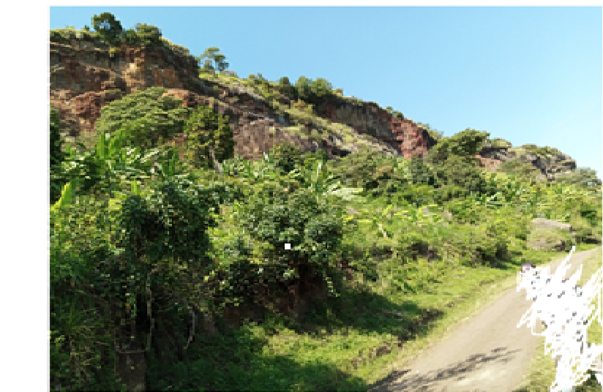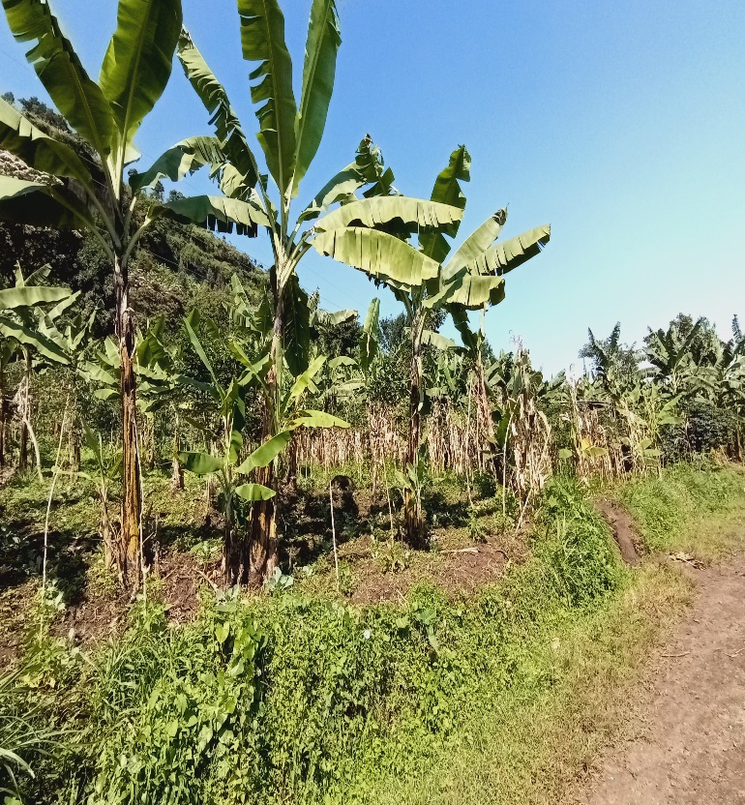
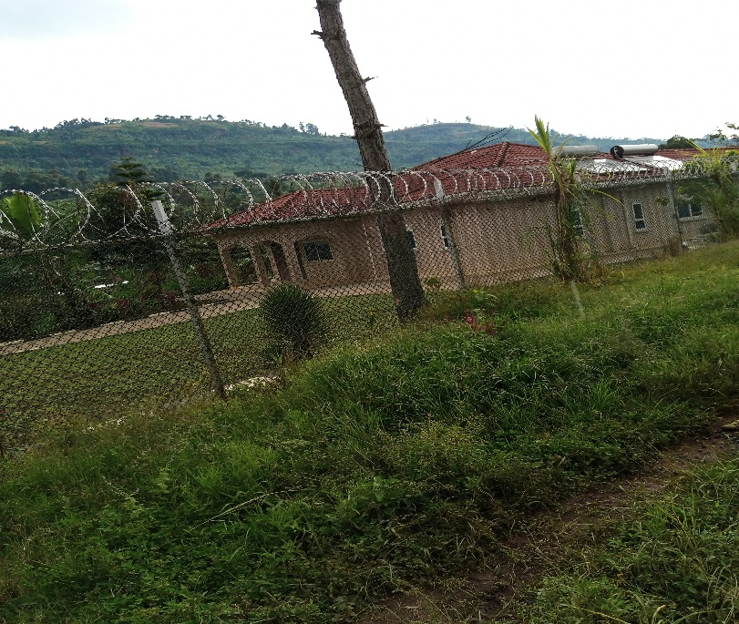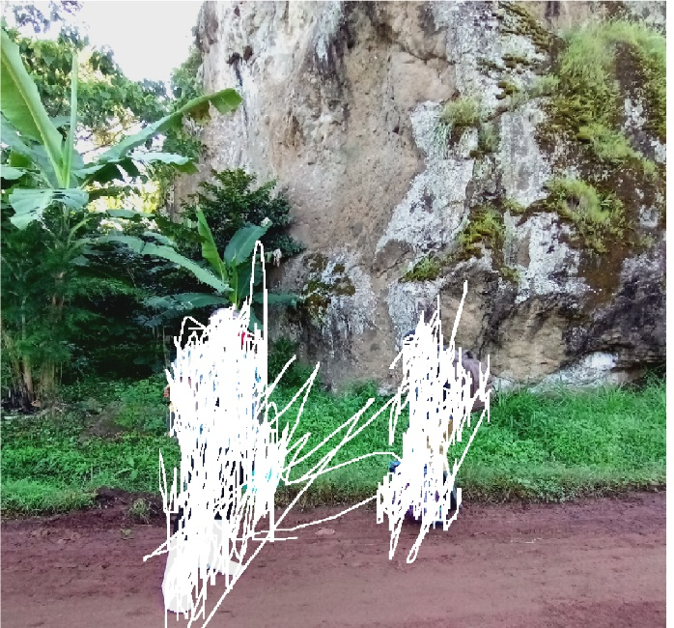
Plate 1: Topography and Vegetation Cover of Sironko and Bulambuli District in the Elgon Sub-Region

Some Plant Species used in the Treatment of Cancer in Sironko and Bulambuli in the Elgon Sub-region
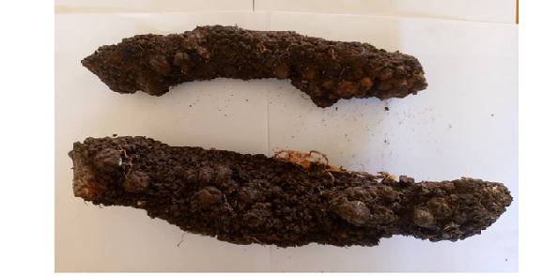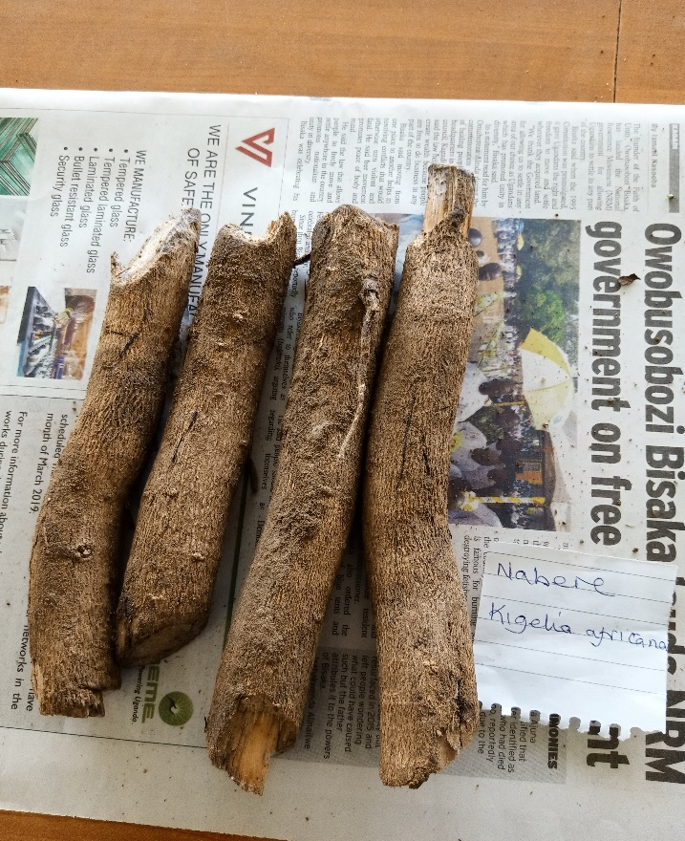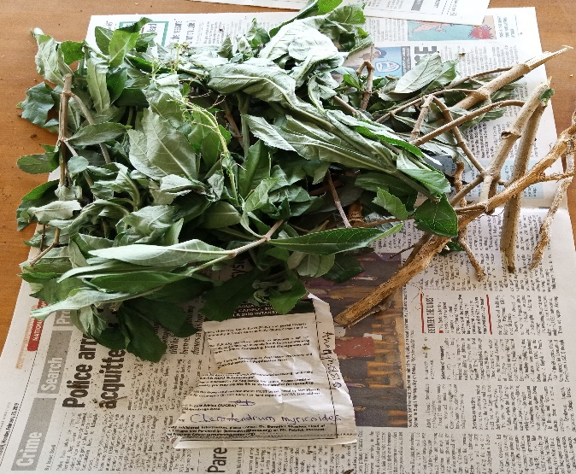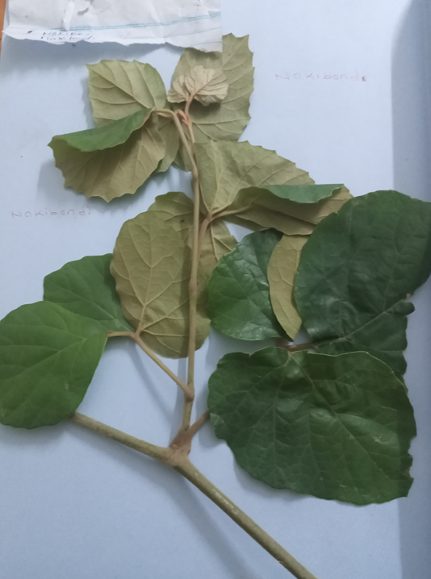
Plate 2: Some Plant Species used in the Treatment of Cancer in Sironko and Bulambuli in the Elgon Sub-Region

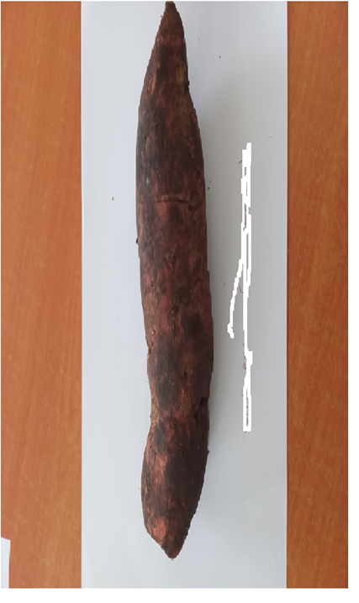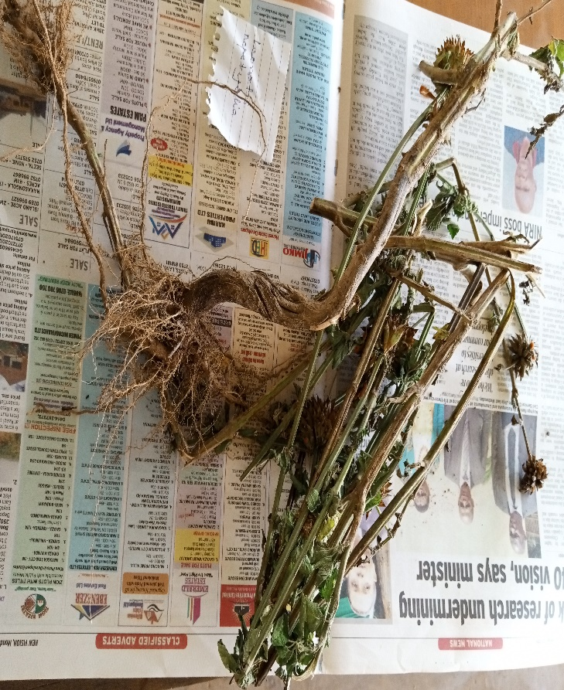
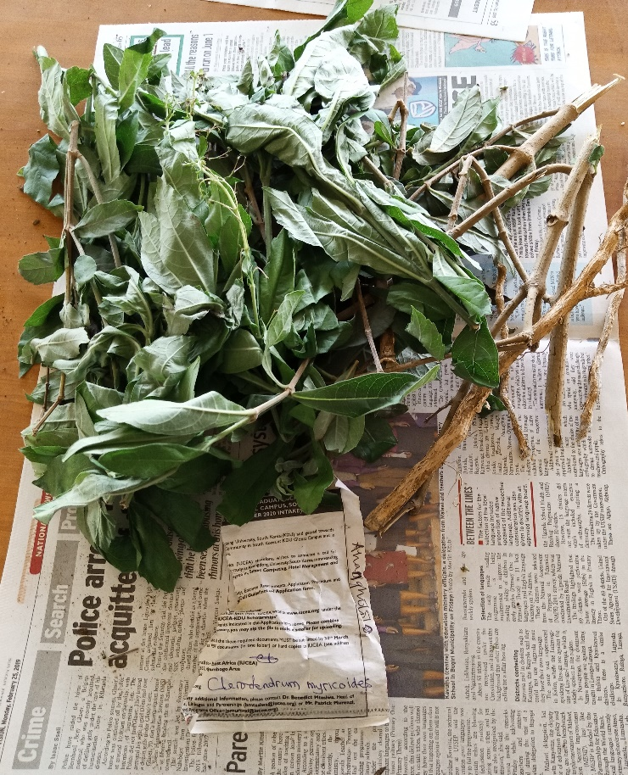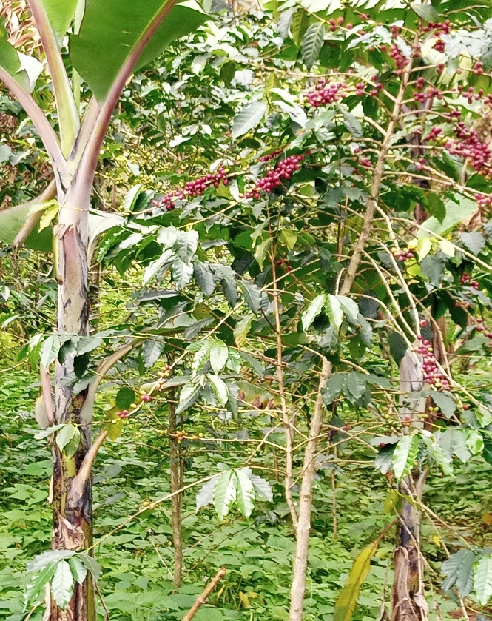
Plate 2: Some Plant Species used in the Treatment of Cancer in Sironko and Bulambuli in the Elgon Sub-Region

