Adsorption of pyrolysis oil model compound (phenol) with plasma-modified hydro-chars and mechanism exploration
Qing An ^{a,b}, Dezhen Chen ^{a,b*}, Yuzhen Tang^{a,b}, Yuyan Hu ^{a,b}, Yuheng Feng ^{a,b}, Kezhen Qian ^{a,b}, Lijie Yin ^{a,b}
ª Thermal and Environmental Engineering Institute, Mechanical Engineering College, Tongji University, Shanghai 201800, China
^{b} Shanghai Engineering Research Center of Multi-source Solid Wastes Co-processing and Energy Utilization
* Corresponding author.
E-mail address: chendezhen@tongji.edu.cn (D, Chen).

Table S1. The characteristics of raw materials and the prepared hydro-char samples
Sample | Proximate analysis/ (wt%, ad ¹) |  |  | Ultimate analysis/ (wt%, db ²) |  |  |  |  | Atomic ratio |  | BET surface area (m²g-1) | Pore volume (cm³g1) | Average pore size (nm)
Sample | Ash (wt %) | VM ³ | FC ⁴ | N | C | H | S | O | H/C | O/C | BET surface area (m²g-1) | Pore volume (cm³g1) | Average pore size (nm)
SS | 45.43 | 48.01 | 6.56 | 4.09 | 25.12 | 4.34 | 0.54 | 20.47 | 2.07 | 0.61 | 4.276 | 0.024 | 20.95
WS | 10.37 | 69.53 | 20.1 | 0.31 | 59.45 | 2.81 | 0.31 | 26.75 | 0.57 | 0.34 | — | — | —
HC | 13.57 | 20.92 | 65.51 | 2.34 | 33.48 | 3.19 | 0.07 | 47.35 | 1.14 | 1.06 | 120.24 | 0.10 | 3.45
HC-NH₃-P-25 | 9.64 | 11.88 | 78.48 | 2.59 | 57.41 | 2.26 | 0.03 | 28.07 | 0.47 | 0.37 | 178.43 | 0.22 | 6.36
HC-NH₃-P-500 | 6.13 | 5.58 | 88.29 | 4.72 | 63.49 | 1.91 | 0.01 | 23.74 | 0.36 | 0.28 | 374.14 | 0.04 | 1.91
¹ad: air-dry basis; ²db: dry basis; ³VM: volatile matter; ⁴FC: fixed carbon
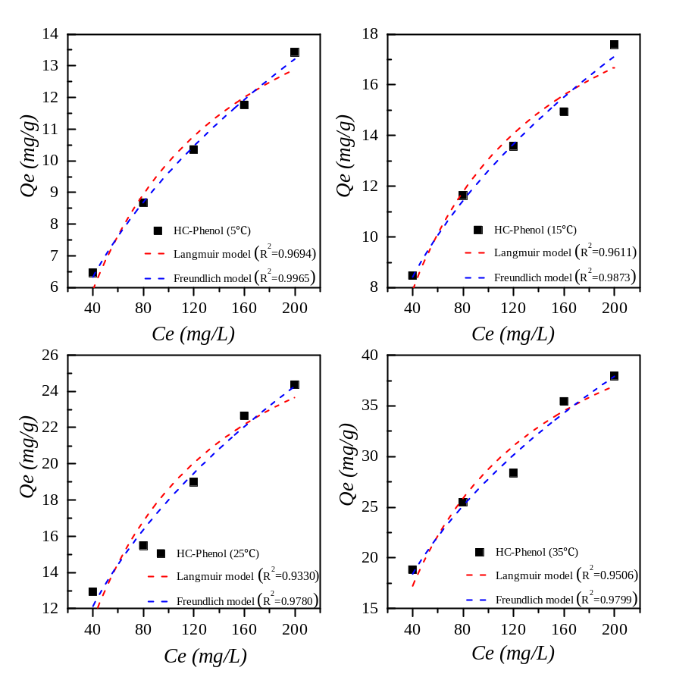
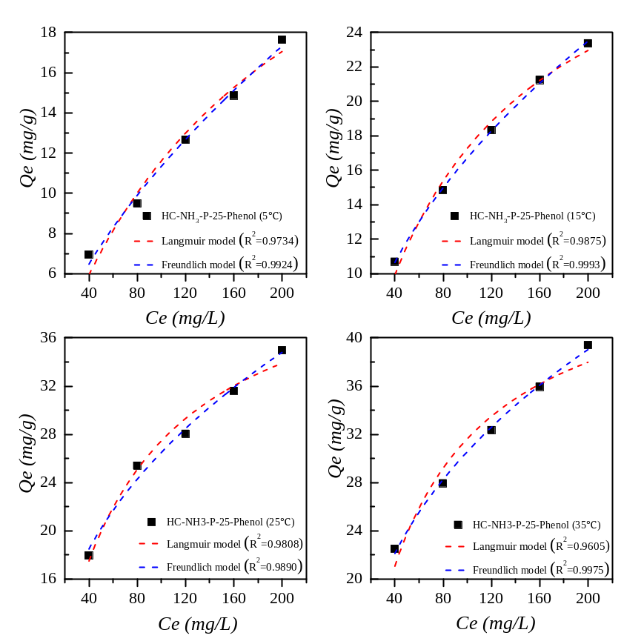
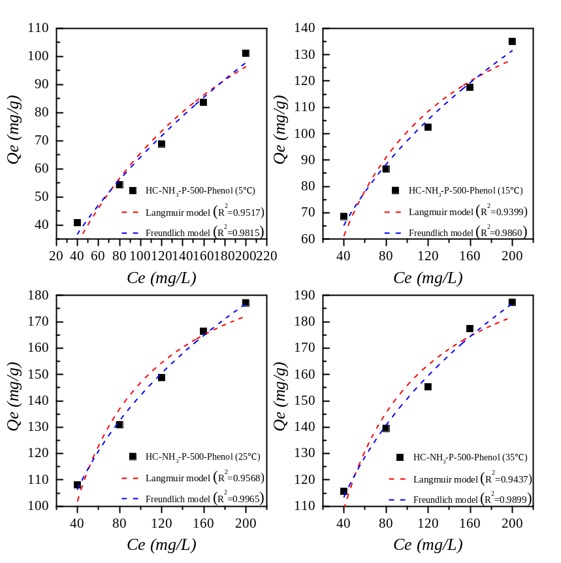

Figure. S1 Sorption isotherms of phenol onto HC, HC-NH₃-P-25 and HC-NH₃-P-500 and comparision between experimental and the modeling results.

