Selective Blood Cell Hitchhiking in Whole Blood with Ionic Liquid-Coated PLGA Nanoparticles to Redirect Biodistribution After Intravenous Injection

Christine M. Hamadani¹, Gaya S. Dasanayake¹, Claylee M. Chism¹$,$Meghan Gorniak¹$,$Wake G. Monroe¹, Anya Merrell¹, Mercedes Pride¹$,$Rebekah Heintz¹, Karen Wong¹, Mehjabeen Hossain², George Taylor¹$,$Sara X. Edgecomb¹, Deauntaye Jones¹, Joy Dhar¹, Alison Banka, Ph.D.³, Gagandeep Singh, Ph.D.¹, Priyavrat Vashisth¹, Joh’nis Randall¹, Donovan S. Darlington¹, Jaylon Everett¹, Ethan Jarrett¹, Thomas A. Werfel, Ph.D. ², Omolola Eniola-Adefeso, Ph.D.³ & Eden E. L. Tanner, D.Phil. ¹*

¹Department of Chemistry & Biochemistry, University of Mississippi, Oxford, MS, 38677, United States
²Department of Biomolecular Sciences, University of Mississippi, Oxford, MS, 38677, United States
³Departments of Chemical & Biomedical Engineering, University of Michigan, Ann Arbor, MI, 48104, United States

*Address for correspondence:

Dr. Eden E. L. Tanner
Department of Chemistry & Biochemistry
The University of Mississippi
University, MS 38677, United States
E-mail: eetanner@olemiss.edu
Phone: 662-915-1165

Supplementary

Materials and Methods:

Materials:
Choline bicarbonate cation (Sigma-Aldrich, #C7519-500ML) and carboxylic acid anions were obtained from Sigma Aldrich or Santa Cruz Biotechnology. BALB/c pooled gender adult whole mouse blood and female adult whole human blood (both k₂EDTA and heparin anticoagulated) were obtained commercially by Bio-IVT. Neat synthesized ionic liquid (IL) was characterized by ¹H NMR (400 MHz Bruker Ascend) in DMSO-D₆ (99.96 atom % D) (Sigma-Aldrich, #156914-10) and by Karl Fischer Titration for water content (Metrohm Coulometer #899).

Carboxylic-acid terminated Resomer® RG 504 H, Poly (D, L-lactide-co-glycolide) 50:50 (PLGA) was obtained from Sigma Aldrich (#719900). For tracking NP biodistribution (BD) and pharmacokinetics (PK), hydrophobic far-red dye 1,1'-Dioctadecyl-3,3,3',3'-Tetramethylindocarbocyanine, 4-Chlorobenzenesulfonate Salt solid (DiD) (ThermoFisher, # D7757) was used. HPLC-grade Acetonitrile (Sigma-Aldrich, #34851-4) was used as the organic phase of nanoprecipitation, with the aqueous phase consisting of Ultrapure MilliQ water (#Milli-Q IQ 7000). 100 mL round bottom flask (RBF) (Sigma-Aldrich, #Z414492) on a cork bottom or a 20 mL glass scintillation vial (DWK Life Sciences (Kimble), #74511-20) was used interchangeably on a 9-plate magnetic stir plate (Corning, #440826). For 20 mL glass scint vials, a 2 x 7 mm (up to 1 cm) PTFE stir bar was used (Bel-Art Scienceware, Cowie, #001.807), while a 1-2 cm pill-shaped stir bar was used for 100 mL RBFs. Centrifuge filtration of NPs by the molecular weight of PLGA (30 kD MWCO Amicon Ultra-4 filter, EMD Millipore, #UFC803024) was performed using a temperature-controlled ultracentrifuge (Thermo Scientific, Sorvall #ST8R).

For IL-PLGA NP NMR quantification and analysis, deuterium oxide (D₂O) (99 atom % D) solvent was used as the aqueous phase (Sigma-Aldrich, #435767-1KG). To quantify the amount of IL present on NPs and to estimate injected dose, a diluted stock of deuterated 3-(trimethylsilyl)-1-propanesulfonic acid (DSS-d₆) sodium salt DSS (0.2 mg/10 µL in D₂O; MW: 224.36 g/mol) NMR internal standard for IL quantification was obtained from Cambridge Isotope Laboratories, Inc. (#DLM-8206-1). For NP physiological use, 1X Phosphate-Buffered Saline (PBS, pH 7.4) was obtained from Gibco™ (#10010072), useable interchangeably with sterile Dulbecco’s Magnesium and Calcium-free 1XPBS (Cytiva, #SH30028.02).

NP-treated blood samples were incubate-shaken in an incubator (37°C) with a 500 RPM-capacity shaker, or alternatively incubate-shaken in a variable-speed rotational incubator (Benchmark Roto-Therm, #H2024). For fluorescence activated cell-sorting (FACS) flow cytometry, an Attune Acoustic Focusing Flow Cytometer was used (Attune Nxt v3.1.2 software). For in-vivo intravenous injection, 0.9% USP-injection-grade saline from Fisher Scientific (#NC9054335) was used and performed under supervision at the Thad Cochran Animal Research Facility, University of Mississippi, under protocol #21-004. For biodistribution studies, homogenization was performed with an IKA 5G homogenizer (IKA, #0003304000), and Pierce RIPA Lysis Extraction Buffer (Thermo Scientific, #89901). PK and NP fluorescence was measured using a 96-well black plate (Greiner Bio-One, #655076) and temperature-controlled Synergy H1 fluorescent plate reader(37°C) (Biotek H1 Synergy Hybrid Multi-mode, Gen5 software).

For hemolysis studies, Triton-X (Cat # 807423) was obtained from BM biomedicals LLC., and clear sterile 96-well polystyrene plates were obtained from Corning (#353075). WBC apoptosis studies were performed in accordance with the Invitrogen FITC Annexin V/PI Dead Cell Apoptosis Kit (# V13242). White Blood Cell live-cell confocal microscopy (Leica SP8) was performed in a 10 mm diameter glass bottom dish (Chemglass, #CLS-1812-024) using Direct FITC (green)-anti-mouse Ly6G (BioLegend, #127606) and PE (yellow) anti-mouse/human CD11b Antibody (BioLegend, #101208). Platelet-live-cell confocal visualization and activation assay by flow cytometry was performed using Direct-FITC anti-mouse CD41 Antibody (BioLegend, #133904), Direct- APC anti-mouse CD62P (P-Selectin) Antibody (BioLegend, #148304), Direct-FITC anti-human CD41 Antibody (BioLegend, #303704), and Direct-APC anti-human CD62P (P-Selectin) Antibody (BioLegend, #304910).

Methods:

Ionic Liquid Synthesis and Characterization:

Choline-carboxylate ILs were synthesized as previously published ^{46,49,50,119,120}. Briefly, choline bicarbonate (80% in water) was combined dropwise with either 95-98% commercially pure or in-house purified anion a 1:1 or 1:2 molar ionic ratio at 40°C. The reaction was stirred at 40°C in an oil bath overnight. A small amount of methanol was added for longer chain anions (9-10C) or functionalized anions (methylation), which was then removed by rotary evaporation (after the overnight stirring period) to remove any residual solvent at 15 mbar for 2 hours at 60°C, and then vacuum dried at -760 mmHg for 48 hours at 60°C. The product was massed by analytical balance to calculate yield, evaluated by Karl Fischer to measure IL water content, and assayed by NMR to evaluate purity and chemical identity:

Choline Butanoate 1:1(CABA 1:1): ¹H NMR (400 MHz, d6-DMSO) δ 3.89 – 3.81 (m, 2H), 3.45 (t, J = 5.0 Hz, 2H), 3.15 (s, 9H), 1.86 (t, J = 7.0 Hz, 2H), 1.42 (h, J = 7.4 Hz, 2H), 0.81 (t, J = 7.3 Hz, 3H).

Choline Butanoate 1:2 (CABA 1:2): ¹H NMR (400 MHz, d6-DMSO) δ 3.84 (dq, J = 5.4, 2.6 Hz, 2H), 3.42 (dq, J = 4.7, 2.6 Hz, 2H), 3.12 (s, 9H), 2.04 (ddd, J = 7.8, 4.9, 3.0 Hz, 4H), 1.46 (h, J = 7.3 Hz, 4H), 0.84 (td, J = 7.4, 1.7 Hz, 6H).

Choline 2-Butenoate 1:1(CA2BE 1:1): ¹H NMR (400 MHz, d6-DMSO) δ 6.30 (dtd, J = 13.7, 6.9, 3.0 Hz, 1H), 5.67 (dd, J = 15.2, 2.1 Hz, 2H), 3.83 (q, J = 4.1 Hz, 2H), 3.49 – 3.42 (m, 2H), 3.15 (s, 9H), 1.66 (d, J = 7.0 Hz, 3H).

Choline 2-Butenoate 1:2 (CA2BE 1:2): ¹H NMR (400 MHz, d6-DMSO) δ 6.55 (ddq, J = 16.1, 7.0, 2.9 Hz, 2H), 5.78 (dd, J = 15.6, 2.3 Hz, 2H), 3.85 (dq, J = 5.6, 2.7 Hz, 2H), 3.44 (tt, J = 5.1, 2.6 Hz, 2H), 3.14 (d, J = 1.8 Hz, 9H), 1.74 (dd, J = 6.9, 1.9 Hz, 6H).

Choline 3-Butenoate 1:1(CA3BE 1:1): ¹H NMR (400 MHz, d6-DMSO) δ 5.93 (ddt, J = 17.3, 9.7, 7.3 Hz, 1H), 4.90 – 4.79 (m, 2H), 3.85 (h, J = 2.6 Hz, 2H), 3.43 (dd, J = 6.1, 3.8 Hz, 2H), 3.13 (s, 9H), 1.66 (dd, J = 6.7, 1.8 Hz, 1H).

Choline 3-Butenoate 1:2 (CA3BE 1:2): ¹H NMR (400 MHz, d6-DMSO) δ 6.55 (dtd, J = 13.7, 8.7, 7.7, 5.9 Hz, 1H), 6.02 – 5.69 (m, 2H), 5.02 – 4.89 (m, 2H), 3.84 (dq, J = 5.4, 2.6 Hz, 2H), 3.46 – 3.37 (m, 2H), 3.12 (s, 9H), 1.75 (dd, J = 6.9, 1.7 Hz, 4H).

Choline Pentanoate 1:1 (CAPA 1:1): ¹H NMR (400 MHz, d6-DMSO) δ 3.85 (dq, J = 8.0, 2.8 Hz, 2H), 3.46 – 3.34 (m, 2H), 3.13 (s, 9H), 1.91 – 1.81 (m, 2H), 1.39 (tt, J = 7.8, 6.5 Hz, 2H), 1.29 – 1.15 (m, 2H), 0.83 (t, J = 7.3 Hz, 3H).

Choline Pentanoate 1:2 (CAPA 1:2): ¹H NMR (400 MHz, d6-DMSO) δ 3.89 – 3.80 (m, 2H), 3.45 – 3.38 (m, 2H), 3.12 (s, 9H), 2.01 (t, J = 7.4 Hz, 4H), 1.48 – 1.36 (m, 4H), 1.31 – 1.17 (m, 4H), 0.84 (t, J = 7.3 Hz, 6H).

Choline 2-Pentenoate 1:1 (CA2PE 1:1): ¹H NMR (400 MHz, d6-DMSO) δ 6.34 (dtd, J = 15.8, 6.4, 2.9 Hz, 1H), 5.63 (dd, J = 15.5, 1.7 Hz, 1H), 3.84 (dq, J = 5.9, 2.7 Hz, 2H), 3.46 (dd, J = 6.2, 3.9 Hz, 2H), 3.15 (s, 9H), 2.08 – 1.96 (m, 2H), 0.93 (td, J = 7.4, 2.0 Hz, 3H).

Choline 2-Pentenoate 1:2 (CA2PE 1:2): ¹H NMR (400 MHz, d6-DMSO) δ 6.61 (dt, J = 15.3, 6.2 Hz, 2H), 5.75 (dt, J = 15.5, 1.7 Hz, 2H), 3.85 (dq, J = 5.4, 2.6 Hz, 2H), 3.44 (dd, J = 6.1, 4.1 Hz, 2H), 3.14 (s, 9H), 2.10 (tt, J = 9.1, 6.6 Hz, 4H), 0.97 (t, J = 7.5 Hz, 6H).

Choline 3-Pentenoate 1:1(CA3PE 1:1): ¹H NMR (400 MHz, d6-DMSO) δ 5.58 (dt, J = 14.1, 6.8 Hz, 1H), 5.32 (dq, J = 13.3, 6.3 Hz, 1H), 3.89 (dq, J = 5.8, 2.7 Hz, 2H), 3.51 (dd, J = 6.5, 3.6 Hz, 2H), 3.21 (d, J = 2.5 Hz, 9H), 2.72 (d, J = 7.3 Hz, 2H), 1.63 (d, J = 6.7 Hz, 3H).

Choline 3-Pentenoate 1:2 (CA3PE 1:2): ¹H NMR (400 MHz, d6-DMSO) δ 5.51 (dtd, J = 13.9, 7.0, 1.7 Hz, 2H), 5.43 – 5.30 (m, 2H), 3.84 (td, J = 5.6, 2.5 Hz, 2H), 3.44 (dt, J = 7.1, 3.4 Hz, 2H), 3.13 (d, J = 3.2 Hz, 9H), 2.80 (d, J = 7.2 Hz, 4H), 1.60 (d, J = 6.8 Hz, 6H).

Choline Hexanoate 1:1 (CAHexa 1:1): ¹H NMR (400 MHz, d6-DMSO) δ 3.84 (dt, J = 7.4, 2.7 Hz, 2H), 3.49 – 3.42 (m, 2H), 3.16 (s, 9H), 1.87 (t, J = 7.5 Hz, 2H), 1.41 (p, J = 7.4 Hz, 2H), 1.27 – 1.15 (m, 4H), 0.83 (td, J = 7.1, 1.8 Hz, 3H).

Choline Hexanoate 1:2 (CAHexa 1:2): ¹H NMR (400 MHz, d6-DMSO) δ 3.84 (td, J = 5.6, 2.6 Hz, 2H), 3.44 (dq, J = 7.5, 3.7 Hz, 2H), 3.14 (dd, J = 5.9, 2.8 Hz, 9H), 2.05 (dt, J = 9.1, 4.5 Hz, 4H), 1.45 (p, J = 7.3 Hz, 4H), 1.23 (pd, J = 8.4, 7.9, 2.9 Hz, 8H), 0.88 – 0.80 (m, 6H).

Choline 2-Hexenoate 1:1(CA2HA 1:1): ¹H NMR (400 MHz, d6-DMSO) δ 6.27 (dt, J = 15.4, 7.0 Hz, 1H), 5.62 (dd, J = 15.4, 1.6 Hz, 1H), 3.89 – 3.81 (m, 2H), 3.50 – 3.43 (m, 2H), 3.15 (s, 9H), 1.99 (qd, J = 7.1, 1.5 Hz, 2H), 1.35 (h, J = 7.3 Hz, 2H), 0.86 (t, J = 7.4 Hz, 3H).

Choline 2-Hexenoate 1:2 (CA2HA 1:2): ¹H NMR (400 MHz, d6-DMSO) δ 6.50 (dt, J = 15.5, 7.0 Hz, 2H), 5.73 (dt, J = 15.4, 1.6 Hz, 2H), 3.85 (dq, J = 5.4, 2.6 Hz, 2H), 3.46 – 3.37 (m, 2H), 3.13 (s, 9H), 2.06 (qd, J = 7.1, 1.5 Hz, 4H), 1.40 (h, J = 7.3 Hz, 4H), 0.88 (t, J = 7.4 Hz, 6H).

Choline 3-Hexenoate 1:1(CA3HA 1:1): ¹H NMR (400 MHz, d6-DMSO) δ 5.56 – 5.48 (m, 1H), 5.29 (ddd, J = 15.3, 7.2, 5.5 Hz, 1H), 3.84 (dq, J = 5.6, 2.7 Hz, 2H), 3.49 – 3.42 (m, 2H), 3.15 (s, 9H), 2.67 – 2.61 (m, 2H), 1.94 (p, J = 7.2 Hz, 2H), 0.91 (t, J = 7.5 Hz, 3H).

Choline 3-Hexenoate 1:2 (CA3HA 1:2): ¹H NMR (400 MHz, d6-DMSO) δ 5.50 (dt, J = 14.5, 6.9 Hz, 2H), 5.38 (dt, J = 15.4, 6.0 Hz, 2H), 3.88 – 3.80 (m, 7H), 3.44 – 3.37 (m, 2H), 3.11 (s, 9H), 2.76 (d, J = 5.9 Hz, 4H), 1.97 (p, J = 7.3 Hz, 4H), 0.93 (t, J = 7.5 Hz, 6H).

Choline Heptanoate 1:1(CAHPA 1:1): ¹H NMR (400 MHz, d6-DMSO) δ 3.85 (dt, J = 7.2, 2.7 Hz, 2H), 3.44 – 3.40 (m, 2H), 3.12 (s, 9H), 1.83 (td, J = 7.5, 2.0 Hz, 2H), 1.39 (p, J = 7.3 Hz, 2H), 1.20 (dt, J = 7.9, 3.1 Hz, 5H), 0.85 (t, J = 6.9 Hz, 3H).

Choline Heptanoate 1:2 (CAHPA 1:2): ¹H NMR (400 MHz, d6-DMSO) δ 3.84 (dq, J = 5.4, 2.7 Hz, 2H), 3.43 – 3.38 (m, 2H), 3.11 (s, 9H), 2.02 (ddd, J = 7.4, 5.9, 1.5 Hz, 4H), 1.42 (d, J = 7.3 Hz, 5H), 1.31 – 1.17 (m, 13H), 0.85 (t, J = 6.8 Hz, 6H).

Choline 2-Heptenoate 1:1 (CA2HPE 1:1): ¹H NMR (400 MHz, d6-DMSO) δ 6.24 (dt, J = 15.4, 6.9 Hz, 1H), 5.60 (dt, J = 15.2, 1.5 Hz, 1H), 3.86 (td, J = 5.6, 2.7 Hz, 2H), 3.49 – 3.42 (m, 2H), 3.15 (s, 9H), 2.06 – 1.96 (m, 2H), 1.30 (dtt, J = 17.9, 7.4, 4.0 Hz, 4H), 0.86 (t, J = 6.9 Hz, 3H).

Choline 2-Heptenoate 1:2 (CA2HPE 1:2):¹H NMR (400 MHz, d6-DMSO) δ 6.60 (dt, J = 15.7, 7.0 Hz, 2H), 5.81 (dt, J = 15.4, 1.5 Hz, 2H), 3.92 (dq, J = 5.5, 2.7 Hz, 2H), 3.54 – 3.47 (m, 2H), 3.20 (s, 9H), 2.15 (qd, J = 7.0, 1.6 Hz, 4H), 1.49 – 1.29 (m, 8H), 0.94 (t, J = 7.1 Hz, 6H).

Choline 3-Heptenoate 1:1(CA3HPE 1:1):¹H NMR (400 MHz, d6-DMSO) δ 5.62 – 5.48 (m, 1H), 5.27 – 5.14 (m, 1H), 3.85 (dq, J = 5.5, 2.7 Hz, 2H), 3.47 – 3.40 (m, 3H), 3.13 (s, 9H), 2.58 (dd, J = 7.1, 1.5 Hz, 2H), 1.91 (q, J = 7.5 Hz, 2H), 1.32 (h, J = 7.4 Hz, 2H), 0.86 (t, J = 7.3 Hz, 3H).

Choline 3-Heptenoate 1:2 (CA3HPE 1:2): ¹H NMR (400 MHz, d6-DMSO) δ 5.57 – 5.45 (m, 2H), 5.39 – 5.27 (m, 2H), 3.85 (td, J = 5.6, 2.8 Hz, 2H), 3.45 – 3.38 (m, 2H), 3.12 (s, 9H), 2.75 (dd, J = 7.0, 1.4 Hz, 3H), 1.93 (q, J = 7.1 Hz, 3H), 1.33 (h, J = 7.3 Hz, 4H), 0.86 (t, J = 7.3 Hz, 6H).

Choline Octanoate 1:1(CAOA 1:1): ¹H NMR (400 MHz, d6-DMSO) δ 3.85 (dq, J = 8.1, 2.8 Hz, 2H), 3.46 – 3.39 (m, 6H), 3.13 (s, 9H), 1.82 (t, J = 7.4 Hz, 2H), 1.40 (q, J = 7.3 Hz, 2H), 1.23 (qd, J = 12.4, 11.2, 7.1 Hz, 9H), 0.86 (t, J = 6.9 Hz, 3H).

Choline Octanoate 1:2 (CAOA 1:2): ¹H NMR (400 MHz, d6-DMSO) δ 3.65 – 3.56 (m, 2H), 3.25 – 3.18 (m, 2H), 2.90 (s, 9H), 1.80 (t, J = 7.5 Hz, 4H), 1.20 (t, J = 7.3 Hz, 4H), 1.03 – 0.95 (m, 16H), 0.59 (t, J = 6.7 Hz, 6H).

Choline 2-Octenoate 1:1(CA2OE 1:1): ¹H NMR (400 MHz, DMSO) δ 6.27 (dtd, J = 16.4, 6.9, 2.7 Hz, 1H), 5.66 – 5.57 (m, 1H), 3.86 (td, J = 5.6, 2.6 Hz, 2H), 3.49 – 3.42 (m, 2H), 3.15 (s, 9H), 2.01 (qd, J = 7.1, 1.5 Hz, 2H), 1.39 – 1.32 (m, 2H), 1.25 (tt, J = 8.9, 5.6 Hz, 4H), 0.86 (t, J = 6.9 Hz, 3H).

Choline 2-Octenoate 1:2 (CA2OE 1:2): ¹H NMR (400 MHz, DMSO) δ 6.49 (dt, J = 15.0, 7.0 Hz, 2H), 5.75 – 5.65 (m, 2H), 3.85 (p, J = 3.0 Hz, 2H), 3.41 (dd, J = 6.1, 4.0 Hz, 2H), 3.12 (s, 9H), 2.07 (q, J = 7.2 Hz, 4H), 1.38 (q, J = 7.3 Hz, 4H), 1.26 (ddt, J = 12.4, 8.6, 5.0 Hz, 8H), 0.87 (t, J = 6.7 Hz, 6H).

Choline 3-Octenoate 1:1(CA3OE 1:1): ¹H NMR (400 MHz, d6-DMSO) δ 5.59 – 5.47 (m, 1H), 5.17 (dt, J = 14.7, 6.7 Hz, 1H), 3.83 (dd, J = 6.2, 3.7 Hz, 2H), 3.11 (s, 9H), 2.09 (s, 2H), 1.92 (d, J = 6.9 Hz, 2H), 1.28 (q, J = 5.1, 3.4 Hz, 4H), 0.90 – 0.82 (m, 3H).

Choline 3-Octenoate 1:2 (CA3OE 1:2): ¹H NMR (400 MHz, d6-DMSO) δ 5.50 (dt, J = 14.5, 6.9 Hz, 2H), 5.35 (dt, J = 15.3, 6.7 Hz, 2H), 3.84 (dq, J = 5.7, 2.8 Hz, 2H), 3.44 (dd, J = 7.6, 4.1 Hz, 2H), 3.17 – 3.11 (m, 9H), 2.80 (t, J = 5.6 Hz, 4H), 1.95 (q, J = 6.8 Hz, 4H), 1.27 (dq, J = 11.3, 7.7, 5.5 Hz, 8H), 0.85 (td, J = 7.2, 3.0 Hz, 6H).

Choline Nonanoate 1:1(CANA 1:1): ¹H NMR (400 MHz, DMSO) δ 3.84 (dq, J = 5.4, 2.6 Hz, 2H), 3.48 – 3.41 (m, 2H), 3.14 (s, 9H), 1.88 (t, J = 7.5 Hz, 2H), 1.40 (t, J = 7.2 Hz, 2H), 1.26 – 1.18 (m, 10H), 0.85 (t, J = 6.7 Hz, 3H).

Choline Nonanoate 1:2 (CANA 1:2): ¹H NMR (400 MHz, d6-DMSO) δ 3.89 – 3.80 (m, 2H), 3.45 – 3.37 (m, 2H), 3.12 (s, 9H), 2.02 (t, J = 7.4 Hz, 4H), 1.43 (p, J = 7.0 Hz, 5H), 1.23 (d, J = 3.8 Hz, 22H), 0.90 – 0.81 (m, 6H).

Choline 2-Nonenoate 1:1(CA2None 1:1): ¹H NMR (400 MHz, d6-DMSO) δ 6.23 (dt, J = 15.7, 6.9 Hz, 1H), 5.60 (dd, J = 15.3, 1.5 Hz, 1H), 3.86 (dq, J = 7.8, 2.8 Hz, 2H), 3.50 – 3.43 (m, 2H), 3.16 (s, 9H), 2.00 (qd, J = 7.1, 1.5 Hz, 2H), 1.33 (t, J = 6.8 Hz, 2H), 1.26 (q, J = 4.7 Hz, 6H), 0.90 – 0.82 (m, 3H).

Choline 2-Nonenoate 1:2 (CA2None 1:2): ¹H NMR (400 MHz, d6-DMSO) δ 6.53 (dtd, J = 17.6, 7.4, 3.0 Hz, 2H), 5.74 (dd, J = 15.5, 1.7 Hz, 2H), 3.90 – 3.81 (m, 2H), 3.47 – 3.38 (m, 2H), 3.13 (d, J = 2.1 Hz, 9H), 2.08 (qd, J = 7.1, 1.5 Hz, 4H), 1.36 (q, J = 7.1 Hz, 4H), 1.32 – 1.23 (m, 12H), 0.90 – 0.82 (m, 6H).

Choline 3-Nonenoate 1:1(CA3None 1:1): ¹H NMR (400 MHz, d6-DMSO) δ 5.54 (dtd, J = 15.6, 7.1, 1.4 Hz, 1H), 5.28 – 5.16 (m, 1H), 3.84 (dq, J = 5.5, 2.7 Hz, 2H), 3.47 – 3.40 (m, 2H), 3.14 (s, 9H), 2.59 (dd, J = 7.1, 1.5 Hz, 2H), 1.92 (q, J = 6.9 Hz, 2H), 1.36 – 1.18 (m, 6H), 0.86 (t, J = 6.7 Hz, 3H).

Choline 3-Nonenoate 1:2 (CA3None 1:2): ¹H NMR (400 MHz, d6-DMSO) δ 5.50 (dtd, J = 15.1, 6.8, 1.3 Hz, 2H), 5.36 (ddd, J = 15.3, 7.3, 5.9 Hz, 2H), 3.84 (dq, J = 5.5, 2.6 Hz, 2H), 3.46 – 3.39 (m, 2H), 3.12 (s, 9H), 2.79 (dd, J = 6.7, 1.5 Hz, 4H), 1.95 (q, J = 6.9 Hz, 4H), 1.38 – 1.26 (m, 8H), 1.24 (d, J = 6.4 Hz, 4H), 0.86 (t, J = 6.8 Hz, 6H).

Choline Decanoate 1:1(CADA 1:1): ¹H NMR (400 MHz, d6-DMSO) δ 3.87 – 3.81 (m, 2H), 3.46 (t, J = 4.9 Hz, 2H), 3.16 (s, 9H), 1.90 (t, J = 7.6 Hz, 2H), 1.40 (t, J = 7.3 Hz, 2H), 1.20 (s, 12H), 0.82 (t, J = 6.6 Hz, 3H).

Choline Decanoate 1:2 (CADA 1:2): ¹H NMR (400 MHz, d6-DMSO) δ 3.91 (dq, J = 5.4, 2.6 Hz, 2H), 3.54 – 3.47 (m, 2H), 3.20 (s, 9H), 2.11 (t, J = 7.5 Hz, 4H), 1.51 (p, J = 7.0 Hz, 4H), 1.34 (s, 3H), 1.30 (s, 20H), 0.92 (t, J = 6.8 Hz, 6H).

Choline 2-Decenoate 1:1 (CA2DE 1:1): ¹H NMR (400 MHz, d6-DMSO) δ 6.37 (dt, J = 15.5, 6.9 Hz, 1H), 5.71 (d, J = 15.3 Hz, 1H), 3.94 (dq, J = 5.8, 2.6 Hz, 2H), 3.58 – 3.51 (m, 2H), 3.24 (s, 9H), 2.09 (q, J = 7.1 Hz, 2H), 1.43 (q, J = 7.1 Hz, 2H), 1.34 (d, J = 5.8 Hz, 8H), 0.94 (t, J = 6.8 Hz, 3H).
Choline 2-Decenoate 1:2 (CA2DE 1:2): ¹H NMR (400 MHz, d6-DMSO) δ 6.52 (dt, J = 15.8, 6.9 Hz, 2H), 5.77 – 5.71 (m, 2H), 3.85 (p, J = 2.8 Hz, 2H), 3.47 – 3.40 (m, 2H), 3.13 (s, 9H), 2.07 (q, J = 7.1 Hz, 4H), 1.37 (p, J = 6.8 Hz, 4H), 1.25 (s, 16H), 0.86 (t, J = 6.6 Hz, 6H).

Choline 3-Decenoate 1:1 (CA3DE 1:1): ¹H NMR (400 MHz, d6-DMSO) δ 5.57 – 5.45 (m, 1H), 5.31 – 5.19 (m, 1H), 3.88 – 3.80 (m, 3H), 3.44 – 3.37 (m, 3H), 3.11 (s, 9H), 2.64 (dd, J = 7.0, 1.4 Hz, 2H), 1.93 (q, J = 6.6 Hz, 2H), 1.35 – 1.18 (m, 11H), 1.01 – 0.92 (m, 1H), 0.86 (h, J = 3.1 Hz, 3H).

Choline 3-Decenoate 1:2 (CA3DE 1:2): ¹H NMR (400 MHz, d6-DMSO) δ 5.49 (dtt, J = 15.1, 6.8, 1.3 Hz, 2H), 5.34 (dtt, J = 14.9, 6.7, 1.4 Hz, 2H), 3.88 – 3.80 (m, 2H), 3.44 – 3.37 (m, 2H), 3.11 (s, 9H), 2.77 (dd, J = 6.8, 1.3 Hz, 4H), 1.95 (q, J = 6.4 Hz, 4H), 1.36 – 1.22 (m, 17H), 0.90 – 0.82 (m, 6H).

Choline 2-Methyl-Butanoate 1:1 (CA2MeButa 1:1): ¹H NMR (300 MHz, d6-DMSO) δ 3.60 (tq, J = 4.6, 2.2 Hz, 2H), 3.20 – 3.09 (m, 2H), 2.84 (s, 9H), 1.79 – 1.63 (m, 1H), 1.19 (dtd, J = 13.1, 7.4, 1.3 Hz, 1H), 1.01 – 0.83 (m, 1H), 0.65 (dd, J = 6.9, 2.6 Hz, 3H), 0.50 (td, J = 7.3, 2.7 Hz, 3H).

Choline 2-Methyl-Butanoate 1:2 (CA2MeButa 1:2): ¹H NMR (400 MHz, d6-DMSO) δ 3.85 (dq, J = 5.4, 2.6 Hz, 2H), 3.42 (dd, J = 6.1, 4.1 Hz, 2H), 3.12 (s, 9H), 2.10 (h, J = 6.9 Hz, 2H), 1.52 (dt, J = 12.9, 7.3 Hz, 2H), 1.34 – 1.19 (m, 2H), 0.96 (d, J = 6.9 Hz, 6H), 0.82 (t, J = 7.4 Hz, 6H).

Choline 2-Methyl-Pentanoate 1:1 (CA2MePenta 1:1): ¹H NMR (400 MHz, d6-DMSO) δ 3.86 (dq, J = 7.8, 2.8 Hz, 2H), 3.47 – 3.40 (m, 2H), 3.14 (s, 9H), 1.95 (h, J = 7.2 Hz, 1H), 1.53 – 1.40 (m, 1H), 1.22 (h, J = 7.3 Hz, 2H), 1.15 – 1.05 (m, 1H), 0.89 (d, J = 6.9 Hz, 3H), 0.82 (t, J = 7.3 Hz, 3H).

Choline 2-Methyl-Pentanoate 1:2 (CA2MePenta 1:2): ¹H NMR (400 MHz, d6-DMSO) δ 3.96 – 3.88 (m, 2H), 3.53 – 3.46 (m, 2H), 3.19 (s, 9H), 2.30 – 2.17 (m, 2H), 1.57 (dddd, J = 12.1, 8.6, 6.9, 5.3 Hz, 2H), 1.38 – 1.30 (m, 3H), 1.30 – 1.18 (m, 3H), 1.03 (d, J = 6.9 Hz, 6H), 0.91 (t, J = 7.1 Hz, 6H).

Choline 2-Methyl-Hexanoate 1:1 (CA2MeHexa 1:2): ¹H NMR (400 MHz, d6-DMSO) δ 3.60 (dq, J = 5.8, 2.8 Hz, 2H), 3.24 – 3.18 (m, 2H), 2.91 (s, 9H), 1.23 (tt, J = 11.6, 5.3 Hz, 1H), 1.03 – 0.83 (m, 6H), 0.66 (d, J = 7.0 Hz, 3H), 0.58 (t, J = 6.9 Hz, 3H).

Choline 2-Methyl-Hexanoate 1:2 (CA2MeHexa 1:2): ¹H NMR (400 MHz, DMSO) δ 3.95 – 3.90 (m, 2H), 3.53 – 3.49 (m, 2H), 3.21 (s, 9H), 2.23 – 2.01 (m, 4H), 1.64 – 1.40 (m, 2H), 1.29 (qd, J = 10.7, 8.9, 5.0 Hz, 8H), 1.02 (d, J = 6.9 Hz, 6H), 0.96 – 0.77 (m, 6H).

Choline 2-Methyl-Heptanoate 1:1(CA2MeHepta 1:1): ¹H NMR (400 MHz, d6-DMSO) δ 3.94 (dd, J = 4.7, 2.5 Hz, 2H), 3.55 – 3.48 (m, 2H), 3.22 (s, 9H), 1.56 (td, J = 7.6, 4.4 Hz, 1H), 1.40 – 1.30 (m, 4H), 1.29 – 1.19 (m, 4H), 1.00 (d, J = 6.9 Hz, 3H), 0.93 (t, J = 6.9 Hz, 3H).

Choline 2-Methyl-Heptanoate 1:2 (CA2MeHepta 1:2): ¹H NMR (400 MHz, DMSO) δ 3.92 (dq, J = 5.4, 2.6 Hz, 2H), 3.54 – 3.47 (m, 2H), 3.20 (s, 9H), 2.27 – 2.18 (m, 2H), 2.16 (s, 2H), 1.56 (s, 2H), 1.35 – 1.25 (m, 12H), 1.03 (d, J = 6.9 Hz, 6H), 0.92 (t, J = 6.8 Hz, 6H).

Choline 2-Methyl-2-Butenoate 1:1(CA2Me2BE 1:1): ¹H NMR (400 MHz, d6-DMSO) δ 6.32 (q, J = 6.9 Hz, 1H), 3.84 (h, J = 2.6 Hz, 2H), 3.46 (dd, J = 6.4, 3.7 Hz, 2H), 3.15 (s, 9H), 1.66 (s, 3H), 1.58 (d, J = 7.2 Hz, 3H).

Choline 2-Methyl-2-Butenoate 1:2 (CA2Me2BE 1:2): ¹H NMR (300 MHz, d6-DMSO) δ 5.99 – 5.96 (m, 2H), 3.93 – 3.77 (m, 2H), 3.50 – 3.36 (m, 2H), 3.13 (s, 9H), 1.73 – 1.62 (m, 12H).

Choline 2-Methyl-2-Pentenoate 1:1 (CA2Me2PE 1:1): ¹H NMR (400 MHz, d6-DMSO) δ 6.22 (td, J = 7.3, 1.6 Hz, 1H), 3.85 (dq, J = 7.7, 2.8 Hz, 2H), 3.49 – 3.42 (m, 2H), 3.15 (s, 9H), 1.98 (p, J = 7.5 Hz, 2H), 1.64 (d, J = 1.7 Hz, 3H), 0.91 (t, J = 7.6 Hz, 3H).

Choline 2-Methyl-2-Pentenoate 1:2 (CA2Me2PE 1:2): ¹H NMR (400 MHz, d6-DMSO) δ 6.43 (td, J = 7.4, 1.8 Hz, 2H), 3.86 (td, J = 5.6, 2.6 Hz, 2H), 3.49 – 3.40 (m, 2H), 3.15 (s, 9H), 2.06 (p, J = 7.5 Hz, 4H), 1.69 (d, J = 1.8 Hz, 6H), 0.95 (t, J = 7.6 Hz, 6H).

Choline 3-Methyl-Butanoate 1:1(CA3MeButa 1:1): ¹H NMR (400 MHz, d6-DMSO) δ 3.90 – 3.82 (m, 2H), 3.47 – 3.40 (m, 2H), 3.13 (s, 9H), 1.88 (ddt, J = 14.1, 13.2, 6.7 Hz, 1H), 1.73 (d, J = 7.0 Hz, 2H), 0.82 (d, J = 6.6 Hz, 6H).

Choline 3-Methyl-Butanoate 1:2 (CA3MeButa 1:2): ¹H NMR (400 MHz, d6-DMSO) δ 3.87 – 3.82 (m, 2H), 3.43 – 3.39 (m, 2H), 3.12 (s, 9H), 2.00 – 1.92 (m, 2H), 1.91 (d, J = 2.4 Hz, 4H), 0.89 – 0.82 (m, 12H).

Choline 3-Methyl-Pentanoate 1:1 (CA3MePenta 1:1): ¹H NMR (400 MHz, d6-DMSO) δ 3.84 (dq, J = 5.7, 2.7 Hz, 2H), 3.49 – 3.45 (m, 2H), 3.16 (s, 9H), 1.92 (q, J = 9.4 Hz, 1H), 1.74 – 1.63 (m, 2H), 1.33 – 1.20 (m, 1H), 1.07 (dq, J = 13.6, 7.1 Hz, 1H), 0.79 (dt, J = 7.5, 4.4 Hz, 6H).

Choline 3-Methyl-2-Pentenoate 1:1 (CA3Me2PE 1:1): ¹H NMR (400 MHz, d6-DMSO) δ 5.54 – 5.46 (m, 1H), 3.98 – 3.90 (m, 2H), 3.55 – 3.48 (m, 10H), 3.21 (s, 9H), 2.04 – 1.94 (m, 3H), 1.89 – 1.43 (m, 2H), 1.00 (dt, J = 15.0, 7.5 Hz, 3H).

Choline 3-Methyl-2-Pentenoate 1:2 (CA3Me2PE 1:2): ¹H NMR (400 MHz, d6-DMSO) δ 5.57 – 5.49 (m, 1H), 3.89 – 3.82 (m, 3H), 3.45 – 3.39 (m, 2H), 3.12 (s, 9H), 2.00 (dd, J = 7.9, 1.3 Hz, 5H), 1.69 (dd, J = 17.7, 1.5 Hz, 3H), 0.96 (dt, J = 9.1, 7.5 Hz, 5H).

Choline 3-Methyl-2-Hexenoate 1:1 (CA3Me2HA 1:1): ¹H NMR (400 MHz, d6-DMSO) δ 5.57 – 5.52 (m, 1H), 4.14 (s, 1H), 3.98 – 3.90 (m, 3H), 3.56 – 3.49 (m, 2H), 3.23 (s, 9H), 2.03 – 1.93 (m, 5H), 1.47 (h, J = 7.4 Hz, 2H), 0.92 (t, J = 7.3 Hz, 3H).

Choline 3-Methyl-2-Hexenoate 1:2 (CA3Me2HA 1:2): ¹H NMR (400 MHz, d6-DMSO) δ 5.65 – 5.60 (m, 2H), 4.70 – 4.62 (m, 2H), 3.92 (dq, J = 5.5, 2.6 Hz, 2H), 3.53 – 3.44 (m, 2H), 3.19 (s, 9H), 2.08 – 2.00 (m, 10H), 1.48 (h, J = 7.4 Hz, 4H), 0.92 (t, J = 7.3 Hz, 6H).

IL-NP Synthesis:

DiD: Bare PLGA and IL-PLGA NPs were synthesized as previously published ^{49,50, 51,120,121}. To load bare PLGA NPs with the far-red bio-tracking dye DiD, 1 mg/mL DiD/ACN stock solution was prepared and combined with a stock solution of 1 mg/mL PLGA/ACN at 2% by weight of the polymer. The organic phase was then combined dropwise in a sterile 100 mL round bottom flask or 20 mL glass scintillation vial at 1200 RPM containing a small stir bar and 3 mL Milli-Q water or D2O water (for chemical characterization) and stirred at 25°C to evaporate solvent for 3 hours on a 9-plate magnetic plate stirrer in the dark. After 3 hours of stirring, IL was added to the bare NPs at 800 RPM and at 25°C: First, the tip of the Pasteur glass or P1000 pipette (set to 1000 uL) was first mixed in the neat IL in a wave-like motion, removed from the neat IL, and then a standard droplet was quickly allowed to form and added to the center stirring vortex of the bare PLGA NPs. To this end, a range of 10-20 mg neat IL/mg PLGA was then added either in the form of one or two liquid drops (IL density was below 0.990 g/cm^{3:} 2 neat drops were added; if between 0.990-1.78 g/cm³: 1 drop was added) in the center of the stirring vortex. If ILs were not in a liquid phase, but instead in a gel form, the equivalence in mass was weighed out onto a weigh boat and added using a sterile metal spatula to “whip” in the IL against the rotating stir bar, creating an opalescent-tinged homogenous solution. ILs in a solid form (such as 10-carbon ILs) were respectively first massed and dissolved in 20-40 μL neat Acetonitrile depending on solubility (saturated vs. unsaturated) by 2 min-vortexing or brief sonicating before being added drop-wise as a liquid solution. For anions with epoxy-like, crystalline-like viscosity/texture or containing methyl-branched, or oxygen-moiety-rich anions that didn’t show success or showed instability with IL-coating by the above stirring methods, a sonication method was used. Briefly, after 3 hours of stirring, bare PLGA NPs in 20 mL glass scintillation vials (or transferred to glass scintillation vial from RBF) were sonicated for 1 minute at 25°C to acclimate to their new environment and remove aggregation, before the respective amount of IL was added and sonicated for 2 additional minutes, briefly evaluated for coating by DLS (size), and then immediately centrifuged filtered by molecular weight following the steps below.

After stirring one hour at 900 RPM (total 2 hours after IL addition) at 25°C in the dark, excess IL was then filtered via 30 kDa MWCO centrifuge filtration at 4°C or 25°C (short-medium chains (4-7C) filtered at 4°C, longer chains (8-10C) filtered at 25°C) and 2500 RPM for 1 hour. Bare PLGA NPs were filtered more gently between 1500-2000 RPM at 4°C. Concentrated filtered IL-NPs were then resuspended to a 1 mg/mL in a range of buffers depending on application (characterization: Milli-Q water, or D₂O; biological: 1x PBS pH 7.4/DPBS pH 7.2, or 0.9% USP-grade saline). Samples were stored at 4°C in the dark for up to 3 weeks, although for biological use, used within the first week of synthesis.

NP Size and Surface Charge Characterization:

Dynamic Light Scattering: A Malvern Zetasizer pro blue was used to measure hydrodynamic diameter and zeta potential surface charge for both 1 mg/mL filtered bare and IL-coated PLGA NPs encapsulating DiD dye (Malvern Panalytical, Model ZSU3200, #MAL1252117, software version 3.0). To account for fluorescence, a fluorescent filter was used, and sample calibration settings were optimized for an additional 40 seconds to evaluate the scattering and zeta profile of bare or screened IL-PLGA DiD NPs. Notably, IL-PLGA DiD NPs synthesized by sonication were briefly measured for size as an internal quality control before centrifugation to ensure coating (shift in correlation coefficient curve and diameter from bare PLGA NP controls). Next, to evaluate surface charge, a palladium-electrode universal dip cell (Malvern, #ZEN1002) was used for zeta potential surface measurements while a DTS 0012 polystyrene cuvette (Sarstedt, cat. no #D-51588) was used for size determination. For each screened sample (n=1) or replicated top candidate (n=4 to n=7 range), an internal measurement triplicate was conducted.

Encapsulation Efficiency (%EE):

Relative Encapsulated Fluorescence (DiD): 200 μL of synthesized 1 mg/mL bare PLGA DiD and top candidate IL-coated PLGA DiD NPs (encapsulating 2% wt/wt DiD) were plated in triplicate (where each replicate was an independently synthesized batch) in a 96-well black, fluorescent plate. For controls, 200 μL of NP suspension buffer was used as a baseline subtraction, and 200 μL of the 2% organic phase DiD/PLGA/CAN stock used to synthesize the PLGA particles. At 25C, the plate height calibrated for the volume of sample and read from the top to gauge fluorescence (640 nm excitation and 670 nm emission). Fluorescence of the baseline subtracted bare and IL-PLGA DiD NP samples were divided by fluorescence of the 2% organic phase stock (100%). Standard deviation (n=3) was used to evaluate DiD encapsulation variance across NP batches.

IL Quantification and Pharmacologic Dose:

The amount of IL present on the PLGA NPs for selected top candidates post-screen were quantified in D₂O by 1H-NMR spectroscopy. Briefly, IL-PLGA NPs and bare PLGA NPs were synthesized as described above in D₂O as the aqueous phase, without DiD dye encapsulation. Post-centrifuge filtration, all NPs were suspended to a final volume of 500 μL in D₂O in 1.5 mL centrifuge tubes and 0.2 mg of DSS internal quantitative standard (10 μL from a 200 mg/mL stock of powder DSS in D₂O) was added and briefly mixed by gentle vortexing to distribute the DSS. Afterwards, all samples were transferred to sterile NMR tubes and evaluated at 400 MHz. The amount of IL present in each NP batch was then calculated by integrating key cation (choline, 3.1 ppm) and anion (singlet at CH₃ tail or CH₂ proximal to CH₃ tail, between 0.8-1.0 ppm) peaks normalized against DSS (9.0 protons). The fraction between the anion/DSS or cation/DSS integrated peak values were then multiplied by moles of known DSS and added together to get total present IL/mg PLGA. This value was then used to estimate the dose of IL in a 100 μL IV injection for an average-weighted BALB/c mouse. An example follows below for moles of CAHPA 1:1 per milligram (mg) of PLGA polymer (ie. 1 batch of IL-PLGA NPs):

¹H NMR (400 MHz, D₂O) δ 4.69 (s, 432H), 4.08 – 4.00 (m, 19H), 3.75 (td, J = 6.5, 3.3 Hz, 15H), 3.62 (dd, J = 11.7, 4.4 Hz, 34H), 3.58 – 3.47 (m, 51H), 3.17 (s, 85H), 2.06 (s, 3855H), 1.53 (p, J = 7.3 Hz, 21H), 1.28 (d, J = 4.5 Hz, 61H), 0.90 – 0.83 (m, 30H), -0.00 (s, 9H).

Anion = (30/9) * 8.91424496 * 10⁻⁷ mol DSS
= 0.00000297141 mol/mg PLGA
Cation = (85/9) * 8.91424496* 10⁻⁷ mol DSS
= 0.000008419 mol/mg PLGA
Total IL = 0.0000114 mol CAHPA 1:1/mg PLGA (1 mL~ 10¹³ PLGA NPs)
Estimated Dose in 100 μL IV injection: 1.14 x 10⁻⁶ mol CAHPA 1:1 (100 μL~10¹² NPs)
Cellular Hitchhiking in situ (ex-vivo): The entirety of the following procedure was performed with caution to light exposure and was performed in the dark and on ice whenever possible. FACS screening of all candidates was performed double-blinded to sample identity. The treatment and separation of adult whole mouse BALB/c blood (pooled gender) and whole human blood (female) was performed as previously described ^{49,120,121}. Briefly, fresh commercial mouse or human blood (k₂EDTA anticoagulated) was received and stored very briefly at 4°C before immediate use. On ice, whole blood was then aliquotted into 1.5 mL aluminum foil-covered centrifuge tubes and then treated at a 1:10 (v/v) ratio of NPs: whole blood (equivalent to the scale of ~100 NPs: RBC). Based on supplier availability, screened BALB/c blood volumes ranged between ~400 μL/ round to ~600 μL/round. Human blood volumes were increased respectively to be equivalent to this ratio and dosing amount due to cellular number difference between species. Controls for each round contained negative control saline buffer as well as 1 mg/mL bare PLGA NPs. To ensure that every component was mechanically interacting with all blood components (such as serum proteins), NP-treated whole blood samples first underwent constant inversion (1 inversion/second) for 1-2 minutes at 25 °C. To next ensure constant thorough mixing with chemical attachment to cells with the most affinity, the centrifuge tubes were securely moved to a shaker incubator at 37°C and 500 RPM for 20 minutes in the dark.

After 20 minutes of shaking-incubating, all samples were then centrifuged immediately at 1000xg for 10 minutes at 4°C. While all samples were on ice, a gradient of gradually smaller pipette volume sizes were used (P200 for serum, P20 for WBCs, and P2.5 for platelets) were used to carefully remove serum (top: translucent pink-clear colored liquid), WBCs (cloudy-beige/opaque pink), and platelets (gelatin-like, bright crimson layer) using a cell density gradient. To do this, after majority of neat serum was removed, 50-100 µL of serum (depending on blood donor) was allowed to remain above the WBC layer. The tube was then lightly rocked side to side to allow the WBCs to “puff” up from the platelet layer without disturbing platelets and RBCs underneath. Cell fractions were carefully removed by angling the pipette tip away from the cell pellet gradient (tip towards the opposite wall of the tube) with constant slow pipette suction while rotating the tube 360 degrees with the other hand. After all other fractions were isolated in a layer-by-layer manner, RBCs (darkest red) were then removed bottom-up with a P200 pipette. All isolated fractions were resuspended in fresh 1.5 mL centrifuge tubes containing saline buffer at the original volume of whole blood used. All samples were then gently shaken by inversion briefly to resuspend, and centrifuge-washed at 4 °C, 3x at 200xg, 5 minutes each time. After each wash, supernatant was carefully removed, leaving about 100 μL above the cell pellet, with resuspension to the original volume in fresh buffer before the next wash. After the third wash, the supernatant was carefully and entirely removed to just leave cell pellet remaining, which was resuspended to a final volume of 1 mL with 1xPBS. While WBCs were then measured directly by fluorescent activated cell sorting (FACS), 200 μL of platelet or RBC cell stock was then brought to 2 mL with saline buffer, stored on ice, and immediately measured. All cell fractions were measured at the same time, and no later than 2 hours after the final wash.

Live-Cell Fluorescent Activated Cell Sorting (FACS): Isolated and washed WBCs, platelets, and RBCs were prepared as described above, and were first gently vortexed for 20 seconds in a glass test tube. On an attune Nxt acoustic flow cytometer, a cell count of 100,000 was selected along with the lowest flow rate (12.5 µL/min) and an acquisition volume of 250 µL. Using unstained and stained controls, Laser compensation was then set up for the blue laser (BL1), and far-red laser (RL1), allowing compatibility with FITC (Annexin), PI, and DiD. Next, cell populations of interest were gated using scatter (side (SSC-A) vs. forward scatter (FSC-A)). After cell populations were selected using a polygon gate, [(FSC-Height) vs. (FSC-Area)] was used to determine singlet populations, and from there the gated population was evaluated for fluorescence (for DiD, RL1-A on the x-axis) against side (SSC-A) scatter (y-axis). Saline buffer negative control was used as a baseline to apply a vertical quadrant gate which determined the % of cells that colocalized with at least 1 far-red DiD NPs. Cells with many NPs scattered to the far right of this vertical quadrant gate, while cells with a few NPs only shifted slightly to the right. Additionally, all identified DiD+ cells were gated with a polygon gate to determine the precise % of colocalized cell population. This allowed gating of healthy singlet lymphocytes, monocytes, granulocytes, platelets, and RBCs. To determine the fold-greater hitchhiking compared to bare PLGA, background fluorescence from the PBS sample was subtracted from every candidate, including bare PLGA. For comparison within each round, the fluorescence of each IL-coated candidate was divided by that of PLGA (normalized to 1), yielding the fold-greater amount of binding. Next, to compare all candidates across all rounds, fluorescence from all PBS samples were averaged and all bare PLGA samples were averaged, to create one baseline subtraction standard and one normalization standard to rank all screened candidates. Using this ranking system, the highest binding was compared to the highest selectivity, and candidates that showed promise for both were selected for quantitative analysis, further biocompatibility characterization and in-vivo experiments.

NOTE* the final round of screening (CA2HA 1:2, CA2DE 1:1, CA2DE 1:2) used a rototherm rotating incubator (constant vertical inversion) as well as a new model Attune Nxt FACS (cat. # ZG11SCATT) with higher laser sensitivities, which visually improved the binding of all cell types to all samples (including PLGA and some higher background noise from saline buffer). However, when baseline-subtracted and normalized to bare PLGA (set to 1) within-round, these values presented equivalently when compared to the other shaker incubator and FACS system. This previous system was used for all other rounds and averaged PBS and PLGA baselines to baseline subtract and normalize all screened candidates across all rounds to one standard. For this reason, CA2HA 1:2, CA2DE 1:1, CA2DE 1:2 were ranked as within-round and then included in the total list, as opposed to inclusion in the across-round ranking system.

Quantitative Cellular Hitchhiking: Whole BALB/c mouse and human blood was treated with saline buffer, PLGA, or IL-PLGA DiD NPs as described above. WBCs, platelets, and RBCs were then isolated and washed as described above, but instead measured by fluorescent plate reader. To this end, four independent replicates of each top candidate were performed for both mouse and human (all treatment and sample volumes respectively adjusted) blood. For quantitative experiments, sterile 0.9% USP-grade physiological saline was used as both the NP and wash buffer to simulate conditions as closely to in-vivo blood circulation.

During separation of blood components, special care was taken to ensure fractions were slowly and carefully extracted with as much cell yield as possible. Neat serum was first collected from each sample (~50% of total volume from 450 µL of whole BALB/c blood sample) and plated in a 300 µL-well black, fluorescent plate, which was stored by parafilm sealing and stored in the dark at 4°C. Before plating, to ensure no WBCs were accidentally collected in the serum, neat serum was spun down for 10 minutes at 1000xg and 4°C. Any pelleted WBC was respectively transferred to its isolated fraction for triplicate washing steps. While isolated BALB/c serum, WBCs, and platelets required no further dilution during plating (all cell pellets brought to final volume of 200 µL), the opacity of RBCs coagulating within the well plate required further dilution, which was factored in the scaling (x7 for BALB/c RBCs) of fluorescence. Respective adjusted volumes for human blood (100 µL to 900 µL whole blood) required scaling of serum (x3.25), platelets (x4) and RBC fractions (x7.5). 200 µL of the fluorescent DiD NPs in saline buffer (or saline buffer alone for baseline subtraction) used for all treatments were also plated as controls to normalize cellular fluorescence to generate ‘% of administered NPs from whole blood’ for each cell fraction. After all wells were plated, the plate was calibrated and temperature adjusted (37°C), height adjusted according to sample volume, and read from the top to measure DiD fluorescence (ex. 640 nm, em. 670 nm). Afterwards, background from saline-treated blood fractions were subtracted and cell fraction fluorescence was normalized to the fluorescence of each NP treatment administered to whole blood. Percentage results were reported as average (n=4) and standard error of the mean (SEM). For human blood, a paired two-tailed t-test was used to compare two samples at a time, and ANOVA was used to compare three or more samples at a time.

Live-Cell Confocal Microscopy: Immediately after plate reading, live cell fractions were transferred to a 24-well glass bottom 10 mm diameter cell culture plate and resuspended up to 3 mL with saline buffer to optimize individual cell staining. To each well containing WBCs, PE-CDllb and FITC-Ly6G were added (5 µL/10⁵ cells). Respectively to each well containing platelets, FITC-CD41 was applied (5 µL/10⁵ cells). RBCs were not stained, but the TRANS-PMT confocal setting was engaged to allow for cell morphology to be visualized in combination with the far-red laser. Using a P1000 pipette, each well was first mixed thoroughly by aspiration. For surface staining and some intracellular contrast, the plate was then parafilm sealed, covered with aluminum foil, and incubated at 4°C for 2 hours.
Afterwards, the contents of each well were collected into a 15 mL falcon tube and centrifuged at 1000xg and 4°C for 10 minutes to wash excess antibody target. This process was done twice more to ensure maximum collection of cell fractions, and stained WBC pellet was resuspended to 1 mL with saline buffer and transferred back into the respective glass well plate. Notably, to allow visibility of individual cells, RBCs were further diluted 10x (v/v), while platelets were further diluted 6x (v/v) after being resuspended back to 200 µL, and 1 mL of that solution was plated for live-cell confocal microscopy. During imaging (63x magnification oil immersion lens), 1 mL of 37°C saline buffer was additionally added to all wells to prevent coagulation of cells and cell death for optimum imaging. Because of the live-cell nature of imaging, z-stacks could not be collected, and instead high-resolution snapshots (1048x1048 at low scan rate (200)) were taken to capture the cells before further movement.

Biocompatibility (RBCs): Top candidates that were selected for all cell types were evaluated for hemocompatibility (IV-injection) by RBC hemolysis as previously described^{49,120-122}. Briefly, fresh k₂EDTA anticoagulated commercial BALB/c or human blood was used immediately upon receipt and stored on ice. 250 μL whole blood was centrifuged at 1000xg for 10 minutes at 4°C, and RBCs were extracted from whole blood and washed three times at 4 °C and 200xg for 5 minutes. Isolated washed RBC pellet was then mixed with saline buffer to create 1:50 (v/v) RBC stocks (BALB/c). As human RBCs differ in count compared to mouse RBCs, this dilution was adjusted to create human RBC stocks of respectively comparable amount between species. In a clear polystyrene 96-well plate, 20 µL of 1x PBS pH 7.4 (negative control), 20% Triton-X (positive control), 1 mg/mL bare PLGA, or 1 mg/mL IL-coated PLGA NPs were then combined with 180 µL of mouse or human RBC stock in quadruplicate, and briefly mixed in-well by pipette aspiration. After incubation at 37°C for one hour, samples were transferred to 1.5 mL centrifuge tubes and centrifuged at 500xg for 10 minutes at 4°C. 100 μL of supernatant was transferred from each sample into a new clear 96-well plate and absorbance was read at 405 nm and 37 °C. Saline buffer was subtracted as a baseline control for all samples, which were then divided by Triton-X positive control to obtain % hemolysis. A paired two-tailed t-test of means was performed for two samples at a time while ANOVA was performed for three or more samples at a time.

White Blood Cell (WBC) Apoptosis: WBC biocompatibility was evaluated via an Annexin V/PI apoptosis assay kit. Briefly, with independent triplicates, whole blood was treated (450 μL for BALB/c mouse, 900 μL for human) 1:10 (v/v) with 1x PBS, bare PLGA NPs, lymphocyte (CA2OE 1:2), monocyte (CA2PE 1:1) and granulocyte (CA3None 1:2) IL-PLGA NP candidates without dye encapsulation. After whole blood was incubated with NPs, WBCs were isolated and washed as described above (yielding 1.6 x 10⁵ BALB/c or 1.0 x 10⁵ human white blood cells/20 μL pellet) in a 1.5 mL microcentrifuge tube. On ice, 100 μL of 1x Bind Buffer was then added per tube (for ~1x 10⁶ cells/assay for both human and mouse) and briefly mixed to evenly distribute across all cells. 1 μL of PI stain and 5 μL of FITC Annexin-V stain were then added to each tube and well mixed by aspiration. After a 15-minute incubation on ice, 400 μL of 1x Bind Buffer was then added to each tube and 150 μL of each sample was run immediately by FACS (compensated on the red and blue laser). On the lowest flow setting (12.5 μL/min) with a 100,000-cell count, WBCs were first gated using side and forward scatter (SSC-A v. FSC-A). Using PBS negative control as a baseline for gating quadrants, BALB/c and human singlet lymphocyte, monocyte, and granulocyte populations were then evaluated for percentage of early (Annexin-V+, PI-) or late (Annexin-V+, PI+) apoptosis. Data is reported as average (n=3) with standard error of the mean (SEM). For both early and late apoptosis, ANOVA was conducted across all sample and WBC subpopulations (including 1xPBS) while a paired two-tailed t-test of means was used to evaluate IL-coated NPs vs. bare PLGA NPs.

Platelet Activation: Whole human (900 μL) or BALB/c mouse (450 μL) blood was treated (1:10 v/v) in 4 independent replicates with: 1xPBS negative control, 1 mg/mL bare PLGA NPs (no dye), 1 mg/mL platelet candidate CA3BE 1:1-PLGA NPs (no dye), and 20 μM Adenosine Diphosphate (ADP) positive control. Treatment of whole blood and isolation/washing of platelets were performed as described above. Isolated platelet pellets were resuspended back to the original volume of treated whole blood in 1x PBS (BALB/c mouse: to 0.5 mL, Human: to 1 mL) and treated with direct FITC-CD41 (platelets) and direct APC-CD62P (P-selectin, activated platelets) stains (BALB/c: 1 μL/10⁶ cells, Human: 5 μL/10⁶ cells) at 25°C in 1.5 mL centrifuge tubes. At 25°C, all platelet samples were gently mixed and incubated for 15 minutes in the dark, and then washed three times with 1xPBS (for 10 minutes at 1000xg and 25°C). Washed and stained platelet samples were then immediately run live by FACS (200 μL acquisition, 100,000 cell count, 12.5 μL/min flow rate). Platelets were gated by side vs. forward scatter (SSC-A vs. FSC-A) and singlet platelet populations were identified. Quadrant gating was determined for 1x PBS-treated platelets and gated singlet platelets were then evaluated for % of healthy (CD41⁺) platelets that were activated (CD41⁺CD62P⁺) by polygon gating. On average (n=4) and SEM reported results, two-tailed t-test of means was used to compare significance of platelet activation between mouse and human species, as well as platelet activation between PLGA and CA3BE 1:1 in mouse (n.s.) and human (n.s.), and platelet activation between ADP+ and CA3BE 1:1 in mouse (p<0.001) and human (p<0.001).

Pharmacokinetics (PK) and Biodistribution (BD) (in-vivo): All animal studies were conduction under the supervision and approval of the University of Mississippi IACUC under protocol 21-004. PK and BD was conducted as previously described^{49,50}. Briefly, adult BALB/c female mice at the University of Mississippi, were orally anesthetized by isoflurane gas and 100 µL of DiD NP samples (weight approximately between 20-25g for all mice) were intravenously injected through the tail vein using a 27G insulin syringe. Using a lancet at the submandibular vein, aliquots of whole blood were collected at the following timepoints: 2 minutes, 1 hour, 6 hours, and 24 hours and delivered into a BD vacutainer k2EDTA tube (BD Microtainer, #365974) and stored on ice. Whole blood was diluted to 200 µL with saline buffer and measured for fluorescence on a 96-well black plate. Raw RFU values were baseline subtracted by saline-treated control, and respectively normalized and scaled to the fluorescence of the specific batch of injected DiD NPs, and fluorescence of the 2% DiD organic stock used, in order to determine clearance over time. Average values (n=3) were reported with the standard error of the mean (SEM) and a paired two-tailed t-test was conducted to determine significance between two samples at a time and ANOVA was performed for 3 or more samples at a time.

After cardiac exsanguination at the 24-hr timepoint to collect the remainder of circulating blood from the bloodstream and flush remaining blood from tissue, whole intact organs were collected (brain, heart, lung, liver, spleen, pancreas, intestine, kidneys) and flash frozen to be stored at -80°C. All organs were massed using a weigh boat before being added into 1.5 mL centrifuge tubes or 15 mL corning falcon tubes on ice, depending on the size of the organ type. For example: heart, brain, and lung were each suspended in a 1.5 mL tube, while the liver, intestine, and pancreas were each suspended in a 15 mL tube. While on ice, after tissues were added into their respective tubes, sterile surgical scissors were used to cut the tissues into small slices. RIPA buffer was then added to resuspend the sliced organs (brain: 1 mL, lung: 1 mL, kidney: 0.75 mL, spleen: 0.5 mL, liver: 2 mL, heart: 0.5 mL, intestine: 4 mL, pancreas: 0.75 mL). Each organ was then homogenized on ice (using an IKA 5G homogenizer) until a homogenous liquid, taking 2-minute breaks to avoid overheating the homogenizer. The liquid homogenates were then centrifuged at 10,000 RPM for 10 minutes at 4°C. 200 uL of supernatant was transferred to and measured on a 96-well black plate (640 ex., 670 em). The raw fluorescence was first normalized to the volume of total supernatant. Signal from the RIPA buffer itself and the saline-treated supernatants were used to eliminate background by baseline subtraction of all homogenate supernatants, and baseline-subtracted & volume-normalized fluorescence was then dosage- normalized to the known fluorescence of the respective injected NP DiD dose, yielding % distribution to each organ. Results were reported as average (n=3) and standard error of the mean (SEM).

Table S1. Screened Choline-Based IL-PLGA DiD NPs Candidates
Treatment (n=1) | Size (nm) | Surface Charge (mV) | Polydispersity index (PDI)
Bare PLGA | 60.9 | -31.3 | 0.25
Butanoic 1:1 | 193.5 | -64.2 | 0.08
Butanoic 1:2 | 213.8 | -63.3 | 0.18
2-Butenoic 1:1 | 168.0 | -64.9 | 0.16
2-Butenoic 1:2 | 170.1 | -43.0 | 0.03
3-Butenoic 1:1 | 166.3 | -54.7 | 0.22
3-Butenoic 1:2 | 213.4 | -47.4 | 0.06
Pentanoic 1:1 | 110.3 | -43.2 | 0.10
Pentanoic 1:2 | 175.9 | -46.6 | 0.11
2-Pentenoic 1:1 | 179.8 | -63.5 | 0.07
2-Pentenoic 1:2 | 193.2 | -62.2 | 0.07
3-Pentenoic 1:1 | 283.2 | -71.9 | 0.21
3-Pentenoic 1:2 | 149.3 | -57.3 | 0.08
Hexanoic 1:1 | 128.9 | -36.0 | 0.07
Hexanoic 1:2 | 207.9 | -39.8 | 0.06
2-Hexenoic 1:1 | 178.0 | -70.1 | 0.14
2-Hexenoic 1:2 | 160.5 | -59.0 | 0.05
3-Hexenoic 1:1 | 94.8 | -48.1 | 0.08
3-Hexenoic 1:2 | 227.8 | -47.4 | 0.07
Heptanoic 1:1 | 144.7 | -68.5 | 0.06
Heptanoic 1:2 | 317.0 | -44.4 | 0.36
2-Heptenoic 1:1 | 248.8 | -34.7 | 0.20
2-Heptenoic 1:2 | 188.0 | -45.0 | 0.05
3-Heptenoic 1:1 | 248.8 | -34.7 | 0.20
3-Heptenoic 1:2 | 91.0 | -41.9 | 0.21
Octanoic 1:1 | 151.7 | -31.9 | 0.13
Octanoic 1:2 | 233.2 | -30.8 | 0.03
2-Octenoic 1:1 | 192.3 | -37.1 | 0.05
2-Octenoic 1:2 | 131.9 | -35.9 | 0.08
3-Octenoic 1:1 | 101.4 | -41.0 | 0.07
3-Octenoic 1:2 | 120.5 | -39.8 | 0.08
Nonanoic 1:1 | 127.7 | -47.5 | 0.08
Nonanoic 1:2 | 129.8 | -45.8 | 0.38
2-Nonenoic 1:1 | 75.2 | -46.4 | 0.13
2-Nonenoic 1:2 | 90.1 | -58.2 | 0.17
3-Nonenoic 1:1 | 189.8 | -46.0 | 0.29
3-Nonenoic 1:2 | 197.4 | -61.7 | 0.02
Decanoic 1:1 | 236.6 | -52.0 | 0.11
Decanoic 1:2 | 641.9 | -43.6 | 0.49
2-Decenoic 1:1 | 117.7 | -77.3 | 0.17
2-Decenoic 1:2 | 679.5 | -44.1 | 0.19
3-Decenoic 1:1 | 176.9 | -41.8 | 0.27
3-Decenoic 1:2 | 157.4 | -42.4 | 0.36
2-Me Butanoic 1:1 | 208.8 | -69.7 | 0.09
2-Me Butanoic 1:2 | 152.3 | -31.3 | 0.11
3-Me Butanoic 1:1 | 121.7 | -38.0 | 0.14
3-Me Butanoic 1:2 | 120.5 | -36.7 | 0.11
2-Me 2-Butenoic 1:1 | 217.5 | -41.6 | 0.41
2-Me 2-Butenoic 1:2 | 598.8 | -61.1 | 0.10
Me 3-Butenoic 1:1 | 230.1 | -53.9 | 0.13
Me 3-Butenoic 1:2 | 974.3 | -53.1 | 0.38
2-Me Pentanoic 1:1 | 127.2 | -48.2 | 0.072
2-Me Pentanoic 1:2 | 168.4 | -49.5 | 0.15
3-Me Pentanoic 1:1 | 123.4 | -49.6 | 0.16
2-Me 2-Pentenoic 1:1 | 135.5 | -43.1 | 0.08
2-Me 2-Pentenoic 1:2 | 167.2 | -34.5 | 0.08
3-Me 2-Pentenoic 1:1 | 125.5 | -48.4 | 0.17
3-Me 2-Pentenoic 1:2 | 195.2 | -47.9 | 0.20
2-Me Hexanoic 1:1 | 138.1 | -66.9 | 0.08
2-Me Hexanoic 1:2 | 125.3 | -52.5 | 0.01
3-Me 2-Hexenoic 1:1 | 112.4 | -40.1 | 0.11
3-Me 2-Hexenoic 1:2 | 432.6 | -58.3 | 0.06
2-Me Heptanoic 1:1 | 199.2 | -73.5 | 0.08
2-Me Heptanoic 1:2 | 241.3 | -65.3 | 0.17

Table S2. IL-PLGA DiD NP Top Candidate DLS Characterization
Treatment | Size (nm) | Surface Charge (mV) | Polydispersity index (PDI)
Bare PLGA (n=4) | 57.83 $±$ 5.61 | -22.94 $±$ 3.85 | 0.19 $±$ 0.07
CAHPA 1:1 (n=4) | 151.60 $±$ 1.66 | -49.53 $±$ 0.67 | 0.06 $±$ 0.02
CA2OE 1:2 (n=7) | 164.72 $±$ 25.14 | -57.54 $±$ 8.34 | 0.12 $±$ 0.08
CA2PE 1:1 (n=7) | 139.51 $±$ 30.75 | -58.17 $±$ 18.80 | 0.17 $±$ 0.04
CA3None 1:2 (n=6) | 164.11 $±$ 37.18 | -49.75 $±$12.02 | 0.11 $±$ 0.10
CA3BE 1:1 (n=6) | 150.36 $±$ 16.48 | -64.52 $±$ 14.81 | 0.20 $±$ 0.06

Table S3. Pharmacological IL-PLGA NP Characterization
Treatment | IL Density (g/mL) | IL Molecular Weight (g/mol) | Total Quantified IL Coating by  ¹H NMR  (mol/mg PLGA) | Approximate IV dose for 20-25g mouse  (mol IL/100 uL)
CAHPA 1:1  (RBC) | 1.410 | 234.35 | 0.0000114 | 1.14 x 10⁻⁶
CA2OE 1:2 (Lymphocyte) | 1.39 | 388.56 | 0.000005 | 4.96 x 10⁻⁷
CA2PE 1:1 (Monocyte) | 1.169 | 204.29 | 0.000035 | 3.50 x 10⁻⁶
CA3None 1:2 (Granulocyte) | 0.831 | 416.63 | 0.0000049 | 4.90 x 10⁻⁷
CA3BE 1:1  (Platelet) | 1.221 | 190.26 | 0.000033 | 3.30 x 10⁻⁶

Table S4. Encapsulation Efficiency of 2% (wt/wt) DiD dye in IL-PLGA NPs

Treatment (n=3) | Average Encapsulation Efficiency (%, std.dev.)
Bare PLGA | 65.09 $±$ 2.29
CA2HA 1:2 | 60.43 $±$ 2.03
CAHPA 1:1 | 62.46 $±$ 2.15
CA2OE 1:2 | 51.76$±$ 6.33
CA2PE 1:1 | 67.69 $±$ 5.12
CA3None 1:2 | 42.18 $±$ 11.43
CA3BE 1:1 | 58.38 $±$ 29.44

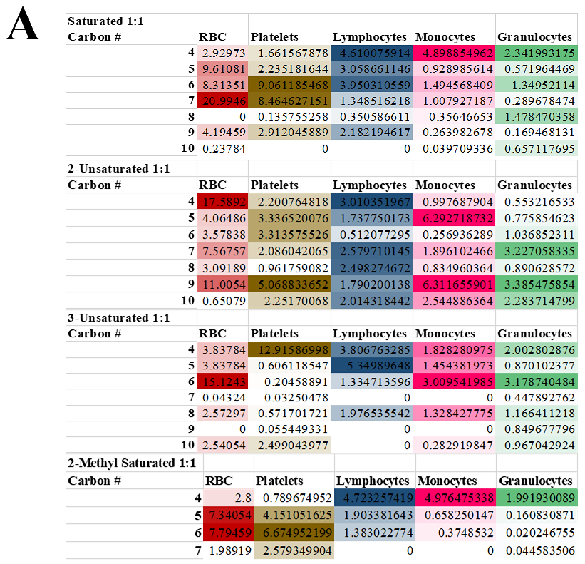

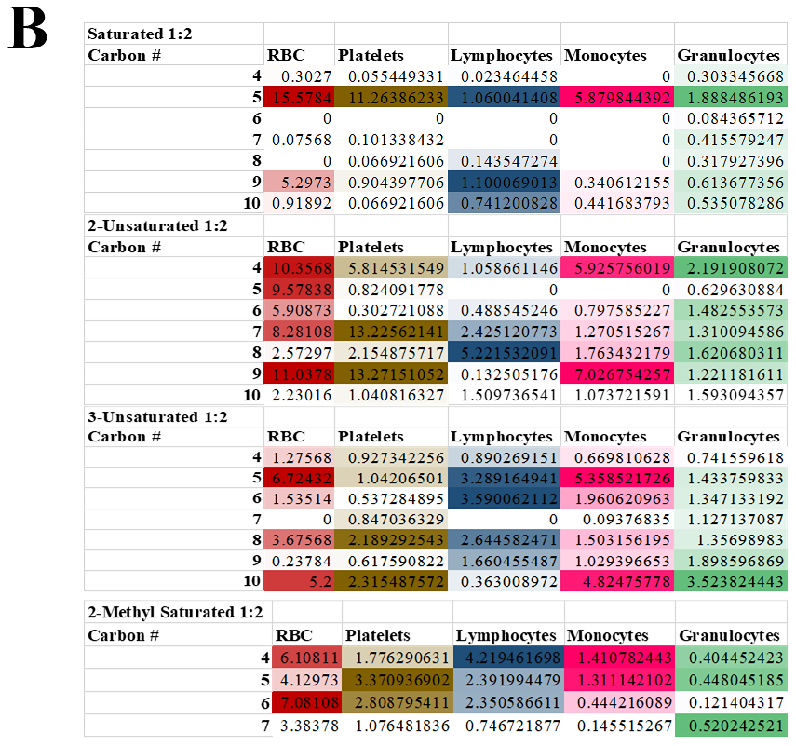

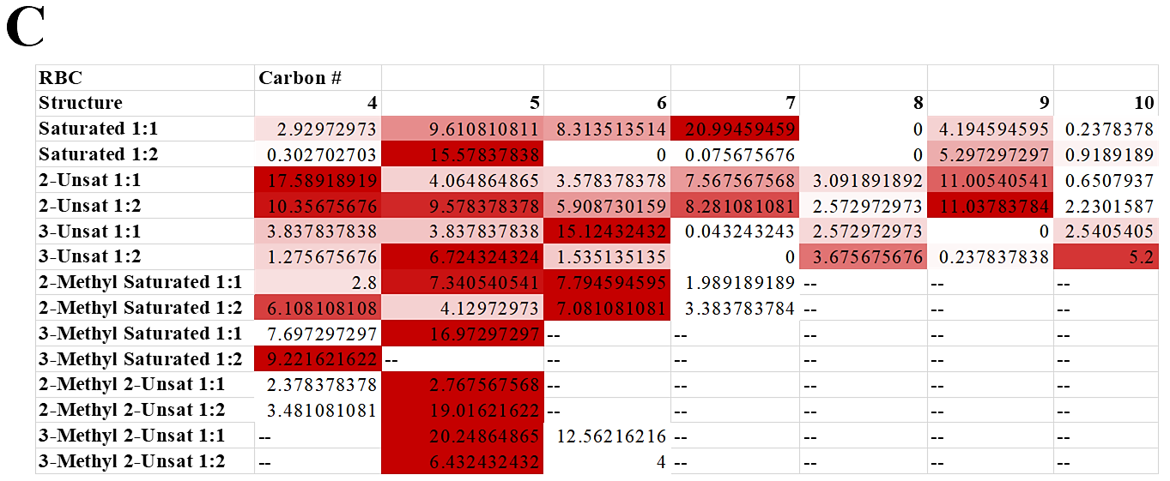
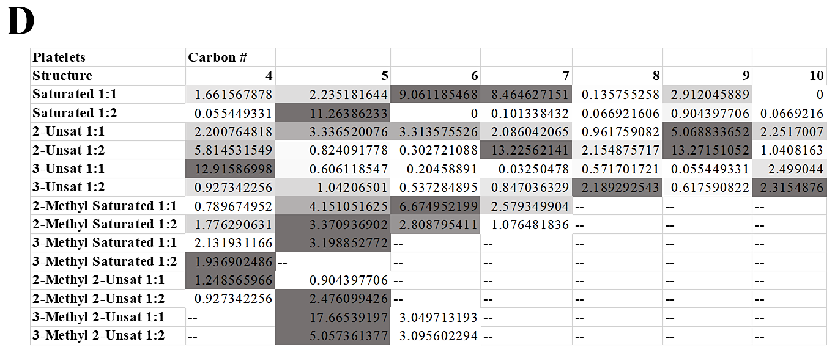
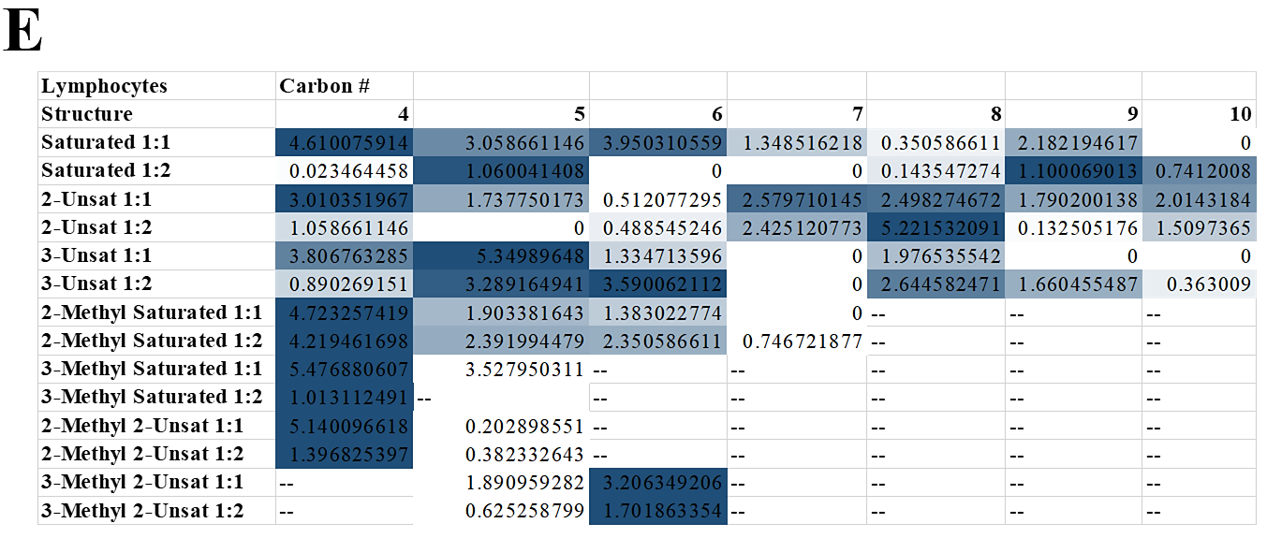
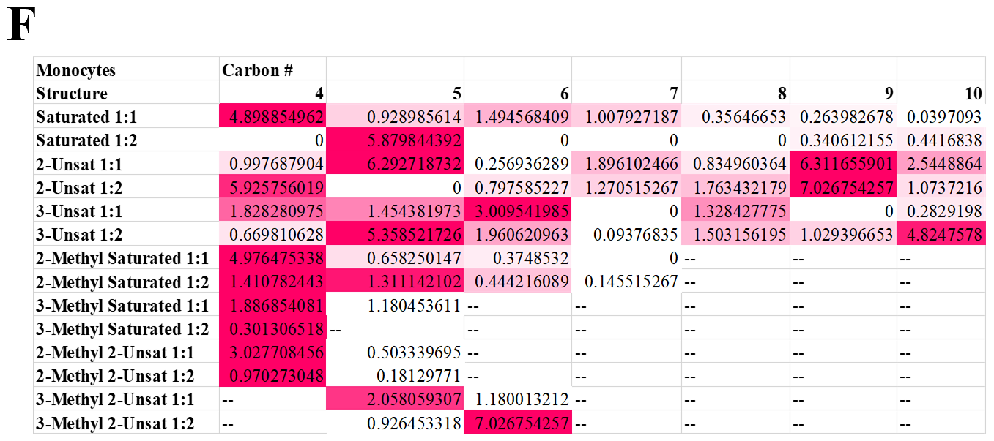
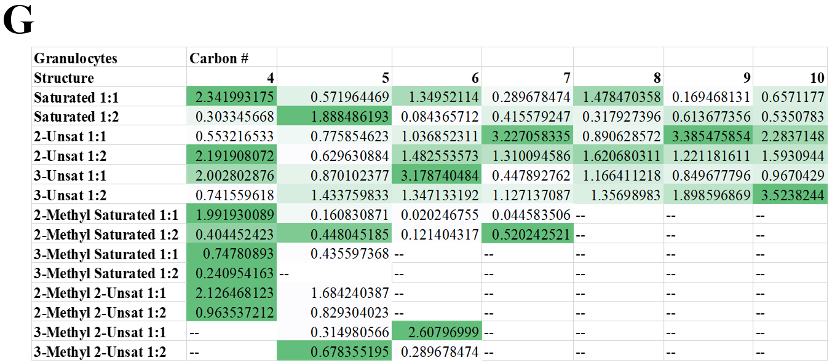

Fig.S1. Structure-function mechanism shows ‘sweet spot’ for screened anions depending on category (saturation, ionic ratio, chain length) for in situ cellular RBC, platelet, and WBC hitchhiking in whole BALB/c pooled gender mouse blood. All values represented as normalized binding to PLGA (set as 1) after saline buffer baseline subtraction, and organized as a vertically ranked heatmap (lightest to darkest) in accordance to carbon chain number vs. all cell types (each ranked top to bottom from C4 to C10 by individual cell type column) compartmentalized by chain saturation (fully saturated, trans-2-unsaturated, or trans-3-unsaturated) at a cation:anion ionic ratio of A) 1:1, or B) 1:2. Additionally, all candidates were simultaneously horizontally ranked left to right (C4-C10 vs. both saturation degree and ionic ratio) and compartmentalized by C) Red blood cells, D) Platelets, E) Lymphocytes, F) Monocytes, and G) Granulocytes.

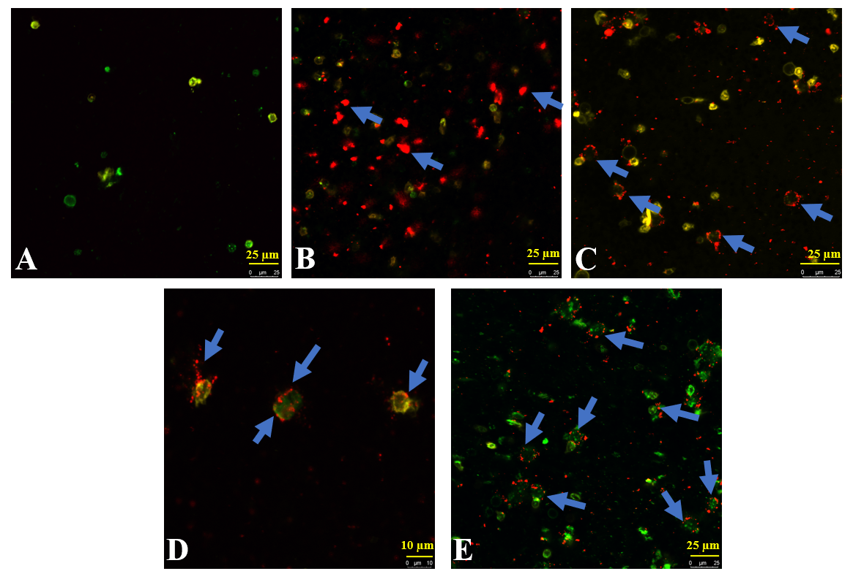
Fig.S2. Heparin anticoagulant does not induce phagocytosis or hinder WBC hitchhiking candidates when administered into whole adult BALB/c blood. Live-cell confocal microscopy (37°C; yellow: PE-CDllb+, green: FITC-Ly6G+, red: DiD NPs) of WBC-candidate treated and washed WBCs isolated from whole BALB/c pooled gender mouse blood after incubation. DiD Treatments: A) 1x PBS pH 7.4, B) Bare PLGA NPs, C) CA2OE 1:2 PLGA NPs, D) CA2PE 1:1 PLGA NPs, E) CA3None 1:2 PLGA NPs. DiD NPs clearly decorate the rounded surfaces of WBCs with membrane penetration (blue arrows) as opposed to direct phagocytosis, seen as a robust red glow for bare PLGA NPs. 63x objective oil immersion.

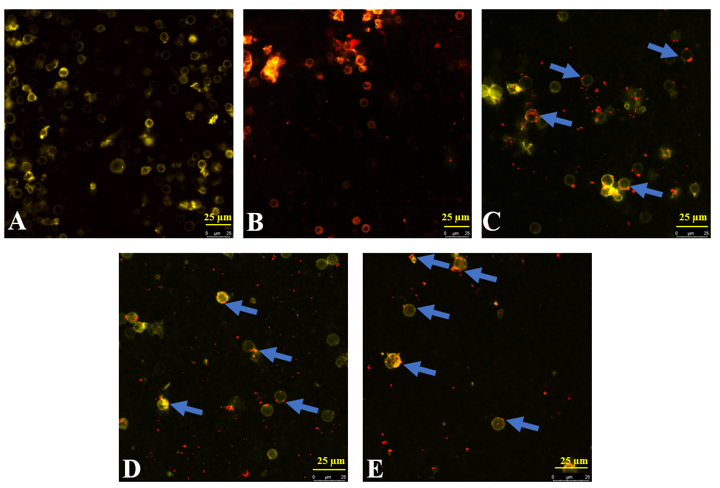
Fig.S3. Heparin anticoagulant does not induce phagocytosis or hinder WBC hitchhiking candidates when administered into whole adult human blood. Live-cell confocal microscopy (37°C; yellow: PE-CDllb+, green: FITC-Ly6G+, red: DiD NPs) of WBC-candidate treated and washed WBCs isolated from whole BALB/c pooled gender mouse blood after incubation. DiD Treatments: A) 1x PBS pH 7.4, B) Bare PLGA NPs, C) CA2OE 1:2 PLGA NPs, D) CA2PE 1:1 PLGA NPs, E) CA3None 1:2 PLGA NPs. DiD NPs clearly decorate the rounded surfaces of WBCs with membrane penetration (blue arrows) as opposed to direct phagocytosis, seen as a robust red glow for bare PLGA NPs. 63x objective oil immersion.

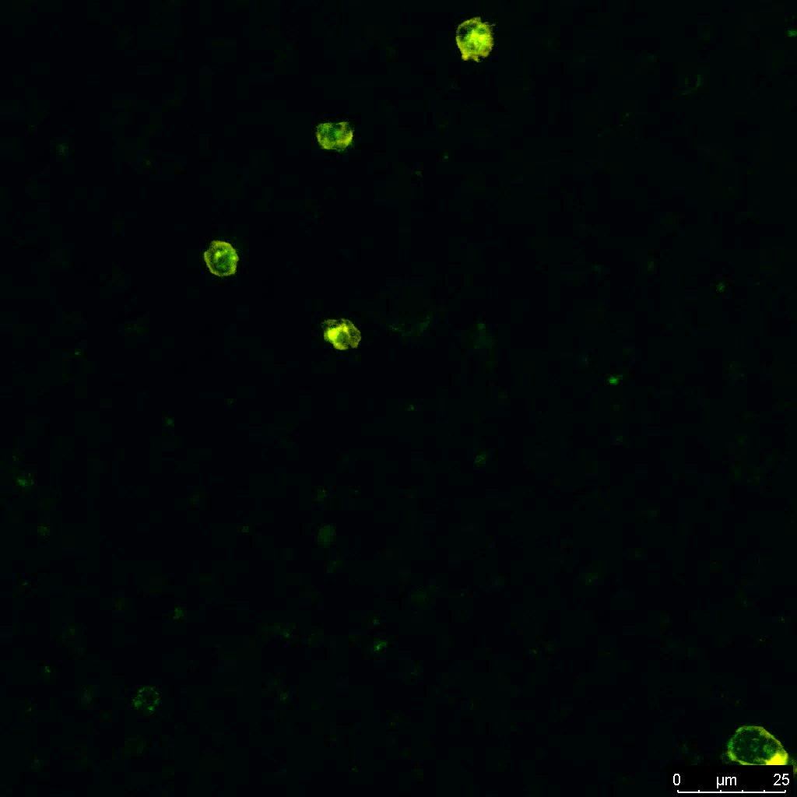
Fig.S4. Isolated white blood cells (WBCs) from k₂EDTA-treated whole mouse pooled gender BALB/c blood treated with 1x PBS pH 7.4. Live-cell confocal microscopy (37°C; yellow: PE-CDllb+, green: FITC-Ly6G+, red: DiD NPs) of WBC-candidate treated and washed WBCs isolated from whole BALB/c pooled gender mouse blood after incubation. Treatment: 1x PBS pH 7.4. 63x objective.

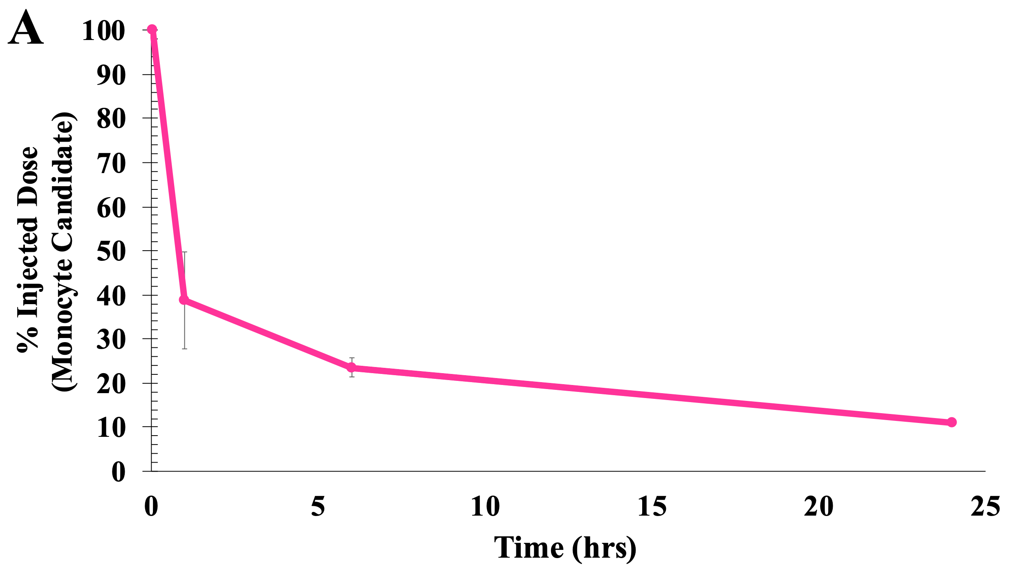
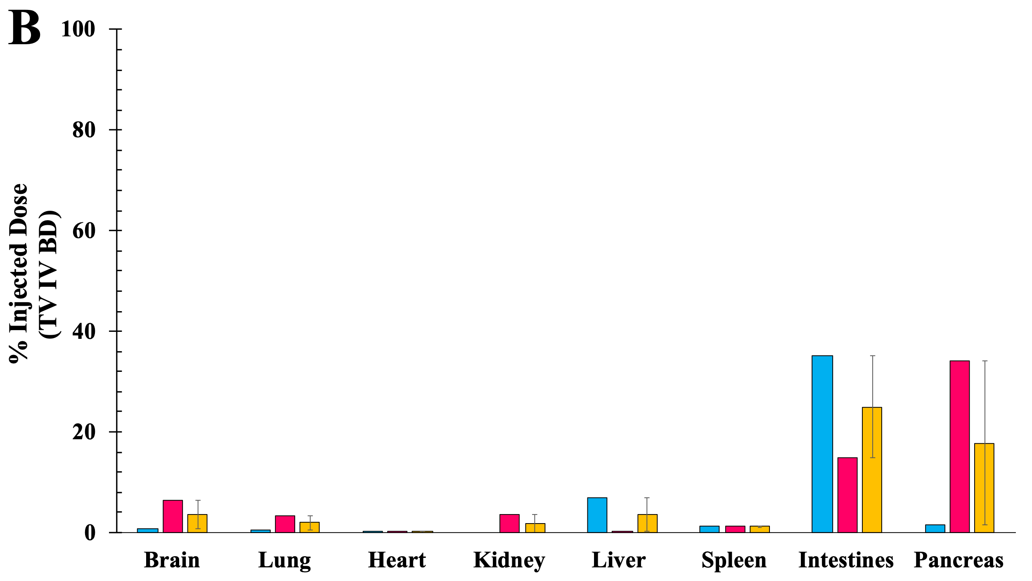

Figure S5. Pharmacokinetics (PK) and Biodistribution (BD) profile of monocyte candidate CA2PE 1:1 post-tail vein IV injection illustrates notable retention in the bloodstream at 24 hours and massive redirection to intestines and pancreas over time, locations of lymphatic vasculature. PK represented as average of injected dose ± SEM. A) PK sample size: n=3 at 2 minutes (100%), n=3 at 1 hour (38.8 ± 11.1%), n=2 at 6 hours (23.5 ± 2.2%), and n=1 (11.1%) at 24 hours. B) BD sample size: n=1 at 2 hours (intestine: 35.1%, pancreas: 1.5%), n=1 at 24 hours (intestine: 14.9%, pancreas: 34.0%, brain: 6.3%), and average ± SEM (n=2).
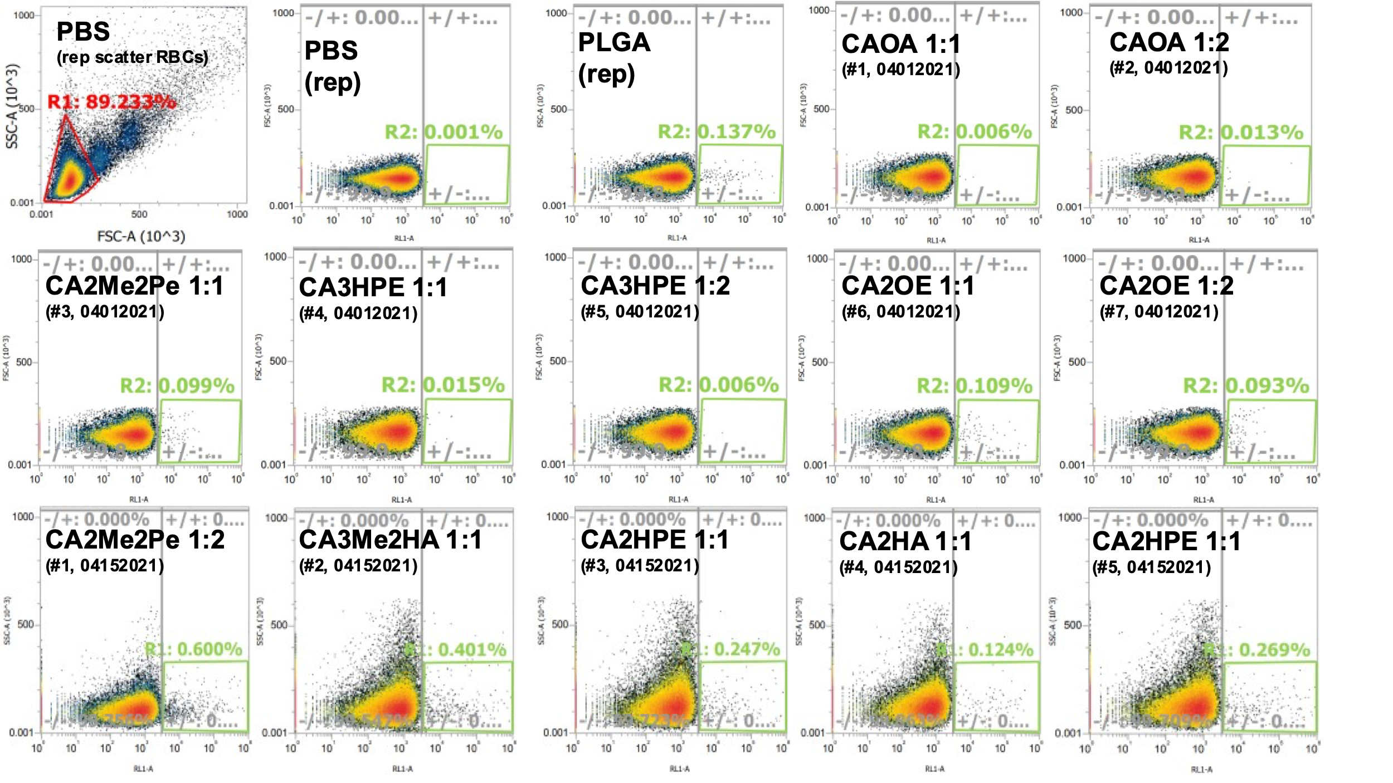
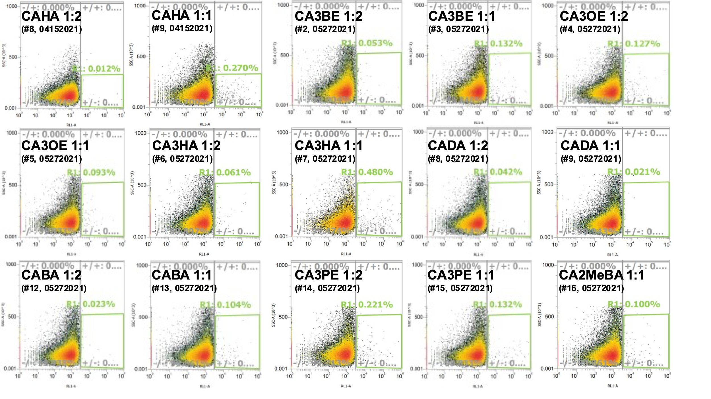
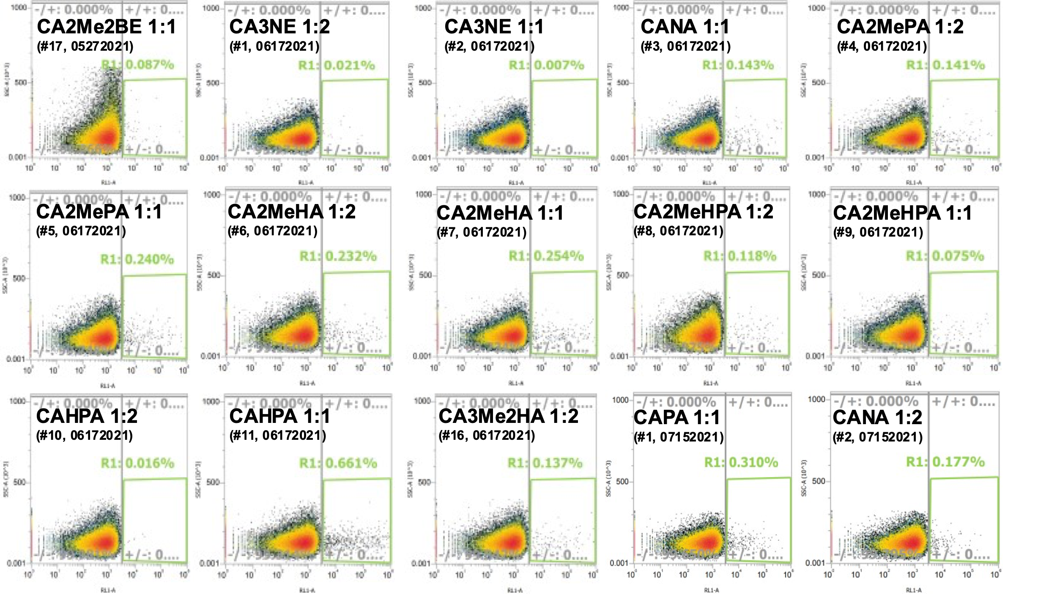
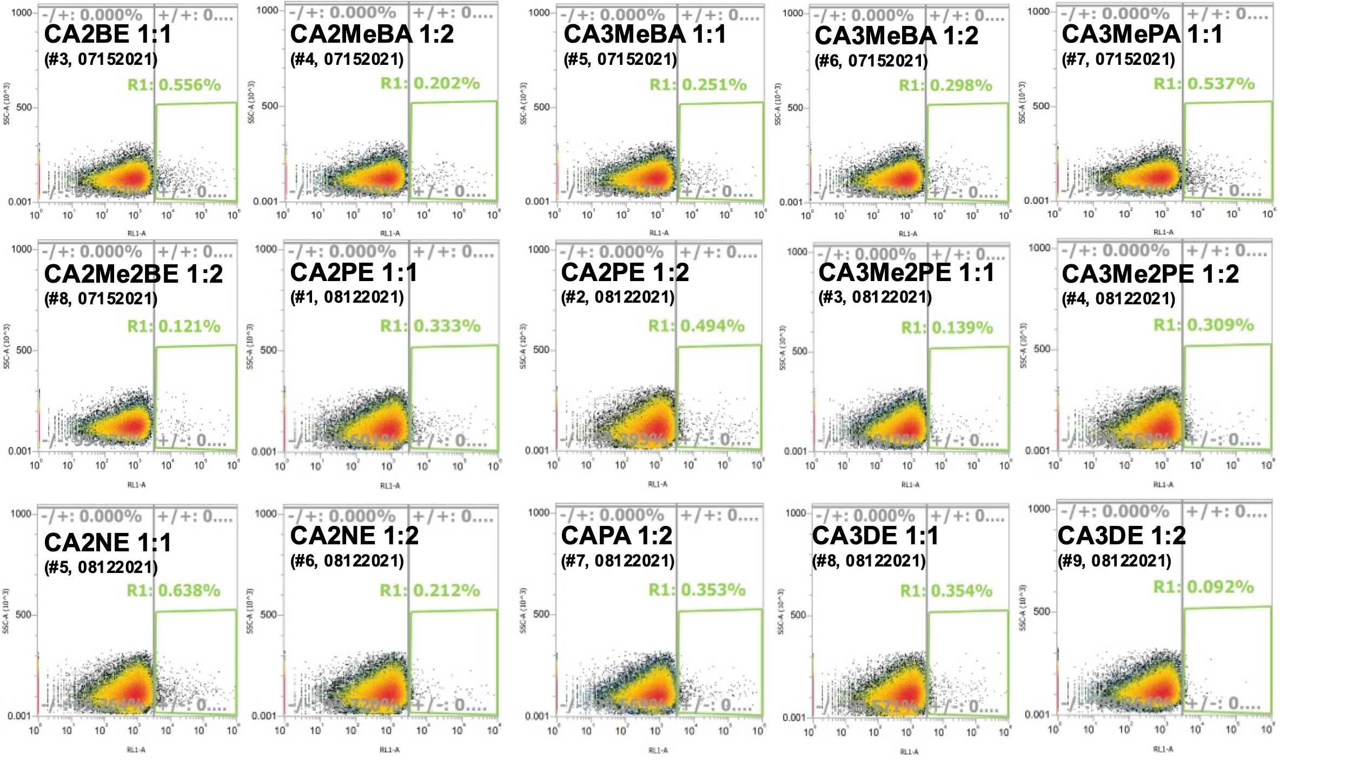
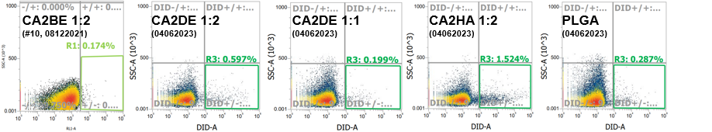
Figure S6. FACS RBC Screening of IL-PLGA DiD NPs from whole BALB/c blood.
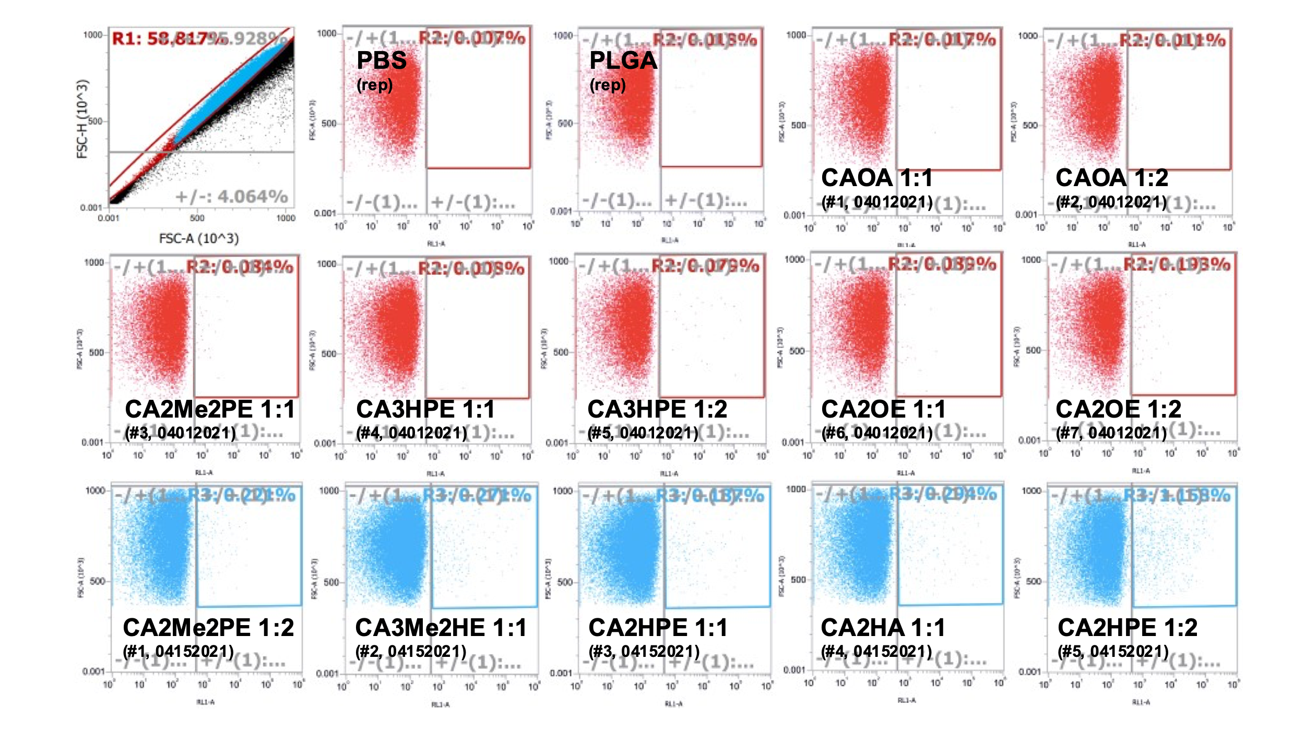
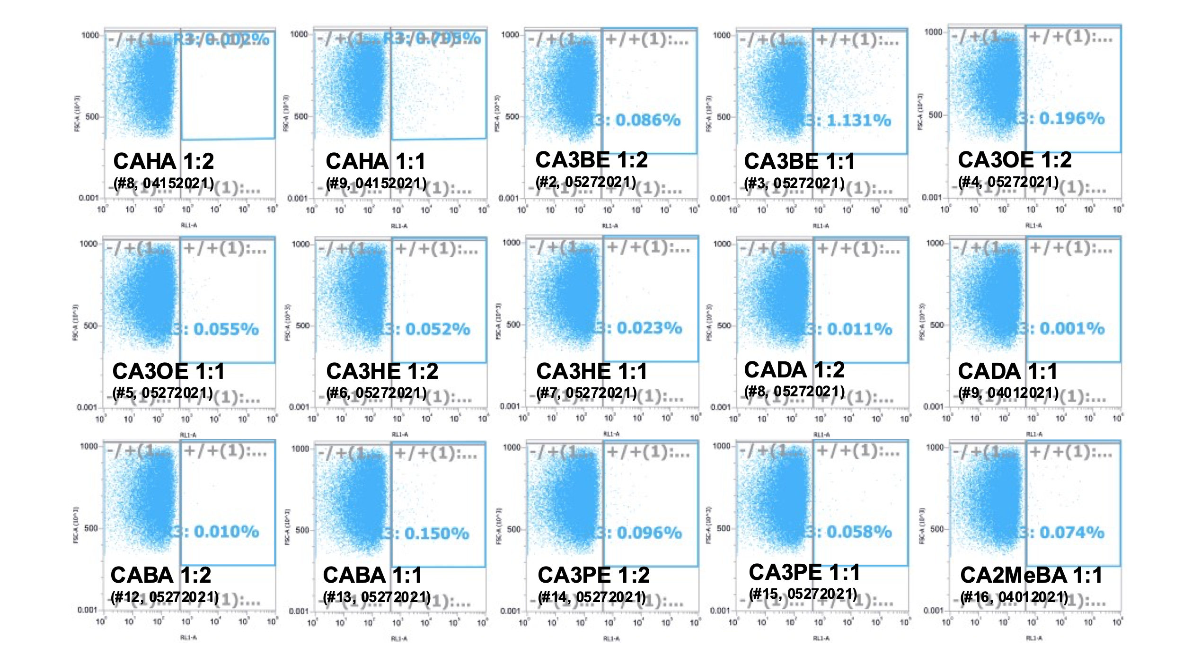
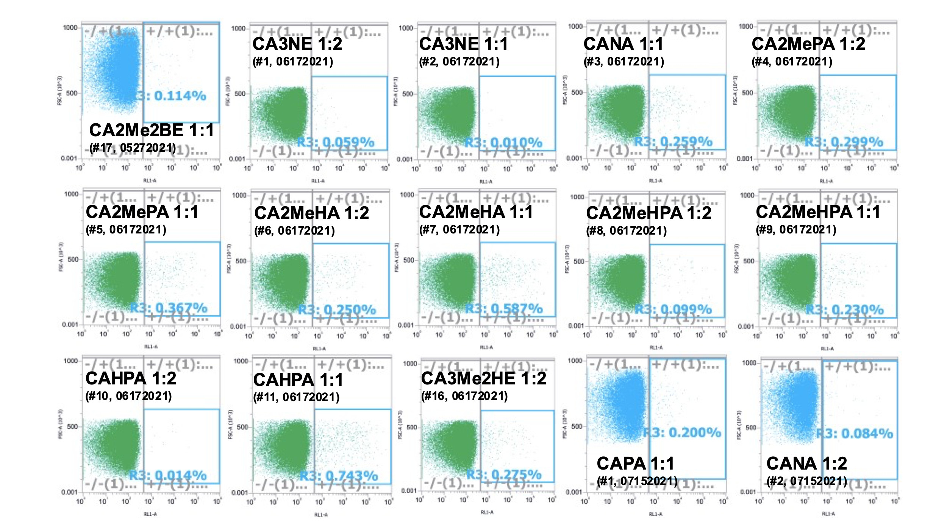
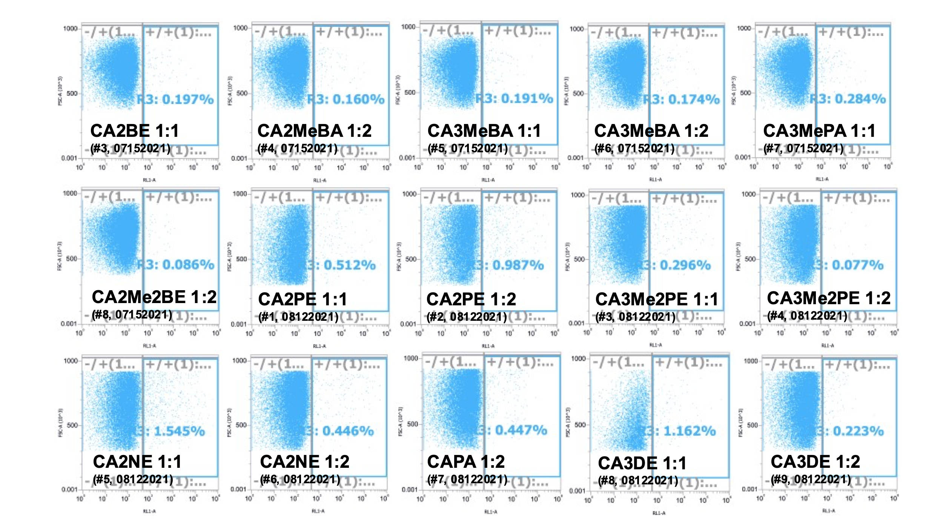
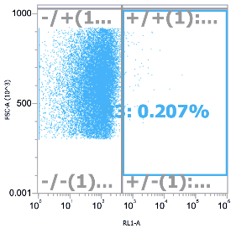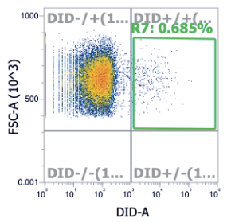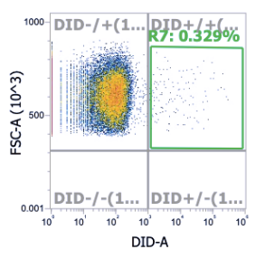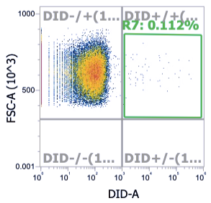
CA2HA 1:2
(04062023)
CA2DE 1:2
(04062023)
CA2DE 1:1
(04062023)
CA2BE 1:2
(#10, 08122021)
Figure S7. FACS Platelet Screening of IL-PLGA DiD NPs from whole BALB/c blood.
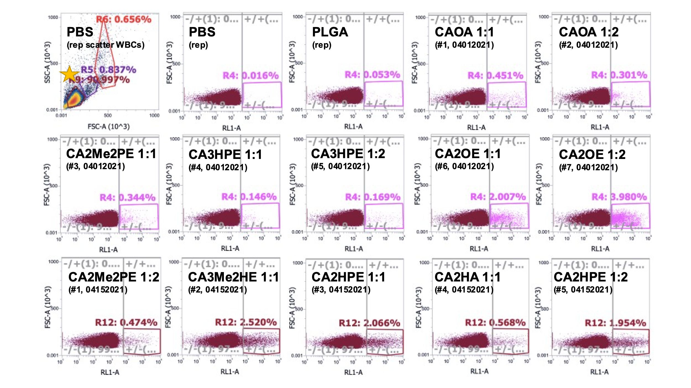
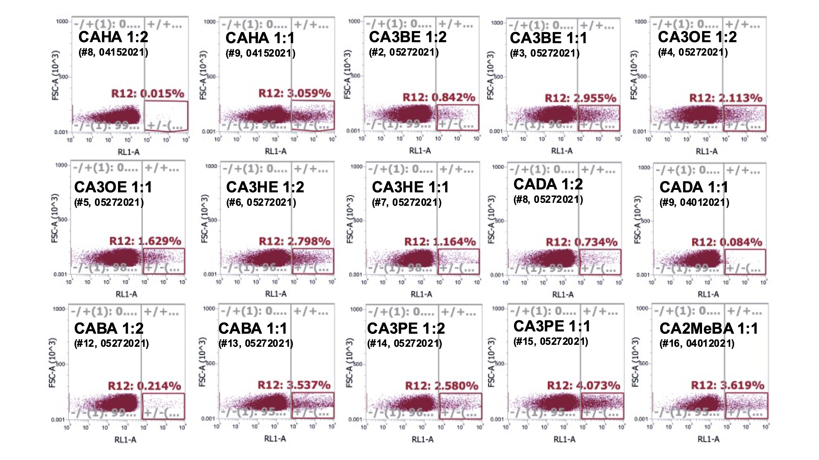
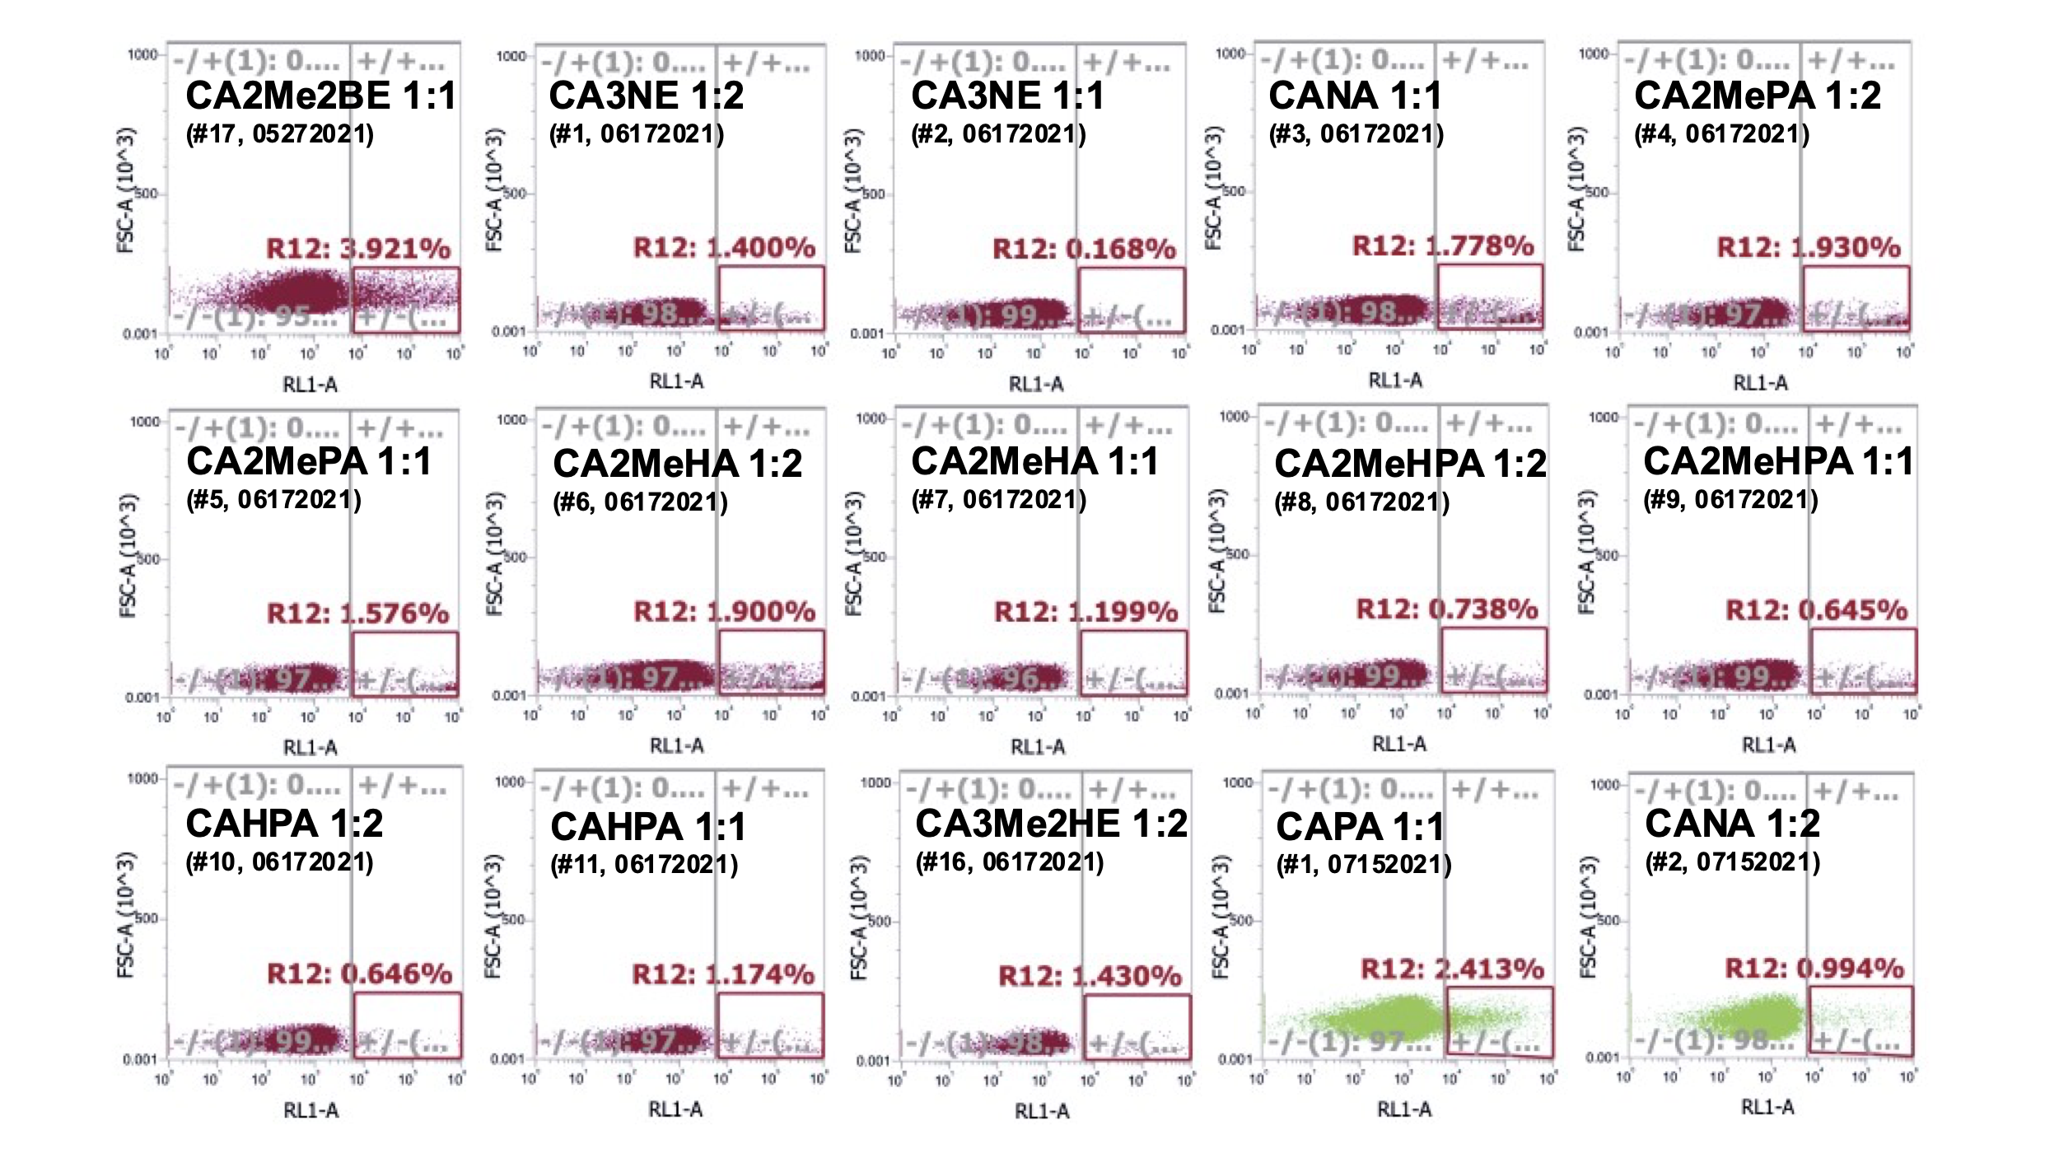
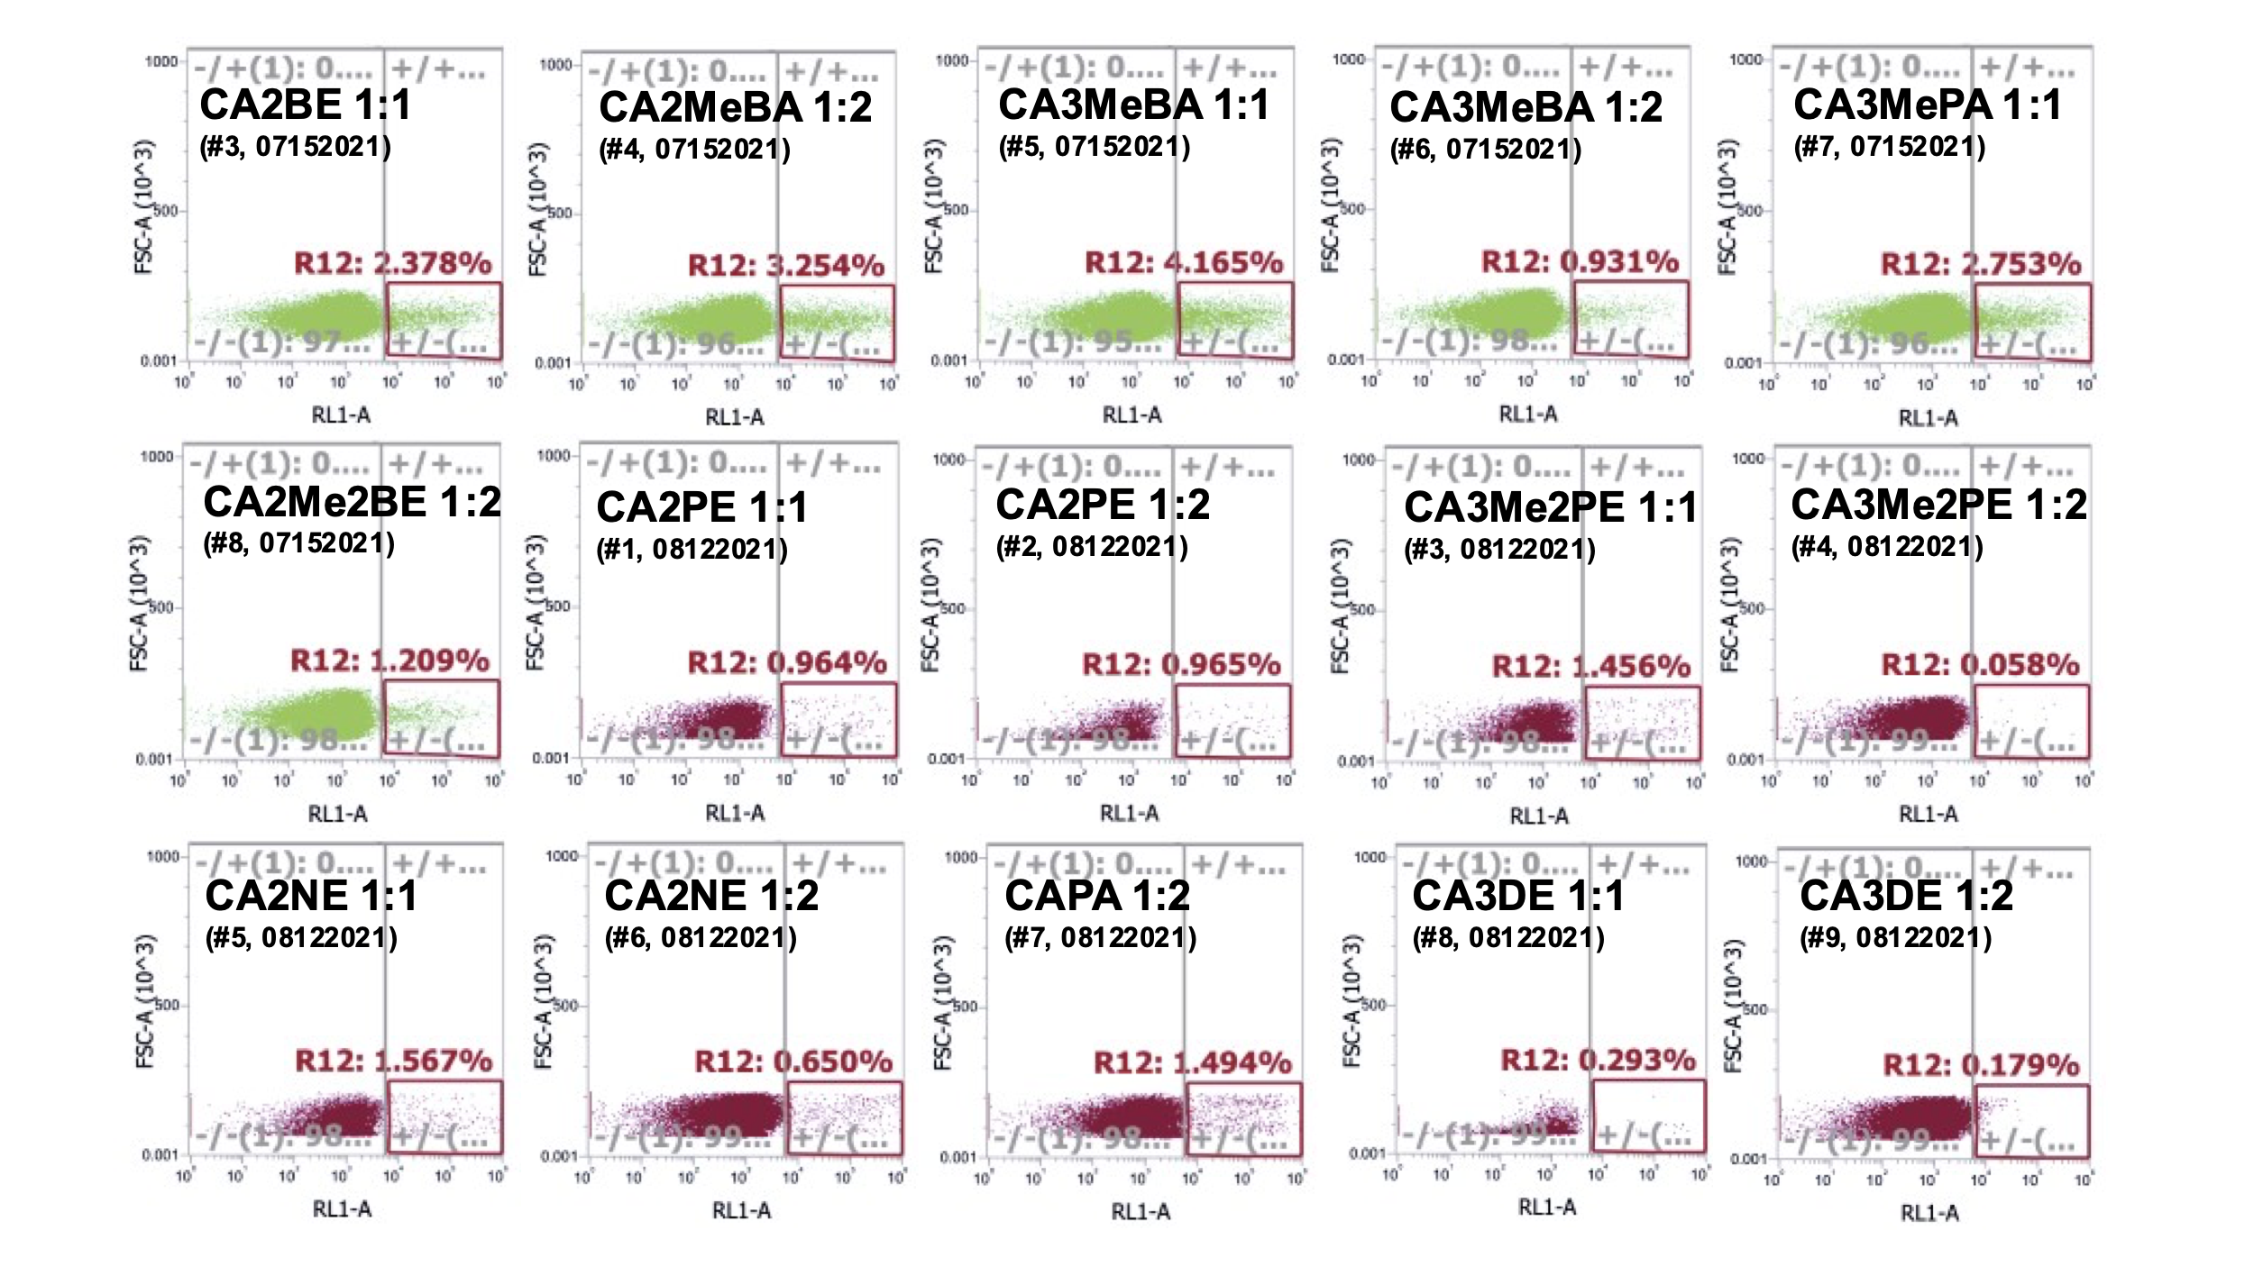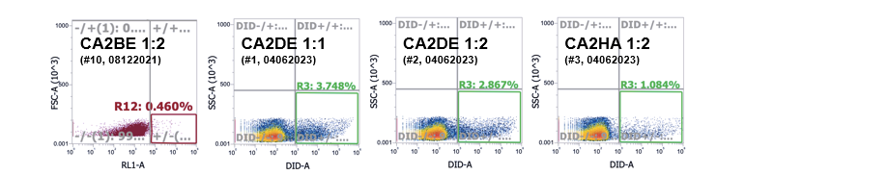
Figure S8. FACS Lymphocyte Screening of IL-PLGA DiD NPs from whole BALB/c blood.
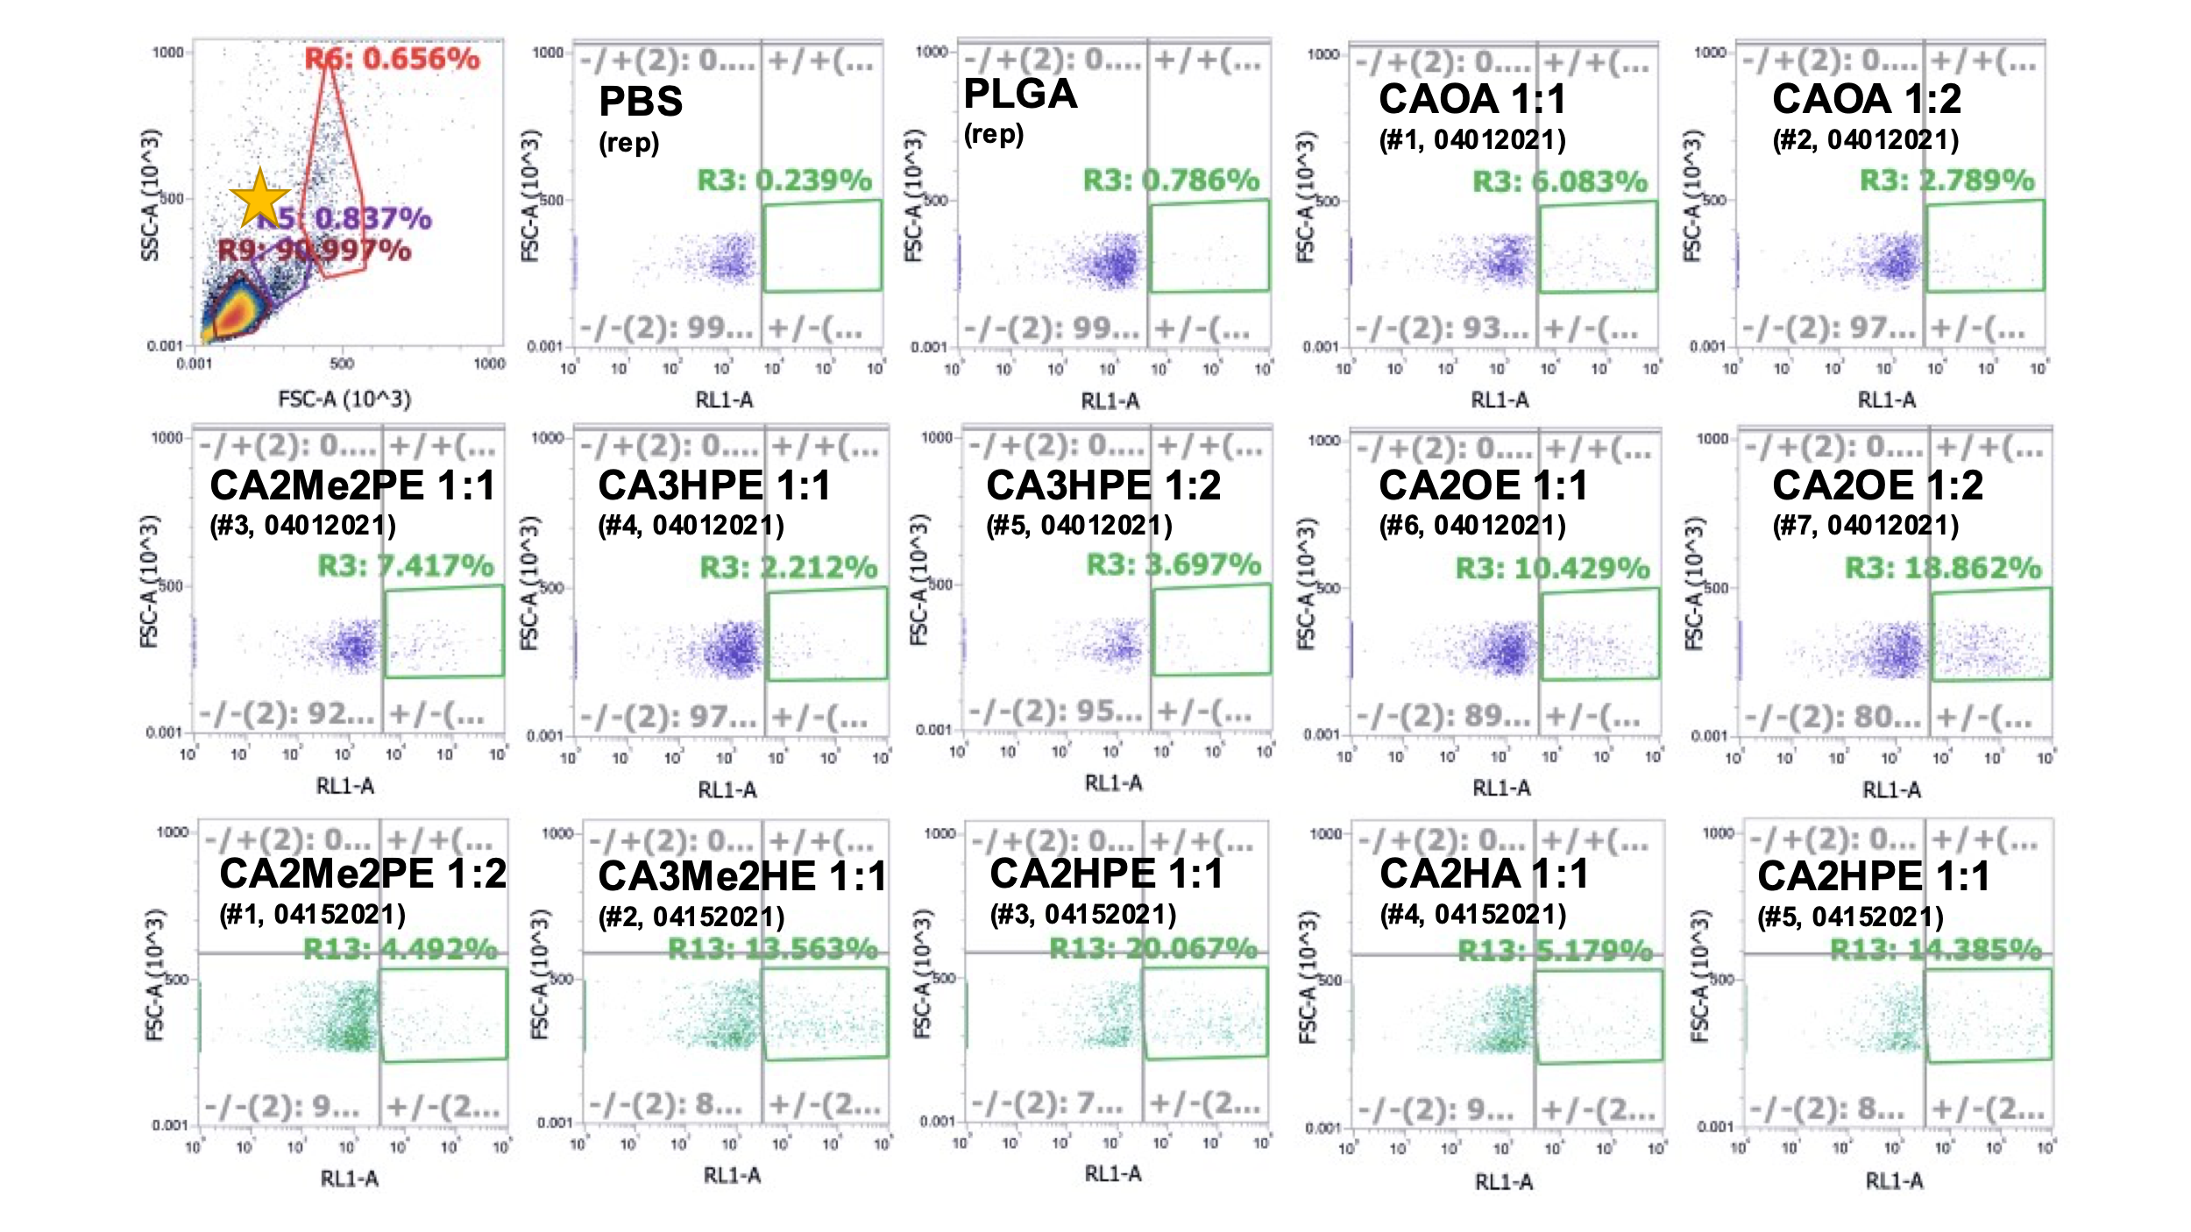
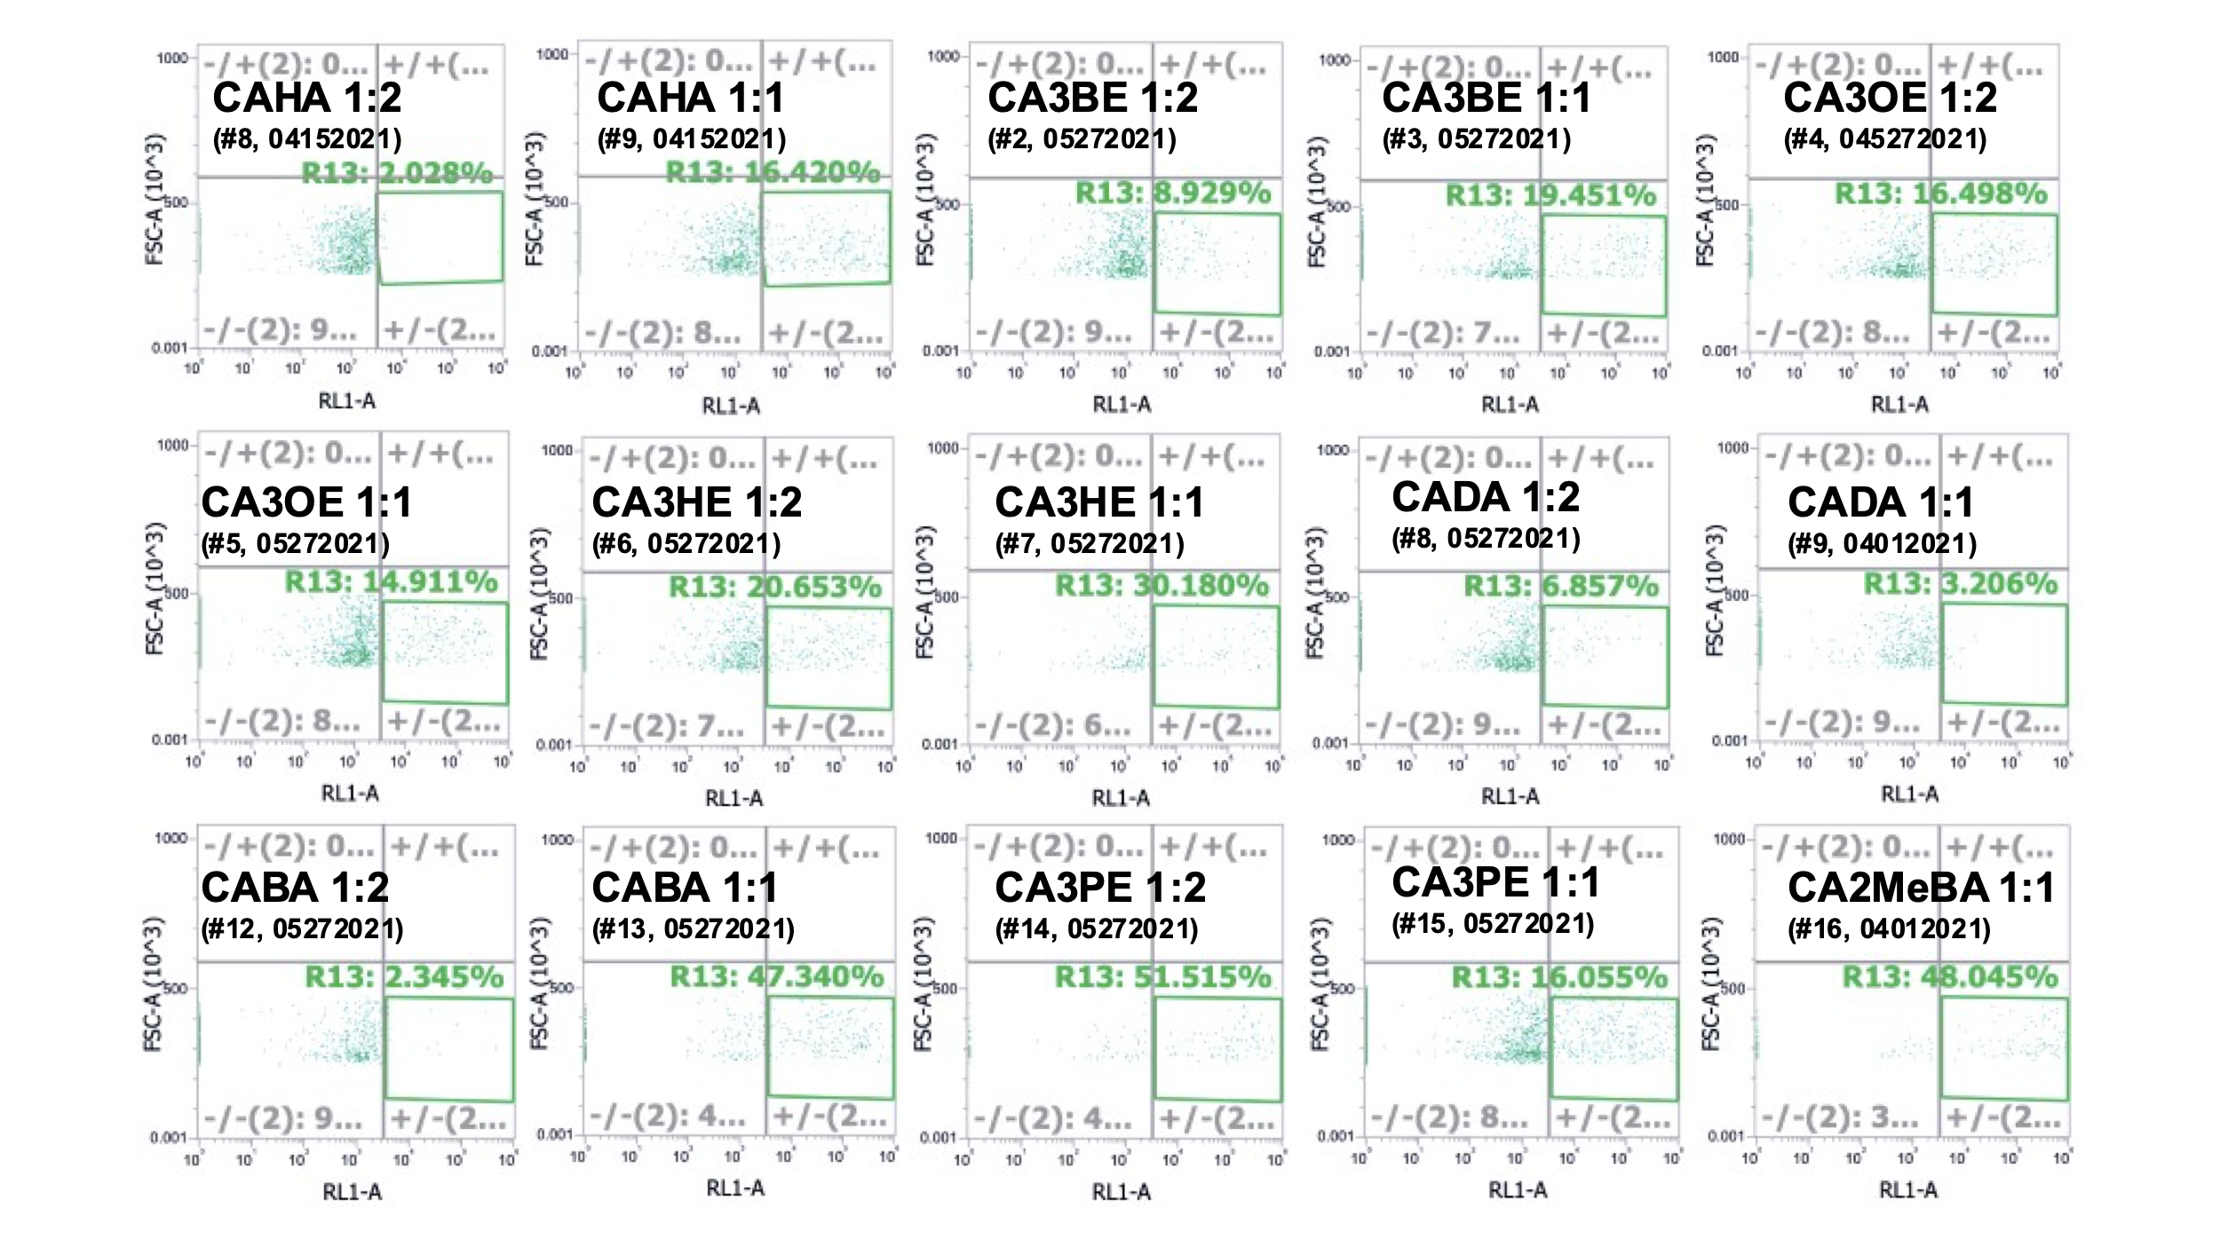
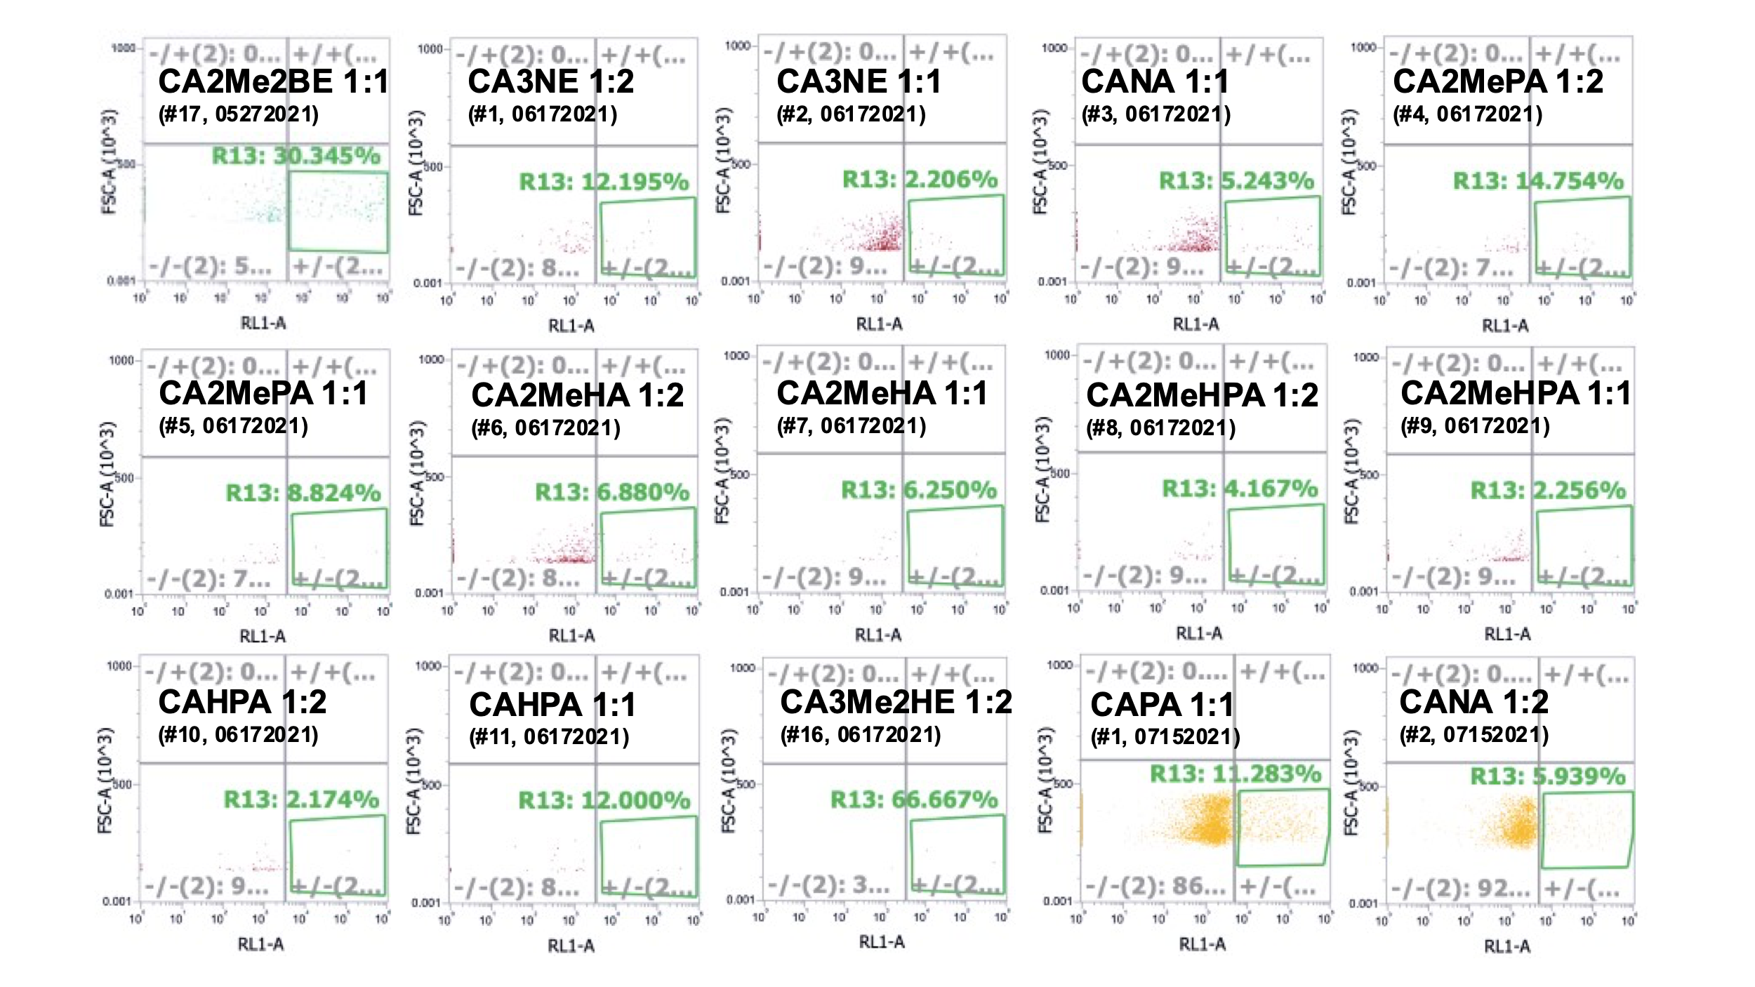
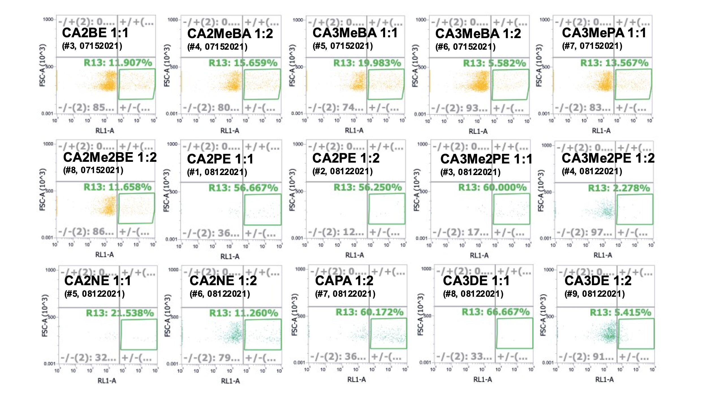
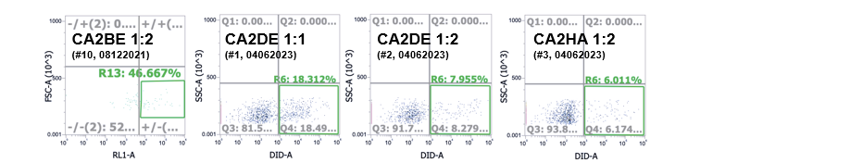
Figure S9. FACS Monocyte Screening of IL-PLGA DiD NPs from whole BALB/c blood.
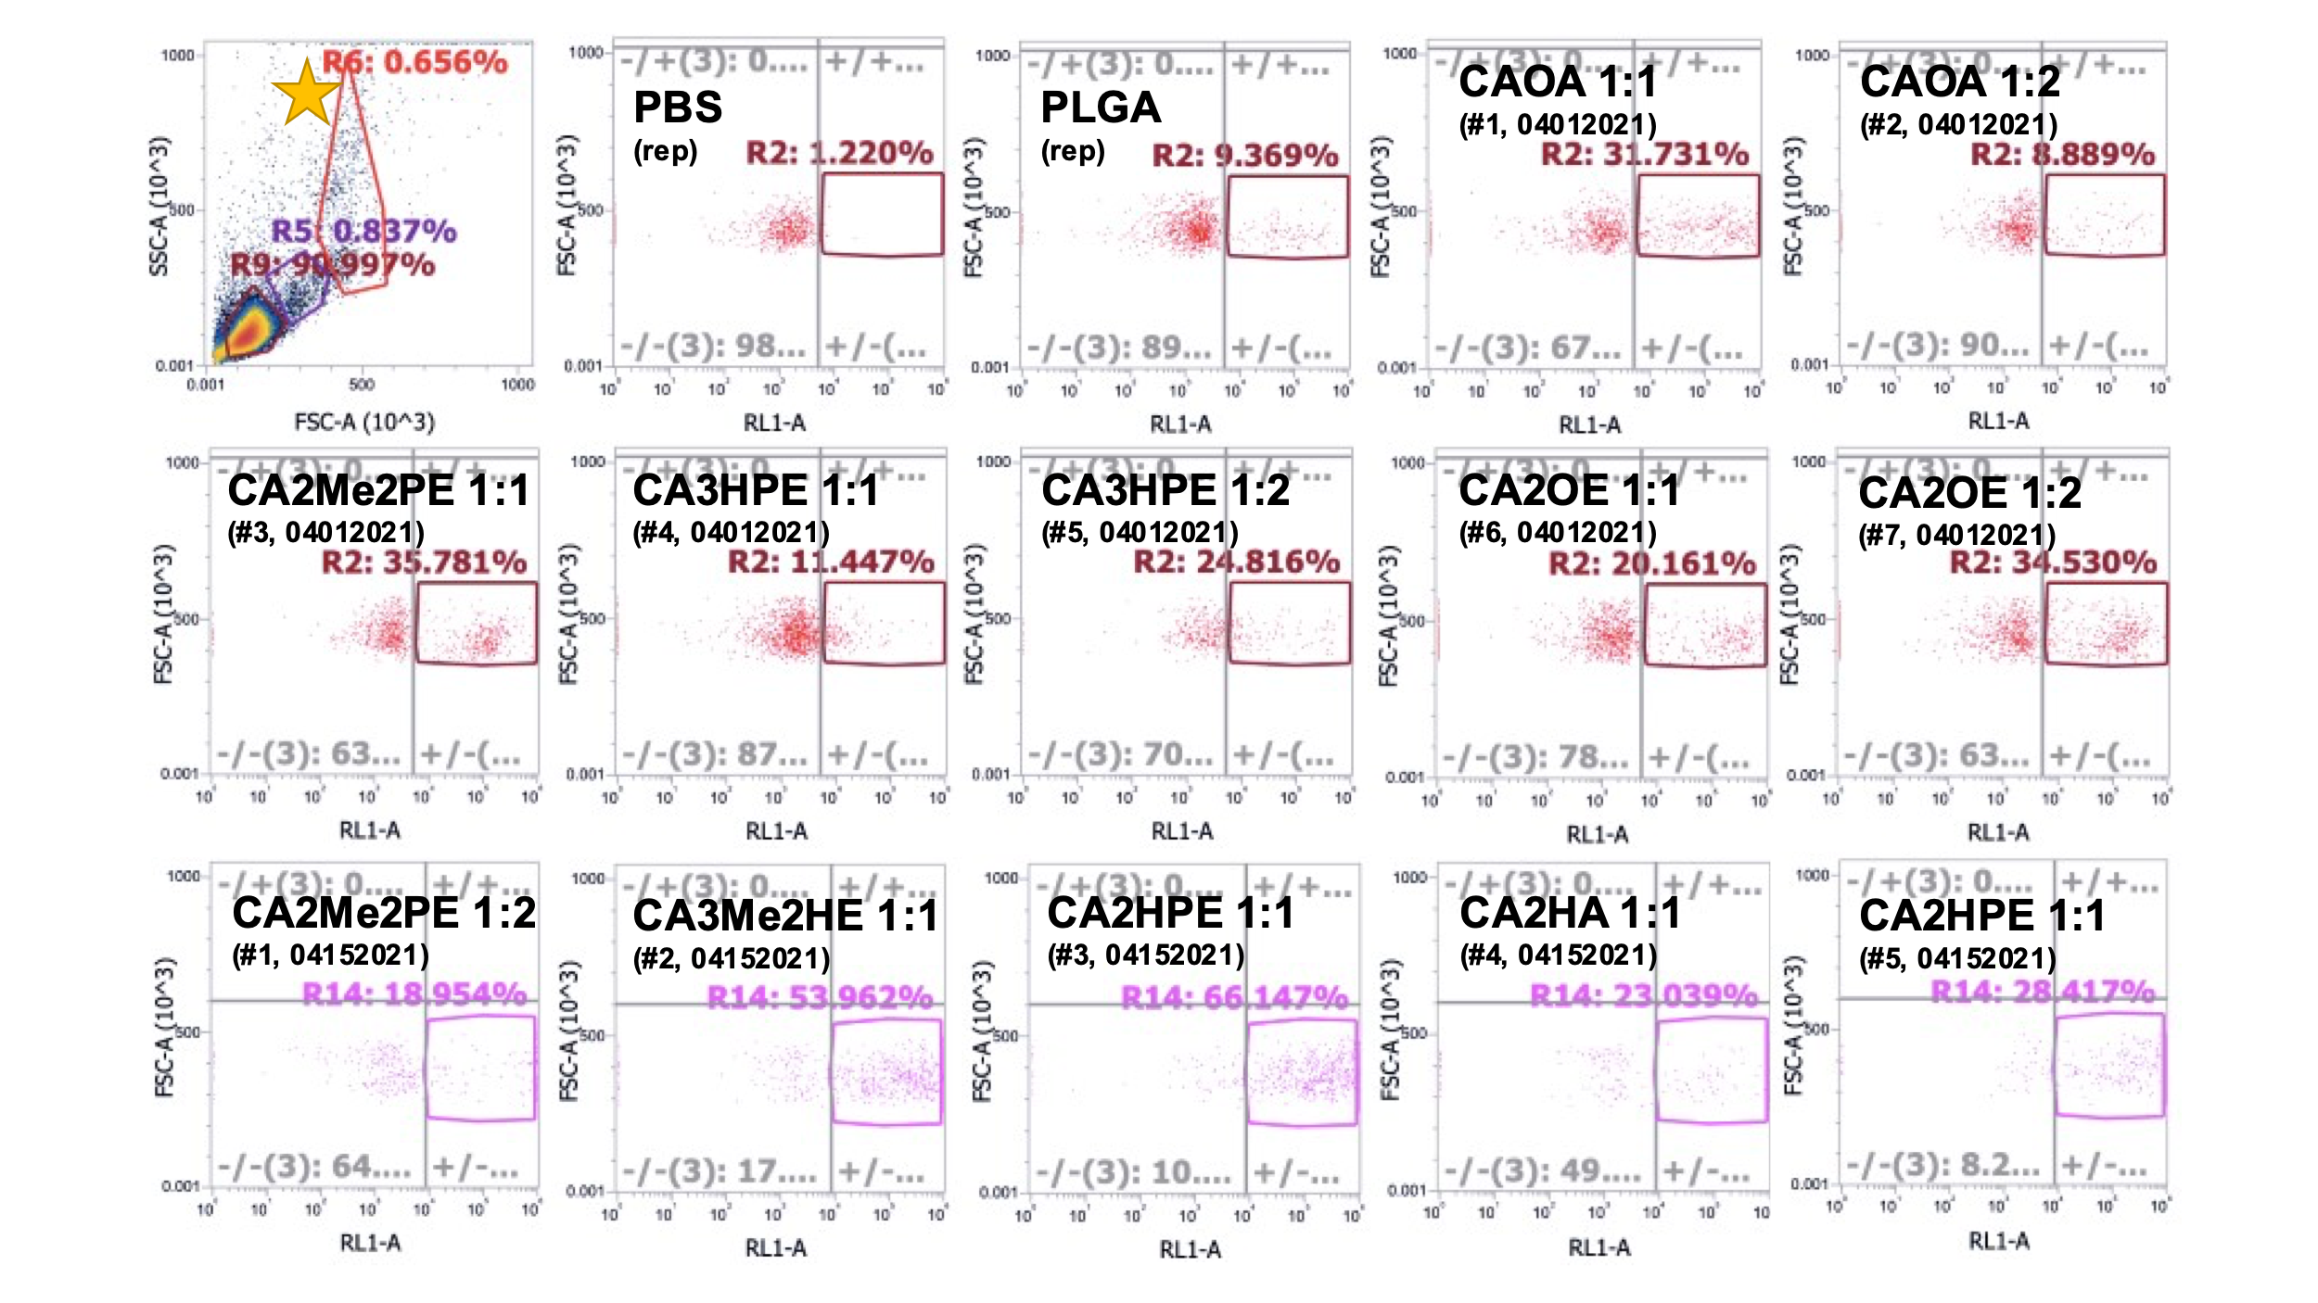
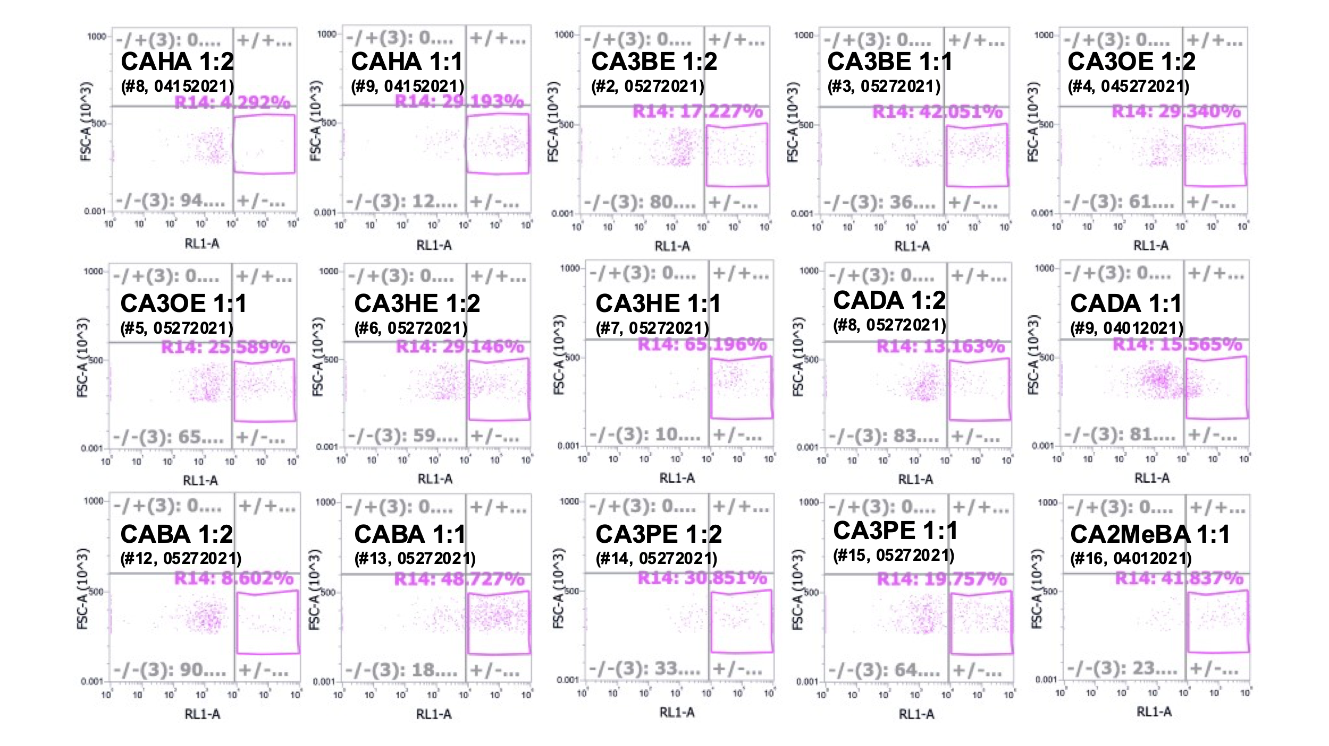
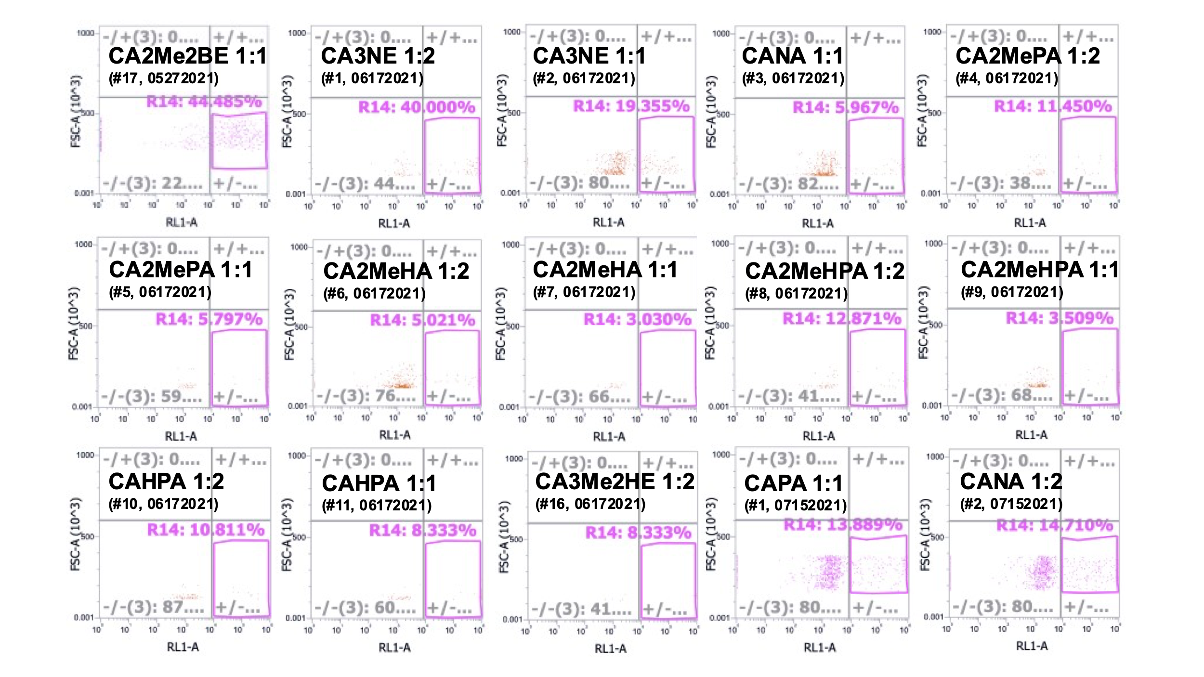
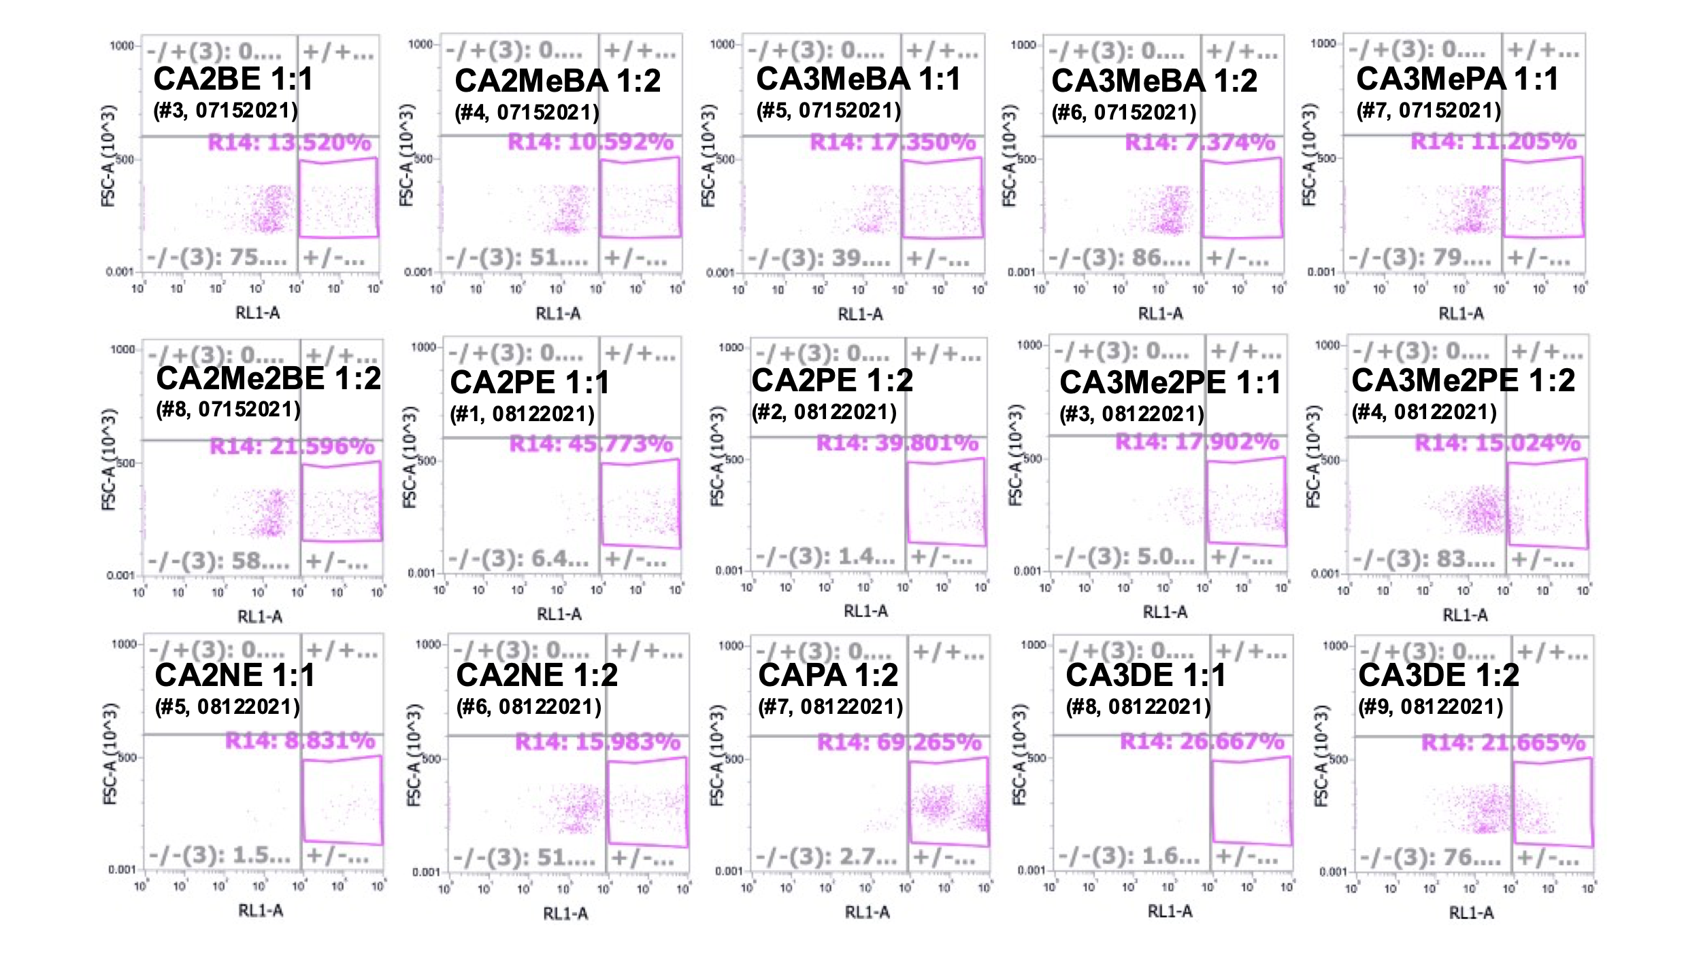
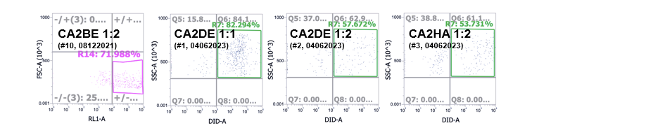
Figure S10. FACS Granulocyte Screening of IL-PLGA DiD NPs from whole BALB/c blood.

