SUPPLEMENTARY INFORMATION
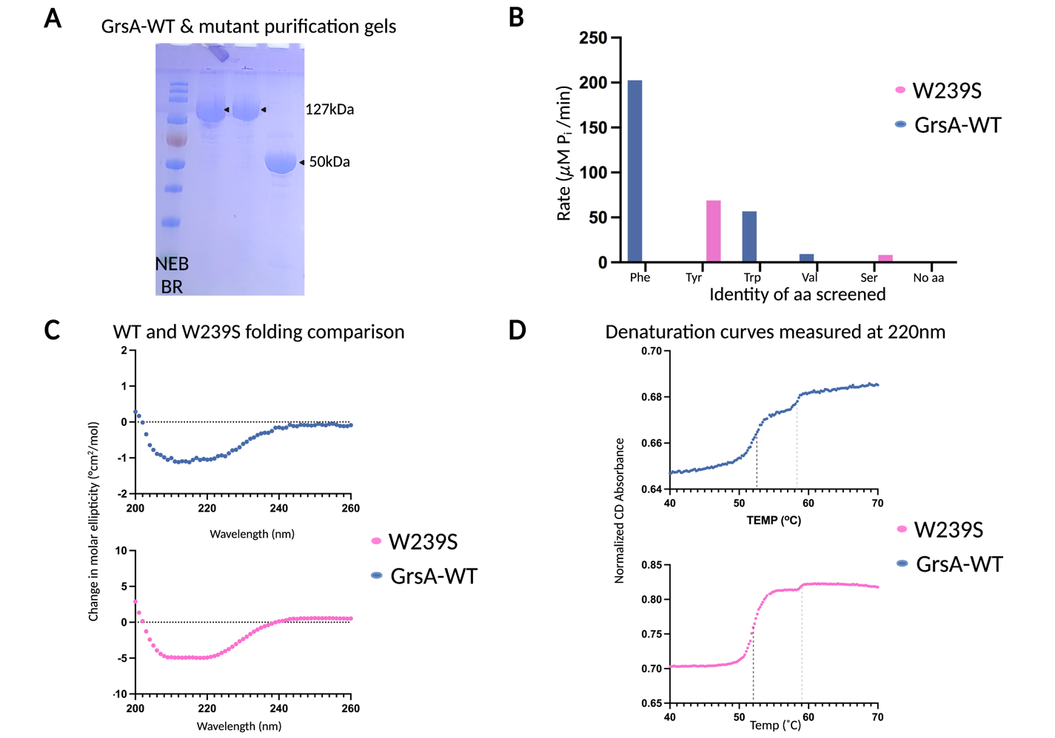
Supplementary Fig. 1. Verification of Protein Constructs of GrsA. A: SDS-page shows purified GrsA-WT, W239S and GrsA-WT-A_{N} in lanes 2, 3 and 4 compared against the NEB-Broad range protein standard, B: PP_{i}-exchange assay shows selective activation of cognate aa for each construct, C: CD-spectra verifies that there is no significant difference in the folding of W239S as compared to GrsA-WT, D: Denaturation curves with CD spectra recorded at 220nm confirm similar unfolding characteristics for both constructs, with primary melting temperature ~52°C and a secondary denaturation event around ~59°C

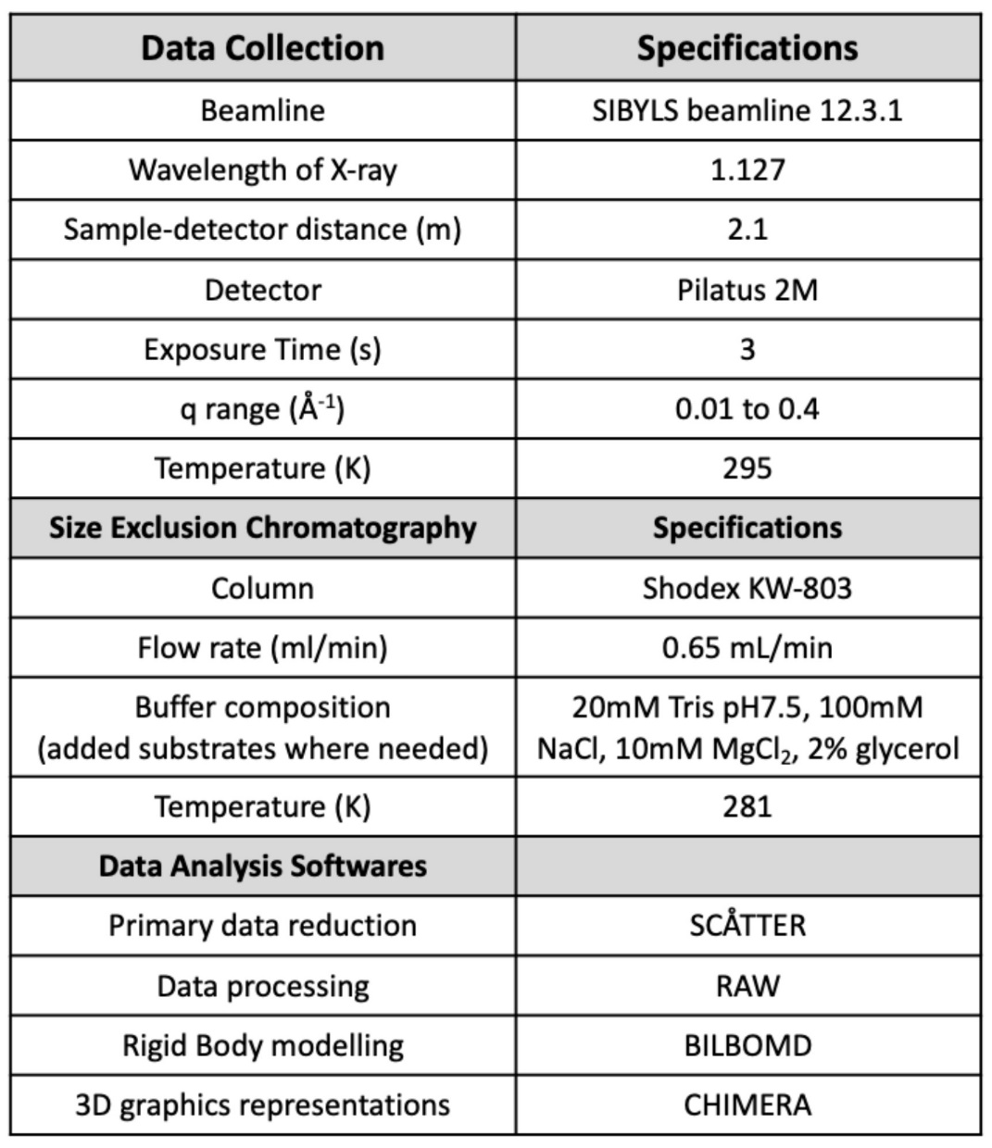
Supplementary Table. 1. Data collection and analysis parameters for the in-line SEC-SAXS experiments performed at the SIBYLS beamline

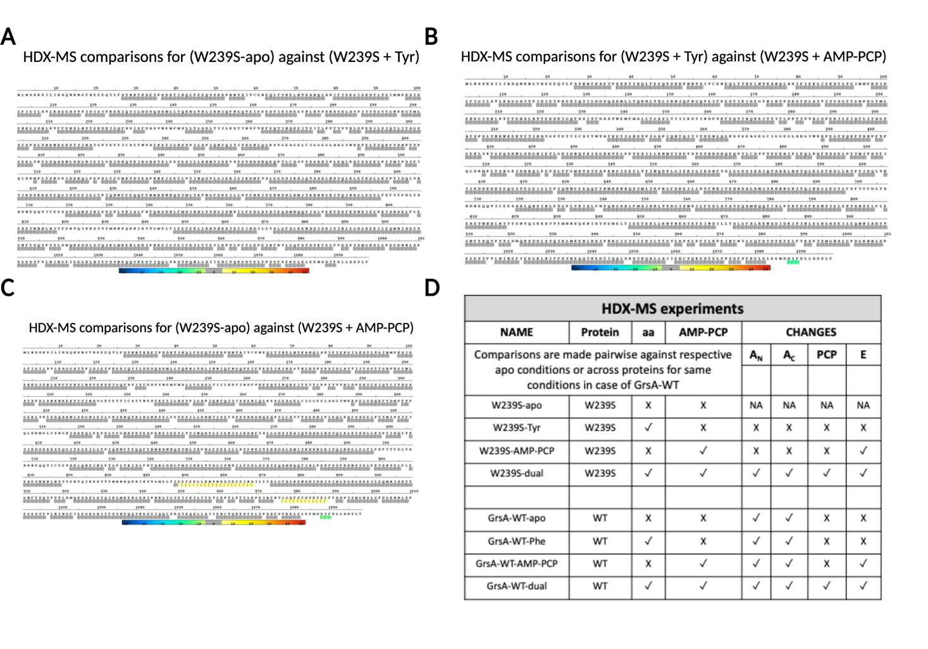Supplementary Fig. 2. A: HDX-MS Results for comparisons of (W239S) against (W239S + Tyr) projected onto protein sequence. There is no apparent differences in D2O uptake between these complexes. B: HDX-MS Results for comparisons of (W239S + Tyr) against (W239S + AMP-PCP) projected onto protein sequence and there is a decrease in D2O uptake at the residue patch ’DIF’ (residues 1088-90, E domain). C: In the case of (W239S + AMP-PCP) there is a similar opening of the DIF patch D. Executive summary table for the HDX experiments performed. Changes highlighted in the last four columns, if observe.

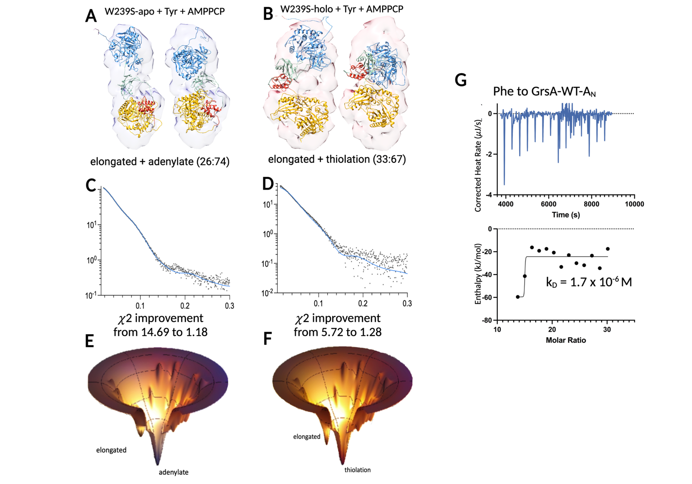
Supplementary Fig. 3. A-B: SAXS envelopes for additional substrate bound states, presented at contour level of 0.011. Envelopes are fitted to each of the states from BilboMD for indicated complex of W239S, domains are color coded as per rest of the article. The contributing states and ratio of the 2-state ensemble that best fits data is written below, C-D: Scattering profile fits showing the 2-state fit of elongated with thiolation states, improvement of fit from 1-state model shown beneath each panel. E-F: Energy funnels representing the relative minima for each two-state ensemble as given by their scattering fits in panels C and D G: Binding affinity measurements of GrsA-WT-A_{N} only: Representative baseline corrected binding curve from nanoITC for Phe titrated into GrsA-WT truncation construct devoid of the A_{C} subdomain with the resulting dissociation constant (K_{D}) from binding models with the best fit. Error bars from triplicates are shown in grey.

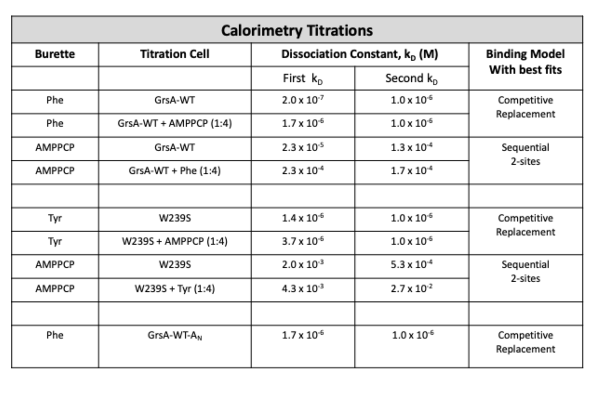Supplementary Table 2 . ITC experiments indicating the aa or AMPPCP as titrant, protein or protein complex, and the resulting dissociation constant(s) (K_{D}) from binding models with the best fit.

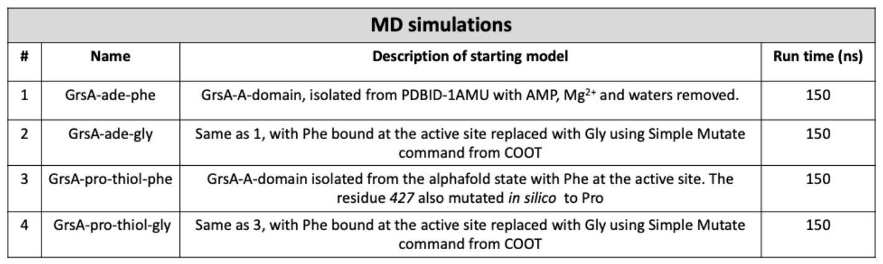
Supplementary Table. 3. Details about the MD simulations run using CHARMM36-all-atom force field for each of the solvated GrsA A-domains and their aa substrates bound

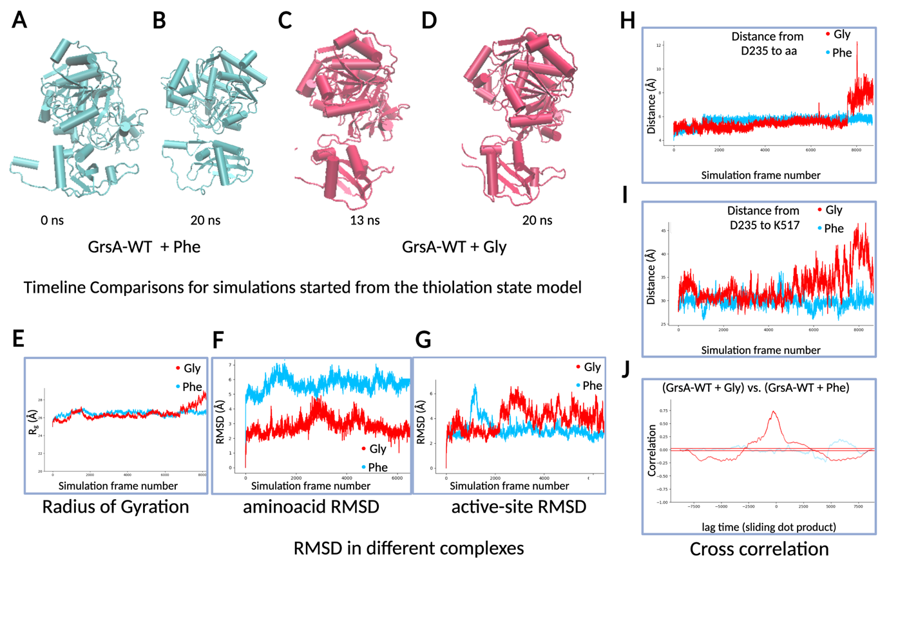Supplementary Fig. 4. MD simulation results comparing the substrate and the protein states between GrsA-WT containing Phe compared to GrsA-WT containing Gly initiated from the thiolation state model A-B: Representative structures of the folded A-domain from GrsA-WT containing Phe compared between the initial and intermediate states of the simulation, C-D: Representative structures of the intermediates, representing partially unfolded A-domain of GrsA-WT containing Gly at 13ns and D: 20ns, E-I: comparison of the two conditions with red representing Gly as non-cognate substrate and blue representing Phe as cognate substrate E: Comparison of Radius of gyration of the A-domain across the length of the simulation, F: Comparison of the RMSD of the aa with respect to the initial state across the length of the simulation, G: Comparison of the RMSD of the active-site pocket with respect to the initial state across the length of the simulation, H: Comparison of the distance from the conserved D235 residue to the aa representing unbinding event in case of Gly, I: Comparison of the distance from the conserved D235 residue to the conserved K517 residue across the length of the simulation, J: Correlation of unbinding event (from panel H) to unfolding event (panel I) across the length of the simulation, overlayed with Phe condition shown as a sliding dot product.

