Supplementary Materials
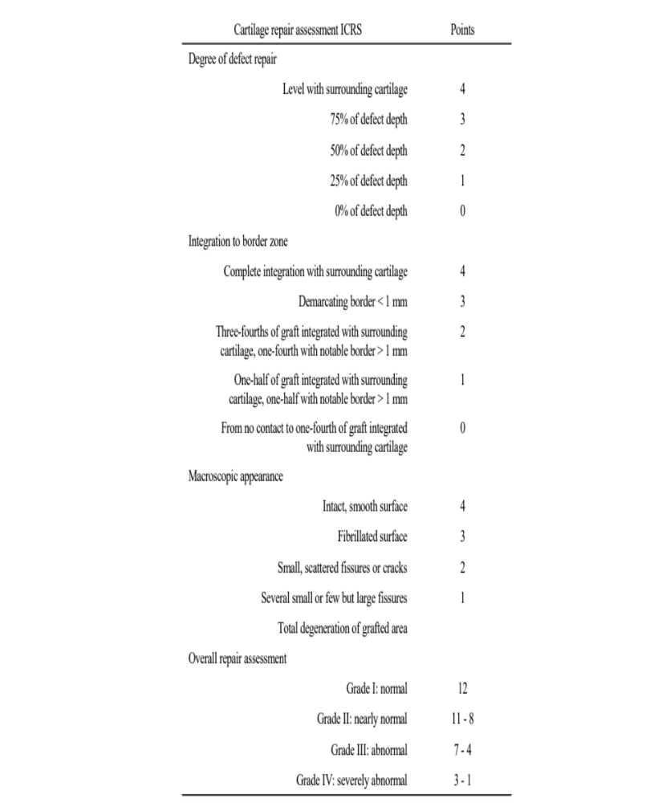
Supplementary Table S1: International cartilage repair society (ICRS) macroscopic scoring system

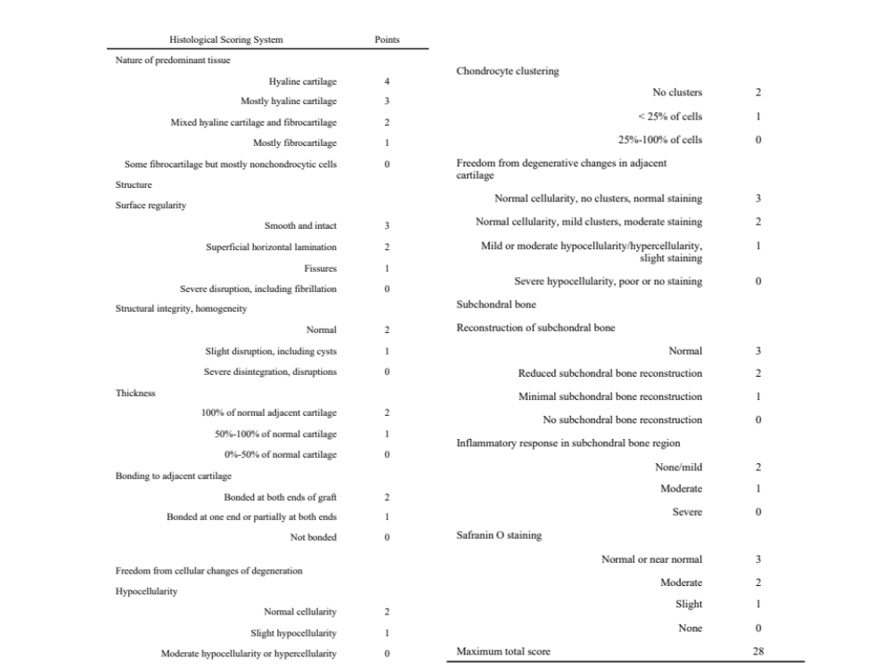
Supplementary Table S2: Histological scores according to Niederauer et al [37]

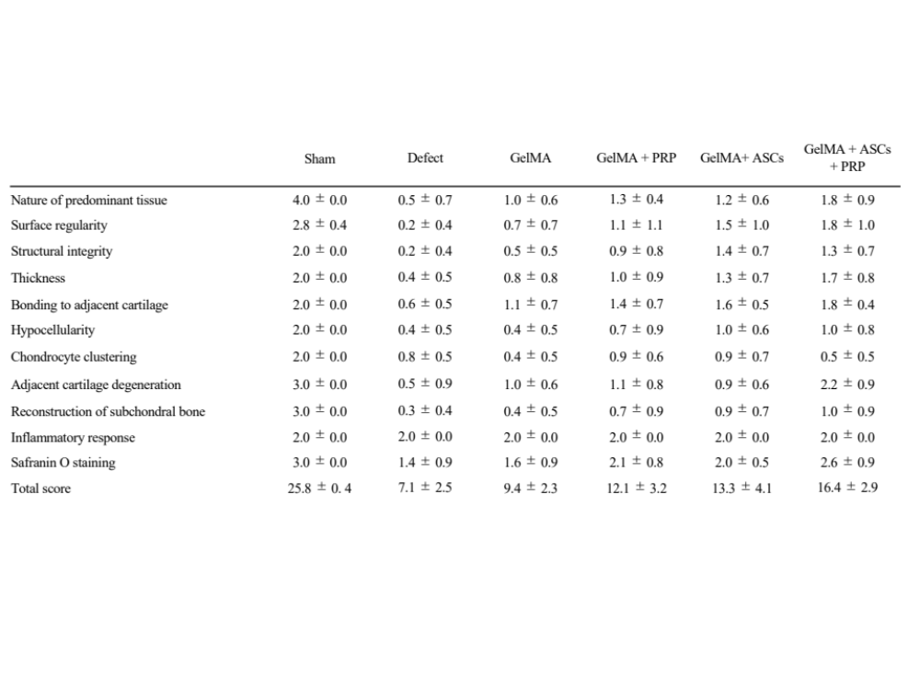Supplementary Table S3: The results of histologically evaluated for each group using the histological scoring system

