Extended data
Extended Data Fig. 1 GEMS modeling of OPC assuming 100% reaction with additional anhydrite content at w/s ratio 0.5. The theoretical space filling of the OPC was controlled by the anhydrite content, which was adjusted to regulate the reaction of C₃A (red range labeled OPC). Experimental points A, B and C in the green range “OPC + Anh. + HyCon® B” correspond to the samples with additional amounts of anhydrite with the hydration control additive (corresponding to 4, 7 and 10% anhydrite in the 70% OPC system, respectively). This range was not possible in the conventional OPC system due to the improper timing of ettringite formation. These values were specific to the cement, which varied depending on the composition of the cement and its aluminate content. Nevertheless, the overall trends of the ettringite content and space filling were similar.

Extended Data Fig. 2 Quantitative phase assemblage of the hardened paste sample cured under Ca(OH)₂-saturated water at 23 °C.
Extended Data Fig. 3 Degree of hydration of the main clinker phases calculated using quantitative XRD. (a) C₃S, (b) Anhydrite (Anh.), (c) C₃A and (d) C₄AF.

Extended Data Fig. 4 Thermogravimetry (left) and differential thermogravimetry (DTG, right) data for the paste after hydration was stopped at 1, 7, 28 and 90 d. The chemically bound water is labeled for the thermogravimetry data. Significantly more ettringite formed with HyCon® B, as shown in the DTG plot.

Extended Data Fig. 5 Correlation of compressive strength of the mortar (w/s = 0.5) to (a) heat release of the paste sample (w/s 0.4) and (b) chemically bound water of the paste sample (w/s 0.4). The overall fitting of the heat release and the strength development was linear, and samples with and without the HyCon® B additive had the same trend. A minimum amount of 68.3 J/g solid was needed to produce efficient strength that could be measured. The correlation of the bound water and the strength showed two main regions: samples without and with HyCon® B. HyCon® B enabled a better water bounding effect due to the enhanced formation of ettringite, which contains 32 water molecules, as shown in Figure 2 (d). This was the reason for the shift in the correlation between strength and bound water compared to the reference system, which formed mainly C-S-H that contained ~4 water molecules ¹⁵.

Extended Data Fig. 6 Expansion of the mortar sample (w/s 0.5) cured under Ca(OH)₂ saturated water and its correlation to the ettringite increment in the paste (w/s 0.4) at 23 °C. (a) expansion and (b) correlation of expansion to ettringite formation after 1 d; (c) expansion and (d) correlation of expansion to ettringite formation after 2 d. The development of expansion depended on the increment of ettringite in the sample. For up to 7% extra anhydrite, the overall expansion did not develop after 2 d.

Extended Data Fig. 7 Expansion of mortar prisms under sulfate solution curing. The addition of sulfate together with HyCon® B (blue solid lines) did not increase the expansion against sulfate attack of the building materials. The less expansion there is, the better the durability. As expected, cement mixtures containing limestone were worse than mixtures with pure OPC due to the dilution effect. The 1-year expansion of the 50% OPC 50% limestone mix with HyCon® B was close to that of the 100% OPC control. Further sulfate storage led to complete failure of prisms without the additive mix (red box), while samples of mortar containing HyCon® B- stayed intact.

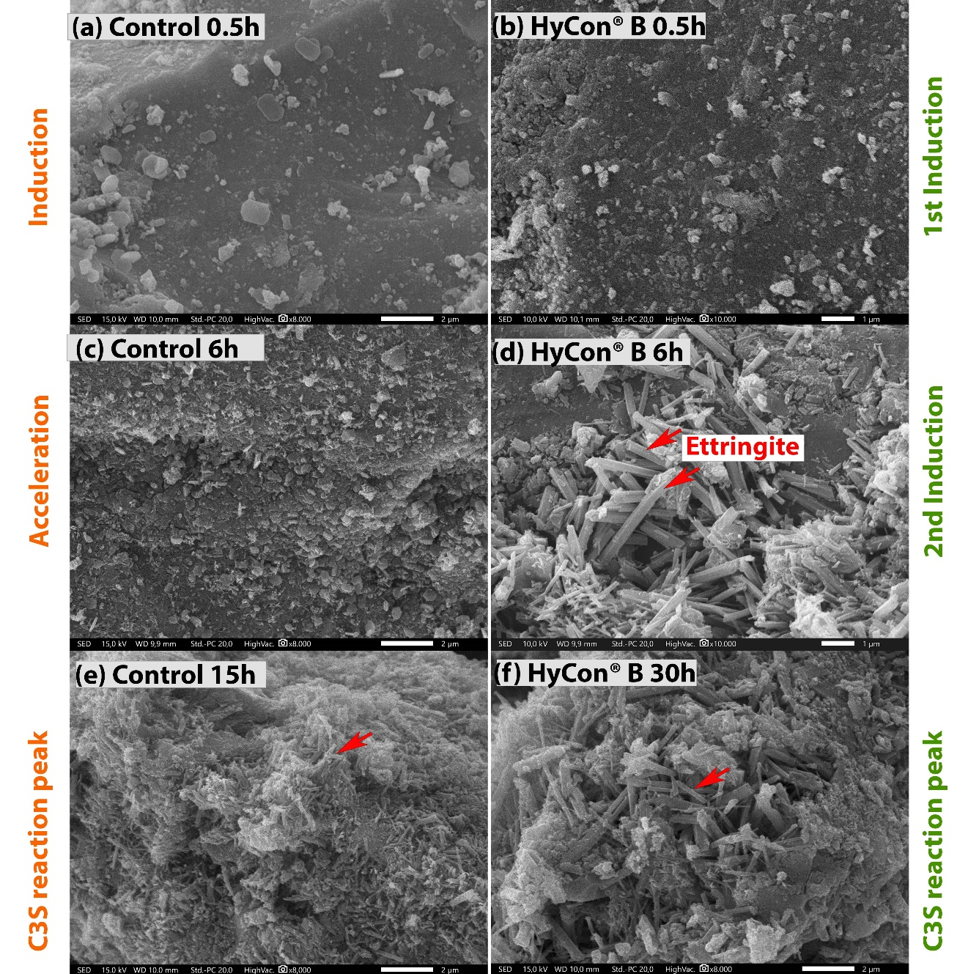
Extended Data Fig. 8 Morphologies of the hydrated cement paste at the induction (1st and 2nd induction) period, acceleration, and peak of the C₃S reaction, as indicated in Figure 1. In the control sample, there were small amounts of ettringite. In the sample with HyCon® B, many large and long ettringite crystals (red arrow) were observed during the 2nd induction (d).

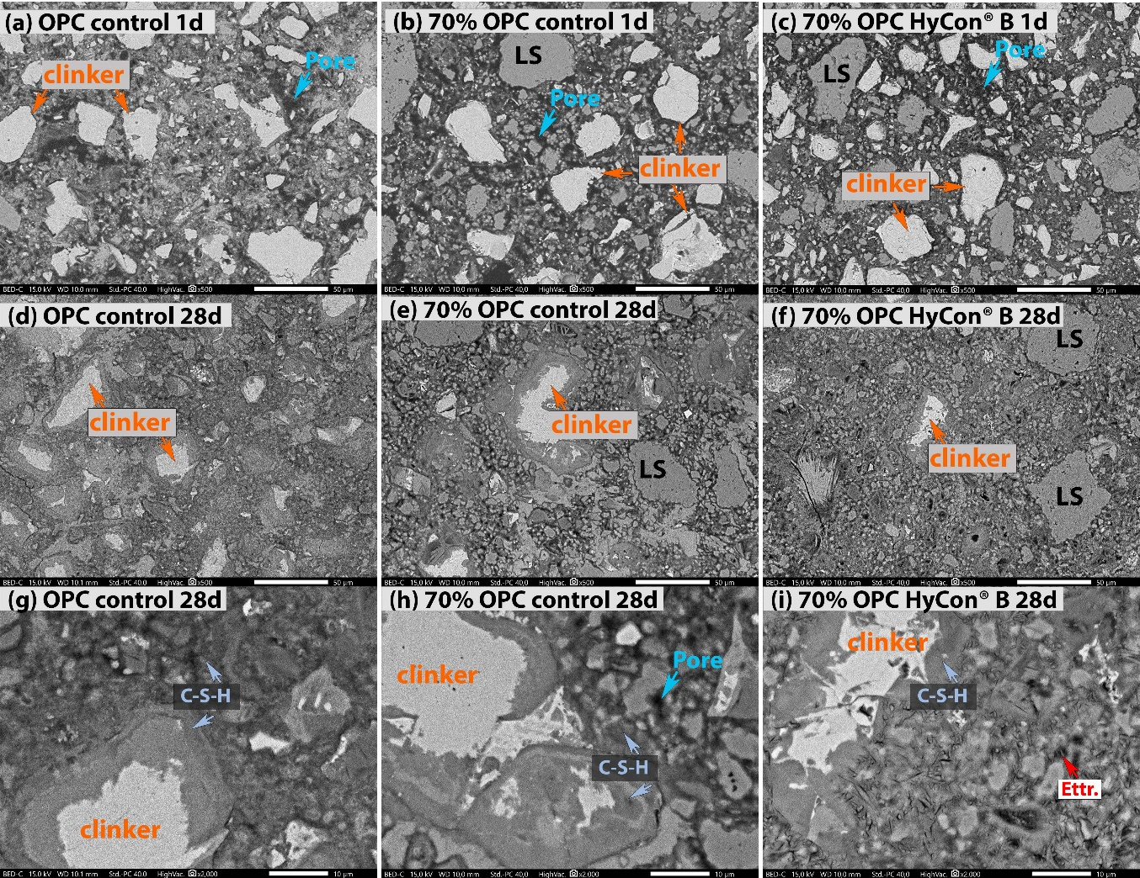
Extended Data Fig. 9 Backscattered electron images of hardened cement paste at 1 d and 28 d under low magnification. “clinker” – unreacted clinker phases; “LS” – limestone powder; “Ettr.” – ettringite.

Extended Data Fig. 10 Compressive strength of (a) 70% OPC with 4% anhydrite and 7% anhydrite with HyCon® B additive; 7% anhydrite resulted in greater strength, especially at ages earlier than 7 days; (b) reducing the w/s ratio from 0.5 to 0.4 and the OPC content from 70 to 50%, 50% OPC produced similar 7 and 28 d strength as the neat OPC control with w/s 0.5; (c) limestone calcined clay with OPC2 from 50–40%, with the concentration of the HyCon® B 1.45 bwos %; performance of the LC³ reference was previously reported²⁷.

Extended Data Table 1 Characteristics of the materials: XRD Rietveld quantitative analysis, chemical composition detected by X-ray fluorescence (XRF), and physical properties
Category | Phase | CEM I  42.5 N |  | CEM I  52.5 N | Calcined clay | Limestone | Anhydrite
XRD Rietveld quantitative analysis (wt%) | Label | OPC | OPC2 | OPC3 | CC | LS | Anh.
XRD Rietveld quantitative analysis (wt%) | C₃S | 58.4 | 54.6 | 60.7
XRD Rietveld quantitative analysis (wt%) | C₂S | 11.7 | 16.2 | 10.3
XRD Rietveld quantitative analysis (wt%) | C₃A | 9.1 | 8.9 | 7.9
XRD Rietveld quantitative analysis (wt%) | C₄AF | 8.9 | 6.7 | 8.9
XRD Rietveld quantitative analysis (wt%) | Calcite | 3.4 | 4.1 | 3.37 |  | 97.0 | 1.4
XRD Rietveld quantitative analysis (wt%) | Anhydrite | 1.0 | 3.5 | 1.2 |  |  | 95.4
XRD Rietveld quantitative analysis (wt%) | Dolomite | 0.6 | 2.5 |  |  | 2.5
XRD Rietveld quantitative analysis (wt%) | Bassanite | 1.8 | 1.2 | 2.4 |  |  | 0.1
XRD Rietveld quantitative analysis (wt%) | Gypsum | 0.1 | 0.8 | 0.1 |  |  | 0.9
XRD Rietveld quantitative analysis (wt%) | Periclase | 1.0 | 0.7 | 0.9
XRD Rietveld quantitative analysis (wt%) | Quartz | 0.4 | 0.5 | 0.5 | 1.5 | 0.5
XRD Rietveld quantitative analysis (wt%) | Ca(OH)₂ | 1.3 | 0.2 | 1.0 |  |  | 1.0
XRD Rietveld quantitative analysis (wt%) | Lime | 0.5 | 0.1 | 0.9
XRD Rietveld quantitative analysis (wt%) | Arcanite | 1.4 |  | 1.3
XRD Rietveld quantitative analysis (wt%) | Hematite | ^{(a)} |  |  | 1.4
XRD Rietveld quantitative analysis (wt%) | Mullite |  |  |  | 9.6
XRD Rietveld quantitative analysis (wt%) | Anatase |  |  |  | 2.0
XRD Rietveld quantitative analysis (wt%) | Illite |  |  |  | 4.4
XRD Rietveld quantitative analysis (wt%) | Kaolinite |  |  |  | 9.5
XRD Rietveld quantitative analysis (wt%) | Rutile |  |  |  | 0.5
XRD Rietveld quantitative analysis (wt%) | Fluorite |  |  |  |  |  | 0.5
XRD Rietveld quantitative analysis (wt%) | Amorphous |  |  |  | 71.1
Chemical composition (wt%) | SO₃ | 3.15 | 2.83 | 3.94 | 0.07 | 0.04 | 52.08
Chemical composition (wt%) | CaO | 61.39 | 63.64 | 60.76 | 0.27 | 54.31 | 40.73
Chemical composition (wt%) | K₂O | 1.53 | 0.5 | 1.07 | 0.06 | 0.11 | 0.43
Chemical composition (wt%) | Na₂O | 0.23 | 0.07 | 0.19 | 0.2 |  | 0.05
Chemical composition (wt%) | SiO₂ | 18.96 | 20.22 | 19.95 | 48.26 | 1.64 | 0.21
Chemical composition (wt%) | Fe₂O₃ | 3.15 | 2.77 | 2.82 | 2.34 | 0.24 | 0.73
Chemical composition (wt%) | Al₂O₃ | 5.81 | 5.8 | 5.97 | 41.08 | 0.69 | 0.12
Chemical composition (wt%) | MgO | 2.00 | 1.5 | 2.25 | 0.13 | 0.49 | 0.01
Chemical composition (wt%) | Na₂O_eq^{(b)} | 1.24 | 0.39 | 0.89
Chemical composition (wt%) | LOD^{(c)} | 0.30 | 0.24 | 0.01 | 0.78 | 0.11 | 0.27
Chemical composition (wt%) | LOI^{(d)} | 2.99 | 2.36 | 2.32 | 2.37 | 42.95 | 2.55
Physical properties | Density (g/cm³) | 3.12 | 3.16 | 3.11 | 2.65 | 2.71
Physical properties | SSA^{(e)} Blaine (cm²/g) | 3329 | 3075 | 4221 | 17931 | 4554
Physical properties | SSA BET (m²/g) | 2.47 | 1.17 |  | 12.2
Physical properties | d_{v10} ^{(f)} (µm) | 5.6 | 2.52 | 1.14 | 0.73 | 1.17 | 0.75
Physical properties | d_{v50} ^{(f)} (µm) | 32.9 | 19.18 | 11.78 | 5.55 | 7.59 | 19.86
Physical properties | d_{v90} ^{(f)} (µm) | 78.3 | 65.98 | 44.89 | 68.56 | 80.41 | 145.38
Physical properties | d_{v63} ^{(f)} (µm) | 43.6 | 28.91 | 19.21 | 9.62 | 14.94
Notes: (a) Blank cell: no data were measured; (b) Na₂O equivalent: Na₂O_eq = wt% Na₂O + 0.658 × wt% K₂O; (c) LOD: loss on drying at 120 °C; (d) LOI: loss on ignition at 1050 °C; (d) Blank cell: case where data were not measured; (e) SSA: specific surface area; (f) for the measurement of the particle size distribution, the dry powder samples were dispersed in a pressurized air flow in the measurement device (Mastersizer 3000 from Malvern Panalytical Ltd.

Extended Data Table 2: Pore solution (mmol/l) using ICP‒OES at 5 min after mixing of the three cement pastes at w/s 0.5.
Sample | Al | Ca | Fe | K | Na | Si | S
100 OPC control | 0.0065±0.0001 | 23.3638±0.6262 | 0.0024±0.0001 | 431.0341±5.2764 | 42.4845±1.1335 | 0.0513±0.0021 | 302.2021±3.2096
70% OPC control | 0.0027 | 28.9331±0.2834 | 0.0020±0.0001 | 332.0733±1.9962 | 32.3435±0.215 | 0.0542±0.0016 | 217.2396±2.6927
70% OPC 7% Anh.+ HyCon® B | 0.0930±0.002 | 17.0177±0.0769 | 0.0554±0.0007 | 307.5914±1,4551 | 158.2443±1.5342 | 0.9126±0.0036 | 199.4011±2.7921
Notes: (a) Pore solution data were obtained after 5 min of hydration and analyzed according to Caruso et. al. ³⁵. (b) In the presence of the hydration control additive, the aluminum, silicon, and iron concentrations increased by a factor of 10. This supported the action of a retardation mechanism on the nucleation of ettringite.
Extended Data Table 3 Binder mix design, CO₂ footprint and performance-based CO₂ footprint
Sample | System | w/s | Binder  (wt%) |  |  |  | Filler  (wt%) | Additive (bwos %) |  | CO₂ footprint  kg CO₂/ton |  | Strength (MPa) | Specific strength  (MPa/(kg OPC in ton dry mortar)) | Specific CO₂ footprint  (kg CO₂/MPa ton dry mortar)
 |  |  | OPC | OPC2 | Calcined clay | Anhydrite | Limestone | HyCon® B solid | Dispersant | Additive | Binder + additive | 28 d | 28 d | 28 d
CO₂ footprint (kg CO₂/ton) |  |  | 818² | 818² | 350² | 90 | 30 | 1630 ⁴⁰ | 800 ⁴⁰
OPC | control | 0.5 | 100 |  |  |  |  |  |  |  | 818.0 | 38.3 | 0.15 | 5.3
OPC-70 | control | 0.5 | 70 |  |  |  | 30 |  |  |  | 581.6 | 28.0 | 0.16 | 5.2
OPC-70 | HyCon® B | 0.5 | 70 |  |  | 7 | 23 | 1.1 |  | 17.9 | 603.7 | 40.8 | 0.23 | 3.7
OPC-70 | control | 0.4 | 70 |  |  |  | 30 |  | 0.7 | 5.6 | 587.2 | 41.0 | 0.23 | 3.6
OPC-70 | HyCon® B | 0.4 | 70 |  |  | 7 | 23 | 1.1 | 0.3 | 20.3 | 606.1 | 56.0 | 0.32 | 2.7
OPC-60 | control | 0.4 | 60 |  |  |  | 40 |  | 0.7 | 5.6 | 508.4 | 33.4 | 0.22 | 3.8
OPC-60 | HyCon® B | 0.4 | 60 |  |  | 6 | 34 | 0.95 | 0.5 | 19.5 | 525.9 | 46.7 | 0.31 | 2.8
OPC-50 | control | 0.4 | 50 |  |  |  | 50 |  | 0.7 | 5.6 | 429.6 | 27.8 | 0.22 | 3.9
OPC-50 | HyCon® B | 0.4 | 50 |  |  | 5 | 45 | 0.79 | 0.4 | 16.1 | 443.1 | 39.8 | 0.32 | 2.8
OPC2 | control | 0.5 |  | 100 |  |  |  |  |  |  | 818.0 | 44.0 | 0.18 | 4.6
LC³-50 | control | 0.5 |  | 50 | 30 | 2 | 18 |  | 0.3 | 2.4 | 525.4 | 40.1 | 0.32 | 3.3
LC³-50 | HyCon® B | 0.5 |  | 50 | 30 | 5 | 15 | 1.45 |  | 23.6 | 546.6 | 51.4 | 0.41 | 2.7
LC³-45 | HyCon® B | 0.5 |  | 45 | 30 | 10 | 15 | 1.45 |  | 23.6 | 510.2 | 45.8 | 0.41 | 2.8
LC³-40 | HyCon® B | 0.5 |  | 40 | 30 | 5 | 25 | 1.45 |  | 23.6 | 467.8 | 42.1 | 0.42 | 2.8

