Supplementary Information

1. Enhanced weathering module 2
1.1 Basalt supply 2
1.2 Carbon dioxide removal 6
1.3 Basalt application in mitigation scenarios 10
2- Sensitivity Analysis 12
2.1 Parameters distributions 12
2.2 Latin hypercube sampling 14
2.3 Morris sampling 15
3. GET-ACC2 model 18
3.1 Overview of the model 18
3.2 Major updates on GET 20
3.2.1 Fossil fuel supply curves 20
3.2.2 Biomass supply curve 20
3.2.3 Methane and Nitrous oxide abatement 20
3.2.4 Parameters updates 20
3.2.4 Renewable energy mix 21
3.3 Comparison of mitigation scenarios and baseline 21
3.4 Calibration of the climate model ACC2 22

Enhanced weathering module

1.1 Basalt supply
The basalt dust supply is integrated in GET7.1 with a 10 year timestep: costs and energy requirements of basalt supply are fed back into GET. Basalt must be mined, crushed and ground, and transported. Each of these steps requires energy. We assume that diesel or gasoline are used for mining and crop-fields spreading. Basalt could be transported by trains, trucks or ships. Here we assume that a minimum share of 70-90% must be transported by trucks. The energy requirements of transport increase the demand in each transport subsector (road, train or water freight). Transport modes are substitutable but a minimum share (70-90%) must be transported on the road.
Process | Energy Intensity | Financial cost | Energy type | Demand in GET-ACC2
Mining¹ | 0.02 EJ/Gt | - | Diesel | Diesel or gasoline
Mining and Crushing² | 0.02 EJ/Gt | 27.3$/t | Electricity | Electricity
Grinding² | 0.06-0.6 EJ/Gt | - | Electricity | Electricity
Road Transport³ | 0.0013 EJ/Gt/km | - | Endogenous | Road freight
Sea and rail transport³ | 0.0002 EJ/Gt/km | - | Endogenous | Sea or rail freight
Spreading (tractors)⁴ | 0.078 EJ/Gt | 10.9$/t (ref.²) | Diesel | Diesel or gasoline
Spreading (aeroplanes) | 1.8-2.5 EJ/Gt | 170-214$/t/year | Endogenous (kerosene, hydrogen or methanol) | Aviation fuel

Transport distances:
There are 3 cases :
Either basalt is spread on croplands with tractors, or basalt is spread on forest areas with tractors, or basalt is spread on forest areas with aircrafts.
Application on croplands
The transport distance for cropland application is derived from Strefler, et al (2018)². The transport distance is generally lower than 200km. It starts from zero and increases as long as the cumulative quantity of basalt applied on croplands increases, as we follow their assumption that the application rate is 15kg/m² which can be easily incorporated into soils.
Application on forests
We assume that the share of roadless forests (i.e. forest areas inaccessible by roads) is approximately the same as the share of global roadless areas, that is to say 80%⁵. This share can be expected to decline in the future, despite the threats roads pose to ecosystems⁵. On the other hand, applying basalt on forests by means of land transport can be challenging, even when a road is available. We therefore assume that between 70% to 90% of basalt application on forests must be spread with aircrafts until 2100. This share depends on the development of roads and on the share of forests that tractors can penetrate. Aerial application is likely to be more expensive and energy intensive than land-based alternatives. If the share of aircraft use were lower, the energy consumption would also be lower, and basalt application could become higher in a cost-optimisation model. Assuming a large part of aerial spraying is therefore pessimistic as far as costs are concerned.
We assume that the rock is ground at a location proximate to the mine. The mean straight-line distance between the airport and the closest area where basalt is available is 250 to 400 km (Fig S1.1.1.). We estimate the average road distance to be around 350 to 560 km by assuming that the actual travel distance on the road is on average larger than the straight-line distance by a factor of the square root of 2 (i.e., a simple analogy from geometry). If basalt is applied with tractors, the distance between basalt source and application site is generally lower than 250 km (Fig S1.1.2), thus the road distance is estimated to be around 350 km under the assumption of the square root of 2. We therefore consider a range of 350 to 550 km for basalt transport distance.
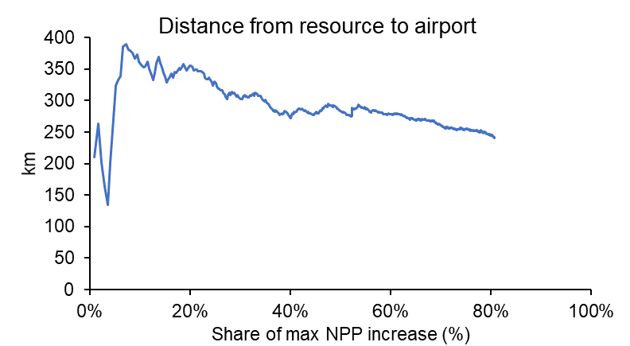
Figure S1.1.1 Straight line distance from basalt resource to the nearest airport from an application site. The x-axis is the cumulative contribution from the application sites, ranked from the most reactive to the least reactive to basalt amendment, to the total NPP increase. The y-axis is the mean distance corresponding to these cumulative contributions.

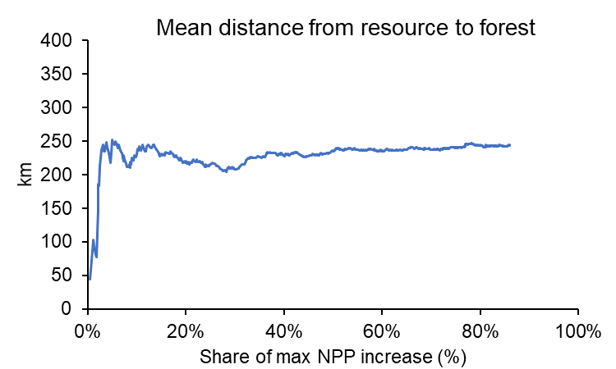
Figure S1.1.2 Distance from basalt resource to application site (straight line).The x-axis is the cumulative contribution from the application sites, ranked from the most reactive to the least reactive to basalt amendment, to the total NPP increase. The y-axis is the mean distance corresponding to these cumulative contributions.
The distances are computed using the software QGIS. The database for basalt resources is the one used in Strefler, et al. (2018), GLiM⁶. The database for airports is the one used by Goll, et al. (2021)⁷ openflights.org.

Cost of aircraft application
Our analysis aims to identify a range of energy requirements and financial costs for airborne spreading of basalt. A small agricultural aircraft like the AirTractor 802, which can be equipped with a dust spreader, could be used to spread basalt dust. This kind of aircraft is commonly used to spread limestone^{8–10} although issues with rock discharge have been reported, due to the large particle size distribution⁸. The details of rock dust discharge are beyond the scope of this analysis, and more research would be needed on how to spread large quantities of basalt dust by air.
The following table summarises the key values used for our cost estimate:

Feature | Source
Useful load : 4.3t | Guide to Air Tractor Aircraft
Cost: USD 1.8 million | https://air.one/
Fuel consumption: up to 330 l/h | Guide to Air Tractor Aircraft
Speed: 306 km/h | AIR TRACTOR AT-802/802A Pilot Training Program

The distance between the centre of spreading sites and the nearest airport ranges between 80 and 120 km (Fig. S1.1.3). We therefore assume a flying distance ranges between 160 and 240 km. It represents a flight duration of 31-47 minutes. Adding 10 minutes for spreading and landing, the average flight duration could reach 41-57 minutes. This represents 226-314 liters of kerosene per mission, or 7.6-10.6 GJ per mission, or 1.8 to 2.5 GJ/t of basalt applied. Assuming that 20 minutes are required to refuel and refill with basalt between each flight, and that the aircraft operates 10 hours per day, and that it is used 5 days out of 7, an aircraft can realise between 2030 and 2550 missions per year. Therefore, the capacity cost per ton/year is 170-214$/t (it depends on the average distance flown). We assume a lifetime of 30 years and annual maintenance costs of 5% of the purchase cost.
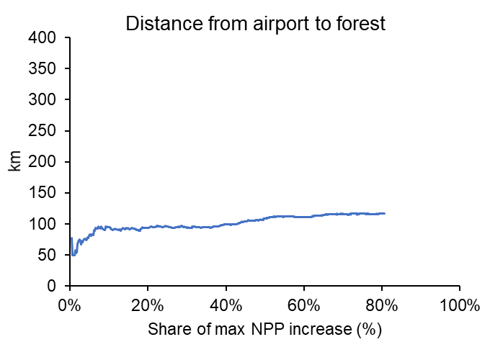
Figure S1.1.3 Distance between application site and nearest airport. The x-axis is the cumulative contribution from the application sites, ranked from the most reactive to the least reactive to basalt amendment, to the total NPP increase. The y-axis is the mean distance corresponding to these cumulative contributions.

1.2 Carbon dioxide removal

We considered two distinct processes that lead to carbon dioxide removal from enhanced weathering: the geochemical capture and the biotic capture. Here, we first describe the release of these elements as modelled in GET-ACC2, and then each of the capture processes.

Weathering rates
In the main text, we assume that the grain size is 20µm. The range of weathering rate used in this study is 1% to 26% per year. The low end is reported in Rinder and von Hagke (2021)⁸. The high end is the mean weathering rate in ORCHIDEE, where the values are based on Strefler et al. (2018)² and on local temperatures. For a temperature of 25°C and a pH of 5.85, Rinder and von Hagke report a weathering rate of 2.63 10⁻¹² mol.g⁻¹.s⁻¹, which is 12.7 times lower than what one obtains with equation G-2 in Strefler et al. (2018), with the same temperature and pH, notably because of a lower reactive surface. Given these diverse estimates of weathering rate, we assume that the uncertainty range of weathering rate is uniformly distributed between 1% and 26% per year. This uncertainty range is small compared to the 5-95% range in ref², which varies by a factor of a thousand. However, due to the critical role of weathering rate, we investigate the impacts of very low values separately. We also assume that all minerals contained in basalt are weathered simultaneously.

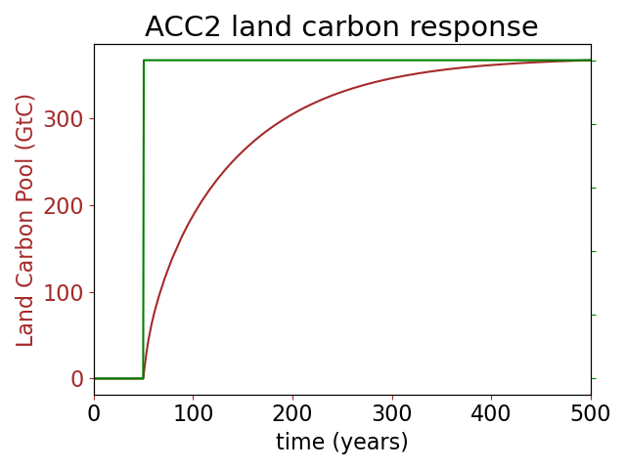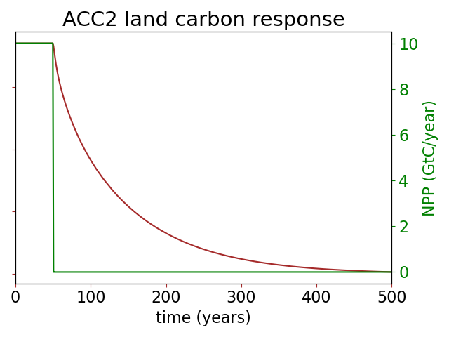
Fig S1.2.1 Response of the land carbon pool to a NPP change from equilibrium (CO₂ and temperature conditions of the year 2000).

Calibration of the model

Since there is no spatial resolution in GET-ACC2, we express $δNPP$ as the function of two unidimensional variables: the area of basalt application a_{B} [Mkm⁻²], and the rock application rate c_{B}. The variable a_{B} is defined by ranking the application sites according to their NPP stimulation from high to low. $δNPP$ also evolves with time: we build a function $f(c_{B},a_{B},t)$ that fits the sets of value $δNPP({c_{B}}^{i},{a_{B}}^{j},t^{k})$. First, the relation $g^{i,k}: {a_{B}}^{}↦ δNPP({c_{B}}^{i},{a_{B}}^{},t^{k})$ can be well fitted as the product of a term $A({c_{B}}^{i},t^{k})$ that depends only on ${c_{B}}^{i}$ and $t^{k}$, by an exponential saturation term $(1-e^{-γa_{B}})$.$f(c_{B},a_{B},t) = A({c_{B}}^{i},t^{k})⋅(1-e^{-γa_{B}})$. This can be observed by plotting $\tilde{g^{i,k}}: {a_{}}^{}↦ \frac{δNPP({c_{B}}^{i},a ,t^{k})}{max_{j}(δNPP({c_{B}}^{i},{a_{B}}^{j},t^{k}))}$ to calibrate$γ$ (Fig S1.2.2).

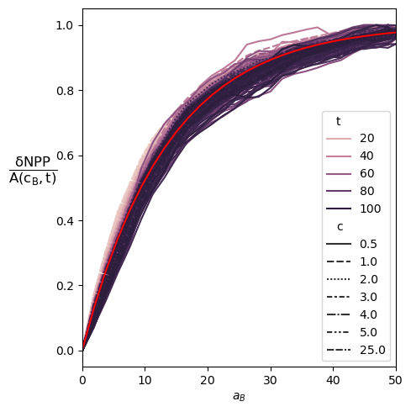
Fig S1.2.2 Fractional increase of the NPP at different times and different rock application rates, divided by the fractional increase of NPP over the whole area (i.e. the maximum value over a_{B} of $δNPP(c_{B}{,a}_{B},t)$ ). The red line is the exponential fit.

Once we have isolated the area-dependency, we want to determine the behaviour of $δNPP$ as a function of c_{B} and t. We thus apply the same procedure as precedently and try to express $δNPP$ as $f(c_{B},a_{B},t)= B(t)⋅(1-e^{-γa_{B}})⋅(1-e^{-αc_{B}})$,

Similarly, we plot $\tilde{h^{j,k}}: {c_{}}^{}↦ \frac{δNPP(c,{a_{B}}^{j} ,t^{k})}{max_{i}(δNPP({c_{B}}^{i},{a_{B}}^{j},t^{k}))}$. Here, the fit with $c_{B} ↦(1-e^{-αc_{B}})$ is less good: $α$ depends on time (Fig S1.2.3). From a physical perspective, $δNPP$ is the consequence of the release of the phosphorus contained in basalt. $δNPP$ decreases with time after basalt application, as a consequence of the decrease of the bioavailable phosphorus concentration. We therefore assume that $δNPP$ can be approximated by a function of phosphorus concentration c_{P} and application area a_{B}.
$δNPP(c_{B},a_{B},t)= δ\hat{NPP}(c_{P}(t),a_{B})=δNPP_{max}(1-e^{-γa_{B}})⋅(1-e^{-α{λc}_{P}(t)})$, where ${λc}_{P}(t_{0})=c_{B}$
For the sake of simplicity, we will neglect the dimension of c_{P} in the following and assume that $λ$=1.

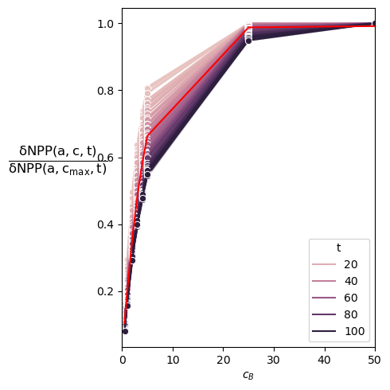
Fig S1.2.3 Fractional increase of the NPP at different times and different rock application rates, normalised by the fractional increase of NPP for the maximum application rate . The red line is the exponential fit.

The NPP response is thus a multiplicative function of the area of application $a_{B}$ [Mkm²] and phosphorus concentration ${δc}_{P}$[Gt.Mkm⁻²] (E.2, Fig. S1.2.4).

$δNPP=δNPP_{max}\left(1-e^{-α{δc}_{P}}\right)\left(1-e^{-γa_{B}}\right)$ (E.5)

The dynamic evolution of the soil phosphorus concentration ${δc}_{P}$ is designed to reproduce the results of ORCHIDEE. It is modelled with an auxiliary pool of phosphorus which is unavailable to plants, exchanges phosphorus with the soil concentration with a turnover time $τ_{e}$=60 years, and leaches with a decay constant $τ_{l}$ = 300 years (Figure 1.2.2)
$\frac{dδc_{P}}{dt}=\frac{λw_{r}B}{a_{B}}-\frac{{δc}_{P}}{τ_{e}}+\frac{{δu}_{P}}{τ_{e}}$ (E.6a)
$\frac{du_{P}}{dt}=\frac{{δc}_{P}}{τ_{e}}-\frac{δr_{P}}{τ_{e}}-\frac{δu_{P}}{τ_{l}}$ (E.6b)
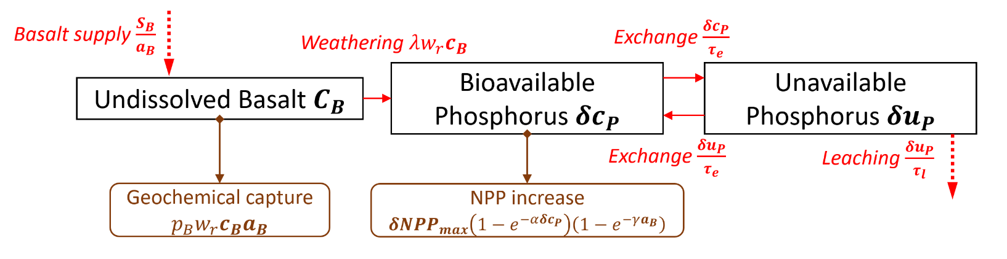
Figure 1.2.2 Phosphorus cycle emulation. Rectangles: pools. Red arrows: flows. Brown arrows: effects on the carbon cycle.
The comparison with ORCHIDEE data shows that the increase of NPP is generally slightly underestimated by the emulator. When the phosphorus addition has stopped, $δ$NPP gradually turns to zero, with a characteristic timescale of $τ_{l}$ = 300 years. As a consequence, the additional carbon stored progressively returns to the atmosphere. (Fig 1.2.3)
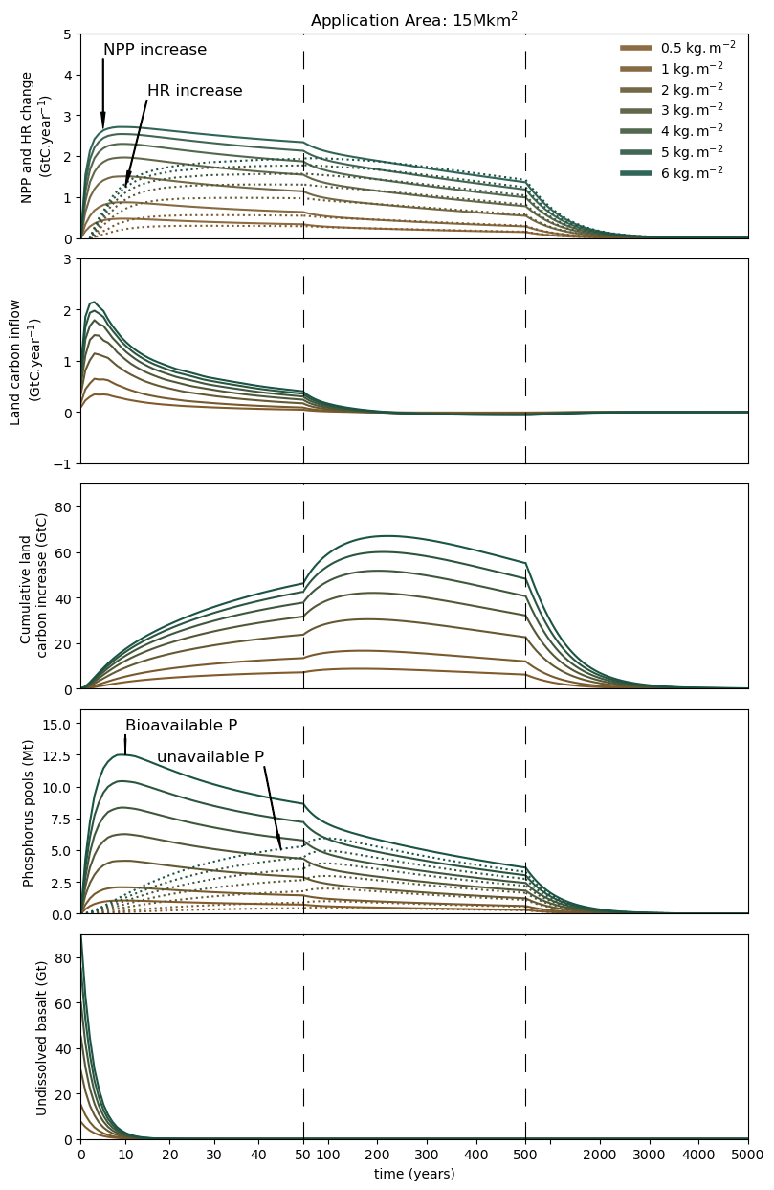
Fig 1.2.3 Response of the land carbon stocks, land carbon flows and phosphorus pools to a basalt addition at year 0. ( weathering rate = 26%), CO₂ and temperature conditions of the year 2000. First panel: dotted lines represent the increase of heterotrophic respiration (HR), solid line the increase of net primary production (NPP). Second panel: Net flow from atmosphere to land carbon (NPP-HR). Third panel: Cumulative land carbon increase.Fourth panel: dotted lines represent the unavailable phosphorus pool, solid line the soil phosphorus pool.

1.3 Basalt application in mitigation scenarios
The maximum surface of application is 40Mkm², which is roughly the global forest area. The mean surface over which basalt is applied during the 21st century is assumed constant, otherwise each application area would have to be treated independently. This constant surface of application is endogenously optimised: it increases with the projected quantity of basalt application on forests. It is between 28Mkm² (in the 1.5C with high OS scenario) and 13 Mkm² in the 1.5°C with low OS scenario.

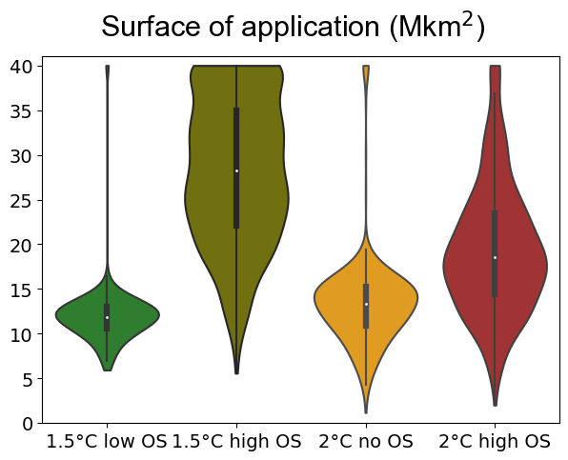
Fig 1.3.4 Forest area of basalt application in the different climate policy scenarios.

We compute the marginal revenues and costs of applying basalt. The revenue (NPV) of basalt application can be mathematically expressed as the discounted sum of the products of the future marginal CDR times future carbon prices.
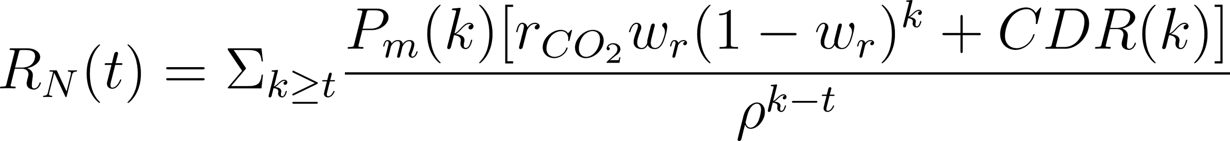
Where CDR(k) is the marginal biotic capture at time k, P_{m}(k) is the marginal cost of carbon abatement at time k, $ρ$ is the discount factor, and r_{CO2} is the rate of geochemical capture per ton of basalt, w_{r} is the weathering rate. The revenue of basalt application increases with future carbon prices. On the other hand, the cost of basalt application also increases with the carbon price, which affects the energy intensity of basalt application (although this is nearly negligible when basalt is applied on croplands). Since the model optimises revenues and costs, basalt is applied as soon as the marginal revenues equal the marginal costs. If the marginal revenues exceed the marginal costs, it means that the application of basalt has reached a limit (for instance, there is no available croplands left). Otherwise, the application level would increase until the marginal cost increase and reaches the marginal revenue.
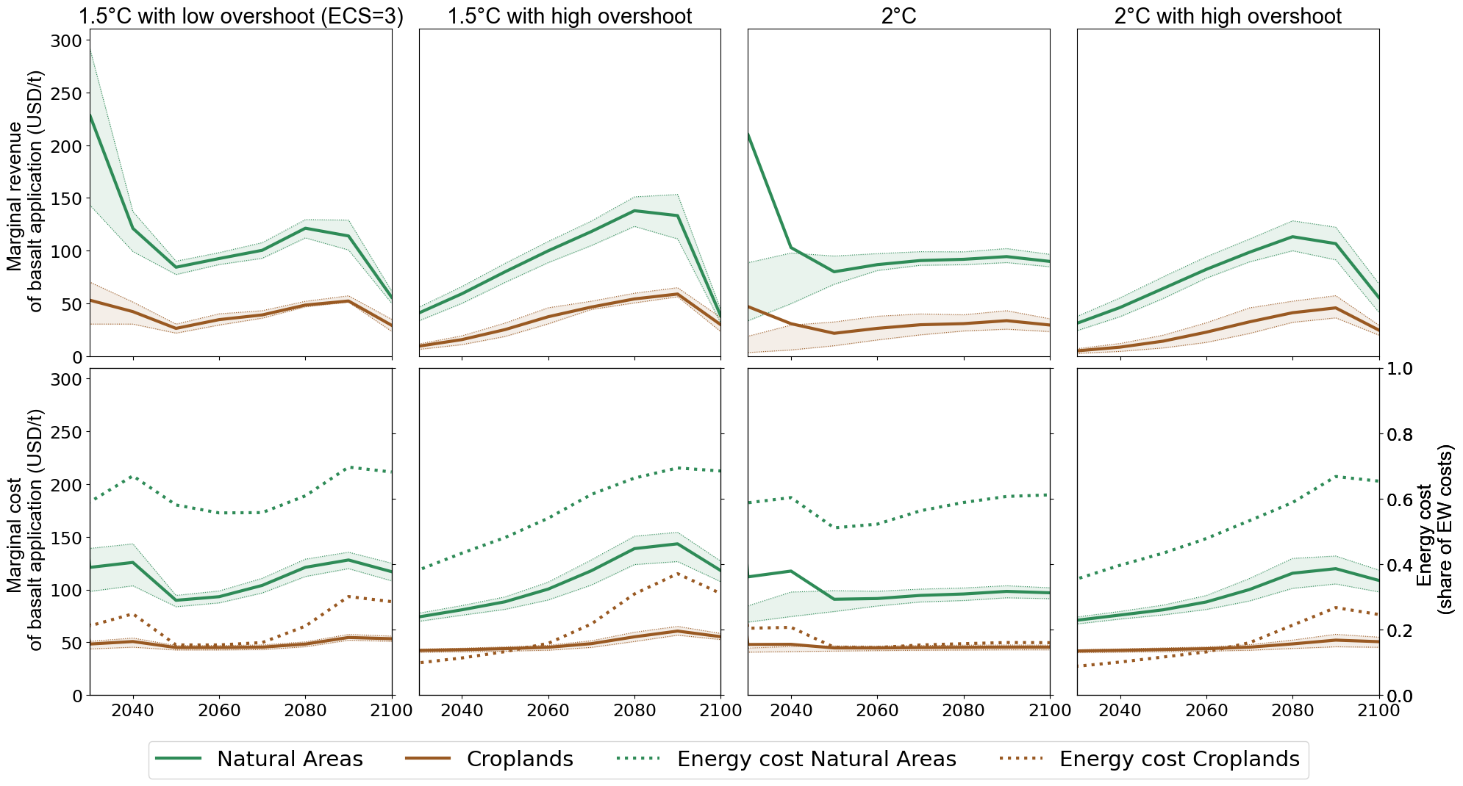

Fig 1.3.5 Marginal revenues and costs of basalt application in the different climate policy scenarios. Shaded area : 25-75% range. Dotted lines: energy cost as a share of marginal basalt application cost (right y-axis). The marginal revenue of basalt application is defined as the nominal benefit associated with the CDR resulting from the application of one ton of rock, if no financial or energy expenditure is required. The marginal cost of basalt application is the nominal cost of applying one ton of rock without any resulting CDR. The energy cost is the nominal price of the energy that would be used to apply one ton of basalt.

2- Sensitivity Analysis

2.1 Parameters distributions

For several parameters, we base the cost uncertainty range on the “Technological Readiness Level” (TRL). The Technological Readiness Level (TRL) describes the maturity of a technology or innovation. It provides a scale to evaluate the progress of a technology from its conception to its deployment in real-world application¹². Although TRL does not explicitly address the cost uncertainty, it reflects the overall progress of a technology, which can influence the accuracy of future costs projections. An exhaustive assessment of cost uncertainty would consider the additional factors such as economies of scale, learning effects, supply chains, labour costs and regulatory requirements that may affect cost estimates.
Parameter | Range | distribution | Justification
Initial bioenergy price | 1.5-4.9 $/GJ | Uniform | Domingues 2022, Cost of ligno-cellulosic biomass production for bioenergy
Energy demand | multiplied by 0.75-1.25 | Uniform | Source: SSP database. The standard deviation of the final energy use in 2100 (across SSP2 scenarios) is assumed to be 25% of its mean value.
Price elasticity of demand | -0.4 for electricity, and space heating, -0.2 for industrial process heat and feedstock, -0.3 for transport demand. +/- 0.05 | Uniform
Electric share of PHEV use | 0.2-0.69 | Uniform | 0.69 : NEDC, 20% real-world
Flexibility of market shares: technology diffusion constraints (e.g.: CCS cannot be used in more than 70% of urban heating systems). | constraints multiplied by 0.9-1.1 | Uniform
H2 vehicle costs | Incremental cost (compared to internal combustion engine vehicle): 3,000$/car, 25,020$ for bus and trucks, multiplied by 0.3-2.7 | Uniform | Multiplier range from Cox, et al 2021¹³.
EV costs (PHEV & BEV) | Incremental cost (compared to internal combustion engine vehicle): 7,200$/car, 62,200$ for bus and trucks, multiplied by 0.9-1.9 | Uniform | Multiplier range from Cox, et al.¹³
CCS costs | The extra cost of adding CCS to an energy conversion plant (1,340$/kW for gas to electricity, 1,920$/kW for coal to electricity and biomass to electricity, 1,050$/kW for biomass to H2, 1,580$ for biomass to MeOH) is multiplied by 0.8-1.2. | Uniform | The technology readiness level (TRL) is quite low: 6 to 7 (biomass), and 8 to 9 (coal & gas).
Variable renewable energy costs | 1,100$/kW (onshore wind), 895$/kW (solar), multiplied by 0.9-1.1 | Uniform | TRL is high : 9-10
Nuclear costs | 5,240$/kW, multiplied by 0.95-1.05 | Uniform | TRL is high : 10 to 11
Biomass to H2 or Methanol costs | 6,000$/kW and 3000$/kW for MeOH and H2 (without CCS), respectively, multiplied by 0.7-1.3 | Uniform | Low TRL (5 to 6)
Electrolysers costs | 1,500$/kW (400$/kW in 2050) multiplied by 0.9-1.1 | Uniform | TRL is quite high (9)
Storage costs | 2,500$/kW multiplied by 0.85-1.15 | Uniform | TRL 8-9
capacity factor of wind and solar | 0.36 for wind, 0.16 solar. multiplied by 0.8-1.00 | Uniform | Coupling of power system model with MESSAGE: slight overestimation of VRE capacity factor in IAMs (Brinkerink, et al. 2022)
carbon storage cost | 37 $/tC for fossil carbon, 73$/tC for bio carbon, multiplied by 0.85-1.15 | Uniform | Base: GET7.0 parameters, range due to medium TRL (7-8).
Bioenergy crops potential | 210-310 EJ/year, that added to 50EJ of other bioenergy sources (residuals, waste) amount to the range 210-310 EJ/year presented in the text. | Uniform | Global Energy Assessment¹⁴, range from Li, et al (2021)¹⁵
Max. capital growth | 10-20% | Uniform | Base 15% per year (GET7.0 parameter).
max CCS per year | 10-20 GtCO2/year | Uniform | Range of maximal annual CCS from ENGAGE IAMs in the EN_NPI700 and EN_NPI1000 scenarios (AIM/CGE, MESSAGEix-GLOBIOM, REMIND-MAGPIE): the mean of IAMs maximum annual CCS is 15GtCO₂, the standard deviation of these maximums is 5GtCO₂.
Max growth of fuel supply (transport) | 15% per year, multiplied by 0.5-2 | Uniform | Central value : GET7.0 parameter
Max intermittent power share | Maximum penetration of wind and solar energy without storage =30%, multiplied by 0.8-1.25 | Uniform | The power system representation is not very detailed in GET7.0 : we assume 30% of VRE penetration without storage or curtailment, and we test the sensitivity of our results to this parameter.
Mean basalt transport distance | 350-550 km | Uniform | see supra 1.1
basalt growth limit | 10-20%/year | Uniform | Same range as max capital growth
Minimum share of basalt road transport | 70-90% | Uniform | Most application sites are in countries where alternative freight modes are not widely available.
Weathering rate | 1-26% per year | Uniform | low range: rinder et al. 2021. 3.55 10⁻¹² mol/m2/s (corresponding to pH=5.84 T=25°C), SSA_{BET} =0.74 m2/g => 1% dissolved after 1 year for a grain size of 20µm.  high range: ORCHIDEE calibration (based on ref² for a grain size of 20µm)
CO2 abiotic capture per ton of rock | 0.24 -0.37 tCO₂/t_{rock} | Uniform | T. Amann personal communication.
max fract. Increase of NPP | 7.3-12.9% | Uniform | ORCHIDEE fit, standard deviation for different surfaces
Share of basalt applied on natural areas with aircrafts | 70-90% | Uniform | see supra
Energy use of aircraft application | 1.8-2.5 EJ/Gt | Uniform | see supra
Electricity required for rock comminution | 0.06-0.6EJ/Gt | quadratic  (max= 0.2 EJ/Gt) | Streffler 2018 : for 20µm, 0.2 EJ/Gt is the central estimate, 0.07 low and 0.61 high: we take a quadratic distribution such that the median is 0.2, the max is 0.6 and the min 0.07.
Equilibrium climate sensitivity | lognormal distribution : sigma=0.22,µ=1.12 | lognormal | Sherwood et al., 2020 Assessment of earth's climate sensitivity using multiple lines of evidence.

Source for all TRLs : IEA (2022), ETP Clean Energy Technology Guide, IEA, Paris https://www.iea.org/data-and-statistics/data-tools/etp-clean-energy-technology-guide

2.2 Latin hypercube sampling

In the main text, the values are the means of the model simulations performed over a large sample of parameters values. We sample these parameters using a quasi random sampling method, the ‘Latin hypercube sampling’ method. The idea is as follows: the set of values accessible for each parameter is divided into N (=620) contiguous segments of equal probability. By taking the weighted mean of each segment, we obtain a set of N values {v₁^{p},v^{p}₂,...v^{p}_{N}} for each parameter p. For each simulation, each parameter takes a single new value from this set, in a random order. This ensures that the k-dimensional space of parameters is properly covered.
The equilibrium climate sensitivity (ECS) is sampled over 20 values, in order to limit the computational burden: the climate model ACC2 must be re-calibrated (the process called inverse simulation in the model documentation¹⁶) each time we change the assumption on ECS because a different ECS value implies different optimal values of other parameters to best explain the historical observations given prior information on all parameters¹⁷. We also run a set of simulations without considering the uncertainty in climate sensitivity: the mean net emission pathways tend to be slightly lower without ECS sampling than with ECS sampling. It is because the relationship between carbon budget for a given temperature target and ECS is not linear, but rather slightly convex.

2.3 Morris sampling

We apply the Morris screening method^{18–20} to quantify the influence of each parameter on the outputs. Let $X=\{x_{1},…,x_{k}\}$ be a vector of parameters which are normalised to [0,1], $Y=f(X)$ the output. The idea is to assess the sensitivity of f to each parameter x_{i} by sampling its ‘elementary effects’$EE_{i }=f\left(x_{1},…x_{i}+Δ…x_{k}\right)-f(x_{1},…x_{k})$ over a sufficiently large set of values of all the x_{j} . Let us call N the size of this set: the procedure must return a sample {EE_{i}¹,...,EE_{i}^{N}} for all i in [1,...,k]. In our case, we chose N=20. The means $µ_{i}$ of the elementary effects, their standard deviation $σ_{i}$ and the mean of their absolute values $µ_{i}^{*}$ give useful information about the influence of these parameters. When the computation of f is time-consuming, the Morris sampling procedure can be used to limit the number of required computations for a given value of N. In the sampling procedure, a trajectory starts with a random vector of parameters. We successively increase the value of each parameter in a random order by $Δ$ to create a set of k+1 vectors. For each parameter, we can calculate an elementary effect by subtracting the values that the function f takes between two successive points where the value of that parameter is increased. We then repeat the procedure N times in order to have N elementary effects per parameter.
More formally, a trajectory T is initiated by choosing an initial point$X_{0}^{T}$ in ${\left[0,\frac{1}{2N-1},\frac{2}{2N-1}, ...,\frac{N-1}{2N-1}\right]}^{k}$ (there are N possible initial values per parameter), and then iteratively increasing each parameter i by $\frac{N}{2N-1}$ in a random order ${\{σ}^{T}{\left(i\right)\}}_{i∈[1,p]}$ where $σ^{T}$ is a permutation, to obtain T={$X_{1}^{T}, X_{2}^{T}…X_{k+1}^{T}$}. Computing the output along this trajectory yields the elementary effects for each parameter i:
$d_{i}^{T}=f(X_{σ(i)+1}^{T}$)-$f\left(X_{σ\left(i\right)}^{T}\right)=f\left(x_{1},…x_{i}+Δ…x_{k}\right)-f(x_{1},…x_{k})$. We produce N=20 trajectories.

Initial points are sampled following a Latin Hypercube method, and trajectories are chosen to maximise their dispersion and thus their coverage of the parameters space on which elementary effects are computed, following ref.¹⁹. However, we do not consider the same dispersion function. In ref.¹⁹, The dispersion between two trajectories is the sum of the Euclidean distance of all their points taken pairwise:
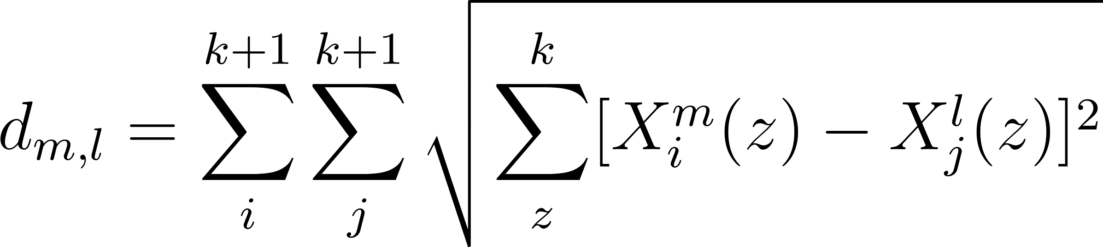

where X_{j}^{l}(z) is the value of parameter number z at step j of trajectory l. This dispersion measure is too computationally expensive for its purpose. We want, for each parameter i, to have a representative set {EE_{i}¹,...,EE_{i}^{N}} of its elementary effects. Therefore, it is necessary that for each i, the ${\{X}_{σ^{t }\left(i\right)}^{t}\}_{t∈[1,..,N]}$ are well spaced. We therefore propose the following dispersion measure:
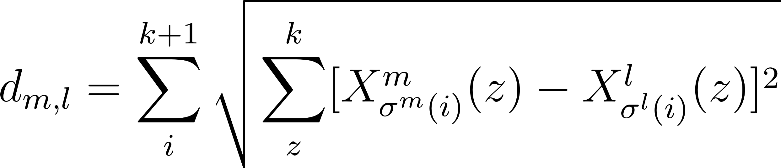
This dispersion measure has the advantage of being less computationally expensive. We want to maximise:
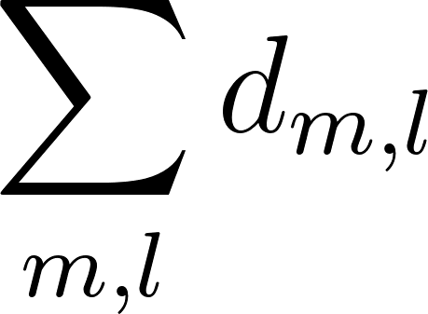

In our case, we have around k=30 input parameters, hence computing the distance between two trajectories requires around k² operations, and computing the dispersion requires (kN)² operations. If we are to pick the N best trajectories out of the N^{k}k! existing trajectories, it would require to find the best combination of N trajectories among N^{k}k!, which means a total of 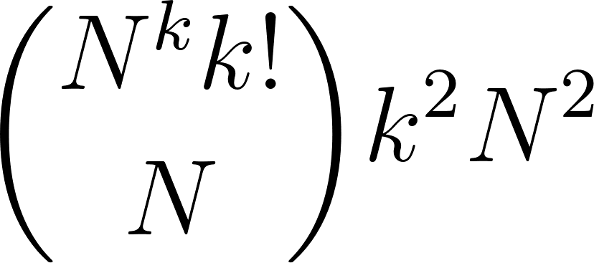 operations (around 10⁷⁶⁸ for N=20 and k =30). This is not computationally feasible if we want to have N sufficiently high. We improve the sampling strategy by using a simulated annealing algorithm instead of a brute force approach, which greatly reduces the computational burden.

Simulated annealing:

initialization
Take N initial points of k parameters with LHS. We sample only over the inferior half-section of each dimension for symmetry reasons. It yields N initial points with coordinates in 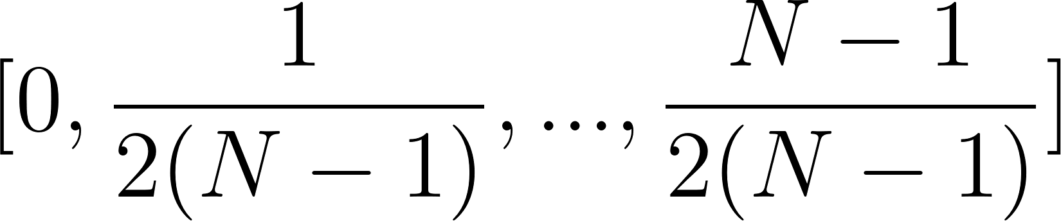, and from each point we will start one trajectory by generating random permutations $\{σ^{1},...,σ^{N}\}$. Each trajectory is built step by step by adding 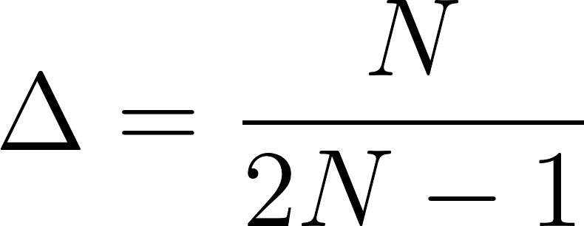 to each coordinate in the order {$σ^{1}$(1), …$σ^{1}$(k)}. We call J_{p}⁰={t⁰₁…t⁰_{N}} this first set of trajectories.
Distance table : compute, for each trajectory t⁰_{i} the distance d⁰_{i} =$Σ^{}d({t_{i}}^{0} ,{t_{j}}^{0})$ (we want to maximise ${D=Σ}^{}d_{i}$)
T is the “temperature”. $λ$ is the cooling factor.
While n < Iterations limits:
step n
- T=$λT$
- Pick a random integer i${∈[1,...,N]}^{}.$ Generate a new random permutation. Let us call ${t^{\sim }}_{i}$ the trajectory built from point i and this permutation. Replacing ${t^{n-1}}_{i}$ by ${t^{\sim }}_{i}$ would increase the dispersion by $Θ=Σ^{}d({t_{i}}^{\sim } ,{t_{j}}^{n-1}){{-d}^{n-1}}_{i}$.
- If $Θ ≥$ 0
  - Replace ${t_{j}}^{n-1}$by ${t_{i}}^{\sim }$and update the distance table.
- If $Θ$ <0
  - With probability $e^{-\frac{Θ}{T}}$:
    - Replace ${t_{j}}^{n-1}$by ${t_{i}}^{\sim }$and update the distance table.
End
Return the best set of trajectories from all those explored.

3. GET-ACC2 model

3.1 Overview of the model
The GET-ACC2 model is an integrated climate-energy-economic model with global coverage. It is used for long-term energy system modelling and technology assessment. It describes how the energy system evolves and minimises its costs across the 21st century to meet the energy demand and respect specified constraints, such as a carbon budget or a climate target. GET-ACC2 is composed of two models: the energy system model GET and the reduced complexity climate model ACC2.
The Aggregated Carbon Cycle, Atmospheric Chemistry, and Climate (ACC2) model describes the physical part of the system. K. Tanaka developed the model in 2007. It computes the evolution of physical parameters, such as greenhouse gas concentrations in the atmosphere, the additional radiative forcing that it induces, and the surface mean temperature resulting from a pathway of anthropogenic emissions. The ACC2 model is clearly and comprehensively described in the documentation by Katsumasa Tanaka and Elmar Kriegler^{16,21}.
The global energy transition (GET) model is a simple linear energy system model that was initially developed at Chalmers University by Christian A. Azar and Kristian Lindgren ^{22,23}. The current version is derived from the one used by D.J.A. Johansson and C. Azar in Azar et al (2013) and Johansson et al (2020). A parallel version of the model, GET-RC 6.1²⁵, modelled energy systems at the regional levels, and included trades of energy commodities. A full documentation of GET-RC 6.1 is available online²⁶, and most of its features are still relevant to the version of GET that we coupled to ACC2.
The GET-ACC2 model computes cost-optimal scenarios to balance energy demand with energy supply. It takes as input a set of assumptions about future demand in several subsectors, technology costs and efficiency, and returns a combination of energetic and economic features of the cost-optimal energy mix, such as primary energy needs, marginal and total costs of production and distribution, etc.
The model has 4 kinds of input data: techno-economical parameters, that characterise the costs and efficiencies of the technologies included in the model, climate model parameters, assumptions on future energy demand, and climate policy constraints.
The energy demand comprises four sectors for stationary end-use: industrial process heat, electricity, feed-stock for chemical industry, residential and commercial heating, and eight transport demand subsectors: road (public & private transport), air and rail for passenger transport, and marine, air, rail and road for freight. These energy demand pathways are derived from ENGAGE SSP2 baseline scenarios²⁷. The GET model computes, at each timestep, new productive capacity, new vehicles, distribution infrastructure etc. that have to be deployed to meet a given demand, as well as the fluxes of primary and secondary energy, the emission of greenhouse gases that stem from them, and costs incurred by the system. The reference year for dollar value is 2010.
Optimisation procedure
The model is solved by a non-linear optimization solver, CONOPT4. There are two options to solve the model: the demand can be either fixed or price-responsive. The solver minimises the objective function: the net present value of future costs (investment costs, O&M costs, fuel costs, carbon tax, etc.), when the demand is fixed, or the net present value of annual surplus, when demand is price-responsive. The discount rate is assumed to be at 5% by default. The solver ensures that the climate constraints are respected - for instance, keeping global warming from pre-industrial level below 1.5°C in 2100. In this study, we use the price-responsive mode.
To allow the demand to decrease when prices grow, price-elasticities are -0.4 for electricity demand²⁸, domestic and commercial heating, -0.2 for industry (process heat and feed-stock), and -0.3 for transport demand^{29,30}.
The model is solved twice:
- A first run with fixed demand and no climate policy ${Q_{b}}^{s}$ (b for “baseline”, s for “sector”) yields baseline end-use prices ${P_{b}}^{s}$ at each timestep, for each sector (the marginal costs of energy supply). Here, the net present value O_{fixed} of future energy system costs C(t) is minimised:
$O_{fixed}=\sum_{t}{}C(t)ρ^{-(t-t_{0})}$ where $ρ=1.05$

These prices are considered the reference prices for the demand pathway, and we deduce the reactive demand curve ${Q_{r}}^{s}$ (r for “reactive”) from the ratio between reference prices and real prices.
$\frac{dlog(Q)}{dlog(P)}=η$ hence ${Q_{r}}^{s}={Q_{b}}^{s}(\frac{{P_{r}}^{s}}{{P_{b}}^{s}})^{η}$ where $η$ is the price-elasticity of demand.
- A second run (with elastic demand) computes the consumer surplus of each sector at each timestep, that is to say the area below the demand curve. The annual social surplus S(t) (Fig 3.1.3) is the consumer surplus minus the production costs, i.e the area below the supply curve:

$${S(t)}^{}=\sum_{sectors}{}[(\frac{{Q_{r}}^{s }(t)}{{Q_{b}}^{s}(t)})^{\frac{1}{η_{s}}} \frac{{P_{b}}^{s}(t)}{\frac{1}{η_{s}}+1}{{Q_{r}}^{s}(t)]-C(t)}^{}$$
The solver maximises the discounted sum O_{reactive} of the annual social surplus between 2020 and 2150.
$O_{elast}= \sum_{t}{}S(t)ρ^{-(t-t_{0})}$ where $ρ=1.05$

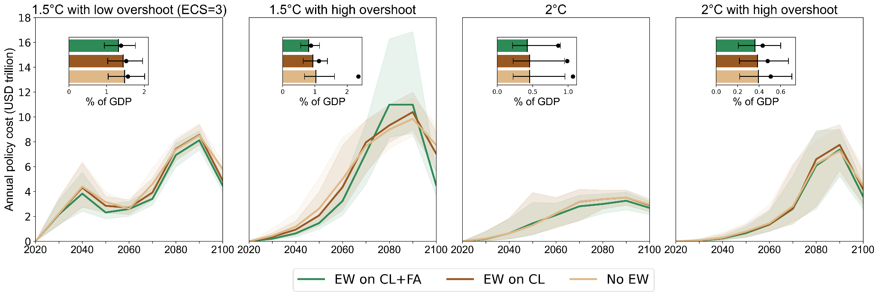
Fig 3.1.3 Annual median mitigation costs in GET-ACC2 (discount rate = 5%). The dotted lines show the 25-75% range.
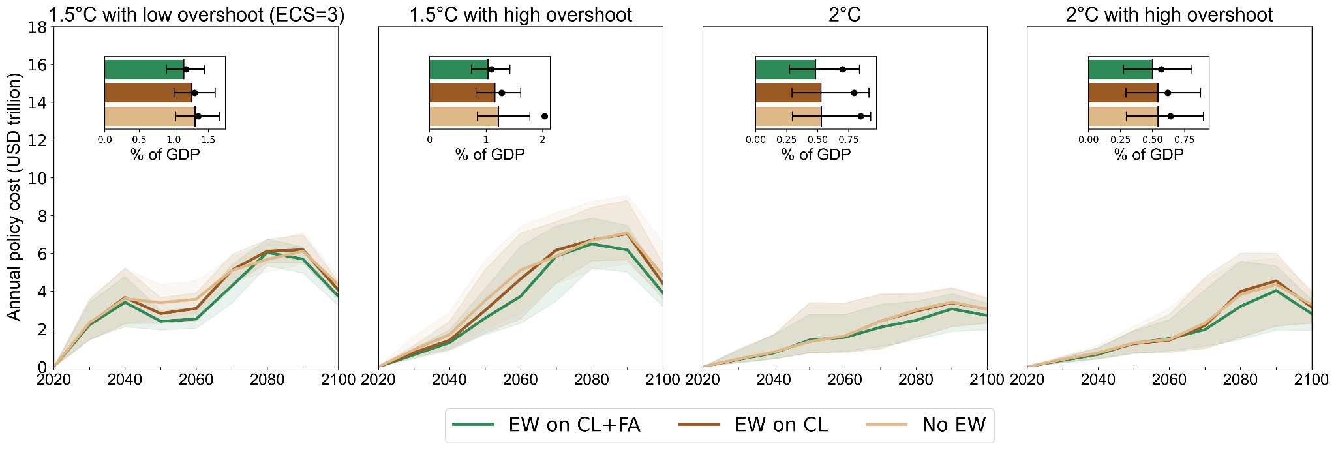
Fig 3.1.3 Annual median mitigation costs in GET-ACC2 with discount rate =2% per year. The dotted lines show the 25-75% range.

3.2 Major updates on GET

3.2.1 Fossil fuel supply curves
The version GET7.0 assumed a constant cost for fossil fuel extraction. The GET7.1 includes fossil fuels supply curves that represent how costs increase as resources are depleted. These supply curves are derived from the TIAM-UCL model³¹.

3.2.2 Biomass supply curve
The version GET7.0 assumed a constant cost for bioenergy supply. The GET7.1 model does not model land use, but represents the increasing marginal costs of bioenergy supply. We use an idealised supply curve based on the one computed with the IMAGE3.0³² model (fig. 6 of ref ³²). We assume that the supply curve follows the equation : P = P_{max} Q⁴ /Q_{max}⁴+b, where b is the initial bioenergy price, P_{max} =15$2005/GJ, and Q_{max} is the assumed maximum bioenergy supply potential (between 160 and 260 EJ/year). This simple supply curve generally underestimates the biomass supply cost compared to the original data, but it remains an improvement compared to the initial static cost parameterization.

3.2.3 Methane and Nitrous oxide abatement
New abatement cost curves to reduce methane and nitrous oxide emissions are implemented. There are 4 source-dependent abatement cost curves for methane (for coal, oil, natural gas and non-energy emissions), and one for N₂O. They were derived from ref.³³

3.2.4 Parameters updates
As solar panels, wind turbines and batteries costs have declined, the capital costs in GET7.1 are different from those in GET7.0. Electricity generation costs are based on the data from EIA, NREL, IRENA^{34–36}, while H2 and MeOH generation costs are based on the REMIND model³⁷. The electric vehicles and plug-in hybrid electric vehicles are also cheaper, as we assume a battery cost of 100$/kWh.
The total CO2 storage reserves were extended to 3000 GtCO₂. A maximum annual injection rate of 0.5% of storage reserves was added, following ref.³⁸ This leads to a maximum annual CO₂ storage of 15GtCO₂ per year, consistent with annual sequestration rates in the ENGAGE database.³⁹ Furthermore, the extension of annual CCS flows is limited to 150 MtC/year, i.e. 5.5 GtCO₂ per decade.

3.2.4 Renewable energy mix
The onshore wind power potential was increased to 2000EJ/year following ref.⁴⁰.
There is no detailed description of wind and solar production in GET, nor of issues related to VRE penetration in power production such as curtailment. The maximum share of variable renewable energy that does not have to be stored is limited to 30%, and the rest can be freely integrated as long as batteries (or cheaper storage with limited potential, such as dams) are purchased. We imposed that the shares of variable renewable energy provided by wind or solar energy cannot exceed given thresholds. Otherwise, since wind power is cheaper than solar, it completely replaces it.

3.3 Comparison of mitigation scenarios and baseline
When no climate target nor carbon tax constrains the model, energy supply relies heavily on coal, although the shares of wind, solar and nuclear power also increase (Fig 3.3.1). The CO₂ emissions rise steadily across the 21st century and peak around 2100 (Fig 3.3.2).
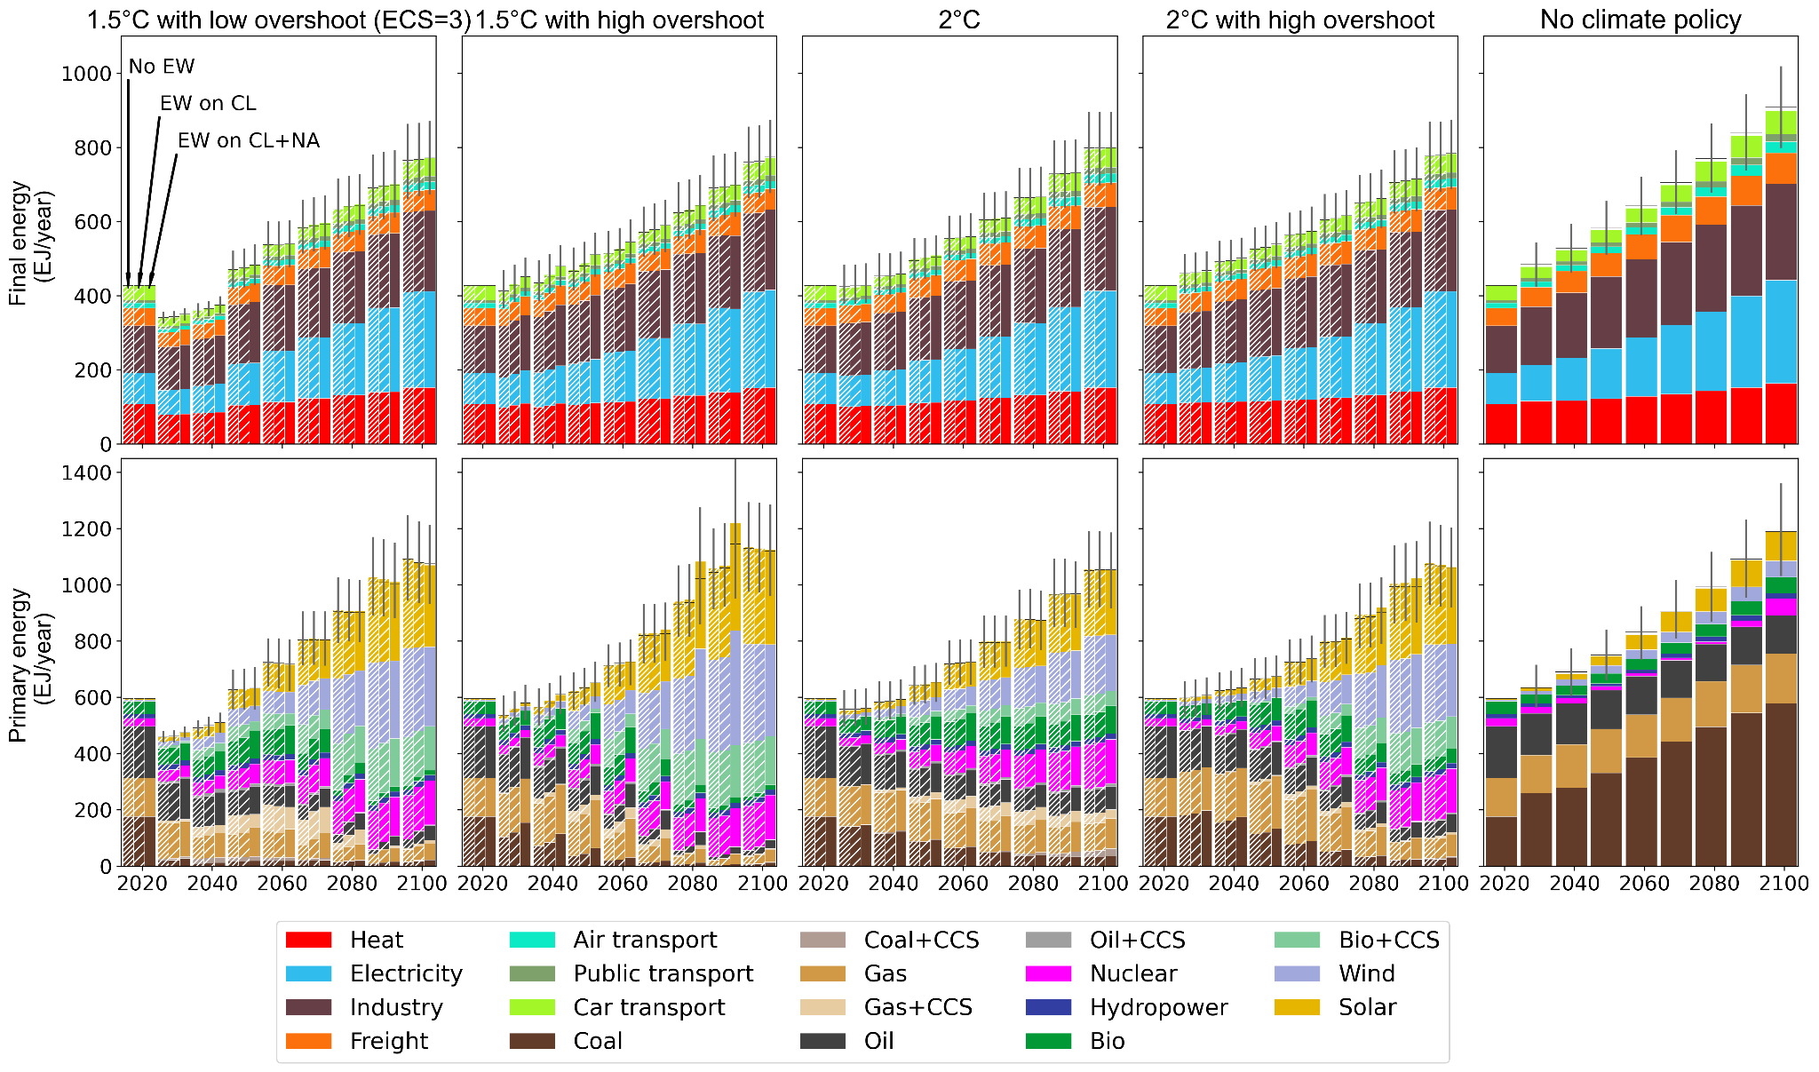
Fig 3.3.1 Energy flows in GET-ACC2. The hatched bars follow the same pattern as in the main text, except for the right panel where no EW is applied. The error bars represent the 25-75% range.

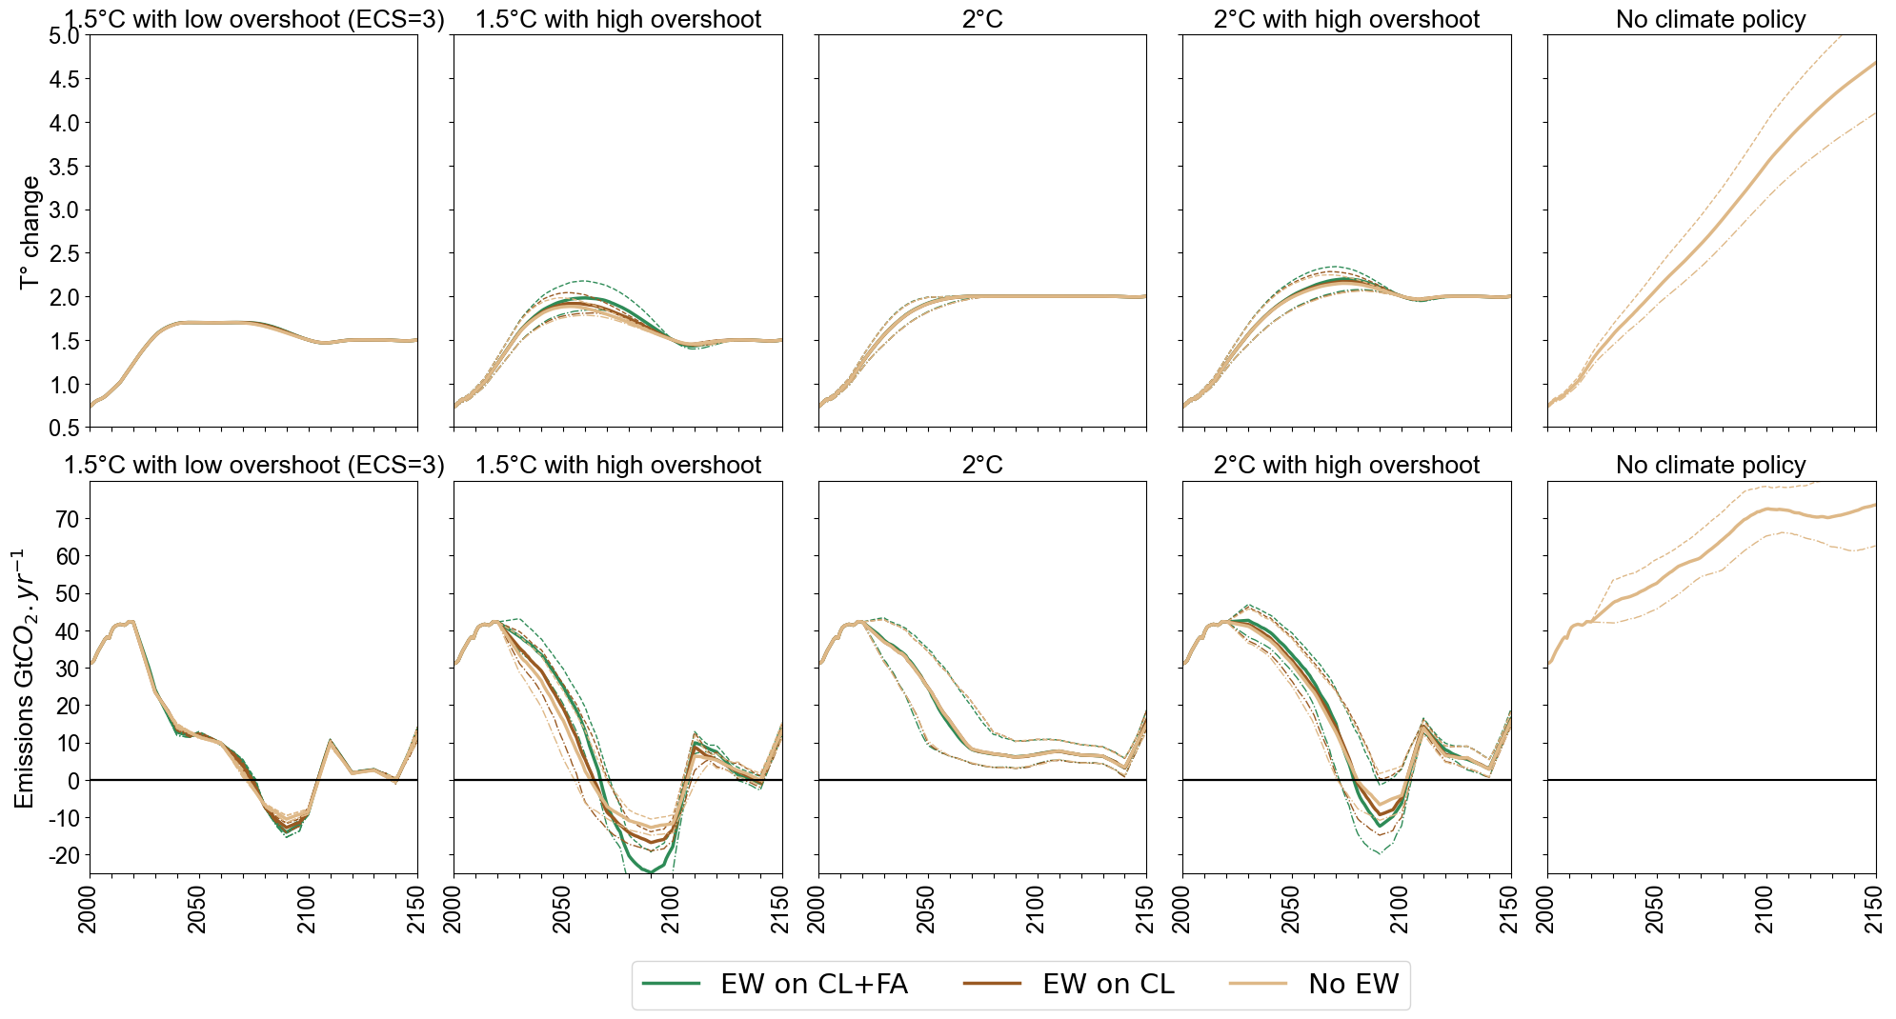
Fig 3.3.2 CO₂ Emissions and Temperature change in GET-ACC2. The dotted lines show the 25-75% range. When the temperature returns to its target after overshoot, the climate inertia leaves a little space for emissions to bounce back, while keeping the temperature below target. As the calculation is made up to 2150, emissions increase slightly in 2150 because they do not have enough time to affect the climate system: it is a side-effect due to the assumed time horizon.

3.4 Inverse parameterisation of the climate model ACC2
The spread of uncertainty relating to the climate system is assessed by sampling the equilibrium climate sensitivity⁴¹ (ECS). In ACC2, several parameters are jointly calibrated on historical values using the inverse mode¹⁶. Here the value of the ECS is exogenously set, and other parameters are calibrated consistently to this ECS value. The most influential parameters are Q10, by which the rate of terrestrial heterotrophic respiration increases with a temperature increase of 10°C, the factor β, which logarithmically scales the CO₂ fertilisation effect on net primary production with the fractional change of atmospheric CO₂ concentration, and the aerosol forcing. The Figure 3.4.1 shows how these parameters vary with the ECS.
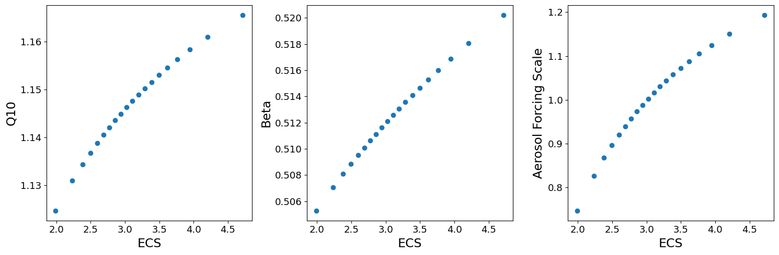Figure 3.4.1| Correlations between climate parameters Q10, Beta and the Aerosol forcing, as estimated from ACC2 inverse mode.

References
1. Atima, D. & Suthirat, K. Estimated Greenhouse Gases Emissions from Mobile and Stationary Sources in the Limestone and Basalt Rock Mining in Thailand. American Journal of Environmental Sciences 12, (2016).
2. Strefler, J., Amann, T., Bauer, N., Kriegler, E. & Hartmann, J. Potential and costs of carbon dioxide removal by enhanced weathering of rocks. Environ. Res. Lett. 13, 034010 (2018).
3. Renforth, P. The potential of enhanced weathering in the UK. International Journal of Greenhouse Gas Control 10, 229–243 (2012).
4. Thrikawala, S., Weersink, A., Fox, G. & Kachanoski, G. Economic Feasibility of Variable-Rate Technology for Nitrogen on Corn. American Journal of Agricultural Economics 81, 914–927 (1999).
5. Ibisch, P. L. et al. A global map of roadless areas and their conservation status. Science 354, 1423–1427 (2016).
6. Hartmann, J. & Moosdorf, N. The new global lithological map database GLiM: A representation of rock properties at the Earth surface. Geochemistry, Geophysics, Geosystems 13, (2012).
7. Goll, D. S. et al. Potential CO2 removal from enhanced weathering by ecosystem responses to powdered rock. Nat. Geosci. 14, 545–549 (2021).
8. Grafton, M., Yule, I., Davies, C., Stewart, R. & Jones, J. Resolving the Agricultural Crushed Limestone Flow Problem from Fixed-Wing Aircraft. Transactions of the ASABE 54, 769–775 (2011).
9. Bošeľa, M. & Šebeň, V. Analysis of the aerial application of fertilizer and dolomitic limestone. Journal of Forest Science 56, 47–57 (2018).
10. Clair, T. A. & Hindar, A. Liming for the mitigation of acid rain effects in freshwaters: A review of recent results. Environ. Rev. 13, 91–128 (2005).
11. Rinder, T. & von Hagke, C. The influence of particle size on the potential of enhanced basalt weathering for carbon dioxide removal - Insights from a regional assessment. Journal of Cleaner Production 315, 128178 (2021).
12. Mankins, J. Technology Readiness Level – A White Paper. (1995).
13. Cox, B., Bauer, C., Mendoza Beltran, A., van Vuuren, D. P. & Mutel, C. L. Life cycle environmental and cost comparison of current and future passenger cars under different energy scenarios. Applied Energy 269, 115021 (2020).
14. Rogner, H.-H. et al. Chapter 7 - Energy Resources and Potentials. in Global Energy Assessment - Toward a Sustainable Future 423–512 (2012).
15. Li, W. et al. Bioenergy Crops for Low Warming Targets Require Half of the Present Agricultural Fertilizer Use. Environ. Sci. Technol. 55, 10654–10661 (2021).
16. Tanaka, K. et al. Aggregated Carbon cycle, atmospheric chemistry and climate model (ACC2): description of forward and inverse mode. 14069106 (2007) doi:10.17617/2.994422.
17. Tanaka, K., Raddatz, T., O’Neill, B. C. & Reick, C. H. Insufficient forcing uncertainty underestimates the risk of high climate sensitivity. Geophys. Res. Lett. 36, L16709 (2009).
18. King, D. M. & Perera, B. J. C. Morris method of sensitivity analysis applied to assess the importance of input variables on urban water supply yield – A case study. Journal of Hydrology 477, 17–32 (2013).
19. Campolongo, F., Cariboni, J. & Saltelli, A. An effective screening design for sensitivity analysis of large models. Environmental Modelling & Software 22, 1509–1518 (2007).
20. Morris, M. D. Factorial Sampling Plans for Preliminary Computational Experiments. Technometrics 33, 161–174 (1991).
21. Tanaka, K. & O’Neill, B. C. The Paris Agreement zero-emissions goal is not always consistent with the 1.5 °C and 2 °C temperature targets. Nature Climate Change 8, 319–324 (2018).
22. Azar, C. A., Lindgren, K. & Andersson, B. Hydrogen Or Methanol in the Transportation Sector? (2000).
23. Azar, C. & Lindgren, K. Global energy scenarios meeting stringent CO2 constraints— cost-effective fuel choices in the transportation sector. Energy Policy 16 (2003).
24. Johansson, D. J. A., Azar, C., Lehtveer, M. & Peters, G. P. The role of negative carbon emissions in reaching the Paris climate targets: The impact of target formulation in integrated assessment models. Environ. Res. Lett. 15, 124024 (2020).
25. Grahn, M., Klampfl, E., Whalen, M. & Wallington, T. Sustainable Mobility: Using a Global Energy Model to Inform Vehicle Technology Choices in a Decarbonized Economy. Sustainability 5, 1845–1862 (2013).
26. Grahn, M., Klampfl, E., Whalen, M. J., Wallington, T. J. & Lindgren, K. Description of the global energy systems model GET-RC 6.1. (2013).
27. Bertram, C. et al. Energy system developments and investments in the decisive decade for the Paris Agreement goals. Environ. Res. Lett. 16, 074020 (2021).
28. Labandeira, X., Labeaga, J. M. & López-Otero, X. A meta-analysis on the price elasticity of energy demand. Energy Policy 102, 549–568 (2017).
29. Dimitropoulos, A., Oueslati, W. & Sintek, C. The rebound effect in road transport: A meta-analysis of empirical studies. Energy Economics 75, 163–179 (2018).
30. Persson, T. A., Azar, C., Johansson, D. & Lindgren, K. Major oil exporters may profit rather than lose, in a carbon-constrained world. Energy Policy 35, 6346–6353 (2007).
31. Welsby, D., Price, J., Pye, S. & Ekins, P. Unextractable fossil fuels in a 1.5 °C world. Nature 597, 230–234 (2021).
32. Daioglou, V., Doelman, J. C., Wicke, B., Faaij, A. & van Vuuren, D. P. Integrated assessment of biomass supply and demand in climate change mitigation scenarios. Global Environmental Change 54, 88–101 (2019).
33. Harmsen, M. J. H. M. et al. Data for long-term marginal abatement cost curves of non-CO2 greenhouse gases. Data in Brief 25, 104334 (2019).
34. IRENA. Renewable Power Generation Costs in 2020, International Renewable Energy Agency, Abu Dhabi. (2021).
35. NREL. ‘2021 Annual Technology Baseline.’ Golden, CO: National Renewable Energy Laboratory. (2021).
36. Cost and Performance Characteristics of New Generating Technologies, Annual Energy Outlook 2022. 4.
37. Luderer, G. et al. Impact of declining renewable energy costs on electrification in low-emission scenarios. Nat Energy 7, 32–42 (2022).
38. Strefler, J. et al. Carbon dioxide removal technologies are not born equal. Environ. Res. Lett. 16, 074021 (2021).
39. Riahi, K. et al. Cost and attainability of meeting stringent climate targets without overshoot. Nat. Clim. Chang. 11, 1063–1069 (2021).
40. Eurek, K. et al. An improved global wind resource estimate for integrated assessment models. Energy Economics 64, (2016).
41. Sherwood, S. C. et al. An Assessment of Earth’s Climate Sensitivity Using Multiple Lines of Evidence. Rev. Geophys. 58, (2020).

Source for all TRLs : IEA (2022), ETP Clean Energy Technology Guide, IEA, Paris https://www.iea.org/data-and-statistics/data-tools/etp-clean-energy-technology-guide

