Extended Data

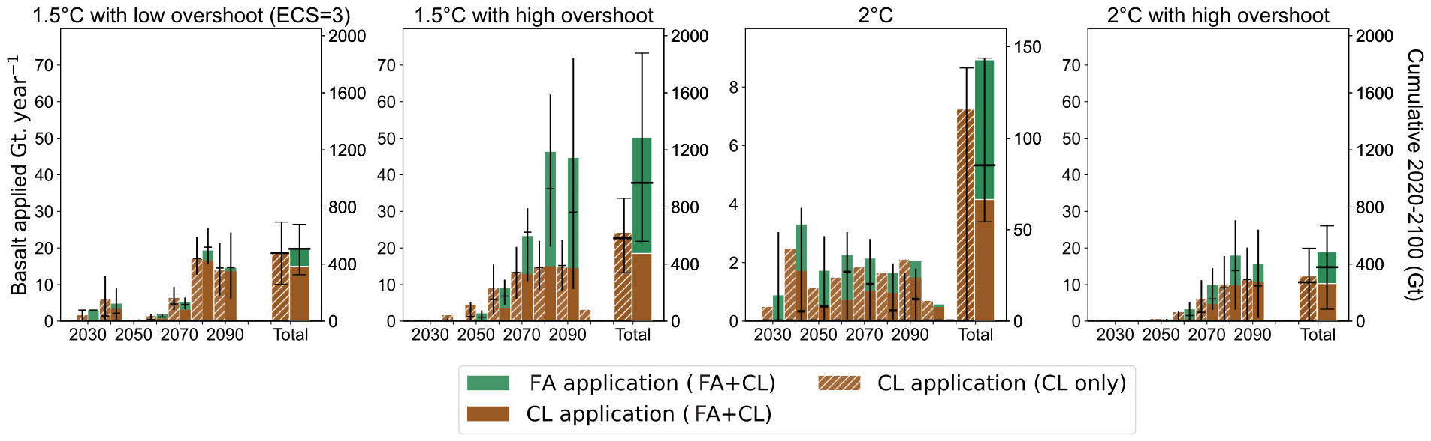

Figure S1| Basalt applied on crop fields and forest areas. Left y-axis: predicted annual application rate (Gt/year). Right y-axis: cumulative application across the 21st century (Gt). The coloured bars indicate the mean, the black horizontal dashes the median and the error bars the 25%-75% range.
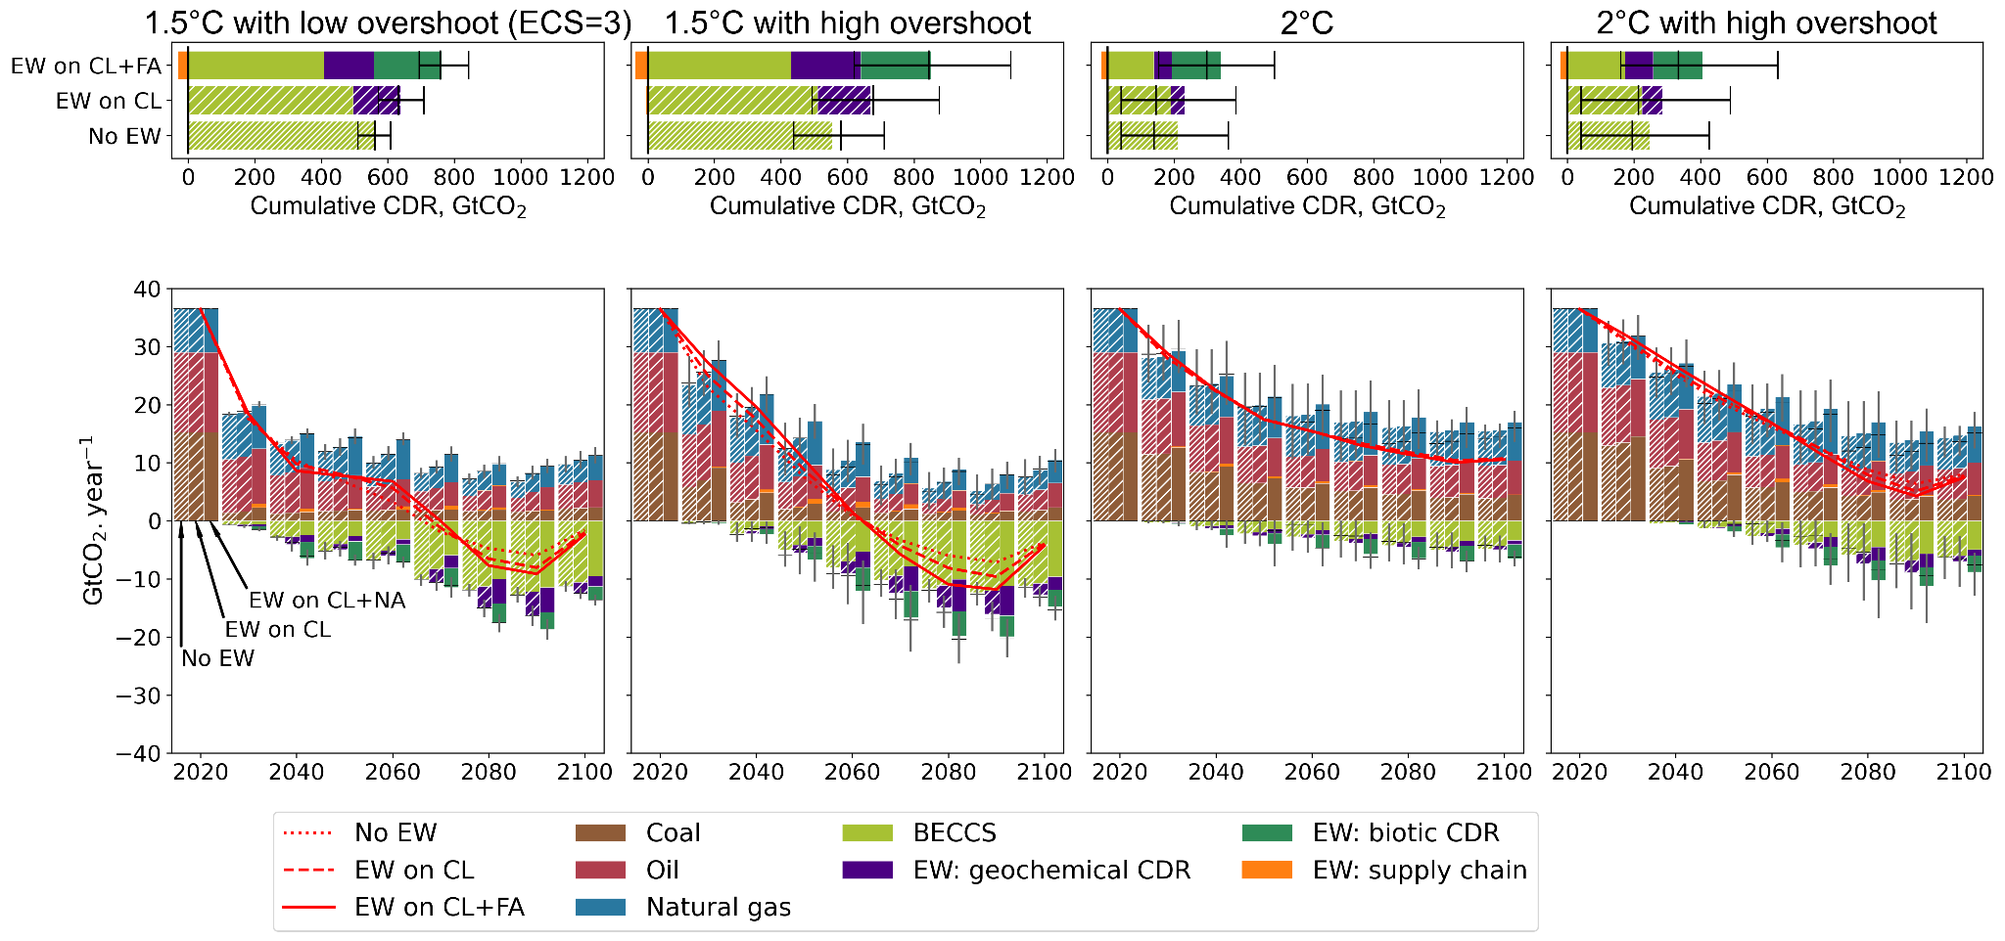
Figure S2| Carbon dioxide emissions across the 21st century for different climate targets, with a discount rate of 2% per year. The red lines represent the net CO₂ emissions from the energy system. Four climate policy targets are compared (one per column): 1.5°C with low OS: The temperature change is limited to 1.5°C after 2100, with a possible overshoot of up to 0.2°C before 2100. 1.5°C with high OS: the temperature change is limited to 1.5°C after 2100. 2°C with no OS: the temperature change is limited to 2°C. 2°C with high OS: the temperature change is limited to 2°C after 2100. Three NET portfolios are assessed: No EW: BECCS only. EW on CL: EW deployed on croplands only, and BECCS. EW on CL+FA: EW deployed on croplands and forest areas, and BECCS. The bars indicate the mean, the black dashes the median and the 25%-75% range.
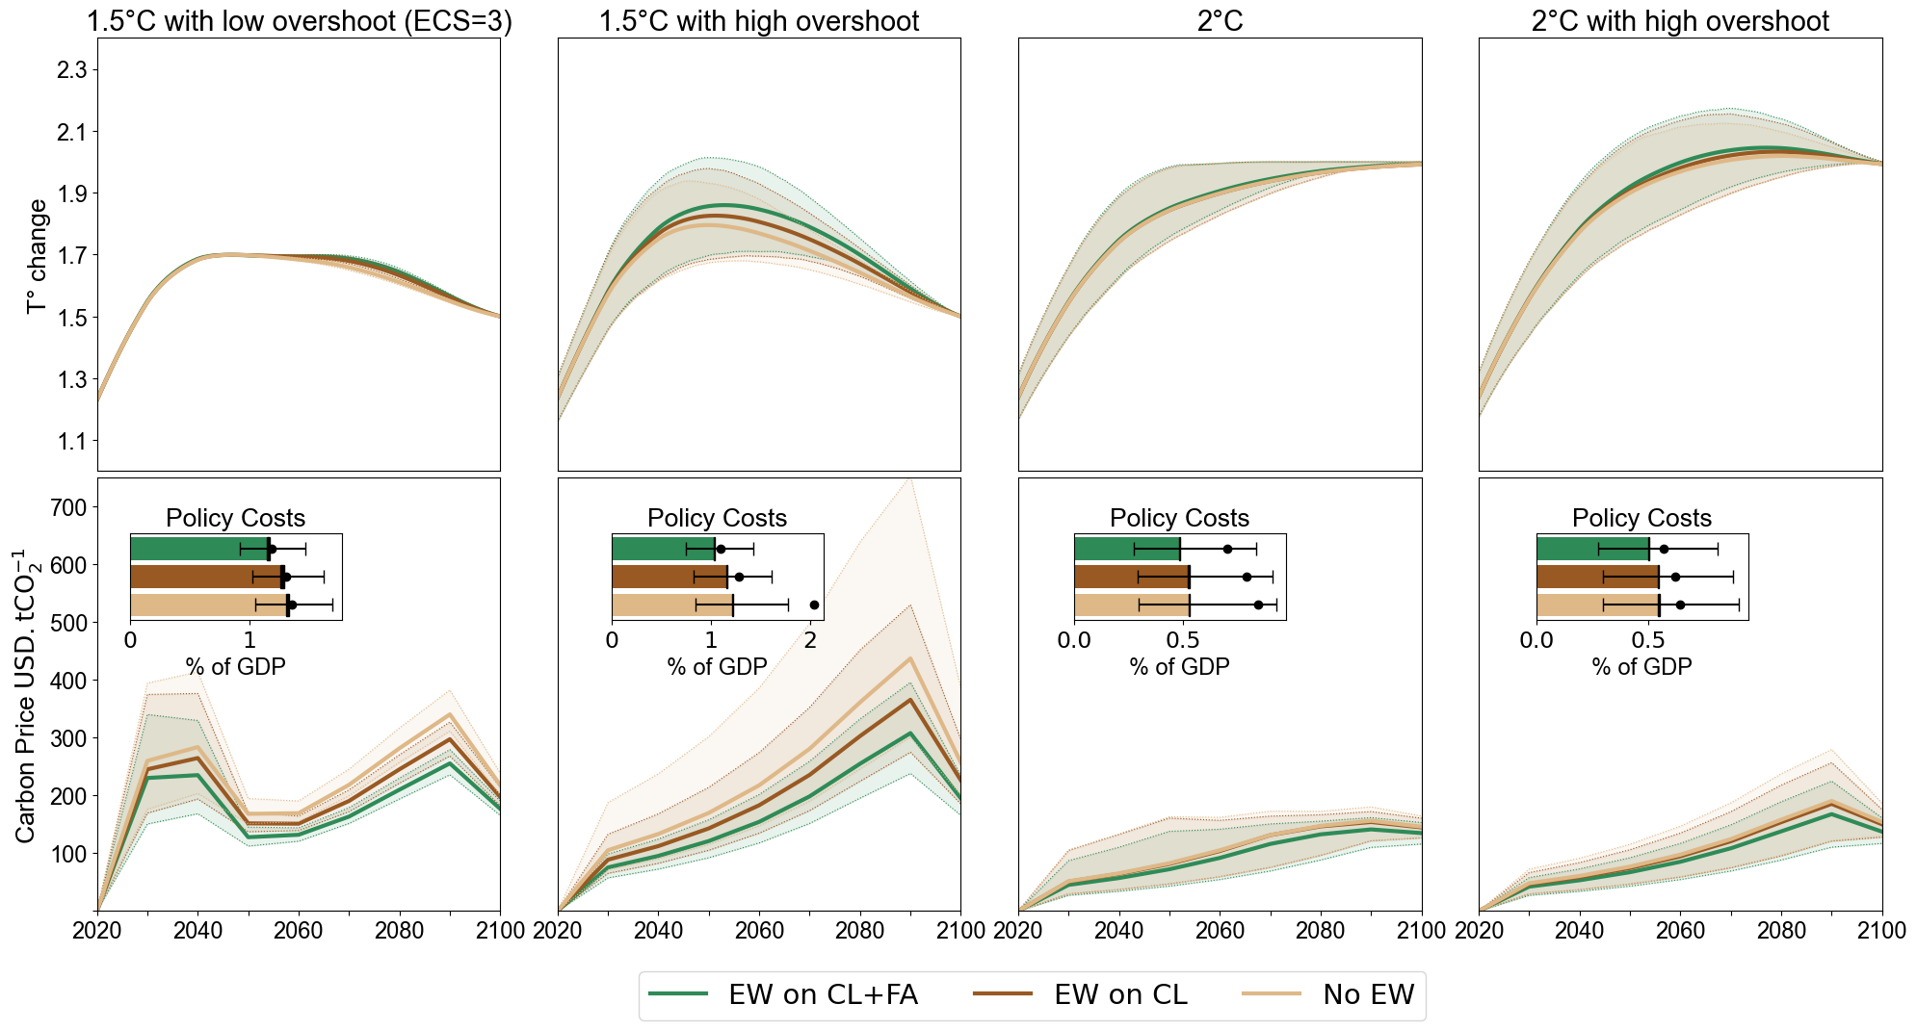
Figure S3 | Discount rate of 2% per year. Top: Mean surface temperature change compared to preindustrial period. Bottom: Shadow price of carbon across the 21st century for different climate targets. The shaded area represents the 25%-75% range. The scale changes between the panels. Policy costs are the net present values of future energy production costs and consumption losses as a percentage of GDP, compared to the no-policy scenario.
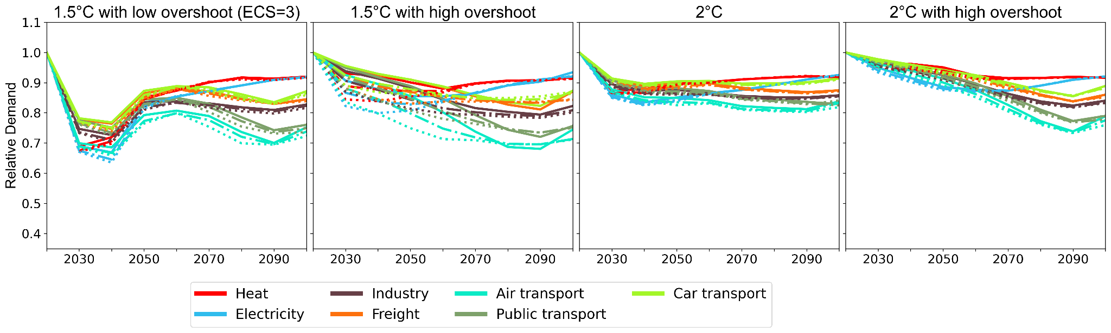
Figure S4| Top: Relative energy demand in mitigation scenarios compared to the baseline. Bottom: Relative biomass price compared to the no-EW scenarios. Solid line: EW on CL+FA. Dash-dotted line: EW on CL only. Dotted line : No EW.

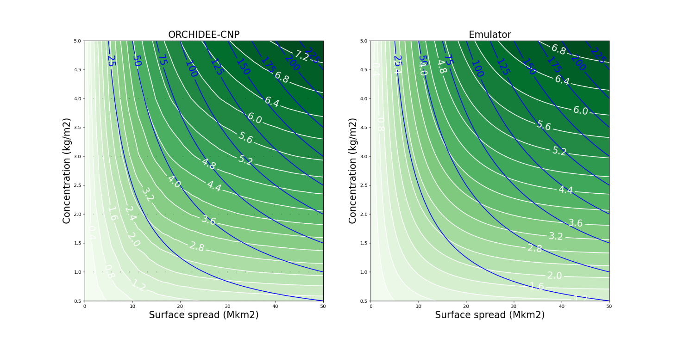
Figure S5| Global NPP increase (in %), averaged over 40 years after soil basalt amendment, depending on the rock concentration (y-axis) and surface of application (x-axis). White lines delineate iso-levels of NPP increase. Blue lines are iso-levels of rock quantity, in Gt. Left: Interpolation of ORCHIDEE-CNP results (black dots). Right: Emulator.

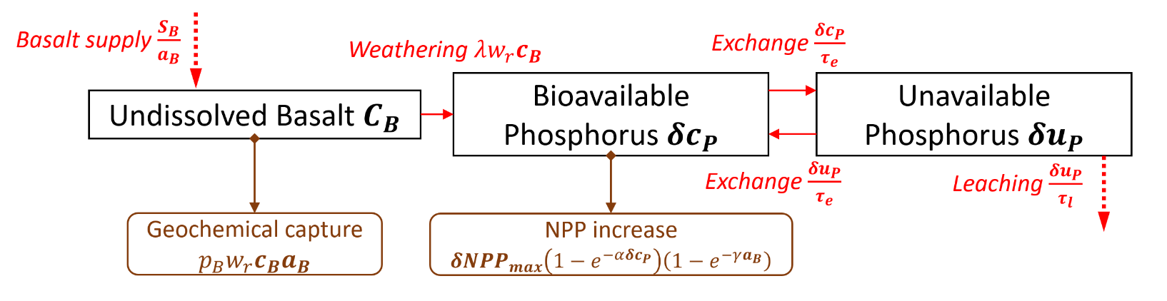
Figure S6 Phosphorus cycle emulation. Rectangles: pools. Red arrows: flows. Brown arrows: effects on the carbon cycle.
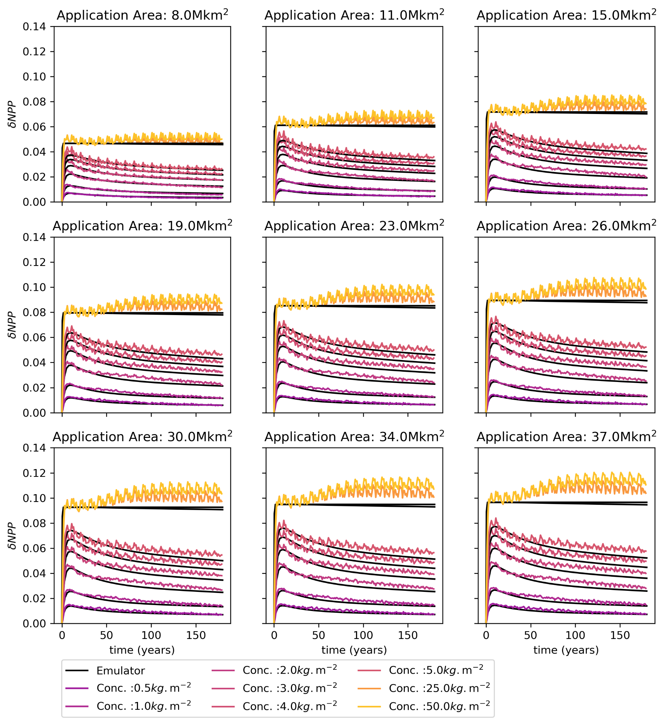
Figure S7 Evolution of the NPP change, for increasing forest areas of application and basalt application rates. The most responsive areas were chosen. Basalt is applied at year zero. The y-axis is the increase of NPP compared to the baseline.

