APPENDIX
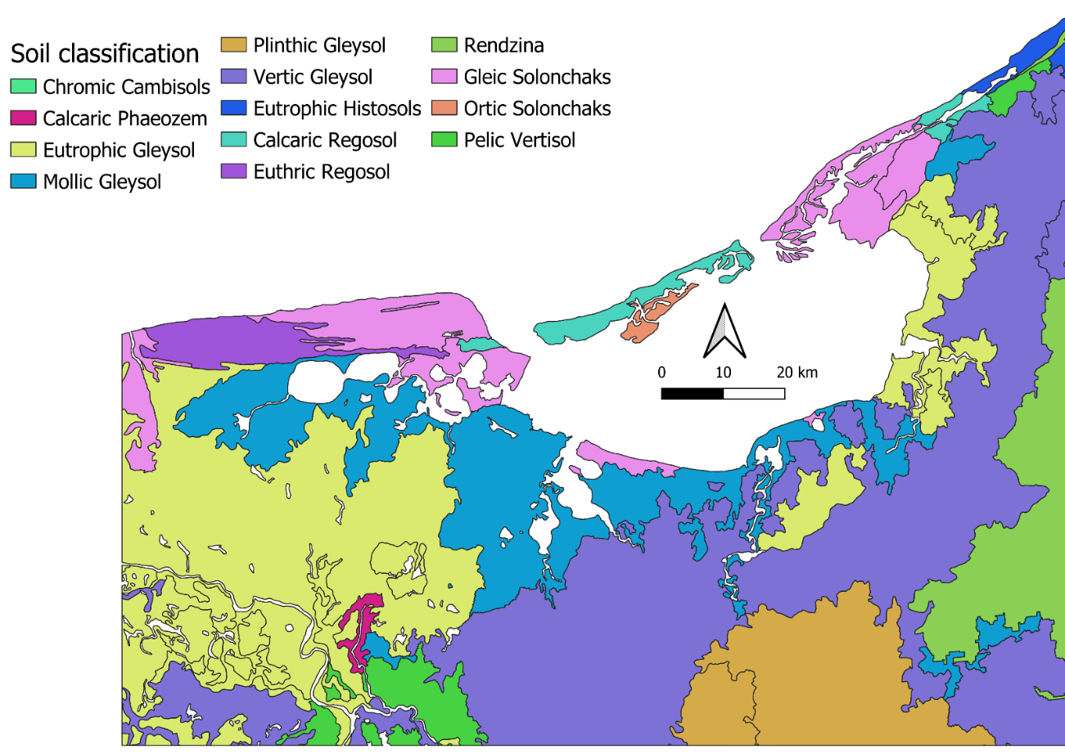
Fig. A1. Soil classification map of the study area. Source: CONABIO 2022
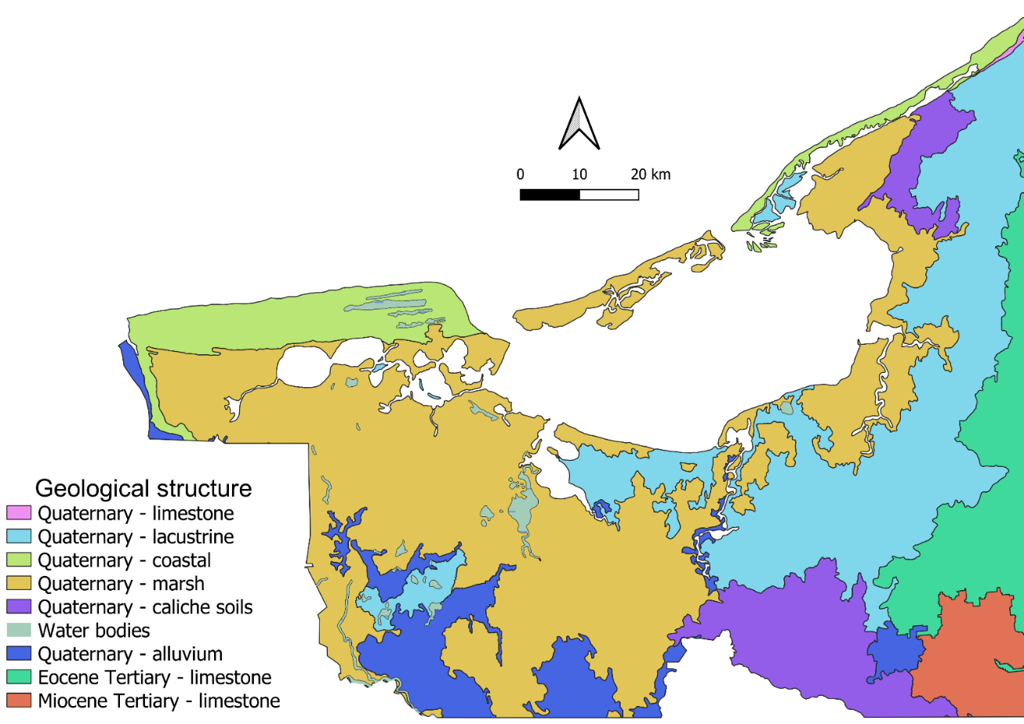
Fig. A2. Geologic map of the study area. Source: CONABIO 2022
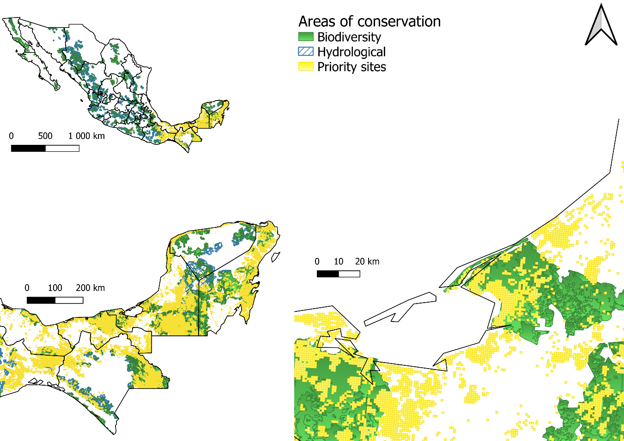
Fig. A3. Areas of conservation and priority sites in Mexico and study area. Source: CONABIO 2022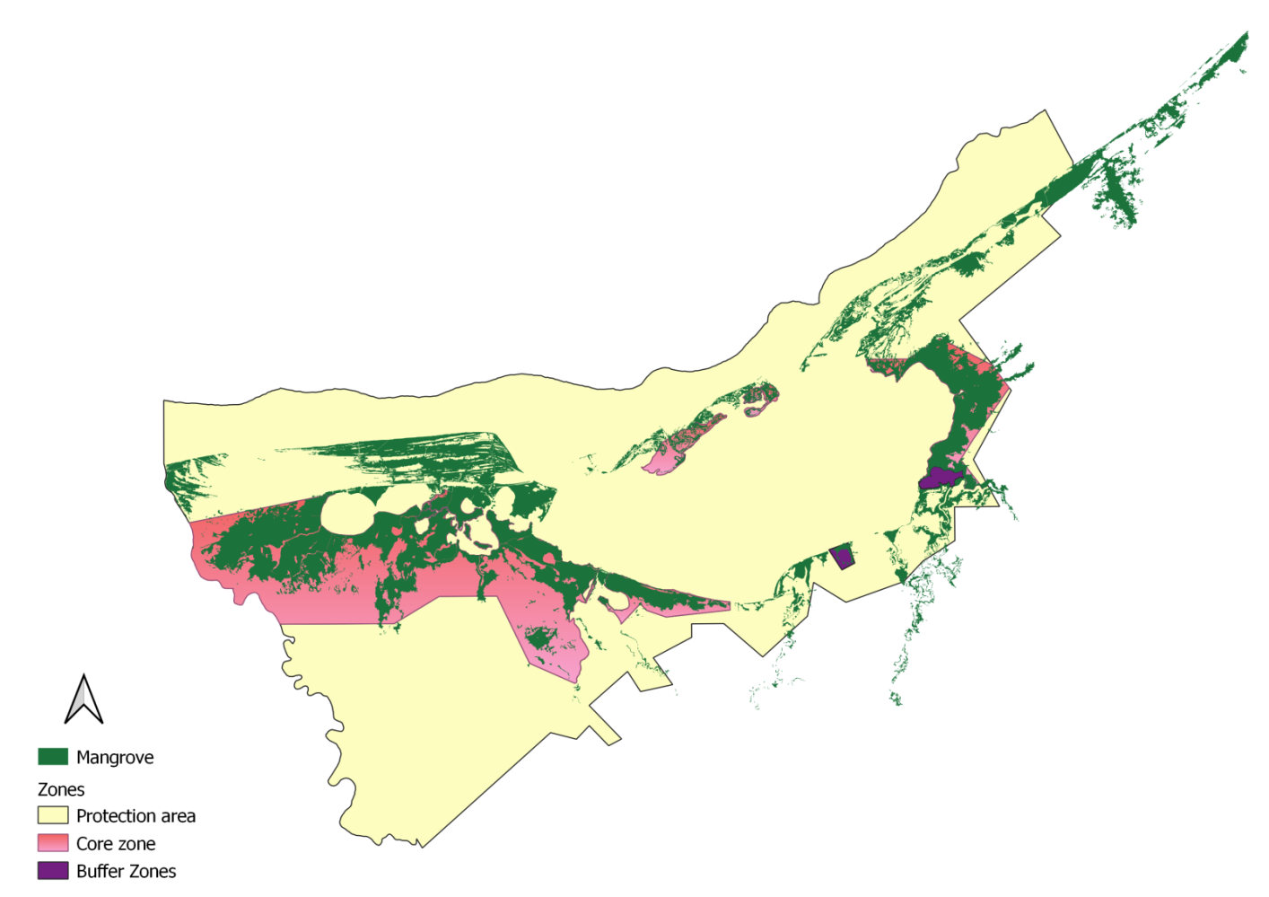
Fig. A4. Mangrove zonation in the study area. Source: CONABIO 2022

