Fig. S1. Introduced honeybees (Apis mellifera) captured while visiting the following orchid species in southwestern Australia, a: Caladenia xantha; b: Eriochilus dilatatus; c: Prasophyllum elatum and in eastern Australia, d: Dendrobium kingianum carrying three orchid pollinia; e: Caladenia flava; f: Prasophyllum elatum; g: Prasophyllum sp (approaching the flower with pollinia on mouthpart). Photo credits: Mark Brundrett (A, B, C. E), and Rudie Kruiter (D, F, G).
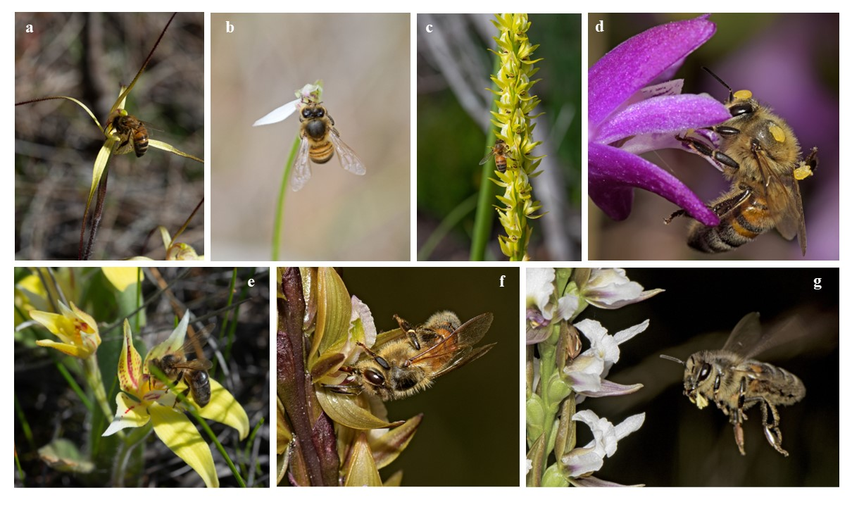
Fig. S2. Records (%) of honeybee (Apis mellifera) pollination in orchid species in the literature survey (Table 1) a: among continents; b: according to pollination effectiveness; c: per orchid subfamilies.
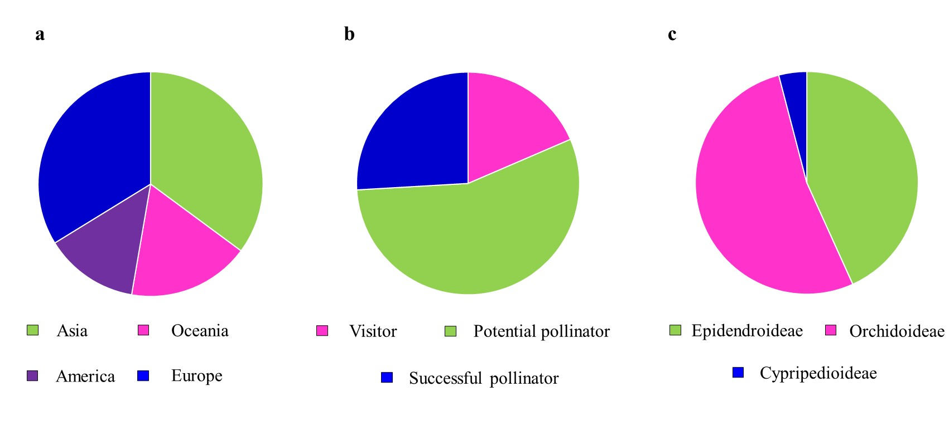

Table S1. Statistical parameters relative to the employed model using continuous predictor variables for the study species Diuris magnifica (Orchidaceae).

Response variable | Model covariates | Final model covariates | Δ AICc | B_{i} | χ2;df | p-value
Male fitness | Native bees’ abundance | Native bees’ abundance | 13 | 0.05278 | 19.572; 1 | <0.001
 | Number of plants
 | Honeybees’ abundance
 | Beetles’ abundance
 | Remnant size
Female fitness | Native bees’ abundance | Native bees’ abundance | 8 | 0.06411 | 5.1371; 1 | 0.023
 | Number of plants
 | Honeybees’ abundance
 | Beetle abundance
 | Remnant size
Pollination efficiency | Native bees’ abundance | I(Honeybees’ abundance) ^2 | 14 | -0.014423 | 7.2195; 1 | 0.007
 | Number of plants | Log(Remnant size) |  | 0.551009 | 6.7399; 1 | 0.009
 | Honeybee abundance
 | Beetle abundance
 | Remnant size

