Modeling population pharmacokinetics of morniflumate in healthy Korean men: Extending pharmacometrics analysis to niflumic acid, its major active metabolite

Supplementary Information & Tables & Figures (with captions)

Seung-Hyun Jeong ^{a,1}, Ji-Hun Jang ^{b,1}, Yong-Bok Lee ^{b,*}

ª College of Pharmacy, Sunchon National University, 255 Jungang-ro, Suncheon-si, Jeollanam-do, 57922, Republic of Korea
^{b} College of Pharmacy, Chonnam National University, 77 Yongbong-ro, Buk-gu, Gwangju, 61186, Republic of Korea

¹ Both authors contributed equally to this manuscript.

*Corresponding author:
Prof. Yong Bok Lee
College of Pharmacy, Chonnam National University, 77 Yongbong-ro, Buk-gu, Gwangju, 61186, Republic of Korea
Tel.: 82-62-530-2931; Fax: 82-62-530-0106
E-mail: leeyb@chonnam.ac.kr
Supplementary Information 1

Non-compartment analysis
Calculations of the basic pharmacokinetic parameters of finasteride were performed by non-compartment analysis (NCA) using the Phoenix WinNonlin software (version 8.3, Pharsight, Certara Inc.). The area under the curve from 0 h to infinite (AUC_{0-∞}) was calculated as the sum of AUC_{0–t} and C_{last}/k, where C_{last} is the last measurable concentration, t is the time in C_{last}, and k is the elimination rate constant at the terminal phase. AUC_{0–t} was calculated using a linear trapezoidal rule from 0 to t h after oral administration of morniflumate. The area under the first-order moment curve (AUMC) was calculated as the area of the graph under the product of time and plasma concentration over time. The mean residence time (MRT) was obtained as the ratio of AUMC and AUC. The half-life (T_{1/2}) was calculated as 0.693/k, and the volume of the distribution (V/F) was calculated as dose/k · AUC_{0–∞}. The clearance (CL/F) was calculated by dividing the dose of morniflumate by AUC_{0–∞}, where F is the bioavailability of oral administration. The peak plasma drug concentration (C_{max}) and time to reach C_{max} (T_{max}) were determined from the plasma morniflumate concentration-time curves of each individual.

Supplementary Information 2

Determination of clinical biochemistry parameters
Blank plasma samples obtained immediately before morniflumate administration (0 h) were used for the analysis of clinical biochemical parameters. The types of biochemical parameters included total proteins, albumin, globulin, alkaline phosphatase (ALP), aspartate transaminase (AST), alanine transaminase (ALT), cholesterol, total bilirubin, blood urea nitrogen, creatinine, creatinine clearance (CrCL), and glomerular filtration rate (GFR). Determination of clinical biochemical parameter values was performed by serological analysis through a dry automated analyzer. The analyses were conducted with a VITROS MicroSlide system (Ortho Clinical Diagnostics, NJ, USA) operated by reflectance spectrophotometry. CrCL was calculated based on the Cockcroft-Gault equation as follows: [(140 - age) × body weight (kg)/serum creatinine (mg/dL) × 72] (Hermsen et al., 2009). GFR was calculated using the Modification-of-Diet-in-Renal-Disease formula: 186.3 × [serum creatinine (mg/dL)^{-1.154} × age (year)^{-0.203}] (Al-Naamani et al., 2008). Body mass index (BMI) and body surface area (BSA) were calculated based on the weight and height of individuals. BMI was calculated based on the Kaup index: [body weight (kg)/height² (m²)] (Hotta et al., 2005). BSA was calculated based on the Mosteller formula: $\sqrt{(height (cm) × weight (kg)/3600)}$ (El Edelbi et al., 2012).

Supplementary Information 3

Model qualification tools
The goodness of fit (GOF) was confirmed using diagnostic scatter plots as follows: (A) Population-predicted concentrations (PRED) versus observed concentrations (DV); (B) Individual-predicted concentrations (IPRED) versus DV; (C) PRED versus conditional weighted residuals (CWRES); (D) Time after dose (IVAR) versus CWRES; (E) Quantile–quantile (QQ) plot of the components of CWRES; and (F) QQ plot of the components of weighted residuals (WRES). A visual predictive check (VPC) of the final established model was performed using the VPC option of Phoenix NLME (version 8.3). The number of simulations for the VPC was 1000. The IVAR-DV concentration data were graphically superimposed on the median values and the 5th and 95th percentiles of the IVAR-simulated concentration profiles. If the DV concentration data were approximately distributed within the 95th and 5th prediction interval, the model was expected to be precise. By using non-parametric bootstrap analysis, the stability of the final model was confirmed. For this, the bootstrap option of Phoenix NLME was used. A total of 1000 replicates were generated via repeated random sampling with replacement from the original dataset. The estimated parameter values including the standard errors (including confidence interval) and medians from the bootstrap procedure were compared with those estimated from the original dataset. The normalized prediction distribution error (NPDE) was used to evaluate the predictive performance of the model via Monte Carlo simulation using R. The NPDE results were graphically summarized using (A) a quantile-quantile plot of the NPDE, (B) a histogram of the NPDE, (C) a scatterplot of NPDE versus IVAR, and (D) a scatterplot of NPDE versus PRED. If the desired predictive performance is achieved, the NPDE will follow a normal distribution (Shapiro-Wilk test) with a mean value of zero (t-test) and a variance of one (Fisher’s test).
Table S1. Demographic information of healthy Korean males (n = 36) upon single oral administration of morniflumate (700 mg).
Demographic | Unit | Value (mean ± standard deviation)
Age | Year | 23.50 ± 3.38
Weight | kg | 67.92 ± 8.76
Height | cm | 174.47 ± 5.94
Total proteins | g/dL | 7.83 ± 0.35
Albumin | g/dL | 5.07 ± 0.20
Globulin | g/dL | 2.76 ± 0.30
ALP | IU/L | 211.83 ± 44.37
AST | IU/L | 20.72 ± 3.72
ALT | IU/L | 21.53 ± 7.91
Cholesterol | mg/dL | 178.11 ± 26.90
Total bilirubin | mg/dL | 0.87 ± 0.34
Blood urea nitrogen | mg/dL | 13.97 ± 3.51
Creatinine | mg/dL | 0.88 ± 0.09
CrCL | mL/min | 125.62 ± 17.01
BMI | kg/m² | 22.26 ± 2.23
BSA | m² | 1.81 ± 0.14
GFR | mL/min | 115.44 ± 13.35
ALP, alkaline phosphatase; AST, aspartate transaminase; ALT, alanine transaminase; CrCL, creatinine clearance; BMI, body mass index; BSA, body surface area; GFR, glomerular filtration rate.
Table S2. Morniflumate pharmacokinetic (PK) parameter values obtained through non-compartmental analysis of morniflumate PK results in healthy Korean males (n = 36) obtained in this bioequivalence study following a single oral administration of 700 mg of morniflumate.
Parameters | Values (mean ± standard deviation)
T_{1/2} (h) | 4.04 ± 2.44
T_{max} (h) | 1.33 ± 0.62
C_{max} (μg/mL) | 1.07 ± 0.45
AUC_{0-t} (h·μg/mL) | 2.84 ± 1.34
AUC_{0-∞} (h·μg/mL) | 3.25 ± 1.46
V/F (L) | 1412.77 ± 840.48
CL/F (L/h) | 289.64 ± 229.03
MRT (h) | 4.91 ± 2.35
T_{1/2}, half-life in plasma; T_{max}, time to reach maximum plasma concentration; C_{max}, maximum plasma concentration; AUC, area under the curve; V/F, volume of distribution; CL/F, total clearance; MRT, mean residence time.
Table S3. Building steps for a basic pharmacokinetic structural model of morniflumate.
Model | Description | nParameter ª | $-$2LL | AIC | △$-$2LL | △AIC | Compared with
Compartment disposition model
01 | 1-compartment | 7 | 4968.27 | 4982.27 | - | - | -
02* | 2-compartment | 11 | 4757.22 | 4779.22 | –211.05 | –203.05 | 01
03 | 3-compartment | 15 | 4897.12 | 4927.12 | 139.90 | 147.90 | 02
Absorption model
02 | No T_{lag} | 11 | 4757.22 | 4779.22 | - | - | -
02-01 | Add T_{lag} | 13 | 4856.33 | 4892.14 | 99.11 | 112.92 | 02
02-02 | No T_{lag}; Non sequential two absorption compartment ^{b} | 15 | 4795.41 | 4821.38 | 38.19 | 42.16 | 02
02-03 | No T_{lag}; Sequential two absorption compartment ^{b} | 13 | 4525.69 | 4574.86 | –231.53 | –204.36 | 02
02-04 | No T_{lag}; Sequential three absorption compartment ^{b} | 15 | 4312.45 | 4383.67 | –213.24 | –191.19 | 02-03
02-05 | No T_{lag}; Sequential four absorption compartment ^{b} | 17 | 4185.53 | 4226.10 | –126.92 | –157.57 | 02-04
02-06* | No T_{lag}; Sequential five absorption compartment ^{b} | 19 | 4150.27 | 4162.32 | –35.26 | –63.78 | 02-05
02-07 | No T_{lag}; Sequential six absorption compartment ^{b} | 21 | 4149.41 | 4161.59 | –0.86 | –0.73 | 02-06
Residual error model
02-06 | Proportional | 19 | 4150.27 | 4162.32 | - | - | -
02-06-01 | Additive | 19 | 5196.26 | 5218.26 | 1045.99 | 1055.94 | 02-06
02-06-02* | Log additive | 19 | 416.88 | 454.88 | –3733.39 | –3707.44 | 02-06
02-06-03 | Mixed | 20 | 4968.25 | 4984.25 | 817.98 | 821.93 | 02-06
02-06-04 | Power | 19 | 5196.13 | 5210.13 | 1045.86 | 1047.81 | 02-06
Interindividual variability model
02-06-02-01 | Remove interindividual variability of V_{c}/F | 18 | 416.83 | 452.83 | –0.05 | –2.05 | 02-06-02
02-06-02-02 | Remove interindividual variability of CL_{c}/F | 18 | 416.60 | 452.60 | –0.28 | –2.28 | 02-06-02
02-06-02-03 | Remove interindividual variability of V_{p}/F | 18 | 476.70 | 512.70 | 59.82 | 57.82 | 02-06-02
02-06-02-04 | Remove interindividual variability of CL_{p}/F | 18 | 468.98 | 504.98 | 52.10 | 50.10 | 02-06-02
02-06-02-05 | Remove interindividual variability of K_{a1} | 18 | 428.83 | 464.83 | 11.95 | 9.95 | 02-06-02
02-06-02-06 | Remove interindividual variability of K_{a2} | 18 | 428.94 | 464.94 | 12.06 | 10.06 | 02-06-02
02-06-02-07 | Remove interindividual variability of K_{a3} | 18 | 428.83 | 464.83 | 11.95 | 9.95 | 02-06-02
02-06-02-08 | Remove interindividual variability of K_{a4} | 18 | 428.83 | 464.83 | 11.95 | 9.95 | 02-06-02
02-06-02-09 | Remove interindividual variability of K_{a5} | 18 | 427.20 | 463.20 | 10.32 | 8.32 | 02-06-02
02-06-02-10* | Remove interindividual variability of V_{c}/F, CL_{c}/F | 17 | 416.83 | 450.83 | –0.05 | –4.05 | 02-06-02
ª nParameter represents the total number of parameters applied to the model.
^{b} represents a kind of multiple absorption compartment models.
* represents the model selected in each step.
T_{lag}, lag-time; V_{c}/F, distribution volume of the central compartment; CL_{c}/F, clearance from the central compartment; V_{p}/F, distribution volume of the peripheral compartment; CL_{p}/F, movement rate between the central and peripheral compartments; K_{a1}, absorption rate constant from morniflumate dosing depot to depot 2; K_{a2}, absorption rate constant from depot 2 to depot 3; K_{a3}, absorption rate constant from depot 3 to depot 4; K_{a4}, absorption rate constant from depot 4 to depot 5; K_{a5}, absorption rate constant from depot 5 to the central compartment.
Table S4. Stepwise selection of potential covariates in the population pharmacokinetic model of morniflumate.
Model | Description | OFV | △OFV | Compared with | nParameter ª
1 | Base model ^{b} | 416.83 | - | - | 17
2 | Total proteins on V_{p}/F | 416.50 | –0.328 | Base model | 18
3 | Total proteins on CL_{p}/F | 416.18 | –0.647 | Base model | 18
4 | Albumin on V_{p}/F | 416.83 | 0.000 | Base model | 18
5 | Albumin on CL_{p}/F | 416.83 | 0.000 | Base model | 18
6 | ALP on CL_{p}/F | 416.78 | –0.047 | Base model | 18
7 | AST on CL_{p}/F | 416.74 | –0.095 | Base model | 18
8 | ALT on CL_{p}/F | 416.12 | –0.709 | Base model | 18
9 | Total bilirubin on CL_{p}/F | 416.21 | –0.618 | Base model | 18
10 | CrCL on CL_{p}/F | 416.71 | –0.120 | Base model | 18
11* | BMI on V_{p}/F | 399.40 | –17.433 | Base model | 18
12 | BMI on CL_{p}/F | 412.04 | –4.789 | Base model | 18
13 | BSA on V_{p}/F | 407.84 | –8.989 | Base model | 18
14 | BSA on CL_{p}/F | 413.26 | –3.575 | Base model | 18
15 | GFR on CL_{p}/F | 412.32 | –4.515 | Base model | 18
16 | BMI on K_{a1} | 413.77 | –3.061 | Base model | 18
17 | BSA on K_{a1} | 413.72 | –3.107 | Base model | 18
18 | BMI, BSA on V_{p}/F | 399.30 | –0.097 | Model 11 | 19
19 | BMI on V_{p}/F, GFR on CL_{p}/F | 395.35 | –4.051 | Model 11 | 19
ª nParameter meant the total number of parameters applied to the model.
^{b} Base model: 2-compartment disposition, 5 sequential first-order absorptions without lag-time, log additive residual error, with no consideration of interindividual variability in V_{c}/F (distribution volume of the central compartment) and CL_{c}/F (clearance from the central compartment).
* represents the finally selected model.
OFV, objective function value; ALP, alkaline phosphatase; AST, aspartate transaminase; ALT, alanine transaminase; CrCL, creatinine clearance; BMI, body mass index; BSA, body surface area; GFR, glomerular filtration rate; V_{p}/F, distribution volume of the peripheral compartment; CL_{p}/F, movement rate between the central and peripheral compartments; K_{a}, absorption rate constant from morniflumate dosing depot to depot 2.

Table S5. Bootstrap results of the finally established population pharmacokinetic model for morniflumate.
Parameter | Final model |  | Bootstrap (n = 1000)
Parameter | Estimate | 95% confidence interval | Median | 95% confidence interval
tvV_{c}/F (L) | 110.88 | 57.81–163.94 | 111.22 | 76.01–196.56
tvCL_{c}/F (mL/h) | 10.38 | 5.00–15.70 | 10.37 | 4.26–16.46
tvV_{p}/F (L) | 10033.78 | 8246.46–11821.09 | 10099.70 | 8890.48–11409.34
tvCL_{p}/F (L/h) | 378.36 | 300.46–456.25 | 383.93 | 310.15–457.83
tvK_{a1} (1/h) | 9.89 | 3.84–15.94 | 10.72 | 5.52–18.99
tvK_{a2} (1/h) | 22.79 | 16.90–28.69 | 21.44 | 12.24–44.32
tvK_{a3} (1/h) | 23.71 | 18.14–29.27 | 22.76 | 12.38–49.08
tvK_{a4} (1/h) | 4.72 | 2.38–7.05 | 5.20 | 2.97–10.71
tvK_{a5} (1/h) | 0.68 | 0.54–0.82 | 0.69 | 0.60–0.88
dV_{p}/FdBMI | 2.37 | 1.16–3.58 | 2.47 | 0.88–3.38
ε | 0.30 | 0.27–0.34 | 0.31 | 0.27–0.34
ω²_{Vp/F} | 0.01 | 0.00–0.02 | 0.01 | 0.01–0.03
ω²_{CLp/F} | 0.35 | 0.13–0.58 | 0.37 | 0.13–0.60
ω²_{Ka1} | 0.00 | 0.00–0.00 | 0.00 | 0.00–0.00
ω²_{Ka2} | 0.86 | 0.78–0.93 | 0.79 | 0.58–0.99
ω²_{Ka3} | 0.87 | 0.80–0.94 | 0.84 | 0.73–0.96
ω²_{Ka4} | 0.92 | 0.30–1.55 | 1.07 | 0.29–1.84
ω²_{Ka5} | 0.02 | 0.00–0.03 | 0.02 | 0.00–0.04
tv means for typical value.
dV_{p}/FdBMI represents the correlation between the body mass index and the distribution volume of the peripheral compartment.
V_{c}/F, distribution volume of the central compartment; CL_{c}/F, clearance from the central compartment; V_{p}/F, distribution volume of the peripheral compartment; CL_{p}/F, movement rate between the central and peripheral compartments; K_{a1}, absorption rate constant from morniflumate dosing depot to depot 2; K_{a2}, absorption rate constant from depot 2 to depot 3; K_{a3}, absorption rate constant from depot 3 to depot 4; K_{a4}, absorption rate constant from depot 4 to depot 5; K_{a5}, absorption rate constant from depot 5 to the central compartment.
Supplementary Figure captions
Fig. S1. Morniflumate pharmacokinetic profile of healthy Korean males (n = 36) obtained in this bioequivalence study (following a single oral administration of 700 mg of morniflumate). The dots on the graph represent the mean concentrations of morniflumate in plasma over time, and the vertical bars represent the standard deviations.
Fig. S2. Goodness-of-fit plots of the final pharmacokinetic model for morniflumate. (A) Population-predicted concentrations (PRED, natural log scale, ng/mL) against observed plasma concentration (DV, natural log scale, ng/mL), (B) individual-predicted concentrations (IPRED, natural log scale, ng/mL) against DV, (C) PRED against conditional weighted residuals (CWRES), (D) time (IVAR, h) against CWRES, (E) quantile-quantile (QQ) plot of CWRES components, and (F) QQ plot of components of weighted residuals (WRES).
Fig. S3. Normalized prediction distribution error (NPDE) plots for the population pharmacokinetic model of morniflumate. (A) Quantile-quantile plots of NPDE versus the theoretical N (0, 1) distribution. (B) Histogram of the distribution of the NPDE, overlaid with the density of the standard Gaussian distribution. (C) Scatter plot of the time (IVAR, h) versus NPDE. (D) Scatterplot of predicted concentrations (DV, ng/mL) versus NPDE.
Fig. S4. Fitting of previously reported pharmacokinetic data following morniflumate exposure to the finally established model visual predictive check as external validation. The dots represent the observed mean concentrations after oral administration of 700 mg morniflumate. The 95th, 50th, and 5th percentiles of the predicted concentrations are represented by black dashed lines. The 95% confidence intervals for the predicted 5th and 95th percentiles are represented by the blue-shaded regions. The 95% confidence intervals for the predicted 50th percentiles are represented by the red-shaded regions.
Fig. S5. Model prediction result of leukotriene B₄ (LTB₄) synthesis inhibition percent profiles over time after a single oral administration of morniflumate (700 mg). The solid line in the graph represents the predicted LTB₄ synthesis inhibition based on the population niflumic acid mean profiles predicted by the morniflumate-niflumic acid pharmacokinetic model (applying the typical values of the model parameters) extended in this study.
Fig. S6. Simulation graphs of the pharmacokinetics of the final model for morniflumate according to the changes in the body mass index (BMI) [(A) Mean BMI of 22.26 kg/m², (B) Median BMI of 21.89 kg/m², (C) Max BMI of 28.41 kg/m², and (D) Min BMI of 17.36 kg/m²]. The 95th, 50th, and 5th percentiles of the predicted concentrations are represented by the black dashed lines. The 95% confidence intervals for the predicted 5th and 95th percentiles are represented by the blue-shaded regions. The 95% confidence intervals for the predicted 50th percentiles are represented by the red-shaded regions.

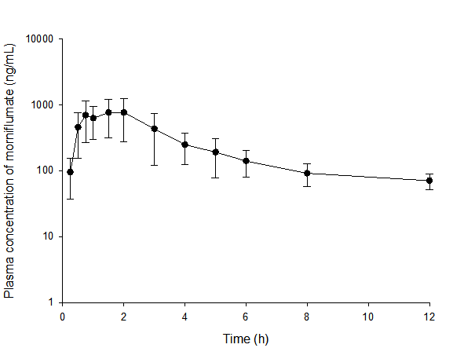
Fig. S1
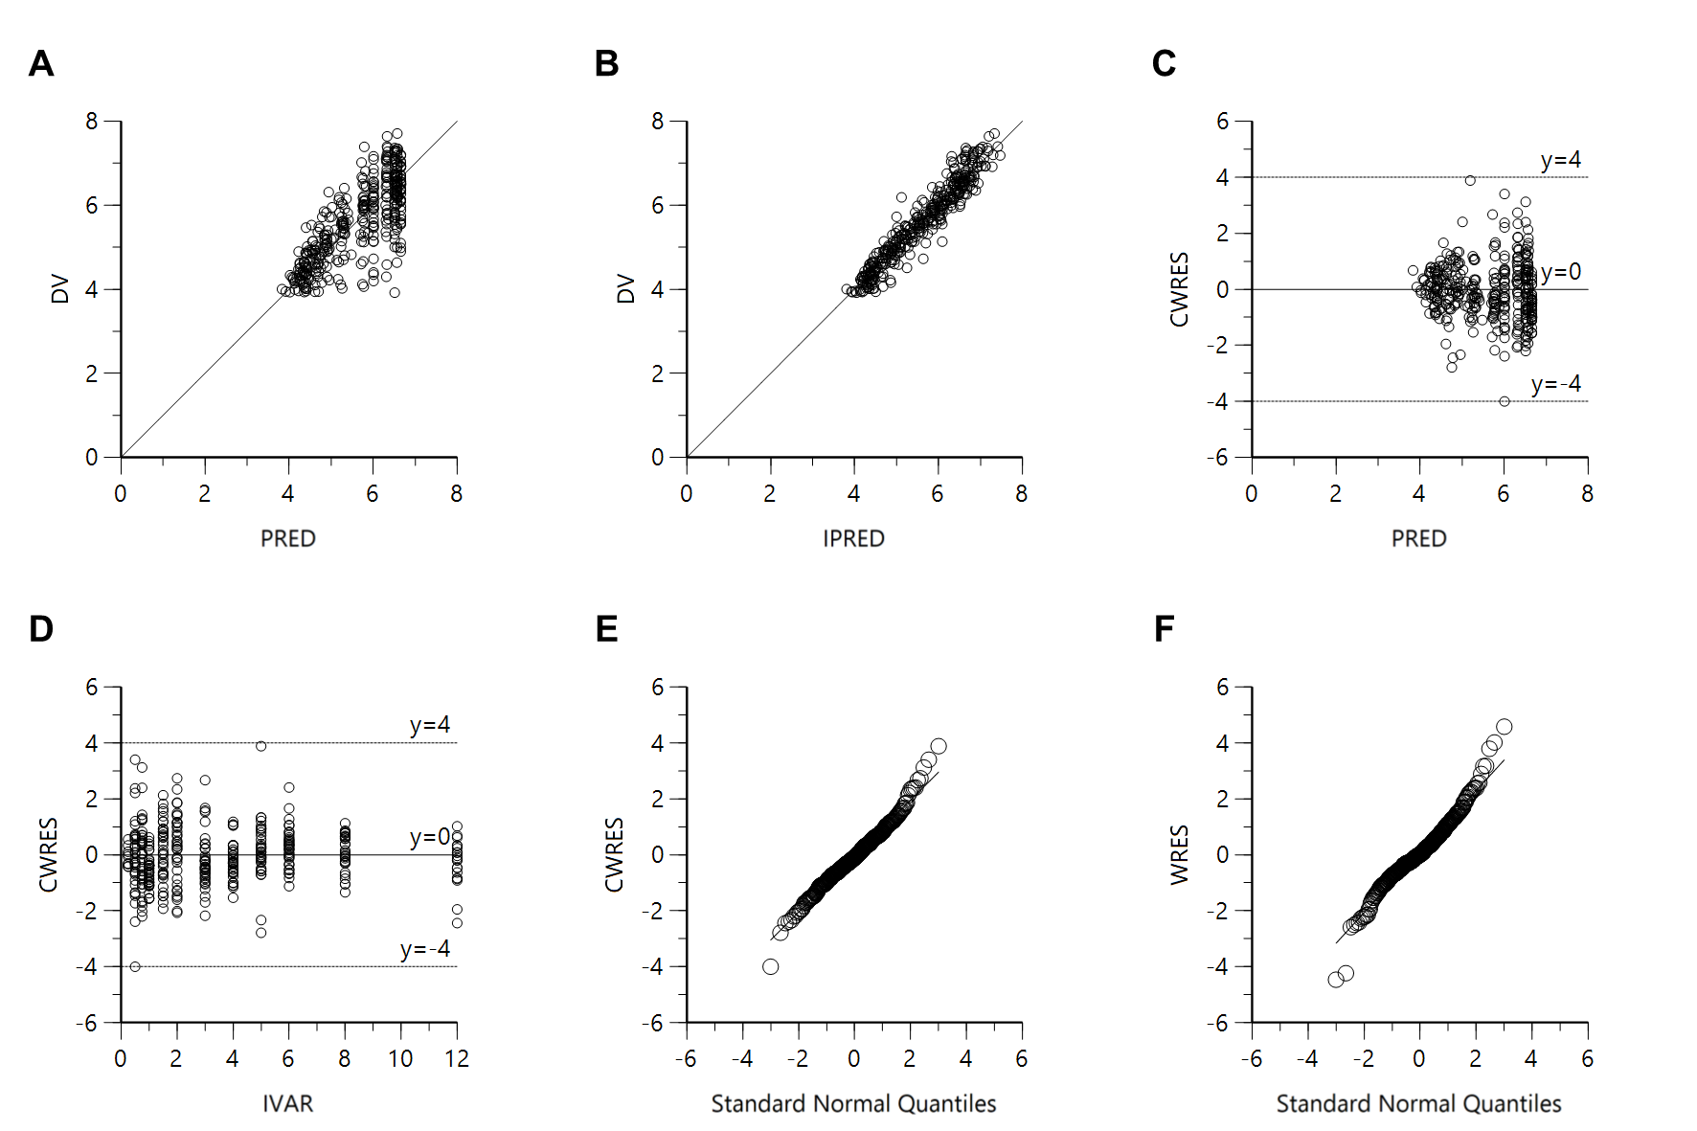
Fig. S2
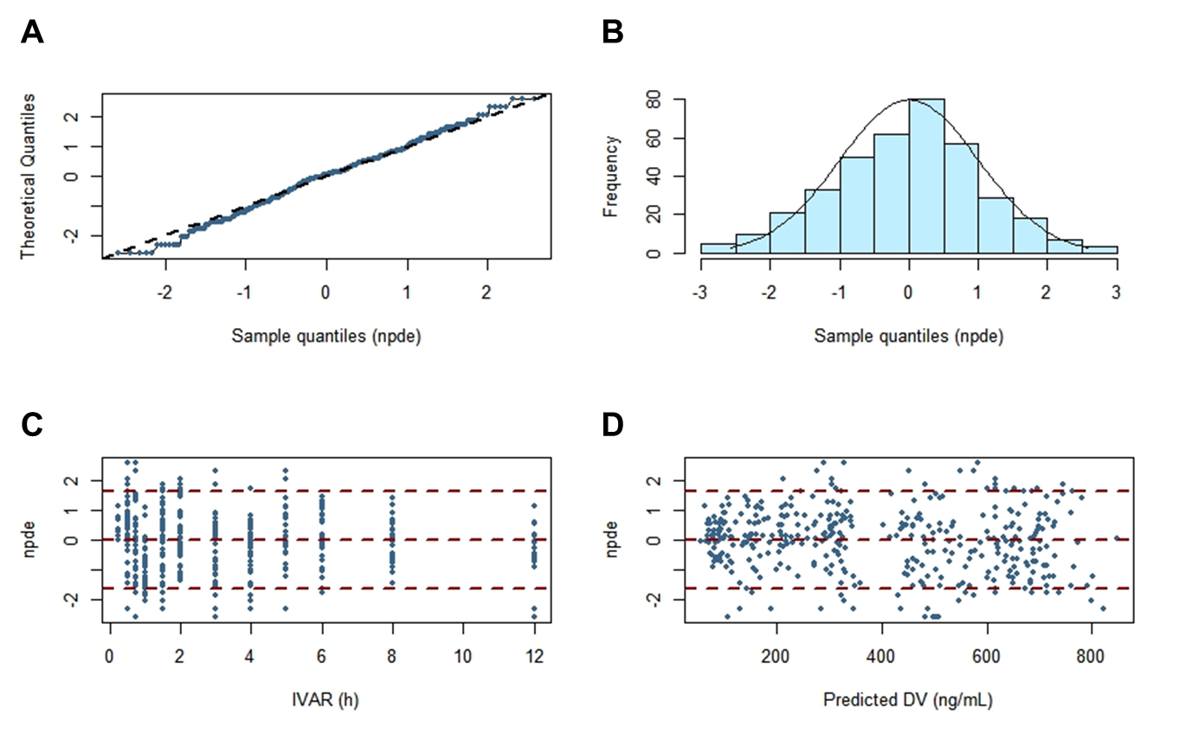
Fig. S3
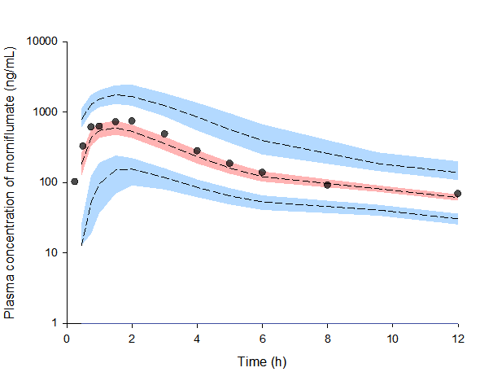
Fig. S4
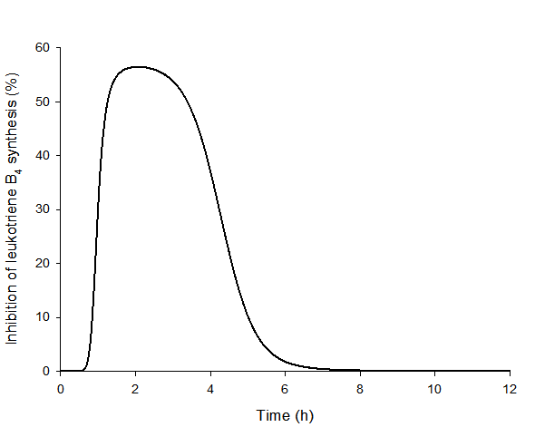
Fig. S5
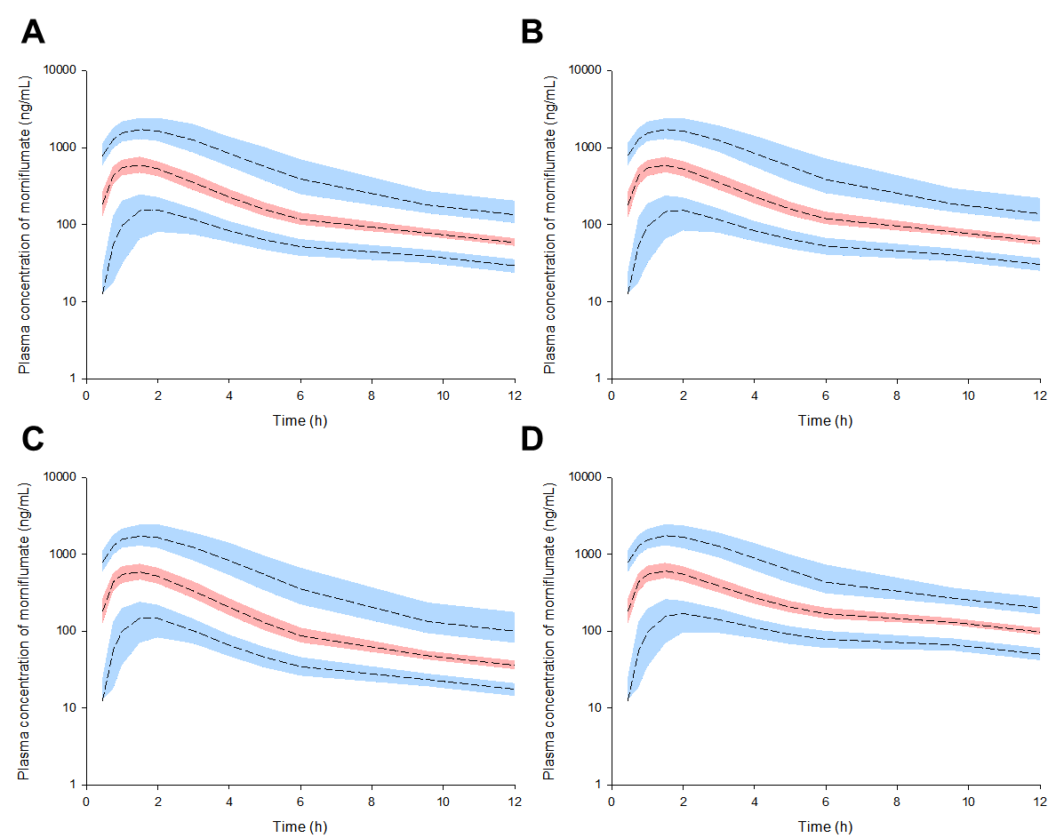
Fig. S6
References

Al-Naamani N, Maarouf O, Wilt J, D’Ovidio F, Sonett J, Arcasoy S, Nickolas T, Lederer D, Kawut S (2008) 25: the Modification of Diet in Renal Disease (MDRD) formula predicts kidney failure after lung transplantation. J Heart Lung Transplant 27: S69
El Edelbi R, Lindemalm S, Eksborg S (2012) Estimation of body surface area in various childhood ages–validation of the Mosteller formula. Acta Paediatr 101: 540-544
Hermsen ED, Maiefski MM, Florescu MC, Qiu F, Rupp ME (2009) Comparison of the modification of diet in renal disease and Cockcroft‐Gault equations for dosing antimicrobials. Pharmacotherapy 29: 649-655
Hotta M, Li Y, Anme T, Ushijima H (2005) Risk factors for low Kaup index among children in rural ethnic minority areas of Yunnan, China. Pediatr Int 47: 147-153

