Understanding Genetic Variability: Exploring Copy Number Variants through Non-Invasive Prenatal Testing in European Populations
Zuzana Holesova*, Ondrej Pös, Juraj Gazdarica, Marcel Kucharik, Jaroslav Budis, Michaela Hyblova, Gabriel Minarik, and Tomas Szemes
* Correspondence: Zuzana Holesova: zuzana.holesova@geneton.sk

Supplementary Figure and Tables
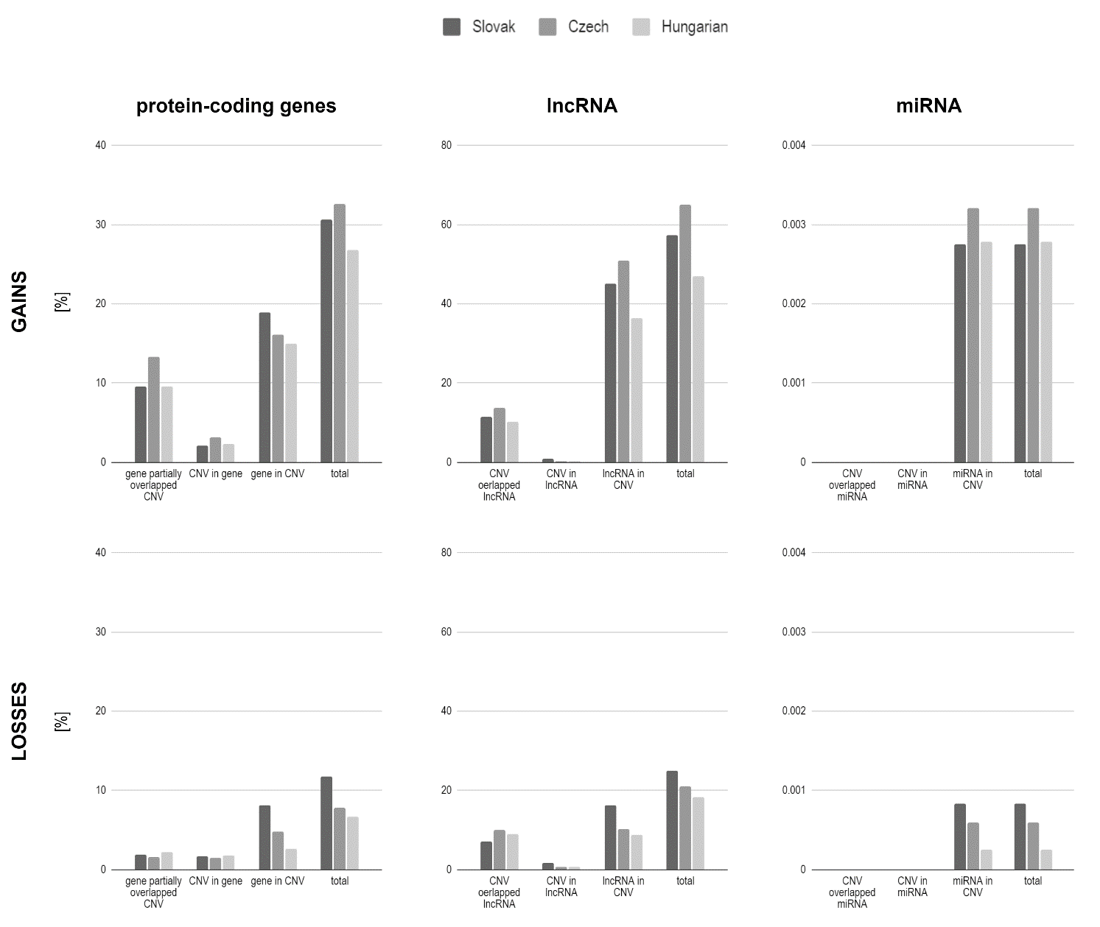
Supplementary Figure 1. The proportions of CNV overlaps for protein-coding genes, lncRNA, and miRNA calculated separately in the studied populations for gains and losses. gene - protein-coding gene, lncRNA – long non-coding RNA, miRNA – microRNA.

Supplementary Table 1. Distribution of gain and loss CNVs on individual chromosomes according to populations.
chromosome | Slovak |  |  |  | Czech |  |  |  | Hungarian
chromosome | gains |  | losses |  | gains |  | losses |  | gains |  | losses
chromosome | count | % | count | % | count | % | count | % | count | % | count | %
1 | 143 | 5.55 | 49 | 4.87 | 35 | 7.61 | 10 | 6.17 | 42 | 6.87 | 15 | 6.15
2 | 134 | 5.2 | 71 | 7.05 | 36 | 7.83 | 4 | 2.47 | 28 | 4.58 | 19 | 7.79
3 | 123 | 4.77 | 71 | 7.05 | 24 | 5.22 | 15 | 9.26 | 26 | 4.26 | 20 | 8.2
4 | 101 | 3.92 | 56 | 5.56 | 12 | 2.61 | 9 | 5.56 | 23 | 3.76 | 19 | 7.79
5 | 88 | 3.41 | 58 | 5.76 | 20 | 4.35 | 10 | 6.17 | 28 | 4.58 | 11 | 4.51
6 | 300 | 11.64 | 43 | 4.27 | 49 | 10.65 | 6 | 3.7 | 66 | 10.8 | 13 | 5.33
7 | 147 | 5.7 | 101 | 10.03 | 22 | 4.78 | 23 | 14.2 | 35 | 5.73 | 30 | 12.3
8 | 194 | 7.53 | 49 | 4.87 | 24 | 5.22 | 10 | 6.17 | 51 | 8.35 | 15 | 6.15
9 | 72 | 2.79 | 60 | 5.96 | 7 | 1.52 | 15 | 9.26 | 12 | 1.96 | 14 | 5.74
10 | 65 | 2.52 | 48 | 4.77 | 8 | 1.74 | 9 | 5.56 | 16 | 2.62 | 10 | 4.1
11 | 146 | 5.66 | 21 | 2.09 | 35 | 7.61 | 4 | 2.47 | 45 | 7.36 | 5 | 2.05
12 | 120 | 4.65 | 42 | 4.17 | 17 | 3.7 | 3 | 1.85 | 42 | 6.87 | 14 | 5.74
13 | 47 | 1.82 | 32 | 3.18 | 2 | 0.43 | 5 | 3.09 | 2 | 0.33 | 9 | 3.69
14 | 62 | 2.4 | 21 | 2.09 | 8 | 1.74 | 1 | 0.62 | 10 | 1.64 | 4 | 1.64
15 | 143 | 5.55 | 38 | 3.77 | 29 | 6.3 | 7 | 4.32 | 22 | 3.6 | 7 | 2.87
16 | 56 | 2.17 | 18 | 1.79 | 13 | 2.83 | 3 | 1.85 | 14 | 2.29 | 4 | 1.64
17 | 51 | 1.98 | 44 | 4.37 | 14 | 3.04 | 7 | 4.32 | 12 | 1.96 | 8 | 3.28
18 | 28 | 1.09 | 22 | 2.18 | 9 | 1.96 | 1 | 0.62 | 8 | 1.31 | 1 | 0.41
19 | 44 | 1.71 | 4 | 0.4 | 10 | 2.17 | 0 | 0 | 17 | 2.78 | 1 | 0.41
20 | 34 | 1.32 | 21 | 2.09 | 7 | 1.52 | 1 | 0.62 | 9 | 1.47 | 5 | 2.05
21 | 14 | 0.54 | 10 | 0.99 | 3 | 0.65 | 0 | 0 | 2 | 0.33 | 0 | 0
22 | 172 | 6.67 | 23 | 2.28 | 31 | 6.74 | 1 | 0.62 | 25 | 4.09 | 4 | 1.64
X | 294 | 11.4 | 105 | 10.43 | 45 | 9.78 | 18 | 11.11 | 76 | 12.44 | 16 | 6.56

Supplementary Table 2. Length range distribution of gain and loss CNVs according to populations.
length range [kbp] | Slovak |  |  |  | Czech |  |  |  | Hungarian
length range [kbp] | gains |  | losses |  | gains |  | losses |  | gains |  | losses
length range [kbp] | count | % | count | % | count | % | count | % | count | % | count | %
200-300 | 1068 | 41.43 | 497 | 49.35 | 165 | 35.87 | 79 | 48.77 | 204 | 33.39 | 130 | 53.28
300-400 | 533 | 20.67 | 243 | 24.13 | 107 | 23.26 | 36 | 22.22 | 130 | 21.28 | 51 | 20.90
400-500 | 318 | 12.34 | 99 | 9.83 | 66 | 14.35 | 12 | 7.41 | 88 | 14.40 | 27 | 11.07
500-600 | 151 | 5.86 | 44 | 4.37 | 34 | 7.39 | 8 | 4.94 | 40 | 6.55 | 5 | 2.05
600-700 | 125 | 4.85 | 23 | 2.28 | 15 | 3.26 | 8 | 4.94 | 31 | 5.07 | 6 | 2.46
700-800 | 90 | 3.49 | 18 | 1.79 | 19 | 4.13 | 2 | 1.23 | 13 | 2.13 | 11 | 4.51
800-900 | 58 | 2.25 | 16 | 1.59 | 9 | 1.96 | 3 | 1.85 | 15 | 2.45 | 4 | 1.64
900-1000 | 34 | 1.32 | 6 | 0.60 | 9 | 1.96 | 3 | 1.85 | 13 | 2.13 | 2 | 0.82
1000-1100 | 28 | 1.09 | 8 | 0.79 | 3 | 0.65 | 1 | 0.62 | 10 | 1.64 | 1 | 0.41
1100-1200 | 21 | 0.81 | 6 | 0.60 | 3 | 0.65 | 3 | 1.85 | 4 | 0.65 | 1 | 0.41
1200-1300 | 24 | 0.93 | 2 | 0.20 | 7 | 1.52 | 0 | 0.00 | 8 | 1.31 | 2 | 0.82
1300-1400 | 14 | 0.54 | 4 | 0.40 | 2 | 0.43 | 0 | 0.00 | 2 | 0.33 | 1 | 0.41
1400-1500 | 14 | 0.54 | 2 | 0.20 | 1 | 0.22 | 2 | 1.23 | 3 | 0.49 | 1 | 0.41
1500-1600 | 5 | 0.19 | 3 | 0.30 | 2 | 0.43 | 0 | 0.00 | 2 | 0.33 | 0 | 0.00
1600-1700 | 41 | 1.59 | 10 | 0.99 | 6 | 1.30 | 3 | 1.85 | 8 | 1.31 | 2 | 0.82
1700-1800 | 5 | 0.19 | 1 | 0.10 | 1 | 0.22 | 0 | 0.00 | 3 | 0.49 | 0 | 0.00
1800-1900 | 3 | 0.12 | 0 | 0.00 | 0 | 0.00 | 0 | 0.00 | 1 | 0.16 | 0 | 0.00
1900-2000 | 2 | 0.08 | 4 | 0.40 | 1 | 0.22 | 1 | 0.62 | 1 | 0.16 | 0 | 0.00
2000-3000 | 13 | 0.50 | 5 | 0.50 | 6 | 1.30 | 1 | 0.62 | 3 | 0.49 | 0 | 0.00
3000-4000 | 3 | 0.12 | 0 | 0.00 | 2 | 0.43 | 0 | 0.00 | 23 | 3.76 | 0 | 0.00
4000-5000 | 3 | 0.12 | 2 | 0.20 | 0 | 0.00 | 0 | 0.00 | 7 | 1.15 | 0 | 0.00
5000-6000 | 11 | 0.43 | 2 | 0.20 | 2 | 0.43 | 0 | 0.00 | 2 | 0.33 | 0 | 0.00
over 6000 | 14 | 0.54 | 12 | 1.19 | 0 | 0.00 | 0 | 0.00 | 0 | 0.00 | 0 | 0.00

Supplementary Table 3. CNVs with allelic frequency ≥ 1 % in at least one population and comparison of their frequencies between populations.
 | CNV position | p-value |  | Variant frequency in the population [%]:
 | CNV position | all pop | 2 pop | Slovak | Czech | Hungarian
gains | 1:175420000-175780000 | 0.2115 |  | 0.66 | 1.2 | 0.82
gains | 6:168260000-168600000 | 0.0526 |  | 3.39 | 2.28 | 2.37
gains | 8:2260000-2640000 | 2.18x10⁻⁸ |  | 1.61 | NA | NA
gains | 8:2340000-2580000 | 2.29x10⁻¹³ | 0.8977 | NA | 1.09 | 1.15
gains | 11:134320000-134720000 | 0.7769 |  | 1.3 | 1.3 | 1.55
gains | 15:32020000-32420000 | 0.0633 |  | 0.875 | 1.52 | 0.575
gains | 22:22280000-22580000 | 0.0284 |  | 2.44 | 2.5 | 1.23
losses | 2:35760000-36080000 | 0.1579 | 0.4927 | 0.9 | NA | 1.23
losses | 3:145460000-145740000 | 0.335 |  | 0.95 | 1.23 | 0.82
losses | 7:64680000-64900000 | 0.0631 |  | 1.34 | 3.09 | 1.64
losses | 8:137620000-137900000 | 0.2084 | 0.4502 | 0.7 | NA | 1.02
losses | 9:11840000-12200000 | 0.0583 | 0.1484 | 0.95 | 1.23 | NA
losses | 12:20960000-21400000 | 0.0016 | 0.0017 | 0.3 | NA | 1.43
losses | 15:22760000-23080000 | 0.2656 |  | 1.34 | 1.85 | 0.62
losses | 17:50920000-51320000 | 0.6836 |  | 1.54 | 1.54 | 1.02
all pop - all population; 2 pop - 2 populations, in which the given variant was not zero; bold number - statistically significant after Bonferroni correction; allelic frequency over 1 %; NA - variant was not found in the given population.

Supplementary Table 4. CNVs with allele frequency > 1 % found in Slovak, Czech and Hungarian populations and gnomAD structural variants with comparable range. Data also include prediction of clinical significance according to the ISV tool (Gažiová et al., 2022), automated ACMG guidelines available at https://genovisio.com and X-CNV tool (Zhang et al., 2021).
 | CNV position | size [bp] | clinical significance |  |  |  |  | gnomAD structural variants with comparable range
 | CNV position | size [bp] | ISV | ACMG | X-CNV |  |  | Variant ID | position | size [bp] | consequence | allele frequency [%] (EU)
 |  |  |  |  | MPV score |  | related genes
gains | 1:175420000-175780000 | 360 000 | B | VUS | B | 0.123 | TNR | DUP_1_2651 | 1:175430116-175761840 | 331 724 | partial duplication | 0.06558
gains | 6:168260000-168600000 | 340 000 | VUS | VUS | VUS | 0.282 | KIF25, AFDN, FRMD1 | DUP_6_19621 | 6:168333440-168597751 | 264 311 | copy gain | 1.403
gains | 8:2260000-2640000 | 380 000 | B | B | B | 0.123 | - | DUP_8_23522 | 8:1704861-2281924 | 328 928 | intergenic | 0.4853
gains | 8:2340000-2580000 | 240 000 | B | B | B | 0.123 | - | -
gains | 11:134320000-134720000 | 400 000 | B | B | B | 0.123 | - | DUP_11_33705 | 11:134336900-134686177 | 439 449 | copy gain | 0
gains | 15:32020000-32420000 | 400 000 | VUS | B | LB | 0.154 | OTUD7A, CHRNA7 | -
gains | 22:22280000-22580000 | 300 000 | B | VUS | LB | 0.154 | PPM1F, TOP3B | -
losses | 2:35760000-36080000 | 320 000 | B | VUS | B | 0.123 | - | DEL_2_16311 | 2:35817000-36090000 | 273 000 | intergenic | 0.0664
losses | 3:145460000-145740000 | 280 000 | B | VUS | B | 0.123 | - | DEL_3_38017 | 3:145475545-145753483 | 277 938 | intergenic | 0.02623
losses | 7:64680000-64900000 | 220 000 | B | B | B | 0.123 | ZNF92 | -
losses | 8:137620000-137900000 | 280 000 | B | B | B | 0.123 | - | DEL_8_97671 | 8:137680282-137862372 | 182 090 | intergenic | 2.308
losses | 9:11840000-12200000 | 360 000 | B | B | B | 0.123 | - | -
losses | 12:20960000-21400000 | 440 000 | B | VUS | VUS | 0.187 | SLCO1B1, SLCO1B3, AC022335.1, SLCO1B7, AC011604.2 | DEL_12_126286 | 12:21007643-21412242 | 404 599 | loss of function | 0.03935
losses | 15:22760000-23080000 | 320 000 | VUS | VUS | P | 0.84 | NIPA2, NIPA1,  CYFIP1, TUBGCP5 | -
losses | 17:50920000-51320000 | 400 000 | VUS | VUS | B | 0.123 | - | DEL_17_161110 | 17:50951275-51314632 | 363 358 | loss of function | 0.02623
B - benign, LB - likely benign, P - pathogenic, VUS - variant of uncertain significant; bold CNV position - no comparable range was found in gnomAD. ISV - Interpretation of Structural Variants prediction method. ACMG - The American College of Medical Genetics and Genomics classification. X-CNV - analysis interface predicts the pathogenicity of CNVs with GRCh37/hg19 Genome Reference. MPV score - meta-voting prediction score, the probability that the CNV is pathogenic. Variant allele frequency in the individual population can be found in Supplementary Table3.

Gažiová, M., Sládeček, T., Pös, O., Števko, M., Krampl, W., Pös, Z., et al. (2022). Automated prediction of the clinical impact of structural copy number variations. Sci. Rep. 12, 555.
Zhang, L., Shi, J., Ouyang, J., Zhang, R., Tao, Y., Yuan, D., et al. (2021). X-CNV: genome-wide prediction of the pathogenicity of copy number variations. Genome Med. 13, 132.

Supplementary Table 5. The proportions of individual CNV-biotype overlaps for genes, lncRNA, and miRNA calculated separately in the studied populations for gains and losses.
overlap type | Gains |  |  | Losses
overlap type | Slovak | Czech | Hungarian | Slovak | Czech | Hungarian
gene partially overlapped CNV | 9.62 % | 13.26 % | 9.58 % | 1.89 % | 1.55 % | 2.23 %
CNV in gene | 2.08 % | 3.18 % | 2.33 % | 1.68 % | 1.50 % | 1.80 %
gene in CNV | 18.90 % | 16.11 % | 14.92 % | 8.17 % | 4.77 % | 2.65 %
total | 30.59 % | 32.56 % | 26.84 % | 11.74 % | 7.82 % | 6.69 %
lncRNA partially overlapped CNV | 11.43 % | 13.84 % | 10.29 % | 7.02 % | 9.97 % | 8.94 %
CNV in lncRNA | 0.91 % | 0.21 % | 0.34 % | 1.78 % | 0.78 % | 0.61 %
lncRNA in CNV | 45.08 % | 50.85 % | 36.27 % | 16.23 % | 10.24 % | 8.85 %
total | 57.42 % | 64.90 % | 46.90 % | 25.03 % | 20.99 % | 18.40 %
miRNA partially overlapped CNV | 0 % | 0 % | 0 % | 0 % | 0 % | 0 %
CNV in miRNA | 0 % | 0 % | 0 % | 0 % | 0 % | 0 %
miRNA in CNV | 0.003 % | 0.003 % | 0.003 % | 0.001 % | 0.001 % | 0.0003 %
total | 0.003 % | 0.003 % | 0.003 % | 0.001 % | 0.001 % | 0.0003 %
gene - protein-coding gene, lncRNA - long non-coding RNA, miRNA - microRNA.

