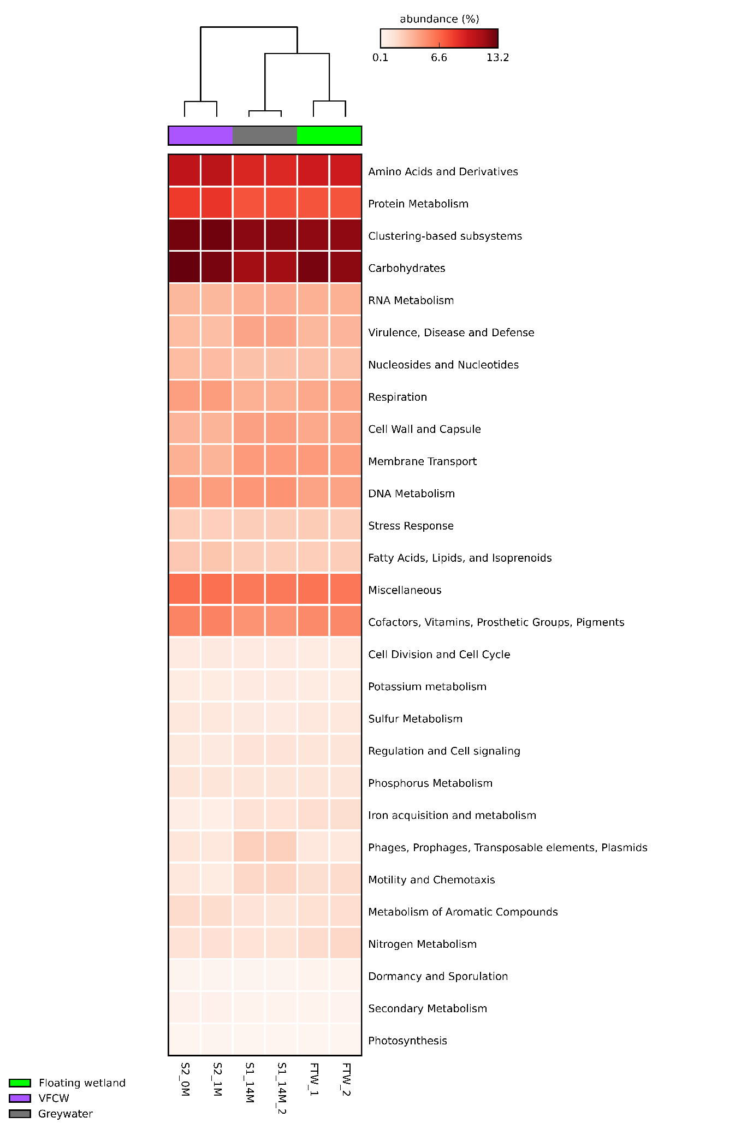
Fig S1: Functional annotation of metagenomes classified against SEED subsystems level I. Heat map depicting abundance of reads in GW, VFCW and FTW.

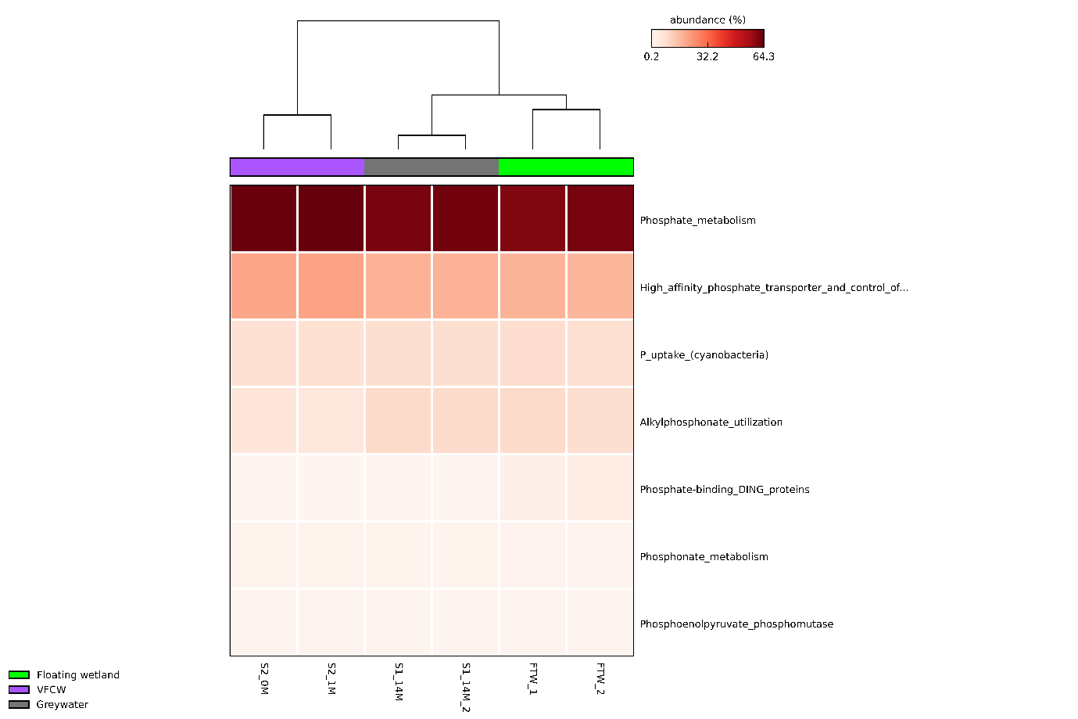
Figure S2: Heat map depicting abundance of reads in FTW, GW and VFCW metagenomes classified against Phosphate metabolism in SEED subsystems level III.

