Supplemental Table 1. Univariable and Multivariable analyses for the survival of the whole corhot.
 | OS |  |  | EFS
 | Univariate | Multivariate |  | Univariate | Multivariate
 | P | HR(95%CI) | P | P | HR(95%CI) | P
Sex, M/F | 0.985 | - | - | 0.698 | - | -
Age (<50 vs ≥50) | 0.995 | - | - | 0.982 | - | -
Disease type  (s/t-AML vs de novo) | 0.09 | 2.07(1.07-3.99) | 0.03 | 0.112 | - | -
ECOG performance (<3 vs ≥3) | 0.42 | - | - | 0.033 | - | -
Salvage treatment (VAH vs VA) | 0.005 | 0.52(0.33-0.82) | 0.005 | <0.001 | 0.47(0.34-0.66) | <0.001
Prior to HMAs | 0.193 | - | - | 0.594 | - | -
Prior to HSCT | 0.131 | - | - | 0.21 | - | -
BM blasts  (<30% vs ≥30%) | 0.068 | - | - | 0.029 | - | -
ELN risk (adverse vs non-adverse) | 0.034 | - | - | 0.02 | - | -
Cytogenetics (adverse vs non-adverse) | 0.018 | 1.63(1.01-2.60) | 0.044 | 0.298 | 1.64(1.16-2.31) | 0.005
Bridge to HSCT | <0.001 | 0.29(0.14-0.58) | <0.001 | <0.001 | 0.52(0.34-0.79) | 0.003
OS, overall survival; EFS, event-free survival; M/F, male/female; s/t-AML, secondary/therapy acute myeloid leukemia; ECOG, Eastern Cooperative Oncology Group; VAH, venetoclax + azacitidine + homoharringtonine; VA, venetoclax + azacitidine; HMAs, hypomethylating agents; HSCT, hematopoietic stem cell transplantation; BM, bone marrow; ELN, European Leukemia Net.

Supplemental Table 2. Subgroup analyses of the CRc rate of VAH versus VA based on genetic patterns.
 | VA | VAH | P value
 | (N=149) | (N=172) | P value
Gene mutation
TET2 | 19/41(46.3) | 38/57(66.7) | 0.044
FLT3-ITD/TKD | 14/37(37.8) | 28/40(70) | 0.005
DNMT3A | 17/32(53.1) | 37/46(80.4) | 0.010
N/KRAS | 7/24(29.2) | 15/21(71.4) | 0.005
RUNX1 | 10/24(41.7) | 25/42(59.5) | 0.162
ASXL1 | 13/21(61.9) | 25/35(71.4) | 0.460
IDH1/2 | 17/23(73.9) | 20/28(71.4) | 0.843
NPM1 | 19/31(61.3) | 17/21(81) | 0.132
CEBPA | 12/19(63.2) | 17/23(73.9) | 0.453
TET1 | 1/5(20) | 7/14(50) | 0.243
TP53 | 4/9(44.4) | 4/11(36.4) | 0.714
SRSF2 | 6/7(85.7) | 4/5(80) | 0.793
Co-mutations
DNMT3A+NPM1+ | 8/16(50) | 11/13(84.6) | 0.051
ASXL1+TET2+ | 5/8(62.5) | 16/21(76.2) | 0.461
NPM1+FLT3+ | 8/18(44.4) | 6/8(75) | 0.149
DNMT3A+IDH1/2+ | 7/10(70) | 10/12(83.3) | 0.457
DNMT3A+BCOR+ | 4/6（66.7%） | 8/10（80%） | 0.551
NPM1+IDH1/2+ | 8/10(80) | 4/5(80) | 1.000
BCOR+IDH1/2+ | 4/4(100) | 5/6(83.3) | 0.389
DNMT3A+FLT3+NPM1+ | 3/10(30) | 4/6(66.7) | 0.152
Genetic pathway
Signaling | 20/65(30.8) | 44/62(71) | <0.001
Methylation-related | 37/72(51.4) | 69/99(69.7) | 0.015
Spliceosome | 10/22(45.5) | 11/15(73.3) | 0.093
Transcription factors | 26/51(51) | 43/65(66.2) | 0.098
Tumor suppressor | 7/16(43.8) | 19/29(65.5) | 0.157
Chromatin modifiers | 22/35(62.9) | 37/51(72.5) | 0.442
Cytogenetic
AML-ETO | 1/10(10.0) | 9/13(69.2) | 0.013
complex karotype | 4/17(23.5) | 8/20(40) | 0.286
MLL rearrangment | 5/9(55.6) | 6/19(31.6) | 0.225
-5/5q-, -7/7q- | 5/8(62.5) | 7/18(38.9) | 0.265

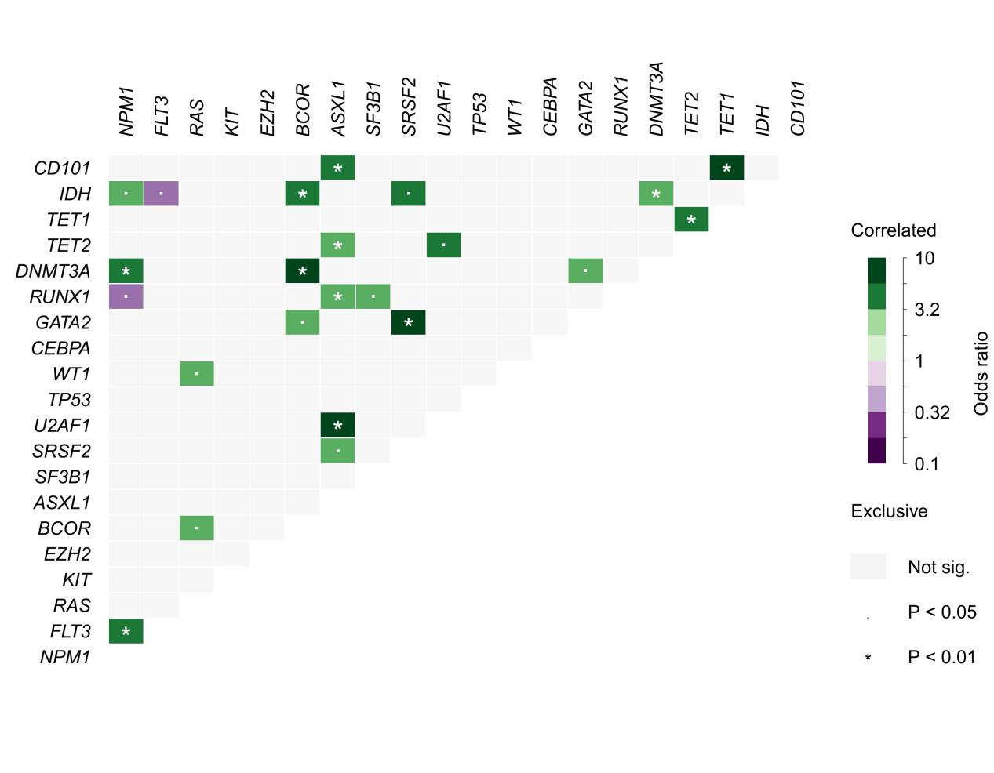Supplemental Figure 1. Analysis of pairwise co-mutation and mutual exclusivity in the top 20 most frequently detected gene mutations. Green/blue colours denote preferential co-mutation/high overlap, while pink/red colours indicate mutual exclusivity.

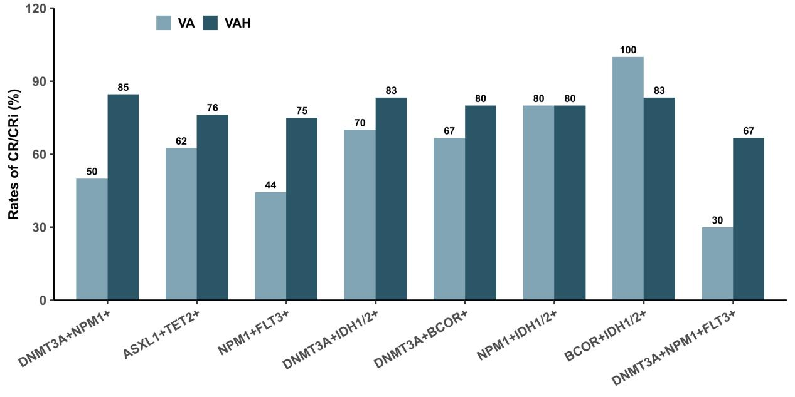
Supplemental Figure 2. Impact of co-mutations on the CRc rate of VAH versus VA.

Supplemental Figure 3. Subgroup analyses of the OS of VAH versus VA regimens based on genetic patterns.

