- Additional file 1: Genes identified in this study: SirexChemosensationGenesInfo.xls
- Additional file 2: Data and references for phylogenetic analyses: ChemosensoryGenesInsectsPhylogenetics.docx
- Additional file 3: RNA Sequencing data information: RNA libraries.xlsx
- Additional file 4: Heatmap of DESeq countdata for all chemosensation genes: CSHM.pdf
- Additional file 5: Phylogenetic tree of OR family: OrTreeOrco9ExonQSirexSpecific.pdf
- Additional file 6: Heatmap of DESeq countdata for OR family: ORDESeqHeatmap.pdf
- Additional file 7: Phylogenetic tree of GR family: GRTreeSugarFructoseCO2Pheromone16112021.pdf
- Additional file 8: Heatmap of DESeq countdata for GR family: GRDESeqHeatmap.pdf
- Additional file 9: Phylogenetic tree of IR family: IrTreeTiplabsAlignedAnnotatedDivergent590.pdf
- Additional file 10: Heatmap of DESeq countdata for IR family: RDESeqHeatmap.pdf
- Additional file 11: Phylogenetic tree of OBP genes: OBPAntWaspBee16112021.pdf
- Additional file 12: Heatmap of DESeq countdata for OBP genes: OBPDESeqHeatmap.pdf
- Additional file 13: Multiple sequence alignment of Sirex CSP amino acid sequences depicting conserved Cysteine residues: CSPConservedCys.png
- Additional file 14: Heatmap of DESeq of countdata for CSP genes: CSPDESeqHeatmap.pdf

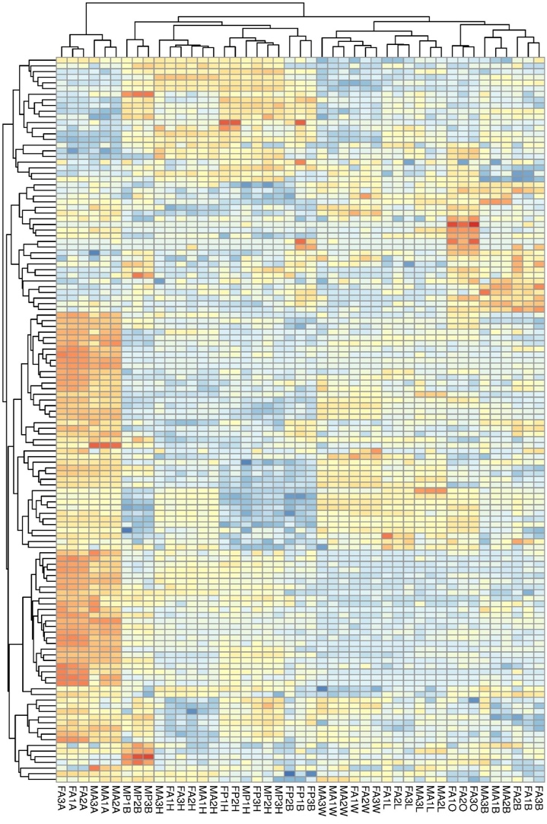
Additional file 4: Heatmap of chemosensation gene expression in Sirex noctilio. Normalised count data was used to produce this figure using the pheatmap package (https://CRAN.Rproject.org/package=pheatmap). The tissue samples for which gene expression was measured are shown on the x-axis (for the 3 biological replicates) and chemosensation genes (Snoc*) are shown on the y-axis.
Count data was produced using featurecounts (http://subread.sourceforge.net). Gene expression data was hierarchically clustered using a k-means approach and count data was transformed using variance stabilizing transformation, both using the R DESeq2 package (Love MI, Huber W, Anders S (2014). “Moderated estimation of fold change and dispersion for RNA-seq data with DESeq2.” Genome Biology, 15, 550. doi: 10.1186/s13059-014-0550-8).

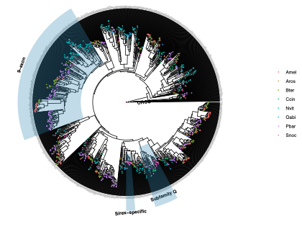
Additional file 5: Phylogenetic tree of OR genes from Sirex noctilio (Snoc), Apis mellifera (Amel), Athalia rosae (Aros), Bombus terristris (Bter), Cephus cinctus (Ccin), Nasonia vitripennis (Nvit), Orussus abietinus (Oabi) and Pogonomyrmex barbatus (Pbar). Sub-families of interest are highlighted: ORCO, 9-exon, Sirex-specific and Subfamily Q.

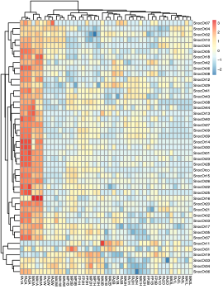
Additional file 6: Heatmap depicting differential expression results for OR genes in Sirex noctilio.

Additional file 7: Phylogenetic tree of GR genes from Sirex noctilio (Snoc), Anopheles gambiae (Agam), Apis mellifera (Amel), Athalia rosae (Aros), Bombyx mori (Bmor), Bombus terristris (Bter), Cephus cinctus (Ccin), Drosophila melanogaster (Dmel), Nasonia vitripennis (Nvit), Orussus abietinus (Oabi), Pogonomyrmex barbatus (Pbar) and Tribolium castaneum (Tcas). Sub-families of interest are highlighted and include: pheromone receptors, sugar and fructose receptors and carbon dioxide receptors

Additional file 8: Heatmap depicting differential expression results for GR genes in Sirex noctilio.

Additional file 9: Phylogenetic tree of IR genes from Sirex noctilio (Snoc), Apis mellifera (Amel), Athalia rosae (Aros), Bombus terristris (Bter), Cephus cinctus (Ccin), Drosophila melanogaster (Dmel), Nasonia vitripennis (Nvit), Orussus abietinus (Oabi) and Pogonomyrmex barbatus (Pbar). Sub-families of interest are highlighted and include: Divergent receptors and Co-receptors (Ir8a and Ir25a).

Additional file 10: Heatmap depicting differential expression results for IR genes in Sirex noctilio.

Additional file 11: Phylogenetic tree of OBP genes from Sirex noctilio (Snoc), Apis mellifera (Amel), Cephus cinctus (Ccin), Nasonia vitripennis (Nvit) and Solenopsis invicta (Sinv). Sub-families of interest are highlighted and include a bee-specific clade, a wasp-specific clade and an ant-specific clade.

Additional file 12: Heatmap depicting differential expression results for OBP genes in Sirex noctilio

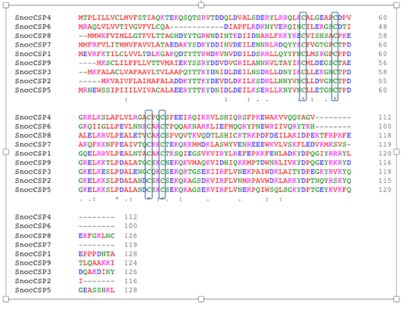
Additional file 13: Protein sequence alignment of Sirex noctilio Chemosensory Proteins (CSP). Conserved Cysteine-residues are highlighted with grey blocks.

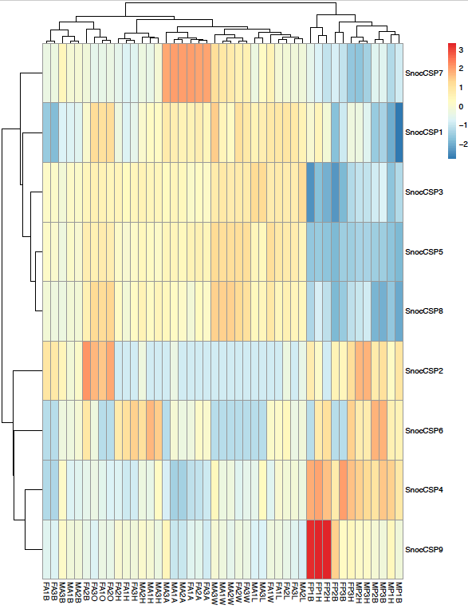

Additional file 14: Heatmap depicting differential expression results for CSP genes in Sirex noctilio

