Supporting Information
for
Photocatalytic degradation of polyethylene and polystyrene microplastics by α-Fe₂O₃/g-C₃N₄

Chao Chaiª, Hao Liang^{b}, Ruike Yaoª, Fangli Wangª, Ningning Songª, Juan Wuª, Yan Li^{c,}*
∗ Corresponding author at: Institute of Agricultural Resource and Environment, Shandong Academy of Agricultural Sciences, Jinan 250100, China
E-mail address: nkyliyan@126.com

ª School of Resources and Environment, Qingdao Engineering Research Center for Rural Environment, Qingdao Agricultural University, Qingdao, 266109, China
^{b} School of Engineering, China Pharmaceutical University, Nanjing 210009, China
^{c} Institute of Agricultural Resource and Environment, Shandong Academy of Agricultural Sciences, Jinan 250100, China

- Characterization of α-Fe₂O₃/g-C₃N₄
The SEM image of α-Fe₂O₃/g-C₃N₄ composite in Fig. S1a indicates that the α-Fe₂O₃ are decorated on the g-C₃N₄ substrate, which results in the formation of a heterogeneous interface. The existence of C, N, O and Fe elements in the α-Fe₂O₃/g-C₃N₄ composite is proved by the EDX pattern (Fig. 1c). Meanwhile, the characteristic morphology of α-Fe₂O₃ in the TEM images of the α-Fe₂O₃/g-C₃N₄ composite (Fig. 1b) demonstrates the existence of α-Fe₂O₃ in the α-Fe₂O₃/g-C₃N₄ composite.
In order to reveal the crystalline and phase structures of the prepared α-Fe₂O₃/g-C₃N₄ composites, the XRD pattern of the α-Fe₂O₃/g-C₃N₄ composites was measured and shown in Fig. 1d. For α-Fe₂O₃/g-C₃N₄, the two diffraction peaks at 12.91 and 27.53 are index to (100) and (002) planes of g-C₃N₄. The diffraction peaks of the derived α-Fe₂O₃ are corresponding with that of typical hematite (JCPDS No. 33-0664). Only reflection peaks of the corresponding components can be seen in the XRD patterns of the α-Fe₂O₃/g-C₃N₄ composite. No other impurity peaks can be detected, which indicates the final synthetic substance with high purity.

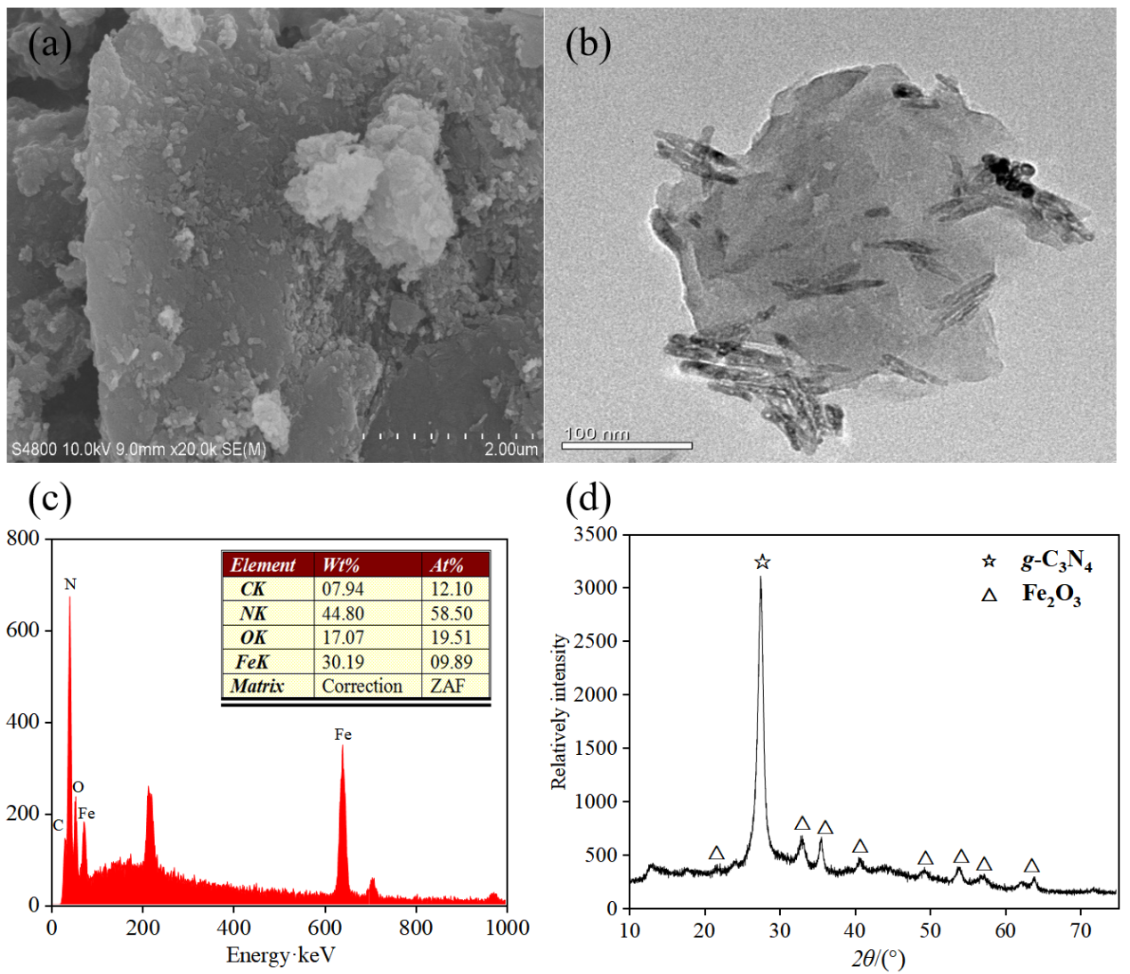
Fig. S1. SEM image (a) TEM image (b) EDX (c) XRD pattern of α-Fe₂O₃/g-C₃N₄ composite.

