More than three-fold increase of compound soil and air dryness across Europe by end of 21st century
Ankit Shekhar¹, Nina Buchmann¹, Vincent Humphrey² Mana Gharun³
¹ Department of Environmental Systems Science, ETH Zürich, 8092 Zürich, Switzerland
² Federal Office of Meteorology and Climate MeteoSwiss, Zürich, Switzerland
³ Faculty of Geosciences, University of Münster, 48149 Münster, Germany

Supplementary Materials

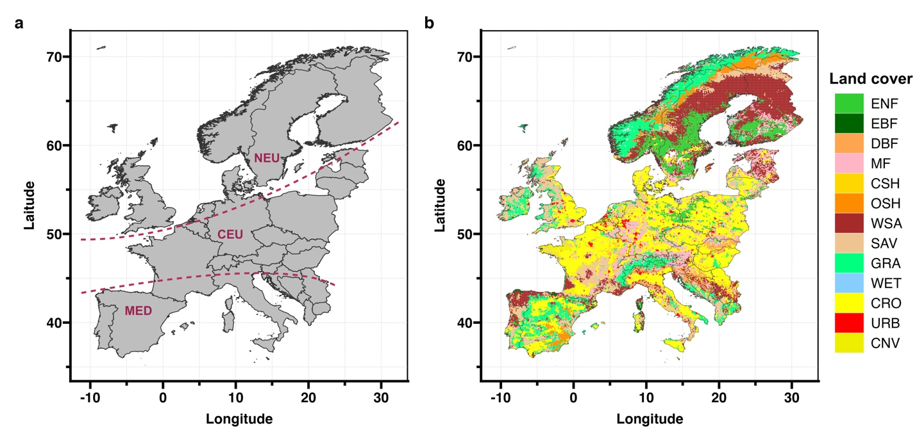
Figure S1. (a) Study area separated into Northern Europe (NEU), Central Europe (CEU) and Mediterranean Europe (MED)¹ and (b) Land cover of Europe of the year 2021 obtained from the MODIS land cover data (MCD12Q1 version 6.1)². The land cover code is as per the IGBP (International Geosphere-Biosphere Program) classification. ENF – Evergreen Needleleaf Forest, EBF – Evergreen Broadleaf Forest, DBF – Deciduous Broadleaf Forest, MF – Mixed Forest, CSH – Closed Shrublands, OSH – Open Shrublands, WSA – Wooden Savannas, SAV – Savannas, GRA – Grasslands, WET – Wetlands, CRO – Croplands, URB – Urban & Build-up Area, CNV – Cropland and Natural Vegetation Mosaics.

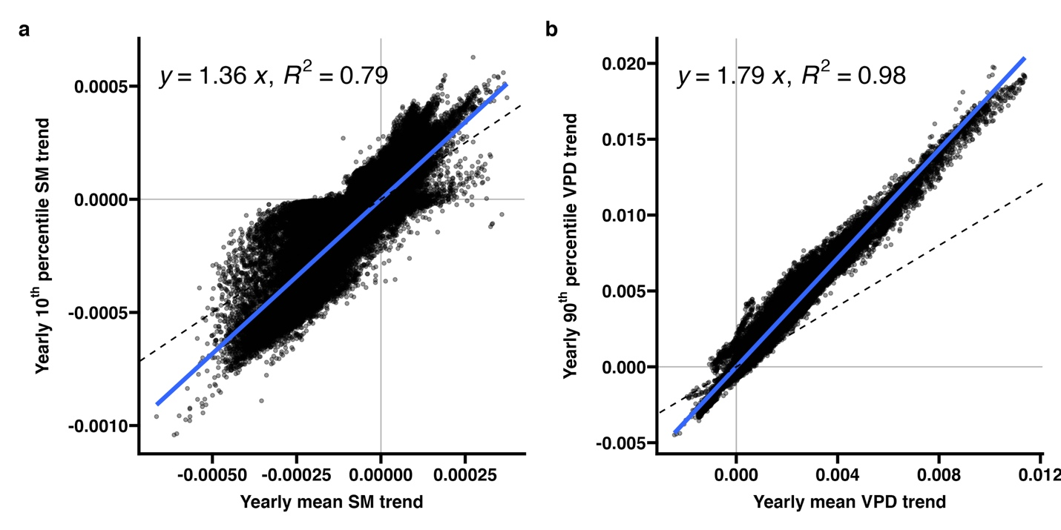
Figure S2. Comparison of trend of (a) yearly mean SM and yearly 10th percentile SM (extreme SM threshold), and (b) yearly mean VPD and yearly 90th percentile VPD (extreme VPD threshold). The 1:1 line is shown in dashed.

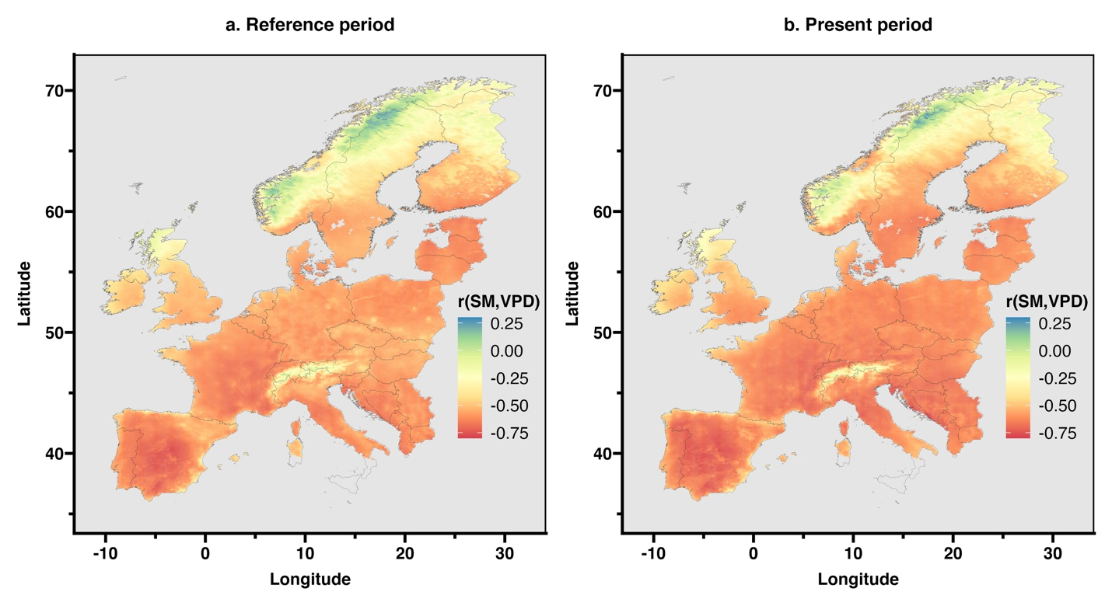
Figure S3. Pearson correlation between daily SM and VPD during (a) reference period of 1950-1990 and (b) present period of 1991-2021.
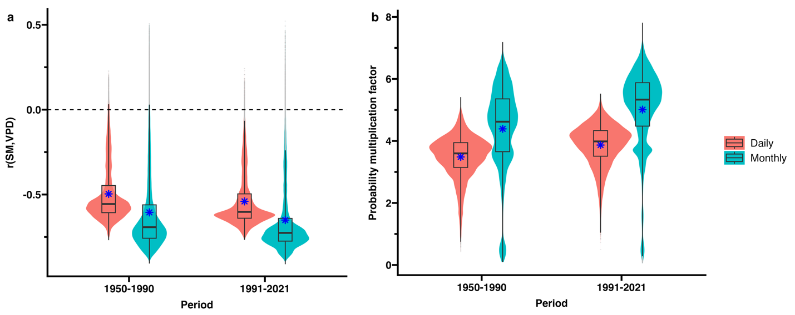
Figure S4. Comparison of (a) SM-VPD coupling (as represented by Pearson correlation and coefficient) and (b) probability multiplication factor of co-occurrence of extreme SM and VPD at daily and monthly scale over reference period (1950-1990) and present period (1991-2021).

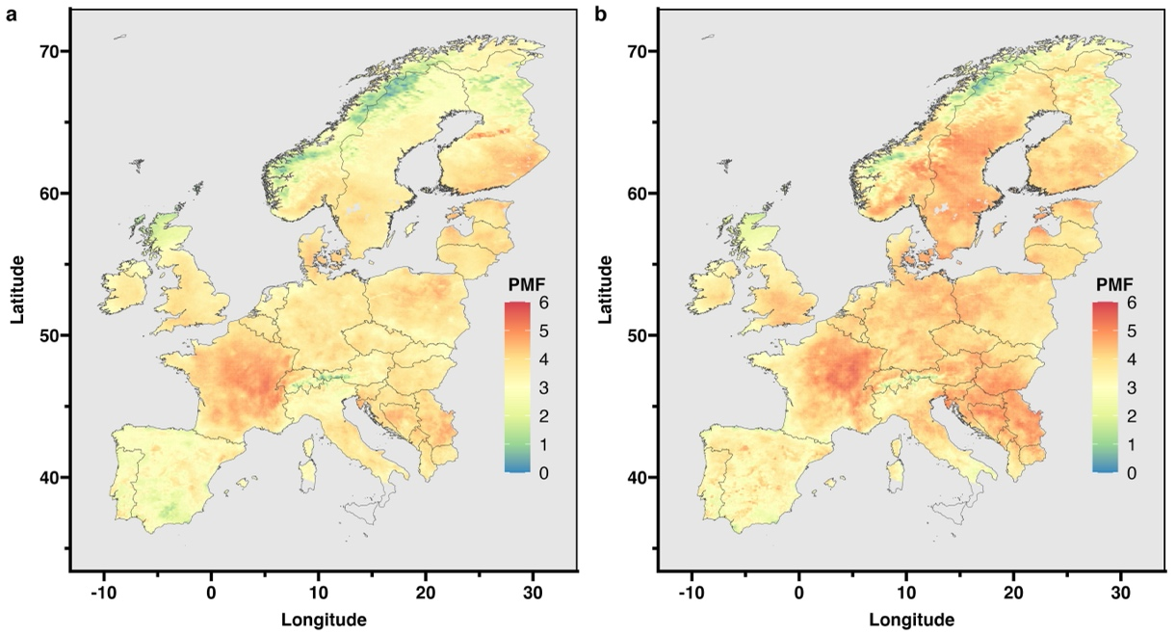
Figure S5. Probability multiplication factor (PMF) of compound extreme dryness during (a) reference period of 1950-1990 and (b) present period of 1991-2021.

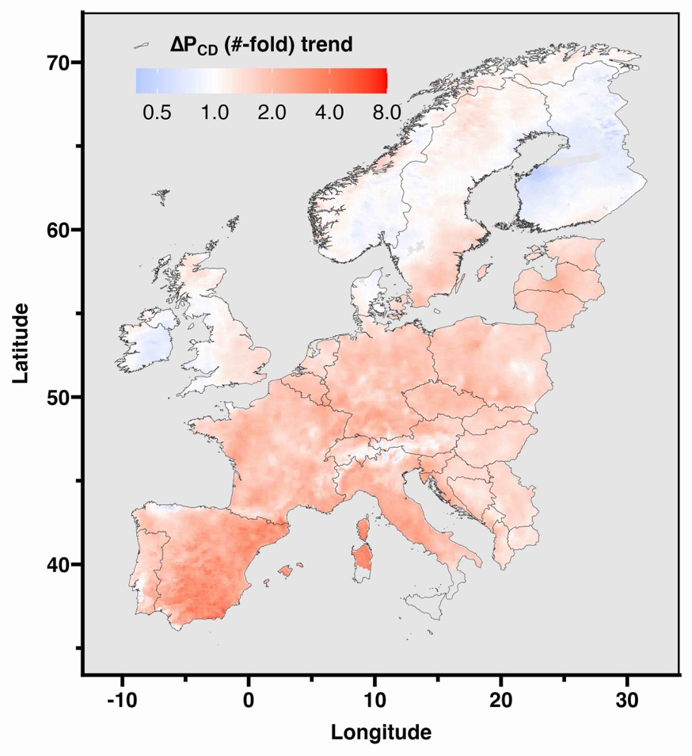
Figure S6. The change in the probability of the occurrence of compound extreme dryness (P_{CD}) across Europe due to decreasing SM and/or increasing VPD trend from reference to the present period.

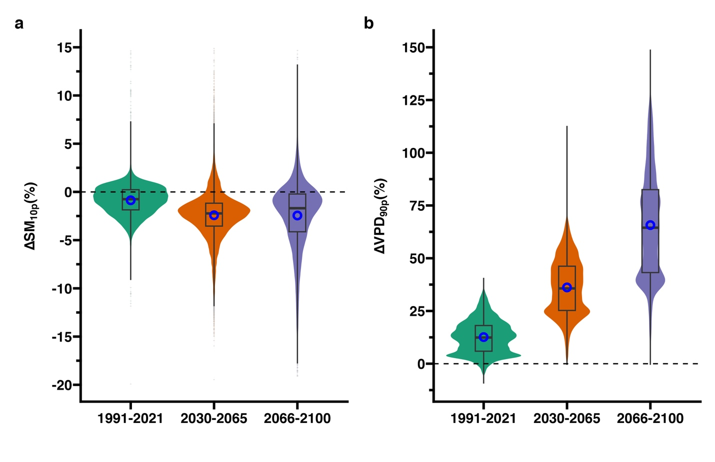
Figure S7. (a) The percent change in 10th percentile SM threshold (∆SM_{10P}) and (b) 90th percentile VPD threshold (∆VPD_{90P}) during present period (1991-2021), mid 21st century (2030-2065) and late 21st century (2066-2100) compared to reference period (1950-1990). The change is calculated based five RCM simulations- ALADIN63, HadREM3-GA7-05, RACMO22E, CCLM4-8-17, and HIRHAM5 using the boundary conditions from the MPI-M-MPI-ESM-LR global climate model and then averaged.

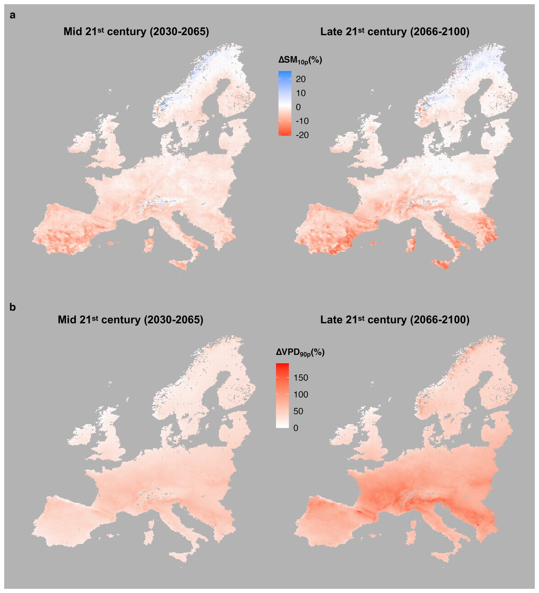
Figure S8. (a) Projected change in SM_{10P} during mid 21st century and late 21st century compared to reference period over Europe and (b) projected change in VPD_{90P} during mid 21st century and late 21st century compared to reference period over Europe. The change is calculated based five RCM simulations- ALADIN63, HadREM3-GA7-05, RACMO22E, CCLM4-8-17, and HIRHAM5 using the boundary conditions from the MPI-M-MPI-ESM-LR global climate model and then averaged.

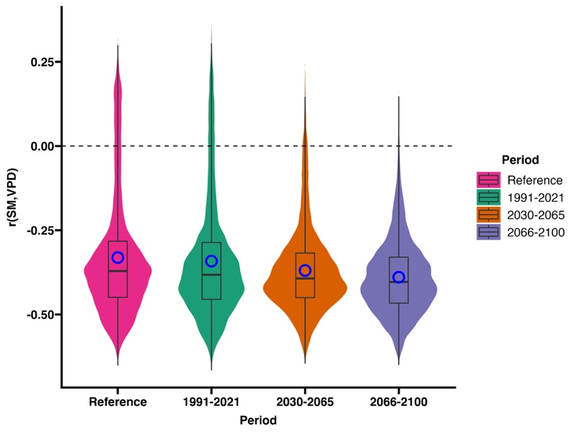
Figure S9. Dependence between SM and VPD as indicated by the Pearson coefficient correlation – r(SM,VPD), during reference, present and future periods as estimated from output from five RCM models. The correlations between periods were significantly different. The correlation values calculated based five RCM simulations- ALADIN63, HadREM3-GA7-05, RACMO22E, CCLM4-8-17, and HIRHAM5 using the boundary conditions from the MPI-M-MPI-ESM-LR global climate model and then averaged.

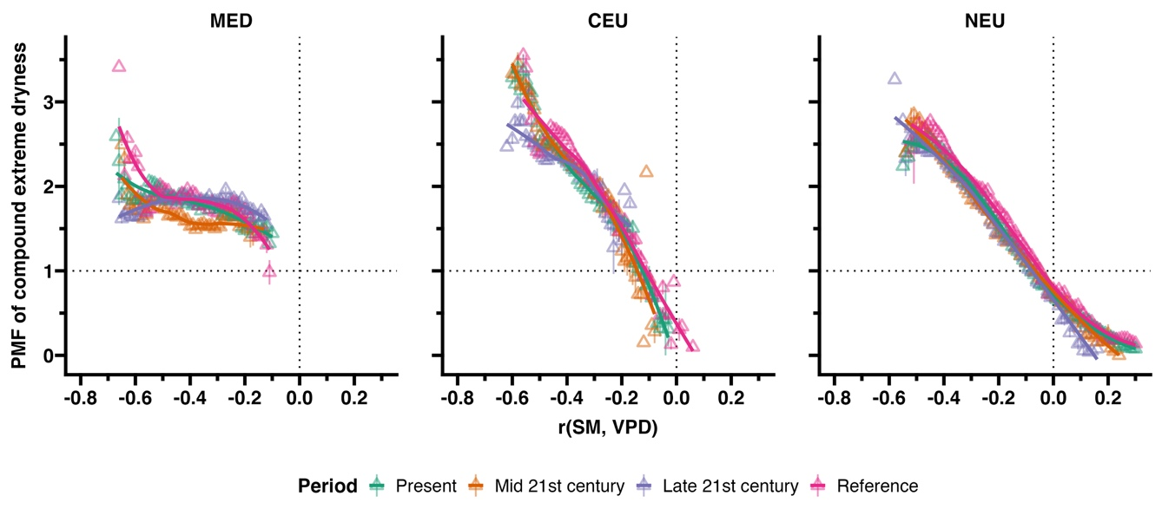
Figure S10. Relationship of coefficient correlation between daily SM and VPD (x-axis: r(SM,VPD) with probability multiplication factor of compound extreme dryness across Mediterranean Europe (MED), Central Europe (CEU) and Northern Europe (NEU) during reference period (1950-1990), present period (1991-2021), mid 21st century (2030-2065) and late 21st century (2066-2100). The curve fitting is done with a locally moving weighted regression (loess with span = 0.8). Each point and error bar represents mean and standard error for a bin of r(SM,VPD) = 0.01.

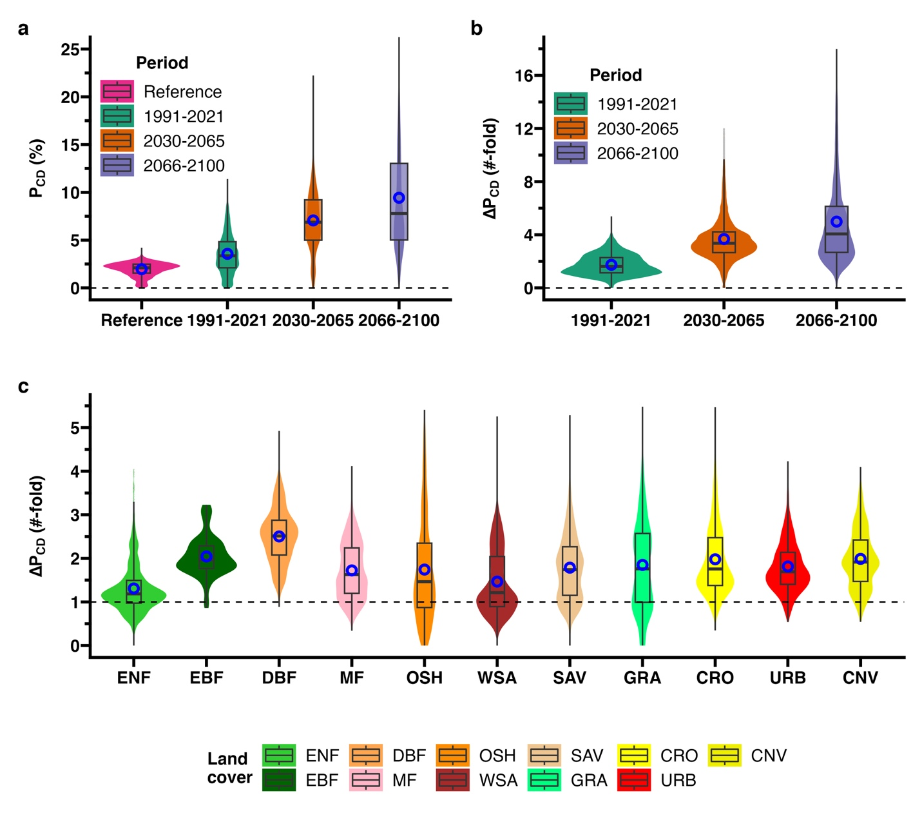
Figure S11. (a) Probability of compound dry extremes based on SM and VPD thresholds during the reference period. (b) Change in probability (in terms of number of times) during the present (1991-2021), mid-21st century (2030-2065) and late-21st century (2066-2100) compared to the reference period. (c) Change in probability during the present period compared to the reference period across different 2021 land cover types in Europe based on the RCM ensemble mean.

Reference
1. Markonis, Y. et al. The rise of compound warm-season droughts in Europe. Science Advances 7, (2021).
2. Friedl, M. & Sulla-Menashe, D. MCD12C1 MODIS/Terra+ Aqua Land Cover Type Yearly L3 Global 0.05 Deg CMG V006 [Data set]. NASA EOSDIS Land Processes DAAC (2015) doi:https://doi.org/10.5067/MODIS/MCD12C1.006.

