SUPPLEMENTARY MATERIAL

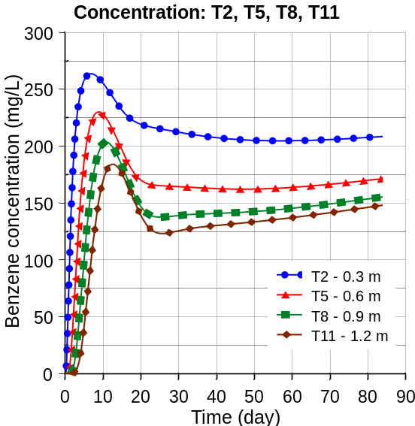
(2)
(1)

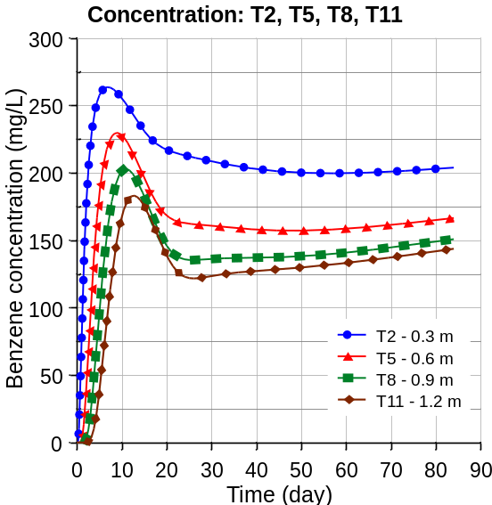

Figure A - modelling of benzene biodegradation with variations of sensitive Monod parameters

With the same bacterial concentration, variations of μ_{máx,Aer} from 1.022 d⁻¹ (Figure A1) and 1.059 d⁻¹ (Figure A2), were performed. Furthermore, soil dispersivity was decreased from 0.035m to 0.030m, respectively. As simulated in Figures A1 and A2, there was no significant deviation. Therefore, dispersivity has little influence on the variation of benzene concentration.

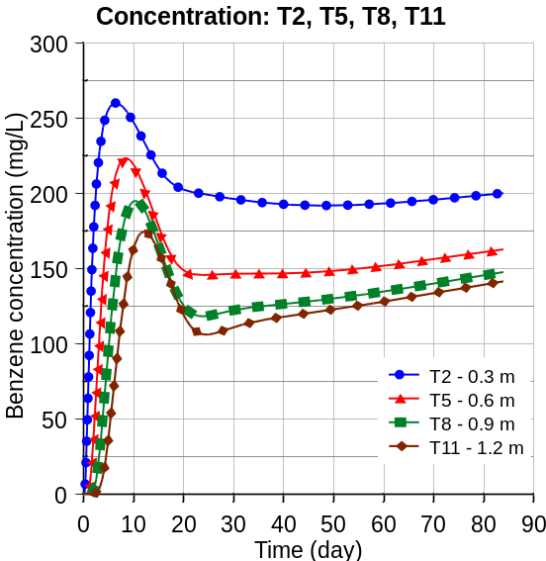
(2)
)
(1)
)

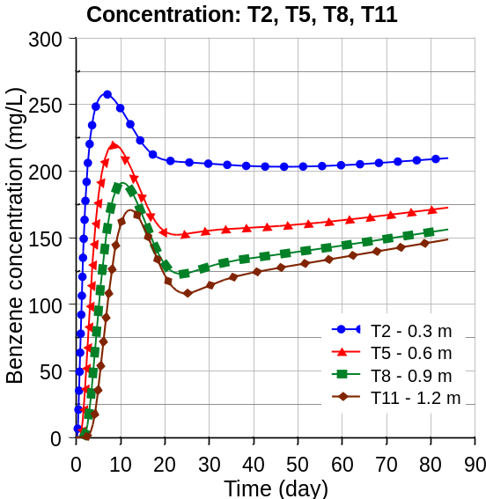

Figure B - modelling of benzene biodegradation

In Figures B1 and B2 a decrease of μ_{máx,An} from 0.325 d⁻¹ to 0.30 d⁻¹ was applied, respectively, with little increase in the concentration of benzene appearing in the curves with the low variation of Δ=0.025 d⁻¹. Besides, dispersivity was also decreased respectively from 0.03 m to 0.02 m, respectively. The greatest effect appeared at the beginning of the modelling process, as a lower dispersivity decreases contaminant dispersion thus keeping the system predominantly aerobic at first, although rapidly shifting. On the other hand, when comparing Figure C1 to Figure 8b (in the article), where only dispersivity had varied, no variation in benzene concentration was observed. Therefore, the results demonstrate that dispersivity does not affect benzene concentration.

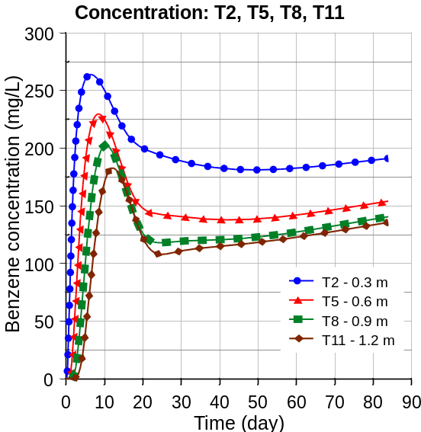
(2)
)
(1)
)

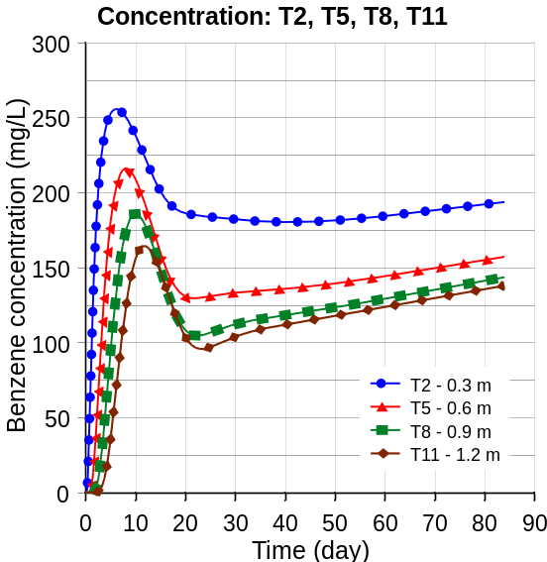

Figure C - modelling of benzene biodegradation with variations of dispersivity and μ_{máx,An}

Figures C1 and B1 differ in aerobic (X_{Aer}) and anaerobic (X_{An}) bacterial concentration: in Fig. 3a, X_{Aer} =15 mg/L, X_{An} =1,5 mg/L, and in Fig. 2a, X_{Aer} =20 mg/L, X_{An}=2 mg/L. Mainly, a significant decrease in benzene concentration is seen at the beginning of the simulation. On the other hand, comparing the previous results with those in Figures 8f (in the artice) and C2, where variations in m_{max,An} were applied, from 0.325 to 0.35 d⁻¹, respectively, the curves present little variation during the simulation, showing the effect is mainly due to the initial concentration of bacteria. Here, m_{max,An} has little influence due to its low variation (Δ=0.025 d⁻¹).
Finally, in Figure C2 and Figure 8f (in the article), where the m_{máx,An} was increased to values of 0.35 d⁻¹ and 0.375 d⁻¹, respectively, results show a lower but still significant difference in benzene degradation.

