Supplementary figures:
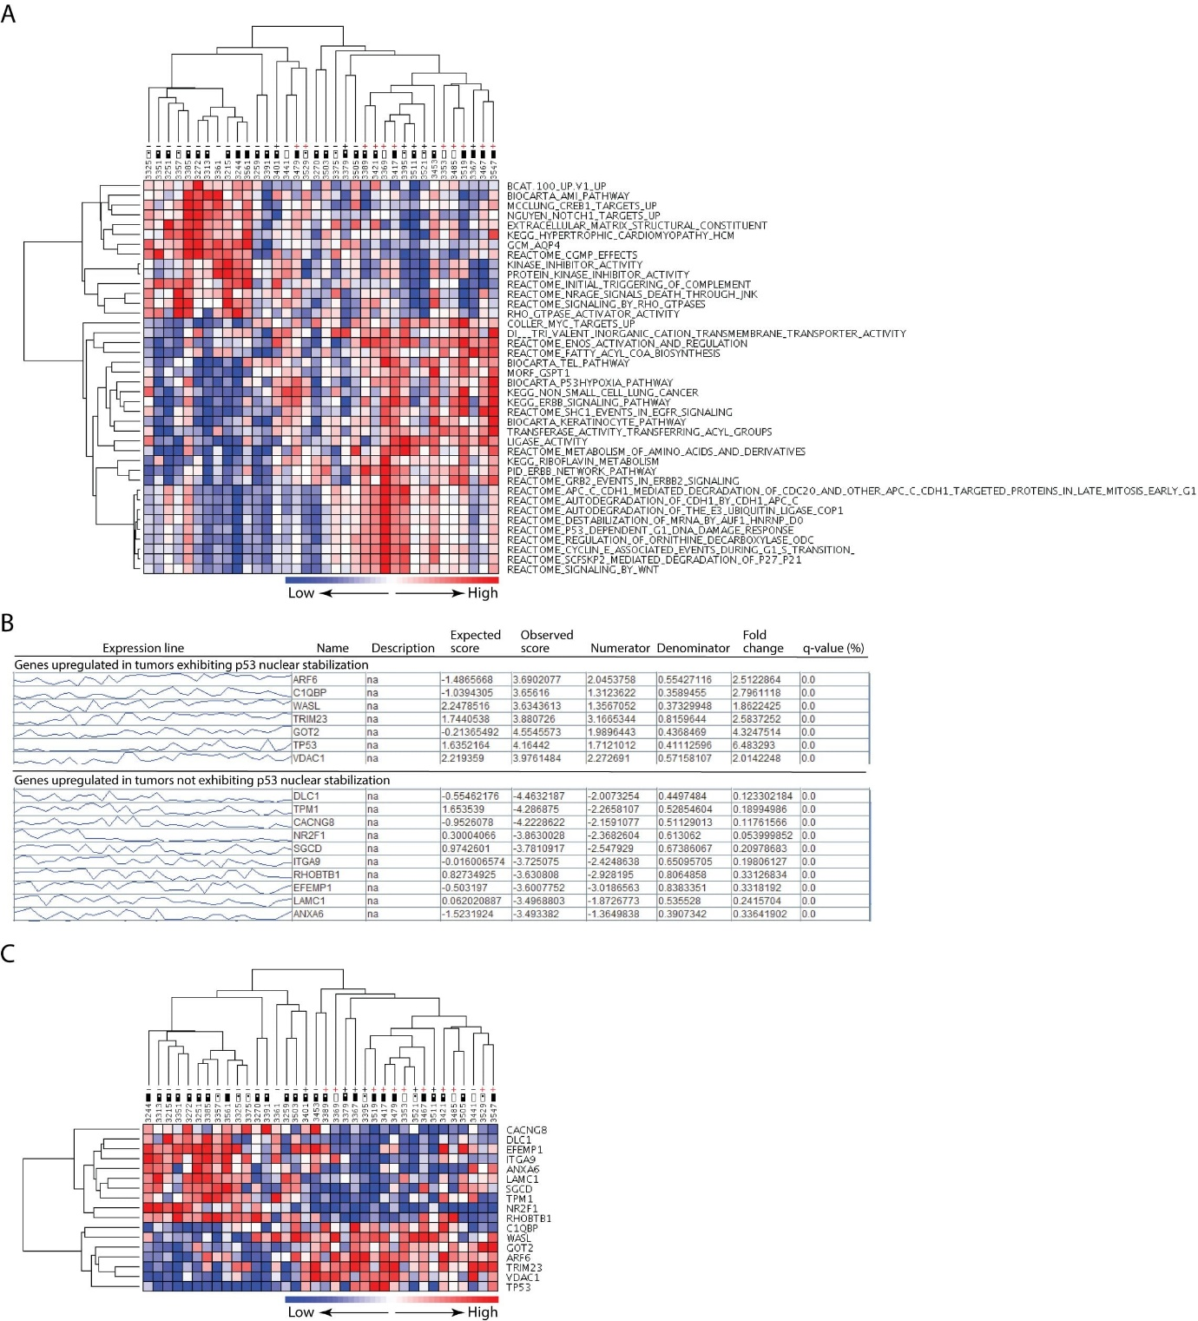Figure S1. Genome-wide transcript profiling of ESCC tumor samples to identify transcriptional targets of mutant p53. Identification of gene sets (A) and genes (B-C) differentially expressed between ESCC tumor samples stratified for p53 status. – and +, p53 NS- and NS+ respectively (red colour denotes mutant p53); box with and without dot, node positive and negative respectively; open and filled box, tumor stage 1 or 2 and 3 or 4, respectively
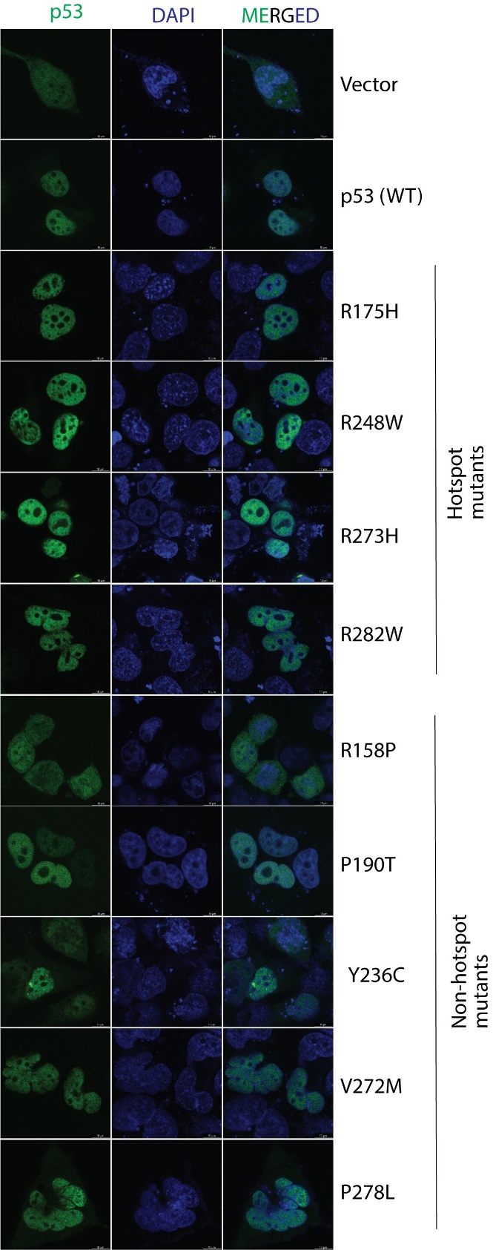
Figure S2. Fluorescence-based visualization of intracellular localization of wild type and various mutant p53 forms. The localizations of different ectopically-expressed p53-EGFP proteins were assessed in H1299 squamous cell carcinoma cell line.
Figure S3. Evaluation of expression levels of ectopically expressed wild type and different mutant p53 forms in KYSE-410 (A), H1299 (B), NT-8e (C), AW13516 (D) and JHU-011 (E) cells; in relation to Figures 2, 3 and S4

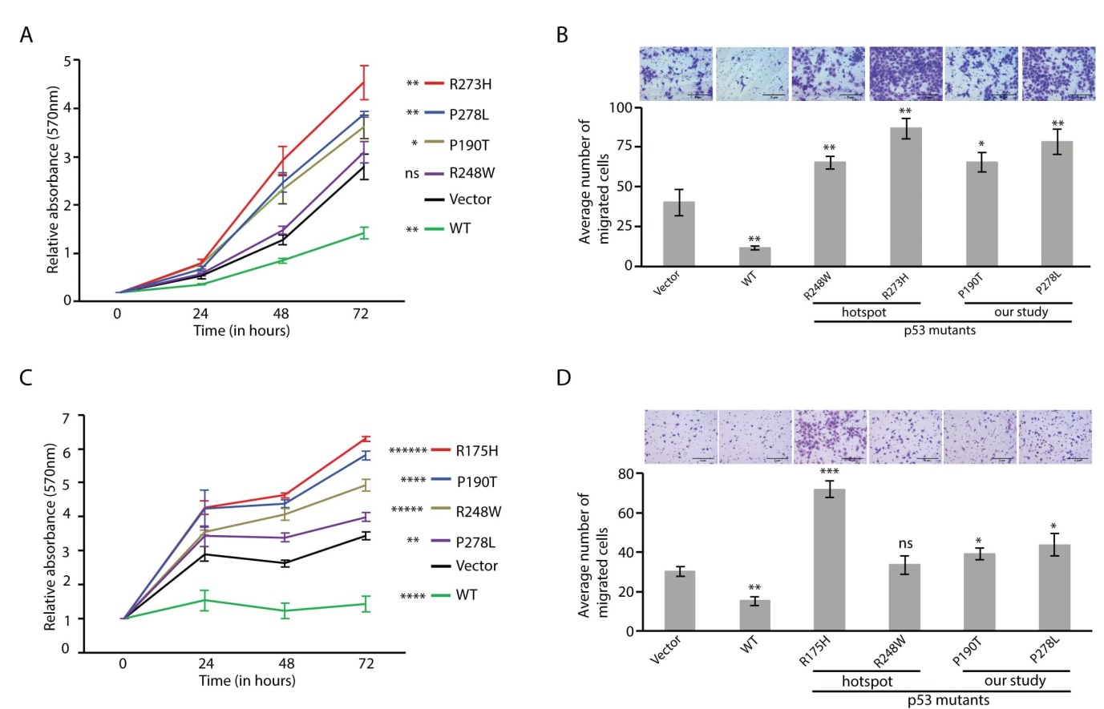Figure S4. Evaluation of oncogenic potential of ‘non-hotspot’ mutant p53 proteins (in relation to Figure 2). Results for MTT (A, C) and cell migration (B, D) are shown for NT-8e (A-B) and JHU-011 (C-D) cells. Each result is based on at least three independent experiments; *, P<0.05; **, P<0.01; ***, P<0.001; ****, P<0.0001; *****, P<0.00001; ******, p<0.000001; ns, not significant (unpaired student’s t-test)

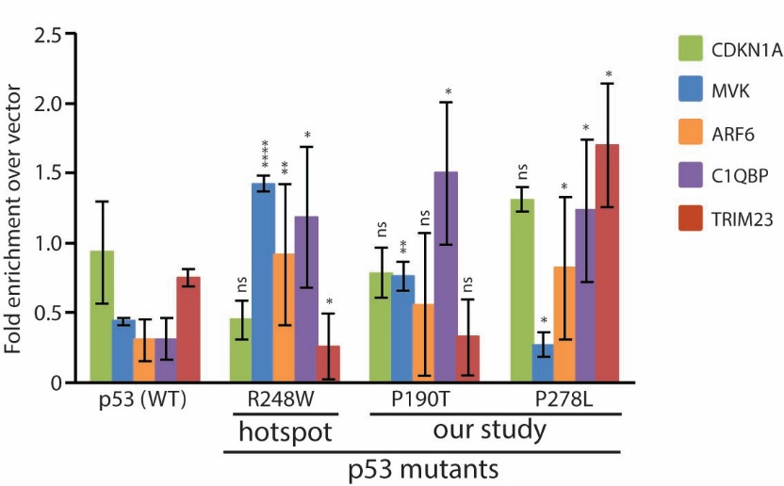
Figure S5. ChAP assay for gene body region of target genes for wild type and various mutant p53 forms (in relation to Figure 3F). Each result is based on at least three independent experiments; *, P<0.05; **, P<0.01; ****, P<0.0001; ns, not significant (unpaired student’s t-test)

Figure S6. Evaluation of the expression levels of ARF6, C1QBP or TRIM23 to confirm knockdown (A-C; in relation to Figure 4 and S7), or expression in rescue experiments (D-F) in relation to Figures 5, S8 and S9. A, D, KYSE-410; B, E, AW13516; C, F, H1299

Figure S7. ARF6, C1QBP and TRIM23 exhibit oncogenic properties in AW13516 (A-F) and H1299 (G-I) cells as determined by performing various tumorigenic assays following stable knockdown (in relation to Figure 4). MTT (A-C and G-I); cell growth (D); colony formation (E), and cell migration (F and J). Each result is based on at least three independent experiments; *, P<0.05; **, P<0.01; ***, P<0.001; ns, not significant (unpaired student’s t-test)

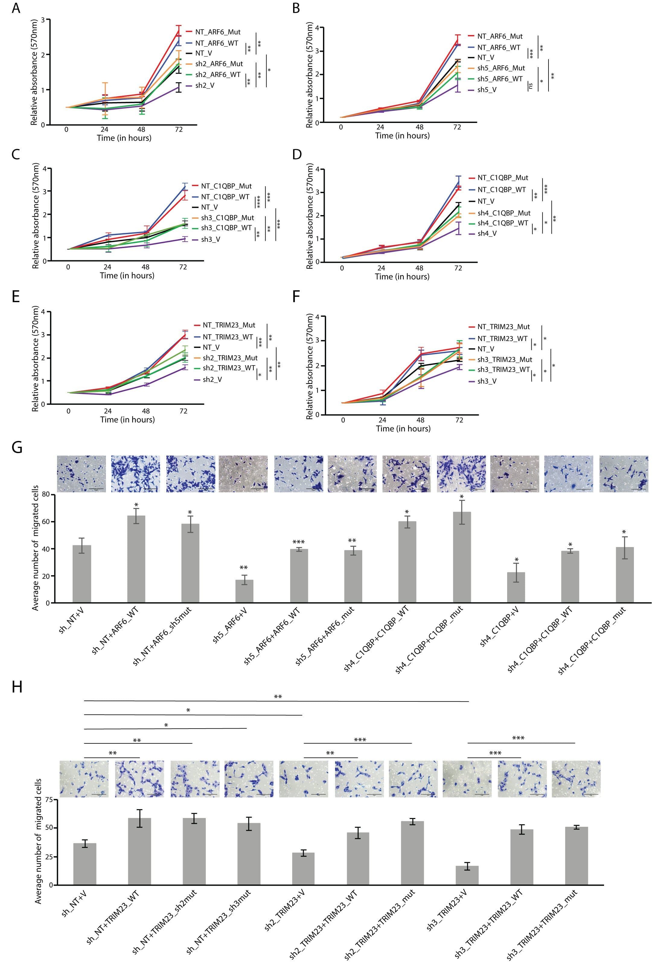
Figure S8. Rescue of reduced cell viability (A-F) and cell migration (G-H) upon respective protein expression in AW13516 cells harboring stable knockdown of ARF6, C1QBP or TRIM23. Both the wild type and the mutant (generated to avoid being targeted by the shRNA) forms of the over-expressed target proteins were observed to rescue the loss of oncogenic phenotypes brought about by their respective knockdown. Each result is based on at least three independent experiments; *, P<0.05; **, P<0.01; ***, P<0.001; ****, P<0.0001; ns, not significant (unpaired student’s t-test)

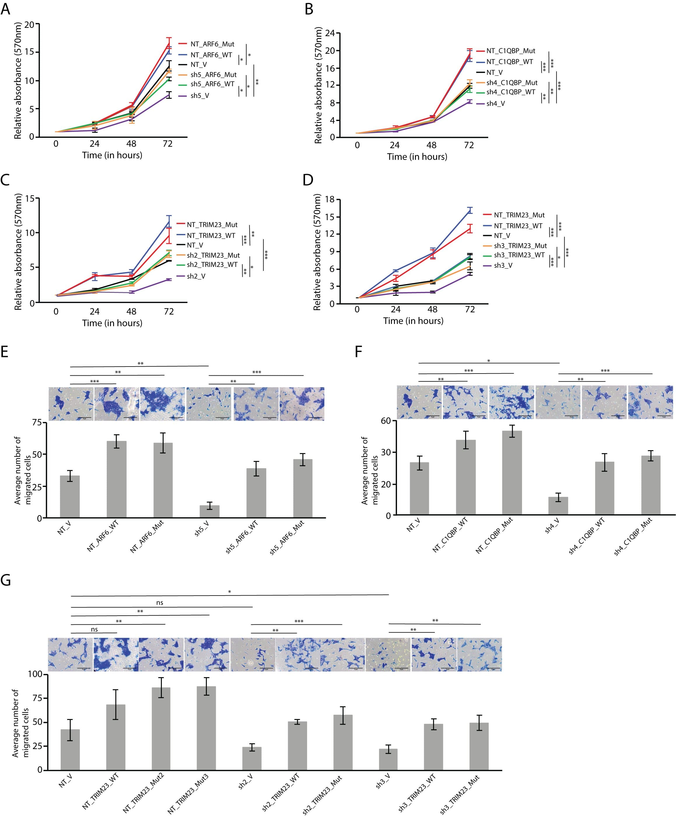Figure S9. Rescue of reduced cell viability (A-D) and cell migration (E-G) upon respective protein expression in H1299 cells harboring stable knockdown of ARF6, C1QBP or TRIM23. Both the wild type and the mutant (generated to avoid being targeted by the shRNA) forms of the over-expressed target proteins were observed to rescue the loss of oncogenic phenotypes brought about by their respective knockdown. Each result is based on at least three independent experiments; *, P<0.05; **, P<0.01; ***, P<0.001; ns, not significant (unpaired student’s t-test)
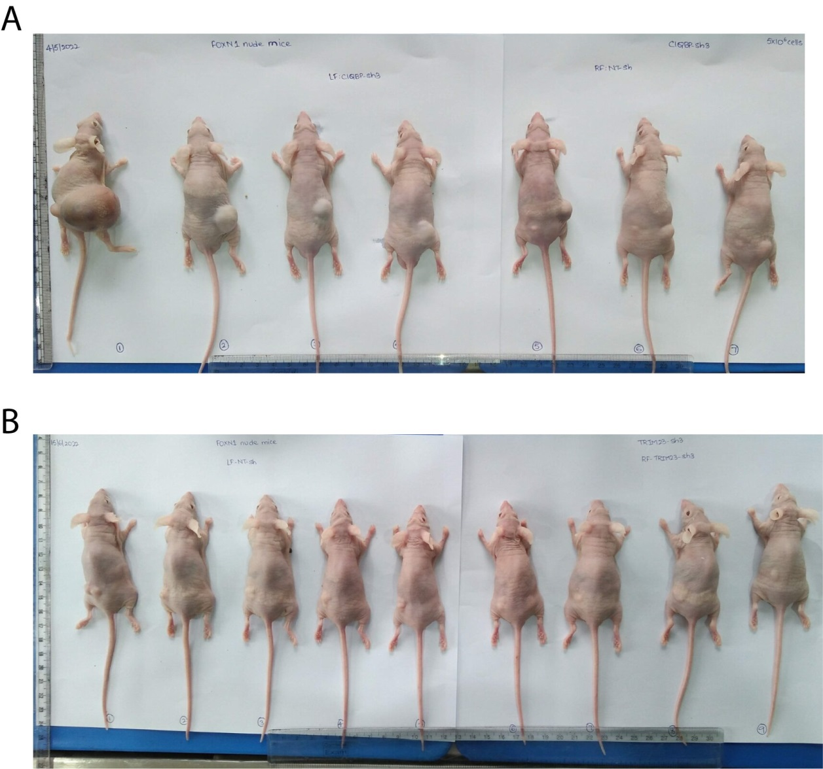
Figure S10. Validation of the oncogenic role of C1QBP and TRIM23 in AW13516 squamous carcinoma cells based on nude mice xenograft assays. (in relation to Figure 6). Images of mice injected with AW13516 cells harboring either control (right flank: C1QBP (panel A), left flank: TRIM23 (panel B)) or gene-specific (left flank: C1QBP (panel A), right flank: TRIM23 (panel B)) shRNA stable constructs (C1QBP, panel A; TRIM23, panel B) following euthanization is shown

Supplementary tables:
Table S1. Details of samples used for array-based expression analysis of ESCC samples
Sample number | Age/ Gender | Grade | Stage | IHC status | p53 status
3215 | 22/M | I | pT3N2 | NS- | WT
3244 | 45/M | I | pT3N0 | NS- | WT
3251 | 52/F | I | pT3N1 | NS- | WT
3259 | 50/F | I | pT3N1 | NS- | WT
3270 | 34/F | I | pT3N1 | NS- | WT
3272 | 55/M | I | pT3N2 | NS- | WT
3313 | 48/F | II | pT3N1bM1b | NS- | WT
3325 | 64/M | II | pT2N1a | NS- | WT
3351 | 70/M | II | pT3N1 | NS- | WT
3353 | 68/F | II | pT2N0Mx | NS+ | p.G266R
3357 | 23/F | II | pT2N2 | NS- | WT
3361 | 45/M | II | NA | NS- | WT
3367 | 62/M | I | pT3N0 | NS+ | WT
3369 | 59/M | I | pT2N0 | NS+ | p.P278L
3375 | 64/F | II | pT2N1b | NS- | WT
3379 | 58/F | II | pT3N1Mx | NS+ | WT
3385 | 50/F | II | pT3N1 | NS- | WT
3389 | 41/M | I | pT3N1 | NS+ | p.F134C
3391 | 50/M | I | pT3N2Mx | NS- | WT
3395 | 47/M | I | pT2N1 | NS+ | WT
3401 | 66/F | I | pT3N2Mx | NS+ | WT
3417 | 62/M | II | pT3N0Mx | NS+ | p.R158P
3421 | 38/F | I | pT3N1 | NS+ | p.P190T
3441 | 79/M | I | pT2N0 | NS- | WT
3453 | 61/M | I | pT3N1 | NS- | WT
3467 | 38/M | I | pT3N0 | NS+ | p.P152T
3479 | 59/M | I | pT3N0 | NS+ | p.C176Y
3485 | 39/F | I | pT2N0 | NS+ | p.V172F
3503 | 32/F | I | pT3N2Mx | NS- | WT
3505 | 55/F | I | pT3N1 | NS- | WT
3511 | 46/M | I | pT3N1 | NS+ | WT
3519 | 69/M | II | pT3N0 | NS+ | p.R248W*
3521 | 61/M | I | pT2N1 | NS+ | WT
3529 | 54/M | II | pT2N1 | NS+ | p.Y163C
3547 | 38/M | I | pT3N0 | NS+ | p.Y236C
3561 | 64/M | I | pT3N0 | NS- | WT
*, a hotspot mutation

Table S2A. Number of samples used for RT-qPCR based gene expression validation in p53 NS+ vs NS- samples
Gene | Number of samples
Gene | Arrayed |  | Non-arrayed |  | Total
Gene | p53 status |  | p53 status |  | p53 status
Gene | NS+ | NS- | NS+ | NS- | NS+ | NS-
ARF6 | 8 | 10 | 2 | 3 | 10 | 13
C1QBP | 6 | 9 | 4 | 2 | 10 | 11
TRIM23 | 7 | 10 | 3 | 3 | 10 | 13

Table S2B. Number of samples used for RT-qPCR based transcript level correlation between TP53 and ARF6, C1QBP and TRIM23
Gene | Number of samples
Gene | Arrayed | Non-arrayed | Total
TP53 | 22 | 5 | 27
ARF6 | 22 | 5 | 27
C1QBP | 16 | 3 | 19
TRIM23 | 22 | 5 | 27

Table S2C. Number of samples used for RT-qPCR based gene expression validation in p53 mutant vs wild type samples
Gene | Number of samples
Gene | Arrayed |  | Non-arrayed |  | Total
Gene | p53 status |  | p53 status |  | p53 status
Gene | WT | Mutant | WT | Mutant | WT | Mutant
ARF6 | 11 | 7 | 5 | 0 | 16 | 7
C1QBP | 9 | 6 | 4 | 2 | 13 | 8
TRIM23 | 11 | 6 | 6 | 0 | 17 | 6

Table S2D. Number of samples used for RT-qPCR based gene expression validation in ESCC tumor vs matched normal
Gene | Number of samples
Gene | Arrayed |  | Non-arrayed |  | Total
Gene | p53 status |  | p53 status |  | p53 status
Gene | Tumour | Normal | Tumour | Normal | Tumour | Normal
ARF6 | 8 | 8 | 4 | 4 | 12 | 12
C1QBP | 8 | 8 | 4 | 4 | 12 | 12
TRIM23 | 8 | 8 | 2 | 2 | 10 | 10

Table S3: Frequency of TP53 mutations evaluated in this study in ESCC mutation databases
Mutation | The TP53 Database* | COSMIC# | TCGA~
Our study
F134 | 0.07% (0%) | 0.15% (0%) | 1.04% (0%)
P152 | 0.16% (0%) | 0.28% (0%) | 0% (0%)
R158 | 0.10% (0.03%) | 0.35% (0.03%) | 2.08% (0%)
Y163 | 0.16% (0.16%) | 0.43% (0.35%) | 1.04% (1.04%)
V172 | 0.16% (0.10%) | 0.18% (0.13%) | 0% (0%)
C176 | 2.07% (0.10%) | 0.96% (0.30%) | 1.04% (1.04%)
P190 | 0.19% (0.07%) | 0.28% (0.01%) | 0% (0%)
Y236 | 0.26% (0.23%) | 0.46% (0.38%) | 0% (0%)
R248† | 1.87% (0.94%) | 1.82% (0.01%) | 3.13% (0%)
G266 | 0.45% (0.19%) | 0.35% (0.20%) | 0% (0%)
P278 | 0.65% (0.13%) | 0.68% (0.15%) | 4.17% (0%)
Hotspot mutants
R175 | 1.91% | 2.00% | 6.25%
G245 | 1.16% | 1.39% | 1.04%
R249 | 0.32% | 0.56% | 2.08%
R273 | 1.71% | 1.49% | 6.25%
R282 | 1.26% | 1.54% | 3.13%
* https://dceg.cancer.gov/tools/public-data/tp53-database
# https://cancer.sanger.ac.uk/cosmic
~ https://gdac.broadinstitute.org/runs/stddata__2016_01_28/data/ESCA/20160128/
† a hotspot mutant
The values in brackets indicate the percentage of the mutants identified in our study, ie. F134C, P152T, R158P, Y163C, V172F, C176Y, P190T, Y236C, R248W, G266R and P278L, in the respective databases.

Table S4. IHC-based evaluation of expression of mutant p53 target genes in ESCC samples
Sample | IHC result
Sample | p53 statusª | p53 target protein (staining score)
ARF6^{b}
3215 | NS- | 2
3244 | NS- | 1
3246 | NS- | 1
3251 | NS- | 1
3259 | NS- | 2
3265 | NS- | 2
3270 | NS- | 1
3272 | NS- | 1
3276 | NS- | 1
3280 | NS- | 1
3293 | NS- | 1
3301 | NS- | 1
3315 | NS- | 1
3321 | NS- | 4
3351 | NS- | 2
3361 | NS- | 2
3379 | NS- | 1
3391 | NS- | 1
3441 | NS- | 4
3445 | NS- | 1
3447 | NS- | 2
3457 | NS- | 1
3491 | NS- | 1
3493 | NS- | 1
3495 | NS- | 1
3501 | NS- | 2
3503 | NS- | 1
3505 | NS- | 1
3507 | NS- | 1
3511 | NS- | 1
3521 | NS- | 1
3525 | NS- | 1
3561 | NS- | 2
3587 | NS- | 6
3595 | NS- | 1
3249 | NS+ | 6
3274 | NS+ | 2
3278 | NS+ | 6
3282 | NS+ | 4
3286 | NS+ | 1
3298 | NS+ | 2
3313 | NS+ | 1
3317 | NS+ | 4
3323 | NS+ | 4
3325 | NS+ | 4
3345 | NS+ | 6
3347 | NS+ | 6
3349 | NS+ | 4
3353 | NS+ | 4
3367 | NS+ | 1
3369 | NS+ | 4
3385 | NS+ | 2
3387 | NS+ | 6
3389 | NS+ | 6
3395 | NS+ | 4
3397 | NS+ | 4
3399 | NS+ | 6
3401 | NS+ | 2
3403 | NS+ | 2
3407 | NS+ | 4
3413 | NS+ | 4
3415 | NS+ | 4
3417 | NS+ | 1
3421 | NS+ | 4
3427 | NS+ | 4
3449 | NS+ | 1
3451 | NS+ | 6
3467 | NS+ | 2
3479 | NS+ | 4
3487 | NS+ | 4
3519 | NS+ | 1
3529 | NS+ | 2
3549 | NS+ | 2
C1QBP^{c}
3215 | NS- | 5
3246 | NS- | 1
3251 | NS- | 2
3259 | NS- | 5
3265 | NS- | 4
3270 | NS- | 1
3272 | NS- | 2
3276 | NS- | 1
3280 | NS- | 2
3301 | NS- | 2
3321 | NS- | 0
3351 | NS- | 2
3361 | NS- | 2
3379 | NS- | 1
3391 | NS- | 4
3441 | NS- | 1
3445 | NS- | 3
3447 | NS- | 2
3457 | NS- | 1
3491 | NS- | 2
3493 | NS- | 2
3495 | NS- | 1
3501 | NS- | 2
3503 | NS- | 1
3505 | NS- | 2
3507 | NS- | 2
3511 | NS- | 1
3521 | NS- | 2
3525 | NS- | 1
3561 | NS- | 5
3587 | NS- | 2
3595 | NS- | 2
3249 | NS+ | 3
3274 | NS+ | 3
3278 | NS+ | 4
3286 | NS+ | 3
3298 | NS+ | 2
3313 | NS+ | 5
3317 | NS+ | 4
3323 | NS+ | 2
3325 | NS+ | 2
3345 | NS+ | 4
3347 | NS+ | 4
3353 | NS+ | 5
3367 | NS+ | 3
3369 | NS+ | 1
3385 | NS+ | 3
3387 | NS+ | 3
3389 | NS+ | 3
3395 | NS+ | 3
3397 | NS+ | 5
3399 | NS+ | 3
3401 | NS+ | 1
3403 | NS+ | 2
3407 | NS+ | 4
3415 | NS+ | 4
3417 | NS+ | 1
3427 | NS+ | 2
3449 | NS+ | 3
3451 | NS+ | 3
3467 | NS+ | 4
3479 | NS+ | 3
3529 | NS+ | 1
TRIM23^{d}
215 | NS- | 1
244 | NS- | 1
246 | NS- | 1
251 | NS- | 5
259 | NS- | 7
265 | NS- | 7
270 | NS- | 1
272 | NS- | 1
276 | NS- | 1
280 | NS- | 6
3301 | NS- | 6
3321 | NS- | 6
3351 | NS- | 2
3361 | NS- | 3
3379 | NS- | 3
3391 | NS- | 6
3441 | NS- | 6
3445 | NS- | 1
3447 | NS- | 1
3457 | NS- | 5
3491 | NS- | 3
3493 | NS- | 1
3495 | NS- | 5
3501 | NS- | 2
3503 | NS- | 1
3505 | NS- | 1
3507 | NS- | 1
3511 | NS- | 6
3521 | NS- | 6
3525 | NS- | 1
3561 | NS- | 1
3587 | NS- | 1
3595 | NS- | 5
249 | NS+ | 6
274 | NS+ | 4
278 | NS+ | 6
286 | NS+ | 6
298 | NS+ | 7
3313 | NS+ | 4
3317 | NS+ | 7
3323 | NS+ | 7
3325 | NS+ | 4
3345 | NS+ | 6
3347 | NS+ | 1
3349 | NS+ | 2
3353 | NS+ | 4
3367 | NS+ | 1
3369 | NS+ | 1
3385 | NS+ | 6
3387 | NS+ | 6
3389 | NS+ | 6
3395 | NS+ | 1
3397 | NS+ | 6
3399 | NS+ | 6
3401 | NS+ | 3
3403 | NS+ | 5
3407 | NS+ | 6
3413 | NS+ | 6
3415 | NS+ | 6
3417 | NS+ | 2
3421 | NS+ | 6
3427 | NS+ | 6
3449 | NS+ | 3
3451 | NS+ | 6
3467 | NS+ | 6
3479 | NS+ | 6
3487 | NS+ | 7
3519 | NS+ | 6
3529 | NS+ | 6

ª, NS-, nuclear unstable p53; NS+, nuclear-stabilized p53
^{b}, Score: 0-3, low expression; 4-6, high expression
^{c}, Score: 0-2, low expression; 3-5, high expression
^{d}, Score: 0-3, low expression; 4-7, high expression

