Title: Rapid review of COVID-19 epidemic estimation studies for Iran

File name: Additional file 1 - Appendix.docx
Title of data: Appendix
Description of data: Contains the following.
Appendix Text 1. Search syntax used in PubMed
Appendix Text 2. Details of studies’ scenarios
Appendix Table 1. Articles and reports assessed for this review
Appendix Table 2. Predictions of cumulative cases for the end of months one to six after the official epidemic start date (2020-02-19)
Appendix Table 3. Predictions of daily deaths at end of months one to six after the official epidemic start date (2020-02-19)
Appendix Table 4. Predictions of daily cases for the end of months one to six after the official epidemic start date (2020-02-19)
Appendix Table 5. Predictions of peak dates and values of outcomes
Appendix Table 6. Predictions of epidemic control dates and values of outcomes
Appendix Figure 1. PRISMA 2009 study flow diagram
Appendix Figure 2. Reported cumulative confirmed cases, deaths, and recovered cases of COVID-19 in Iran
Appendix Figure 3. Reported daily confirmed cases, deaths, and recovered cases of COVID-19 in Iran
Appendix Figure 4. Reported and worst-scenario estimated cumulative deaths of COVID-19 in Iran, including predictions by Mashayekhi
Appendix Figure 5. Reported and worst-scenario estimated cumulative deaths of COVID-19 in Iran, without predictions by Mashayekhi

Appendix Text 1. Search syntax used in PubMed

((Iran[Title/Abstract])) AND (((COVID[Title/Abstract]) OR (COVID-19[Title/Abstract]) OR (COVID 19[Title/Abstract]) OR (Corona[Title/Abstract]) OR (SARS-CoV-2[Title/Abstract])) AND ((Epidemic[Title/Abstract]) OR (Outbreak[Title/Abstract]) OR (Pandemic[Title/Abstract]) OR (case*[Title/Abstract]) OR (death*[Title/Abstract]) OR (fatal*[Title/Abstract]) OR (mortalit*[Title/Abstract])) AND ((Model*[Title/Abstract]) OR (estimat*[Title/Abstract]) OR (predict*[Title/Abstract]))).

Appendix Text 2. Details of studies’ scenarios
Most study scenarios were based on planned interventions. Study scenarios were formulated as follows: Ghaffarzadegan had two “policy effect” scenarios: the first being status quo contact rate, and the second was “aggressive efforts to decrease contact rate by half what it would be otherwise” [17]. Haghdoost had a Basic scenario (no intervention) with only 10% isolation (we named it S0), and three intervention scenarios that had different levels of isolation: S1, Worst scenario, with minimum (25%) isolation; S2, Medium scenario, medium (32%) isolation; and S3, Best scenario, maximum (40%) isolation [24].
Mashayekhi had three scenarios. S1: Ideal scenario, serious distancing. Individuals reduce their social [physical] contacts to 20% of regular level, voluntarily or on a forced basis, after number of cases and deaths have increased, plus commitment to recommended personal hygiene, so that transmission rate reduces by 65%. S2: Medium scenario, not serious distancing. Individuals reduce their social [physical] contacts only to 20% of regular level, voluntarily, after number of cases and deaths have increased, and other settings are like scenario 1. S3: Worst scenario. Individuals reduce their social [physical] contacts only to 50% of regular level, voluntarily, after number of cases and deaths have increased, plus inadequate commitment to recommended personal hygiene, so that transmission rate reduces only by 40% (instead of 55%), and 60% of people do not care about the recommendations [25].
Moradi had four scenarios with Case Fatality Rate values of 0.3%, 0.5%, 1%, and 2% [18]. Saberi had 12 final scenarios, a combination of three options for number of cases and deaths to start with, and four options for the susceptible population size [13]. The three options for number of cases and deaths were as follows. Scenario 1, Best scenario, based on official reports, with correction factor of 1. Scenario 2, Medium scenario, based on official reports with correction factor of 5 (referring to the comment of the WHO Director of Emergency Operations - Dr. Brennan - on country mission report) [27]. Scenario 3, Worst scenario, based on official reports with correction factor of 10 (after Russell [42], 2020-03-30), with 80 million susceptible population. It is notable that Russell estimated proportion of symptomatic cases reported in different countries using corrected case fatality rate (cCFR) estimates based on case and death timeseries data from the European Center for Disease Control (ECDC) for each country, whose values were 12% (95% confidence interval 9.9% - 22%) for Iran. Those estimates result in correction factor of 8.33 (4.55-10.10). The four options for the susceptible population size were 10, 30, 50, and 80 million [13, 42].
Two studies used flight and passenger data to estimate the number of cumulative cases at the certain point in calendar time in Iran [20, 23]. The scenarios they used where about possible events before the time they conducted their studies. Tuite had six scenarios, from which we report the main, as well as the best and the worst ones (the lowest and highest estimates, for the sake of brevity) [20]. The main scenario was based on travel destinations United Arab Emirates, Lebanon, and Canada. The best scenario used the same destinations with assumption of with no additional undetected cases. The worst scenario was based on destinations United Arab Emirates, Lebanon, Canada, and Syria [20]. Zhuang had five scenarios with selected combinations of effective catchment population size (81800269 or 60000000), detection window duration (8 or 10 days), and “load factor” (70% or 90%), that was the “attendance rate for each aircraft” [23]. Two studies had one scenario only, Zareie and Zhan [21, 22]. Muniz-Rodriguez predicted daily cases only for 11 days [19]. Zhan predicted Cumulative cases for one day at national level for Iran (14450 infected individuals, its peak around March 22, 2020) [22].

Appendix Table 1. Articles and reports assessed for this review

# | First author, Date | Included or excluded
1 | Ahmadi 2020-03-17 [16] | Included (1 of 11) (preprint)
2 | Davaee Markazi 2020-04-05 ^{(a)} | Excluded: Absent minimum details on methods (report)
3 | Ghaffarzadegan 2020-03-22 [17] | Included (2 of 11) (preprint)
4 | Haghdoost 2020-03-15 ^{(b)} [24] | Included (3 of 11) (report)
5 | Haghdoost 2020-03-21 ^{(c)} | Excluded: Not an independent estimation study (report)
6 | KUMS-RCMH 2020-04-01^{(d)} | Excluded: Not an independent estimation study (report)
7 | KUMS- RCMH 2020-04-04 ^{(e)} | Excluded: Not an independent estimation study (report)
8 | Khalili 2020-04-01 ^{(f)} | Excluded: Not an epidemic modeling study (published)
9 | Moftakhar 2020-04-01 [10] | Kept for a next version of this rapid review (published)
10 | Moghadami 2020-03-24 [9] | Kept for a next version of this rapid review (preprint)
11 | MOHME, No date ^{(g)} | Excluded: Absent minimum details on methods (report)
12 | MOHME 2020-04-09 ^{(h)} | Excluded: Not an epidemic estimation study (report)
13 | Moradi 2020-03-29 [18] | Included (4 of 11) (published)
14 | Muniz-Rodriguez 2020-03-08 [19] | Included (5 of 11) (preprint)
15 | Saberi 2020-03-30 ^{(i)} [13] | Included (6 of 11) (report)
16 | Shariatnia 2020-03-[??] ^{(j)} | Excluded: Absent minimum details on methods (preprint)
17 | Mashayekhi 2020-03-13 [25] | Included (7 of 11) (report)
18 | University of Shiraz, No date ^{(k)} | Excluded: Absent minimum details on methods (report)
19 | Tuite 2020-03-16 [20] | Included (8 of 11) (published)
20 | Zahiri 2020-03-29 [8] | Kept for a next version of this rapid review (preprint)
21 | Zareie 2020-04-01 [21] | Included (9 of 11) (published)
22 | Zhan 2020-03-08 [22] | Included (10 of 11) (preprint)
23 | Zhuang 2020-04-05 [23] | Included (11 of 11) (accepted pre-proof)

(a) Davaee Markazi 2020-04-05: Davaee Markazi AH. Mathematical model of COVID-19 virus prevalence and social distancing scenarios. Version 24. Iran University of science and Technology. 1399-01-17 [2020-04-05]. (b) Haghdoost 2020-03-15: Predictions are reported for both the national level and for greater city of Tehran. We reviewed the national level here and kept the subnational level for a next version of this rapid review. (c) Haghdoost 2020-03-21: Haghdoost AA, COVID-19 Epidemiology Committee, Ministry of Health and Medical Education, Iran. Modeling COVID-19 deaths in Iran. Iran Epidemiology Daily. 1399-01-02 [2020-03-21]. (d) KUMS-RCMH 2020-04-01: Kerman University of Medical Sciences (KUMS), Research Center for Modelling in Health (RCMH). COVID-19 epidemic modeling results assessment for Iran and Tehran until end of Khordad 1399 [2020-06-20]. 1398-01-13 [1399-01-13, 2020-04-01]. (e) KUMS- RCMH 2020-04-04: Kerman University of Medical Sciences (KUMS), Research Center for Modelling in Health (RCMH). Modeling effect of physical distancing on epidemic burden reduction. Report number 2. COVID-19 epidemic modeling results assessment for effect of closure of educational centers in line with physical distancing on epidemic burden reduction. 1399-01-16 [2020-04-04]. (f) Khalili 2020-04-01: Khalili M, Karamouzian M, Nasiri N, Javadi S, Mirzazadeh A, Sharifi H. Epidemiological Characteristics of COVID-19; a Systemic Review and Meta-Analysis. 2020-04-01. medRxiv preprint doi: https://doi.org/10.1101/2020.04.01.20050138. (g) MOHME, No date: Ministry of Health and Medical Education, Deputy for Education, National Agency of Strategic Research in Medical Education. Bayesian Approach to Case Definition in COVID-19 Disease. No date. First seen 2020-03-19. (h) MOHME 2020-04-09: Ministry of Health and Medical Education, and Kerman University of Medical Sciences, Institute for Futures Studies in Health, Modeling in Health Research Center. Haghdoost AA, Sharifi H, Jahani Y, Nakhaei M, Ahmadi M. Estimating the number of COVID-19 related infections, deaths, and hospitalizations of COVID-19 in Iran: A compartmental mathematical model. No date. First seen 2020-04-09. (i) Saberi 2020-03-30: Predictions were update periodically and we fixed on the version of 2020-03-30; will include further updates on a next version of this rapid review. (j) Shariatnia 2020-03-[??]: Shariatnia A. Prediction of prevalence trend of Corona virus in Iran using cubic method. March 2020. Preprint at ‘researchgate’. https://www.researchgate.net/publication/339738967_pysh_byny_rwnd_shyw_wyrws_krwna_dr_ayran_ba_rwsh_kwbyk_nqth_bhrany_krwna_w_msyr_njat (k) University of Shiraz, No date: University of Shiraz, and Shiraz Chamber of Commerce. Analysis and forecast of trend of Coronavirus patients in Iran. Abbasi A, Mohammadi, SS. Document code SCCIM-FR-009-00. No date.

Appendix Table 2. Predictions of cumulative cases for the end of months one to six after the official epidemic start date (2020-02-19)
 |  | Date, Gregorian | 20-03-19 | 20-04-19 | 20-05-20 | 20-06-20 | 20-07-21 | 20-08-21
 |  | Date, Hijri | 98-12-29 | 99-01-31 | 99-02-31 | 99-03-31 | 99-04-31 | 99-05-31
Study 1st author | Scenario / model | Outcome | Value | Value | Value | Value | Value | Value
MOHME official [5] | N/A ^{(a)} | Cumulative cases | 18407 | 82211 | ·· | ·· | ·· | ··
Ahmadi [16] | M1 ^{(b)} | Cumulative cases | 22379 | 60720 | ·· | ·· | ·· | ··
Ahmadi [16] | M2 ^{(c)} | Cumulative cases | 23857 | ·· | ·· | ·· | ·· | ··
Ahmadi [16] | M3 ^{(d)} | Cumulative cases | 18797 | ·· | ·· | ·· | ·· | ··
Ghaffarzadegan[17] | S1P1 ^{(e)} | Cumulative cases | 892009 | 1489201 | 2245140 | 2917927 | ·· | ··
Ghaffarzadegan[17] | S1P2 ^{(f)} | Cumulative cases | 892009 | 1285097 | 1632829 | 1995680 | ·· | ··
Ghaffarzadegan[17] | S2P1 ^{(g)} | Cumulative cases | 892009 | 1489201 | 2245140 | 2494600 | ·· | ··
Ghaffarzadegan[17] | S2P2 ^{(h)} | Cumulative cases | 892009 | 1285097 | 1557235 | 1700864 | ·· | ··
Ghaffarzadegan[17] | S3P1 ^{(i)} | Cumulative cases | 892009 | 1489201 | 2260259 | 2109071 | ·· | ··
Ghaffarzadegan[17] | S3P2 ^{(j)} | Cumulative cases | 892009 | 1285097 | 1549676 | 1602592 | ·· | ··
Haghdoost [24] | S0 ^{(k)} | Cumulative cases | ·· | ·· | 2400000 | ·· | ·· | ··
Haghdoost [24] | S1 ^{(l)} | Cumulative cases | 499054 | 953943 | 1160000 | ·· | ·· | ··
Haghdoost [24] | S2 ^{(m)} | Cumulative cases | 499054 | 953943 | 951000 | ·· | ·· | ··
Haghdoost [24] | S3 ^{(n)} | Cumulative cases | 437764 | 704230 | 812991 | ·· | ·· | ··
Moradi [18] | S1 ^{(o)} | Cumulative cases | 2617251 | ·· | ·· | ·· | ·· | ··
Moradi [18] | S2 ^{(p)} | Cumulative cases | 1570351 | ·· | ·· | ·· | ·· | ··
Moradi [18] | S3 ^{(q)} | Cumulative cases | 785175 | ·· | ·· | ·· | ·· | ··
Moradi [18] | S4 ^{(r)} | Cumulative cases | 392587 | ·· | ·· | ·· | ·· | ··
Tuite [20] | S1 ^{(s)} | Cumulative cases ^{(w)} | 1816 (405-5270) | ·· | ·· | ·· | ·· | ··
Tuite [20] | S2 ^{(t)} | Cumulative cases ^{(x)} | 18307 (3713-53333) | ·· | ·· | ·· | ·· | ··
Tuite [20] | S3 ^{(u)} | Cumulative cases ^{(y)} | 20965 (5728-53737) | ·· | ·· | ·· | ·· | ··
Zhuang [23] | S1 ^{(v)} | Cumulative cases ^{(z)} | 16533 (5925-35538) | ·· | ·· | ·· | ·· | ··
Zhuang [23] | S2 ^{(w)} | Cumulative cases ^{(aa)} | 12125 (4345-12145) | ·· | ·· | ·· | ·· | ··
Zhuang [23] | S3 ^{(x)} | Cumulative cases ^{(bb)} | 20667 (7408-44424) | ·· | ·· | ·· | ·· | ··
Zhuang [23] | S4 ^{(y)} | Cumulative cases ^{(cc)} | 18368 (6583-39482) | ·· | ·· | ·· | ·· | ··
Zhuang [23] | S5 ^{(z)} | Cumulative cases ^{(dd)} | 23627 (8472-50780) | ·· | ·· | ·· | ·· | ··

- N/A: Not applicable
- Ahmadi [16] M1: Model 1, Gompertz
- Ahmadi [16] M2: Model 2, Von Bertalanffy growth
- Ahmadi [16] M3: Model 3, Cubic Polynomial
- Ghaffarzadegan [17] S1P1: Seasonality conditions 1 (no effect or status quo) and Policy effect 1 (status quo contact rate). Estimates for 2020-03-19, the end of first month after the epidemic start date, are equal across the six scenarios.
- Ghaffarzadegan [17] S1P2: Seasonality conditions 1 (no effect or status quo) and Policy effect 2 (aggressive efforts to decrease contact rate by half of what it would be otherwise)
- Ghaffarzadegan [17] S2P1: Seasonality conditions 2 (moderate effect; infectivity of the virus decreases linearly from April 1st and halves by June 1st, then stays the same for the rest of the simulation) and Policy effect 1 (status quo contact rate)
- Ghaffarzadegan [17] S2P2: Seasonality conditions 2 (moderate effect; infectivity of the virus decreases linearly from April 1st and halves by June 1st, then stays the same for the rest of the simulation) and Policy effect 2 (aggressive efforts to decrease contact rate by half of what it would be otherwise)
- Ghaffarzadegan [17] S3P1: Seasonality conditions 3 (very strong mitigating effect; infectivity of the virus decreases from April 1st to a quarter of its base value by June 1st, then stays the same for the rest of the simulation) and Policy effect 1 (status quo contact rate)
- Ghaffarzadegan [17] S3P2: Seasonality conditions 3 (very strong mitigating effect; infectivity of the virus decreases from April 1st to a quarter of its base value by June 1st, then stays the same for the rest of the simulation) and Policy effect 2 (aggressive efforts to decrease contact rate by half of what it would be otherwise)
- Haghdoost [24] S0: Basic scenario (no intervention), only 10% isolation. Prediction values for the end of months one and two not available
- Haghdoost [24] S1: Worst scenario, minimum (25%) isolation
- Haghdoost [24] S2: Medium scenario, medium (32%) isolation
- Haghdoost [24] S3: Best scenario, maximum (40%) isolation
- Moradi [18] S1: Scenario 1, Case Fatality Rate, 0.3%
- Moradi [18] S2: Scenario 2, Case Fatality Rate, 0.5%
- Moradi [18] S3: Scenario 3, Case Fatality Rate, 1%
- Moradi [18] S4: Scenario 4, Case Fatality Rate, 2%
- Tuite [20] S1: Best scenario, United Arab Emirates, Lebanon, Canada (travels) with no additional undetected cases, point (interval) estimate. Date: Late February 2020. Exact date not mentioned
- Tuite [20] S2: Main scenario, United Arab Emirates, Lebanon, Canada (travels), point (interval) estimate. Date: Late February 2020. Exact date not mentioned
- Tuite [20] S3: Worst scenario, United Arab Emirates, Lebanon, Canada, Syria (travels), point (interval) estimate. Date: Late February 2020. Exact date not mentioned
- Zhuang [23] S1: Baseline scenario. Effective catchment population 81800269; detection window, 10 days. Date: 2020-02-25
- Zhuang [23] S2: Smaller catchment scenario. Effective catchment population 60000000; detection window, 10 days. Date: 2020-02-25
- Zhuang [23] S3: Shorter detection window. Effective catchment population 81800269; detection window, 8 days. Date: 2020-02-25
- Zhuang [23] S4: 90% load factor. Effective catchment population 81800269; detection window, 10 days. Date: 2020-02-25
- Zhuang [23] S5: 70% load factors. Effective catchment population 81800269; detection window, 10 days. Date: 2020-02-25

Appendix Table 3. Predictions of daily deaths at end of months one to six after the official epidemic start date (2020-02-19)

 |  | Date, Gregorian | 20-03-19 | 20-04-19 | 20-05-20 | 20-06-20 | 20-07-21 | 20-08-21
 |  | Date, Hijri | 98-12-29 | 99-01-31 | 99-02-31 | 99-03-31 | 99-04-31 | 99-05-31
Study 1st author | Scenario / model | Outcome | Value | Value | Value | Value | Value | Value
MOHME official [5] | N/A ^{(a)} | New deaths | 149 | 87 | ·· | ·· | ·· | ··
Mashayekhi [25] | S1 ^{(b)} | Daly deaths | 224 | 125 | 10 | 5 | ·· | ··
Mashayekhi [25] | S2 ^{(c)} | Daily deaths | 245 | 1194 | 658 | 403 | 239 | 139
Mashayekhi [25] | S3 ^{(d)} | Daily deaths | 176 | 7839 | 27704 | 44934 | 29270 | 7782

(a) N/A: Not applicable
(b) Mashayekhi [25] S1: Ideal scenario, serious distancing. People reduce their social [physical] contacts to 20% of regular level, voluntarily or on a forced basis, after number of cases and deaths have increased, plus close observation of sanitation cautions, so that transmission rate reduces by 65%
(c) Mashayekhi [25] S2: Medium scenario, not serious distancing. People reduce their social [physical] contacts only to 20% of regular level, voluntarily, after number of cases and deaths have increased, and other settings are like scenario 1
(d) Mashayekhi [25] S3: Worst scenario. People reduce their social [physical] contacts only to 50% of regular level, voluntarily, after number of cases and deaths have increased, plus inadequate observation of sanitation cautions, so that transmission rate reduces only by 40% (instead of 55%), and 60% of people do not observe the sanitation cautions

Appendix Table 4. Predictions of daily cases for the end of months one to six after the official epidemic start date (2020-02-19)
 |  | Date, Gregorian | 20-03-19 | 20-04-19 | 20-05-20 | 20-06-20 | 20-07-21 | 20-08-21
 |  | Date, Hijri | 98-12-29 | 99-01-31 | 99-02-31 | 99-03-31 | 99-04-31 | 99-05-31
Study 1st author | Scenario / model | Outcome | Value | Value | Value | Value | Value | Value
 |  | Incident Daily Cases
MOHME official [5] | N/A ^{(a)} | New cases | 1046 | 1343 | ·· | ·· | ·· | ··
Haghdoost [24] | S1 ^{(b)} | New cases | 12454 | 13460 | 7859 | ·· | ·· | ··
Haghdoost [24] | S2 ^{(c)} | New cases | 11993 | 9716 | 4254 | ·· | ·· | ··
Haghdoost [24] | S3 ^{(d)} | New cases | 11427 | 6934 | 2272 | ·· | ·· | ··
Zareie [21] | S0 ^{(e)} | Daily cases | 1087 | 650 | ·· | ·· | ·· | ··
 |  | Prevalent Daily Cases
Ghaffarzadegan[17] | S1P1 ^{(f)} | Current cases | 491126 | 277846 | 324026 | 314798 | ·· | ··
Ghaffarzadegan[17] | S1P2 ^{(g)} | Current cases | 491126 | 150818 | 157809 | 167500 | ·· | ··
Ghaffarzadegan[17] | S2P1 ^{(h)} | Current cases | 491126 | 277846 | 261864 | 158041 | ·· | ··
Ghaffarzadegan[17] | S2P2 ^{(i)} | Current cases | 491126 | 150818 | 119971 | 49935 | ·· | ··
Ghaffarzadegan[17] | S3P1 ^{(j)} | Current cases | 491126 | 277846 | 228080 | 63448 | ·· | ··
Ghaffarzadegan[17] | S3P2 ^{(k)} | Current cases | 491126 | 150818 | 102404 | 20205 | ·· | ··
Haghdoost [24] | S0 ^{(l)} | Maximum cases per day | ·· | ·· | 1600000 | ·· | ·· | ··
Haghdoost [24] | S1 ^{(m)} | Maximum cases per day | ·· | ·· | 91300 | ·· | ·· | ··
Haghdoost [24] | S2 ^{(n)} | Maximum cases per day | ·· | ·· | 92100 | ·· | ·· | ··
Haghdoost [24] | S3 ^{(o)} | Maximum cases per day | ·· | ·· | 9150 | ·· | ·· | ··
Mashayekhi [25] | S1 ^{(p)} | Daily [symptomatic?] | 36946 | 370 | 370 | 655 | ·· | ··
Mashayekhi [25] | S1 ^{(q)} | Daily asymptomatic case | 148344 | 6698 | 370 | 655 | ·· | ··
Mashayekhi [25] | S2 ^{(r)} | Daily [symptomatic?] ^{(t)} | 81383 | 281442 | 192199 | 117139 | 69563 | 40307
Mashayekhi [25] | S2 ^{(s)} | Daily asymptomatic cases ^{(vu} | 206678 | 183333 | 115662 | 69858 | 40603 | 24054
Mashayekhi [25] | S3 ^{(t)} | Daily [symptomatic?] ^{(w)} | 826260 | 101577 | 2228704 | 3506023 | 2332975 | 805405
Mashayekhi [25] | S3 ^{(u)} | Daily asymptomatic case ^{(w)} | 226702 | 760221 | 1889823 | 2311252 | 1142548 | 330104
Saberi [13] | S1P10 ^{(v)} | Daily active cases | 28999 | 144333 | 1125843 | 2168910 | 1072138 | 331782
Saberi [13] | S1P30 ^{(w)} | Daily active cases | 74594 | 147681 | 1385549 | 5970776 | 5129813 | 1814997
Saberi [13] | S1P50 ^{(x)} | Daily active cases | 39758 | 229167 | 1581030 | 8407606 | 9655053 | 3914672
Saberi [13] | S1P80 ^{(y)} | Daily active cases | 17394 | 83007 | 829045 | 11116260 | 17146193 | 7887213
Saberi [13] | S2P10 ^{(z)} | Daily active cases | 97629 | 657612 | 2155808 | 1450279 | 483272 | 151105
Saberi [13] | S2P30 ^{(aa)} | Daily active cases | 113556 | 712576 | 4369618 | 6238980 | 2685992 | 803934
Saberi [13] | S2P50 ^{(bb)} | Daily active cases | 166153 | 826643 | 5535232 | 10922721 | 5462056 | 1802843
Saberi [13] | S2P80 ^{(cc)} | Daily active cases | 87135 | 765505 | 6266482 | 17479235 | 10561303 | 3484396
Saberi [13] | S3P10 ^{(dd)} | Daily active cases | 155497 | 1135577 | 2215204 | 1071274 | 330704 | 64927
Saberi [13] | S3P30 ^{(ee)} | Daily active cases | 166231 | 1277903 | 5910654 | 5216125 | 1905813 | 555933
Saberi [13] | S3P50 ^{(ff)} | Daily active cases | 284459 | 1472165 | 8276968 | 9809578 | 4007948 | 1289460
Saberi [13] | S3P80 ^{(gg)} | Daily active cases | 186313 | 1467698 | 10125068 | 17115184 | 7863266 | 2463785

- N/A: Not applicable
- Haghdoost [24] S1: Worst scenario, minimum (25%) isolation
- Haghdoost [24] S2: Medium scenario, medium (32%) isolation
- Haghdoost [24] S3: Best scenario, maximum (40%) isolation
- Zareie [21] S0: Single scenario. There is an apparent mistake in using and graphing of the reported cases. In the graph, the "reported" cases start on Feb 20, but in fact, "reported" cases started on Feb 19. This discrepancy has been related to use of (https://www.worldometers.info/coronavirus/) with a lag in daily updates. The value 650 is for 2020-04-15, that is the closest day to the end of second month after epidemic start date
- Ghaffarzadegan [17] S1P1: Seasonality conditions 1 (no effect or status quo) and Policy effect 1 (status quo contact rate). Estimates for 2020-03-19, the end of first month after the epidemic start date, is equal across the six scenarios.
- Ghaffarzadegan [17] S1P2: Seasonality conditions 1 (no effect or status quo) and Policy effect 2 (aggressive efforts to decrease contact rate by half of what it would be otherwise)
- Ghaffarzadegan [17] S2P1: Seasonality conditions 2 (moderate effect; infectivity of the virus decreases linearly from April 1st and halves by June 1st, then stays the same for the rest of the simulation) and Policy effect 1 (status quo contact rate)
- Ghaffarzadegan [17] S2P2: Seasonality conditions 2 (moderate effect; infectivity of the virus decreases linearly from April 1st and halves by June 1st, then stays the same for the rest of the simulation) and Policy effect 2 (aggressive efforts to decrease contact rate by half of what it would be otherwise)
- Ghaffarzadegan [17] S3P1: Seasonality conditions 3 (very strong mitigating effect; infectivity of the virus decreases from April 1st to a quarter of its base value by June 1st, then stays the same for the rest of the simulation) and Policy effect 1 (status quo contact rate)
- Ghaffarzadegan [17] S3P2: Seasonality conditions 3 (very strong mitigating effect; infectivity of the virus decreases from April 1st to a quarter of its base value by June 1st, then stays the same for the rest of the simulation) and Policy effect 2 (aggressive efforts to decrease contact rate by half of what it would be otherwise)
- Haghdoost [24] S0: Basic scenario (no intervention), only 10% isolation. Prediction values for the end of months one and two not available
- Haghdoost [24] S1: Worst scenario, minimum (25%) isolation. While, Haghdoost figure 3 and figure 4 titles read "maximum isolation", Figures 7 and 8 titles also read "maximum isolation" and show the lowest numbers. Therefore, figures 3 and 4 that show the highest numbers are probably the "minimum isolation". Prediction values for the end of months one and two (2020-03-19 and 2020-04-19) not available
- Haghdoost [24] S2: Medium scenario, medium (32%) isolation. Prediction values for the end of months one and two not available
- Haghdoost [24] S3: Best scenario, maximum (40%) isolation. Prediction values for the end of months one and two not available
- Mashayekhi [25] S1: Ideal scenario, serious distancing. People reduce their social [physical] contacts to 20% of regular level, voluntarily or on a forced basis, after number of cases and deaths have increased, plus close observation of sanitation cautions, so that transmission rate reduces by 65%
- Mashayekhi [25] S1: Ideal scenario, serious distancing. People reduce their social [physical] contacts to 20% of regular level, voluntarily or on a forced basis, after number of cases and deaths have increased, plus close observation of sanitation cautions, so that transmission rate reduces by 65%
- Mashayekhi [25] S2: Medium scenario, not serious distancing. People reduce their social [physical] contacts only to 20% of regular level, voluntarily, after number of cases and deaths have increased, and other settings are like scenario
- Mashayekhi [25] S2: Medium scenario, not serious distancing. People reduce their social [physical] contacts only to 20% of regular level, voluntarily, after number of cases and deaths have increased, and other settings are like scenario
- Mashayekhi [25] S3: Worst scenario. People reduce their social [physical] contacts only to 50% of regular level, voluntarily, after number of cases and deaths have increased, plus inadequate observation of sanitation cautions, so that transmission rate reduces only by 40% (instead of 55%), and 60% of people do not observe the sanitation cautions. Values digitized from graph on page 35
- Mashayekhi [25] S3: Worst scenario. People reduce their social [physical] contacts only to 50% of regular level, voluntarily, after number of cases and deaths have increased, plus inadequate observation of sanitation cautions, so that transmission rate reduces only by 40% (instead of 55%), and 60% of people do not observe the sanitation cautions.
- Saberi [13] S1P10: Scenario 1 (Best scenario, based on official reports with correction factor of 1) with 10 million susceptible population
- Saberi [13] S1P30: Scenario 1 (Best scenario, based on official reports with correction factor of 1) with 30 million susceptible population
- Saberi [13] S1P50: Scenario 1 (Best scenario, based on official reports with correction factor of 1) with 50 million susceptible population
- Saberi [13] S1P80: Scenario 1 (Best scenario, based on official reports with correction factor of 1) with 80 million susceptible population
- Saberi [13] S2P10: Scenario 2 (Medium scenario, based on official reports with correction factor of 5 (after Dr. Rick Brennan [27], Director of Emergency Operations, World Health Organization)) with 10 million susceptible population
- Saberi [13] S2P30: Scenario 2 (Medium scenario, based on official reports with correction factor of 5 (after Dr. Rick Brennan [27], Director of Emergency Operations, World Health Organization)) with 30 million susceptible population
- Saberi [13] S2P50: Scenario 2 (Medium scenario, based on official reports with correction factor of 5 (after Dr. Rick Brennan [27], Director of Emergency Operations, World Health Organization)) with 50 million susceptible population
- Saberi [13] S2P80: Scenario 2 (Medium scenario, based on official reports with correction factor of 5 (after Dr. Rick Brennan [27], Director of Emergency Operations, World Health Organization)) with 80 million susceptible population
- Saberi [13] S3P10: Scenario 3 (Worst scenario, based on official reports with correction factor of 10 (after Russell [42]) with 80 million susceptible population
- Saberi [13] S3P30: Scenario 3 (Worst scenario, based on official reports with correction factor of 10 (after Russell [42]) with 30 million susceptible population
- Saberi [13] S3P50: Scenario 3 (Worst scenario, based on official reports with correction factor of 10 (after Russell [42]) with 50 million susceptible population
- Saberi [13] S3P80: Scenario 3 (Worst scenario, based on official reports with correction factor of 10 (after Russell [42]) with 10 million susceptible population

Appendix Table 5. Predictions of peak dates and values of outcomes

Study 1st author | Scenario / model | Outcome | Value | Date
 |  | Daily Deaths
MOHME official [5] | N/A ^{(a)} | Daily deaths | 158 | 20-04-04
Mashayekhi [25] | S1 ^{(b)} | Daily deaths | 443 | 20-03-27
Mashayekhi [25] | S2 ^{(c)} | Daily deaths | 1283 | 20-04-10
Mashayekhi [25] | S3 ^{(d)} | Daily deaths | 44934 | 20 06-20
 |  | Incident Daily Cases
MOHME official [5] | N/A ^{(a)} | Daily cases | 3186 | 20-03-30
Haghdoost [24] | S1 ^{(e)} 1st peak | New cases | 13512 | 20-03-02
Haghdoost [24] | S1 ^{(f)} 2nd peak | New cases | 14133 | 20-03-11
Haghdoost [24] | S1 ^{(g)} 3rd peak | New cases | 15172 | 20-04-10
Haghdoost [24] | S2 ^{(h)} 1st peak | New cases | 13514 | 20-03-02
Haghdoost [24] | S2 ^{(i)} 2nd peak | New cases | 14203 | 20-03-11
Haghdoost [24] | S2 ^{(j)} 3rd peak | New cases | 11771 | 20-04-10
Haghdoost [24] | S3 ^{(k)} 1st peak | New cases | 13689 | 20-03-02
Haghdoost [24] | S3 ^{(l)} 2nd peak | New cases | 14272 | 20-03-11
Haghdoost [24] | S3 ^{(m)} 3rd peak | New cases | 9223 | 20-04-10
Zareie [21] | S0 ^{(n)} | Daily cases | 1715 | 20-03-25
 |  | Prevalent Daily Cases
Ghaffarzadegan[17] | S1P1 ^{(o)} | Current cases | 492473 | 20-03-19
Ghaffarzadegan[17] | S1P2 ^{(p)} | Current cases | 492473 | 20-03-19
Ghaffarzadegan[17] | S2P1 ^{(q)} | Current cases | 492473 | 20-03-19
Ghaffarzadegan[17] | S2P2 ^{(r)} | Current cases | 492473 | 20-03-19
Ghaffarzadegan[17] | S3P1 ^{(s)} | Current cases | 492473 | 20-03-19
Ghaffarzadegan[17] | S3P2 ^{(t)} | Current cases | 492473 | 20-03-19
Mashayekhi [25] | S1 ^{(u)} | Daily [symptomatic?] cases | 41429 | 20-03-18
Mashayekhi [25] | S1 ^{(v)} | Daily asymptomatic cases | 160119 | 20-03-21
Mashayekhi [25] | S2 ^{(w)} | Daily [symptomatic?] cases ^{(y)} | 258916 | 20-03-24
Mashayekhi [25] | S2 ^{(x)} | Daily asymptomatic cases ^{(z)} | 294680 | 20-04-10
Mashayekhi [25] | S3 ^{(y)} | Daily [symptomatic?] cases ^{(aa)} | 3510276 | 20-06-21
Mashayekhi [25] | S3 ^{(z)} | Daily asymptomatic cases ^{(bb)} | 2407381 | 20-06-11
Saberi [13] | S1P10 ^{(aa)} | Daily active cases | 2240000 | 20-06-19
Saberi [13] | S1P30 ^{(bb)} | Daily active cases | 6709000 | 20-07-04
Saberi [13] | S1P50 ^{(cc)} | Daily active cases | 11180000 | 20-07-10
Saberi [13] | S1P80 ^{(dd)} | Daily active cases | 17880000 | 20-07-16
Saberi [13] | S2P10 ^{(ee)} | Daily active cases | 2263000 | 20-05-29
Saberi [13] | S2P30 ^{(ff)} | Daily active cases | 6731000 | 20-06-13
Saberi [13] | S2P50 ^{(gg)} | Daily active cases | 11200000 | 20-06-19
Saberi [13] | S2P80 ^{(hh)} | Daily active cases | 17900000 | 20-06-25
Saberi [13] | S3P10 ^{(ii)} | Daily active cases | 2290000 | 20-05-19
Saberi [13] | S3P30 ^{(jj)} | Daily active cases | 6759000 | 20-06-03
Saberi [13] | S3P50 ^{(kk)} | Daily active cases | 11230000 | 20-06-10
Saberi [13] | S3P80 ^{(ll)} | Daily active cases | 17930000 | 20-06-16
 |  | Cumulative Cases Synchronous with Prevalent Daily Cases
Saberi [13] | S1P10 ^{(mm)} | Cumulative cases | 8837600 | 20-06-19
Saberi [13] | S1P30 ^{(nn)} | Cumulative cases | 26503000 | 20-07-04
Saberi [13] | S1P50 ^{(oo)} | Cumulative cases | 44168000 | 20-07-10
Saberi [13] | S1P80 ^{(pp)} | Cumulative cases | 70665000 | 20-07-16
Saberi [13] | S2P10 ^{(qq)} | Cumulative cases | 8857700 | 20-05-29
Saberi [13] | S2P30 ^{(rr)} | Cumulative cases | 26523000 | 20-06-13
Saberi [13] | S2P50 ^{(ss)} | Cumulative cases | 44188000 | 20-06-19
Saberi [13] | S2P80 ^{(tt)} | Cumulative cases | 70685000 | 20-06-25
Saberi [13] | S3P10 ^{(uu)} | Cumulative cases | 8882600 | 20-05-19
Saberi [13] | S3P30 ^{(vv)} | Cumulative cases | 26548000 | 20-06-03
Saberi [13] | S3P50 ^{(ww)} | Cumulative cases | 44213000 | 20-06-10
Saberi [13] | S3P80 ^{(xx)} | Cumulative cases | 70711000 | 20-06-16
Zhan [22] | S0 ^{(yy)} | Cumulative cases | 14450 (± 6244) | 20-03-22

- N/A: Not applicable
- Mashayekhi [25] S1: Ideal scenario, serious distancing. People reduce their social [physical] contacts to 20% of regular level, voluntarily or on a forced basis, after number of cases and deaths have increased, plus close observation of sanitation cautions, so that transmission rate reduces by 65%
- Mashayekhi [25] S2: Medium scenario, medium (32%) isolation. Prediction values for the end of months one and two not available
- Mashayekhi [25] S3: Worst scenario. People reduce their social [physical] contacts only to 50% of regular level, voluntarily, after number of cases and deaths have increased, plus inadequate observation of sanitation cautions, so that transmission rate reduces only by 40% (instead of 55%), and 60% of people do not observe the sanitation cautions
- Haghdoost [24] S1: Worst scenario, minimum (25%) isolation. 1st peak
- Haghdoost [24] S1: Worst scenario, minimum (25%) isolation. 2nd peak
- Haghdoost [24] S1: Worst scenario, minimum (25%) isolation. 3rd peak
- Haghdoost [24] S2: Medium scenario, medium (32%) isolation. 1st peak
- Haghdoost [24] S2: Medium scenario, medium (32%) isolation. 2nd peak
- Haghdoost [24] S2: Medium scenario, medium (32%) isolation. 3rd peak
- Haghdoost [24] S3: Best scenario, maximum (40%) isolation. 1st peak
- Haghdoost [24] S3: Best scenario, maximum (40%) isolation. 2nd peak
- Haghdoost [24] S3: Best scenario, maximum (40%) isolation. 3rd peak
- Zareie [21] S0: Single scenario. There is an apparent mistake in using and graphing of the reported cases. In the graph, the "reported" cases start on Feb 20, but in fact, "reported" cases started on Feb 19. This discrepancy has been related to use of (https://www.worldometers.info/coronavirus/) with a lag in daily updates. The value 650 is for 2020-04-15, that is the closest day to the end of second month after epidemic start date
- Ghaffarzadegan [17] S1P1: Seasonality conditions 1 (no effect or status quo) and Policy effect 1 (status quo contact rate)
- Ghaffarzadegan [17] S1P2: Seasonality conditions 1 (no effect or status quo) and Policy effect 2 (aggressive efforts to decrease contact rate by half of what it would be otherwise)
- Ghaffarzadegan [17] S2P1: Seasonality conditions 2 (moderate effect; infectivity of the virus decreases linearly from April 1st and halves by June 1st, then stays the same for the rest of the simulation) and Policy effect 1 (status quo contact rate)
- Ghaffarzadegan [17] S2P2: Seasonality conditions 2 (moderate effect; infectivity of the virus decreases linearly from April 1st and halves by June 1st, then stays the same for the rest of the simulation) and Policy effect 2 (aggressive efforts to decrease contact rate by half of what it would be otherwise)
- Ghaffarzadegan [17] S3P1: Seasonality conditions 3 (very strong mitigating effect; infectivity of the virus decreases from April 1st to a quarter of its base value by June 1st, then stays the same for the rest of the simulation) and Policy effect 1 (status quo contact rate)
- Ghaffarzadegan [17] S3P2: Seasonality conditions 3 (very strong mitigating effect; infectivity of the virus decreases from April 1st to a quarter of its base value by June 1st, then stays the same for the rest of the simulation) and Policy effect 2 (aggressive efforts to decrease contact rate by half of what it would be otherwise)
- Mashayekhi [25] S1: Ideal scenario, serious distancing. People reduce their social [physical] contacts to 20% of regular level, voluntarily or on a forced basis, after number of cases and deaths have increased, plus close observation of sanitation cautions, so that transmission rate reduces by 65%
- Mashayekhi [25] S1: Ideal scenario, serious distancing. People reduce their social [physical] contacts to 20% of regular level, voluntarily or on a forced basis, after number of cases and deaths have increased, plus close observation of sanitation cautions, so that transmission rate reduces by 65%
- Mashayekhi [25] S2: Medium scenario, not serious distancing. People reduce their social [physical] contacts only to 20% of regular level, voluntarily, after number of cases and deaths have increased, and other settings are like scenario 1.
- Mashayekhi [25] S2: Medium scenario, not serious distancing. People reduce their social [physical] contacts only to 20% of regular level, voluntarily, after number of cases and deaths have increased, and other settings are like scenario 1.
- Mashayekhi [25] S3: Worst scenario. People reduce their social [physical] contacts only to 50% of regular level, voluntarily, after number of cases and deaths have increased, plus inadequate observation of sanitation cautions, so that transmission rate reduces only by 40% (instead of 55%), and 60% of people do not observe the sanitation cautions.
- Mashayekhi [25] S3: Worst scenario. People reduce their social [physical] contacts only to 50% of regular level, voluntarily, after number of cases and deaths have increased, plus inadequate observation of sanitation cautions, so that transmission rate reduces only by 40% (instead of 55%), and 60% of people do not observe the sanitation cautions.
- Saberi [13] S1P10: Scenario 1 (Best scenario, based on official reports with correction factor of 1) with 10 million susceptible population
- Saberi [13] S1P30: Scenario 1 (Best scenario, based on official reports with correction factor of 1) with 30 million susceptible population
- Saberi [13] S1P50: Scenario 1 (Best scenario, based on official reports with correction factor of 1) with 50 million susceptible population
- Saberi [13] S1P80: Scenario 1 (Best scenario, based on official reports with correction factor of 1) with 80 million susceptible population
- Saberi [13] S2P10: Scenario 2 (Medium scenario, based on official reports with correction factor of 5 (after Dr. Rick Brennan [27], Director of Emergency Operations, World Health Organization)) with 10 million susceptible population
- Saberi [13] S2P30: Scenario 2 (Medium scenario, based on official reports with correction factor of 5 (after Dr. Rick Brennan [27], Director of Emergency Operations, World Health Organization)) with 30 million susceptible population
- Saberi [13] S2P50: Scenario 2 (Medium scenario, based on official reports with correction factor of 5 (after Dr. Rick Brennan [27], Director of Emergency Operations, World Health Organization)) with 50 million susceptible population
- Saberi [13] S2P80: Scenario 2 (Medium scenario, based on official reports with correction factor of 5 (after Dr. Rick Brennan [27], Director of Emergency Operations, World Health Organization)) with 80 million susceptible population
- Saberi [13] S3P10: Scenario 3 (Worst scenario, based on official reports with correction factor of 10 (after Russell [42]) with 80 million susceptible population
- Saberi [13] S3P30: Scenario 3 (Worst scenario, based on official reports with correction factor of 10 (after Russell [42]) with 30 million susceptible population
- Saberi [13] S3P50: Scenario 3 (Worst scenario, based on official reports with correction factor of 10 (after Russell [42]) with 50 million susceptible population
- Saberi [13] S3P80: Scenario 3 (Worst scenario, based on official reports with correction factor of 10 (after Russell [42]) with 10 million susceptible population
- Saberi [13] S1P10: Scenario 1 (Best scenario, based on official reports with correction factor of 1) with 10 million susceptible population
- Saberi [13] S1P30: Scenario 1 (Best scenario, based on official reports with correction factor of 1) with 30 million susceptible population
- Saberi [13] S1P50: Scenario 1 (Best scenario, based on official reports with correction factor of 1) with 50 million susceptible population
- Saberi [13] S1P80: Scenario 1 (Best scenario, based on official reports with correction factor of 1) with 80 million susceptible population
- Saberi [13] S2P10: Scenario 2 (Medium scenario, based on official reports with correction factor of 5 (after Dr. Rick Brennan [27], Director of Emergency Operations, World Health Organization)) with 10 million susceptible population
- Saberi [13] S2P30: Scenario 2 (Medium scenario, based on official reports with correction factor of 5 (after Dr. Rick Brennan [27], Director of Emergency Operations, World Health Organization)) with 30 million susceptible population
- Saberi [13] S2P50: Scenario 2 (Medium scenario, based on official reports with correction factor of 5 (after Dr. Rick Brennan [27], Director of Emergency Operations, World Health Organization)) with 50 million susceptible population
- Saberi [13] S2P80: Scenario 2 (Medium scenario, based on official reports with correction factor of 5 (after Dr. Rick Brennan [27], Director of Emergency Operations, World Health Organization)) with 80 million susceptible population
- Saberi [13] S3P10: Scenario 3 (Worst scenario, based on official reports with correction factor of 10 (after Russell [42]) with 80 million susceptible population
- Saberi [13] S3P30: Scenario 3 (Worst scenario, based on official reports with correction factor of 10 (after Russell [42]) with 30 million susceptible population
- Saberi [13] S3P50: Scenario 3 (Worst scenario, based on official reports with correction factor of 10 (after Russell [42]) with 50 million susceptible population
- Saberi [13] S3P80: Scenario 3 (Worst scenario, based on official reports with correction factor of 10 (after Russell [42]) with 10 million susceptible population
- Zhan [22] S0: Single scenario. Point estimate (± uncertainty width)

Appendix Table 6. Predictions of epidemic control dates and values of outcomes
Study 1st author | Scenario / model | Outcome | Value | Date | Description
Ahmadi [16] | M1 ^{(a)} | Cumulative cases | 87000 | 2020-05-13 | End of the epidemic
Ahmadi [16] | M2 ^{(b)} | Cumulative cases | 87000 | 2020-05-13 | End of the epidemic
Ahmadi [16] | M1 ^{(c)} | Cumulative deaths | 11000 | 2020-06-01 | End of the epidemic
Ahmadi [16] | M2 ^{(d)} | Cumulative deaths | 4900 | 2020-06-01 | End of the epidemic
Haghdoost [24] | S2 ^{(e)} | Maximum number of infected people in day | 92100 | 20-04-20 to 20-05-20 (1399-02-01 to 1399-01-31) | Epidemic is well controlled
Haghdoost [24] | S3 ^{(6f} | Maximum number of infected people in day | 9150 | 20-04-20 to 20-05-20 (1399-02-01 to 1399-01-31) | Epidemic is well controlled
Zhan [22] | S0 ^{(g)} | ·· | ·· | By end of April 2020 | Epidemic under control
Zhan [22] | S0 ^{(h)} | ·· | ·· | Before June 2020 | Epidemic expected to end
(a) Ahmadi [16] M1: Model 1, Gompertz
(b) Ahmadi [16] M2: Model 2, Von Bertalanffy
(c) Ahmadi [16] M1: Model 1, Gompertz
(d) Ahmadi [16] M2: Model 2, Von Bertalanffy
(e) Haghdoost [24] S2: Medium scenario, medium (32%) isolation
(f) Haghdoost [24] S3: Best scenario, maximum (40%) isolation
(g) Zhan [22] S0: Single scenario. Estimated outcome values not provided for “epidemic under control by the end of April 2020”
(h) Zhan [22] S0: Single scenario. Estimated outcome values not provided for “epidemic expected to end before June 2020”

Appendix Figure 1. PRISMA 2009 study flow diagram

Screening

Included

Eligibility

Identification
Records excluded (n = 7)
Including 1 kept for a next version of this review

Full-text articles excluded, with reasons (n = 5)
3 Excluded due to absent minimum details,
2 Kept for a next version of this review
Records identified through database searching
(n = 14)
Additional records identified through other sources
(n = 9)
Records after duplicates removed
(n = 0)
Records screened
(n = 23)

Full-text articles assessed for eligibility
(n = 16)

Studies included in qualitative synthesis
(n = 11)

Appendix Figure 2. Reported cumulative confirmed cases, deaths, and recovered cases of COVID-19 in Iran
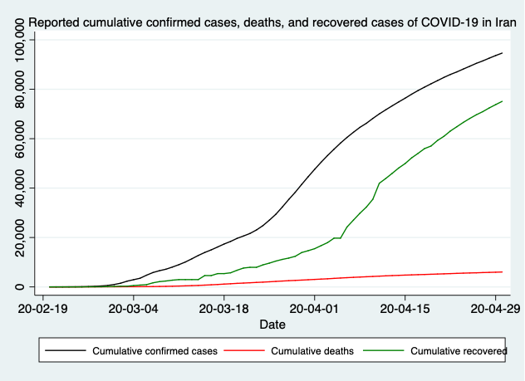

Appendix Figure 3. Reported daily confirmed cases, deaths, and recovered cases of COVID-19 in Iran

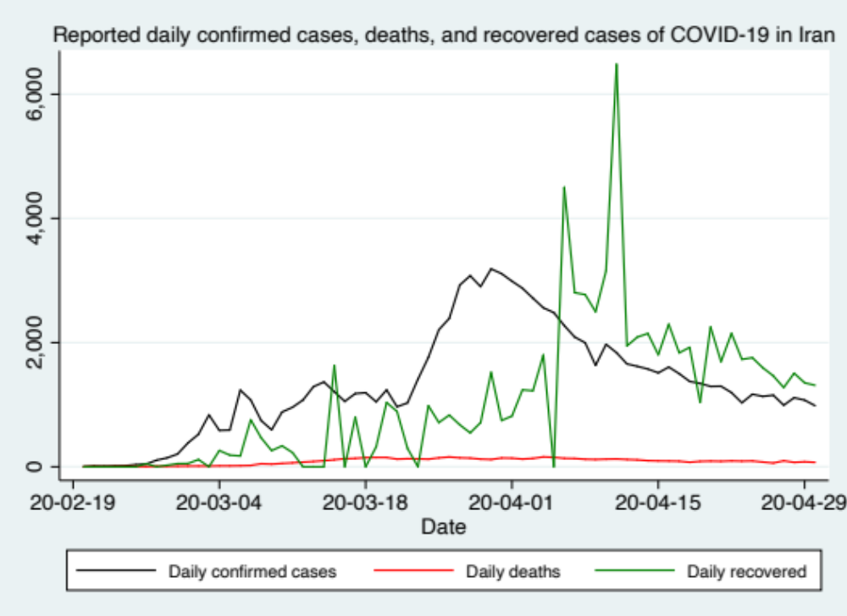

Appendix Figure 4. Reported and worst-scenario estimated cumulative deaths of COVID-19 in Iran, including predictions by Mashayekhi
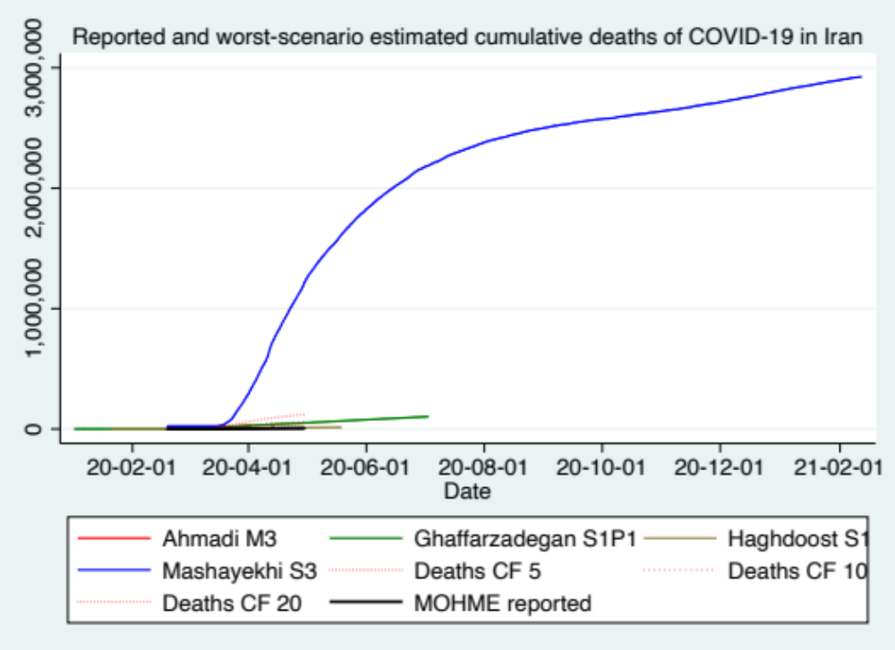
Ahmadi [16] M3: Model 3, Cubic Polynomial. Ghaffarzadegan [17] S1P1: Seasonality conditions 1 (no effect or status quo) and Policy effect 1 (status quo contact rate). Haghdoost [24] S1: Worst scenario, minimum (25%) isolation. Mashayekhi [25] S3: Worst scenario. People reduce their social [physical] contacts only to 50% of regular level, voluntarily, after number of cases and deaths have increased, plus inadequate observation of sanitation cautions, so that transmission rate reduces only by 40% (instead of 55%), and 60% of people do not observe the sanitation cautions. Deaths CF 5: Reported deaths with a Correction Factor of 5, after Dr. Rick Brennan, Director of Emergency Operations, World Health Organization [27]. Deaths CF 10: Reported deaths with a Correction Factor of 10, after Russell [42]. Deaths CF 20: Reported deaths with a Correction Factor of 20, after Younsian [28]. MOHME reported: Official reported deaths [5]

Appendix Figure 5. Reported and worst-scenario estimated cumulative deaths of COVID-19 in Iran, without predictions by Mashayekhi
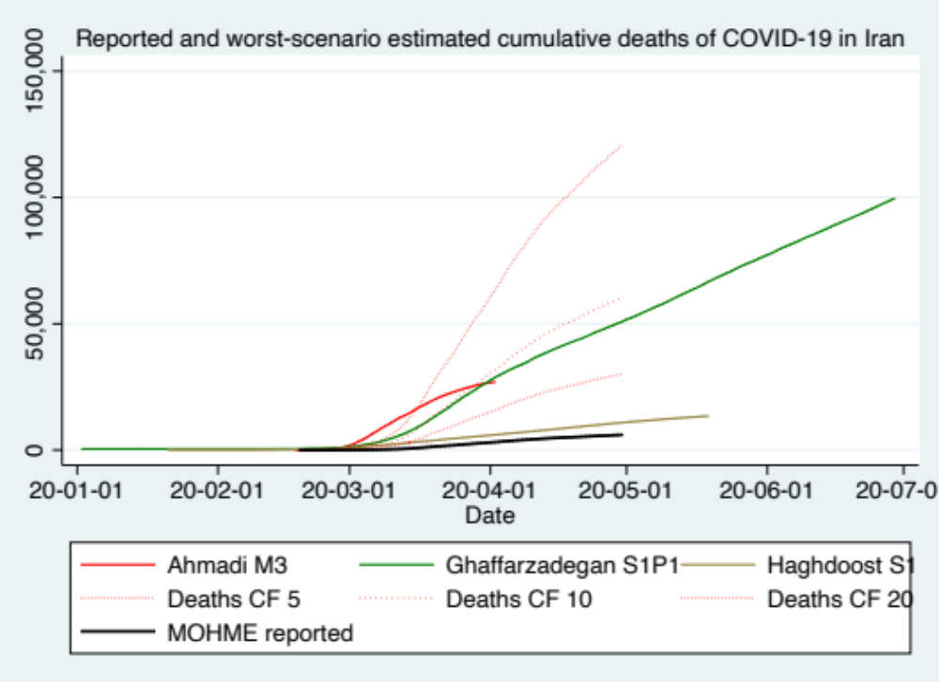
Ahmadi [16] M3: Model 3, Cubic Polynomial. Ghaffarzadegan [17] S1P1: Seasonality conditions 1 (no effect or status quo) and Policy effect 1 (status quo contact rate). Haghdoost [24] S1: Worst scenario, minimum (25%) isolation. Deaths CF 5: Reported deaths with a Correction Factor of 5, after Dr. Rick Brennan, Director of Emergency Operations, World Health Organization [27]. Deaths CF 10: Reported deaths with a Correction Factor of 10, after Russell [42]. Deaths CF 20: Reported deaths with a Correction Factor of 20, after Younsian [28]. MOHME reported: Official reported deaths [5]

