Additional file
Title: In Silico and In Vitro Development of novel small interfering RNAs (siRNAs) to inhibit SARS -CoV-2
Authors: Noha Samir Taibe ª, Sara H. Mahmoud^{b}, Maimona A.Kord^{c}, Mohamed Ahmed Badawy^{d} , Mahmoud Shehata^{b}, Mahmoud Elhefnawi^{e}*
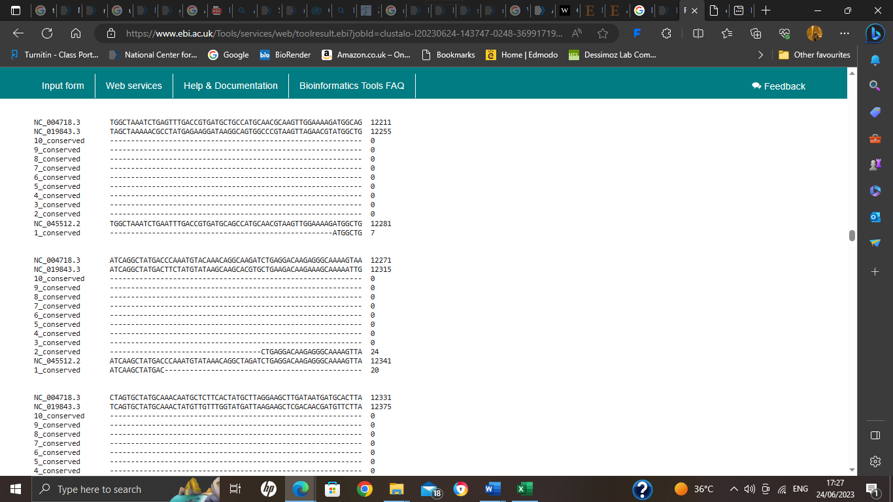
Additional file 2: Figures

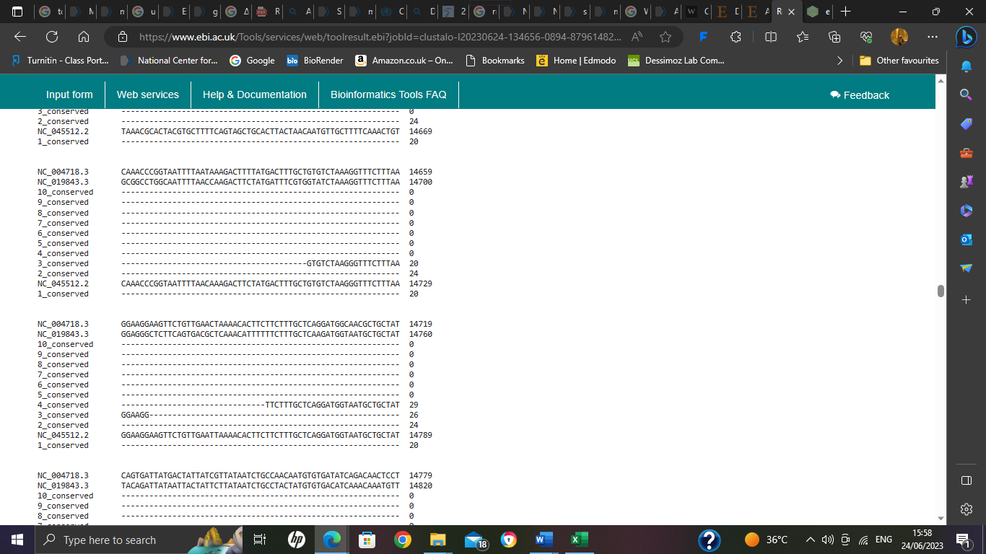

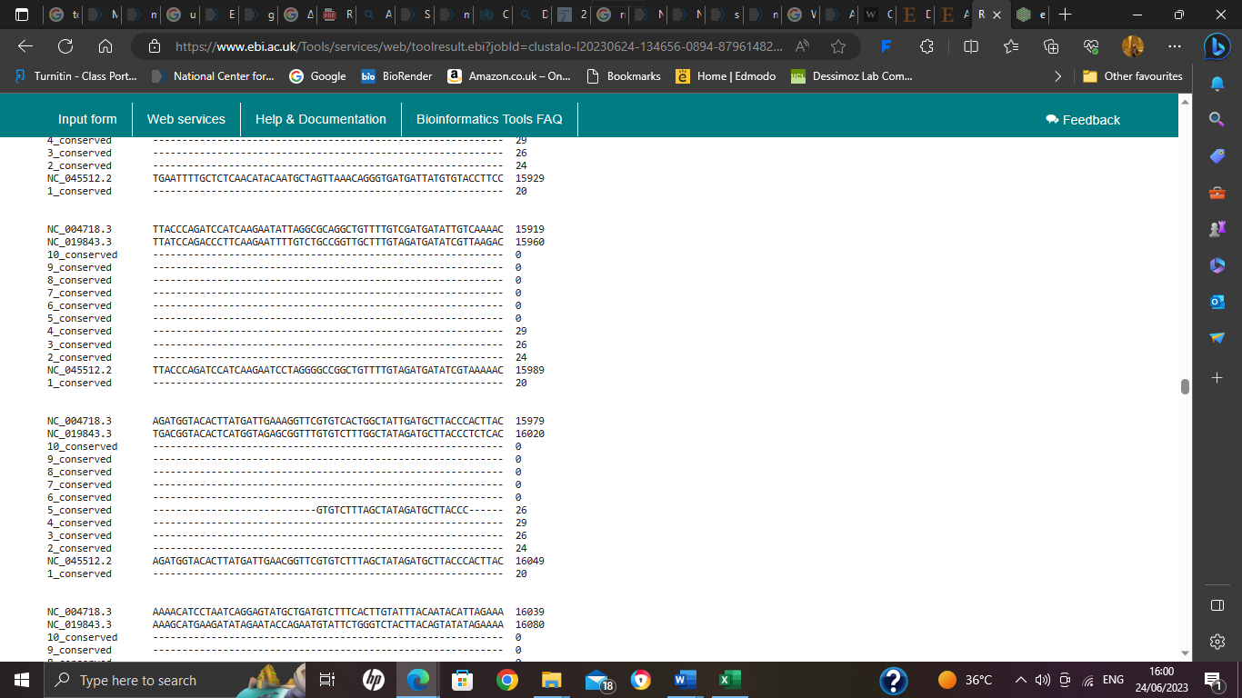

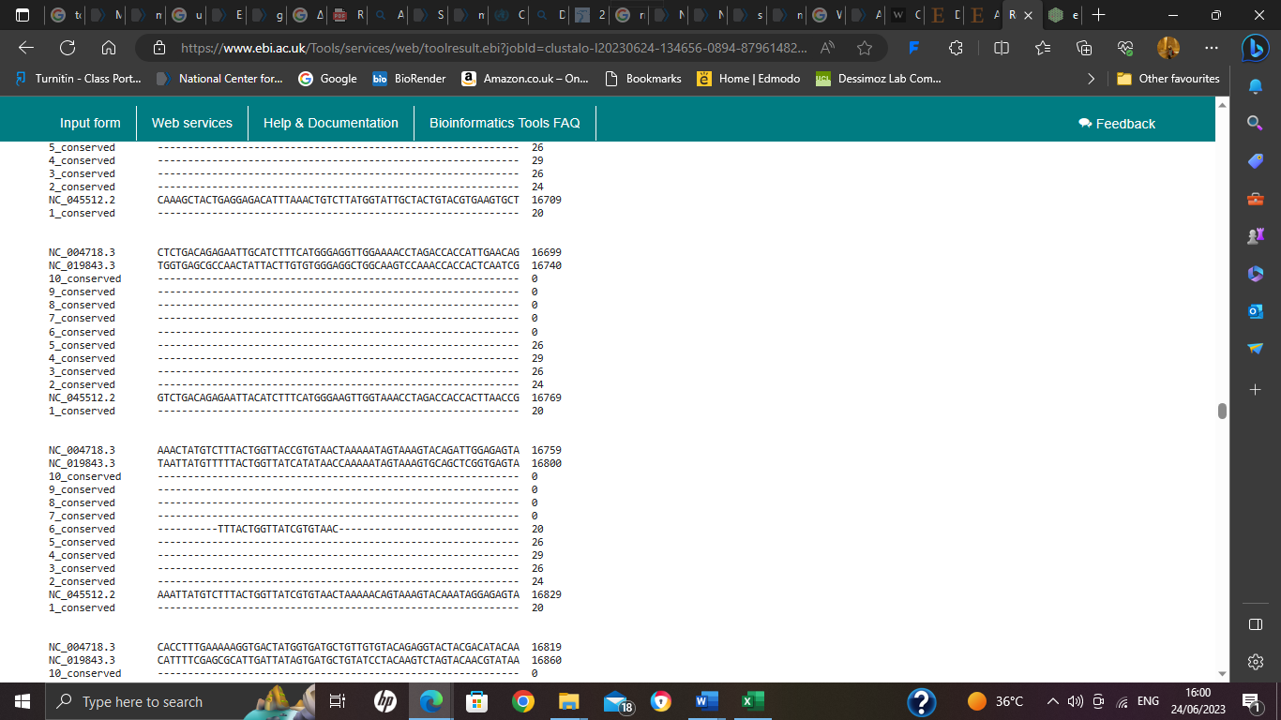

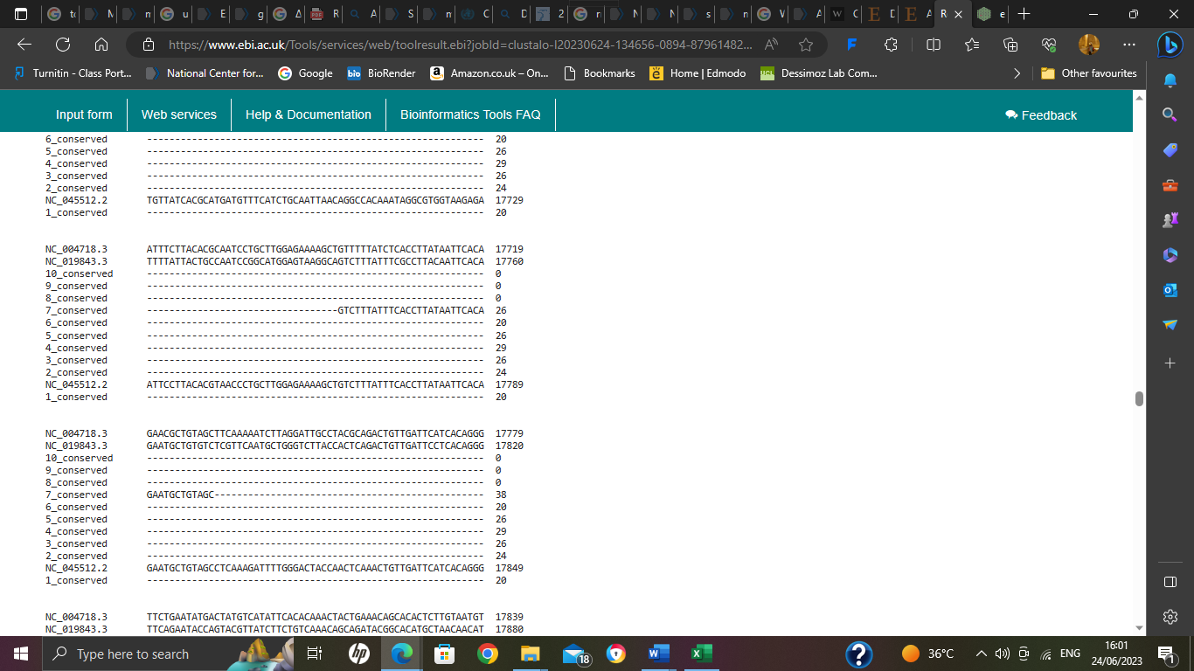

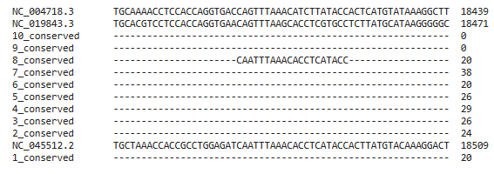

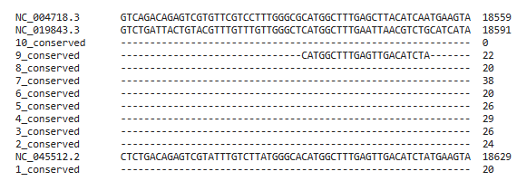

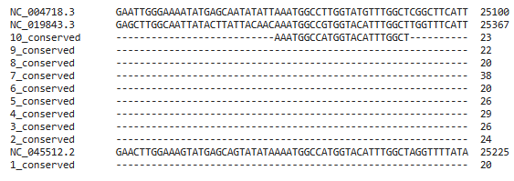

Additional file 1: Fig. S1: Alignment of 10 conserved regions against SARS, MERS, and SARS-CoV-2 reference sequences.
This figure displays the outcome of an alignment using Clustal Omega of 10 conserved regions against the reference sequences for SARS (NC 004718.3), SARS-CoV-2 (NC 045512.2), and MERS (NC 019843.3).

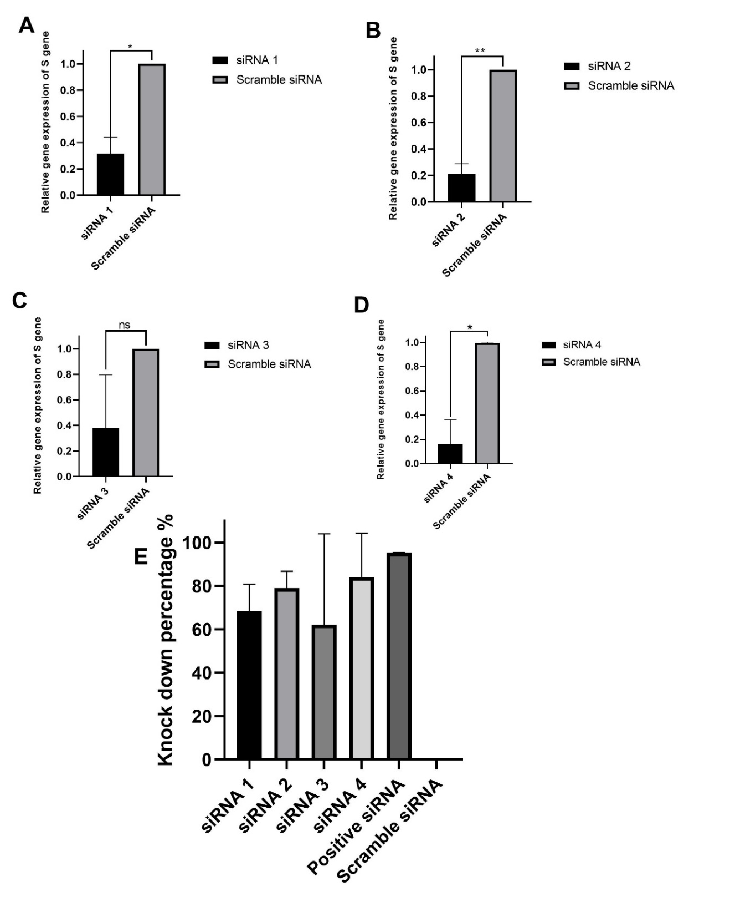
Additional file 1: Fig. S2: S gene knockdown in VeroE6 cells treated with siRNAs after 12 hours post-infection.
B: siRNA2 shows high significance in reduction of mRNA of SARS-CoV-2 with P value <0.0021 compared to A: siRNA1, C: siRNA3, D: siRNA4. E: the knockdown percentage of all siRNAs compared with scramble siRNA. All results were normalized against scramble siRNA and quantitative examination (n = 2 in each group). By GraphPad Prism, version 8, means ± SEM is used to represent the values. significance was determined using unpaired t-test. The significant difference is shown by the symbols *p<0.0332, **p< 0.0021, ***p< 0.0002, ****p <0.0001; ns (not significant) p< 0.1234.

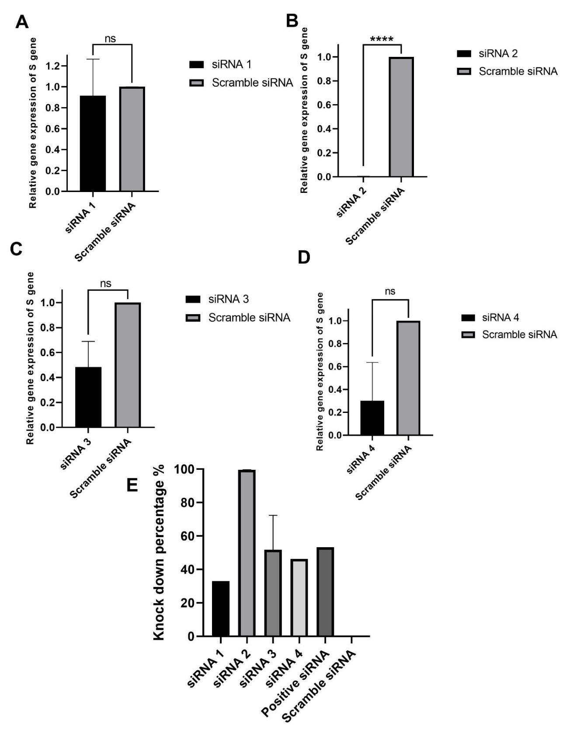
Additional file 1: Fig. S3: S gene knockdown in VeroE6 cells treated with siRNAs after 36 hours post-infection.
B: siRNA2 shows high significance in reduction of mRNA of SARS-CoV-2 with P value <0.0001 compared to A: siRNA1, C: siRNA3, D: siRNA4. E: the knockdown percentage of all siRNAs compared with scramble siRNA. All results were normalized against scramble siRNA and quantitative examination (n = 2 in each group). By GraphPad Prism, version 8, means ± SEM is used to represent the values. significance was determined using unpaired t-test. The significant difference is shown by the symbols *p<0.0332, **p< 0.0021, ***p< 0.0002, ****p <0.0001; ns (not significant) p< 0.1234.
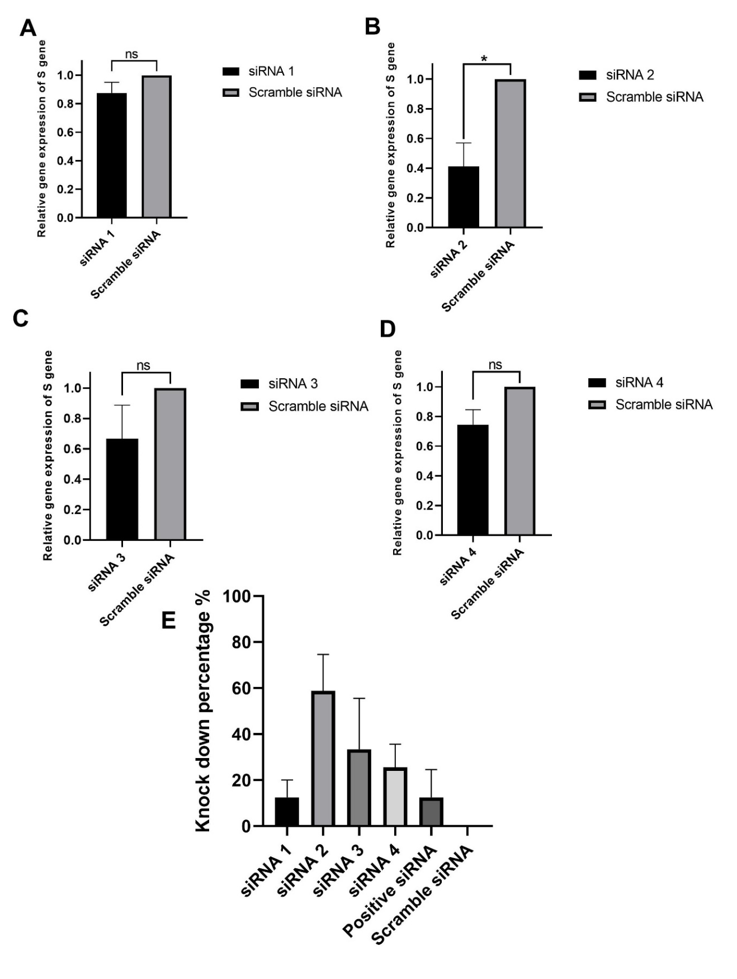
Additional file 1: Fig. S4: S gene knockdown in VeroE6 cells treated with siRNAs after 48 hours post-infection.
B: siRNA2 still show significance in reduction of mRNA of SARS-CoV-2 with P value <0.0332 compared to A: siRNA1, C: siRNA3, D: siRNA4. E: the knockdown percentage of all siRNAs compared with scramble siRNA. All results were normalized against scramble siRNA and quantitative examination (n = 2 in each group). By GraphPad Prism, version 8, means ± SEM is used to represent the values. significance was determined using unpaired t-test. The significant difference is shown by the symbols *p<0.0332, **p< 0.0021, ***p< 0.0002, ****p <0.0001; ns (not significant) p< 0.1234.
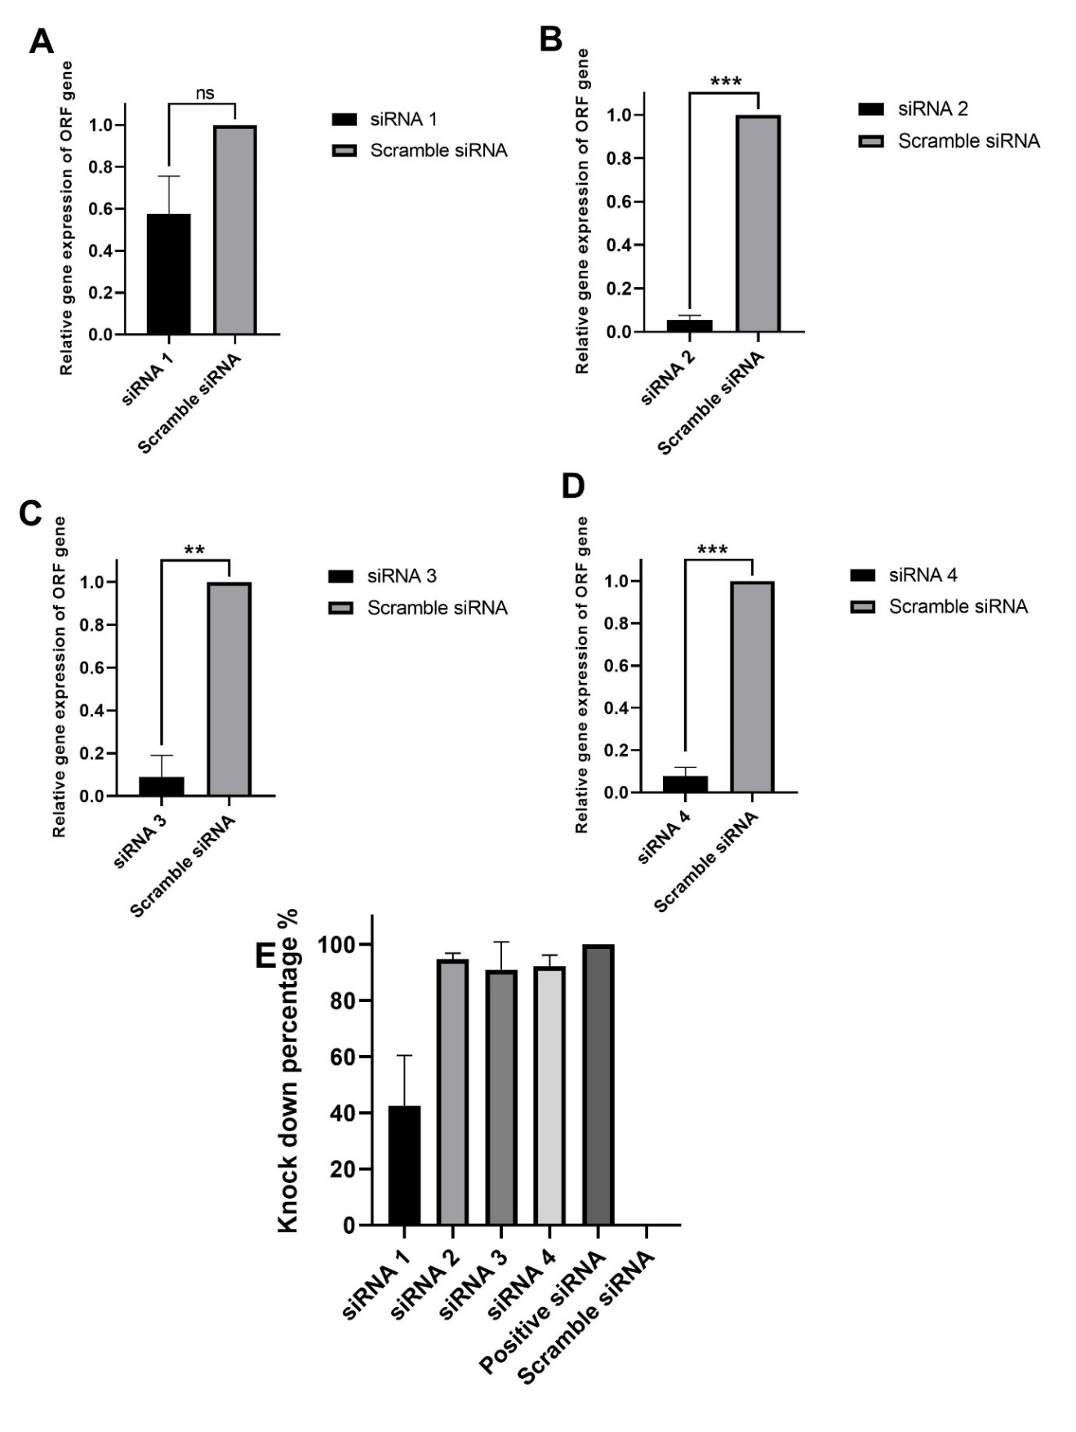
Additional file 1: Fig. S5: ORF1b gene knockdown in VeroE6 cells treated with siRNAs after 12 hours post-infection.
A: siRNA1 shows reduction of mRNA of SARS-CoV-2 with P value <0.1234, while B: siRNA2, and D: siRNA4 show a clear decrease in the mRNA of ORF1b with P value<0. 0002.Also,C:siRNA3 shows reduction in viral mRNA with P value<0.0021 E: the knockdown percentage of all siRNAs compared with scramble siRNA. All results were normalized against scramble siRNA and quantitative examination (n = 2 in each group). By GraphPad Prism, version 8, means ± SEM is used to represent the values. significance was determined using unpaired t-test. The significant difference is shown by the symbols *p<0.0332, **p< 0.0021, ***p< 0.0002, ****p <0.0001; ns (not significant) p< 0.1234.

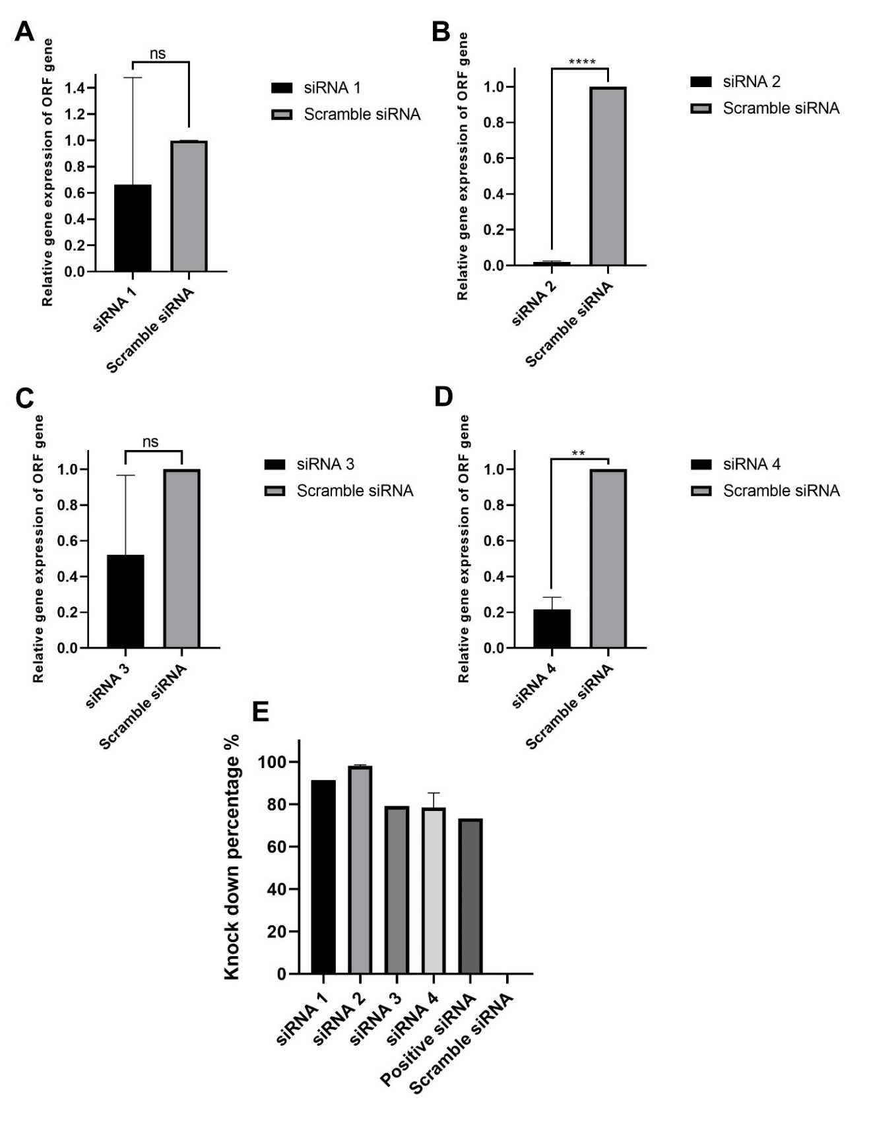
Additional file 1: Fig. S6: ORF1b gene knockdown in VeroE6 cells treated with siRNAs after 36 hours post-infection.
A: siRNA1 and C:siRNA3 show reduction of ORF1b mRNA with no statistical significance , while B: siRNA2, and D: siRNA4 show a clear decrease in the mRNA of ORF1b with P value<0. 0001 and P value <0.0021 respectively. E: the knockdown percentage of all siRNAs compared with scramble siRNA. All results were normalized against scramble siRNA and quantitative examination (n = 2 in each group). By GraphPad Prism, version 8, means ± SEM is used to represent the values. significance was determined using unpaired t-test. The significant difference is shown by the symbols *p<0.0332, **p< 0.0021, ***p< 0.0002, ****p <0.0001; ns (not significant) p< 0.1234.

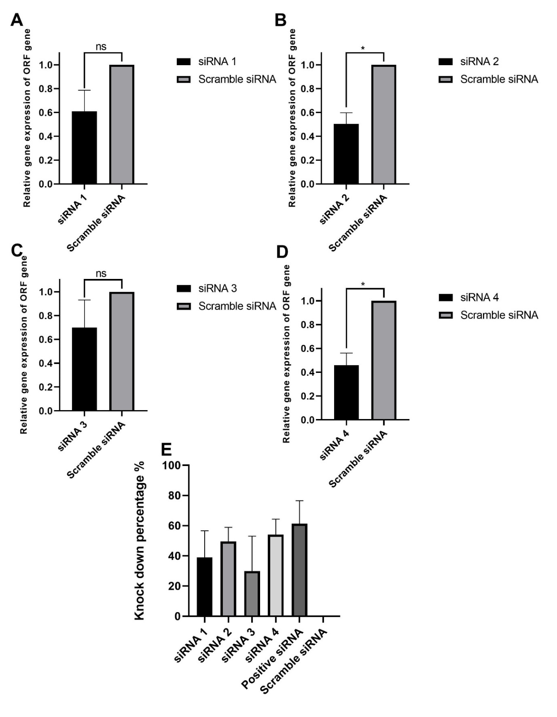
Additional file 1: Fig. S7: ORF1b gene knockdown in VeroE6 cells treated with siRNAs after 48 hours post-infection.
B: siRNA2, and D: siRNA4 still show a clear decrease in the mRNA of ORF1b with P value<0. 0332 A: siRNA1 and C:siRNA3 show reduction of ORF1b mRNA with no statistical significance. E: the knockdown percentage of all siRNAs compared with scramble siRNA. All results were normalized against scramble siRNA and quantitative examination (n = 2 in each group). By GraphPad Prism, version 8, means ± SEM is used to represent the values. significance was determined using unpaired t-test. The significant difference is shown by the symbols *p<0.0332, **p< 0.0021, ***p< 0.0002, ****p <0.0001; ns (not significant) p< 0.1234.

