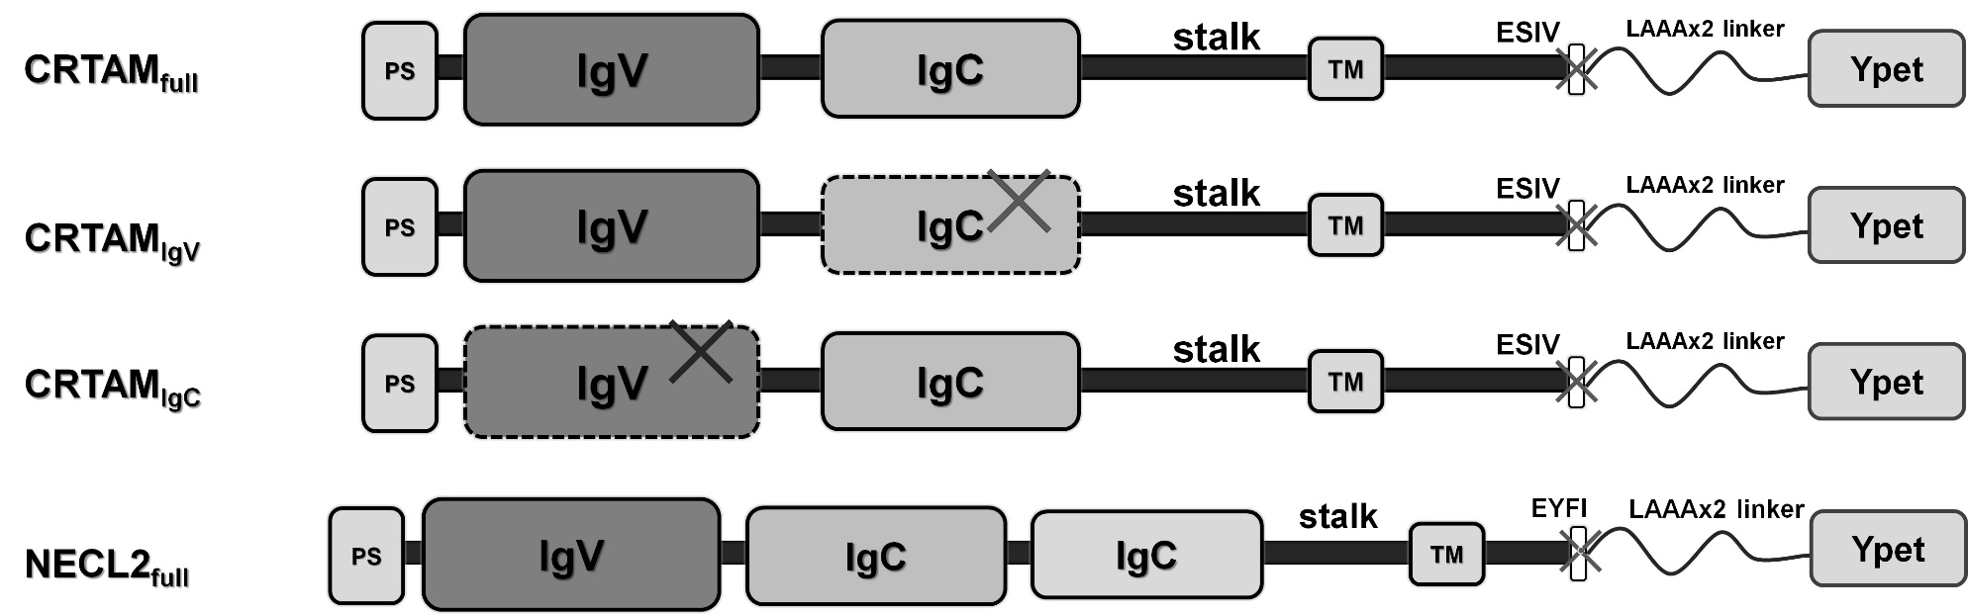
Supplementary figure 1. Three CRTAM and one NECL2 genes constructions were design y cloned in pYpet-N1 for mammalian expression. CRTAM_{full}: full-lenght of CRTAM; CRTAMIgV, the constant domain was deleted; CRTAMIgC, the variable domain were deleted; NECL2full: full-length of NECL2. All constructions contain the sequence that encodes the original peptide signal (PS) and transmembrane region (TM) of each molecule. The sequence that encodes for ESIV and EYFI intracellular motif were deleted and a sequence the encodes to LAAALAAA linker were added to C-termini of CRTAM and NECL2 to fusion Ypet fluorescent protein codified for the pYpet-N1 plasmid. The symbol “X” and dashed lines means region deleted.

Supplementary figure 2. Calibration of Superdex-75 10/300 GL column (Cytivia) with Bio-Rad gel filtration standard (#1511901). BSA, bovine serum albumin (66kDa); OVA, chicken ovalbumin (44 kDa); Equine myoglobin (17 kDa), Vitamin-B12 (1.35 kDa). Ve, elution volume; Vo, column void volume; MW, molecular weight.

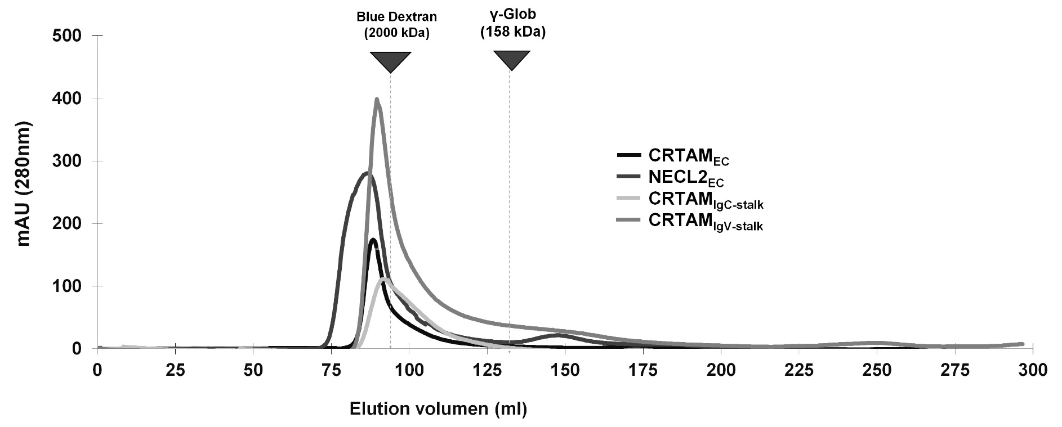
Supplementary figure 3. Unfolded recombinants form high molecular weight aggregates. Recombinants proteins purified after IMAC-chromatography form aggregates with molecular weight that elutes in column void volume (>2000 kDa). Sephacryl S-200 HR column was used for this gel filtration chromatography.

Supplementary figure 4. NECL2_{EC} forms a dimer in solution. The folded recombinant NECL2_{EC} was subjected to gel filtration assay which elutes a main peak close to BSA marker (~66 kDa) as shown in the chromatography, SDS-PAGE profile shows the molecular weight of the monomer the NECL2_{EC} eluted.

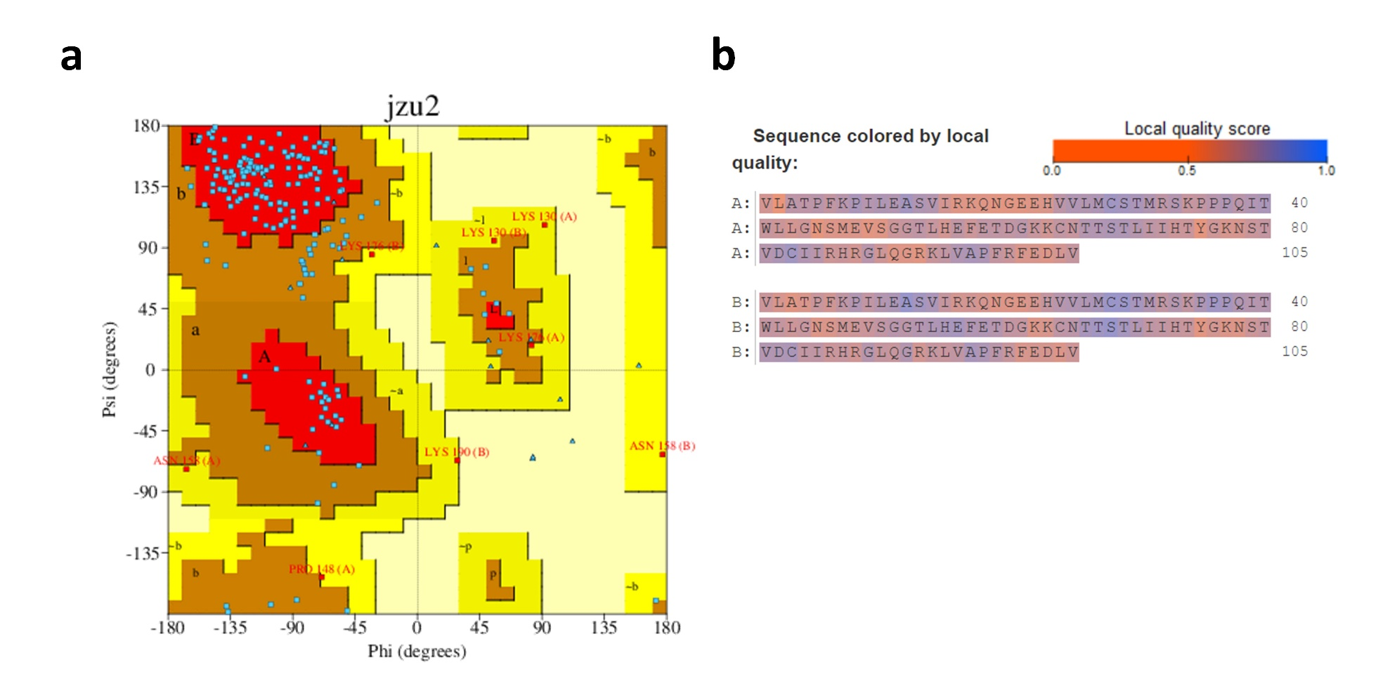
Supplementary figure 5. Ramachandran plot and and QMEANDisCo score of constant domain modeling. a) The plot shows the most favored region that is denoted in red, the additionally allowed region in yellow, the generously allowed region in pale yellow, and the additionally allowed region in white. b) The quality of the model was calculated for QMEANDisCo Score, being 1.0 (blue) the best score.

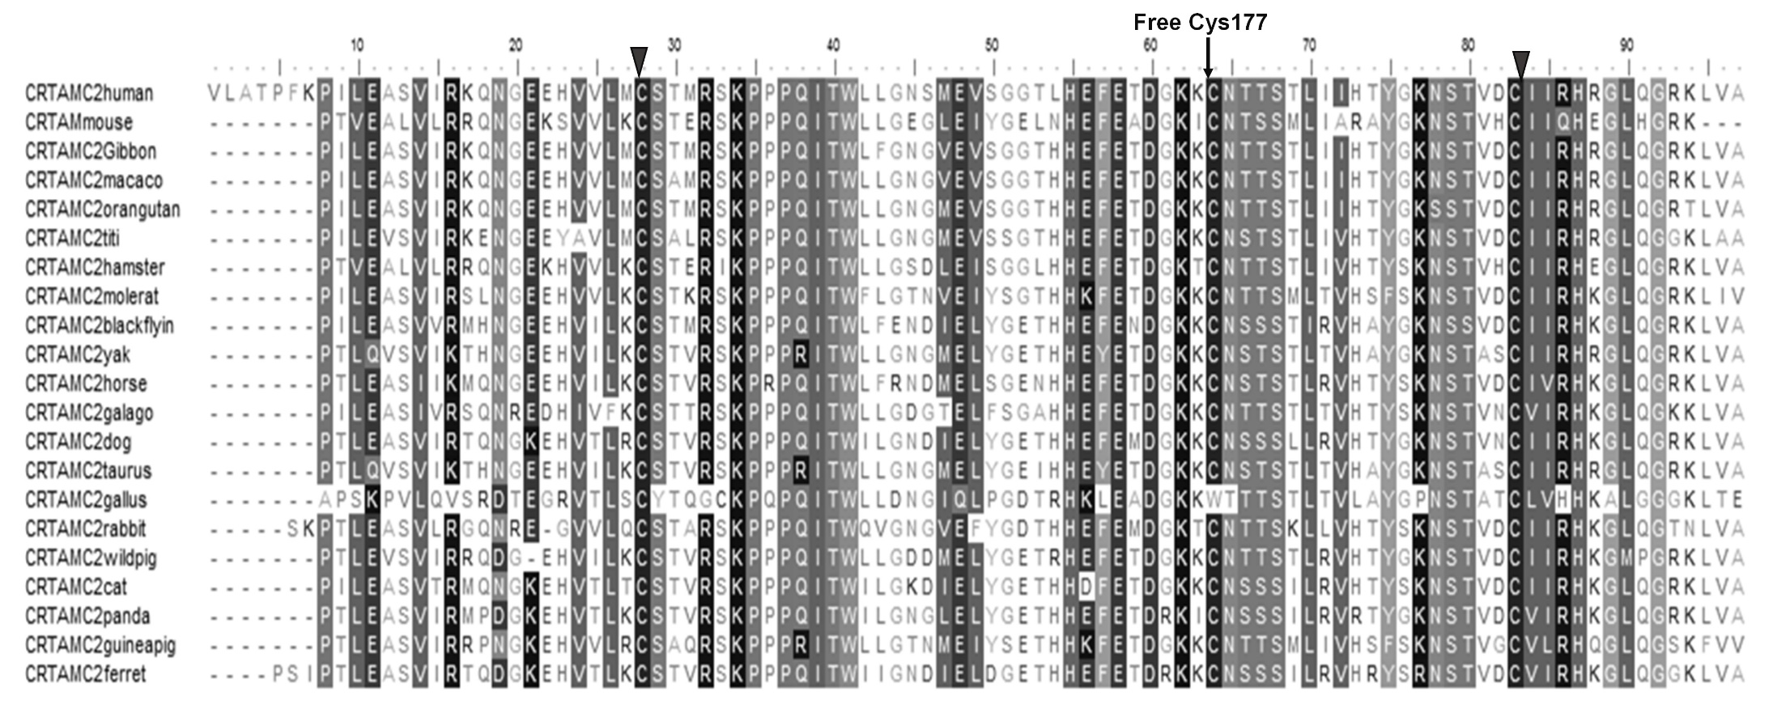

Supplementary figure 6. The free residue Cys177 of human CRTAM is conserved between CRTAM of different species. Black arrow above the alignment marks the free Cys177 of CRTAM. Two black triangles above the alignment denoted to canonical cysteine of a immunoglobulin domain. The sequence alignment was done by CLUSTALW server, inputting the sequence of the constant domain of CRTAM from different species.

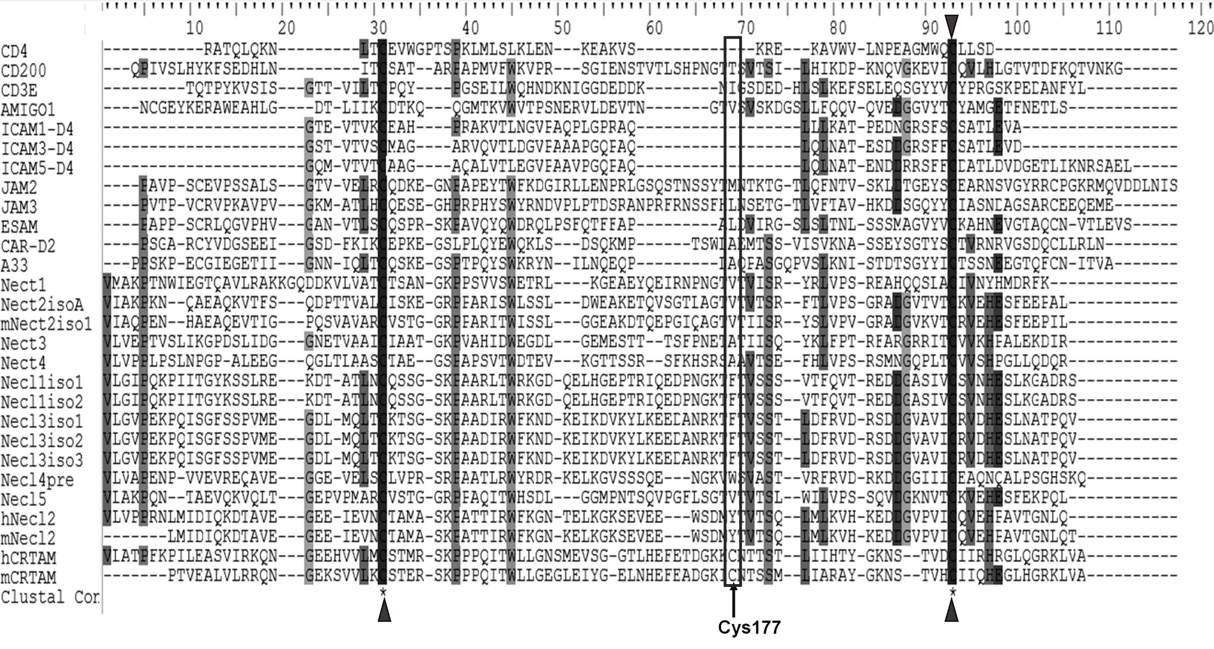

Supplementary figure 7. The free residue Cys177 of human CRTAM is not conserved between Nectin and other IgSFs proteins. Black arrow below the alignment marks the free Cys177 of CRTAM. Two black triangles below the alignment denoted to canonical cysteine of a immunoglobulin domain. The sequence alignment was done by CLUSTALW server, inputting the sequence of the constant domain of human and mouse CRTAM, and the sequence of constant domain of proteins of Nectin, Nectin-like, JAMs, ICAMs and other protein of the IgSF.

