Supplementary figures & tables:
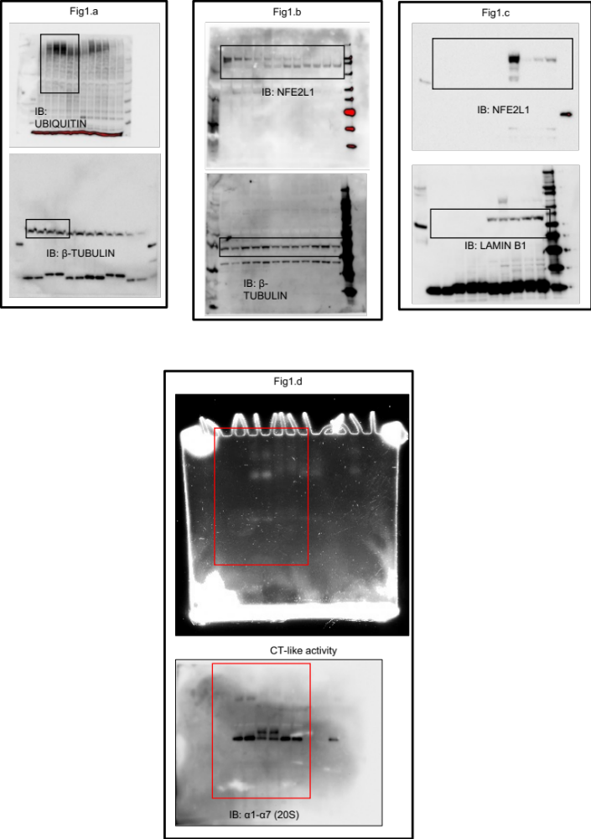

Supplementary Fig. 1: Uncropped immunoblots and gel pictures

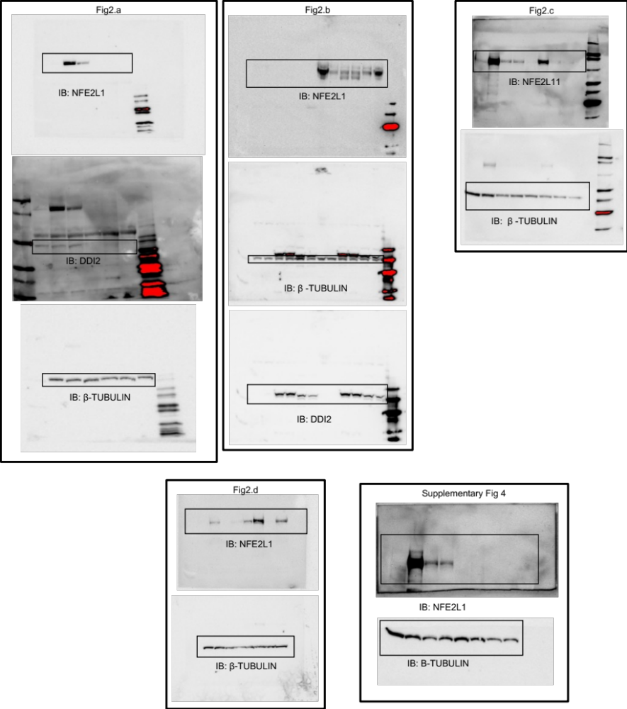
Supplementary Fig. 2: Uncropped immunoblots

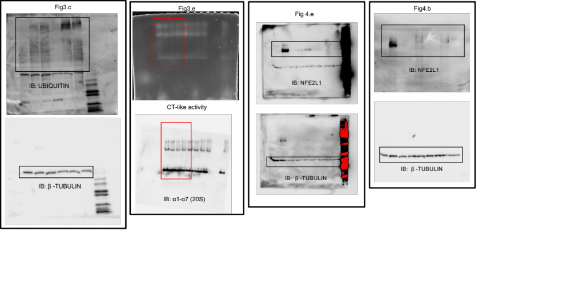
Supplementary Fig. 3: Uncropped immunoblots and gel pictures
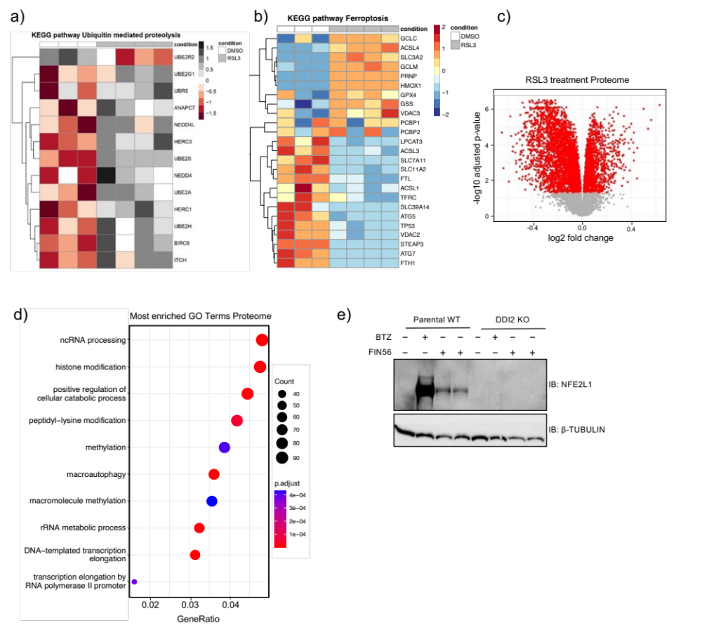
Supplementary Fig. 4. (a) KEGG pathway analysis of ubiquitin mediated proteolysis from ubiquitome of EaHy926 cells treated with 5 µM of RSL3 in the total proteome. (b) KEGG pathway analysis of ferroptosis from total proteome of EaHy926 cells treated with 5 µM of RSL3. (c) Volcano Plot of the proteome of EaHy926 cells treated for 9 h with 5 µM RSL3 P_{adj} < 0.05 indicated by red color. (n=4 replicates) (d) Top 10 enriched gene ontology (GO) terms in the proteome of EaHy926 cells treated for 9 h with 5 µM RSL3. (e) Immunoblot of NFE2L1 in wild-type EA.hy926 and DDI2 KO cells treated with 10 µM FIN56 for 9 h and 100 nM BTZ for 3 h.

Supplementary Table 1:
Antibody | Company (Cat. No.) | Dilution
DDI2 | Abcam (ab197081) | 1:1000
NFE2L1 | Cell signaling technologies (D9K6P) | 1:500
β-TUBULIN | Cell signaling technologies (2146) | 1:1000
UBIQUITIN (P4D1) | Cell signaling technologies (3936) | 1:1000
20S Proteasome ɑ subunit | Abcam (ab22674) | 1:1000
Anti-Lamin B1 | Abcam (ab229025) | 1:1000
Anti-rabbit IgG, HRP-linked | Cell signaling technologies (7074) | 1:10000
Anti-mouse IgG, HRP-linked | Cell signaling technologies (7076) | 1:10000

Supplementary Table 2:
Gene | Forward Primer (5’) | Reverse Primer (5’)
NFE2L1 | AGTGGAGACTTAACCAAAGAGGAC | CTCCTTCTGGCGGTGACTAT
TBP | CCCATGACTCCCATGACC | TTTACAACCAAGATTCACTGTGG

