Tables
In file Supplementary Tables:

- Numerosity of each site, for each data selection
- Subjects involved in each data selection
- List of the most important structural features in common for each harmonization method and for both, fQC and minSC, datasets.
- List of the most important connectivity features in common for each harmonization method and for both, fQC and minSC, datasets.

Figures
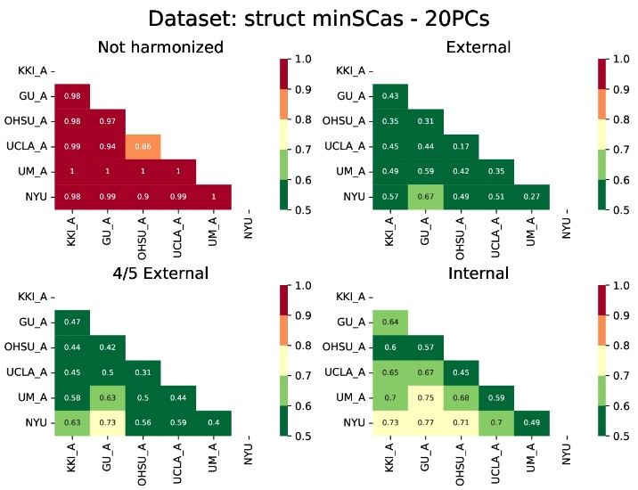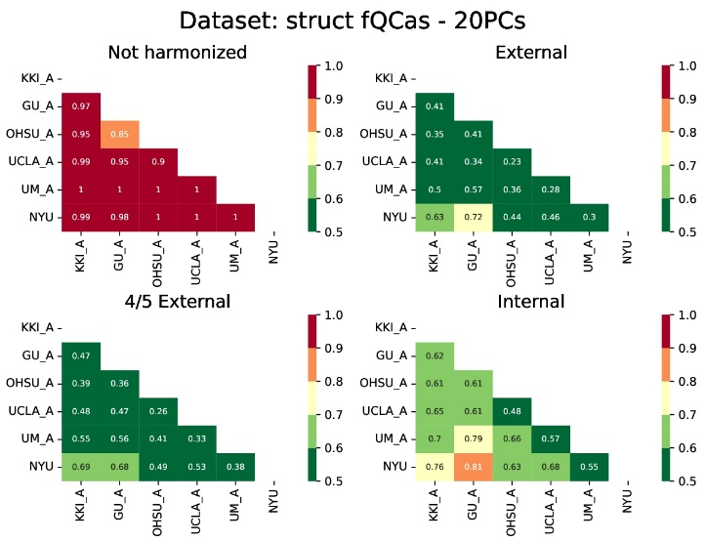
Fig.A1: Site identification for different harmonization strategies for structural features. Left: minSCas data set. Right: fQCas dataset. In order to limit LSS-LES effects, only sites with more than 20 TDs are considered.

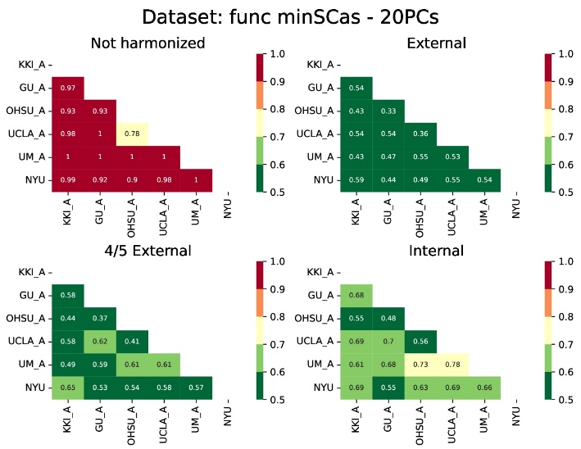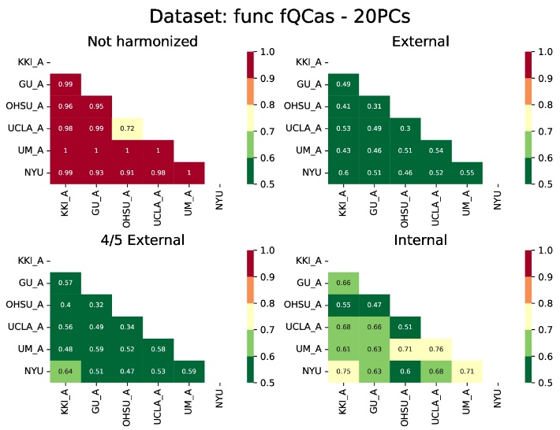
Fig.A2: Site identification for different harmonization strategies for connectivity features. Left: minSCas data set. Right: fQCas dataset. In order to limit LSS-LES effects, only sites with more than 20 TDs are considered.

