Supporting information

A Microphase-Separated Design Toward an All-Round Ionic Hydrogel with Discriminable and Anti-Disturbance Multisensory Functions

Xue Liu¹, Xinyi Ji¹, Rongjie Zhu¹, Jianfeng Gu¹, Jiajie Liang^{1,2,3}*

1 School of Materials Science and Engineering, National Institute for Advanced Materials, Nankai University, Tianjin 300350, China.
2 Key Laboratory of Functional Polymer Materials of Ministry of Education, College of Chemistry, Nankai University, Tianjin 300350, China.
3 School of Materials Science and Engineering, Smart Sensing Interdisciplinary Science Center, Nankai University, Tianjin 300350, China.

E-mail: liang0909@nankai.edu.cn (J. Liang)

Supplementary Note 1:
Measurement of the weight swelling ratio. The initial weight m₀ of PA-SN hydrogels and PAS-SN hydrogels was measured, and then the single-network hydrogels were immersed in DADMAC monomer solutions for 24 h. After a predetermined time, the swollen hydrogels were removed, and their weight was measured as mt. At least five parallel samples were prepared in each group to ensure the accuracy of the experimental results. The weight swelling ratio (denoted as WSR) was obtained by the following equation¹:
$$WSR=\frac{m_{t}-m_{0}}{m_{0}} × 100\%$$

Supplementary Note 2:
Characterization of water-retention properties. The water retention of PAS-SN, PD-SN, and PAS/PD-IPN hydrogel was characterized by recording the residual weight at different times. We prepared five parallel samples in each group and recorded the initial weights of each. Then, all samples were placed in identical environments with 57% humidity at 25℃. The weight changes were recorded every 12 h. Finally, the normalized weight retention percentage (denoted as WRP) to the initial weight was calculated using the following formula^{1, 2}:
$$WRP=\frac{w}{w_{0}}×100\%$$
where w and w₀ refer to the real-time weight and initial weight, respectively.

Supplementary Note 3:
Calculation of signal-to-noise ratio (SNR). The SNR was calculated from the following equation^{3, 4}:
$$SNR=20×\log_{10}{(\frac{A_{Signal}}{A_{Noise}}})$$
where A_{Signal} and A_{Noise} denote the amplitude of the signal and background, respectively. The values of A_{Signal} and A_{Noise} can be assessed using root-mean-squared (RMS) analysis to indicate fluctuations in the signal over time.

Supplementary Note 4:
Evaluation of temperature-sensing performance. To evaluate the temperature-sensing performance, various temperature gradients were formed by using two Peltier devices (TEC2-24508, OMEGA Engineering, USA), independently powered and controlled by a DC power supply system (DH1766-2, DAHUA, China). At the same time, the accurately-monitored temperature difference was used to calculate the temperature gradient between the two Ag electrodes. The measurement was performed by K-type thermocouples (5TC-TT-K-40-36, OMEGA Engineering, USA) within a feedback loop, which was fixed to the other side of the glass substrate and electrically isolated from the hydrogel sample blocks by a thin layer of polyimide. Based on this, the thermovoltage was recorded using a Keithley 2000 multimeter. The ionic thermopower (S_{i}) was then calculated using the equation below⁵:
$$S_{i}=\frac{ΔU}{ΔT}×\frac{d_{T}}{d_{U}}$$
where ΔU is the open-circuit voltage, ΔT is the temperature difference measured by the thermocouples, and d_{T} and d_{U} are the distances between two thermocouples (10 mm) and two Ag electrodes (10 mm), respectively. The size of the glass substrate was 26 × 76 mm². The Ag electrodes were prepared by using a silver plate, and they had a length of 20 mm and a width of 1 mm. The thickness of the ionic hydrogel was measured by a micrometer. To ensure stable environmental conditions, all measurements were performed within our home-built air bath thermostat equipped with a humidity-control system. The temperature difference of liquids (such as water) was characterized by using a similar method to the thermovoltage detection method. Water (0.5 mL) with different temperatures (10℃, 15℃, 20℃, 25℃, 30℃) was rapidly dropped onto the homemade silver electrode, while the other side was kept at 20℃. The corresponding thermovoltages were recorded using a Keithley 2000 multimeter.

Supporting Figures:
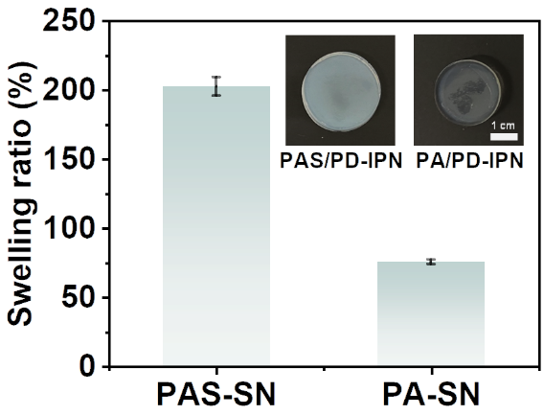
Figure S1. Calculation and comparison of the swelling ratios of the PAS-SN hydrogel and PA-SN hydrogel after immersion in DADMAC monomer solution for 24 h.

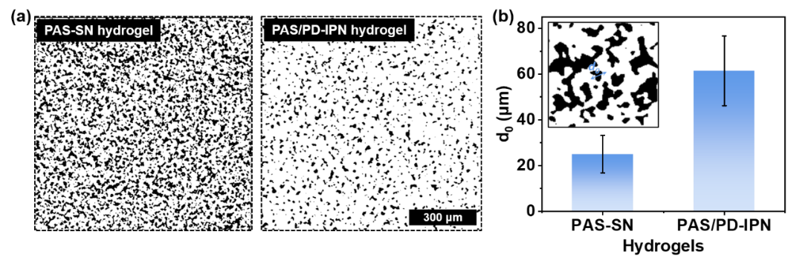
Figure S2. (a) 2D nano CT images of PAS-SN and PAS/PD-IPN hydrogels. The white and black areas represent the heavy (polymer-rich) and light regions (solvent-rich), respectively. (b) The average d₀ (spacing between adjacent polymer-rich regions). The error bars represent the mean ± standard deviation (n ≥ 5 independent experiments).

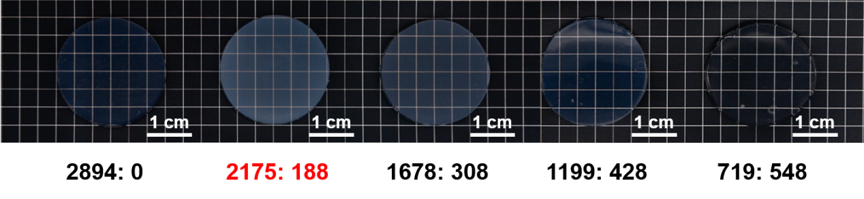
Figure S3. Photographs of PAS/PD-IPN hydrogels with different AM-to-SBMA molar ratios in the first network (the red color represents the optimized ratio used in this work).

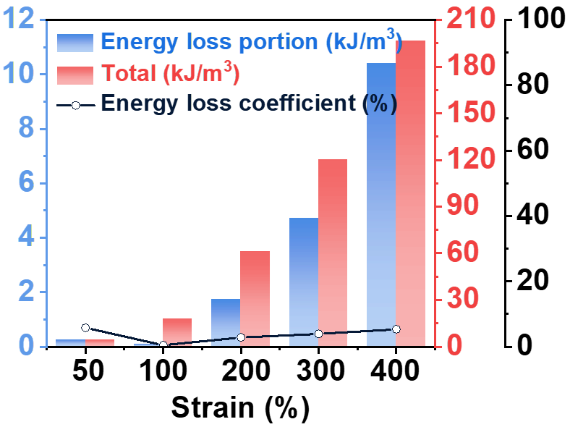
Figure S4. The dissipated energy and energy loss coefficient of PAS/PD-IPN hydrogel under different cyclic strains.

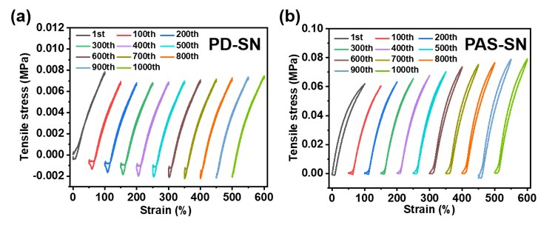
Figure S5. The loading-unloading tensile curves over 1000 strain cycles for (a) PD-SN hydrogel and (b) PAS-SN hydrogel.

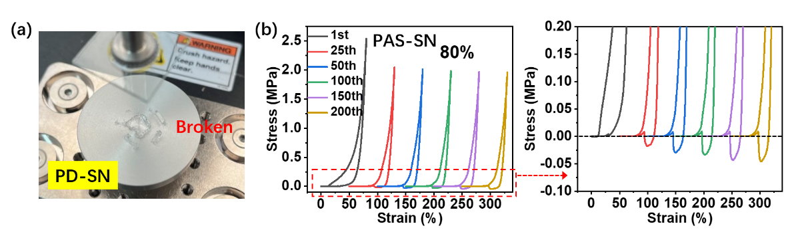
Figure S6. (a) Photo of PD-SN hydrogel after compression to 80%. (b) The loading-unloading compressive curves up to 80% for 200 cycles for the PAS-SN hydrogel.

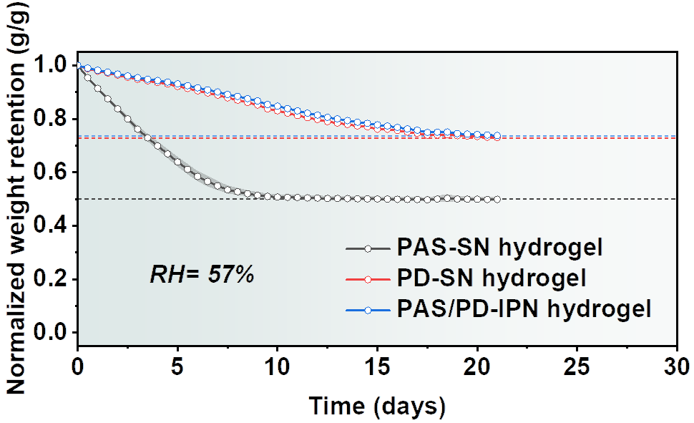
Figure S7. Water retention of PAS-SN, PD-SN, and PAS/PD-IPN hydrogels at ~57% humidity and room temperature.

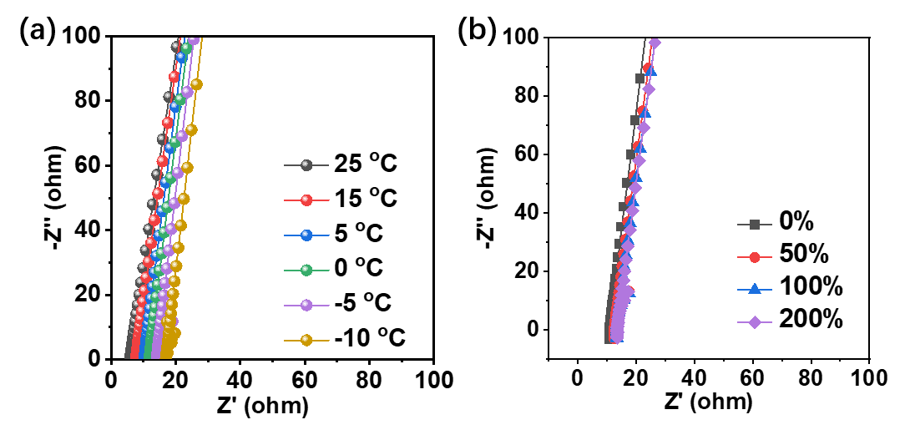
Figure S8. Electrochemical impedance spectroscopy (EIS) spectra of PAS/PD-IPN hydrogel at (a) different temperatures and (b) different strains.

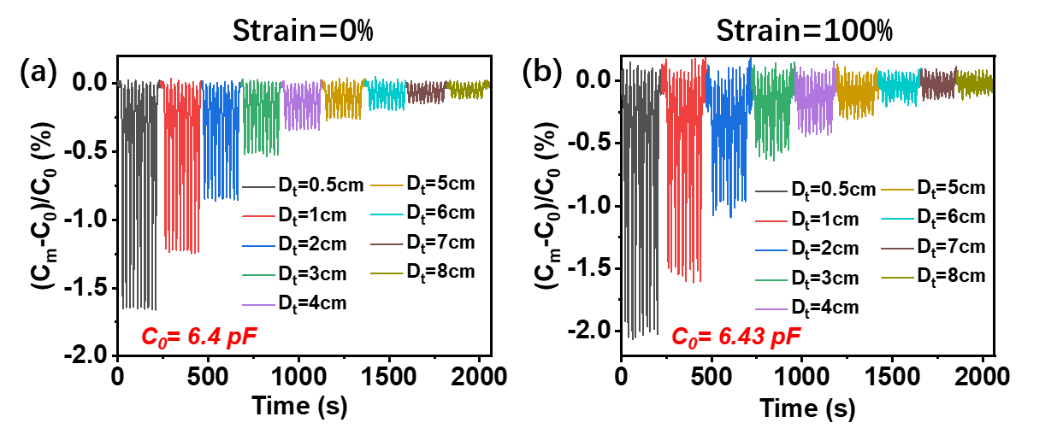
Figure S9. Relative capacitance change upon response to the cyclic approach of water at different distances under (a) 0% and (b) 100% strain.

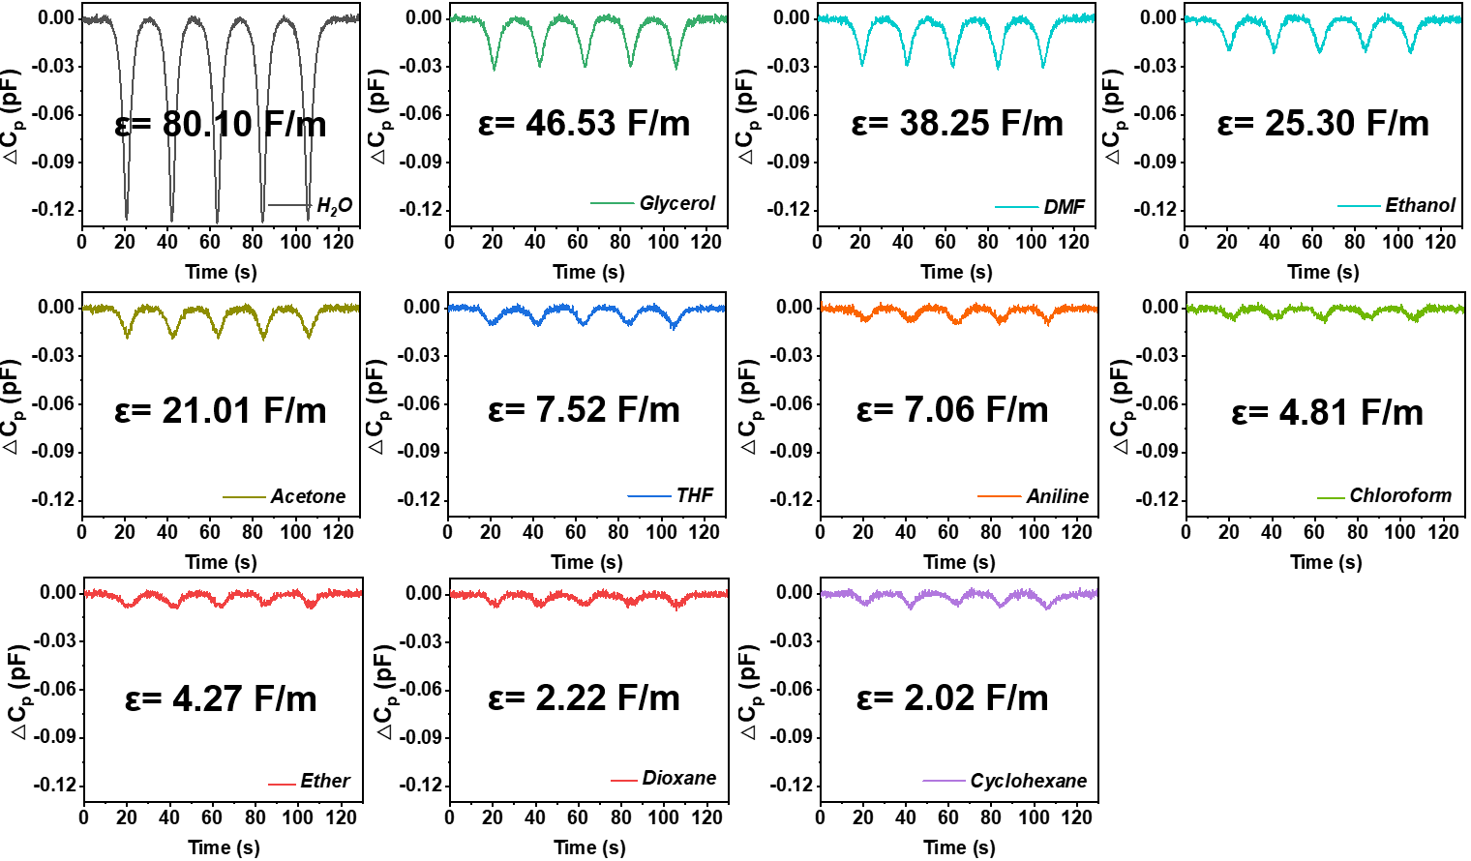
Figure S10. Capacitance changes of eleven typical solvents with different permittivities.

Table S1. Mechanical data summary for PAS-SN, PD-SN, and PAS/PD-IPN hydrogels.
Hydrogel | Modulus  (kPa) | Strength  (kPa) | Toughness (kJ/m³) | Elongation  at break (%)
PAS-SN | 132.0 ± 3.5 | 160.8 ± 25.0 | 1026.9 ± 33.4 | 965.2 ± 37.6
PD-SN | 9.6 ± 1.3 | 18.3 ± 4.6 | 22.4 ± 5.7 | 250 ± 25.7
PAS/PD-IPN | 60.2 ± 4.1 | 220.2 ± 30.1 | 1023.0 ± 27.5 | 900.0 ± 42.3

Table S2. Comparison of tensile strain, resilience, and hysteresis with state-of-the-art reported hydrogels and elastomers.
Number | Materials system | Type | Tensile strain (%) | Resilience (%) | Hysteresis (%) | Ref.
1 | poly(AM-co-AA)/PVA | hydrogel | ~ 725 | N.A. | 0.01 (strain = 50%);  1 (strain = 100%);  16 (strain > 200%); | 6
2 | hf-gel ACS_{5.0} | hydrogel | ~ 1060 | N.A. | 1.7  (strain = 600%) | 7
3 | AA-TD 0.8 hydrogel | hydrogel | 328 | 94 (strain < 200%);  90 (strain = 250%); | N.A. | 8
4 | POCL0.5 | elastomer | 620 | N.A. | ~ 4.2 | 9
5 | silk fibroin-based hydrogel (As-prepared) | hydrogel | 110 | 98.2 ± 0.7 (ε = 0.1);  96.2 ± 0.2 (ε = 0.9); | N.A. | 10
6 | γ-PGA/P-N15 | hydrogel | ≈ 280 | N.A. | ~ 12 | 11
7 | AIE-active NC hydrogel | hydrogel | 700 | N.A. | ≈ 5.0  (strain = 400%) | 12
8 | Highly entangled PEG hydrogels | hydrogel | 590 | N.A. | ~ 0.015 | 13
9 | PAM hydrogel (W = 2.0, C = 1*10⁻⁵) | hydrogel | ≈ 350 | N.A. | < 1 | 14
10 | CS-PHEAA DN (DN-Cit) | hydrogel | 692 | N.A. | 79.2  (strain = 200%) | 15
11 | A₅N₂MC_{1.5%} gel | hydrogel | 1450 | ~ 78.2 (strain = 300%) | N.A. | 16
12 | A₆PC23_{1%} gel | hydrogel | > 1250 | > 94 (strain = 100%);  > 91 (strain = 500%); | N.A. | 17
13 | DPC hydrogel | hydrogel | 302.27 ± 15.70 | N.A. | 52.36  (strain = 25%) | 18
14 | RLP hydrogel (20 wt% polypeptide) | hydrogel | 150 | 94.4 (strain = 100%) | N.A. | 19
15 | PAM-micelle cross-linked hydrogel | hydrogel | ~ 1630 | > 96 (strain = 400%) | N.A. | 20
16 | PAS/PD-IPN | hydrogel | 900 | strain = 200%:  94.1 (20 mm/min);  98.5 (50 mm/min);  99.1 (100 mm/min);  99.2 (200 mm/min); | strain = 200%:  2.9 (20 mm/min);  1.5 (50 mm/min);  0.9 (100 mm/min);  1.0 (200 mm/min) | This work
N.A. represents that the specific value was not provided.

Table S3. Overview of ionic conductivity, anti-freezing ability, and tensile strain with state-of-the-art reported stretchable hydrogels.
Number | Gel systems | Salt added | Conductivity  (S/m) | Antifreezing temp. (°C) | Tensile strain  (%) | Ref.
1 | PVA/Gel/CNFs/borax organohydrogels | NaCl | 4.8 | ≈ -65~15 | 400 | 21
2 | PACMO | [EMIM][TFSI], LiTFSI | 0.218 | - | 1062 | 22
3 | PAM/PBA-IL/CNF hydrogel | - | 0.694 | - | 1810 ± 38 | 23
4 | Ca-Alg/D/Ca-Fe-Li | LiBr | 0.22 | - | ~ 18% | 24
5 | chitosan/PAM dual-network hydrogel | Zn(ClO₄)₂ | 2.361 | −30 | ~ 620 | 25
6 | PVA/alginate gel | ZnSO₄ | 1.5 | - | 750 | 26
7 | PAM/PVA-glycerol organohydrogel | LiCl | 0.011 | −50 | ~ 2780 | 27
8 | PEGDA/SBMA/PDA hydrogel | - | 0.03 | - | N.A. | 28
9 | PAAm/Agar/TA-borax hydrogel | - | 0.002 | - | 400 | 29
10 | TFEA/AAm hydrogel | [EMIM][TFSI] | 0.292 | −25.5 | 2066 | 30
11 | pDMAPS-clay nanocomposite hydrogels | - | 0.14± 0.01 | - | 1500 | 31
12 | CS-P(AM-co-AA) | FeCl₃ | 0.31 | −25 | ~ 450 | 32
13 | P(DMAPS-co-AA) | AlCl₃ | 2.54 | < 0 | 511 ± 28.4 | 33
14 | PVA-CNFs | NaCl | 3.2 | −70 | 660 | 34
15 | HPC/PVA hydrogel | NaCl | 3.4 | - | 975 | 35
16 | TiO₂-PDA-perfluorosilica carbon dot/CS/PVA/TA hydrogel | - | 0.1096 | - | < 278 | 36
17 | PACMO-PC organogel | LiTFSI | 0.079 | −100 | 1219 | 37
18 | PAA/CCl | FeCl₃ | 0.0028 | - | 1100 | 38
19 | PVA/TTSBI-2@Fe³⁺-12 | FeCl₃ | 0.216 | - | 752 | 39
20 | double-cross-linked cellulose ionic hydrogels | NaCl | 0.0018 | −22.4 | ~ 100 | 40
21 | PAAS/PMA hydrogel | - | 2 | −35 | 1200 | 41
22 | P(urea-ILa-SPMAb)-3d hydrogels | KCl | ≈ 3 | - | ≈ 720 | 42
23 | PAS/PD-IPN | - | 2.3 | −20 | 900 | This work

Table S4. Comparison of sensitivity with the reported capacitive pressure sensors.
Number | Samples | Applications | Sensitivity | Ref.
1 | PVA hydrogel | dielectric layer | 1.09 kPa⁻¹ (< 100 kPa)  0.06 kPa⁻¹ (> 100 kPa) | 43
2 | PAAm/SA@Ecoflex hydrogel fiber | electrode | 0.91 kPa⁻¹ (0-30 kPa)  0.18 kPa⁻¹ (43-88 kPa) | 44
3 | PAA/PEO-PANI DN hydrogel | electrode | 7.10 kPa⁻¹ (0-0.39 kPa)  1.48 kPa⁻¹ (0.39-1.11 kPa) | 45
4 | PMEA-PAM-PDA organohydrogel | electrode | 2.05 kPa⁻¹ (0-0.4 kPa) | 46
5 | MWCNT/CF Hydrogel | dielectric layer | 5.32 kPa⁻¹ (0-0.8 kPa)  3.43 kPa⁻¹ (0.8-2 kPa)  2.68 kPa⁻¹ (2-7.5 kPa) | 47
6 | PVA/PANI hydrogel | electrode | 7.70 kPa⁻¹ (0-0.86 kPa)  3.95 kPa⁻¹ (0.86-4.9 kPa)  1.26 kPa⁻¹ (4.9-7.4 kPa) | 48
7 | P(AA-co-MLA)-ODex/Fe³⁺ hydrogel | electrode | 0.55 kPa⁻¹ (0-0.1 kPa)  0.12 kPa⁻¹ (0.1-2 kPa)  0.02 kPa⁻¹ (> 2 kPa) | 49
8 | PAM/c-CNF/(PVA-PVP) | electrode | 0.97 kPa⁻¹ (0-0.86 kPa) | 50
9 | Ag NW/PVA Nanocomposite Dielectric Layer | dielectric layer | 1.88 kPa⁻¹ (0-20 kPa)  0.13 kPa⁻¹ (> 20 kPa) | 51
10 | PAAm-NaCl hydrogel | dielectric layer | 0.24 kPa⁻¹ (< 70 kPa)  1.5 kPa⁻¹ (70-150 kPa)  0.13 kPa⁻¹ (150-330 kPa) | 52
11 | (PAA-r-BVIT)/PEO | electrode | 0.22 kPa⁻¹ (0-1.4 kPa)  0.13 kPa⁻¹ (1.4-4.7 kPa),  0.07 kPa⁻¹ (4.7-8 kPa) | 53
12 | PAAm/TEMED-NaCl hydrogel | electrode | 0.267 kPa⁻¹ (< 3.45 kPa)  0.0757 kPa⁻¹ (3.45-12 kPa) | 54
13 | GelMA hydrogel | dielectric layer | 0.19 kPa⁻¹ (0-1.2 kPa)  0.02 kPa⁻¹ (1.6-5 kPa) | 55
14 | MXene-PpyNW-VSNP-PAM | electrode | 1.82 kPa⁻¹ (< 0.2 kPa)  6.74 kPa⁻¹ (0.2-0.4 kPa) | 56
15 | PAAm (microstructure) | dielectric layer | 2.33 kPa⁻¹ (0-3 kPa)  0.33 kPa⁻¹ (> 3 kPa) | 57
16 | PVA/SA/BC/MCC hydrogel | electrode | 0.033 kPa⁻¹ (0-29 kPa)  0.009 kPa⁻¹ (29-172 kPa)  0.004 kPa⁻¹ (172-337 kPa) | 58
17 | Fe³⁺/PAA-PVA IPN | electrode | ~ 0.018 kPa⁻¹ (0-100 kPa) | 59
18 | poly(ionic liquid) nanofibers | electrode | 0.49 kPa⁻¹ (< 0.2 kPa)  0.18 kPa⁻¹ (0.2-10 kPa) | 60
19 | ACC/PAA/alginate mineral hydrogel | electrode | 0.17 kPa⁻¹ (0-1 kPa) | 61
20 | PAS/PD-IPN hydrogel | electrode | 7.92 kPa⁻¹ (0-0.2 kPa)  6.10 kPa⁻¹ (0.2-2.0 kPa)  0.45 kPa⁻¹ (2.0-10.0 kPa) | This work

Table S5. The sensitivity of PAS/PD-IPN hydrogel sensor under different stretched states and different temperatures.
 | Sensitivity in pressure range of 0-0.2 kPa | Sensitivity in pressure range of 0.2-2.0 kPa | Sensitivity in pressure range of 2.0-10 kPa
0% strain | 7.83 kPa⁻¹ | 4.77 kPa⁻¹ | 0.74 kPa⁻¹
50% strain | 5.92 kPa⁻¹ | 4.30 kPa⁻¹ | 0.76 kPa⁻¹
100% strain | 5.65 kPa⁻¹ | 3.61 kPa⁻¹ | 0.93 kPa⁻¹

 | Sensitivity in pressure range of 0-0.2 kPa | Sensitivity in pressure range of 0.2-2.0 kPa | Sensitivity in pressure range of 2.0-10 kPa
Initial state | 7.83 kPa⁻¹ | 4.77 kPa⁻¹ | 0.74 kPa⁻¹
After 200 cycles with 200% strain | 8.68 kPa⁻¹ | 3.84 kPa⁻¹ | 0.69 kPa⁻¹

 | Sensitivity in pressure range of 0-0.2 kPa | Sensitivity in pressure range of 0.2-2.0 kPa | Sensitivity in pressure range of 2.0-10 kPa
25ºC | 7.92 kPa⁻¹ | 6.10 kPa⁻¹ | 0.45 kPa⁻¹
0ºC | 6.12 kPa⁻¹ | 0.92 kPa⁻¹ | 0.18 kPa⁻¹

References.
1. Xu, L. et al. Conjoined-network rendered stiff and tough hydrogelsfrom biogenic molecules. Sci. Adv. 5, aau3442 (2019).
2. Liu, H. et al. Approaching intrinsic dynamics of MXenes hybrid hydrogel for 3D printed multimodal intelligent devices with ultrahigh superelasticity and temperature sensitivity. Nat. Commun. 13, 3420 (2022).
3. Li, M. et al. Flexible accelerated‐wound‐healing antibacterial mxene‐based epidermic sensor for intelligent wearable human‐machine interaction. Adv. Funct. Mater. 32, 2208141 (2022).
4. Yang, L. et al. Self-healing, reconfigurable, thermal-switching, transformative electronics for health monitoring. Adv. Mater. 35, 2207742 (2023).
5. Cheng, H., He, X., Fan, Z. & Ouyang, J. Flexible quasi‐solid state ionogels with remarkable Seebeck coefficient and high thermoelectric properties. Adv. Energy Mater. 9, 1901085 (2019).
6. Chen, A. et al. Self-adhesive electronic skin for ultra-sensitive healthcare monitoring. J. Mater. Chem. A 11, 4977-4986 (2023).
7. Meng, X. et al. Hysteresis-free nanoparticle-reinforced hydrogels. Adv. Mater. 34, 2108243 (2022).
8. Han, G. Y., Park, J. Y., Lee, T. H., Yi, M. B. & Kim, H. J. Highly resilient dual-crosslinked hydrogel adhesives based on a dopamine-modified crosslinker. ACS Appl. Mater. Interfaces 14, 36304-36314 (2022).
9. Chu, X. et al. Cross-Links-Entanglements Integrated Networks Contributing to Highly Resilient, Soft, and Self-Adhesive Elastomers with Low Hysteresis for Green Wearable Electronics. ACS Appl. Mater. Interfaces 14, 16631-16640 (2022).
10. Mu, X. et al. Conformation-driven strategy for resilient and functional protein materials. PNAS 119, e2115523119 (2022).
11. Chen, K., Wu, Z., Liu, Y., Yuan, Y. & Liu, C. Injectable double‐crosslinked adhesive hydrogels with high mechanical resilience and effective energy dissipation for joint wound treatment. Adv. Funct. Mater. 32, 2109687 (2021).
12. Su, G. et al. Information-storage expansion enabled by a resilient aggregation-induced-emission-active nanocomposite hydrogel. Adv. Mater. 34, 2207212 (2022).
13. Nian, G., Kim, J., Bao, X. & Suo, Z. Making highly elastic and tough hydrogels from doughs. Adv. Mater. 34, 2206577 (2022).
14. Kim, J., Zhang, G., Shi, M. & Suo, Z. Fracture, fatigue, and friction of polymers in which entanglements greatly outnumber cross-links. Science 374, 212-216 (2021).
15. Yang, Y. et al. Anti-freezing, resilient and tough hydrogels for sensitive and large-range strain and pressure sensors. Chem. Eng. J. 403, 126431 (2021).
16. Liu, R. et al. Tough, resilient, adhesive, and anti-freezing hydrogels cross-linked with a macromolecular cross-linker for wearable strain sensors. ACS Appl. Mater. Interfaces 13, 42052-42062 (2021).
17. Liu, R. et al. Highly tough, stretchable and resilient hydrogels strengthened with molecular springs and their application as a wearable, flexible sensor. Chem. Eng. J. 415, 128839 (2021).
18. Jiang, P. et al. 3D printing of dual-physical cross-linking hydrogel with ultrahigh strength and toughness. Chem. Mater. 32, 9983-9995 (2020).
19. Li, L. & Kiick, K. L. Transient dynamic mechanical properties of resilin-based elastomeric hydrogels. Front. Chem. 2, 21 (2014).
20. Tan, M., Zhao, T., Huang, H. & Guo, M. Highly stretchable and resilient hydrogels from the copolymerization of acrylamide and a polymerizable macromolecular surfactant. Polym. Chem. 4, 5570 (2013).
21. Guo, R. et al. Hofmeister effect assisted dual-dynamic-bond cross-linked organohydrogels with enhanced ionic conductivity and balanced mechanical properties for flexible sensors. Adv. Funct. Mater. 33, 2213283 (2023).
22. Zhang, M. et al. Mechanically robust and highly conductive ionogels for soft ionotronics. Adv. Funct. Mater. 33, 2208083 (2022).
23. Yao, X. et al. Super stretchable, self-healing, adhesive ionic conductive hydrogels based on tailor-made ionic liquid for high-performance strain sensors. Adv. Funct. Mater. 32, 2204565 (2022).
24. Ji, D. et al. Superstrong, superstiff, and conductive alginate hydrogels. Nat. Commun. 13, 3019 (2022).
25. Huang, S., Hou, L., Li, T., Jiao, Y. & Wu, P. Antifreezing hydrogel electrolyte with ternary hydrogen bonding for high-performance zinc-ion batteries. Adv. Mater. 34, 2110140 (2022).
26. Cui, W. et al. Strong tough conductive hydrogels via the synergy of ion‐induced cross‐linking and salting‐out. Adv. Funct. Mater. 32, 2204823 (2022).
27. Wu, Y. et al. Hofmeister effect and electrostatic interaction enhanced ionic conductive organohydrogels for electronic applications. Adv. Funct. Mater. 32, 2110859 (2021).
28. Zhang, C. et al. Dopamine-triggered hydrogels with high transparency, self-adhesion, and thermoresponse as skinlike sensors. ACS Nano 15, 1785-1794 (2021).
29. Lei, H., Zhao, J., Ma, X., Li, H. & Fan, D. Antibacterial dual network hydrogels for sensing and human health monitoring. Adv. Healthcare Mater. 10, 2101089 (2021).
30. Xu, L. et al. A transparent, highly stretchable, solvent-resistant, recyclable multifunctional ionogel with underwater self-healing and adhesion for reliable strain sensors. Adv. Mater. 33, 2105306 (2021).
31. Gao, G. et al. Bioinspired self-healing human-machine interactive touch pad with pressure-sensitive adhesiveness on targeted substrates. Adv. Mater. 32, 2004290 (2020).
32. Liu, H. et al. Freezing-tolerant, highly sensitive strain and pressure sensors assembled from ionic conductive hydrogels with dynamic cross-links. ACS Appl. Mater. Interfaces 12, 25334-25344 (2020).
33. Tan, Y. et al. Dual cross-linked ion-based temperature-responsive conductive hydrogels with multiple sensors and steady electrocardiogram monitoring. Chem. Mater. 32, 7670-7678 (2020).
34. Ye, Y., Zhang, Y., Chen, Y., Han, X. & Jiang, F. Cellulose nanofibrils enhanced, strong, stretchable, freezing-tolerant ionic conductive organohydrogel for multi-functional sensors. Adv. Funct. Mater. 30, 2003430 (2020).
35. Zhou, Y. et al. Highly stretchable, elastic, and ionic conductive hydrogel for artificial soft electronics. Adv. Funct. Mater. 29, 1806220 (2019).
36. Ryplida, B., Lee, K. D., In, I. & Park, S. Y. Light-induced swelling-responsive conductive, adhesive, and stretchable wireless film hydrogel as electronic artificial skin. Adv. Funct. Mater. 29, 1903209 (2019).
37. Gao, Y. et al. Highly stretchable organogel ionic conductors with extreme-temperature tolerance. Chem. Mater. 31, 3257-3264 (2019).
38. Dang, C. et al. Transparent, highly stretchable, rehealable, sensing, and fully recyclable ionic conductors fabricated by one-step polymerization based on a small biological molecule. Adv. Funct. Mater. 29, 1902467 (2019).
39. Zhang, X., Cai, J., Liu, W., Liu, W. & Qiu, X. Synthesis of strong and highly stretchable, electrically conductive hydrogel with multiple stimuli responsive shape memory behavior. Polymer 188, 122147 (2020).
40. Tong, R. et al. Ultrastretchable and antifreezing double-cross-linked cellulose ionic hydrogels with high strain sensitivity under a broad range of temperature. ACS Sustainable Chem. Eng. 7, 14256-14265 (2019).
41. Zhao, X. et al. Bioinspired ultra-stretchable and anti-freezing conductive hydrogel fibers with ordered and reversible polymer chain alignment. Nat. Commun. 9, 3579 (2018).
42. Long, T., Li, Y., Fang, X. & Sun, J. Salt-mediated polyampholyte hydrogels with high mechanical strength, excellent self-healing property, and satisfactory electrical conductivity. Adv. Funct. Mater. 28, 1804416 (2018).
43. Zhu, W., Wang, J., Sun, W., Zhou, S. & He, M. Preparation of gradient hydrogel for pressure sensing by combining freezing and directional diffusion processes. Chem. Eng. J. 451, 138335 (2023).
44. Ding, H. et al. An ultrastretchable, high-performance, and crosstalk-free proximity and pressure bimodal sensor based on ionic hydrogel fibers for human-machine interfaces. Mater. Horiz. 9, 1935-1946 (2022).
45. Yue, M., Wang, Y., Guo, H., Zhang, C. & Liu, T. 3D reactive printing of polyaniline hybrid hydrogel microlattices with large stretchability and high fatigue resistance for wearable pressure sensors. Compos. Sci. Technol. 220, 109263 (2022).
46. Li, S. et al. Mussel-inspired self-adhesive hydrogels by conducting free radical polymerization in both aqueous phase and micelle phase and their applications in flexible sensors. J. Colloid Interface Sci. 607, 431-439 (2022).
47. Zhang, J. et al. Hydrogel from chrome shavings as a sustainable, highly sensitive ionic skin for pressure sensing. ACS Sustainable Chem. Eng. 10, 8172-8183 (2022).
48. Zhou, H. et al. Capacitive pressure sensors containing reliefs on solution-processable hydrogel electrodes. ACS Appl. Mater. Interfaces 13, 1441-1451 (2021).
49. Chen, Y. et al. Self-healing hydrogel sensors with multiple shape memory properties for human motion monitoring. New J. Chem. 45, 314-320 (2021).
50. Jin, Z. et al. Self-recoverable, stretchable, and sensitive wearable sensors based on ternary semi-interpenetrating ionic hydrogels. ACS Appl. Polym. Mater. 3, 2732-2741 (2021).
51. Wang, P. et al. Tailorable capacitive tactile sensor based on stretchable and dissolvable porous silver nanowire/polyvinyl alcohol nanocomposite hydrogel for wearable human motion detection. Adv. Mater. Interfaces 8, 2100998 (2021).
52. Shen, Z., Zhu, X., Majidi, C. & Gu, G. Cutaneous ionogel mechanoreceptors for soft machines, physiological sensing, and amputee prostheses. Adv. Mater. 33, 2102069 (2021).
53. Wang, A. et al. Hydrogen-bonded network enables semi-interpenetrating ionic conductive hydrogels with high stretchability and excellent fatigue resistance for capacitive/resistive bimodal sensors. Chem. Eng. J. 411, 128506 (2021).
54. Dong, W., Yao, D. & Yang, L. Soft bimodal sensor array based on conductive hydrogel for driving status monitoring. Sensors 20, 1641 (2020).
55. Li, Z. et al. Gelatin methacryloyl-based tactile sensors for medical wearables. Adv. Funct. Mater. 30, 2003601 (2020).
56. Cai, Y. et al. Mixed-dimensional MXene-hydrogel heterostructures for electronic skin sensors with ultrabroad working range. Sci. Adv. 6, abb5367 (2020).
57. Yin, M.-J., Yin, Z., Zhang Y., Zheng, Q. & Zhang, A. P. Micropatterned elastic ionic polyacrylamide hydrogel for low-voltage capacitive and organic thin-film transistor pressure sensors. Nano Energy 58, 96-104 (2019).
58. Huang, J. et al. A dual-mode wearable sensor based on bacterial cellulose reinforced hydrogels for highly sensitive strain/pressure sensing. Adv. Electron. Mater. 6, 1900934 (2019).
59. Shin, S.-H. et al. Ion-conductive self-healing hydrogels based on an interpenetrating polymer network for a multimodal sensor. Chem. Eng. J. 371, 452-460 (2019).
60. Wang, Z. et al. Flexible and washable poly(ionic liquid) nanofibrous membrane with moisture proof pressure sensing for real-life wearable electronics. ACS Appl. Mater. Interfaces 11, 27200-27209 (2019).
61. Lei, Z., Wang, Q., Sun, S., Zhu, W. & Wu, P. A bioinspired mineral hydrogel as a self-healable, mechanically adaptable ionic skin for highly sensitive pressure sensing. Adv. Mater. 29, 1700321 (2017).

