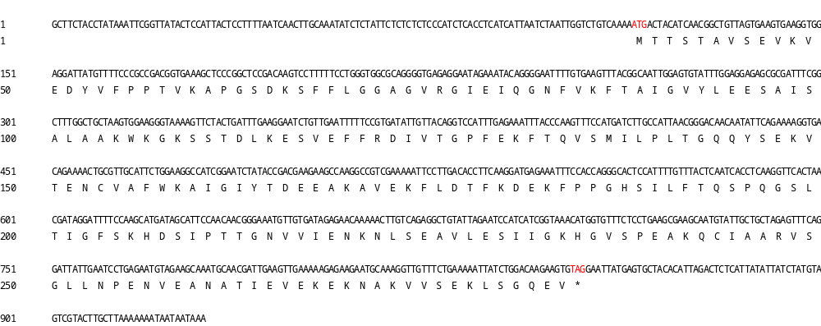
Supplementary Fig. S1 The full-length nucleotide sequence and encoding amino acid sequence of AcCHI from A. canescens. Red marks are the start codon (ATG) and the stop codon (TGA), respectively.

Supplementary Fig. S2 Sequence alignment and phylogenetic analysis of AcCHI with other CHI proteins. (A) Sequence alignment of AcCHI with its homologs in other species. the red boxes indicate conserved amino acid residues in AcCHI. (B) Phylogenetic relationships analysis of AcCHI with homologous proteins from higher plants. The scale bar on the bottom left of the diagram represents a distance of 5 changes per 100 amino acid positions. Bv: Beta vulgaris; Cq: Chenopodium quinoa; Cs: Camelina sativa; So: Spinacia oleracea; Zm: Zea mays; Cn: Camellia nitidissima; Ag: Apium graveolens; Pc: Prunus cerasifera; Md: Malus domestica; Mt: Medicago truncatula; Vr: Vigna radiata.
Supplementary Fig. S3 Schematic map of T-DNA region of binary vector pCAMBIA1302-Basta containing AcCHI cDNA and the restriction sites was Ncol. This overexpression cassette was used for A. thaliana transformation. Transgene expression was under the control of a CaMV 35S promoter.
Supplementary Fig. S4 RT-PCR analysis of AcCHI in transgenic lines (I1 and I2) and WT A. thaliana.

Supplementary Table S1 Primer sequences used in qRT-PCR of AcCHI, AcCHS and AcF3H in A. canescens
Primers | Sequences (5’-3’)
AcCHI-RTF | GGATTATGTTTTCCCGCCGAC
AcCHI-RTR | TCTATTCCTCTCACCCCTGC
AcCHS-RTF | TGGTGATGGGTTGGATTGGG
AcCHS-RTR | TGACACTACGGAGCACAACA
AcF3H-RTF | TCTATTCCTCTCACCCCTGC
AcF3H-RTR | GAAATAGCCCCCACTCCTCG
AcActin-F | AAGAACTACGAGCTACCTGACGG
AcActin-R | GATACCAGAAGATTCCATTCCAAC

Supplementary Table S2 Primer sequences used in AcCHI gene cloning
Primers | Sequences (5’-3’)
AcCHI-Outer-F | CTCCATTACTCCTTTTAATC
AcCHI-Outer-R | ACTAAGGGTATTGAGACG
AcCHI-Inner-F | CTCTATTCTCTCTCTCCCA
AcCHI-Inner-R | AGAGTCTAATGTGTAGCA

Supplementary Table S3 Primer sequences for construction of plant expression vector of AcCHI
Primers | Sequences (5’-3’)
AcCHI-F | GGACTCTTGACCATGGCCATGACTACATCAACGGCTGTTAGTG
AcCHI-R | GTCAGATCTACCATGGCTACACTTCTTGTCCAGATAATTTT

Supplementary Table S4 Primer sequences for analyzing the expression level of AcCHI in transgenic A. thaliana
Primers | Sequences (5’-3’)
AtActin2-RT-F | TCATGCCATCCTCCGTCTTG
AtActin2-RT-R | TGAACGATTCCTGGACCTGC
AcCHI-RT-F | CGCAGGGGTGAGAGGAATAG
AcCHI-RT-R | ACAAAATGGAGTGCCCTGGT

Supplementary Table S5 Primers for expression analysis of key genes of flavonoids biosynthesis in A. thaliana
Primers | Sequences (5’-3’)
AtActin-qRT-F | TCAGATGCCCAGAAGTGTTGTTCC
AtActin-qRT-R | CCGTACAGATCCTTCCTGATATCC
AtC4H-qRT-F | GGCTAGCAAACAACCCCAAC
AtC4H-qRT-R | GCTTCCACGTGCGATTCTTC
At4CL1-qRT-F | TCGTGTCGAAACAGGTTGTG
At4CL1-qRT-R | AGTTTTGCCCTCAGATCTTTCCT
AtPAL1-qRT-F | GCCTGGAGAAGAGTTCGACA
AtPAL1-qRT-R | CTCCGTTCCACTCGTTGAGA
AtCHS-qRT-F | CAAAGAAGCGGCAGTGAAGG
AtCHS-qRT-R | CCGGAGGTAGTGCAGAAGAC
AtF3H-qRT-F | TCTGCCGTCAGATCGTTGAG
AtF3H-qRT-R | AGCAAAGAAGTCACGAGCGA
AtFLS1-qRT-F | GCAATCCCGTTGGAGTTCATC
AtFLS1-qRT-R | CTTCGTCGGGATCGCTTAGA
AtDFR-qRT-F | CAAACGCCAAGACGCTACTC
AtDFR-qRT-R | GGAAAACACCGTCACATCCG
AtANS-qRT-F | TGGTTGCGGTTGAAAGAGTTG
AtANS-qRT-R | TCGAGCTCTTCTTTTGGACGA

Supplementary Table S6 Candidate genes encoding key enzymes of flavonoids biosynthesis in A. canescens
Gene ID | protein | log2 Ratio(SL6/CL6) | log2 Ratio(SL24/CL24)
CL5595.Contig2_All | CHS | 11.04028972 | 3.315501826
CL990.Contig3_All | CHI | 6.108524457 | 1.091922489
Unigene9407_All | F3H | 2.169925001 | 4.700439718

