Annex 1 (Questionnaire)

The questionnaire is addressed to specialists in interior design
Name: Workplace: Scientific Major
The following is a questionnaire that includes inquiries about the methods of using some interior design elements (shape - color - material) within the spaces of the community centers, where the specialist can choose more than one answer
Topics | options |  | Waiting room and reception % | dining % | workshop % | sports space % | Spa area % | Montessori % | Diagnostic % | health promotion spaces with Music % | health promotion spaces with Art % | Sensory training space % | Movement training space %
The right block for a space function | Vertical angle |  | 62 | 77 | 62 | 62 | 54 | 85 | 92 | 46 | 62 | 69 | 69
The right block for a space function | Italic angle |  | 15 | 15 | 15 | 15 | 15 | 8 |  | 23 | 31 | 23 | 15
The right block for a space function | Curved walls |  | 62 | 54 | 62 | 46 | 46 | 31 | 23 | 85 | 62 | 38 | 46
The right block for a space function | pyramidal block |  |  |  | 8 | 8 |  |  |  | 15 | 31 | 31 | 23
The right block for a space function | cylinder block |  | 31 | 38 | 8 | 31 | 23 | 15 |  | 31 | 31 | 23 | 15
The right block for a space function | (dome - part of a sphere) |  | 46 | 38 | 46 | 38 | 38 | 8 | 8 | 15 | 23 | 38 | 38
The appropriate covering material for the function of the space | inner cover  (ceilings - walls) | Uncoated cement | 15 | 15 | 23 | 38 | 8 |  | 15 | 8 | 31 | 8 | 38
 | inner cover  (ceilings - walls) | coated cement | 62 | 54 | 62 | 69 | 54 | 54 | 38 | 54 | 62 | 38 | 62
 | inner cover  (ceilings - walls) | Wood | 69 | 69 | 77 | 38 | 38 | 77 | 77 | 77 | 54 | 62 | 54
 | inner cover  (ceilings - walls) | Metal | 8 | 31 | 8 | 23 | 15 |  | 15 | 8 | 23 | 31 | 15
 | inner cover  (ceilings - walls) | Glass | 15 | 31 | 15 | 23 | 23 | 15 | 8 | 15 | 23 | 31 | 15
 | Flooring | smooth, non-slip | 77 | 62 | 46 | 23 | 31 | 38 | 31 | 31 | 46 | 38 | 23
 | Flooring | vinyl | 15 | 23 | 62 | 92 | 31 | 31 | 54 | 38 | 23 | 62 | 69
 | Flooring | parquet | 38 | 31 | 62 | 23 | 23 | 62 | 62 | 77 | 69 | 54 | 46
The right color for space function | Red. Gradients |  | 15 | 23 | 23 | 31 | 8 |  |  | 15 | 15 | 23 | 46
The right color for space function | Orange. Gradients |  | 23 | 62 | 54 | 46 | 15 | 15 | 8 | 15 | 23 | 31 | 54
The right color for space function | Green. Gradients |  | 38 | 31 | 31 | 31 | 38 | 46 | 46 | 23 | 31 | 31 | 23
The right color for space function | Blue. Gradients |  | 15 | 15 | 38 | 31 | 77 | 23 | 15 | 23 | 31 | 23 | 8
The right color for space function | Yellow. Gradients |  | 15 | 15 | 15 | 38 | 8 |  | 15 | 8 | 23 | 38 | 38
The right color for space function | Violet. Gradients |  | 15 | 23 | 23 | 31 | 23 | 31 | 15 | 31 | 38 | 31 | 8
The right color for space function | Calm pastel colors |  | 46 | 38 | 54 | 15 | 62 | 69 | 38 | 62 | 54 | 31 | 31
The right color for space function | neutral colors  (White - Black - Gray - Beige) |  | 62 | 31 | 54 | 38 | 31 | 46 | 54 | 54 | 54 | 46 | 38

Annex 2
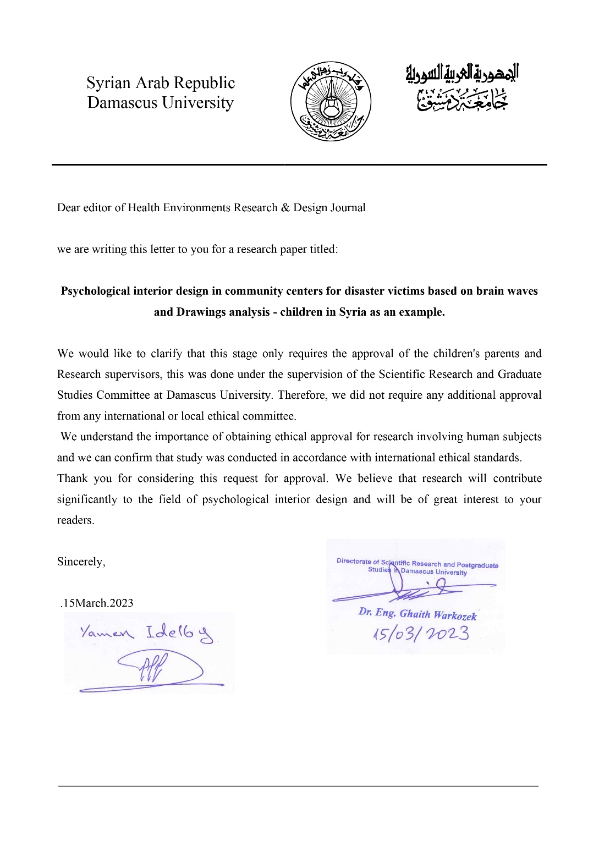

Annex 3
Y. Idelby, “Artistic drawings and their role in uncovering post-traumatic stress disorder: A case study of children affected by war in Syria”, HSS, vol. 20, no. 2, Jun. 2023.
https://spu.sharjah.ac.ae/index.php/HSS/article/view/1891
Doi: https://doi.org/10.36394/jhss/20/2/6

The stages of the study that achieve the result
(Drawings Analyses)
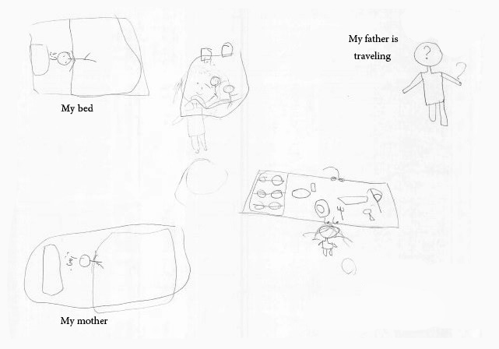
Age: 10
Date: 4/7/2020
A beautiful child who loves those around her and wishes to be loved and close to her family. She feels the loss of her father and considers him from the past (the feeling that he will not return), but she longs for him and sees his absence as unjustified according to her simple thinking.
She feels that his presence with them is more important than any return he can provide for them in his distance and because this leads to more responsibilities that fall on the shoulders of the mother, towards whom she feels pity for carrying those responsibilities. She also feels the mother’s nostalgia and her feeling of loneliness due to the absence of the father, with the constant hope of his return (the presence of a third dish on the table).

Paint 1: Family drawing – case A

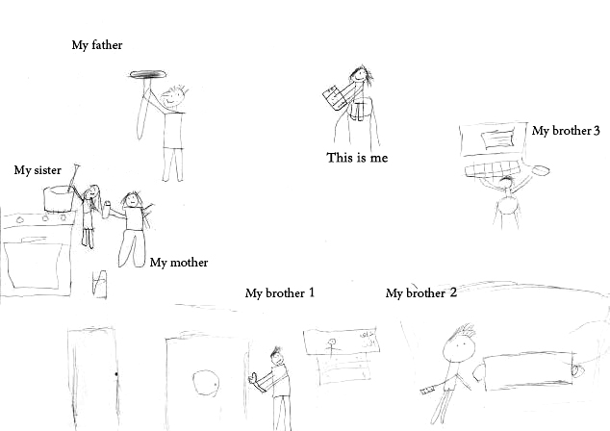
Age: 12
Date: 2/7/2020
A diligent family, sees the parents doing their utmost despite the distress or lack of capabilities sometimes (lack of limbs) due to the circumstances that everyone may go through at some point in time, but they actually need help, even with thanks and gratitude (the sister’s help to the mother). A girl who loves and strives to be distinguished and superior (she is at the top) and is keen to appear as a polite child who is obedient to orders and directives (holding her book), unlike her male brothers, who are having fun and playing indifferently, while the parents work hard, with satisfaction and love, to provide for the needs of their family.

Paint 2: Family drawing – case B

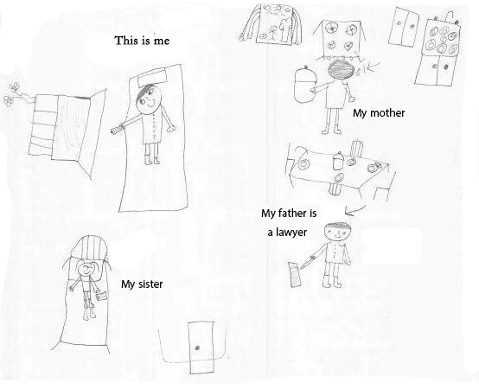
Age: 11
Date: 4/7/2020
A beautiful, happy, interconnected (apparently) family. They are housed in a spacious house, complete to the point of luxury. An equipped kitchen, a soft mattress, and a well-equipped dining table. But where are the mother and father? The mother is moody, sometimes understanding and affectionate, and at other times serious and nervous. He may feel that this is due to the father's focus and preoccupation with his work and building his future, which made her bear full responsibility towards the family.

Paint 3: Family drawing – case C

(Drawings Analyses) – Dream house

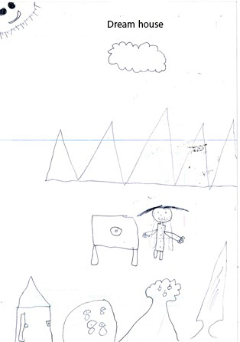
Age: 10
Date: 4/7/2020
She feels a state of frustration and perhaps a near lack of hope in obtaining a stable house filled with joy and life (below the painting). Even if it exists, she hopes that it will be a small, safe, abbreviated house that no one can reach or live inside unless she desires it (the door is small with an external lock, as well as the windows She also feels that. The source of her strength (the mysterious sun).
sometimes harsh in his attitude towards her (whether it is the family or the institution to which she belongs) and she may feel that she does not find support from him to achieve her ambitions. What she is currently wishing for is the strength and ability that enables her to achieve her ambitions, dreams, and wishes (mountains in the middle)

Paint 4: Dreamhouse – case D

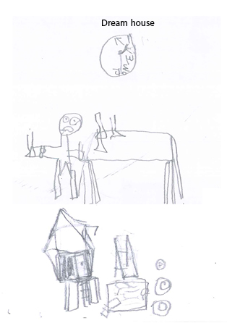
Age: 8
Date: 4/7/2020
A frustrated young child who feels fear and lack of confidence in the future (eyes protruding, inconsistent parties) and hopes not to lose his past and present.
This was reflected (in fear and mistrust) in the shape and location of his dream house, a small, dull house with no features or details, unstable and surrounded by whirlpools (volatility of conditions) that require effort to reach it.

Paint 5: Dreamhouse – case E

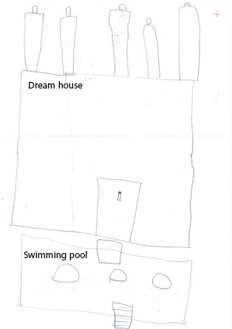
Age: 9
Date: 4/7/2020
A people with simple features. He is content to the point of surrender.
He does not really want a dream house, as it is empty and closed strangely locked. It does not even contain living people. Rather, they are closer to the dead who watch the house in the distance. A dry pool is devoid of life. A pessimism that may lead to despair in life.

Paint 6: Dreamhouse – case F

